The Technology we have used:
- Visual C#
- .Net framework 4.0
- Visual Studio Ultimate 2010

C#:
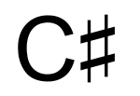
C# (pronounced see sharp) is a multi-paradigm programming language encompassing strong typing, imperative, declarative, functional, generic, object-oriented (class-based), and component-oriented programming disciplines. It was developed by Microsoft within its .NET initiative and later approved as a standard by Ecma (ECMA-334) and ISO (ISO/IEC 23270). C# is one of the programming languages designed for the Common Language Infrastructure.
C# is intended to be a simple, modern, general-purpose, object-oriented programming language. Its development team is led by Anders Hejlsberg. The most recent version is C# 4.0, which was released on April 12, 2010.


.NET Framework:
The .NET Framework (pronounced dot net) is a software framework that runs primarily on Microsoft Windows. It includes a large library and supports several programming languages which allows language interoperability (each language can use code written in other languages). Programs written for the .NET Framework execute in a software environment (as contrasted to hardware environment), known as the Common Language Runtime (CLR), an application virtual machine that provides important services such as security, memory management, and exception handling. The class library and the CLR together constitute the .NET Framework.

Design features:
1.Interoperability 2.Common Language Runtime Engine
3.Language Independence 4.Base Class Library
5.Simplified Deployment 6.Security 7.Portability

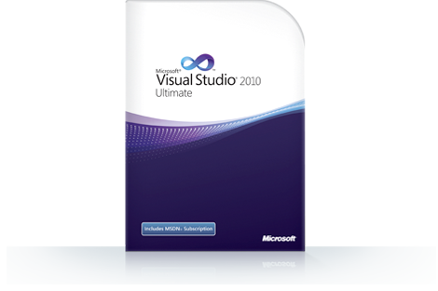
Visual Studio:
Microsoft Visual Studio is an integrated development environment (IDE) from Microsoft. It is used to develop console and graphical user interface applications along with Windows Forms applications, web sites, web applications, and web services in both native code together with managed code for all platforms supported by Microsoft Windows, Windows Mobile, Windows CE, .NET Framework, .NET Compact Framework and Microsoft Silverlight.

Visual Studio supports different programming languages by means of language services, which allow the code editor and debugger to support (to varying degrees) nearly any programming language, provided a language-specific service exists. Built-in languages include C/C++ (via Visual C++), VB.NET (via Visual Basic .NET), C# (via Visual C#), and F# (as of Visual Studio 2010). Support for other languages such as M, Python, and Ruby among others is available via language services installed separately. It also supports XML/XSLT, HTML/XHTML, JavaScript and CSS. Individual language-specific versions of Visual Studio also exist which provide more limited language services to the user: Microsoft Visual Basic, Visual J#, Visual C#, and Visual C++.

Visual Studio Ultimate 2010:
Microsoft Visual Studio 2010 Ultimate is the comprehensive suite of application lifecycle management tools for teams to ensure quality results, from design to deployment. Whether you're creating new solutions or enhancing existing applications, Visual Studio 2010 Ultimate lets you bring your vision to life targeting an increasing number of platforms and technologies—including cloud and parallel computing.

