ShatruBetaarJaal

A Tree-Based Self-Organizing Network

PROTOCOL SPECIFICATION
Hierarchical admission • Subtree authority • Liveness • Recovery
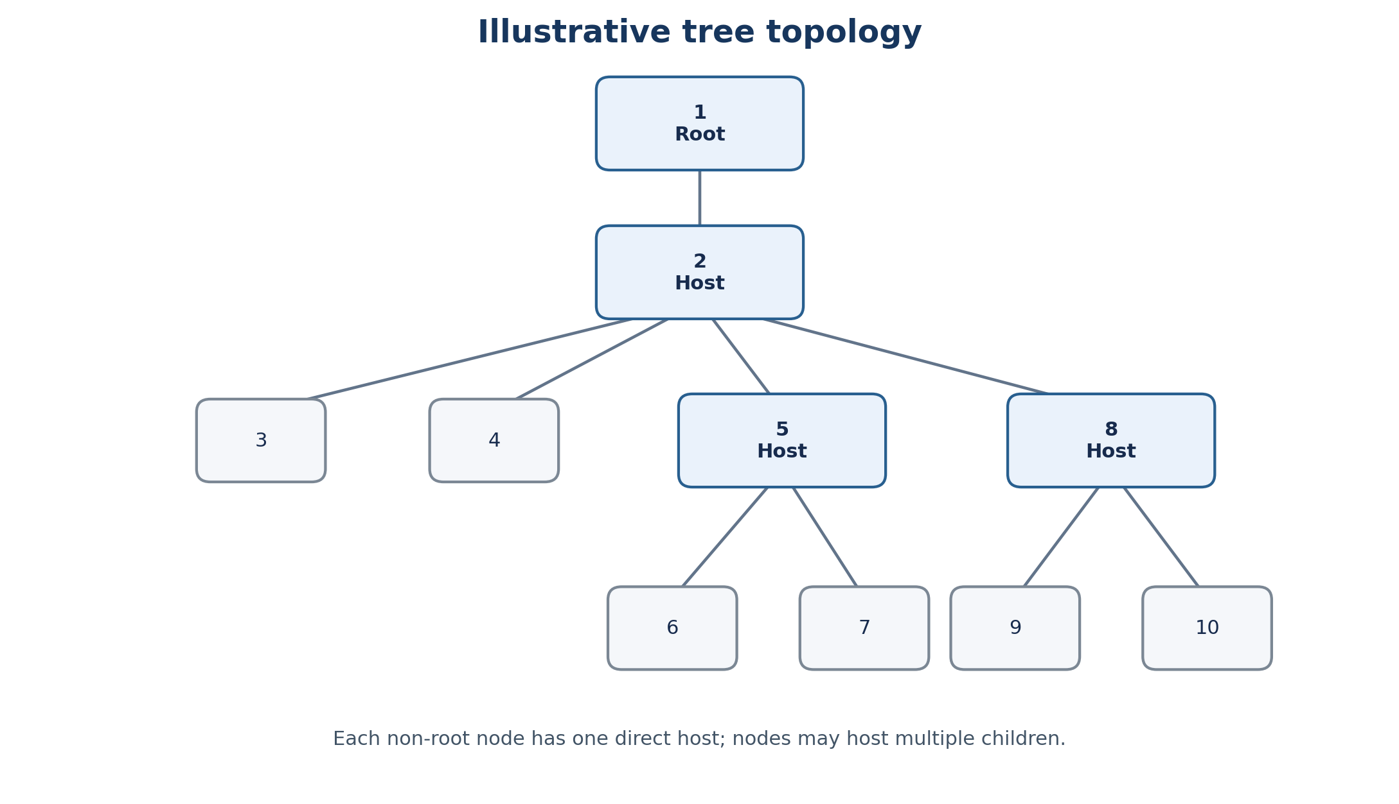
Reference topology illustrating single-host parent–child relationships.

Document ID | TSN-PROT-001
Version | 0.1 — Draft
Status | Architecture specification
Scope | Tree formation, admission, map synchronization, liveness and recovery

Specification note
This document consolidates the protocol rules established in the design discussion. Unspecified numerical parameters and unresolved implementation details are explicitly marked; they are not silently assumed.

Document control
Field | Value
Document title | Tree-Based Self-Organizing Network Protocol
Document ID | TSN-PROT-001
Version | 0.1
Status | Draft for technical review
Primary purpose | Specify topology, authority, admission, synchronization, liveness and recovery behavior
Normative language | “Must” indicates a required invariant; “should” indicates a design recommendation; “pending” indicates an unresolved specification detail.

Contents
- 1. Purpose and scope
- 2. Terminology
- 3. Topology and invariants
- 4. Subtree authority and register/map
- 5. Host compatibility and tie-break
- 6. Admission protocol
- 7. Acknowledgment and map consistency
- 8. Normal-operation liveness
- 9. Failure detection and recovery
- 10. Protocol overhead
- 11. Security and robustness considerations
- 12. Implementation parameters and open items
- Appendix A. Message-flow reference

1. Purpose and scope
This specification describes a decentralized network protocol in which participating nodes organize into one or more rooted trees. Nodes select suitable hosts, coordinate admission, synchronize the structural register/map, monitor direct-host availability, and recover from host failure.
The protocol is tree-based, not mesh-based. It does not assign a permanent hardware role as root. Each independent tree has a root determined by initiation, and multiple trees may coexist before joining.
The specification covers:
- Parent–child topology and root determination.
- Exclusive authority over hosted subtrees.
- Weighted compatibility evaluation using five parameters.
- Admission acknowledgments and complete-map transfer.
- Ping/pong liveness during normal operation.
- Recovery of orphaned subtrees and associated overhead.

2. Terminology
Term | Definition
Node | A device participating in the network.
Host | The direct parent of a node.
Child | A node directly hosted by another node.
Root | The initiating node at the top of a tree; it has no host.
Tree | A hierarchical structure where every non-root node has exactly one host.
Subtree | A node and all descendants beneath it.
Incomer | A node or orphaned-tree root attempting to join an existing tree.
Register/map | The structural representation of nodes and host–child relationships.
Initiator | The node coordinating an admission attempt.
XMComplete | The acknowledgment indicating completion of the required admission sequence.
Orphaned tree | A subtree whose former host has failed or become unavailable.

3. Topology and invariants
A tree consists of a root and zero or more descendant nodes. Every admitted non-root node has exactly one direct host and may have multiple children. Multiple independent trees may exist concurrently.
Figure 1. Example tree; host labels are illustrative.

3.1 Root determination
There is no permanent device role that inherently determines the root. The node that initiates first becomes the root of its tree. An orphaned subtree may have its own root while seeking admission into a surviving tree.

3.2 Topology invariants
- Every admitted non-root node has exactly one host.
- A node may host multiple children.
- A node cannot simultaneously belong to two committed parent relationships.
- The committed structure must not contain mesh links or cycles.

4. Subtree authority and register/map

4.1 Exclusive subtree authority
Each node is authorized to modify the portion of the register/map corresponding to the subtree it hosts. An ancestor may not arbitrarily overwrite a descendant's exclusively controlled subtree.
For example, in 1{2{3,4,5{6,7}}}, node 5 controls the subtree containing nodes 6 and 7. Node 2 cannot directly replace that subtree's contents merely because it is an ancestor.

4.2 Structural change propagation
A valid structural change is propagated through the tree as required. Forwarding or incorporating a change does not grant an intermediate node ownership of the originating subtree.

4.3 Complete-map synchronization
Key operating rule
The complete register/map is transferred during admission. After admission completes, normal-operation control traffic consists only of alive pings and their corresponding pongs. There is no recurring complete-map redistribution during steady state.

The complete-map transfer is therefore a temporary admission/recovery cost rather than a recurring steady-state cost.

5. Host compatibility and tie-break

5.1 Compatibility parameters
Parameter | Evaluation dimension
Subtree depth | Depth of the candidate host's subtree.
Total subtree node count | Number of nodes in that subtree.
RSSI | Received signal strength relevant to the candidate/host relationship.
Bandwidth | Available or relevant communication capacity.
Power | The power-related compatibility measure defined by the architecture.

Each parameter contributes according to its assigned weight and evaluation rule. Numerical weights, normalization, and preference directions must be supplied by the implementation specification; they are not invented here.

5.2 Absolute-tie resolution
If the weighted compatibility scores are equal, compare the competing hosts' complete 48-bit MAC addresses as hexadecimal integers. The protocol must define one consistent direction: select either the numerically lower or numerically higher address.
Host | MAC address | Numerical representation
A | 24:6F:28:AB:CD:10 | 0x246F28ABCD10
B | 30:AE:A4:12:34:56 | 0x30AEA4123456

Assuming MAC addresses are unique within the network, numerical ordering yields a deterministic winner. The MAC comparison is a final tie-breaker and does not replace the five weighted parameters.

6. Admission protocol
Admission coordinates host selection, acknowledgment, and structural synchronization. The incoming node must not begin ordinary data exchange before admission completion.
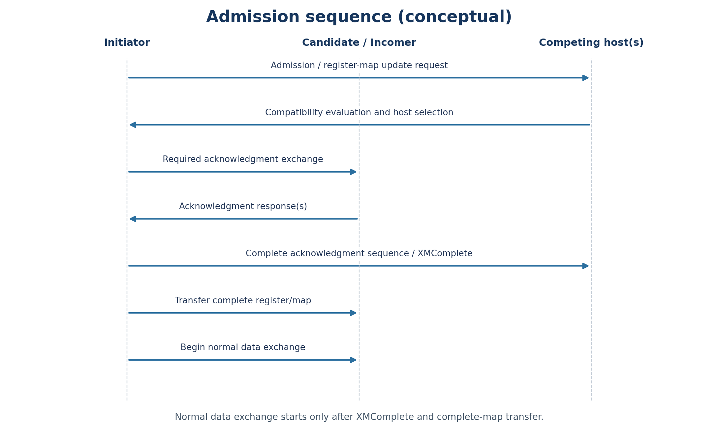
Figure 2. Conceptual admission message flow. Exact message fields and ordering should be finalized in the wire-protocol specification.

6.1 Initiation and host competition
A seed node or existing tree node may initiate admission. Multiple hosts may evaluate the same incomer concurrently. Each host evaluates compatibility against its subtree characteristics and relevant resources using the five parameters.

6.2 Register/map update acknowledgment request
The initiator sends the register/map update acknowledgment request as part of admission. The recipient evaluates the request against its current register/map, authority boundaries, and compatibility rules. If the incomer already appears in the register/map, that existing entry is relevant to the evaluation.

6.3 Acknowledgment handling
- If an acknowledgment has already been served, the completed action is not repeated; the initiator withdraws its competing request.
- If another register/map update arrives during a competing admission, a participant may reply with its own register/map and a warning so the other participant can evaluate the competing state.
- Acknowledgment completion is a coordinated sequence, not merely receipt of the first response.

6.4 Admission commitment
Admission invariant
The initiator treats the incomer as admitted only after the required acknowledgment sequence completes and XMComplete is received. The complete network map is then transferred to the incomer, and normal data exchange begins.

The precise wire-level definition of XMComplete, including fields, correlation identifiers, and timeout behavior, remains a specification item if not already fixed elsewhere.

7. Acknowledgment and map consistency

7.1 Authority validation
The receiver validates a register/map update against the sender's authorized subtree. A sender may not use an update to overwrite structural information outside its scope.

7.2 Competing and repeated updates
Updates received during competing admission activity are evaluated against the existing state and acknowledgment rules. An already-served acknowledgment is not repeated merely because another request arrives.

7.3 State commitment
A node is not an ordinary data-exchange participant before the admission sequence is complete. The wire-protocol specification should explicitly define how delayed messages are correlated with an admission attempt and how stale or out-of-order updates are handled wherever the current sequence does not already prevent them.

8. Normal-operation liveness

8.1 Direct-host monitoring
Each node sends an alive ping to its direct host and expects a corresponding pong. Nodes do not need to send routine liveness pings to every other node.

8.2 Steady-state control traffic
Normal operation
After admission is complete, routine protocol control traffic is limited to alive ping/pong exchanges. Complete-map transfer and admission acknowledgment traffic are not recurring steady-state messages.

The ping interval, timeout, and retry policy are implementation parameters. Each ping is expected to receive a pong under normal operating conditions.

9. Failure detection and recovery

9.1 Failure detection
A node detects loss of its host through the defined ping/pong liveness mechanism and timeout. Exact timeout and retry values must be specified by the implementation.

9.2 Orphaned subtrees
When a host fails, its descendants may lose their direct host relationship. The affected structure becomes an orphaned subtree or, if separate subtrees are detached, multiple orphaned trees. Existing descendant relationships remain relevant; the entire network does not automatically become a collection of isolated nodes.

9.3 Recovery admission
An orphaned-tree root acts as an incomer while seeking a suitable host in a surviving tree. The normal compatibility and admission procedures apply. After admission completion, the required complete-map synchronization occurs and ordinary data exchange resumes.

9.4 Recovery scope
Recovery is scoped to the affected subtree or subtrees. Unrelated branches do not require re-admission merely because another branch has failed. Arbitration for concurrent recovery and the behavior of a returning former host must be explicitly specified.

10. Protocol overhead

10.1 Steady-state message rate
A tree containing N nodes has N − 1 host–child relationships. With one ping and one pong per relationship every T seconds:
Rsteady = 2(N − 1) / T
For 100 nodes and a one-second interval, the application-level rate is 198 messages/s. This excludes Wi-Fi framing, contention, retransmissions, and other application data.
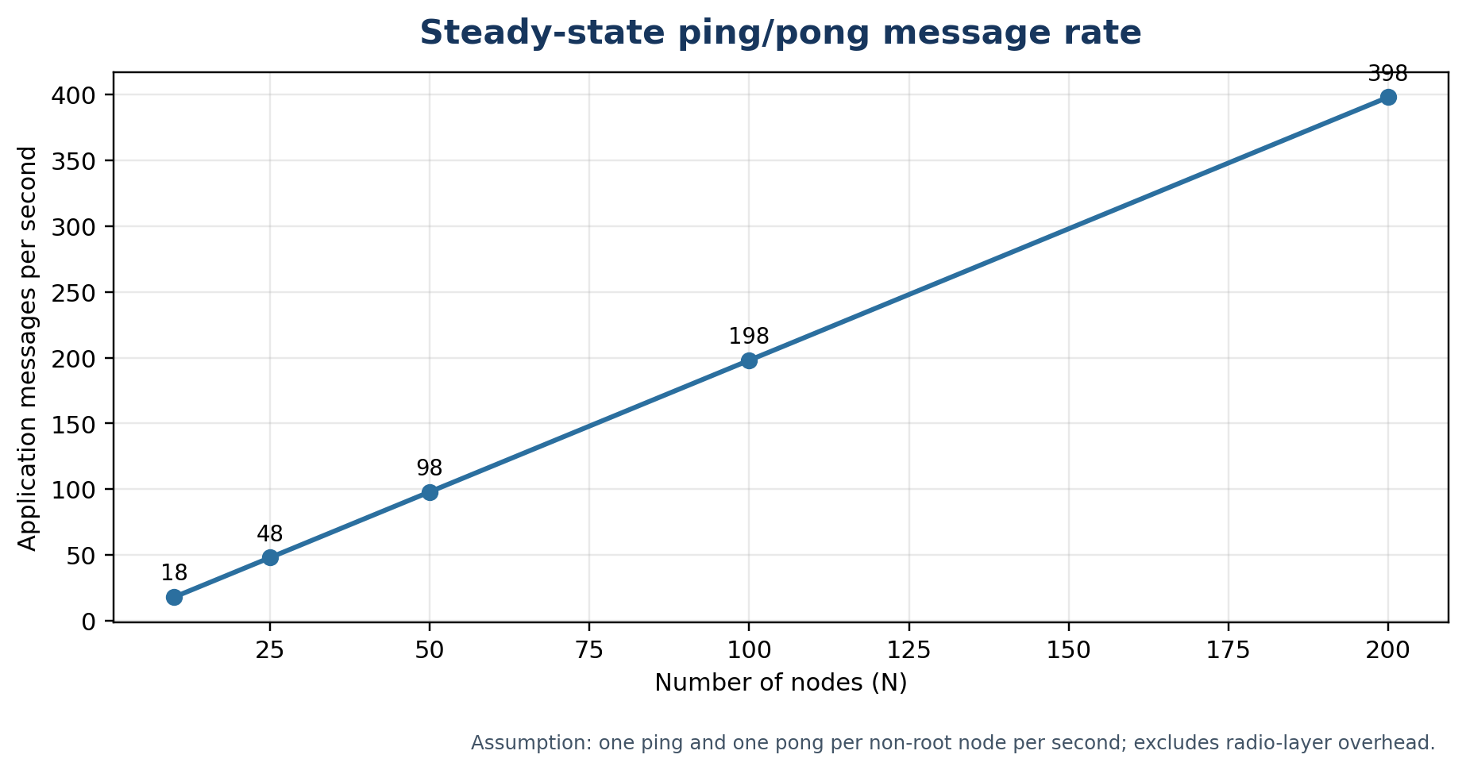
Figure 3. Linear scaling of ping/pong message rate for a one-second interval.

10.2 Admission and recovery cost
Admission incurs control exchanges and complete-map transfers. Recovery adds temporary failure-detection and re-admission traffic. Their cost depends on map size, the number of competing hosts, the number of admission attempts, and the affected subtree.

10.3 Scaling conclusion
- Routine liveness traffic scales linearly with node count.
- Complete-map transfer is confined to admission and recovery rather than repeated during steady state.
- Admission and recovery produce event-driven bursts whose size depends on topology and map representation.

11. Security and robustness considerations
The current architecture defines authority and consistency behavior, but these alone do not authenticate senders. A production implementation should evaluate:
- Authentication and integrity protection for admission, map updates, pings, pongs, and acknowledgments.
- Validation that a sender's update stays within its authorized subtree.
- Replay protection or transaction correlation for delayed acknowledgments and repeated requests.
- Handling of duplicate, malformed, or conflicting node identities.
- Resource limits for repeated admission attempts and recovery bursts.
These are engineering considerations for a robust deployment, not claims that the current design already implements cryptographic protection or replay resistance.

12. Implementation parameters and open items
Item | Status / required definition
Compatibility weights and normalization | Pending: specify weights, normalization, and preference direction for each parameter.
MAC tie-break direction | Pending: choose lower or higher numerical MAC and apply consistently.
Ping interval and timeout | Pending: define interval, timeout, and retry policy.
Acknowledgment fields | Pending: define message fields, correlation, completion conditions, and timeout behavior.
Stale/out-of-order message handling | Specify only where not already prevented by the defined acknowledgment/ownership sequence.
Concurrent recovery arbitration | Pending: define behavior for simultaneous orphaned-tree recovery.
Former host returns | Pending: define behavior if a failed host reappears after its former subtree has joined another tree.
Register/map encoding | Pending: specify serialization, bounds, and versioning if required.
Identity uniqueness | Assumption for deterministic MAC tie-break: addresses are unique within the network.

Appendix A. Message-flow reference
Phase | Message / action | Expected outcome
Admission | Register/map update acknowledgment request | Recipients evaluate current state and compatibility.
Admission | Compatibility evaluation | Preferred host is determined by weighted score and MAC tie-break.
Admission | Required acknowledgment exchange | Participants resolve competing admission state.
Admission completion | XMComplete | Initiator recognizes completion of required acknowledgment sequence.
Map synchronization | Complete register/map transfer | Incomer receives the complete network map.
Normal operation | Alive ping → pong | Direct host liveness is monitored.
Recovery | Failure detection and re-admission | Affected subtree seeks a suitable host and synchronizes map.

Closing specification statement
The protocol separates topology admission from steady-state operation. Admission performs host selection, acknowledgment coordination, and complete-map synchronization. Once admission completes, normal control traffic is limited to ping/pong exchanges between each node and its direct host. Tree authority governs structural changes, and recovery is scoped to affected subtrees.

