COMP 6411
Comparative Study of Programming Languages
Summer 2013

POTUM: THE BEVERAGE COASTER PROJECT
Deliverable I (D1)

G

List of Team Members:
Pratik Bidkar
Eric Chan
Tarnum Sharma
Jaiminkumar Patel
Radha Mendhurwar
Bargavi Chinni Krishnamoorthy

1. Introduction
The main objective of the POTUM is to design and implement an efficient algorithm for finding the overlap of the beverage coasters with the study of various programming languages. Our proposed solution includes comparison between different algorithms considering the accuracy and efficiency factors and uses the most efficient algorithm, like Bisection method and Taylor Series. We are implementing the proposed algorithm in various programming languages like Java, JavaScript, Lua, Python, Ruby and Scala to solve this problem. This document contains the analysis made in choosing the particular algorithm, keeping the purpose and the constraints of the problem in mind. This document also encloses the algorithm for calculating various functions like sine, cosine and pi from scratch, rather than using inbuilt functions available in respective languages. While calculating the functions some techniques are followed to reduce floating-point hardware issues while summing up the terms of mathematical procedure. The algorithm was selected and modified to achieve accuracy (minimize the floating point errors), simplicity and efficiency in the output.
In terms of programming style guidelines, the team has decided to implement functions with same names and arguments across all the language implementations for the sake of consistency. The team members also have documented the instructions for processing their respective source code and programming style guidelines that have to be followed during development. Also the sample outputs for different values of radius are provided in this document. This project helped us in learning advantages and limitations of various programming languages.

2. Problem Statement
Let there be two circular beverage coasters of equal area and negligible height are provided. The purpose of POTUM is to find how far the two coasters need to be overlapped such that the area of the overlapping region is half the area of any one of the coasters. We need to find the value of an angle of overlapping of the coasters so that the area will be the same as specified. This angle (α) is given bt the equation

α - sin(α) = Π/2

Also we need to compute the length of the overlap with the given equation

l = 2 * radius * (1 – cos(α/2))

Here, the goal is to compute the value of “l” for different values of radius R.

Programming languages chosen by the team members:

Team Member | Programming Language
Tarnum Sharma | Java
Eric Chan | JavaScript
Radha Mendhurwar | Lua
Jaiminkumar Patel | Python
Pratik Bidkar | Ruby
Bargavi Chinni Krishnamoorthy | Scala

3. Description of algorithms

3.1 Factorial Algorithm

In mathematics, the factorial of a non-negative integer n, denoted by n!, is the product of all positive integers less than or equal to n. For example, 5! = 5 x 4 x 3 x 2 x 1 = 120. The value of 0! is 1, according to the convention for an empty product.

Algorithm - Iterative Version

Input: An integer number (n)
Output: Factorial of given number

ret ← 1
while n > 0
ret ← ret * n
n ← n - 1
return ret

Algorithm - Recursive Version

Input: An integer number (n)
Output: Factorial of given number

if n == 0
return 1
return n * factorial (n - 1)

Team Decision:

We chose Iterative version of factorial over recursive method because the latter method is usually slower due to the overhead of maintaining the stack and it uses more memory.

3.2 power Algorithm

3.3 Sine/Cosine Algorithms

CORDIC algorithm:
The CORDIC algorithm is a shift and add algorithm, for computing elementary functions like sine and cosine. This basic explanation shows how to use CORDIC in rotation mode to calculate the sine and cosine of an angle, and assumes that the desired angle is given in radians and represented in a fixed floating-point representation.

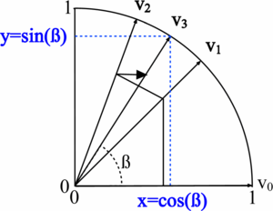

Basic Idea of CORDIC implementation:
Rotate point P(1, 0) by ‘α’ degrees to get (x, y):
X = cos (α)
Y = sin (α)
Rotation of any vector is given by
X` = x.cos(α) – y.sin(α)
Y’ = y.cos(α) + x.sin(α), which can be further re-arranged as
X` = cos(α).(x – y.tan(α))
y` = cos(α).(y + x.tan(α)).
Rotations in turn are computed in steps where each step is of size
tan(α) = ± 2^{-i}
Since same angles are rotated always K can be pre computed as follows.
K = 1.646760258121.

Taylor Series:
A Taylor series is a representation of a function as an infinite sum of terms that are calculated from the values of the function's derivatives at a single point.
It is common practice to approximate a function by using a finite number of terms of its Taylor series. Any finite number of initial terms of the Taylor series of a function is called a Taylor Polynomial. The Taylor series of a function is the limit of that function's Taylor polynomials, provided that the limit exists.
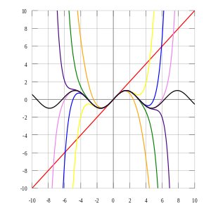
The above figure shows the sine function approximations of degrees 1, 3, 5, 7, 9, 11 and 13.

We can use the following polynomial to calculate sine and cosine of an angle.
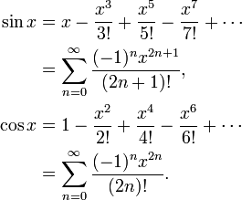

Team Decision:
Team decided to implement Taylor’s series to calculate sine and cosine of an angle since it is easy to implement as compared to CORDIC algorithm.
CORDIC algorithm involves complex vector and exponential computations and also requires a scaling factor K (Expansion Vector).
Pseudo code for modified sine function (using Taylor Series):
Input: x some integer or float value; TRIG_ITER: maximum number of iterations
Output: value of sine of x
- ret = 0
- for i = TRIG_ITER to 1
- ret += pow(-1, i) * pow(x, 2 * i + 1) / fact (2 * i + 1)
- return ret

Pseudo code for modified cosine function (using Taylor Series):
Input: x some integer or float value; TRIG_ITER: maximum number of iterations
Output: value of cosine of x
- ret = 0
- for i = TRIG_ITER to 1
- ret += pow(-1, i) * pow(x, 2 * i ) / fact (2 * i )
- return ret

3.4 PI Algorithms
Infinite Series
An infinite series is the sum of the terms of an infinite sequence. The following series is used to compute the value of PI.

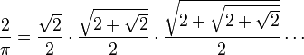

Rapidly Convergent Series:
This modern infinite series converges much more rapidly than most arctan series, including Machin's formula. The series is as follows:

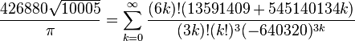

Spigots Algorithm:
They are called Spigots Algorithm because, like water dripping from a spigot, they produce single digits of π that are not reused after they are calculated. This is in contrast to infinite series or iterative algorithms, which retain and use all intermediate digits until the final result is produced.

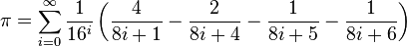

Team Decision:
We all collectively decided to calculate the value of PI using the Spigot’s Algorithm since it is faster in calculating PI’s value and unlike other algorithms it does not use intermediate digits to compute the final value.
Also the other reason being that the other series implement the calculation of square root values which in turn are expensive to calculate and affect the efficiency.
Pseudocode for PI function:
Input: PI_ITER : maximum number of iterations
Output: value of PI
- ret =0
- for i = PI_ITER to 1
- ret += 1 / pow(16, i) * (
- 4 / (8 * i + 1) – 2 / (8 * i + 4) –
- 1 / (8 * i + 5) – 1 / (8 * i + 6))
- return ret

3.5 Computing an angle (α)

A simple bisection procedure for iteratively converging on a solution which is known to lie inside some interval [a, b] proceeds by evaluating the function in question at the midpoint of the original interval c = (a + b) / 2 and testing to see in which of the subintervals [a, (a + b)/2] or [(a + b)/2, b] the solution lies. The procedure is then repeated with the new interval as often as needed to locate the solution to the desired accuracy.
It is a very simple and robust method. This method is also called as the binary search method or the dichotomy method.
ALGORITHM
INPUT: Function f, endpoint values a, b, tolerance TOL, maximum iterations NMAX CONDITIONS: a < b, either f (a) < 0 and f (b) > 0 or f (a) > 0 and f (b) < 0
OUTPUT: value which differs from a root of f (x) = 0 by less than TOL
N ← 1
While N ≤ NMAX {limit iterations to prevent infinite loop
c ← (a + b)/2 new midpoint
If (f(c) = 0 or (b – a)/2 < TOL then {solution found
Output(c)
Stop
}
N ← N + 1 increment step counter
If sign (f(c)) = sign (f (a)) then a ← c else b ← c new interval
}
Output ("Method failed.") max number of steps exceeded

3.6 Issues and Refinement

4. Style guidelines used in programming languages

4.1 Style guidelines common for the team

Meta Information:
/**
* Name: potum.<language specific extension>
* Purpose: POTUM: THE BEVERAGE COASTER PROJECT
*
* Author: <name>
* Version: 1.0
* Created: <yyyy-mm-dd>
*/

We like to follow multiple line comments /* */ for Java, Scala, JavaScript as shown above. Lua offers block comments which start with “--[[“ and run until the corresponding “]]”. Python uses triple quoted strings. And Ruby uses =begin and =end for multiline comments.

Functions:
We use the same function names and argument names to be consistent within a team.
calcpi() : a function to calculate PI value
fact(n) : a function to calculate factorial of n
pow(b, e) : a function to calculate power
solve(...) : a function to solve for alpha angle
lsin(x) : a function to calculate the modified sin value of x
lcos(x) : a function to calculate the modified cos value of x
f(x) : f(x) = x - sin(x) - pi/2

Every function should have a comment block to describe about it.
For example in scala,

/**
* Calculates factorial of given number
* @param n Number
* @return factorial value of n
*/

And wherever necessary, single line comments are used inside the function.

Indentation Depth:
The indention depth describes how far a subordinate syntax element shall be indented. We decided to go with the indentation depth of 4 spaces.

Brace Style:
The brace style describes the position of surrounding syntax elements like curly braces {}. Java, JavaScript and Scala put the opening brace of a function body in the same line of function prototype.

Execution Style:
All our potum programs can be run in command line terminal. Unless the user input is "exit" or "quit", it loops forever. We handle exceptions when other than numeric input are given; we catch that exception and print "Try Again!!"
Line Length:
Line length should not exceed 80 characters.

Method Invocation:
Each argument in a function should be separated by a single space following the comma (,).

4.2 Language specific style guidelines

4.2.1 Java

4.2.2 JavaScript

4.2.3 Lua

4.2.4 python
Programming Style:
1. Use 4 spaces for indentation level:
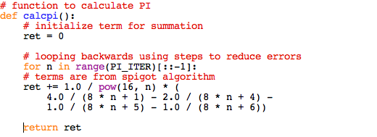
2. Source code meta-information (author, version, creation date, etc)
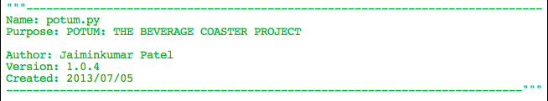
3. Exception Handling – run-time errors must be intercepted and handled
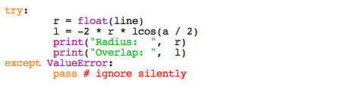
4. Use proper naming for style
5. There are no braces in Python language, use indentation to control the indentation level.
6. First word of each comment should be capitalized, unless it is an identifier that begins with a lower case letter.

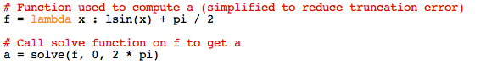
7. Sample Output
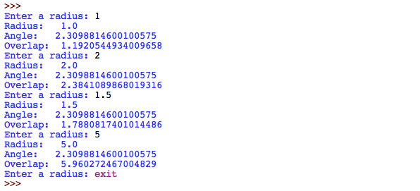

4.2.5 Ruby

4.2.6 Scala

5. Instructions for processing the source code

5.1 Java

5.2 JavaScript

5.3 Lua

5.4 python

Assumption
It is assumed that Python v3.3.2 is pre-installed and properly configured before compiling and running the source code.
Python on Windows
- Start Python from the Start Menu, or make sure the PATH is set correctly so Windows can find the Python interpreter
- Use the cd command to navigate to the directory where the source file was saved
- Then run the following command:
{Python-directory} {Program-file}
For example, C:\Python\python.exe potum.py
- You can exit the interpreter prompt by pressing ctrl-d or entering exit()

Python on Unix platforms
- Open the terminal and run the command “python” to start the python interpreter and will give you “>>>” prompt.
- Once this works, navigate to the directory where the source code is located and then run the program with following command:
python {program-file}
For example: python potum.py
- You can exit the interpreter prompt by pressing ctrl-d or entering exit()

5.5 Ruby

5.6 Scala

Compile it! The scalac command compiles one (or more) Scala source file(s) and generates Java bytecode which can be executed on any standard JVM. $ scalac potum.scala
By default scalac generates the class files into the current working directory. You may specify a different output directory using the -d option. $ scalac -d classes potum.scala
Execute it! The scala command executes the generated bytecode with the appropriate options: $ scala potum

6. Output of different implementations across diff. programming languages

Probgramming Language | Radius = 1 | Radius = 1.5 | Radius = 5
Java
JavaScript
Lua
Python | 1.1920544934009658 | 1.7880817401014486 | 5.960272467004829
Ruby
Scala

References
- http://docs.python.org/3.2/
- [Scala Community, 2013] Scala Style Guide. By Scala Community. 2013.
- [Odersky, 2010] Programming in Scala. By Martin Odersky. Second Edition. Artima. 2010.

