DESCRIPTION OF THE DOMAIN TEAM 7

By
Team 7:

Eric Chan
Corey Clayton
Mathieu Dumais-Savard
Andreas Eminidis
Phuong-Anh-Vu Lai
Julia Lemire
Marc-André Moreau
Sébastien Parent-Charette

A Technical Report
submitted in partial fulfillment
of the requirements of
SOEN 341
Concordia University
January 2010

At Concordia University, interactions between the student body and the registrar can be pretty cumbersome. Every student is faced with the challenge of finishing the desired degree in a timely manner. To achieve such a goal, a student has to fulfill all of the requirements defined by the ENCS faculty in the university's Undergraduate Calendar.

These requirements are largely comprised of courses to be taken. However due to various factors such as prerequisite courses, scheduling conflicts and certain courses only being offered during specific sessions, the task of organizing these requirements can become quite complicated. To help alleviate this situation, the ENCS faculty generally provides a recommended course sequence. Those students wishing to obtain their degree in four years are encouraged to follow it.

Many students, however, are out of sequence due to failing a course or electing to reduce their course load to four classes per semester. The current web-based registration system offered at Concordia does not make any suggestions that would help students in this situation. It is Team 7's goal to produce a web-based schedule planner that will determine a proposal schedule based on a student's current academic record and the sequence of their program of study. This planner will take into account any and all conflicts and prerequisites as well as any constraints the students wishes to add.

The data for the courses the schedule planner will have access to will be extracted from the university's Class Schedule tables. It has been decided that these courses will be limited to the Software Engineering and Computer Science courses as well as the technical electives available to these students.

Figure 1 shows the different sketches of the user interface. It is to be separated into different tabs that are to be kept in order in the page header. There are to be five different tabs, each serving a specific purpose. The Schedule View page will act as the default tab and will display the registered courses, for both the fall and winter sessions, in a five-day table. The Course List tab will act as the reference page containing all of the information for each course, including course descriptions. It will include a set of filters that will help the user when searching for a specific course. The Sequence tab will contain a diagram depicting how all the courses relate to each other. The Academic Records tab will hold a list of all of the students previously taken courses and their corresponding grade. The Planner tab will host the most important part feature – the schedule planner. It will have a defined space to display any conflicts the planner may find. It will also have a space where the user can input the desired constraints. All conflicts and constraints will be removable. Beneath these designated spaces will be where the proposed schedules are displayed. In the case where more than one schedule is possible, the user will be able to view each one individually by means of the Previous and Next arrows.

Figure 2 shows a block diagram of the functions of this planner and their interconnections. These functions include logging in and logging out, accessing the menu, browsing all available courses, viewing suggested courses, viewing the current schedule, accessing the student's academic record and modifying the schedule.

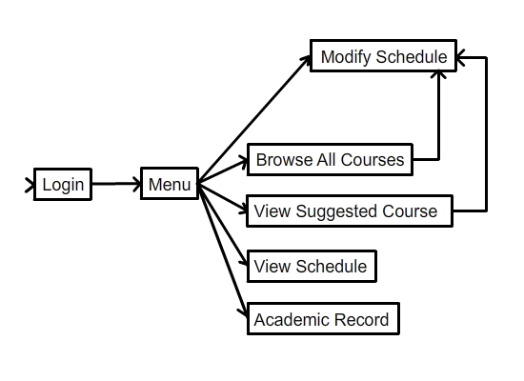
Figure 2 – Block diagram displaying the schedule planner's functions and their interconnections.

Team 7 includes eight members: Eric Chan, Corey Clayton, Mathieu Dumais-Savard, Andreas Eminidis, Phuong-Anh-Vu, Julia Lemire, Marc-André and Sébastien Parent-Charette. Eric is to act as team leader throughout the duration of the project. Other key roles have been assigned such as Marc-André as the system administrator and Julia as the documentation coordinator. When it comes to who will be programming which aspects of the application, this is subject to change depending on what is needed.

Glossary

ENCS: Concordia Faculty of Engineering and Computer Science
Student: An individual taking courses at Concordia
Course: one unit of a study program, ex: SOEN 341
Class: an instance of a course, ex: SOEN 341 2009/4 Section S
Term: a period of the year around which the school is synchronised, ex: 2009/4
stands for the Winter session from Jan.- Apr. 2010
Prerequisite: a course that should be taken prior to another

