SOFTWARE DESIGN

By
Team 7:

Marc-André Moreau
Eric Chan
Sébastien Parent-Charette
Corey Clayton
Mathieu Dumais-Savard
Julia Lemire
Phuong-Anh-Vu Lai
Andreas Eminidis

A Technical Report
submitted in partial fulfillment
of the requirements of
SOEN 341
Concordia University
January 2010

TABLE OF CONTENTS

1. Architecture 1
1.1 Overview 1
2. Presentation Tier 3
2.1 Pages 3
2.1.1 Core 3
2.1.2 Academic Record 3
2.1.3 Sequence Planner 3
2.1.4 Schedule Viewer 3
2.1.5 Course Browser 3
2.2 Controls 3
2.2.1 Modal Window 3
2.2.2 Filter 4
2.2.3 Calendar 4
3. Logic Tier 5
3.1 Authentication 5
3.2 Academic Record 5
3.3 Registration 5
3.4 Scheduling 5
3.5 Course 5
4. Data Tier 6
4.1 Overview 6
4.2 Users 6
4.2.1 Administrator 7
4.2.2 Student 7
4.2.3 Teacher 8
4.3 Courses 8
4.3.1 Course 8
4.3.2 Class 8
4.3.3 Department 9
4.3.4 Faculty 9
4.4 Requirements 9
4.4.1 Simple Requirements 9
4.4.2 Elective Requirements 10
4.4.3 Multiple Requirements 10
4.5 Programs 10
4.5.1 Program Options 10
4.5.2 Course Sequence 11

TABLE OF FIGURES

Figure 1: 3-tier Architecture 1
Figure 2: UML Component Diagram 2
Figure 3: Entity-Relationship Diagram 6
Figure 4: Different types of users 7
Figure 5: Courses in the database 8
Figure 6: Representation of requirements 9

Architecture

1.1 Overview

The team7 scheduling system uses a 3-tier software architecture, meaning that presentation, logic and data are separated. This has the advantage of making the code more reusable, as the tiers can be modified without necessarily affecting the others. Figure 1 shows the different components of a 3-tier architecture:
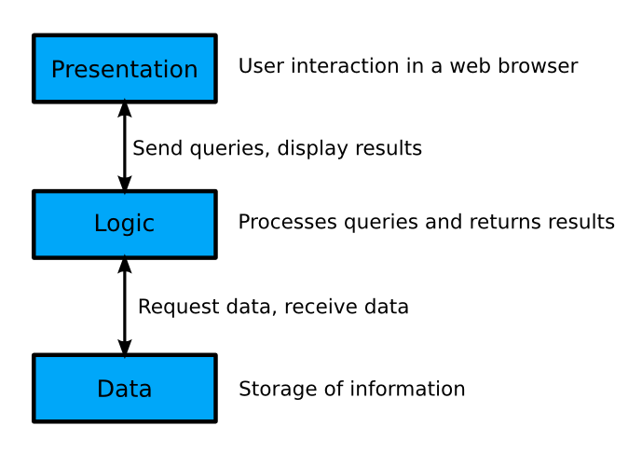
Figure 1: 3-tier Architecture

In the case of the team7 scheduling system, the presentation is what is presented to the user, as a website. This part is done using jQuery, a library on top of Javascript that makes it easier to support a broader range of browsers.

The logic tier is composed of multiple PHP modules for the various tasks the application needs to handle. This includes user authentication, scheduling, registration and courses.

The third tier is the database. The database used in this project is MySQL. The multiple PHP modules interact with the database in order to query data requested by a user in the presentation tier, and return the results in a format ready to be used by the presentation tier.

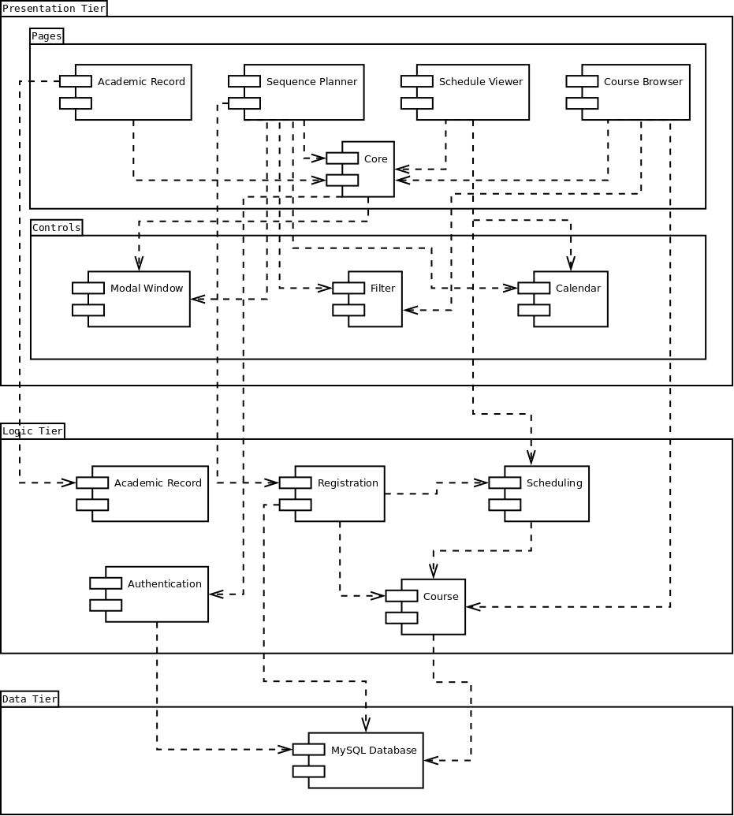
Figure 2: UML Component Diagram

2. Presentation Tier

2.1 Pages

2.1.1 Core

2.1.2 Academic Record

2.1.3 Sequence Planner

2.1.4 Schedule Viewer

2.1.5 Course Browser

2.2 Controls

2.2.1 Modal Window

2.2.2 Filter

2.2.3 Calendar

3. Logic Tier

3.1 Authentication

3.2 Academic Record

3.3 Registration

3.4 Scheduling

3.5 Course

4. Data Tier

4.1 Overview

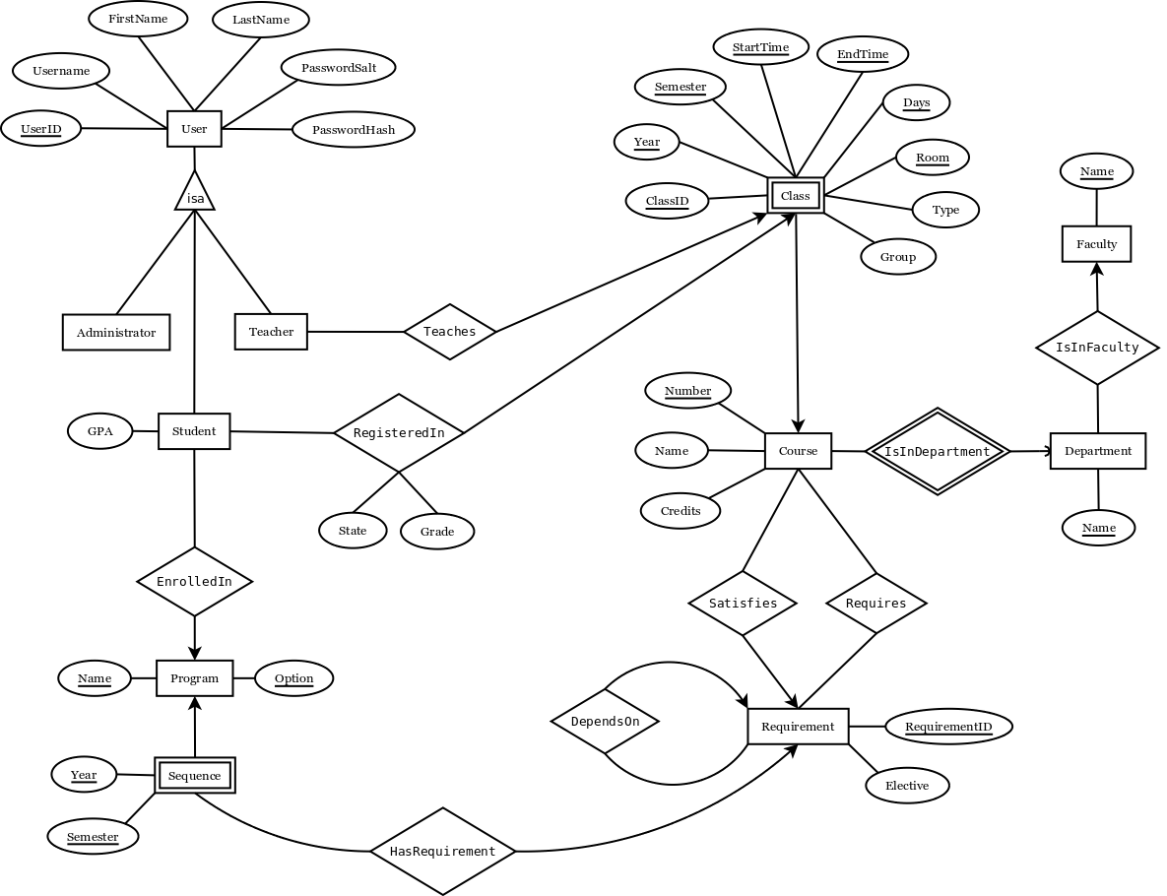
Figure 3: Entity-Relationship Diagram

4.2 Users

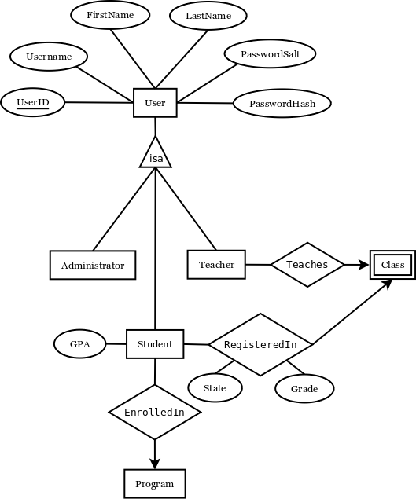
Figure 4: Different types of users

4.2.1 Administrator

Users in the administrators table have administrative powers on the database. This would usually be staff from the school that can add new courses, manually register students into courses that are already full, and similar operations that other types of users are not allowed to do.

4.2.2 Student

Students are a special type of users that can be enrolled in a program and registered in courses. It inherits all of the attributes from User, and has an extra attribute for the student’s GPA. The RegisteredIn relationship is used for both present and past courses: if a student has successfully passed a course, then the State attribute should say “Pass” and the Grade attribute should contain the associated grade. If the course is currently being taken, then State should say “Current” and no grade should be there yet.

4.2.3 Teacher

Teachers, like students, are a special type of users. They can teach different classes. The “Teaches” relationship is made with class and not course, because it is possible to have many teachers for one course (for instance, a teacher is giving the lecture, and another teacher is in charge of the tutorials and labs).

4.3 Courses

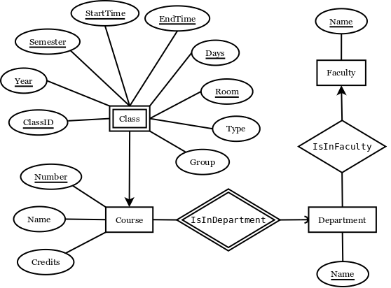
Figure 5: Courses in the database

4.3.1 Course

A course is uniquely identified by its department and course number. For this reason, each course must be related to Department with the IsInDepartment relationship. The IsInDepartment relationship uses short 4-letter department names such as COMP or SOEN. The Name attribute of Course is simply the full name describing the course. The number of credits is also stored with the course.

4.3.2 Class

For each course there may be a different number of classes. A class is a weak entity, as it depends on a course to be uniquely distinguished from other classes. This is where you find important information such as semester, year, time, days, group and room. The type attribute is used to identify the class as being a lecture, tutorial or lab. Because of the large number of attributes required to uniquely identify a class, an extra attribute has been added: ClassID. The ClassID is simply a convenience in order to relate teachers to classes.

4.3.3 Department

A department is one of the departments by which a course is given. This can be COMP (Computer Science), SOEN (Software Engineering), or anything else. The 4-letter abbreviation is used to relate courses to departments, but the Department entity also stores the full name of the department. As departments are part of a faculty, each department is related to the faculty it belongs to.

4.3.4 Faculty

Each faculty has an abbreviation of a few letters that is used to relate faculties to departments (such as ENCS with COMP). Like departments, the Faculty entity stores the full name of the faculty (for instance, ENCS is Engineering and Computer Science).

4.4 Requirements

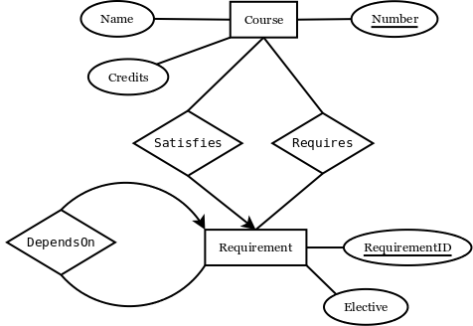
Figure 6: Representation of requirements

4.4.1 Simple Requirements

The simplest case of a requirement is a course depending on a certain number of others courses. Let’s say that course A depends on courses B and C. In the database, course A would be related to a requirement with the Satisfies relationship. That requirement would in turn be related to courses B and C using the Requires relationship.

4.4.2 Elective Requirements

In many programs students have to take an elective course. The elective course usually has to be chosen from a predefined set of possible courses. Let’s say that course A depends on a technical elective. Course A would be related to a Requirement, that would in turn be related to all the possible courses through the Requires relationship. The difference between a requirement where you have to take all courses required and one where you have to pick one of them is made with the Elective attribute. Whenever Elective is non null, it is set as the name of the elective, such as “Technical Elective”.

4.4.3 Multiple Requirements

There are even more complex cases of requirements that require an extra relationship DependsOn that relates a requirement to another requirement. Let’s say, for instance, that course A depends on B+C or D+E. This can be represented in the database by an elective requirement depending on two other requirements (B+C and D+E).

4.5 Programs

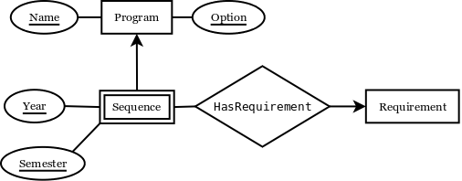

4.5.1 Program Options

A program can have many possible options. However, each option of a program corresponds to a different course sequence. For this reason, a Program is uniquely defined as a program and its option (for instance, bachelor of engineering with software engineering).

4.5.2 Course Sequence

A course sequence is usually given presented to the student as a full schedule of which course to take for each semester of his program. This is why a semester is identified by the Program it is associated with, a year and a semester. The courses that have to be taken to meet the requirements of the sequence are represented using Requirement entities, just like with courses.

