Concordia University
Department of Computer Science and Software Engineering
SOEN 341/4 S — Software Process
Homework Assignment Number 2
Due date: April 12, 2010

Question 1 [20 marks]

Using function points, estimate the size of the project in terms of source lines of code. Specify your inputs to the analysis used in this estimate (e.g., identify the screens for EI, EO, etc.)

Question 2 [20 marks]

Give an estimate in terms of person-months and lines of code of the time required to produce a commercial version of your project. Use the COCOMO analysis program which you will find in the project folder of the Moodle site. Run the analysis based on the function points of your answer to question 1. Include a copy of the completed form and of the result. You must include a brief explanation of your scale factors, process multipliers, and schedule.

Question 3 [20 marks]

Identify two patterns you are using or could have used in the design of your project. Include a class diagram of these patterns. Explain how they contribute (or could contribute) to the quality of your design.

Singleton Pattern

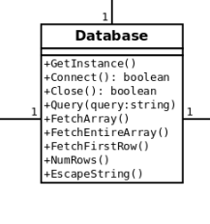
The singleton pattern could have been used with our database abstraction class. We only need one instance of the database class per user session, so it makes sense to use this pattern. The only modifications required to make use of the singleton pattern in our web application is the addition of a GetInstance() method that returns the current instance or instantiate a new one if none currently exists.

Bridge Pattern

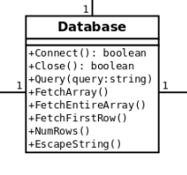
The bridge pattern has been used for our database abstraction class. Instead of making MySQL-specific function calls, we decided to wrap all the MySQL function calls in our Database abstraction class, so that we could easily adapt our program to a different DBMS in the future such as Oracle. The Database class is making the bridge between database-agnostic calls to database-specific calls.

Question 4 [40 marks]

Software Process Assessment

This question is concerned with the assessment of your software process. You are required to assess your software process according to one of the key process areas of level 2, of the Capability Maturity Model of the Software Engineering Institute. Your reference is the following document:

Keypractices.pdf in week 12 of the course Moodle website

The key process area you will examine is Software Project Tracking and Oversight

This document is 479 pages long. Do not download the whole document, read only the specific part you need: Pages 121 to 134

The report on the topic should be structured as follows:
Discussion of Goals

Discussion of the 5 common features
Discussion of Commitment to perform
Discussion of Ability to Perform
Discussion of Activities Performed
Discussion of Measurement and Analysis
Discussion of Verifying Implementation

These are defined in the Key Practices document.

Note that a discussion is all that is required. You should refer to the items and examples in Software Project Tracking and Oversight, and relate them to your own team practices, but you do not need to discuss every point in detail. The objective of your answer is to give an idea of how close or how far away you are from the key practice definitions.

You should comment on the relevance of the CMM to your experience with an agile and iterative project. You should also comment on its relevance to a large commercial project that may use agile and iterative techniques. Can the two be complementary?

Your answer to this question should not exceed 5 pages. Structure it clearly according to the common features of the key process area.

