x. USER MANUAL

Welcome to Planzilla, this manual will walk you through all of Planzilla features to make your day as a student as easy as it can be. The following is a description of how to use each feature of the PlanZilla web application.

X.1 Accessing Planzilla

In order to access the PlanZilla web application, the following must be done:
1) Open a compatible web browser*.
2) Type this address into the url bar: https://team7.ath.cx/.
*NOTE: This application is guaranteed to work with Internet Explorer 8.0+, Safari 2.0+, Chrome 2.0+ and Firefox 2.0+. Previous versions might be subject to unknown errors.

X.3 Login/Logout

If you are a registered user, you have a username and password. When prompted to login, a window will pop up as seen in Figure X.
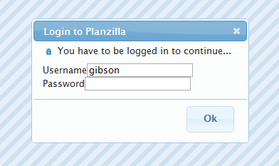
Figure 1 - Login Screen
Enter your username and password where required. Then either click on the ‘OK’ button or press enter to login. If this is successful, the window should disappear. If not you will be prompted to try again.

X.4 Navigation Bar

Figure 2 - PlanZilla navigation bar.
The navigation bar consists of five tabs, as seen in Figure X. Each tab contains its own function. By clicking on a tab, access to that specific function is gained. If the user is logged in, the logout button will also be displayed in the navigation bar.

X.5 View Schedule

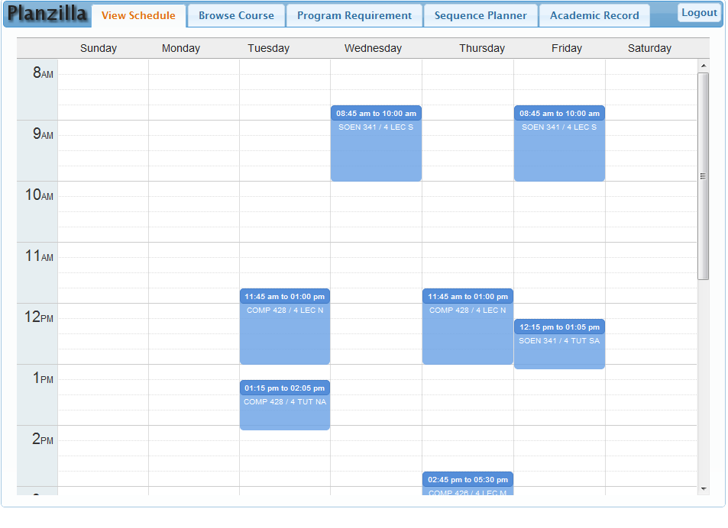
Figure 3 - View schedule screenshot.
When the View Schedule tab is clicked, the user gains access to the currently registered schedule as seen in Figure X.

X.6 Browse Course

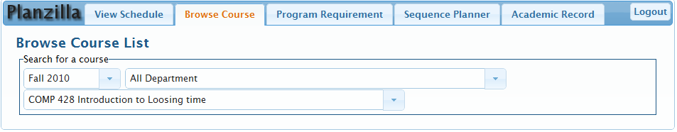
Figure 4 - Browse course screenshot.
When the Browse Course tab is clicked, the user gains access to all course information. To view information for a specific course:
1) Select the appropriate semester in which the course is offered.
2) Select the corresponding department.
3) Type the name or code of the course.
4) Select the course you wish to view.
The course information will be loaded. To view another course within the same department, simply type in the new course name or code.

X.7 Program Requirement

When the Program Requirement tab is clicked, the user gains access to the course sequence for their registered program.

X.8 Sequence Planner

When the Sequence Planner tab is clicked, the user gains access to the schedule generator.

X.8.1 Adding /Removing a course
<Explain how to add/remove a course>
Upon accessing the Sequence Planner tab, the user is provided with a list of suggested courses to register for. These courses are taken from the user’s program’s specific course sequence. To add a course:
1) Type the name or code of the course.
2) Select the course you wish to view.
3) Click the ‘Add’ button.

To remove a course, click on the ‘Delete’ button that is shaped in the form of an X.

X.8.2 Adding/Removing constraints
<Explain what are constraints and how to add/remove>
The user can add constraints such to the schedule so that the generator will know not to add a course during this time.
1) Select a timeslot on the calendar by clicking at the start time and dragging until the end time.
2) A window should appear. Type in the name of the constraint.
3) Either click on the ‘Ok’ button or press enter.

To remove a constraint, click on the ‘Delete button in the shape of an X.

x.8.3 Generate Schedule
<Explain Planzilla’s wonderful keyfeature>
Once all of the courses have been added, click on the ‘Generate Schedule’ button. The user can then use the left and right arrow buttons to view the different schedule options when more than one are available.

X.9 Academic Record

When the Academic Record tab is clicked, the user gains access to all of their academic information. This includes their program, their GPA, their past courses – along with their corresponding grade – and their currently registered courses.

INSTALLATION MANUAL

Installation Instructions

Planzilla uses some server software and needs to be configured manually prior to deployment. Before attempting installation, please be sure you have permission to perform all the required tasks and any pertinent information - such as database credentials - to avoid an incomplete or failed installation.

Server Verification & Installation

Planzilla requires the use of the Apache Web Server with support for SSL and PHP 5 as well as MySQL. If you are installing Planzilla on its own machine, you may use a compatible AMP stack – such as XAMPP - or install the software separately. If you have an existing server for deployment, please make sure it is running at least PHP version 5 with support for MySQL. Otherwise you can upgrade to the latest version of PHP. Perl and Python are also required to execute the data mining and database population scripts.

NOTE: Installation of these software packages is beyond the scope of this document. Please refer to the software vendor's homepage for up-to-date versions of the software and installation instructions.

PlanZilla Installation

All the files required for PlanZilla are located in the www directory of the installation bundle. Be sure to extract the contents of the bundle to the appropriate directory of the web server. Also make sure that the directory has permission to execute PHP scripts.

PlanZilla Configuration

You can configure Planzilla by filling in the required values in the Config.php file. An example file named Config.php.example is provided for your convenience and is located in that same directory.

Database Preparation

Against the database, run the setup script dbsetup.sql found in the scripts directory of the installation bundle. One way to go about doing this would be to execute the command "mysql <db> -u <username> -p < scripts/dbsetup.sql" where '<db>' is the name of the mysql database and '<username>' is a valid user with sufficient privileges to modify this database.

Database Population

The purpose of this section is to populate the database with all the required information such as Courses, Course Sections, Program Sequences. An example script, which will automatically pull data from the Concordia University course listing, is available under the scripts directory of the installation bundle. The script is called generateAll.py. When it is executed, it will generate a file called INITIAL_DB.sql, which is to be loaded manually, as in the previous step.

Deployment

The only way to add a user is through the database. In order to start adding students, the database has been set up with a default user __INSERTDEFAULTUSERNAMEHERE__ and a default password __INSERTDEFAULTPASSWORDHERE__.

Congradulations, you have successfully set up Planzilla!

Software Downloads

URIs to the software used throughout the installation process and downloads of the required software can be found at the following homepages.

XAMPP
http://www.apachefriends.org/en/xampp.html

Apache Web Server
http://httpd.apache.org/

PHP
http://php.net/

MySQL
http://www.mysql.com/

Perl
http://www.perl.org/

Python
http://www.python.org/

