No table of figures entries found.

Q1)

ILF

Table 1 shows the “Class” table from the database.

Table 1 - Database "Class" table.
Class | Description | Physical DET | Logical DET
ClassID | Sequence Id | No | No
Year |  | Yes | Yes
Semester |  | Yes | Yes
Section |  | Yes | Yes
CourseID | Foreign key | Yes | Yes

Table 2 shows the “ClassBlock” table from the database.

Table 2 - Database " ClassBlock " table.
ClassBlock | Description | Physical DET | Logical DET
ClassBlockId | Sequence Id | No | No
ClassId | Foreign key | Yes | Yes
Start |  | Yes | Yes
End |  | Yes | Yes
Day |  | Yes | Yes

Table 3 shows the “Course” table from the database.

Table 3 - Database "Course" table.
Course | Description | Physical DET | Logical DET
CourseId | Sequence Id | No | No
DepartmentId | Foreign key | Yes | Yes
Number |  | Yes | Yes
Name |  | Yes | Yes
Credits |  | Yes | Yes
Description |  | Yes | Yes
Note |  | Yes | Yes

Table 4 shows the “Department” table from the database.

Table 4 - Database " Department " table.
Department | Description | Physical DET | Logical DET
DepartmentId |  | Yes | Yes
FacultyId | Foreign key | Yes | Yes
DepartmentName |  | Yes | Yes

Table 5 shows the “Faculty” table from the database.

Table 5 - Database " Faculty " table.
Department | Description | Physical DET | Logical DET
FacultyId |  | Yes | No
FacultyName |  | Yes | Yes

RET relationships are described between tables as follows:
- Class
  - Classblock
- User
  - UserRole
- Course
  - Satisfies
  - Requires
- Department
  - Faculty
- RegisteredIn
  - Grade

ELF

- assuming no external logic files used

EI

Figure 1 shows a screenshot of the login modal window.

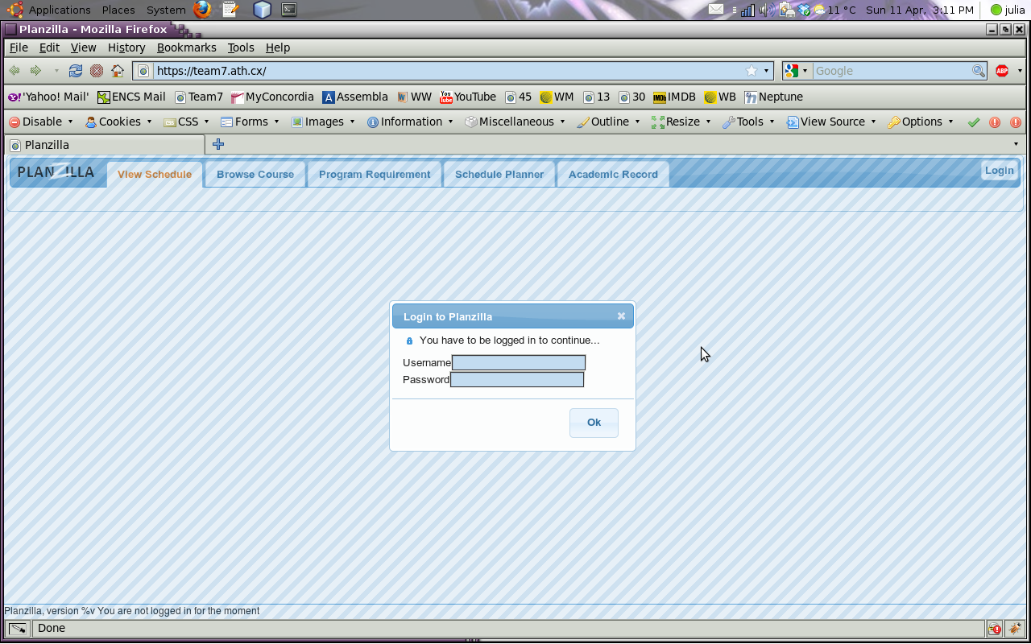
Figure 1 - Login screenshot.

Figure 2 shows a screenshot of the Browse Course tab’s contents. The “Select a course” combobox can take user inputs – it includes an autocomplete function – or act as a dropdown list.
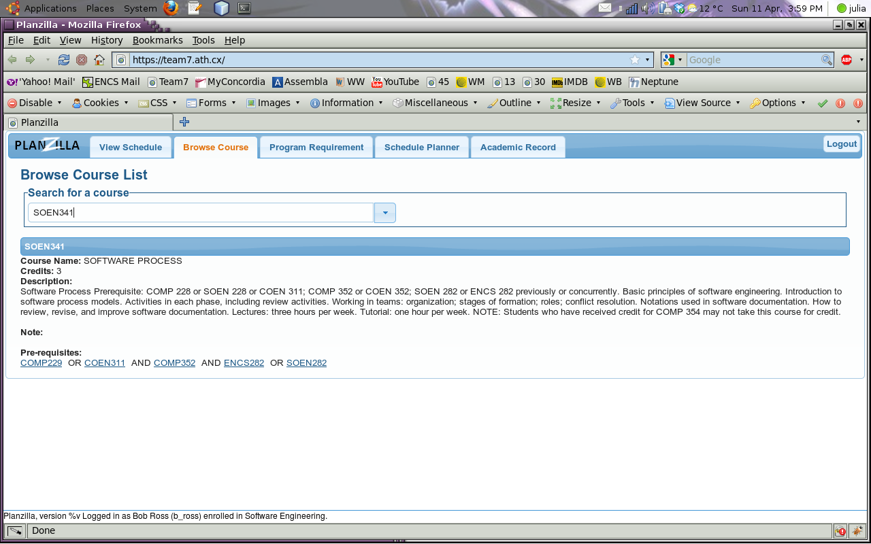
Figure 2 - Browse Course Tab screenshot.

Figure 3 shows a screenshot of the course information modal window. It should be noted that the course pre-requisites can be clicked to view their course information.

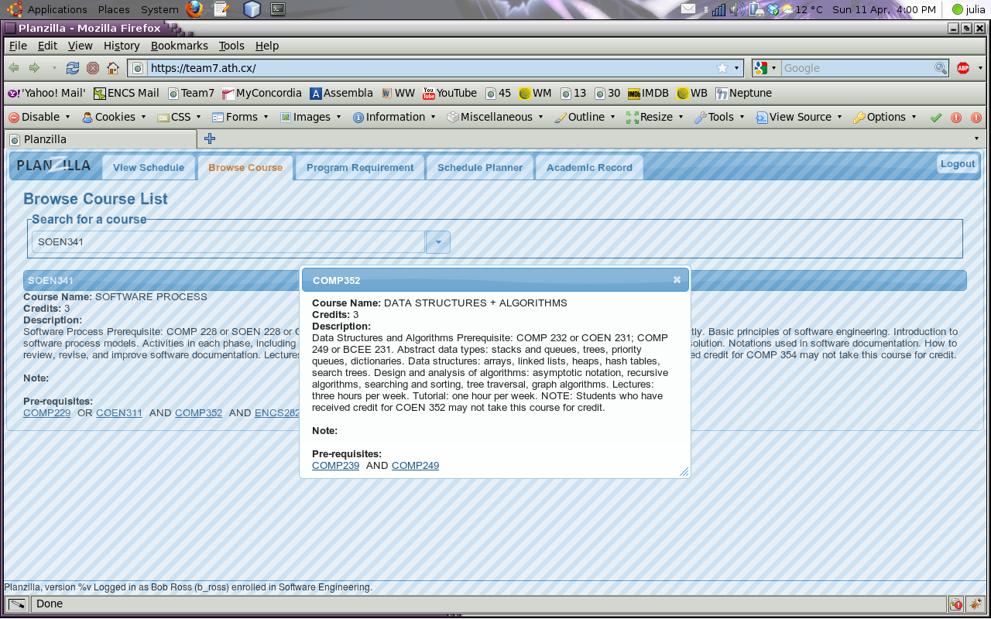
Figure 3 - Course information modal window screenshot.

Figure 4 shows a screenshot of the View Schedule tab’s contents. It should be noted that the course information can be viewed by clicking on the class block.

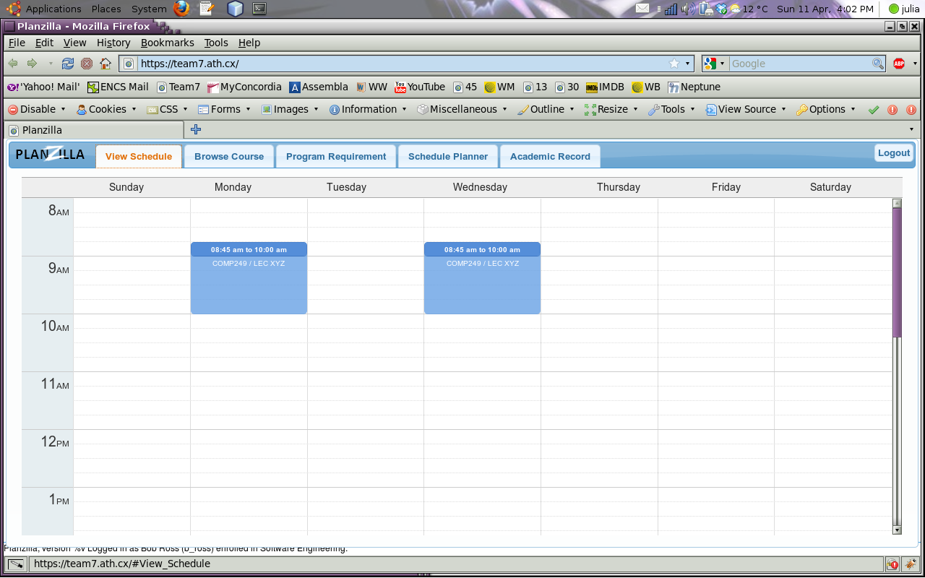
Figure 4 - View Schedule screenshot.

Figure 5 shows a screenshot of the Schedule Planner tab’s contents. It should be noted that the course information can be viewed by clicking on the class block.

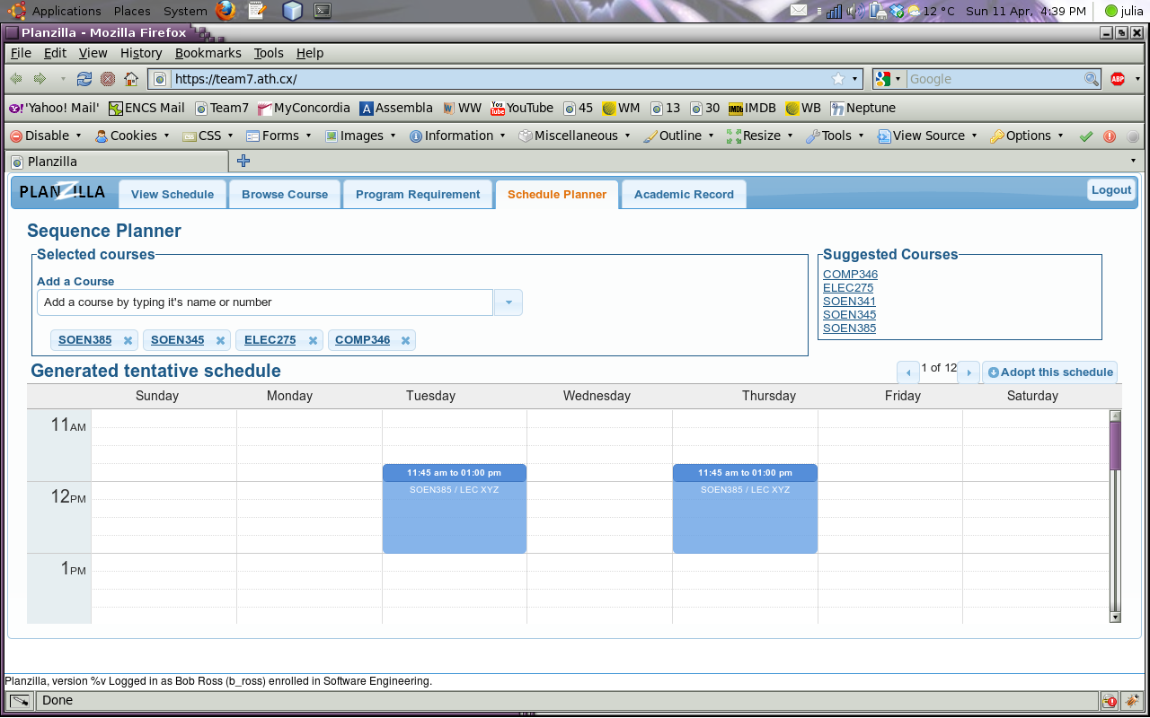
Figure 5 - Schedule Planner screenshot.

Figure 6 shows a screenshot of the navigation tabs.

Figure 6 - Navigation tabs screenshot.

Figure 7 shows a screenshot of the Academic Record tab’s contents. It should be noted that the course information can be viewed by clicking on the course code.

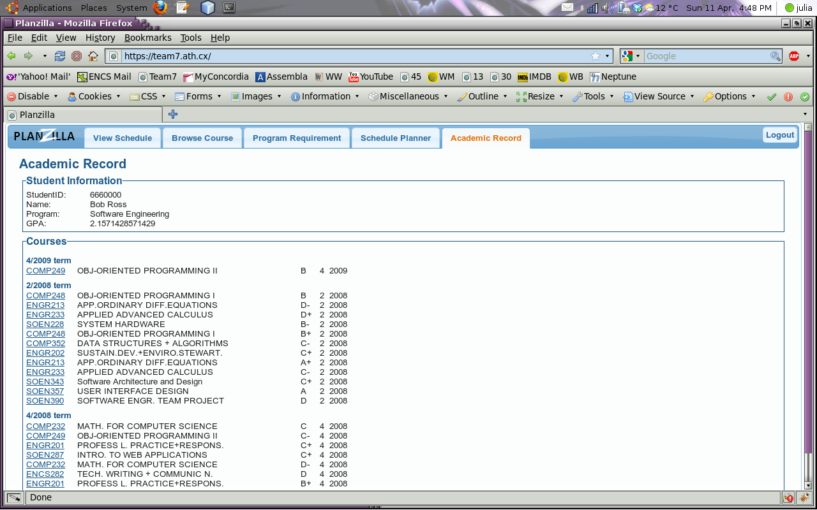
Figure 7 - Academic Record screenshot.

Figure 8 shows a screenshot of the Program Requirement tab’s contents. It should be noted that the course information can be viewed by clicking on the course code.

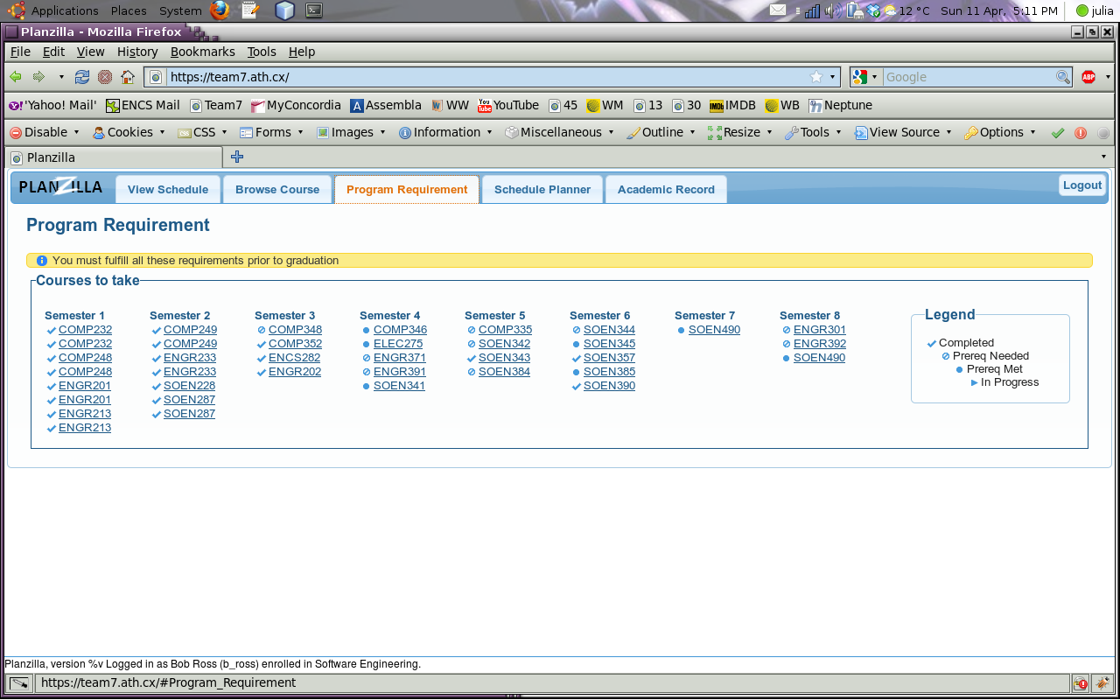
Figure 8 - Program Requirement screenshot.

EO

- derived data output to the user

EQ

- data dump output to the user

ILF
Complexity | Number of Occurrences | Function Points per Complexity | Function Points
Low | 10 | 7 | 70
Average | 0 | 10 | 0
High | 0 | 15 | 0

EIF
Complexity | Number of Occurrences | Function Points per Complexity | Function Points
Low | 0 | 5 | 0
Average | 0 | 7 | 0
High | 0 | 10 | 0

EI
Complexity | Number of Occurrences | Function Points per Complexity | Function Points
Low | 9 | 3 | 27
Average | 1 | 4 | 4
High | 0 | 6 | 0

EO
Complexity | Number of Occurrences | Function Points per Complexity | Function Points
Low | 0 | 4 | 0
Average | 2 | 5 | 10
High | 1 | 7 | 7

EQ
Complexity | Number of Occurrences | Function Points per Complexity | Function Points
Low | 4 | 3 | 12
Average | 1 | 4 | 4
High | 1 | 6 | 6
Q2)

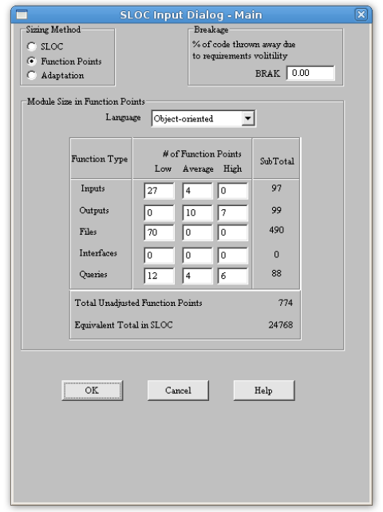
Figure 9 - COCOMO Estimated Source Lines of Code

In the figure above is a screenshot of the COCOMO SLOC estimation using the values found in question 1. As PHP is absent from the list of programming languages, “Object-Oriented” has been chosen (PHP5 supports classes, and we have used them). However, as C++ and Java are also absent from the list and are languages that also fall into the category of “Object-Oriented languages”, the number of estimated source lines of code is to be taken with a grain of salt: there is a significant difference in terms of source lines of code between PHP, C++ and Java. Our application was not entirely written in PHP, but is in fact composed of PHP, Javascript, HTML, CSS and also includes MySQL queries. It doesn’t change that we went for an object-oriented design even though not all of those languages support classes. A count of the number of source lines of code using the UNIX command “wc -l” gives approximately 4000 lines of code, while COCOMO estimated around 25 000. The huge difference between the estimation and reality can be put on the fact the COCOMO software used for this estimation is 10 years old. A decade ago, the programming languages in use were much different than the modern languages we have now. It pretty much changes all the important measurements of accurate software estimation: different languages all have their flaws in different places, and that’s where the risk is. You certainly won’t worry about dynamic memory management in PHP while you would in C++, yet they are both considered to be equivalent by COCOMO. As risk estimation is crucial, and COCOMO fails to evaluate the risks of modern programming languages, then COCOMO simply fails at modern languages. What makes it even funnier in this case is that the only language in the list that actually gives a result close to reality is if we consider PHP a “spreadsheet” programming language (it gives approximately 4000 SLOC).

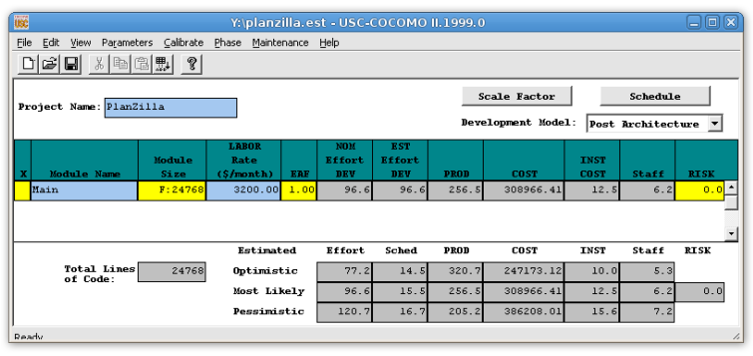
Figure 10 - Overall COCOMO Estimation for PlanZilla

In the more complete view of the COCOMO estimation for PlanZilla, a salary of 20$ per hour for a full-time worker was used to determine a LABOR value of 3200$/month. COCOMO then estimates the total COST of our web application above 300 000$.
Q3)

Singleton Pattern

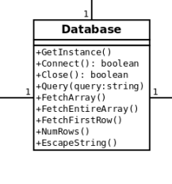
The singleton pattern could have been used with our database abstraction class. We only need one instance of the database class per user session, so it makes sense to use this pattern. The only modifications required to make use of the singleton pattern in our web application is the addition of a GetInstance() method that returns the current instance or instantiate a new one if none currently exists.

Bridge Pattern

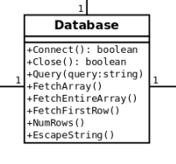
The bridge pattern has been used for our database abstraction class. Instead of making MySQL-specific function calls, we decided to wrap all the MySQL function calls in our Database abstraction class, so that we could easily adapt our program to a different DBMS in the future such as Oracle. The Database class is making the bridge between database-agnostic calls to database-specific calls.
Q4)

For our project, we decided to use git as our version control system. The choice of git over alternatives such as subversion or cvs was made because git is absolutely beautiful and is being widely adopted by people who were using other version control systems. It also is the version control system used by the Linux kernel developers, so this means a lot. Our git server was located at assembla.com, which provided us with an online team collaboration environment. Besides providing the git server, assembla.com provides an online team space where each member could be added to the project and informed of various things. Outside of meetings, we were frequently communicating through emails. Git was also central to the way we synchronized our work: each team member would frequently check what the latest changes were and the associated comments.

In order to put everybody on the same track, the entire process of setting up development tools and accessing our resources was documented. A software design document was also used in order to centralize all the information about the software design. It is meant to be updated every time it is needed, and should reflect the current state of the software design. This way, we can ensure that we have a clear idea of where we’re going and avoid misunderstandings.

For our test environment, we have used an OpenSolaris server running Apache, MySQL and PHP. Each team member was given a shell account on the OpenSolaris server, and each account had its own web folder meant to be used as a sandbox. The root of the web folder was used to mirror the latest version of the web application on git. With the shell account, each member could program, deploy in their own sandbox and then commit new code to the git repository. Each time changes were put to git, assembla.com would trigger an update on our test web server, in such a way that the test server would always keep a copy of the very latest version of the application.

For testing, a testing shell account was created on the OpenSolaris server, and was intended to be used to deploy a testing version. This deployed version would not automatically update itself, as it needs to be “frozen” for the testing time. Once tests are done on that version, a new testing version with bug fixes would be deployed for a next testing session.

The most critical computer resource in our project is the OpenSolaris server, as if it’s down, nobody can work. It happened once that we encountered a weird problem with the MySQL server, which made the team’s system administrator work in a hurry to fix it. It turned out that we were using a version of MySQL with a nasty bug, so we reverted to an older maintenance version of MySQL that wasn’t affected by the bug.

Git was not only used for version control of our code, but it was also used for documentation during the entire development process. What is nice about it is that you can easily go back in time and see the progress of the updates, and get the documentation at any time of the project. After each meeting we had, someone would add notes from the meeting on git, and also send an email summarizing the matters that were discussed.

