X. USER MANUAL

<Intro text>

X.1 Accessing Planzilla
<Explain how to access the web app>

X.2 Registration

<Describe registration procedure>

X.3 Login/Logout

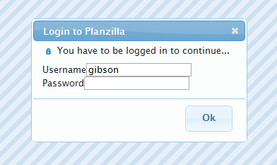
Figure X.3.1 Login Screen
<Explain how to login and logout>

X.4 Navigation Bar

Figure X.4.1 Planzilla Navigation bar
<Introduce the navigation bar and briefly describe their functions>

X.5 View Schedule

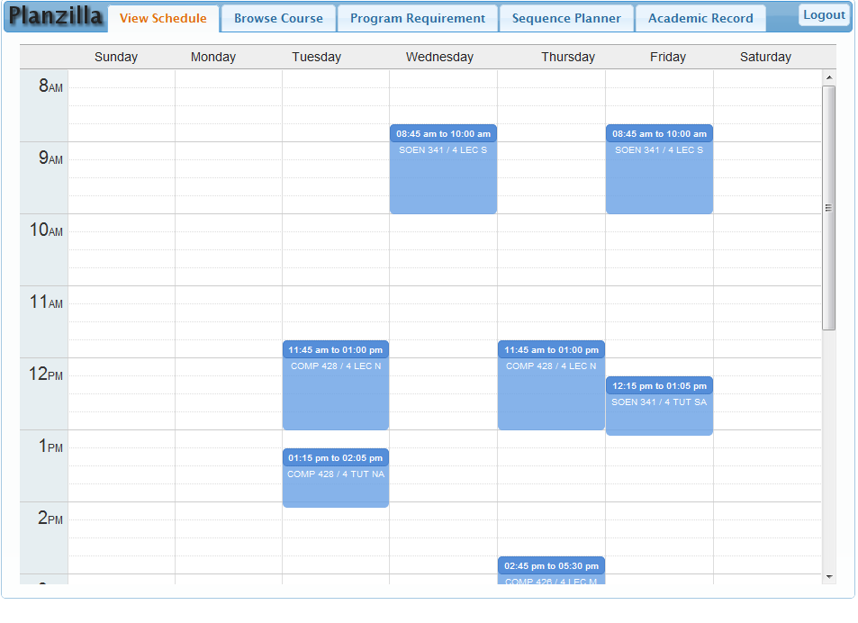
Figure X.5.1 View Schedule Screen

<Describe elements on this page><DEFAULT PAGE>

X.6 Browse Course

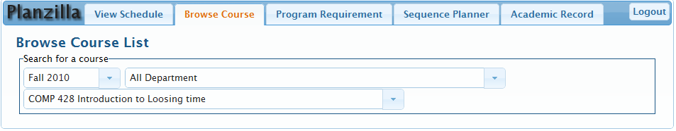
Figure X.6.1 Browse Course Screen
<Explain how to browse for a course>

X.7 Program Requirement

<SCREENSHOT>
<Explain the elements on this page>

X.8 Sequence Planner

<Screenshot>
<Describe main components on this page>

X.8.1 Adding /Removing a course
<Explain how to add/remove a course>

X.8.2 Adding/Removing constraints
<Explain what are constraints and how to add/remove>

x.8.3 Generate Schedule
<Explain Planzilla’s wonderful keyfeature>

X.9 Academic Record

<Screenshot>
<Describe what this page is>

