Concordia University
Department of Computer Science
and Software Engineering

Software Process
SOEN 341/4 --- Winter 2009 --- Section S

PLANZILLA DEVELOPEMENT PROCESS
DOCUMENT

Team members information
Name | SID
Marc-André Moreau | 9347100
Mathieu Dumais-Savard | 6095275
Julia Lemire | 9402969
Phuong-Anh-Vu Lai | 5644399
Sébastien Parent-Charette | 9178821
Andreas Eminidis | 9377603
Corey Clayton | 9349200
Eric Chan | 9365079
TABLE OF CONTENTS
1 INTRODUCTION 12
2 PROJECT DESCRIPTION 13
2.1 System Description 13
2.1.1 System Function 13
2.2 Project Goals 13
2.2.1 Objectives 13
2.2.2 Deliverables 13
3 GOALS AND CONSTRAINTS 15
3.1 Functional Requirements 15
3.1.1 Use Cases 15
3.1.2 Use Case Model 20
3.2 Domain Model 22
3.2.1 Domain Model Diagram 22
3.2.2 DLO Login 22
3.2.3 DLO Student 22
3.2.4 DLO Schedule 23
3.2.5 DLO Course List 23
3.2.6 DLO Course 23
3.2.7 DLO Planner 23
3.2.8 DLO Academic Record 23
3.3 Quality Standards 23
3.3.1 Speed 23
3.3.2 Ease of Use 24
3.3.3 Scalability 24
3.3.4 Security 24
3.3.5 Accessibility 24
3.3.6 Printer Friendly 24
3.3.7 Workflow Resilience In Regards to Network Issues 24
3.4 Platform Requirement 25
3.4.1 Cross Platform Support 25
4 SCOPING 26
4.1 Scope 26
4.1.1 Core Component 26
4.1.2 Course Planner 26
4.1.3 Academic Record 26
4.1.4 Browse Course List 26
4.1.5 Other Features 27
4.2 Priority 27
4.3 Removed Features 27
4.4 Excluded Features 27
4.4.1 Administrative Functions 27
5 PLAN 28
5.1 Design 28
5.1.1 Initial Discussions 28
5.1.2 General Design 28
5.1.3 Architecture and Overall Implementation 29
5.1.4 In-Depth Implementation Design 30
5.1.5 Final Implementation 30
5.2 Presentation Tier 30
5.2.1 Implementation of the Tab Modules 31
5.2.2 Implementation of the Control Modules 31
5.3 Logic Tier 32
5.4 Data Tier 33
5.4.1 Construction of the Course Database 33
5.4.2 Implementation of the Database 33
5.5 Working Environment 33
5.6 Gantt Chart 34
6 SERVER SETUP 36
6.1 Assembla.com Team Collaboration Space 36
6.1.1 Team Collaboration 36
6.1.2 Git Distributed Version Control System 36
6.1.3 Webhook 36
6.2 OpenSolaris Server 37
6.2.1 Web Stack (AMP) 37
6.2.2 Development Web Stack (AMP-dev) 37
6.2.3 Hostname 37
6.2.4 Individual Test Space 37
7 DEVELOPER CLIENT SIDE SETUP 38
7.1 Git 38
7.1.1 Installation (Windows) 38
7.1.2 Installation (Linux / Mac OS X) 38
7.1.3 Initial Configuration 38
7.1.4 Contributing Changes 40
7.1.5 Synchronizing Work 41
7.2 NetBeans IDE 41
7.2.1 Installation 41
7.2.2 Plugins 41
7.2.3 Initial Configuration 41
7.2.4 Remote PHP Debugger 42
8 PROGRAMMING LANGUAGES AND LIBRARIES 43
8.1 Languages 43
8.1.1 PHP 43
8.1.2 HTML 43
8.1.3 CSS 43
8.1.4 Javascript (a dialect of ECMAScript) 43
8.2 Libraries 44
8.2.1 jQuery 44
8.2.2 jQueryUI 44
8.3 Plugins 44
8.3.1 jQuery-Week-Calendar 44
9 OTHER SOFTWARE 45
9.1 Operating Systems 45
9.1.1 Microsoft Windows 45
9.1.2 Apple Mac OS X 45
9.1.3 GNU/Linux 45
9.2 Office Software 45
9.2.1 Microsoft Office 45
9.2.2 Dia 45
9.2.3 MySQL 46
10 Human Resources 47
10.1 Eric Chan 47
10.2 Sébastien Parent-Charrette 47
10.3 Corey Clayton 47
10.4 Mathieu Dumais-Savard 48
10.5 Andreas Eminidis 48
10.6 Phuong-Anh-Vu Lai 48
10.7 Julia Lemire 48
10.8 Marc-André Moreau 49
11 Tier Architecture 50
11.1 Overview 50
12 Development View 51
12.1 Component Diagram 51
12.2 Brief Component Diagram Description 52
12.2.1 User 52
12.2.2 Tabs 52
12.2.3 Controls 52
13 Presentation Tier 53
13.1 Tabs 53
13.1.1 Academic Record 53
13.1.2 Sequence Planner 53
13.1.3 Schedule Viewer 53
13.1.4 Course List Browser 53
13.2 Controls 53
13.2.1 Core 53
13.2.2 Modal Window 54
13.2.3 Filter 54
13.2.4 Calendar 55
14 Logic Tier 56
14.1 Authentication 56
14.2 Academic Record 56
14.3 Registration 56
14.4 Scheduling 56
14.5 Course 56
15 Data Tier 57
15.1 Overview 57
15.2 Users 57
15.2.1 Administrator 58
15.2.2 Student 58
15.2.3 Teacher 58
15.3 Courses 58
15.3.1 Course 59
15.3.2 Class 59
15.3.3 Department 59
15.3.4 Faculty 59
15.4 Requirements 59
15.4.1 Simple Requirements 60
15.4.2 Elective Requirements 60
15.4.3 Multiple Requirements 60
15.5 Programs 60
15.5.1 Program Options 61
15.5.2 Course Sequence 61
16 Process View 62
16.1 Activity Diagram 62
17 Physical View 64
17.1 Deployment Diagram 64
17.1.1 OpenSolaris Server 64
17.1.2 User Client 65
18 Logical View 66
18.1 Class Diagram 66
18.1.1 Unit Descriptions 66
18.1.2 ScheduleViewer 66
18.1.3 CourseBroswer 66
18.1.4 SequencePlanner 67
18.1.5 AcademicRecord 67
18.1.6 Main 67
18.1.7 Course 67
18.1.8 Authentication 68
18.1.9 StudentRecord 68
18.1.10 Database 68
19 Module Interface Specification 69
19.1 Authentication Class 69
19.1.1 Detailed Description 69
19.1.2 Public Member Functions 69
19.1.3 Public Attributes 69
19.1.4 Member Function Documentation 69
19.1.5 Member Data Documentation 71
19.1.6 Source File 71
19.2 Course Class 71
19.2.1 Detailed Description 71
19.2.2 Public Member Functions 71
19.2.3 Member Function Documentation 72
19.2.4 Source File 73
19.3 Database Class 73
19.3.1 Detailed Description 73
19.3.2 Public Member Functions 73
19.3.3 Member Function Documentation 73
19.3.4 Source File 74
19.4 StudentRecord Class 74
19.4.1 Detailed Description 74
19.4.2 Public Member Functions 74
19.4.3 Private Attributes 74
19.4.4 Member Function Documentation 75
19.4.5 Member Data Documentation 75
19.4.6 Source File 76
20 Dynamic Design Scenarios 77
20.1 Browse Course List 77
20.1.1 System Sequence Diagram 1 (SSD1) 77
20.1.2 Operational Contract 1.1 (CO1.1) 77
20.2 Generate Schedule (Advanced) 78
20.2.1 System Sequence Diagram 2 (SSD2) 78
20.2.2 Operational Contract 2.1 (CO2.1) 79
20.2.3 Operational Contract 2.2 (CO2.2) 79
20.2.4 Operational Contract 2.4 (CO2.4) 79
20.2.5 Operational Contract 2.5 (CO2.5) 79
20.2.6 Operational Contract 2.6 (CO2.6) 80
20.2.7 Operational Contract 2.7 (CO2.7) 80
20.2.8 Operational Contract 2.8 (CO2.8) 80
20.2.9 Operational Contract 2.9 (CO2.9) 80
20.3 Miscellaneous 81
20.3.1 Operational Contract 3.1 (CO3.1) 81
20.3.2 Operational Contract 3.2 (CO3.2) 81
20.3.3 Operational Contract 3.3 (CO3.3) 81
20.3.4 Operational Contract 3.4 (CO3.4) 81
20.3.5 Operational Contract 3.5 (CO3.5) 81
20.3.6 Operational Contract 3.6 (CO3.6) 82
20.3.7 Operational Contract 3.7 (CO3.7) 82
20.3.8 Operational Contract 3.8 (CO3.8) 82
20.3.9 Operational Contract 3.9 (CO3.9) 82
21 Revision History 83
22 Testing Report 84
22.1 Test coverage 84
22.1.1 Tested Items 84
22.1.2 Untested Items of Interest 85
22.2 Test Cases 86
22.2.1 Unit Testing 86
22.2.2 Requirement Testing 90
22.2.3 Stress testing 95
23 System Delivery 96
23.1 Install Manual 96
23.1.1 Installation Instructions 96
23.1.2 Server Verification & Installation 96
23.1.3 PlanZilla Installation 96
23.1.4 PlanZilla Configuration 96
23.1.5 Database Preparation 97
23.1.6 Database Population 97
23.1.7 Deployment 97
23.1.8 Software Downloads 97
23.2 Instruction Manual 98
23.2.1 Accessing Planzilla 98
23.2.2 Login/Logout 98
23.2.3 Navigation Bar 99
23.2.4 View Schedule 99
23.2.5 Browse Course 100
23.2.6 Program Requirement 100
23.2.7 Sequence Planner 100
23.2.8 Academic Record 101
24 Appendix A – Latest Requirement Test Report 102
25 Appendix B – Latest Unit Testing Reports 107

LIST OF FIGURES

Figure 2.2.2-1 Overview of the project’s five deliverables 14
Figure 3.1.2-1 Use Case Model 21
Figure 3.2.1-1 Domain Model Diagram 22
Figure 5.4.2-1 Gantt Chart 35
Figure 7.1.3-1 - Example of proper git clone 38
Figure 7.1.3-2 - Example of a list of git configurations 39
Figure 7.1.3-3 - Instructions for configuring the user.name and the user.email settings 39
Figure 7.1.3-4 - Instruction for calling the configured settings and a list of the current ones 39
Figure 7.1.4-1 - Example of a git status summary 40
Figure 7.1.4-2 - Instruction for a git commit including a comment 40
Figure 7.1.4-3 - Instruction for pushing changes into the git repository 40
Figure 7.2.4-1 - Command for opening an ssh tunnel in a linux terminal. 42
Figure 9.2.3-1 - 3-tier architecture 50
Figure 9.2.3-1 - UML Component Diagram 51
Figure 13.2.2-1 - Example of a modal window 54
Figure 13.2.4-1 - Example of the calendar 55
Figure 13.2.4-1 - Entity-Relationship Diagram 57
Figure 13.2.4-1 - The different types of users that can access PlanZilla 57
Figure 15.2.3-1 - Courses in the database 58
Figure 15.3.4-1 - Representation of requirements 60
Figure 15.4.3-1 - Representation of a program 61
Figure 15.5.2-1 - Activity diagram 62
Figure 15.5.2-1 - Deployment diagram 64
Figure 17.1.2-1 - Class diagram 66
Figure 20.1.1-1 - Browse Course List system sequence diagram (SSD1) 77
Figure 20.2.1-1 - Generate Schedule (Advanced) system sequence diagram (SSD2) 78
Figure 23.2.2-1 - Login Screen 98
Figure 23.2.3-1 - PlanZilla navigation bar 99
Figure 23.2.4-1 - View schedule screenshot 99
Figure 23.2.5-1 - Browse course screenshot 100

LIST OF TABLES

Table 5-1 - Plan of the initial discussions of the project. 28
Table 5-2 - Plan of the general design of the project. 29
Table 5-3 - Plan for the architecture and overall implementation decisions. 29
Table 5-4 - Plan for the in-depth look at the implementation of the project. 30
Table 5-5 - Plan for the final implantation of the complete project. 30
Table 5-6 - Plan for the implementation of the tab modules of the UI. 31
Table 5-7 - Plan for the implementation of the control modules of the UI. 32
Table 5-8 - Plan for the logic tier of the application 32
Table 5-9 - Plan for the construction of the course database. 33
Table 5-10 - Plan for the design and implementation of the main database of the system. 33
Table 5-11 - Plan for setting up and maintaining the working environment 34
Table 21-1 - Revision History 83

LIST OF USE CASES

Use Case 1 Open the Application (UC1) 14
Use Case 2 Login (UC2) 15
Use Case 3 Logout (UC3) 15
Use Case 4 View Schedule (UC4) 15
Use Case 5 View a Room or Professor Schedule (UC5) 16
Use Case 6 Browse Course List (UC6) 16
Use Case 7 View Program Sequence (UC7) 17
Use Case 8 View Academic Record (UC8) 17
Use Case 9 Generate Schedule (UC9) 18
Use Case 10 View Activity Log (UC10) 18
Use Case 11 Generate Schedule (advanced) (UC11) 19

INTRODUCTION

During university course registration, Concordia ENCS students are required to choose their own courses according to their program, prerequisites, time availabilities and preferences. This task can become very complex. However, there is currently no official application that help student organize their time tables. Students are actually forced to do so manually and use trial and error with the Concordia registration system. This creates extra traffic in the registration system and consumes precious studying time.

PlanZilla is web-based application that is designed to help students organize their schedule prior to using the Concordia Registration system. It helps students find the optimal schedule based on time constraints, preferences, program requirements and course sequence. The application takes care of finding all possible schedule combination for the student. All the student needs to do is give time constraints.

This document describes the software development process of PlanZilla. It contains the following steps: Identifying requirements, planning, scoping, designing, implementing and testing. Each section of this document describes a specific development process.

Currently, PlanZilla has finished its development phase with the release of version 1.4111. Future revisions are only maintenance releases.

PROJECT DESCRIPTION

The aim of this project is to implement a personal web-based scheduling system, designed for undergraduate students enrolled in Software Engineering, based on certain specifications and requirements.

System Description

System Function

This web application will enable registered students to login to their account using a username and a password. Once authenticated, the current official schedule for the upcoming semesters will be displayed. Students will have access to an official course sequence. It is up to the student whether or not to follow this sequence. Students can change their schedule by using an elaborated schedule generator that takes into account the courses to be taken (selected from the official sequence by default) and various time-related constraint to accommodate students with special needs. Every modification requested by the student has to meet a list of requirements. For example, if a student wishes to add a course, all of its prerequisites must have been previously completed.

Project Goals

Objectives

The main goal of this project is to design and implement a software package that automates the process of schedule generating. This is to be done using the tools and skills acquired from the SOEN 341 lectures and tutorials that are designed to teach efficient software development. An important aspect of this is to create an attractive graphical user interface, which will enable the user to generate schedules based on specific criteria he or she sets. A key feature of this user interface is its authentication. At each stage, the web application must be secure and all inputs made by the user have to be verified to screen for potential remote exploits. Another aspect of the design and implementation of this project is the design, creation and maintenance of a database. Lastly, the website is to have a specific framework in order to enforce proper coding standards and so as to make the software easily maintainable.

Deliverables

Throughout the semester, the progress of the project will be demonstrated by delivering five documents. Figure 2.2.2-1 shows a list of the objectives of each document.
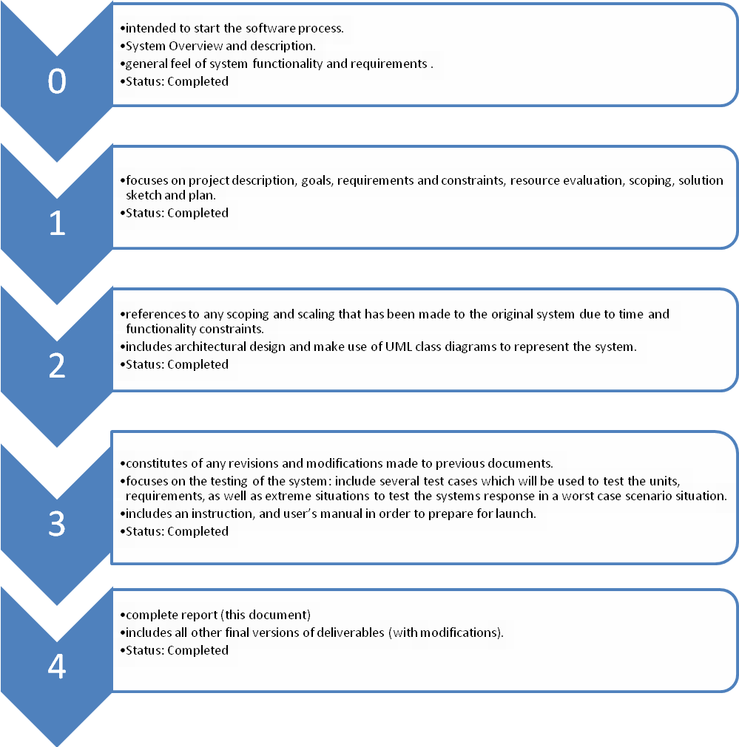
Figure 2.2.2-1 Overview of the project’s five deliverables

Each subsequent document should build and expand upon the previous documents. This includes any modifications that have been made to the previous topics covered. It should be noted that along with the complete report, the final version of the software should be completed.

GOALS AND CONSTRAINTS

The objective of this project is to design and implement a personal scheduler for undergraduate Software Engineering students. This section descriptions the requirements, constraints and quality standards the system is to meet.

Functional Requirements

Use Cases

The functional requirements are defined as individual use cases. The following twelve use cases have been outlined for this project. Each one has been assigned an importance and a difficulty level ranging from one to five, with one being considered the lowest importance or difficulty and five being considered the highest importance or difficulty. When a use case has pre-conditions listed, these must be met before the use case can be accessed.

There are two types of actors: a registered user and an unregistered user. A registered user is one with an account they can access with a username and password. This is usually a student. An unregistered user is one who does not have an account. This can be a teacher, a student without an account or someone wishing to view course related information.

Use Case 1 Open the Application (UC1)
Importance | 5/5 | Difficulty | 1/5
Description | The trivial step of accessing the system.
Actors | Any user (public)
Goal | Actor wants to access the system.
Pre-conditions
Step  (success path) | 1. Actor accesses the entry page of the system.
Post-condition (success) | The front-end is displayed on the user’s screen and the default view is activated.
Failure end conditions | User uses a non-optimal browser:  Warning message is displayed on the screen but application is still accessible to the user. (Scoped out)  User uses a non-supported browser:  Error message is displayed and application is not accessible to the user. (Scoped out)
Related Use Case

Use Case 2 Login (UC2)
Importance | 5/5 | Difficulty | 2/5
Description | Action of signing in into the system.
Actors | Any user (public)
Goal | Actor gives credentials to the system to confirm it has access to certain features.
Pre-conditions | - The user has not logged into the system.  - The front-end is loaded and a login view is activated.
Step  (success path) | 1. User identifies itself to the system with its credentials.  2. System acknowledges
Post-condition  (success) | - A session is opened on the system for that user
Failure end conditions | Wrong Credentials:  - Message displayed in login window asking for the user to retry.
Related Use Case | Open the application (UC1)

Use Case 3 Logout (UC3)
Importance | 5/5 | Difficulty | 1/5
Description | Action of signing out of the system.
Actors | Registered user
Goal | Actor terminates the session so that it can no longer be modified.
Pre-conditions | - A session is opened
Step  (success path) | 1. The user activates the sign out feature OR does not perform any  action for a significant amount of time.  2. Sign out request is acknowledged by the system.
Post-condition | - Session is closed on the server.  - All front-end data is cleared.
Failure End Condition | - The system displays an error message stating the error’s cause.  - The user will not be logged into the system.
Related Use Case | Open the application (UC1), Login (UC2)

Use Case 4 View Schedule (UC4)
Importance | 3/5 | Difficulty | 3/5
Description | Default view presented to the user upon login.
Actors | Registered user
Goal | Actor wants to consult their schedule.
Pre-conditions | - A session is opened
Step  (success path) | 1. User requests the “View Schedule” feature.  2. The system presents the user’s schedule
Post-condition
Failure End Condition | - No schedule is available for current actor.
Related Use Case | Login (UC2)

Use Case 5 View a Room or Professor Schedule (UC5) (Scoped out)
Importance | 3/5 | Difficulty | 3/5
Description | A user accesses the schedule of a given room or professor.
Actors | Any User (public)
Goal | A user wishes to consult the schedule of a room or professor.
Pre-conditions
Step  (success path) | 1. User requests the “View Schedule” feature.  2. The system presents the user’s schedule.  3. User requests the schedule for a specific room or professor.  4. The system presents the schedule of the selected entity.
Post-condition
Failure End Condition | - No schedule is available for the given entity.
Related Use Case

Use Case 6 Browse Course List (UC6)
Importance | 5/5 | Difficulty | 3/5
Description | Course calendar can be browsed at will.
Actors | Any user (public)
Goal | A user who wants more information about a course accesses it in the browse course list section.
Pre-conditions
Step  (success path) | 1. User activates the “Browse Course List” feature.  2. System prompts about which types of courses to display.  3. User indicates department and/or course number and/or  professor and asks for the course list.  4. System presents a list of corresponding courses.  5. User selects a course in that list.  6. System displays detailed information about the selected course.
Post-condition
Failure End Condition
Related Use Case
Use Case 7 View Program Sequence (UC7)
Importance | 2/5 | Difficulty | 1/5
Description | View the complete course sequence of the program in which the student is enrolled.
Actors | Registered user
Goal | To inform the user about their progression in the program’s sequence.
Pre-conditions | - A session is opened
Step  (success path) | 1. The user requests the “View Program Sequence” feature.  2. System reports on the sequence by listing courses and their status.
Post-condition
Failure End Condition | - The system warns there is no sequence data available for the current student. Maybe the student is not enrolled in a program.
Related Use Case | Login (UC2)

Use Case 8 View Academic Record (UC8)
Importance | 1/5 | Difficulty | 1/5
Description | To display the current academic information of a student.
Actors | Registered user
Goal | Student wants to access their academic information pertaining to either previously taken or current courses.
Pre-conditions | - A session is opened
Step  (success path) | 1. The user activates the “View Academic Record” feature.  2. System presents the user’s academic record, stating courses  taken with their grade and courses currently registered in.
Post-condition
Failure End Condition | - No academic record found for the current student.
Related Use Case | Login (UC2)

Use Case 9 Generate Schedule (UC9)
Importance | 5/5 | Difficulty | 5/5
Description | In order to register for courses, the user needs to generate a schedule. They can do so by selecting courses.
Actors | Registered user
Goal | Student desiring to register for courses must generate their schedule.
Pre-conditions | - A session is opened.
Step  (success path) | 1. User activates the “Generate Schedule” feature.  2. The system responds with a list of possible schedules.  3. The user adopts one of the proposed schedules.  4. The system prompts for confirmation, specifying any currently  registered courses that might be dropped or replaced in the process.  5. User confirms the selection.  6. System confirms the transaction.
Post-condition | - A new scheduled is saved and the selected courses are registered.  - Alternate courses (if any) for the present semester are dropped.
Failure End Condition | - System displays an error if no schedule can be generated based on the selected courses.
Related Use Case | Login (UC2)

Use Case 10 View Activity Log (UC10) (Scoped out)
Importance | 0/5 | Difficulty | 2/5
Description | To access a detailed log of a user’s account
Actors | Registered user
Goal | The user wishes to check details about the occurrence of events.
Pre-conditions | - A session is opened
Step  (success path) | 1. User activates the “View Activity Log” feature.  2. The system responds with a list of login/logout transactions and  detailed information all events and their origin.
Post-condition
Failure End Condition | - No log found for the current user.
Related Use Case | Login (UC2)

Use Case 11 Generate Schedule (advanced) (UC11)
Importance | 5/5 | Difficulty | 5/5
Description | In order to register for courses, the user needs to generate a schedule. They can do so by selecting courses and constraints.
Actors | Registered user
Goal | Student desiring to register for courses must generate their schedule with some conditions.
Pre-conditions | - A session is opened.
Step  (success path) | 1. User activates the “Generate Schedule” feature.  2. The system responds with a list of possible schedules.  3. User specifies which courses they want to take by rejecting the ones  offered by the system and specifying new ones.  4. User specifies time constraints during which they do not want class.  5. System presents a new set of possible schedules.  6. User adopts one of the presented schedules.  7. The system prompt for confirmation, specifying any currently  registered courses that might be dropped or replaced in the process.  8. User confirms the selection.  9. System confirms the transaction.
Post-condition | - A new scheduled is saved and selected courses are registered.  - Alternate courses (if any) for the present semester are dropped.
Failure End Condition | - System displays an error if no schedule can be generated from the data input by the user. This may be due to time conflicts between selected coursed or too many constraints.
Related Use Case | Login (UC2)

Use Case Model

Figure 3.1.2-1 shows the use case model for this application. As previously mentioned, there are two actors: a registered user and an unregistered user. The registered user has access to all of the use cases. The unregistered user is limited to the public use cases. More specifically these are opening the application (UC1), logging in (UC2), viewing the schedule of a given room or teacher (UC5) and browsing the course list (UC6). It is important to note that should an unregistered user attempt to login, this should result in a failure end condition since an unregistered user does not have an account.

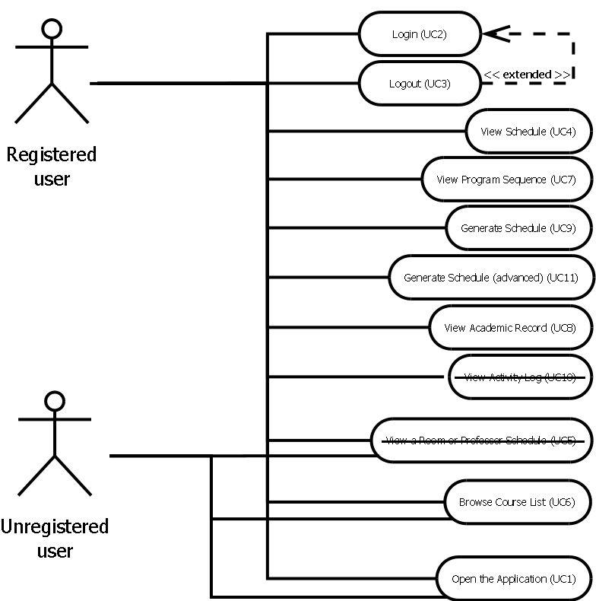

Figure 3.1.2-2 Use Case Model
Use case model depicting the relationship between the actors and the use cases.

Domain Model

Domain Model Diagram

Figure 3.2.1-1 depicts the domain model of the project. There are a total of seven domain level objects (DLO).

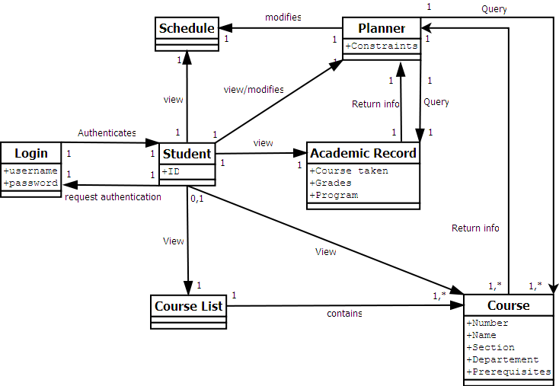
Figure 3.2.1-3 Domain Model Diagram

DLO Login

Login has two attributes, they being a username and a password. It is connected to the student domain level object. Login authenticates student it if its two attributes are valid. This is a one-to-one relationship.

DLO Student

Student has one attribute – an identification number. It is connected to the login schedule, course list, academic record, course and planner domain level objects. It requests authentication from login. It can view schedule, course list, course and academic record. The student-course list relationship can either be one-to-one or zero-to- one since course list can also be accessed by a user that is not logged in. The student-schedule, student-academic record and student-planner relationships are all one-to-one. The student-course relationship can be one-to-one, zero-to-one, one-to-many or zero-to-many. Once again, a user can access the course DLO without being logged in. A user may also access more than one course at a time. Student can both view and modify planner. This is a one-to-one relationship.

DLO Schedule

Schedule has no attributes and does not connect to other domain level objects. This is not to say that other domain level objects do not connect to schedule.

DLO Course List

Course list has no attributes. It is connected to course by either a one-to-one or a one-to-many relationship. More than one course may be contained by course list at a given time.

DLO Course

Course can have five attributes – a name, a number, a section, a department and a prerequisite. It is connected to planner by a one-to-one or a many-to-one relationship. Course returns information to planner.

DLO Planner

Planner can have one attribute – a constraint. It is connected to course, academic record and schedule. Planner queries data from course and academic record. Planner-course can either be a one-to-one or a one-to-many relationship since more than one course may be queried at a given time. Planner-academic record is a one-to-one relationship. Planner can modify the schedule of a given user. This is a one-to-one relationship.

DLO Academic Record

Academic record can have three attributes – courses taken, grades and the student’s program. It is connected to the planner domain level object in that it returns a student’s information. This is a one-to-one relationship.

Quality Standards

This section covers all of the non-functional requirements of the system, as well as the quality standards the system must meet.

Speed

Due to the nature of the system, i.e. a web application, it is expected to respond quickly. More specifically, all general requests are expected to take less than two seconds. The schedule generating request is expected to take less than five seconds.

Ease of Use

The system must be user-friendly. Since this is being made for students, there are a lot of different people with various backgrounds who will use it. Any user to access the domain should be able to easily find their way around without a formal training session. To ensure this, it is important that the most frequently used features of the application are intuitive. This could be tested by having untrained users experiment with the application to see how long it takes to generate a schedule. Also, features common to web-browsers should be integrated into the user interface.

Scalability

The system should be scalable and should support a minimum of 5000 concurrent users. It should be feasible for this minimum number of users to be connected simultaneously to the system. Should this not be possible, a fallback could be to display a warning message to a user at login when there are a large number of users already using the system.

Security

The system might be used in a public kiosk environment, for example in a computer lab. In this environment any user can log in using a monitored workstation. The private data should in no way be accessible to anyone else but the authenticated user.

Accessibility

Since the application is web-based, it should be easily accessible to anyone with an internet connection and a web browser. Users with disabilities like visual impairment should be able to use their browser’s accessibility features, like page zooming or text reading, without disrupting the application.

Printer Friendly

If the user so chooses, they should be able to print any pertinent information from the application using the native print feature of their browser. More specifically, the layout and other artefacts should be neglected and only the specific content of the page should be printed.

Workflow Resilience In Regards to Network Issues

A lot of client these days connect to the Internet wirelessly. When using a wireless connection, the signal might often be dropped due to various issues. When an application does not take this into account, random runtime error can occur. Users then have to refresh the page losing all inputted data and resetting the state of the application. Often this implies users have to restart the workflow from scratch. We need our application to properly handle such situations. All requests to the server should be resumed once the connection has been re-established in the event of a network failure. The user should be notified of this.

Platform Requirement

Cross Platform Support

The basic requirement for the system is a web browser that can function on the client side. Any HTML 4.01 compliant browser with JavaScript support should be able to operate it. This means the system should work on any device with an operating system, including a phone as long as the web browser it uses is HTML 4.01 and JavaScript compliant.

SCOPING

Scope

This project aims to create a web application in which a Software Engineering student can plan his or her schedule for a given semester. The system has a core unit which must be completed, as well as extra features that would make the application more flexible.

Core Component

The core component of the application includes the user login, the basic schedule generation and the schedule display. The user must login using a valid username and password. Upon successful authentication, the default display of the current schedule is shown. If there is no schedule available, one will be generated on the spot.

Course Planner

Along with the core component, other features hope to be included in the application. One of these includes extra features to be added to the component that generates the schedule. This falls under the Course Planner module. It is through this feature that user will be able to plan their schedule. This is done by selecting courses that will be displayed in the schedule. Constraints such as unavailable time slots or other time preferences can be added by the user to help optimize the schedule to the student’s specific needs. The planner will also be able to suggest courses to be taken according to the course sequence and academic record information.

Academic Record

Students will have access to their academic record. This will include all courses that have been previously taken, along with their corresponding grade as well as any other academia related information. This data is used by other features in the application.

Browse Course List

Students will have access to a complete course list. This list includes the different sections for a course, the time slots for the classes, their prerequisites, their room location, the teacher assigned to the class and a description of the course. It will also display the course sequence of the student’s program. It is to differentiate the courses that have already been completed from the ones yet to be taken.

Other Features

An activity log which keeps track of any and all transactions made by the student is to be included as a feature in the application. The ability to save a generated schedule, to view the schedule of a specific room or teacher, and to register for courses directly from a generated schedule are also featured to be included in this application.

Priority

The core component of the application has the highest priority in terms of implementation. The course planner and the academic record modules are second in terms of priority since many modules are dependent on them. The course list browser is third in terms of implementation since it is mostly outputting data from the database to the user interface. Other features such as the activity log, the save and registration capabilities and the room or teacher schedules have the lowest priority implementation wise. When looking to scope out features, the ones with the lowest priority are likely to go first.

Removed Features

A few low priority features have been removed from the application in order to meet expected release deadline. These features are:

- Warning users if their browser is not supported by the application (parts of use case 1).
- Displaying Professor or Class schedules under view schedule (use case 5).
- Accessing an Activity Log (Use case 10).
- The application will no longer save/register a schedule for the user (parts of Use Case 9 and 11). User should not need to access an already made schedule if already registered to ENCS registration system. This feature will be implemented in a future revision.

These features can be identified in this document as crossed out text.

Excluded Features

Administrative Functions

Administrative capabilities for the application and the database management, such as enabling or disabling tabs and modifying user permissions, are currently not part of the scope of this project and therefore, will not be implemented. This is mainly due to the fact that these features are currently not needed in order to achieve the goal of this project. Also, according to the planning of the implementation of this application, there is simply not enough time nor resources available to complete the project with this added functionality.

PLAN

This section is to act as a guide for the implementation of the project. It contains a detailed schedule of all of the activities and artefacts to be completed as well as the estimated amount of time each one will take to complete. The activities and artefacts of the project have been divided up into five categories: design, implementation, logic, database and other. For the sack of convenience, each module is represented by a table consisting of all of the artefacts and activities it encompasses and their estimated cost in terms of hours.

Design

Initial Discussions

The initial discussions of the project encompass everything from what features the application will have to what the user interface will look like. It is very likely that the end result of the project will be drastically different from the initial plans. Table 5.1.1.1 details this.

Table 5-1 - Plan of the initial discussions of the project.
Activity | Initial project discussions : Domain, functionalities, Interface
Assigned To | Corey, Mathieu (Mat), Phuong-Anh-Vu (JB), Sébastien (Seb), Andreas, Eric, Julia, Marc-André (Marc)
Due date | Week 2, Friday
- Establishing the scope of the project and the various features.
Artefact | System Overview Document
Costs | 20
- Representation of the overall design of the system
Artefact | Block Diagram
Costs | 10
- Basic representation of the modules.
Artefact | User interface mock-up draft
Costs | 10
- Basic representation of the various parts of the interface and how they are linked.

General Design

The general design for the project includes all of the requirements and scope of the application, the plan, the UML diagram and the database diagram. Table 5.1.2.1 details this.

Table 5-2 - Plan of the general design of the project.
Activity | General design discussion
Assigned To | Corey, Mat, JB, Seb, Andreas, Eric, Julia, Marc
Due date | Week 5, Friday
- Initiate discussion between team members on the various aspect of the design and establish the software process and various communication protocols to be used by the team.
Artefact | Requirement, scope and plan document
Costs | 30
- Documentation of the requirements, the scope and the plan of the project.
Artefact | UML Diagram
Costs | 10
- Documentation of the software process.
Artefact | Use Case Diagram
Costs | 10
- Documentation about the actors, their possible actions and results.
Artefact | Project Schedule
Costs | 5
- Establishes the various deadlines of each part of the process to be completed / delivered.
Artefact | Database diagram
Costs | 10
- Documentation about the database and its structure and relationships.

Architecture and Overall Implementation

The architecture and overall implementation discussions involved deciding the structure of the application so that it would be straightforward to code and easy to maintain. Table 5.1.3.1 details this.

Table 5-3 - Plan for the architecture and overall implementation decisions.
Activity | Architecture / implementation discussion
Assigned To | Corey, Mat, JB, Seb, Andreas, Eric, Julia, Marc
Due date | Week 9, Friday
- Establish the various parts of the general architecture and implementation.
Artefact | Architecture and design document
Costs | 30
- Documentation of the architecture of the software and it’s actual implementation.
Artefact | In depth UML diagram
Costs | 15
- In-depth documentation representing an abstraction of the software processes.
Artefact | In depth database diagram
Costs | 15
- Documentation of the database and its various components (tables, relationships, etc).

In-Depth Implementation Design

The in-depth design of the implementation includes the documentation of all of the decisions made and executed as well as the test cases designed from the use cases of the project. Table 5.1.4.1 details this.

Table 5-4 - Plan for the in-depth look at the implementation of the project.
Activity | In depth implementation discussions
Assigned To | Corey, Mat, JB, Seb, Andreas, Eric, Julia, Marc
Due date | Week 12, Friday
- General discussion between team members outlining the various aspects of the implementation and establishing the actual implementation methods to be used.
Artefact | Implementation documents
Costs | 60
- Establishes the methods used to implement the various modules of the software.
Artefact | Testing specifications
Costs | 40
- Designing testing methods for each module based on the use cases and other requirements.

Final Implementation

The final result of the project is to include all of the documentation describing the process of designing, implementing and testing the application as well as a functional application. Table 5.1.5.1 details the plan for this.

Table 5-5 - Plan for the final implantation of the complete project.
Activity | Project completion and final implementations
Assigned To | Corey, Mat, JB, Seb, Andreas, Eric, Julia, Marc
Due date | Week 13, Friday
- The completion of the entire project (documents, implementation, testing, etc).
Artefact | Complete Report
Costs | 80
- The final report composed of all documents related to design, architecture, implementation and testing documenting the entire software process for this project from beginning to end.

Presentation Tier

This section looks at the implementation of the presentation tier of the project in greater detail. It breaks down the design of the project into different modules based on the architecture of the application. For an in-depth description of the architecture outlined for this system, look at the System Design document.

Implementation of the Tab Modules

The user interface of the application is to be broken down into tabs, with each one serving a specific purpose. Table 5.2.1.1 looks at the plan for the implementation of these tabs.

Table 5-6 - Plan for the implementation of the tab modules of the UI.
Activity | Coding and testing tab modules
Assigned To | UI Team (consisting of Mat & Julia)
Due date |  | Week 12, Friday
- The programming required to make a tab styled navigation interface using JavaScript and HTML. This is followed by thorough testing from a user's point of view of each module.
Artefact | Academic record module
Costs | 10
- Tab used to access the page presenting a student’s record. It is visible from all other modules.
Artefact | Sequence planner
Costs | 30
- Tab used to access the page presenting the sequence planner for courses. It is visible from all other modules.
Artefact | Schedule view module
Costs | 10
- Tab used to access the page containing the course schedule for a student. It is visible from all other modules.
Artefact | Core Module
Costs | 50
- The default module that provides the grants the user access to key components of the application upon successful login. It is also the basis for the other modules in the presentation tier.
Artefact | Course Browser
Costs | 25
- Tab used to access the page containing the list of courses offered by the university. It is visible from all other modules. It is also a public resource.

Implementation of the Control Modules

The user interface will frequently include specific controls in its implementation. In order to reduce repetition of code, these controls have been separated into modules. Table 5.2.2.1 shows the plan for the implementation of these control modules.
Table 5-7 - Plan for the implementation of the control modules of the UI.
Activity | Coding and testing of control modules
Assigned To | UI Team (consisting of Mat & Julia)
Due date | Week 12, Friday
- The actual implementation – the code – of the logic required to generate the objects and data used in the presentation layer as well as the testing of this implementation.
Artefact | Model window module
Costs | 25
- The module to construct objects needed for UI windows.
Artefact | Filter module
Costs | 25
- The module for parsing courses based on the users specifications.
Artefact | Calendar Module
Costs | 25
- The module responsible for creating the objects to be rendered in a calendar. These objects will consist mostly of courses. Filters may also be visualized.

Logic Tier

This section looks at the plan for the different modules within the logic tier of the application’s architecture. This can be seen in Table 5.3.1.

Table 5-8 - Plan for the logic tier of the application
Activity | Coding and testing of Logical Modules
Assigned To | Corey, Marc, JB, Seb, Andreas, Eric
Due date |  | Week 12, Friday
- All the underlying implementation of the logic required to present a schedule to a user based on selected courses and temporary filters.
Artefact | Academic record module
Costs | 30
- The module responsible for the generation of the completed courses and grades of student.
Artefact | Authentication
Costs | 30
- The module handling the secure login of users, and ensuring the security of transactions.
Artefact | Course module
Costs | 50
- The module dealing with the objects representing courses.
Artefact | Registration
Costs | 25
- Validates necessary requirements and registers the student.
Artefact | Scheduling module
Costs | 60
- This module handles the generation of data structures that represent valid schedules.

Data Tier

This section examines the plan for the data used by the application. All of the data is to be stored in a database created by team7.

Construction of the Course Database

The database containing all of the data pertaining to courses the student can select when generating their schedule must be created by team7. The plan for this can be seen in Table 5.4.1.1.

Table 5-9 - Plan for the construction of the course database.
Activity | Course database construction
Assigned To | Marc, Corey
Due date | Week 11, Friday
- Make a dataset either by mining the registrar’s website or by dumping previously compiled databases.
Artefact | Course Database Entries
Costs | 15
- Uses the obtained course data to populate rows in the relational database.

Implementation of the Database

The main database of the system contains the data relating to the academic history of a student, user accounts, course lists, generated schedules, etc. The plan for this is shown in Table 5.4.2.1.

Table 5-10 - Plan for the design and implementation of the main database of the system.
Activity | Coding and testing of the database
Assigned To | Seb, Marc
Due date |  | Week 11, Friday
- The design and implementation of the relational database to facilitate the operation of the entire system.
Artefact | Main MySQL database
Costs | 30
- The database for storing all of the states involved in the system. This includes academic records, user accounts, course lists, etc.

Working Environment

This section includes all other work related to the project that is not directly linked to the design and implementation of the application. This includes taking care of the web server, the git repository and the mailing list. Table 5.5.1 shows the plan for these tasks.

Table 5-11 - Plan for setting up and maintaining the working environment
Activity | Setting up the server and working environment
Assigned To | Marc
Due date | Week 3, Friday
- Deploying and maintaining the back-end services that act as a platform for the project.
Artefact | Web Server
Costs | 15
- Provides hyper-text document to web clients. Platform on which the system will run.
Artefact | Git repository
Costs | 5
- The distributed version control system used for team members to share resources and track modifications to documents and code.
Artefact | Mailing List
Costs | 5
- For keeping team members in regular communication with each other.

Gantt Chart

Figure 5.6.1-1 is a Gantt chart depicting the expected progress of the project. It contains all of the components outlined in the plan. Each component includes a start date, an end date, the expected duration time, a percentage representing what has been completed to-date and a visual representation of the expected time the component will take to complete. The blue bar graph indicates the time a component is expected to take before it is completed. The pink bar graph indicates the actual amount of time spent working on a component.
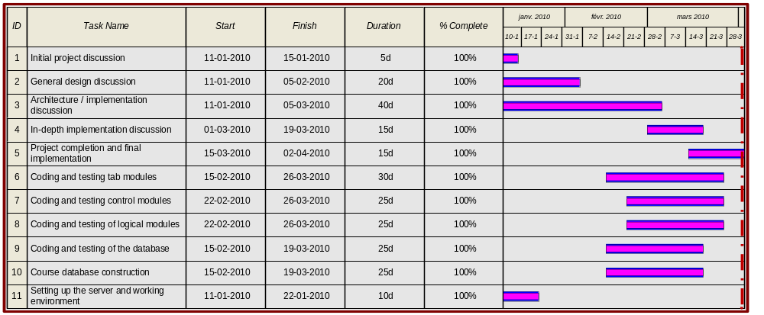
Figure 5.4.2-4 Gantt Chart
This chart represents the estimated progress of work for the project.

SERVER SETUP

Assembla.com Team Collaboration Space

Assembla.com is a website that offers an integrated solution for online team collaboration. While various paid plans are available, a free public plan exists that provides enough resources for the scope of this project.

Team Collaboration

In order to manage a project, the team leader can create a new team collaboration space and invite each member to join it. This requires that each member of the team create an account on assembla.com. To simplify things, we have used our Concordia netnames as our account names. Through team collaboration space, members can easily reach the rest of the team through a messaging system and a chat function. There is also a place where one can view a history of the latest events.

Git Distributed Version Control System

One of the main reasons for using assembla.com’s service is because they provide free version control system hosting. Version control can easily be added to the team collaboration space by the administrator with a one-click installation. Assembla.com provides multiple version control systems such as subversion, mercurial and git. While subversion is a popular version control system, the new trend is to move to git. Git is a more recent and efficient system originally created by Linus Torvalds. When compared to subversion, git is a faster and more efficient system, especially in regards to branching.

Webhook

Another nice feature that made assembla.com a good choice for hosting our git repository is webhooks. The webhook is a simple HTTP POST that is sent automatically to notify of an event. As we wanted to host our web application on a separate server, we are using it to trigger an update of the application on the remote server whenever someone commits changes on the git repository. Without webhooks, this would have to be done by constantly polling the git server for updates, which is a quite inefficient way of doing things.

OpenSolaris Server

OpenSolaris is a free open source operating system based on Sun’s Solaris. It is one of the variants of UNIX based on SVR4. As Sun mostly ships Solaris with their selection of high performance servers of all types, OpenSolaris is a good choice for making our web server. For this project, a dedicated server with a P4 3.0GHz and 1 GB of RAM is used to host our web application in development.

Web Stack (AMP)

OpenSolaris’ web stack, called the “AMP” stack, which stands for Apache, MySQL and PHP, provides an easy way to set up the various programs needed to host our web application. This is perfect for us since this is exactly what we need.

Development Web Stack (AMP-dev)

A web development stack is also available, providing a full set of tools to develop web applications. While it is not really an option for team members to use, since nobody uses OpenSolaris as their desktop OS, it comes with documentation and instructions on how to use the tools it installs. This is great as it provided a lot of ideas on what alternatives to use, such as the NetBeans IDE.

Hostname

The server is connected to the internet with a residential Videotron connection. Since Videotron uses the usual HTTP port 80, we are using the alternative port 8080. Also, since Videotron does not provide a static IP, we registered a free hostname from dyndns.org. It can be automatically updated to point to the current IP address of the server using a client program. Our website can be accessed at http://team7.ath.cx:8080/

Individual Test Space

Since we are eight people working on the same website, a separate space is provided to each member so they can do their own testing without breaking the work of other members. Each member has an account on the server with a username corresponding to their Concordia netname. Apache has been configured to enable the user directory features, which gives each member a web folder accessible at http://team7.ath.cx:8080/~username/. Each user’s home folder contains a public_html folder where they can put their files for their personal web space.

DEVELOPER CLIENT SIDE SETUP

Git

Installation (Windows)

A windows port of git is available as the msysgit project, available at http://code.google.com/p/msysgit/. The installation is straightforward – just follow the installation wizard and a shortcut should be added on the desktop. The program gives a full bash shell with git installed.

Installation (Linux / Mac OS X)

On Linux, the distribution’s package manager is able to install git. On Mac OS X, an installer is available at http://code.google.com/p/git-osx-installer/.

Initial Configuration

Log in to your assembla.com account, click on the Source/Git tab. Click on “More Instructions” under “clone/push URL”. There are two URLs that can be used for git, one is for public read-only access, and the second one is for read/write access. As we want read/write access, we need to use git@git.assembla.com:team7.git. The first thing that you have to do is to set up ssh with a public key that you need to give to assembla.com so that they can identify you. If you already have a key, it should normally be placed in ~/.ssh/id_rsa.pub. If you do not have a key, you can generate a new one with “ssh-keygen –t rsa”. The ida_rsa.pub file is just a text file containing your public key. Either output it to your terminal to copy it with “cat ~/.ssh/id_rsa.pub” or open it with a text editor. In assembla, click on “My Start Page” on top right hand corner and then click the “Profile” page. Scroll down the profile page, and there should be a space to paste your ssh public key. Paste it there and save your changes. It is important that this step is correctly done otherwise you will not be able to modify anything on the git repository.

Once the ssh keys are correctly set up, open a terminal (or in Windows, start the git bash shell) and then enter the command “git clone git@git.assembla.com:team7.git”. The result should resemble Figure 7.1.3-1.

marcan_m@linux:~/$ git clone git@git.assembla.com:team7.git
Initialized empty Git repository in /home/marcan_m/team7/.git/
remote: Counting objects: 49, done.
remote: Compressing objects: 100% (44/44), done.
Receiving objects: 100% (49/49), 78.10 KiB | 10 KiB/s, done.
remote: Total 49 (delta 5), reused 0 (delta 0)
Resolving deltas: 100% (5/5), done.

Figure 7.1.3-5 - Example of proper git clone

If you see something like this, you have successfully fetched a copy of the git repository with full history of the source code. Now switch to the newly created directory using “cd team7”. Once you are inside the directory, you can start configuring settings specific to your own copy of the git repository. “git config -l” lists the current configuration. Figure 7.1.3-2 shows an example of this.

marcan_m@linux:~/team7$ git config -l
core.repositoryformatversion=0
core.filemode=true
core.bare=false
core.logallrefupdates=true
remote.origin.fetch=+refs/heads/*:refs/remotes/origin/*
remote.origin.url=git@git.assembla.com:team7.git
branch.master.remote=origin
branch.master.merge=refs/heads/master

Figure 7.1.3-6 - Example of a list of git configurations

We need to configure two settings that do not appear in the current list of settings: “user.name” and “user.email”. The instructions page on assembla.com should give instructions similar to this. Figure 7.1.3-3 shows how this is done.

git config user.name “marcan_m”
git config user.email “marcandre.moreau@gmail.com”

Figure 7.1.3-7 - Instructions for configuring the user.name and the user.email settings

It is important that these two settings match the username and email address listed in your assembla.com account, otherwise you will fail to submit any changes to the remote git repository. It is not necessary to use the –global flag, since we only need these settings to be set for this git repository. Next, verify that the new settings have been accepted. See Figure 7.1.3-4 for an example.

marcan_m@linux:~/team7$ git config -l
core.repositoryformatversion=0
core.filemode=true
core.bare=false
core.logallrefupdates=true
remote.origin.fetch=+refs/heads/*:refs/remotes/origin/*
remote.origin.url=git@git.assembla.com:team7.git
branch.master.remote=origin
branch.master.merge=refs/heads/master
user.name=marcan_m
user.email=marcandre.moreau@gmail.com

Figure 7.1.3-8 - Instruction for calling the configured settings and a list of the current ones

You should now be ready to start making changes.

Contributing Changes

So you have worked on the project and you are ready to contribute your changes back to the git repository. The first thing you must do is add the files you have modified to the set of modifications you want to submit. Adding a file is as simple as typing “git add <filename>”. Removing a file is also simple, with “git rm <filename>”. If you want to move a file without losing its history in the repository, you can use “git mv <source> <destination>”. These are the most basic commands you need to know. Once you’ve added all of the items you wanted to submit, you can use “git status” to get a summary of what is going to be added and what is going to be ignored. Figure 7.1.4-1 shows an example where two new files have been created since the last version, but only one of the will be submitted:

marcan_m@linux:~/team7$ git status
# On branch master
# Changes to be committed:
# (use "git reset HEAD <file>..." to unstage)
#
# new file: a.txt
#
# Untracked files:
# (use "git add <file>..." to include in what will be committed)
#
# b.txt

Figure 7.1.4-9 - Example of a git status summary

Once you are ready, you can use commit these changes. Figure 7.1.4-2 shows an example of the instruction for this.

Marcan_m@linux:~/team7$ git commit –a –m “comment describing the changes”

Figure 7.1.4-10 - Instruction for a git commit including a comment

A git commit creates a new version and commits the changes into that new version. The “-a” commits all of the added changes, and the “–m” is used to include a comment describing what those changes are. You can use git commit as many times as you want without affecting the work of other people, since the new version is only local to your machine at this stage.

After using git commit, you need to “push” your changes to the remote git repository so that the other developers can get it. Figure 7.1.4-3 shows the command for this.

marcan_m@linux:~/team7$ git push origin master

Figure 7.1.4-11 - Instruction for pushing changes into the git repository

The “origin” command is the root of the remote git repository, and the “master” command links to the master branch. Because this is a small project, we will not be using the git superb branching feature. W e will only use a single branch, a.k.a. the master branch.

Synchronizing Work

If you attempt a “git push” and it fails, chances are it is because someone else has pushed a new version that is more recent than the one your work was based on. In this case, use “git pull” to fetch the latest version from the git repository. In the case that you had made changes that have not yet been contributed, git will automatically merge your changes with the latest version. After a successful merge, you should be ready to attempt to push your changes again. To see what the changes were, you can use “git log” or use a graphical tool like gitk. The log of the latest changes can also be browsed from assembla.com.

NetBeans IDE

Installation

On Linux, NetBeans can be installed by the distribution’s package manager. On Mac OS X and Windows, installers are available from netbeans.org. You need to install the PHP NetBeans bundle. If you choose to install the full NetBeans bundle, you will also need to install the JDK (Java Development Kit).

Plugins

In NetBeans, click on “tools->plugins” to get a list of available plugins, or to get updates. If you installed NetBeans without PHP, you can install the PHP plugin from there. A Javascript debugger plugin is available, which may be helpful.

Initial Configuration

Create a new project by going to “File->New Project” and selecting “PHP/PHP Application with Existing Sources”. Click “next”, which brings you to a dialog asking you for the source files location. Browse for the “www” folder of your local git repository. Call the project “Team7”, and then click “next”. For “Run As”, select “Remote Web Site (FTP, SFTP)”. Change the project url to http://team7.ath.cx:8080/~username/, where you replace “username” with your own, and a trailing slash at the end. For “remote connection”, click “manage”. Create a new connection of type SFTP. The hostname is team7.ath.cx, with your own username and password for ssh. Set the initial directory to /export/home/username/public_html where “username” is again your own username. Save the new connection by clicking “OK” and then select it. Empty the “Upload Directory” field and set “Upload Files” to “On Run”. Click “Finish” and you are done for that part. You can now code PHP in NetBeans. Clicking the green play button will automatically deploy your PHP code in your personal web folder and open a browser for you.

Remote PHP Debugger

In order to be able to use the remote PHP debugger from NetBeans, you need to open an ssh tunnel for port 9000 from the server to your own machine. This has to be done because the debugger attempts to connect to the debugger client locally on port 9000. By redirecting port 9000 to your own machine instead, the debugger will be able to connect to the PHP debugger client embedded into NetBeans. When you wish to use that feature, open a terminal and open an ssh tunnel as shown in Figure 7.2.4-1.

ssh -R 9000:localhost:9000 username@team7.ath.cx

Figure 7.2.4-12 - Command for opening an ssh tunnel in a linux terminal.

Leave the terminal window open for the entire time you need to use the remote PHP debugger.

PROGRAMMING LANGUAGES AND LIBRARIES

Languages

PHP

PHP is a server-side scripting language, which will be used to interface the database with the client-side application as well as process client-side requests with database information. We choose PHP to code the logic tier of the application because of several factors. It is the language that the largest number of people in our team felt comfortable coding with. It is well documented, largely used in the wild and easily deployable on any Apache instance. The code written using PHP is generally platform and environmentally neutral so it can be ported to any other environment quite easily without costly compilation.

HTML

HTML, which is short for Hypertext Markup Language, is a logical representation of a web interface and will used to organize the client-side aspect of the software. HTML was adopted for the front-end system, in order to comply with some of the platform constraints we met with in the problem statement defining our project. While many different technologies could display information in a web browser, only HTML provide compatibility across the largest amount of platforms and vendors. It is a well-defined, standardized markup language that will make the deployment of our application easier on any HTML 4.01 compliant browser, such as Internet Explorer 6.0+, Safari 2.0+, Chrome 2.0+ or Firefox 2.0+.

CSS

CSS, which is short for Cascading Style Sheets, is a system which maps visual styles and themes onto the web interface. Using CSS to style the page, an HTML document need not contain the visual aspect of the content, leaving it only the content and the structure in the HTML document. CSS can be disabled to permit a visually impaired person to access the page with little outside assistance.

Javascript (a dialect of ECMAScript)

Javascript is a client-side scripting language, which will be used to interact with the user on the web interface and send requests to the server and present responses from the server. In order to ease development by having a front-end with a constant and easily maintainable state, we choose JavaScript. Manipulating the object displayed in the browser’s window will enable us to minimize the load placed on our logic tier thus complying with requirements of speed and load we have to deal with. Javascript is the standard for interacting with the DOM (domain object model) that the browser exposes, in order to enable a programmer to manipulate objects parsed in the HTML code in various ways. This feature is standard across all major browsers aforementioned and is enabled on more than 95% of the web user’s [1].

Libraries

jQuery

jQuery is a fast and concise JavaScript Library that simplifies HTML document traversing, event handling, animating, and Ajax interactions for rapid web development. jQuery is designed to change the way that you write JavaScript [2]. It is lightweight and offers a developer a lot of options that will help implement a complex UI project like ours. This open source project is maintained by the jQuery foundation, which is an NPO professionally run by a group of software engineers. The most prominent figure is John Resig, founder of jQuery, currently employed at Mozilla Corporation. Companies like Microsoft, Nokia, Google, Dell, Wordpress actively support jQuery. At the time of writing, 26.95% of all web sites used jQuery. Of all the sites that used Javascript as a web technology, more than 37% used jQuery which makes it the most popular technology used on the web today [3]. It is even more popular than Adobe Flash [4]. Of course popularity is of no interest without a community of devoted developers that provide bug fixes and plug-ins written for jQuery. jQuery is being served by google CDN (content delivery network) which ensure an up-to-date version is always running in our production environment [5].

jQueryUI

While jQuery provides an interface between the browser DOM and Javascript, jQueryUI provides a set of rich graphical user interface element that is highly reusable and customizable. We will particularly be interested in jQueryUI’s ability to manage color themes, tabs, modal dialog, icons and buttons in a visually consistent manner without any added code in our project. jQueryUI is being served by google CDN (content delivery network), which ensure an up-tp-date version is always running in our production environment.

Plugins

Plugins are pieces of code maintained by a third-party. We use plugins to alleviate development while help the development process.

jQuery-Week-Calendar

The calendar view is our standard calendar control for displaying to the screen the schedule objects. Our goal is to provide a rich user experience, so an outlook-like view is preferable. This is exactly what the jQuery-Week-Calendar plugin by Rob Monie provides us with [6].

OTHER SOFTWARE

The following section covers the software used by the development team in order to plan and produce the application.

Operating Systems

Microsoft Windows

Microsoft Windows is the most widely used desktop operating system in the world and is one of the target platforms for the client-side aspect of the software being produced. It will be used by the team members mostly for its Office software.

Apple Mac OS X

Apple Mac OS X is a UNIX compliant operating system, which will be used by certain members of the development team to produce parts of the application. It will also be used to test the client-side aspect of the application for compatibility. Its use in the project is strictly a matter of personal preference of some members of the development team.

GNU/Linux

GNU/Linux is a UNIX compliant operating system, which will serve as the back-end of our application. It has been chosen for having a great architecture and a solid reputation as an operating system in the industry. It will be used in conjunction with the Apache server, the mySQL database management system and PHP.

Office Software

Microsoft Office

Microsoft Office is a set of software applications, which will be used in the planning and the documenting of the application during development. More specifically, the Microsoft Office Word, Microsoft Office Excel and Microsoft Office Visio applications will be used.

Dia

Dia is a software application, which will be used to construct the different diagrams required in documenting key aspects of the application.

MySQL

MySQL is a database management system, which will be used to store all of the persistent information used by the application. It one of the most used database management systems used in web applications and offers excellent performance with nominal overhead.

Human Resources

This section details the members of the development team, their roles, their technical experience and their average availability per week.

Eric Chan

Role: Team Leader, Programmer
Knowledge: - Web Development
- Database management
- Assembler, C, C++, Perl, Python, HTML/CSS/JavaScript
Experience: - Team projects
- Internships
Availability: 4 hours weekly

Sébastien Parent-Charrette

Role: Programmer
Skill: - Database development
- Low level system programming
- Assembler, C, C++, Java, Visual Basic, Perl, PHP
Experience: - Contract based software development
- Team projects
Availability: 4 hours weekly

Corey Clayton

Role: Programmer
Skill: - Low level system programming
- Mobile hardware system development
- Assembler, C, C++, Perl, Python
Experience: Team projects
Availability: 4 hours weekly

Mathieu Dumais-Savard

Role: Programmer
Skill: - Web Development
- Database Management
- HTML/CSS/JavaScript, Perl, PHP, Python
Experience: - Extensive number of web related personal projects.
- Business Intelligence
- Team projects
Availability: 4 hours weekly

Andreas Eminidis

Role: Programmer
Skill: - Database Development
- Detailed knowledge of security practices
- Assembler, C/C++, C#, Java, Perl, PHP, Python
Experience: - Work Experience
- Team projects
Availability: 4 hours weekly

Phuong-Anh-Vu Lai

Role: Programmer
Skill: - Database Programming
- 3D graphics programming
- C/C++, Java, Visual Basic, Perl, PHP, MATLAB
Experience: - Team projects
- Quality Assurance Testing for mobile device applications
Availability: 4 hours weekly

Julia Lemire

Role: Documentation Coordinator, Programmer
Skill: - Group management skills
- C++, C#, HTML/CSS/JavaScript ( jQuery, Ext JS)
Experience: - Work Experience in web application maintenance
- Team projects
Availability: 4 hours weekly

Marc-André Moreau

Role: Systems Administrator, Programmer
Skill: - Detailed knowledge of networking protocols
- Detailed knowledge of security practices
- Knowledge of documentation process
- Assembler, C/C++, Java, Perl, PHP, Python
Experience: - Extensive number of personal projects
- Work Experience (incl. Software development process)
- Team projects
Availability: 4 hours weekly

Tier Architecture

Overview

The team7 scheduling system, hereby referred to as PlanZilla, uses a 3-tier software architecture. This means that the presentation, the logic and the data are separated. This has the advantage of making the code more reusable and maintainable since the tiers can be modified without necessarily affecting each other. Figure 11.1-1 shows the different components of a 3-tier architecture:

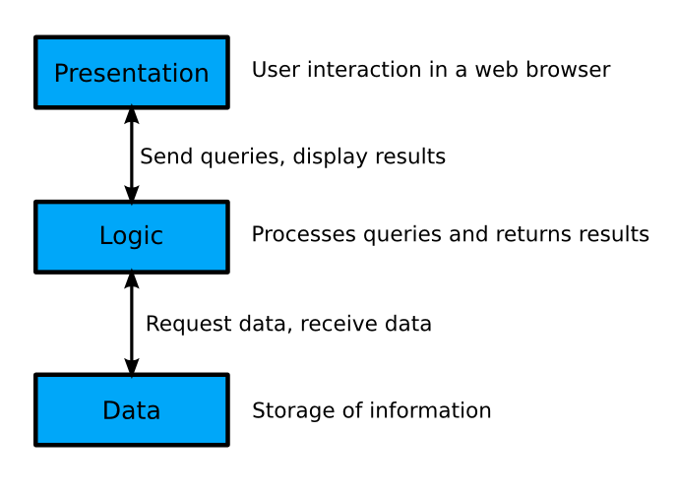
Figure 9.2.3-13 - 3-tier architecture

In the case of PlanZilla, the presentation is what is presented to the user in the form of a website. This part is done using combination of HTML documents with JavaScript and a library named jQuery to abstract access to the logic tier using AJAX methods and provide us with a a set of rich re-usable user interface controls.

The logic tier is composed of multiple PHP modules for the various tasks the application needs to handle. This includes user authentication, scheduling, registration and courses.

The third tier is the database. The database used in this project is MySQL. The multiple PHP modules interact with the database in order to query data requested by a user in the presentation tier, and return the results in a format ready to be used by the presentation tier.

Development View

Component Diagram

Figure 12.1-1 shows a component diagram depicting the 3-tier architecture used for PlanZilla.

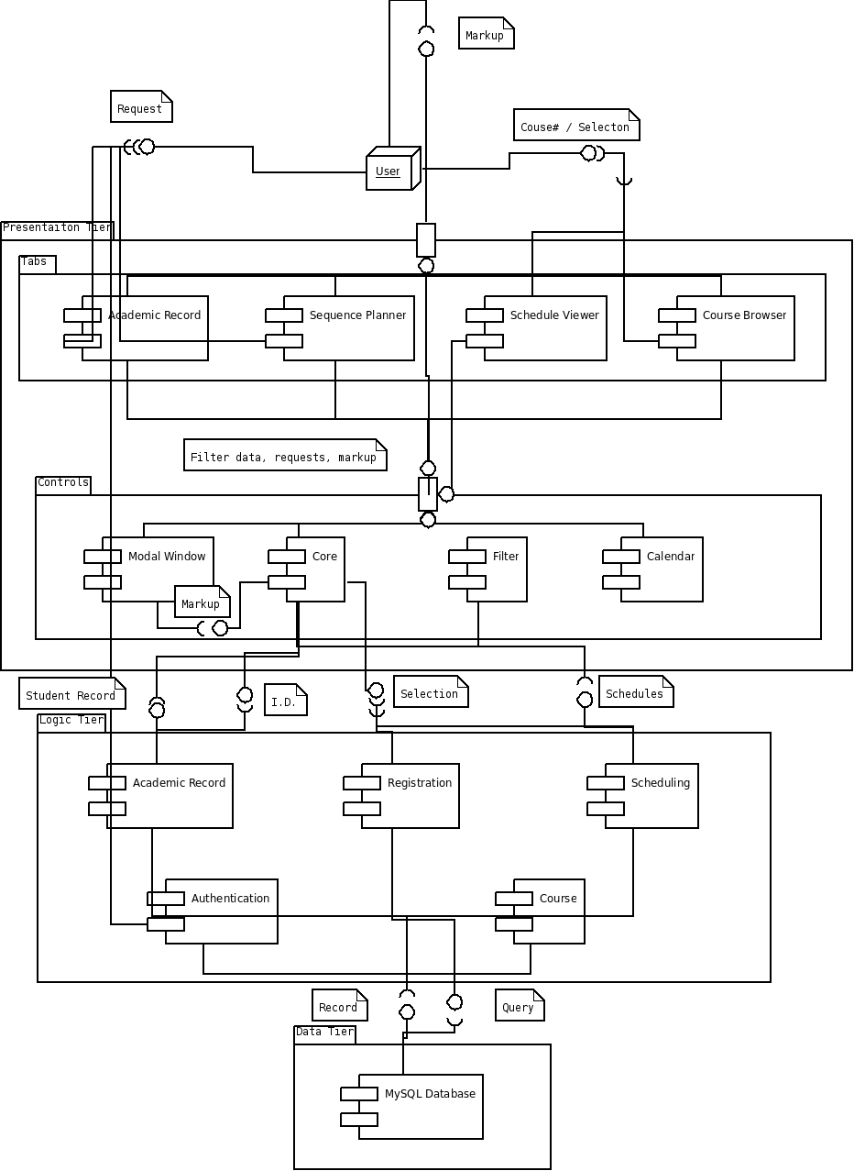

Figure 9.2.3-14 - UML Component Diagram

Brief Component Diagram Description

Figure 2 illustrates how the components of Planzilla are connected to each other.

User

Starting at the top of the diagram, the user provides either a page request – i.e. simple tab navigation – or specific data, which may include a course’s information or a course selection. The user then receives a markup containing either a JSON string, HTML code or a JavaScript post that is rendered on the page.

Tabs

The tabs package acts as the main part of the user interface. They provide the user with aforementioned markup. At the same time, they provide and receive filtered data, requests and a markup from the core. This markup is likely to contain sectional HTML data.

Controls

The controls package of the presentation tier is mainly composed of the core which acts as a bridge between the tabs component and the logic tier. The component diagram has been modified so that any component from the presentation tier trying to access a component in the logic tier must do so through the core component. The only component that acts as the exception to this is the authentication component. This is because it must receive login credentials directly from the user.

The next three sections describe the modules of each tier in further detail.

Presentation Tier

The presentation tier contains all of the logic for the user interface. It is primarily handled by JavaScript functions.

Tabs

Academic Record

The application has a tab called Academic Records, in which students can view their transcripts and other useful academia related information. The Academic Record module in the presentation tier only handles the presentation of the data that is provided by the analogous Academic Record from the second tier, while this information stored in the MySQL database.

Sequence Planner

The Sequence Planner is a handy tool that can generate potential schedules from a list of given courses that a student wants to register for. It has the ability to propose courses from the student’s course sequence. The user also has the option of setting special constraints, such as not having classes late on Friday night or early Monday morning.

Schedule Viewer

The schedule viewer shows a student’s schedule in a calendar view. A schedule is only available if the student has registered for courses.

Course List Browser

The course list browser can be accessed by both an authenticated and an unauthenticated user. It provides a full list of the courses offered with some general information. This can be useful for both registered students, who want to learn more about the courses they have to take, and for people currently not enrolled in any program but would like to know more about a give course.

Controls

Core

The core is the main page of the website. It contains the tab controller. It provides access to the authenticated and the unauthenticated sections with the use of an authentication module. Other formatting features like headers, footers and the main menu are managed in this module. The core is responsible for consuming services provided by the Logic Tier and handle error such as communication issues if any.

Modal Window

At different places in the application a modal window is needed, such as for the authentication of a user. The modal window prompt user for a question and require immediate attention for the process to go further. When a Modal Window is opened, nothing else can be clicked in the application. Instead of rewriting the same code multiple times, a modal window module is used. A sample of a modal window used in the PlanZilla application can be seen in Figure 13.2.2-1.

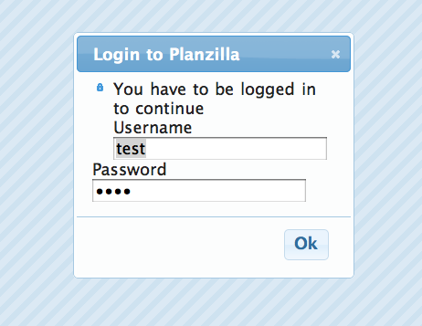

Figure 13.2.2-15 - Example of a modal window

Filter

The filter is a control used for the auto completion of a text entry in various modules of the presentation tier. For instance, if a user starts typing “Software” the filter could suggest the auto completion “Software Engineering”.

Calendar

The calendar module is used for the presentation of schedules in a sleek calendar view. Both the schedule viewer and the sequence planner access this module. A sample of the calendar can be seen in Figure 13.2.4-1.

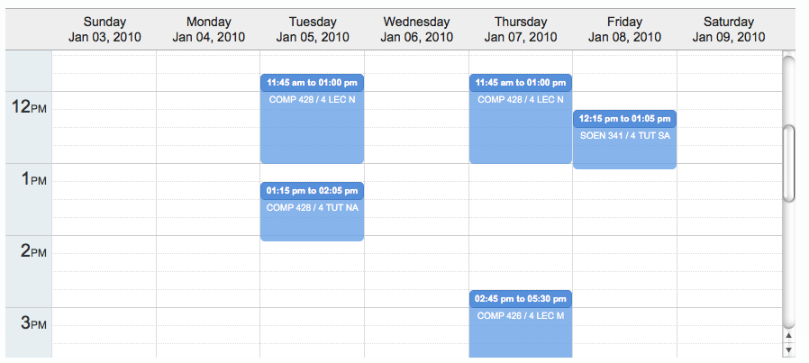

Figure 13.2.4-16 - Example of the calendar

Logic Tier

Authentication

The Authentication module is responsible for properly validating a user for the duration of their session on the website. It receives a user’s credentials and validates them according to the information stored in the database. Passwords are stored with the following hashing function: sha256(sha256(password) + random_salt).

Academic Record

The Academic Record module in the logic tier has the task of gathering information, such as the grades of a student, and returning this data in the form of a full student transcript. This is to be readily displayed by the Academic Record module from the presentation tier.

Registration

The Registration module is used when a student has chosen a schedule and now wants to register the selected courses. Registration first uses the Course module to verify that the schedule is valid and that the student can take all the courses selected. The student is then registered in these courses. In the case of an invalid schedule, such as when a course becomes full right before the student wants to register, then the Registration module will deny the request and a brief reason for the error will be given.

Scheduling

The Scheduling module takes a list of courses and a list of constraints, and generates all of the possible schedules resulting from them. The list of possible schedules is then sent back to the calling module, which in this case is the Sequence Planner module. Scheduling also depends on the Course module in order to verify the validity of the generated schedules. This is important to ensure that a student satisfies all prerequisites of a given course.

Course

The Course module is used to access course information. It also to handle the logic of validating a course schedule with regards to course dependencies and the courses a student has already taken.

Data Tier

Overview

Figure 15.1-1 shows an overview of the database architecture for PlanZilla:

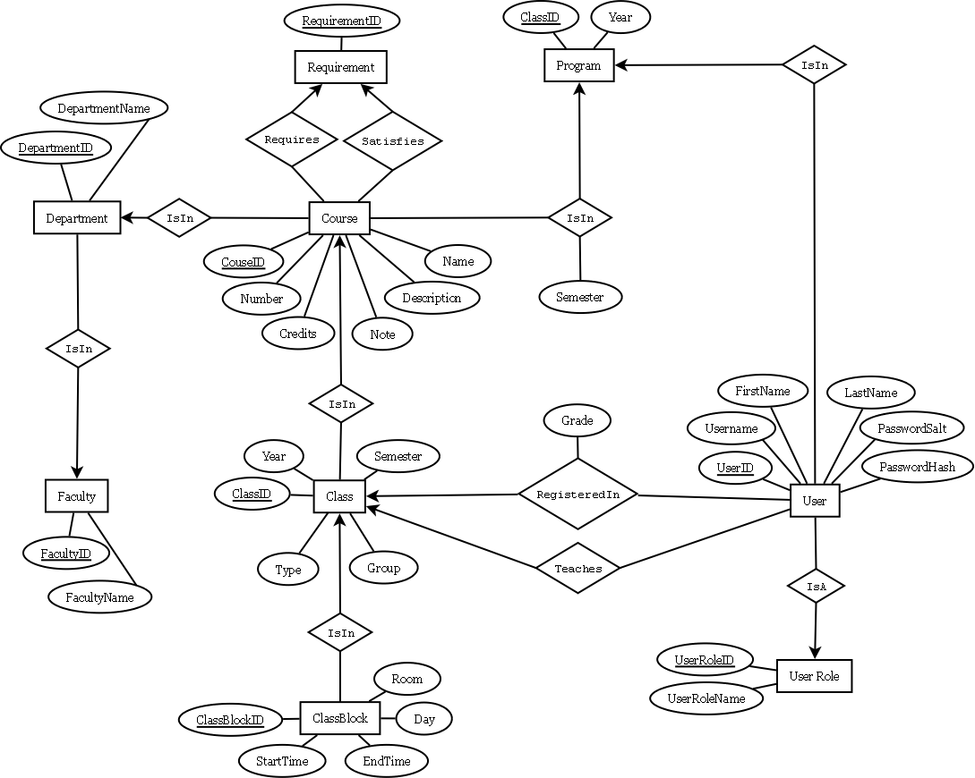

Figure 13.2.4-17 - Entity-Relationship Diagram

Each part of the above entity-relationship diagram is explained more thoroughly in the following sections.

Users

Figure 15.2-1 shows how users can access the system. Each user is assigned a role that determines what can be accessed (viewed, modified, removed).

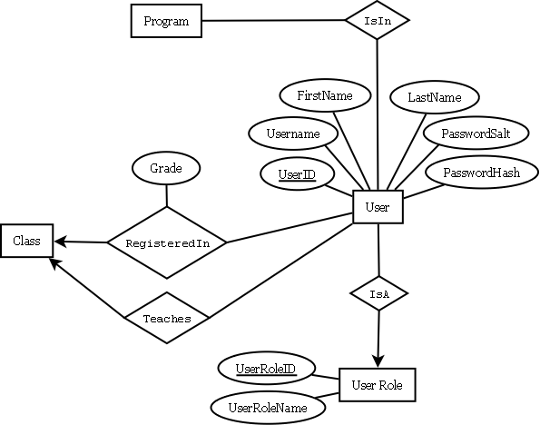

Figure 13.2.4-18 - The users and how they can access PlanZilla

Administrator

Users with the administrator role have administrative powers in the database. This would usually be reserved for the staff of the school that have access to operations that other types of users do not. This may include adding new courses and manually registering students for courses that are already full. But such functions are not in the scope of this project.

Student

Users with a student role are a special type of users that can be enrolled in a program and registered in courses. The RegisteredIn relationship is used for both present and past courses. The Grade attribute represents the current status of the course. If a course has been completed the field will contain the grade received. If the course is currently being taken, then it will display “IP”. The grade field can also contain other status such has “R” for classes to be repeated or “DISC” for discontinued courses.

Teacher

Users with the teacher role, like students, are a special type of users. They can teach different classes. The Teaches relationship is made with class and not course. This is because it is possible to have many teachers for one course. For instance, there may be more than one teacher giving different lecture sections and other teachers in charge of tutorials and labs.

Courses
Figure 15.3-1 focuses on how a course’s information is listed in the database.

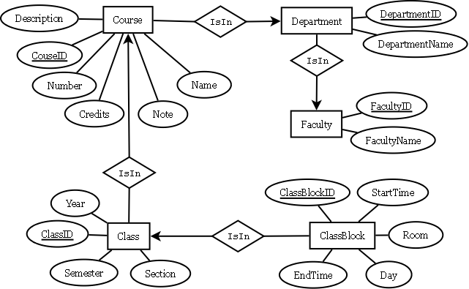

Figure 15.2.3-19 - Courses in the database

Course

A course is uniquely identified by its department and course number. For this reason, each course must be related to Department with the IsIn relationship. The IsIn relationship uses short four letter department names such as COMP or SOEN. The Name attribute of Course is simply the full name of the course and the Description attribute contains the full description of the course. The number of credits is also stored within the course. A Note attribute is also added for special information users with the administrator and teach roles.

Class

For each course there may be a different number of classes. A class is a weak entity, as it depends on a course to be uniquely distinguished from other classes. This is where you find important information such as year, semester and section. The Section attribute is used to identify the class and the hierarchy between lectures, tutorials and labs. Because of the large number of attributes required to uniquely identify a class, an extra attribute has been added: ClassID. The ClassID attribute is used internally by the database to relate users to classes.

Department

A department is one of the departments by which a course is given. Examples of this are COMP (Computer Science) and SOEN (Software Engineering). The four letter abbreviation is used to relate courses to departments, but the Department entity also stores the full name of the department. As departments are part of a faculty, each department is related to the faculty it belongs to.

Faculty

Each faculty has an abbreviation of a few letters that is used to relate faculties to departments, such as ENCS with COMP. Like departments, the Faculty entity stores the full name of the faculty. For instance, ENCS stands for Engineering and Computer Science.

Requirements

Figure 15.4-1 depicts how the prerequisites for a course are stored in the database.

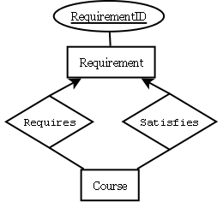

Figure 15.3.4-20 - Representation of requirements

"AND" Requirements

The simplest case of a requirement is a course which is dependent on one or more other courses. For example, let course A require courses B and C. In the database, course A would be related to two different requirements, R1 and R2, with the Requires relationship. One requirement, R1, would in turn be related to course B and R2 would be related to course C using the Satisfies relationship.

"OR" Requirements

The second requirement case is when a course is dependant on two or more courses that are equivalent. For example, let course A require course B or C. In the database, course A would be related to one requirement, R1, with the Requires relationship. The requirement R1 would in turn be related to both course B and C using the Satisfies relationship. This means that if the user has completed either course B, course C or both then course A’s requirement is satisfied.

Combination of "AND" and "OR" Requirements

There are even more complex cases of requirements in which groups of required courses are equivalent. For example, let course A require course B and course C or D. In the database, course A would be related to two different requirements, R1 and R2, with the Requires relationship. One requirement, R1, would be related to course B and R2 would be related to course C and D. This makes course A available only if the user has completed course B and course C or D (or both). Many other cases of combinations or requirements exists.

Programs

Figure 15.5-1 shows how a program is stored in the database.

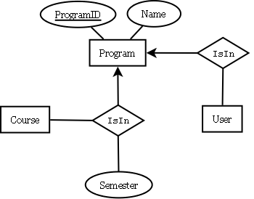

Figure 15.4.3-21 - Representation of a program

Program Options

A program can have many possible options. However, each option of a program corresponds to a different course sequence. For this reason, each program option/sequence has its own row in the Program entity and is uniquely defined by the ProgramID attribute and has its full name in the Name attribute. An example of a program would be Software Engineering or Computer Engineering, Hardware Option. In this case, the Computer Engineering, Software Option would have its own Program entity.

Course Sequence

A course sequence is usually presented to the student as a full list of courses to be taken according to each semester of the program. This is why a Semester attribute is present in the IsIn relationship between the Course and Program entities. The courses that have to be taken to meet the requirements of the sequence are represented using the established Requirement entities, as seen in section 15.4.

Process View

The process view of the 4+1 architectural view model examines the process flow of the application. The overall flow is represented by an activity diagram.

Activity Diagram

Figure 16.1 shows a UML 2.0 activity diagram representing the process expressed by UC 11 (Generate Schedule Advanced).

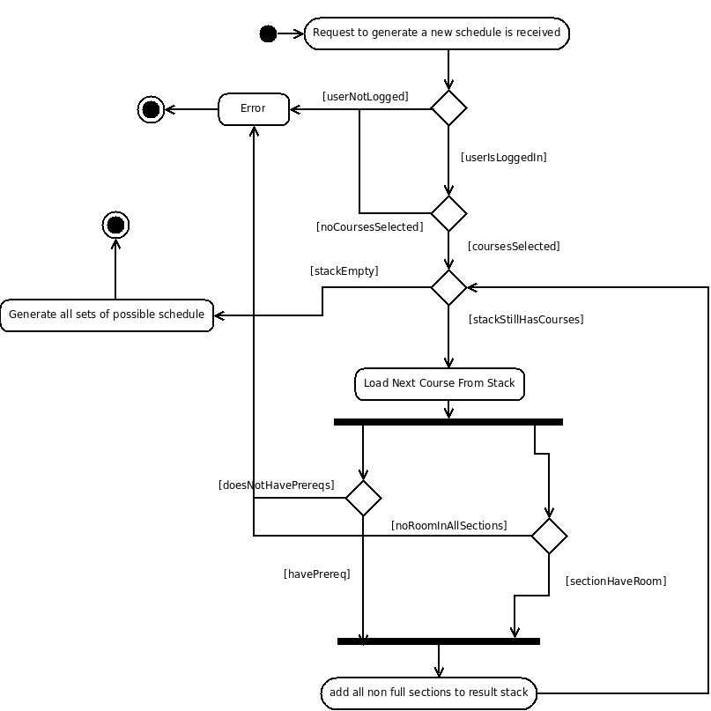
Figure 15.5.2-22 - Activity diagram
The workflow of UC11 begins when the request to generate a new schedule is received. The login status of the user is verified. If the user is not logged in, an error occurs. This results in an error being given at the output. The front-end is set to deal with it accordingly. This is seen as the end of the workflow for the generate schedule advanced function.

If the user is logged in, the option to select a course becomes available. If no course is selected, an error occurs and the same general process as aforementioned is followed. If a course is selected, it is added to the stack.

If there are courses on the stack, the next course from the stack is loaded. If the student has passed the prerequisites for the given course, and the section is not full, the course is added to the result stack. If the student does not have the necessary prerequisites and/or the section is full, an error occurs and the workflow ends.

Once the stack has been emptied, and no errors have occurred, all of the possible schedules are generated and the workflow ends.

Physical View

The physical view of the 4+1 architectural view model examines how each component of the application interacts with the systems it is being run on and by. This is depicted by a deployment diagram.

Deployment Diagram

Figure 17.1-1 shows the deployment diagram for the PlanZilla web application.

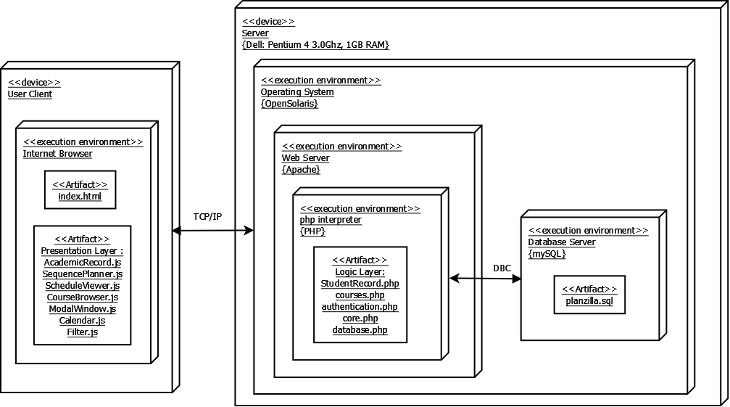

Figure 15.5.2-23 - Deployment diagram

The deployment of Planzilla's architecture is simple and straightforward. By using this layout, there should be less data being sent between the client and server. This means that the web page will load much faster.

OpenSolaris Server

Two physical device entities are required for this application. One of them is physical server. This server is running on a Dell Pentium 4, which has 1 GB of RAM and a processor speed of 3.0GHz. This computer uses an OpenSolaris platform.

Within the OpenSolarsis Server there are three virtual environments. These environments communicate between each other and execute specific tasks.

Apache

The first environment is the web server application, Apache. This layer receives information from the client and processes it. It then selects the PHP script to be executed and sends the command for execution to the PHP interpreter.

PHP Interpreter

The PHP interpreter is the second virtual environment. It contains all of the logic tier code written in PHP, which has been separated into classes. This layer communicates with the database as needed.

Database Server

The third virtual environment is the database. Its function is to perform database operations such as querying for information or modifying the database. These functions are controlled by the PHP interpreter.

User Client

The other physical entity in the architecture is the actual user client. It contains the Internet browser. In order to optimize the speed and efficiency of the Planzilla application, the presentation layer is processed by the client's browser. Initially, the web server uploads all of the necessary JavaScript files to the client. When the user clicks on a link or inputs data, the only data being retrieved is the data from the database, such as course related data or scheduling information. This is then rendered by the JavaScript and is displayed to the user.

Logical View

The logical view of the 4+1 architectural view model shows the breakdown of each component of the application from the

Class Diagram

Figure 18.1-1 shows the class diagram for the PlanZilla application.

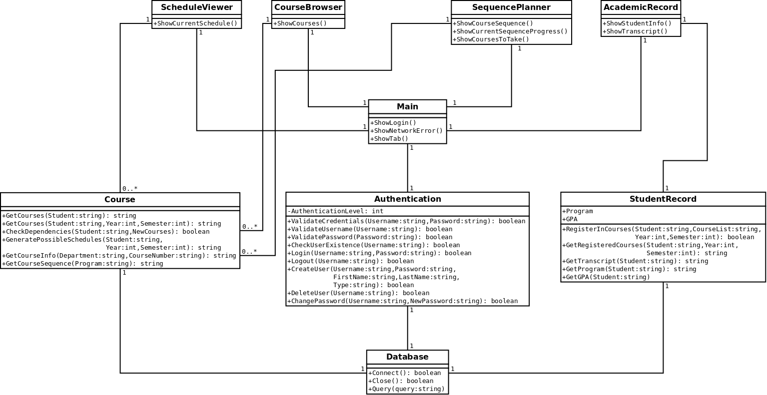

Figure 17.1.2-24 - Class diagram

Unit Descriptions

The following section is a detailed description of each class seen in Figure 12. This includes the purpose of the class and its functions and attributes. These classes make up the logic tier.

ScheduleViewer

The SceduleViewer class is to be written in JavaScript as it is part of the presentation tier. As such, its attributes and functions are not listed in this diagram. This class will be used to display a schedule to the user.

CourseBroswer

The CourseBrowser class is to be written in JavaScript as it is part of the presentation tier. As such, its attributes and functions are not listed in this diagram. This class will be used to display a course’s information to the user.

SequencePlanner

The SequencePlanner class is to be written in JavaScript as it is part of the presentation tier. As such, its attributes and functions are not listed in this diagram. This class will be used to display the scheduling options to the user.

AcademicRecord

The AcademicRecord class is to be written in JavaScript as it is part of the presentation tier. As such, its attributes and functions are not listed in this diagram. This class will be used to display the student’s academic record.

Main

The Main class is the central module of the application. It handles each request from the client and redirects them to the appropriate module, whose task it is to handle the request. This class implements the Core component. It acts as the central node of the program, by loading different tabs presented to the user which will in turn forward requests to the logic tier, all of which passes through the Main module.

Reminders

It is important to determine if this design could have any performance issues, such as with the case where many users are connected to a single server. It should also be ensured that Ajax is being used correctly from the client’s side, in order to avoid sending unnecessary information to the server.

Course

The Course class is responsible for obtaining course information, verifying any potential course dependencies, and generating possible schedules given any constraints.

Important Notes

In order to implement the CheckDependecies() function, an efficient algorithm that will execute the task without wasting too much CPU time on the server must be found.

Authentication

The Authentication class is the module responsible for validating, creating and modifying users. It is an important module, since many of the other classes communicate with this module before proceeding with their function.

Reminders

It would be beneficial to create a simple SSL/TLS certificate. This would protect a client’s session from hackers attempting to steal their unique ID as a session is opened.

Furthermore, each input from the client needs to be checked for potential security vulnerabilities. For example, SQL injections, which enables a user to potentially manipulate the instructions sent to the database.

StudentRecord

The StudentRecord class handles the tasks of obtaining and modifying information in the student record. This includes retrieving a list of currently registered courses as well as past courses.

Database

The database class abstracts the database and controls access to it. The Query() function receives the SQL query from other classes and it sends it to the MySQL database that’s being used for our project. This abstraction was created in order to simplify the maintenance and modification processes.

Module Interface Specification

Authentication Class

Detailed Description

The Authentication class is the module used for validating, creating or modifying users.

Public Member Functions

The following are the public member functions for the Authentication class:

- ValidateCredentials ($Username, $Password)
- ValidateUsername ($Username)
- ValidatePassword ($Password)
- CheckUserExistence ($Username)
- Login ($Username, $Password)
- Logout ($Username)
- CreateUser ($Username, $Password, $FirstName, $LastName, $Type)
- DeleteUser ($Username)
- ChangePassword ($Username, $NewPassword)

Public Attributes

The following is a list of public attributes for the Authentication class:

- $AuthenticationLevel
User authentication level.

Member Function Documentation

Authentication::ChangePassword ($ Username, $ NewPassword)
Parameters:
string $Username
string $NewPassword
Returns:
Boolean

Authentication::CheckUserExistence ($ Username)
Parameters:
string $Username
Returns:
Boolean

Authentication::CreateUser ($ Username, $ Password, $ FirstName, $ LastName, $ Type)
Parameters:
string $Username
string $NewPassword
string $FirstName
string $LastName
string $Type
Returns:
Boolean

Authentication::DeleteUser ($ Username)
Parameters:
string $Username
Returns:
boolean

Authentication::Login ($ Username, $ NewPassword)
Parameters:
string $Username
string $NewPassword
Returns:
boolean

Authentication::Logout ($ Username)
Parameters:
string $Username
Returns:
boolean

Authentication::ValidateCredentials ($ Username, $ NewPassword)
Parameters:
string $Username
string $NewPassword
Returns:
boolean

Authentication::ValidatePassword ($ NewPassword)
Parameters:
string $NewPassword
Returns:
boolean

Authentication::ValidateUsername ($ Username)
Parameters:
string $Username
Returns:
boolean

Member Data Documentation

Authentication:: $AuthenticationLevel
User authentication level:
- -1 = Not authenticated.
- 0 = Administrator.
- 1 = Teacher.
- 2 = Student.

Source File

The documentation for this class was generated from the following file:

- www/php/Authentication.php

Course Class

Detailed Description

The Course class is the module for obtaining course information, verifying dependencies, and generating possible schedules in function of given constraints.

Public Member Functions

The following are the public member functions for the Course class:

- GetCourses ($Student)
- GetCourses ($Student, $Year, $Semester)
- CheckDependencies ($Student, $NewCourses)
- GeneratePossibleSchedules ($Student, $Year, $Semester)
- GetCourseInfo ($Department, $CourseNumber)
- GetCourseSequence ($Program)

Member Function Documentation

Course::CheckDependencies ($ Student, $ NewCourses)
Parameters:
string $Student
string $NewCourses
Returns:
boolean: True if dependencies are satisfied. False otherwise.

Course::GeneratePossibleSchedules ($ Student, $ Year, $ Semester)
Parameters:
string $Student
int $Year
int $Semester
Returns:
string: An array of possible schedules.

Course::GetCourseInfo ($ Department, $ CourseNumber)
Parameters:
string $ Department
string $ CourseNumber
Returns:
string: Course information.

Course::GetCourses ($ Student, $ Year, $ Semester)
Parameters:
string $Student
int $Year
int $Semester
Returns:
string: Student's courses for a given semester (may be a past semester).

Course::GetCourses ($ Student)
Parameters:
string $Student
Returns:
string: Student's past, present and future courses.

Course::GetCourseSequence ($ Program)
Parameters:
string $Program
Returns:
string: Course sequence.

Source File

The documentation for this class was generated from the following file:

- www/php/Course.php

Database Class

Detailed Description

The Database class is the module for abstracting the database and controlling access to it.

Public Member Functions

The following are the public member functions for the Database class:

- Connect()
Connect to database using credentials from configuration file.
- Close()
Close current connection to the database.
- Query()
Send a query to the database.

Member Function Documentation

Database::Close()
Close current connection to the database.
Returns:
boolean: True if successful. False otherwise.

Database::Connect()
Connect to database using credentials from configuration file.
Returns:
boolean: True if successful. False otherwise.

Database::Query()
Send a query to the database.
Returns:
boolean: True if successful. False otherwise.

Source File

The documentation for this class was generated from the following file:

- www/php/Database.php

StudentRecord Class

Detailed Description

The StudentRecord class is the module for obtaining or modifying the student record information.

Public Member Functions

The following are the public member functions for the StudentRecord class:

- RegisterInCourses ($Student, $CourseList, $Year, $Semester)
- GetRegisteredCourses ($Student, $Year, $Semester)
- GetTranscript ($Student)
- GetProgram ($Student)
- GetGPA ($Student)

Private Attributes

The following are the private attributes for the StudentRecord class:

- $Program
- $GPA

Member Function Documentation

StudentRecord::GetGPA ($ Student)
Parameters:
string $Student
Returns:
int: Student's GPA.

StudentRecord::GetProgram ($ Student)
Parameters:
string $Student
Returns:
string: Student's program.

StudentRecord::GetRegisteredCourses ($ Student, $ Year, $ Semester)
Parameters:
string $Student
int $Year
int $Semester
Returns:
string: Courses in which the given student is registered for a particular semester.

StudentRecord::GetTranscript ($ Student)
Parameters:
string $Student
Returns:
string: Student's transcript.

StudentRecord::RegisterInCourses ($ Student, $ CourseList, $ Year, $ Semester)
Parameters:
string $Student
string $CourseList
int $Year
int $Semester
Returns:
boolean: True if registration is successful. False otherwise.

Member Data Documentation

StudentRecord::$GPA [private]
Student's GPA

StudentRecord::$Program [private]
Student's Program

Source File

The documentation for this class was generated from the following file:

- www/php/StudentRecord.php

Dynamic Design Scenarios

Browse Course List

System Sequence Diagram 1 (SSD1)

Figure 20.1.1 shows the system sequence diagram for the Browse Course List use case (UC6).

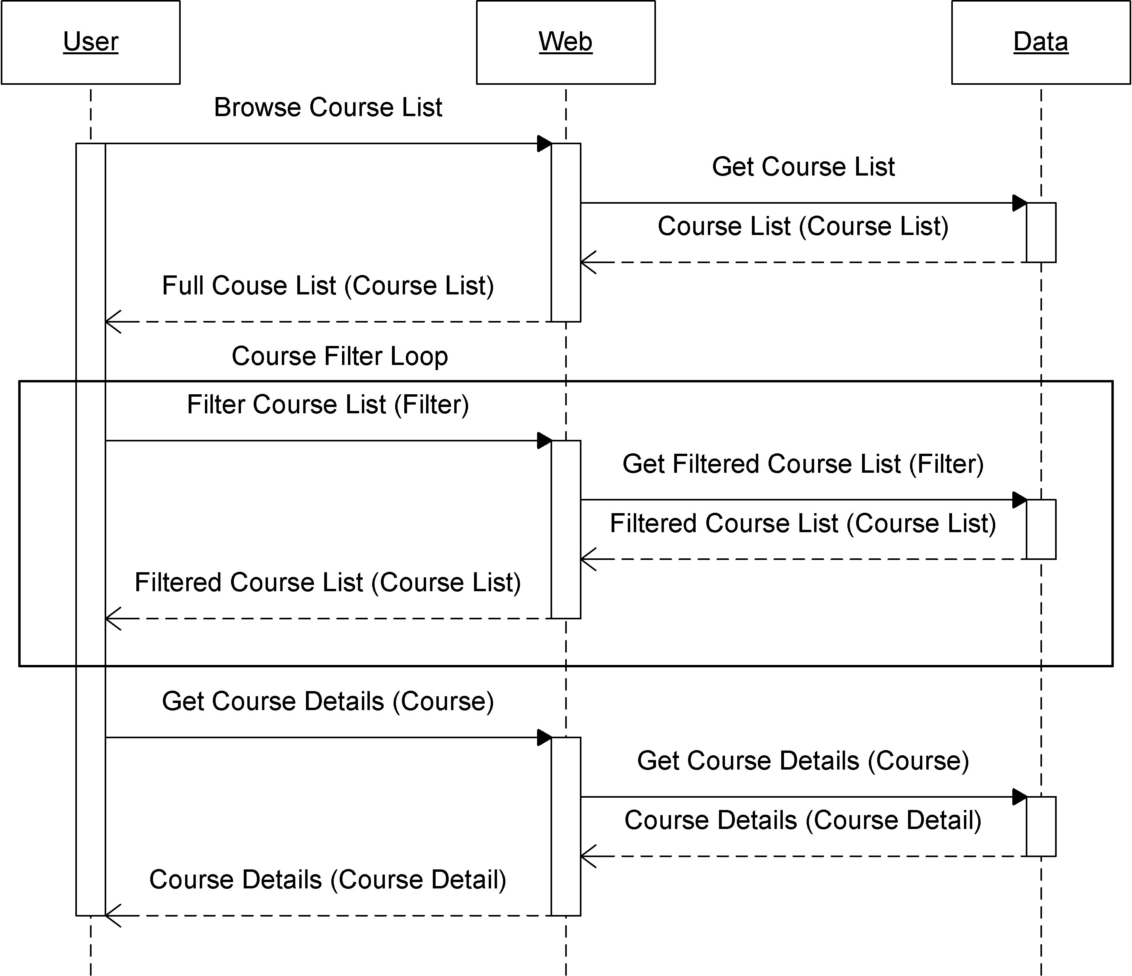
Figure 20.1.1-25 - Browse Course List system sequence diagram (SSD1)

The user activates the "Browse Course List" feature causing the application to query the database for all the courses. This list in then returned to the user. The user may filter the list as often as desired. In doing so, the database is queried for a filtered course list which again is returned to the user. Finally, the user selects a course, which causes the system to query the database for the details on the course and returns the result to the user.

Operational Contract 1.1 (CO1.1)

It is important to note that for SSD1, there is only one operational contract – i.e. DBgetCourses. This function is not limited by a number of courses and can therefore be used to get all courses, get a select few courses or simply get one course.

Name: | DBgetCourses()
Related Use Case: | View Courses, View Sequence, View Schedule, Generate Schedule
Preconditions: | - A table of courses exists in the database
Post Conditions: | - List of courses is retrieved from database

Generate Schedule (Advanced)

System Sequence Diagram 2 (SSD2)

Figure 20.2.1 shows the system sequence diagram for the Generate Schedule (Advanced) use case (UC11).

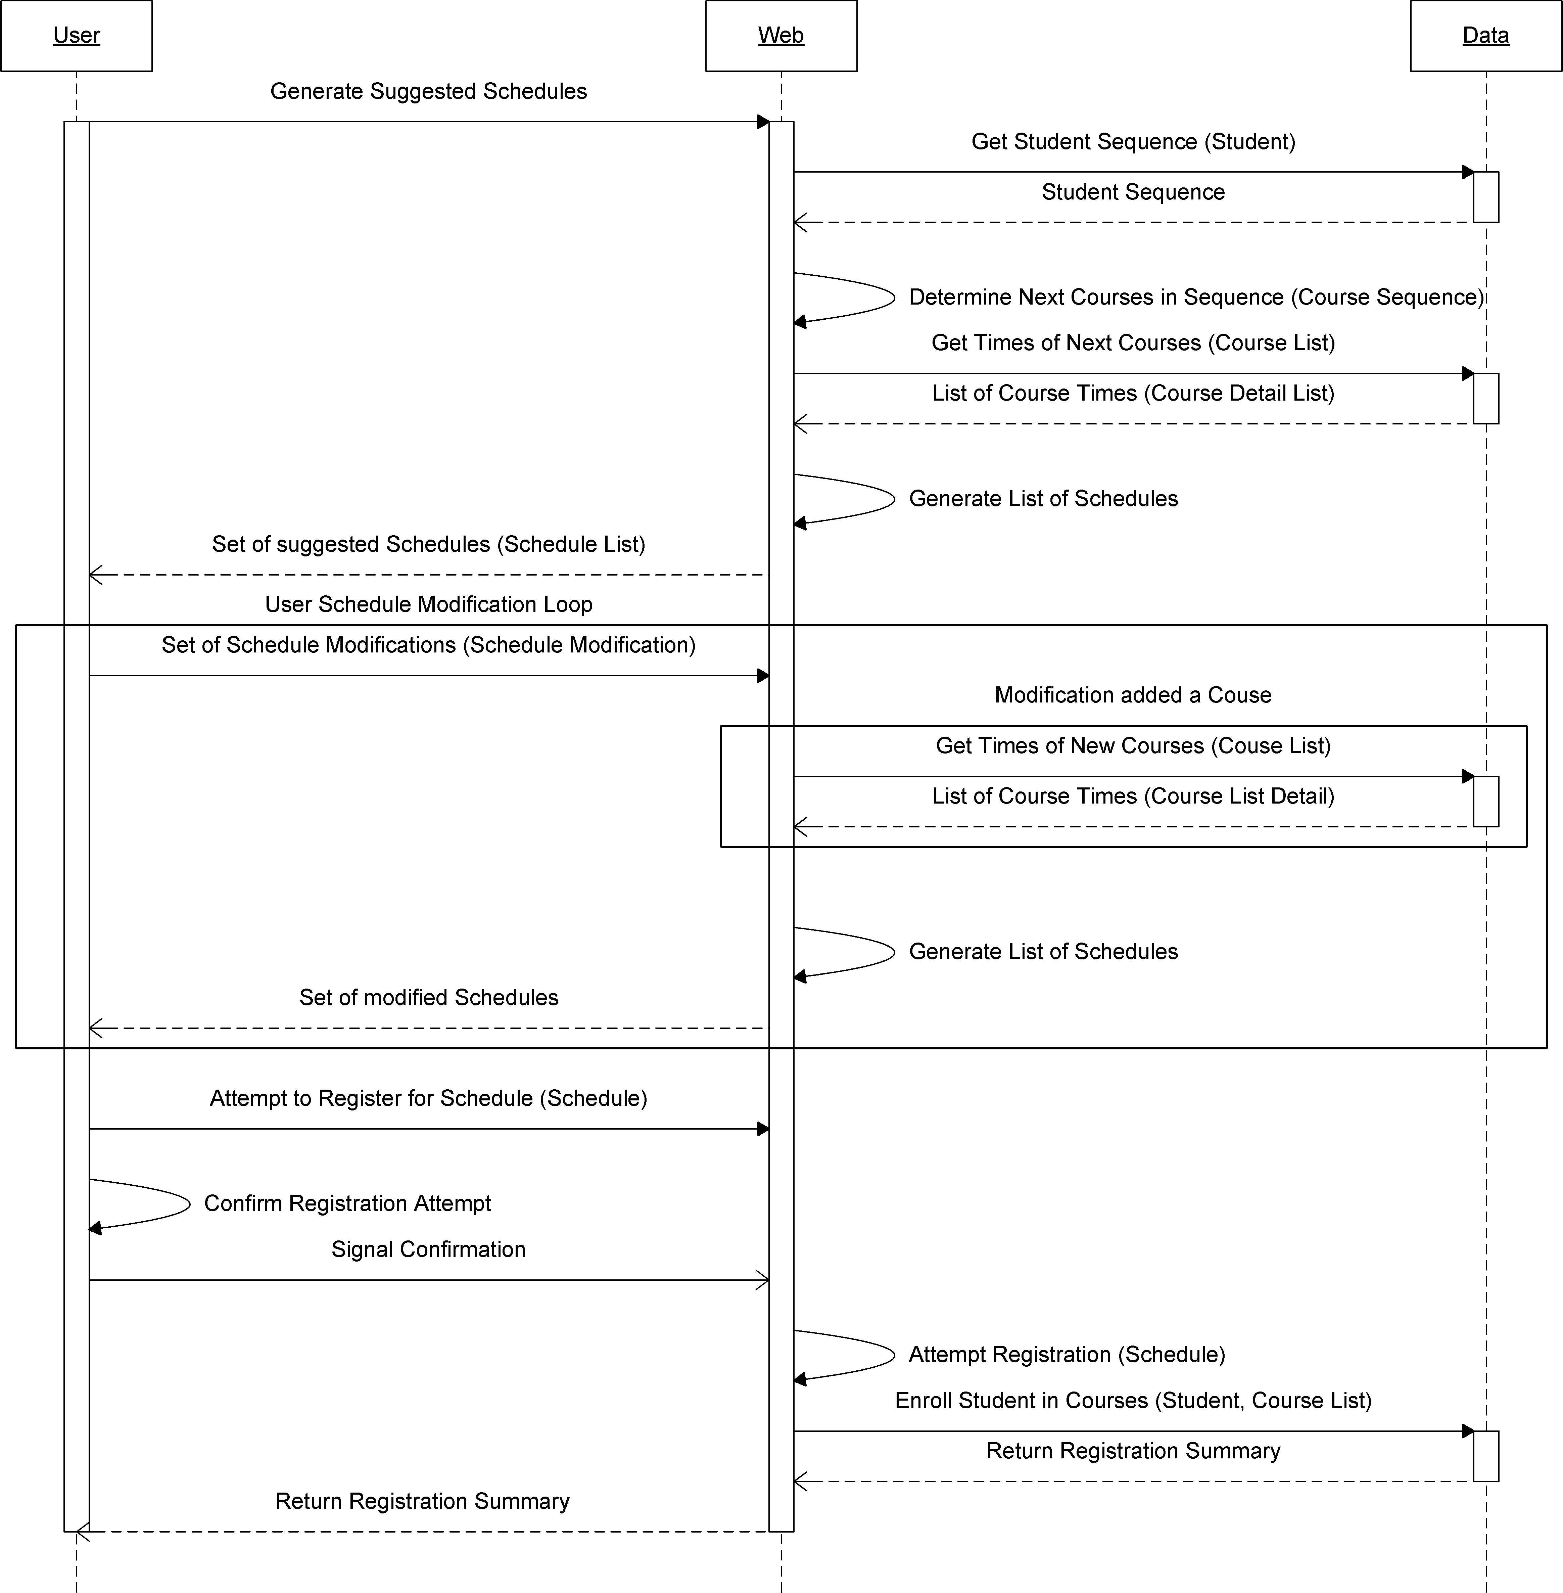

Figure 20.2.1-26 - Generate Schedule (Advanced) system sequence diagram (SSD2)

The user activates the "Generate Schedule" feature causing the application to query the database for the student’s sequence. The sequence is then used to determine the courses the student must take next. The database is queried for the timeslots of these courses. All of the possible schedules generated using these courses are then returned to the user.

The user may make modifications to the suggested list of courses as often as desired. Upon doing so, the database is queried for the timeslots of any new courses selected. A new set of generated schedules in returned to the user. The user then selects one and confirms it.

The confirmation is sent to the system, which then attempts the registration and records it in the database. The database returns the summary of all registrations and failures - if any – to the application and the application returns this summary to the user.

Operational Contract 2.1 (CO2.1)

Name: | DBgetStudentRecord()
Related Use Case: | View academic record
Preconditions: | - User is a valid student logged in to the system
Post Conditions: | - Student object associated with record data

Operational Contract 2.2 (CO2.2)

Name: | DBgetGPA()
Related Use Case: | View academic record
Preconditions: | - User is a valid student logged in to the system
Post Conditions: | - Student object associated with GPA

Operational Contract 2.4 (CO2.4)

Name: | genJSONSchedList()
Related Use Case: | View Courses, View Sequence, View Schedule, Generate Schedule
Preconditions: | - User is logged in to the system  - Student Record is available for the user  - User has requested a schedule to be generated  - Course sequence data is available  - Course data is available
Post Conditions: | - JSON objects instanciated

Operational Contract 2.5 (CO2.5)

Name: | renderSchedule()
Related Use Case: | View Courses, View Sequence, View Schedule, Generate Schedule
Preconditions: | - A list of schedules was generated was provided
Post Conditions: | - Date objects are associated with the WeekCalendar instance.

Operational Contract 2.6 (CO2.6)

Name: | applyFilter()
Related Use Case: | Generate Schedule
Preconditions: | - User is logged in to the system  - User has selected some conditions to filter possible schedules
Post Conditions: | - Course objects instanciated

Operational Contract 2.7 (CO2.7)

Name: | DBcheckSpots()
Related Use Case: | Generate Schedule
Preconditions: | - User is logged in to the system  - User is a valid student  - User selects a valid course to check free spots  - There exists a table in the database with the number of seats in the section
Post Conditions: | - Course object's seatsFree attribute modified

Operational Contract 2.8 (CO2.8) (Scoped out)

Name: | ValidateRegRequest()
Related Use Case: | Generate Schedule
Preconditions: | - User is logged in to the system  - User is a valid student  - User attempts to register for a course
Post Conditions: | - RegRequest object's valid attribute modified

Operational Contract 2.9 (CO2.9) (Scoped out)

Name: | DBregisterStudent()
Related Use Case: | Generate Schedule
Preconditions: | - User is logged in to the system  - User is a valid student  - User attempts to register for a course  - Database table exists for students registered in courses  - Registration request was valid
Post Conditions: | - Student object's registeredIn atribute modified

Miscellaneous

This section covers the operational contracts that are relevant to both system sequence diagrams.

Operational Contract 3.1 (CO3.1)

Name: | validateUsername()
Related Use Case: | Login
Preconditions: | - User attempts to log on to the system
Post Conditions: | - Modified validID, validPW attributes in Authentication object

Operational Contract 3.2 (CO3.2)

Name: | validatePwd ()
Related Use Case: | Login
Preconditions: | - User attempts to log on to the system
Post Conditions: | - Modified validPW attribute in Authentication object

Operational Contract 3.3 (CO3.3)

Name: | Auth()
Related Use Case: | Login
Preconditions: | - Valid user name and passwords were provided by the user
Post Conditions: | - User object instanciated

Operational Contract 3.4 (CO3.4)

Name: | DBgetUsers()
Related Use Case: | Login
Preconditions: | - Database table of users account data exists
Post Conditions: | - User objects are instanciated

Operational Contract 3.5 (CO3.5)

Name: | generateToken()
Related Use Case: | Login
Preconditions: | - User has logged on to the system and has been authenticated
Post Conditions: | - A Unique ID is instanciated

Operational Contract 3.6 (CO3.6)

Name: | giveCookie()
Related Use Case: | Login
Preconditions: | - Authenticated user is logged on to the system  - User's browser supports cookies  - A token has been generated for the user
Post Conditions: | - User object is associated with a unique ID

Operational Contract 3.7 (CO3.7)

Name: | validateCookie()
Related Use Case: | Login
Preconditions: | - User logs on to system  - User has a token from a past log on  - User's browser provides cookie info to the system
Post Conditions: | - User object is instanciated

Operational Contract 3.8 (CO3.8)

Name: | displayError()
Related Use Case: | ALL
Preconditions: | - An error is thrown
Post Conditions: | - Error Object instanciated

Operational Contract 3.9 (CO3.9)

Name: | logEvent()
Related Use Case: | ALL
Preconditions: | - A meaningful state change has occurred in the system
Post Conditions: | - An event object is instanciated

Revision History

The following table contains all official released revisions of the Planzilla application meant for testing. For a full log of all revisions during development, go to the following website http://www.assembla.com/code/team7/git/changesets.

Table 21-12 - Revision History

Date | Version | Description | Author
04/04/2010 | 0.1 | Early Pre-Alpha Release meant to try a first run through tests. Most functionality not present. Build failed testing phase as predicted. | Marc-André, Corey, Julia, Sebastien, Matt, Andreas, Eric, J.B.
06/04/2010 | 0.3 | Added few core functionalities. Database now linked to front-end, displaying correct information. Build still fails during testing for missing functionalities. | Corey, Eric, Matt, Julia, Andreas
09/04/2010 | 0.5 | Added more back-end logic and front-end mock-ups. Fixed bug with database. Build still fails during testing for missing functionalities. | Eric, Corey, Sebastien, Marc
10/04/2010 | 1.0 | Major push to complete back-end logic and front-end. Linked both ends. Build fails for minor functionality issues. | Corey, Eric, Matt, Julia, Andreas, Sebastien, J.B., Marc
10/04/2010 | 1.4111 | Minor bug fix. Build passes testing phases. Official release build. | Corey, Eric, Matt, Julia, Andreas, Sebastien, J.B., Marc

Testing Report

This section contains all information on the testing of the Planzilla web application. The first section is an update on the current status of the testing such as what was tested and the results of these tests. The second section is a description of the performed tests along with all of their test cases.

Test coverage

Tested Items

Note: Latest test reports can be found in Appendix A and B towards the end of this document.

The application was tested for all listed requirements which mean the following group of functionalities were tested if they have met all requirements that were designed from requirements document (for more details on test cases, please consult section 3.2.2):

- Initial Start up (Req. Test cases 1.1.1 to 1.1.4)
High priority. If start up does not work, nothing will work.

- Authentication (Req. Test cases 1.2.1 to 1.2.7)
High priority. It is the basis of data security for user. Also, the application was designed to only enable certain functionalities once user is logged in.

- Schedule viewer (Req. Test cases 1.3.1 to 1.3.4)
High priority. It is one of the main views for the user. Displays all information about current scheduling.

- Room/Professor Schedule (Req. Test cases 1.4.1 and 1.4.2)
Lower priority, but only contains 2 test cases. Helps student choose their courses.

- Course Browsing (Req. Test cases 1.5.1 to 1.5.4)
Medium priority. Helps students find courses and information about the courses.

- Program sequence (Req. Test cases 1.6.1 to 1.6.4)
Medium priority. Helps student find what courses they should take.

- Academic Records (Req. Test cases 1.7.1 to 1.7.3)
Low priority. Allows student to see information about his current and past courses.

- Activity log (Req. Test cases 1.8.1 to 1.8.3)
Low priority. Allows student to see past actions on authentication done from his account.

- Schedule Planner (Req. Test cases 1.9.1 to 1.9.12)
High Priority. The key functionality of planzilla which will save student a lot of time when trying to find a schedule.

- Non-functional requirement (Req. Test cases 2.1 to 2.12)
Medium Priority. Not related to functionality but all test cases are related to the quality of the application.

The result of these tests on the latest build can be seen from the latest Requirement Testing Checklist Report in Appendix A of this document.

Although, implementation is not yet complete, several modules or class have been tested due to their importance in the proper functioning of this application. These are:

- Database module
This module contains all the information needed for the application to work properly such as course information and user information.

- Authentication class
This is the basis of user security for this application. Functionalities such as schedule saving or registration can only be enabled when user is logged in.

- Course class
This class treats all functionalities related to courses such as getting course information, getting course sequence and most important of all, generating course schedules.

- StudentRecord class
This class displays information from student’s transcript such as past courses and current program. This information is necessary for suggestion course schedules.

- Main class
This is the core of the program which connects the front-end and the back-end.

Untested Items of Interest

All important items are actually being tested on each release build. However, smaller classes such as the Schedule viewer, Course Browser, Sequence Planner and Academic Record should also be tested. They do not contain any major logic, they are the layer in which the front-end communicates with; therefore, they are still should be tested for discrepancies in design.

Test Cases

Note: The numbering of test cases in this section has been set to correspond with the same numbering in their checklists.

Unit Testing

This section will describe the testing of the database and the authentication module. Both are essential parts of the application; therefore, they are highest in our unit testing priority. The testing is done using a black box approach: queries are sent to the modules, and a check is done on what is returned by the module. If the result is invalid, the test fails.

For the database, the tests consist of checking if it is able to handle the storing and retrieving of information. As for the authentication module, the tests consist of checking if the module can manage user credentials in a secure manner. More precisely, users need to be able to login, logout and manage user accounts without and issues or insecurities.

The following consists of all the test cases for the database unit testing:

- Design requirement

  - Database handles storing course information such as the department, course number, credits, course description, different classes for the same course with a time and a teacher.

Check if there are tables matching the ER diagrams from the software design document. Using phpmyadmin, it can be verified that there are tables for departments, courses, classes and teachers. The logical links between the tables are also present, with referential integrity enforced in the database. In this case, this means that foreign keys are used between the course and department tables (a course needs to be in a department), between the classes and courses (you can't have a class without a course).

  - Database is able to store student and teacher information.

There are different ways to test this part of the database as described in the higher-level ER diagram. The test was done using a single user table, with a field indicating the type of the user. The user table can store usernames, passwords, and personal information associated with the student or teacher. The test was just to check that these fields were present as indicated in the ER diagram.

  - Database is able to represent teachers teaching different classes and students being registered in different classes.

Check if a table representing the relationship "teachers" between a teacher and a class is present, effectively enabling the representation of teachers teaching more than one class. Also, check if a table representing the relationship "RegisteredIn" is present, enabling a student to be registered in more than one class.

- Implementation Tests

  - Obtaining course information

Using phpmyadmin, the contents of the course table could be listed, which contain all the course information. As the database is being tested, this is a sufficient test to know that the database can be used to obtain course information. If it can't be done in the database, then it can't be done in the front-end either.

  - Obtaining student information

Using phpmyadmin, the contents of the student table could be listed, which contain all student information. A simple mysql query can be built to select a student by its student ID, so that information for a single student is obtained.

- Other Tests

  - SQLInjectMe does not detect any SQL injection points.

SQLInjectMe is a firefox plugin that checks for html forms in a website, and tries common SQL injection attempts agains the various fields of the html forms. It then gives you a summary of the attempted SQL injection attacks, with those that were successful and those that were unsuccessful. For PlanZilla, SQLInjectMe reported no SQL injection success.

  - Nikto does not find any relevant security issues in the web application.

Nikto is a popular web application vulnerability scanner. It works by using a collection of scripts that try to detect all sorts of security flaws in web applications. It then gives you a complete list of anything it could find, usually including a vulnerability ID so that further information can be found (known vulnerabilities are indexed into vulnerability databases, where information is gathered about them, making it easier for security experts to refer to a particular vulnerability and avoid duplication). Usually nikto will also output a lot of false positives, or comments about particularities of the web application that are not necessarily security issues. For instance, if it finds a file called "admin.html", it will output a comment saying that "admin.html" may be a worth a closer look, but it does not imply that vulnerabilities were found in it. For PlanZilla, nikto did not reveal any relevant security issues.

The authentication module test both uses white box and black box approaches for testing. The white box approach is used to check if all requirements from design are present in the module’s code. As to check if the functionalities work and are secure, the black box approach is used by giving an input to the module and check if the module correctly performs the necessary tasks or returns the correct output.

This module is the basis of security in this application since it makes sure that unauthorized users are not able to access and use modules in ways that are not permitted to them. To thoroughly accomplish this, the module needs to be tested for security flaws that can potentially lead to system and data security issues. Google offers such a web application called Skipfish that does exactly this (For more information, visit http://code.google.com/p/skipfish/).

Google created Skipfish to smoke test their web applications before deployment. This tool has been written by the company’s best security engineers. In March 2010, Google decided to make this tool public. By using this, Planzilla can be thoroughly and effectively tested, since all the security flaws that we know of, are being taken into account by this tool. Furthermore, Skipfish was chosen over other publicly available tools, such as Nikto and Nessus, because of following advantages:

- High performance (can achieve 500+ requests/seconds with a very modest CPU, network, and memory footprint)
- Multiplexing single-thread, fully asynchronous network I/O and data processing model that eliminates memory management, scheduling, and IPC inefficiencies present in some multi-threaded clients.
- Smart response caching and advanced server behaviour heuristics are used to minimize unnecessary traffic.
- Smart, up-to-date and active (but hopefully non-disruptive) security checks (Google engineers update this tool almost every day!)

The following list contains all the tests concerning the authentication module including a simplified version of Skipfish’s numerous tests:

- Design requirement

  - The Authentication module can communicate with the Main module and the MySQL database without any issues.
  - The Authentication module forces clients to have proper access rights for each module by requesting them to login using their credentials.

The following tests only checks if the member functions are present in the code. This is to be manually tested by the developer.

  - ValidateCredentials is implemented.
  - ValidateUsername is implemented.
  - ValidatePassword is implemented.
  - CheckUserExistence is implemented.
  - Login is implemented.
  - Logout is implemented.
  - CreateUser is implemented.
  - DeleteUser is implemented.
  - ChangePassword is implemented.
  - $AuthenticationLevel is an implemented as an attribute.

- Implementation Test

For the following test, please refer the design documents for their functionalities. Test if they do exactly what they were designed to do. These should also to be tested by the developer only.

  - ValidateCredentials works as intended by design.
  - ValidateUsername works as intended by design.
  - ValidatePassword works as intended by design.
  - CheckUserExistence works as intended by design.
  - Login works as intended by design.
  - Logout works as intended by design.
  - CreateUser works as intended by design.
  - DeleteUser works as intended by design.
  - ChangePassword works as intended by design.
  - $AuthenticationLevel works as intended by design.

For the following three section, these test cases are automated test by Google’s Skipfish web application. Therefore, details about these tests will not be documented here. For more information about these tests please refer to Skipfish’s website: http://code.google.com/p/skipfish/.

- SkipFish High Risk Security Tests

  - Server-side SQL injection (including blind vectors, numerical parameters)
  - Explicit SQL-like syntax in GET or POST parameters.
  - Server-side shell command injection (including blind vectors).
  - Server-side XML / XPath injection (including blind vectors).
  - Format string vulnerabilities.
  - Integer overflow vulnerabilities.
  - Locations accepting HTTP PUT
- SkipFish Medium Risk Security Tests

  - Stored and reflected XSS vectors in document body (minimal JS XSS support present).
  - Stored and reflected XSS vectors via HTTP redirects.
  - Stored and reflected XSS vectors via HTTP header splitting.
  - Directory traversal (including constrained vectors).
  - Assorted file POIs (server-side sources, configs, etc).
  - Attacker-supplied script and CSS inclusion vectors (stored and reflected).
  - External untrusted script and CSS inclusion vectors.
  - Mixed content problems on script and CSS resources (optional).
  - Incorrect or missing MIME types on renderables.
  - Generic MIME types on renderables.
  - Incorrect or missing charsets on renderables.
  - Conflicting MIME / charset info on renderables.
  - Bad caching directives on cookie setting responses.

- SkipFish Low Risk Security Tests

  - Directory listing bypass vectors.
  - Redirection to attacker-supplied URLs (stored and reflected).
  - Attacker-supplied embedded content (stored and reflected).
  - External untrusted embedded content.
  - Mixed content on non-scriptable subresources (optional).
  - HTTP credentials in URLs.
  - HTML forms with no XSRF protection.
  - Bad caching directives on less sensitive content.

Requirement Testing

This section contains all test cases that were derived from the requirements identified during the design phase. The tests are divided into two subsections. One for functional requirements which are derived directly use cases from the design document. The second is for non-functional requirements which are derived from the Quality Standards section of the same document.

- Functional Requirement Test Cases

  - Initial Start Up

    - User is able to launch the web application using a web browser entering this address: https://team7.ath.cx/.
Use a HTML 4.01 compliant browser or higher with JavaScript support.

    - If a non-optimal browser was used to access this application, a warning message will appear but will let user continue. (Scoped out)
Use a browser that uses HTML 4.00 or lower with JavaScript support.

    - If a non-supported browser was used to access this application, this application will display an error and will not launch. (Scoped out)
Use a browser that uses HTML 4.00 or lower without JavaScript support.

    - The application launches successfully and displays the correct initial screen: “View schedule”.

  - Authentication

    - User is able to access a login page or module.
A login module appears at any point in the application.

    - User can enter credentials for login.
Use the following username/password: dummy/0mgh4x

    - If credential is valid, the user will be successfully logged in.
A status comment in the bottom of the screen indicates user login status.

    - If an invalid credential was used, the system will display an error message and ask user to try again.
Use the following usernames/passwords:
dumm/abc → Gives invalid username error.
notadummy/abc → Gives invalid password error.
notadummy/abc123 → Gives invalid username or password error.

    - While being logged in, the users can logout of the application.
Logout button is present and functional while logged in.

    - Accessing "Log out" successfully logs the user out of his account.
Application returns to login screen.

    - After having successfully logged out, the screen no longer display any information related to user's session or account and is taken back to default page.

  - Schedule Viewer

    - View Schedule button is available on the navigation bar.

    - View Schedule page is the default page after logged in.

    - A schedule is displayed on screen.

    - The schedule viewer correctly displays the current saved schedule in user's account. If no schedule has been set, that should also be reflected correctly on the viewer. (Scoped out registering functionality)

  - Room / Professor Schedule (Scoped out)

    - From the Schedule Viewer, user can access specific room and professor schedules.

    - The Schedule viewer displays the schedule correctly.

  - Course Browsing

    - Browse Course List is available on the navigation bar.

    - Clicking on Browse Course List button will display the correct page.

    - From this page, user can select a department and course number from a list.

    - Upon selecting a course, the correct information for that course is displayed. Browsing through courses does not yield any errors.

  - Program Sequence

    - Program Sequence button is available from the navigation bar.

    - Clicking on Program Sequence will display the correct page.

    - A complete list of user's program course sequence is displayed correctly.

    - If the user is not enrolled in a program, an warning should be displayed to inform user that a sequence is not available.

  - Academic Record

    - Academic Record is available from the navigation bar.

    - Clicking on Academic Record will display the correct page.

    - User's academic record page correctly displays previously and currently taken course and displays their grade correctly.

  - Activity Log (Scoped out)

    - Activity Log is available from the navigation bar.

    - Clicking on Activity Log will display the correct page.

    - User's academic record correctly displays logged transactions from user's activity in the system.

  - Schedule Planner

    - Schedule planner is available from the navigation bar.

    - Clicking on Schedule planner will display the correct page.

    - The page contains a Generate Schedule button.

    - Pressing this button will offer user a list of possible schedules.

    - Users are able to cycle through different schedule and choose a specific one.
    - The application will prompt for confirmation when a schedule is selected.

    - Once user has confirmed, the system confirms that the operation was successful.
    - Schedules are displayed correctly on the viewer.

    - While user is selecting schedule, the application offers the option to add time constraint or preferences.

    - Any changes in the constraints are reflected on the schedule viewer.

    - Once a schedule is successfully selected. All changes and scheduling are saved and will be displayed the next time user logs in. (Scoped out)

    - An error is generated if application cannot find a suitable schedule for the user according to his constraints.

- Non-Functional Requirement test cases

  - The application responds quickly. Any regular requests should take less than 2 seconds except for schedule generation. (Req. Section 3.3.1)
Check several functionalities such as clicking through navigation bar, login, logout etc.

  - Generating schedules should not take more than 5 seconds. (Req. Section 3.3.1)
Use the Generate schedule button and measure time of response.

  - The system is user-friendly and intuitive. User should never be lost while navigating through application and can easily find sections. (Req. Section 3.3.2)

  - Each page contains a back button which takes user to the last visited page. (Req. Section 3.3.2) (Scoped out)

  - The system should easily scalable. (Can only be tested by certified a developer. Pass by default if build is released for testing unless indicated otherwise by test lead) (Req. Section 3.3.3)

  - System should support a minimum of 5000 concurrent users. (See Stress testing results) (Req. Section 3.3.3)

  - If system cannot log user in due to large traffic, the application should return an error message to try again later. (Req. Section 3.3.3)

  - System is secure against security threats (see Security Testing results). (Req. Section 3.3.4)

  - User with disabilities should be able to use the application with accessibility features without any problems. (Req. Section 3.3.5)
Run am accessibility application such as the Magnifier or Text-To-Speech. Check if these applications run normally when navigating through Planzilla.

  - The application is printer friendly. Printing any page should not yield unwanted artefacts or extra white pages. (Req. Section 3.3.6)
After having generated a schedule, print the page by using default browser printing function under file menu.

  - User is able to resume a session without losing input data after a wireless connection is lost. (Req. Section 3.3.7)
Navigate through application using a wireless connection. Disconnect and reconnect wireless and check if information has been lost.

  - Application is free from any graphical issues.

Stress testing

There are several moments during the year where the number of users can peak. This is during registration periods. Thousands of students are logged in at the same time to consult course information, register in their courses, or even drop them as they change their mind. Students often will constantly try to change schedule to match their needs. They will constantly check the availability for class availability changes and therefore, they will be using the application several times before they are satisfied. This kind of situation involves the following operations being stressed in particular: browsing courses, obtaining available classes for a course, registering in courses, generating possible schedules, etc. In other words, all functionalities of the system will be heavily in demand.

These situations can be tested by setting up a server in a controlled environment, in LAN with 4 other computers. Each computer would have gigabit network cards, and would be connected together with a gigabit router. The goal here is to reduce network latency to almost nothing. This setup will allow each computer, simulating a heavy load of students, to not lag down while trying to flood the server with hundreds of thousands of queries.

The test will be performed using a PERL script that simulates users using the system, through the use of libcurl (a library for various web operations that are normally done by a browser). The script will be doing a complete set of operations effectively simulating all sorts of demands that can be done with the web application. The same routine would be done over and over again, with information about the response time for each operation being stored for analysis of the system performance under stress conditions. Also, queries that are faking user interaction won't always be the same (for instance, always querying for the same user). This is to avoid possible caching from the server that would enable it to react better than it would have had in a real life situation. A single PERL script ran on 4 computers would not suffice to take the system down, so the script would be forking the simulation routine somewhere about 10 000 times and running it concurrently on each test computer. Hopefully, that should generate enough stress on the server in order to get valuable results from the stress test.

System Delivery

This section contains a manual that describe how to properly install Planzilla on a web server and a second manual that informs users how to use the application.

Install Manual

Installation Instructions

Planzilla uses some server software and needs to be configured manually prior to deployment. Before attempting installation, please be sure you have permission to perform all the required tasks and any pertinent information - such as database credentials - to avoid an incomplete or failed installation.

Server Verification & Installation

Planzilla requires the use of the Apache Web Server with support for SSL and PHP 5 as well as MySQL. If you are installing Planzilla on its own machine, you may use a compatible AMP stack – such as XAMPP - or install the software separately. If you have an existing server for deployment, please make sure it is running at least PHP version 5 with support for MySQL. Otherwise you can upgrade to the latest version of PHP. Perl and Python are also required to execute the data mining and database population scripts.

NOTE: Installation of these software packages is beyond the scope of this document. Please refer to the software vendor's homepage for up-to-date versions of the software and installation instructions.

PlanZilla Installation

All the files required for PlanZilla are located in the www directory of the installation bundle. Be sure to extract the contents of the bundle to the appropriate directory of the web server. Also make sure that the directory has permission to execute PHP scripts.

PlanZilla Configuration

You can configure Planzilla by filling in the required values in the Config.php file. An example file named Config.php.example is provided for your convenience and is located in that same directory.

Database Preparation

Against the database, run the setup script dbsetup.sql found in the scripts directory of the installation bundle. One way to go about doing this would be to execute the command "mysql <db> -u <username> -p < scripts/dbsetup.sql" where '<db>' is the name of the mysql database and '<username>' is a valid user with sufficient privileges to modify this database.

Database Population

The purpose of this section is to populate the database with all the required information such as Courses, Course Sections, and Program Sequences. An example script, which will automatically pull data from the Concordia University course listing, is available under the scripts directory of the installation bundle. The script is called generateAll.py. When it is executed, it will generate a file called INITIAL_DB.sql, which is to be loaded manually, as in the previous step.

Deployment

The only way to add a user is through the database. In order to start adding students, the database has been set up with a default user “admin” and a default password “default”.

Congratulations, you have successfully set up Planzilla!

Software Downloads

URIs to the software used throughout the installation process and downloads of the required software can be found at the following homepages.

XAMPP - http://www.apachefriends.org/en/xampp.html

Apache Web Server - http://httpd.apache.org/

PHP - http://php.net/

MySQL - http://www.mysql.com/

Perl - http://www.perl.org/

Python - http://www.python.org/

Instruction Manual

Welcome to Planzilla, this manual will walk you through all of Planzilla features to make your day as a student as easy as it can be. The following is a description of how to use each feature of the PlanZilla web application.

Accessing Planzilla

In order to access the PlanZilla web application, the following must be done:
- Open a compatible web browser*.
- Type this address into the url bar: https://team7.ath.cx/.

*NOTE: This application is guaranteed to work with Internet Explorer 8.0+, Safari 2.0+, Chrome 2.0+ and Firefox 2.0+. Previous versions might be subject to unknown errors.

Login/Logout

If you are a registered user, you have a username and password. When prompted to login, a window will pop up as seen in Figure 23.2.2.

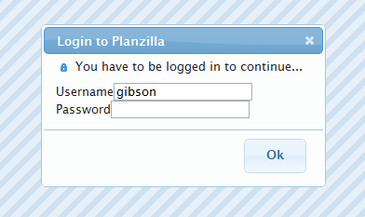

Figure 23.2.2-27 - Login Screen

Enter your username and password where required. Then either click on the ‘OK’ button or press enter to login. If this is successful, the window should disappear. If not you will be prompted to try again.

Navigation Bar

Figure 23.2.3-28 - PlanZilla navigation bar

The navigation bar consists of five tabs, as seen in Figure 2. Each tab contains its own function. By clicking on a tab, access to that specific function is gained. If the user is logged in, the logout button will also be displayed in the navigation bar.

View Schedule

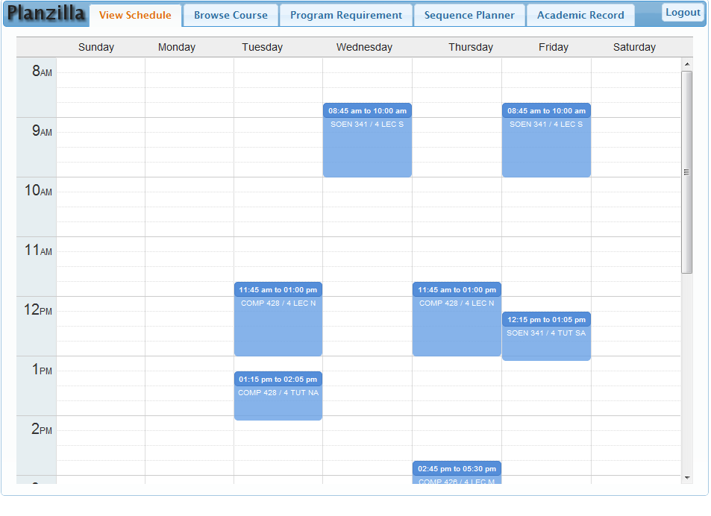
Figure 23.2.4-29 - View schedule screenshot

When the View Schedule tab is clicked, the user gains access to the currently registered schedule as seen in Figure 23.2.4-1.

Browse Course

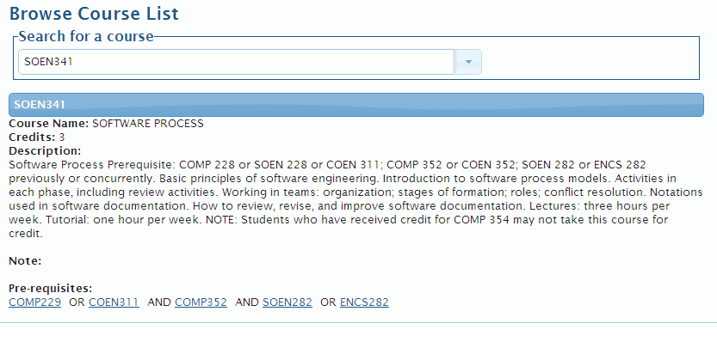

Figure 23.2.5-30 - Browse course screenshot

When the Browse Course tab is clicked, the user gains access to all course information. To view information for a specific course, select the course you wish to view from the drop down box.

The course information will be loaded. To view another course within the same department, simply type in the new course name or code.

Program Requirement

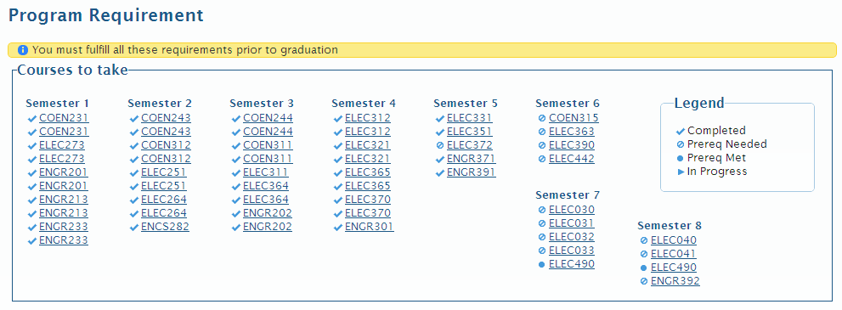
Figure 23.2.6-31Program Requirement screenshot

When the Program Requirement tab is clicked, the user gains access to the course sequence for their registered program.

Sequence Planner

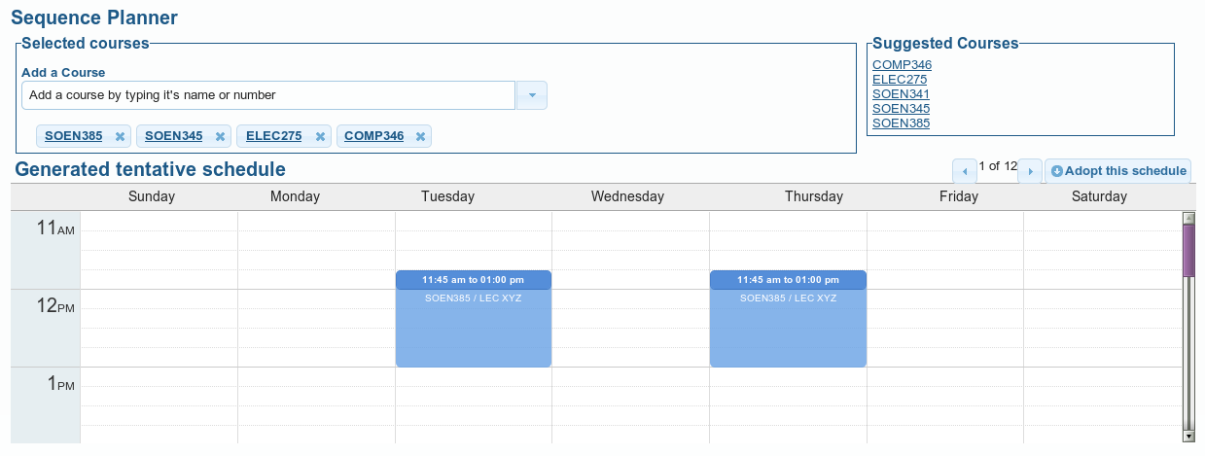
Figure 23.2.7-32- Sequence Planner Screenshot

When the Sequence Planner tab is clicked, the user gains access to the schedule generator.

Adding /Removing a course

Upon accessing the Sequence Planner tab, the user is provided with a list of suggested courses to register for. These courses are taken from the user’s program’s specific course sequence. To add a course:

- Type the name or code of the course.
- Select the course you wish to view.
- Click the ‘Add’ button.

To remove a course, click on the ‘Delete’ button that is shaped in the form of an X.

Cycling through Schedules

PlanZilla may provide user with more than one suggested schedule. To cycle through this schedule the left and right arrows on the top right of the schedule viewer.

Adding/Removing constraints

The user can add constraints such to the schedule so that the generator will know not to add a course during this time.

- Select a timeslot on the calendar by clicking at the start time and dragging until the end time.
- A window should appear. Type in the name of the constraint.
- Either click on the ‘Ok’ button or press enter.

To remove a constraint, click on the ‘Delete button in the shape of an X.

Generate Schedule

Once all of the courses have been added, click on the ‘Generate Schedule’ button. The user can then use the left and right arrow buttons to view the different schedule options when more than one are available.

Academic Record

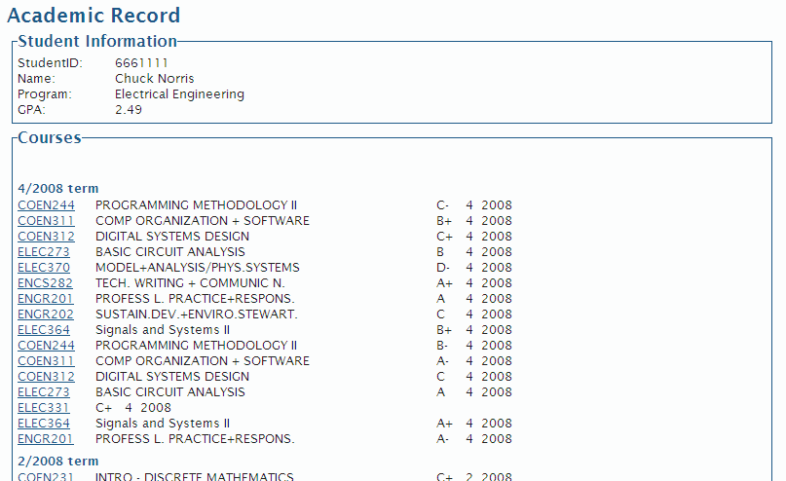

Figure 23.2.8-33- Academic Record Screenshot

When the Academic Record tab is clicked, the user gains access to all of their academic information. This includes their program, their GPA, their past courses – along with their corresponding grade – and their currently registered courses.

Appendix A – Latest Requirement Test Report

PLANZILLA REQUIREMENT & QA CHECKLIST
 |  |  |  |  |  |  |  |  |  |  | Checklist version 1.0.5
Build Version: |  | 1.4111 |  |  |  |  | Tested by: |  | Phuong-Anh-Vu Lai
 |  |  |  |  |  |  | Date : |  | 070410
Test platform: |  | Windows 7 - Google Android
Additional Info:
Test Status: |  |  | FAIL - Build fails for multiple requirement issues.
Build Status: |  |  | To be revised by developpers.
Comments: |  |  | Pre-release alpha testing build.
Section 1 : Functional Requirements
These test cases are related to actual functionalities within the application. They can be tested while using the application normally. Each case is related to a corresponding user case. For more detail about the test consult the related user case from the Scope, Requirement and Plan document. |  |  |  |  |  |  |  |  |  |  | Pass
Case ID | Test Description |  |  |  |  |  |  |  | Related UC |  | Result
1.1 | Initial Start Up |  |  |  |  |  |  |  |  |  | Pass
1.1.1 | User is able to launch the web application using a web browser entering this address : (https://team7.ath.cx/) |  |  |  |  |  |  |  | UC1 |  | Pass
1.1.2 | If a non-optimal browser was used to access this application, a warning message will appear but will let user continue. |  |  |  |  |  |  |  | UC1 |  | N/A
1.1.3 | If a non-supported browser was used to access this application, this application will display an error and will not launch. |  |  |  |  |  |  |  | UC1 |  | N/A
1.1.4 | The application launches succesfully and displays the correct initial screen : View schedule. |  |  |  |  |  |  |  | UC1 |  | Pass
1.2 | Authentication |  |  |  |  |  |  |  |  |  | Pass
1.2.1 | User is able to access a login page or module. |  |  |  |  |  |  |  | UC2 |  | Pass
1.2.2 | User can enter credentials for login. |  |  |  |  |  |  |  | UC2 |  | Pass
1.2.3 | If credential is valid, the user will be succesfully logged in. |  |  |  |  |  |  |  | UC2 |  | Pass
1.2.4 | If an invalid credential was used, the system will display a error message and ask user to try again. |  |  |  |  |  |  |  | UC2 |  | Pass
1.2.5 | While being logged in, the user can logout from the application. |  |  |  |  |  |  |  | UC3 |  | Pass
1.2.6 | Accessing "Log out" sucessfully logs the user out of his account. |  |  |  |  |  |  |  | UC3 |  | Pass
1.2.7 | After having succesfully logged out, the screen no longer display any information related to user's session or account and is taken back to default page. |  |  |  |  |  |  |  | UC3 |  | Pass
1.3 | Schedule Viewer |  |  |  |  |  |  |  |  |  | Pass
1.3.1 | View Schedule button is available on the navigation bar. |  |  |  |  |  |  |  | UC4 |  | Pass
1.3.2 | View Schedule page is the default page after logged in. |  |  |  |  |  |  |  | UC4 |  | Pass
1.3.3 | A schedule is displayed on screen. |  |  |  |  |  |  |  | UC4 |  | Pass
1.3.4 | The schedule viewer correctly displays the current saved schedule in user's account. If no schedule has been set, that should also be reflected correctly on the viewer. |  |  |  |  |  |  |  | UC4 |  | Pass
1.4 | Room / Professor Schedule |  |  |  |  |  |  |  |  |  | Pass
1.4.1 | From the Schedule Viewer, user can access specific room and professor schedules. |  |  |  |  |  |  |  | UC5 |  | N/A
1.4.2 | The Schedule viewer displays the schedule correctly. |  |  |  |  |  |  |  | UC5 |  | N/A
1.5 | Course Browsing |  |  |  |  |  |  |  |  |  | Pass
1.5.1 | Browse Course List is available on the navigation bar. |  |  |  |  |  |  |  | UC6 |  | Pass
1.5.2 | Clicking on Browse Course List button will display the correct page. |  |  |  |  |  |  |  | UC6 |  | Pass
1.5.3 | From this page, user can select a departement and course number from a list. |  |  |  |  |  |  |  | UC6 |  | Pass
1.5.4 | Upon selecting a course, the correct information for that course is displayed. Browsing through courses does not yield any errors. |  |  |  |  |  |  |  | UC6 |  | Pass
1.6 | Program Sequence |  |  |  |  |  |  |  |  |  | Pass
1.6.1 | Program Sequence button is available from the navigation bar. |  |  |  |  |  |  |  | UC7 |  | Pass
1.6.2 | Clicking on Program Sequence will display the correct page. |  |  |  |  |  |  |  | UC7 |  | Pass
1.6.3 | A complete list of user's program course sequence is displayed correctly. |  |  |  |  |  |  |  | UC7 |  | Pass
1.6.4 | If the user is not enrolled in a program, an warning should be displayed to inform user that a sequence is not available. |  |  |  |  |  |  |  | UC7 |  | Pass
1.7 | Academic Record |  |  |  |  |  |  |  |  |  | Pass
1.7.1 | Academic Record is available from the navigation bar. |  |  |  |  |  |  |  | UC8 |  | Pass
1.7.2 | Clicking on Academic Record will display the correct page |  |  |  |  |  |  |  | UC8 |  | Pass
1.7.3 | User's academic record page correctly displays previously and currently taken course and diplays their grade correctly. |  |  |  |  |  |  |  | UC8 |  | Pass
1.8 | Activity Log (Scoped out) |  |  |  |  |  |  |  |  |  | N/A
1.8.1 | Activity Log is available from the navigation bar. |  |  |  |  |  |  |  | UC8 |  | N/A
1.8.2 | Clicking on Activity Log will display the correct page |  |  |  |  |  |  |  | UC8 |  | N/A
1.8.3 | User's academic record correctly displays logged transactions from user's activity in the system. |  |  |  |  |  |  |  | UC8 |  | N/A
1.9 | Schedule Planner |  |  |  |  |  |  |  |  |  | Pass
1.9.1 | A Schedule planner is available from the navigation bar. |  |  |  |  |  |  |  | UC9 |  | Pass
1.9.2 | Clicking on Schedule planner will display the correct page. |  |  |  |  |  |  |  | UC9 |  | Pass
1.9.3 | The page contain a Generate Schedule button. |  |  |  |  |  |  |  | UC9 |  | Pass
1.9.4 | Pressing this button will offer user a list of possible schedules. |  |  |  |  |  |  |  | UC9 |  | Pass
1.9.5 | User is able to cycle through different schedule and choose a specific one. |  |  |  |  |  |  |  | UC9 |  | Pass
1.9.6 | The application will prompt for confirmation when a schedule is selected. |  |  |  |  |  |  |  | UC9 |  | N/A
1.9.7 | Once user has confirmed, the system confirms that the operation was sucessfull. |  |  |  |  |  |  |  | UC9 |  | N/A
1.9.8 | Schedules are diplayed correctly of the viewer. |  |  |  |  |  |  |  | UC11 |  | Pass
1.9.9 | While user is selecting schedule, the application offers the option to add time constraint or preferences. |  |  |  |  |  |  |  | UC11 |  | Pass
1.9.10 | Any changes in the constraints and preferences are reflected on the schedule viewer. |  |  |  |  |  |  |  | UC11 |  | Pass
1.9.11 | Once a schedule is succesfully selected. All changes and scheduling are saved and will be displayed the next time user logs in. |  |  |  |  |  |  |  | UC11 |  | N/A
1.9.12 | An error is generated if application cannot find a suitable schedule for the user according to his constraints. |  |  |  |  |  |  |  | UC11 |  | Pass
Section 2 : Non-Functional Requirements
This section contains qualitative requirements and is not tied with a specific funtionality. Should these test fail at any point in the application, it automatically fails. |  |  |  |  |  |  |  |  |  |  | Pass
Case ID | Test Description |  |  |  |  |  |  |  |  | Result
2.1 | The application responds quickly. Any regular requests should take less than 2 seconds except for schedule generation. (Req. Section 3.3.1) |  |  |  |  |  |  |  |  | Pass
2.2 | Generating schedules should not take more than 5 seconds. (Req. Section 3.3.1) |  |  |  |  |  |  |  |  | N/A
2.3 | The system is user-friendly and intuitive. User should never be lost while navigating through application and can easilly find sections. (Req. Section 3.3.2) |  |  |  |  |  |  |  |  | Pass
2.4 | Each page contain a back button which takes user to the last visted page. (Req. Section 3.3.2) |  |  |  |  |  |  |  |  | N/A
2.5 | The system should easily scalable. (Can only be tested by certified a developper. Pass by default if build is released for testing) (Req. Section 3.3.3) |  |  |  |  |  |  |  |  | Pass
2.6 | System should support a minimum of 5000 concurrent users. (See Stress testing results) (Req. Section 3.3.3) |  |  |  |  |  |  |  |  | Not tested
2.7 | If system cannot log user in due to large traffic, the application should return a error message to try again later. (Req. Section 3.3.3) |  |  |  |  |  |  |  |  | Not tested
2.8 | System is secure against security threats (see Security Testing results). (Req. Section 3.3.4) |  |  |  |  |  |  |  |  | Pass
2.9 | User with disabilities should be able to use the application with accessibility features without any problems. (Req. Section 3.3.5) |  |  |  |  |  |  |  |  | Pass
2.10 | The application is printer friendly. Printing any page should not yield unwanted artifacts or extra white pages. (Req. Section 3.3.6) |  |  |  |  |  |  |  |  | Pass
2.11 | User is able to resume a session without losing input data after a wireless connection is lost. (Req. Section 3.3.7) |  |  |  |  |  |  |  |  | Pass
2.12 | The application is free from graphical issues. |  |  |  |  |  |  |  |  | Pass

Appendix B – Latest Unit Testing Reports

PLANZILLA UNIT TESTING CHECKLIST
 |  |  |  |  |  |  |  |  |  |  |  |  |  |  | Checklist version 1.0.0
COMPONENT : |  | Authentication
Compon. Version: |  |  | 1.0.0 |  |  |  |  |  | Tested by: |  |  | Andreas Eminidis & Phuong-Anh-Vu Lai
Build Version: |  |  | 0.3.0 |  |  |  |  |  | Date : |  |  | 070410
Test platform: |  |  | Windows 7 – Chrome – Notepad - SkipFish
Additional Info: |  |  | PASS - Authentication Module passes tests for build 0.3.0
Section 1 : Design Requirement
This section contains test cases related to the presence of requirement and functionalities of the module as described in the design document.
Case ID | Test Description |  |  |  |  |  |  |  |  |  |  |  |  |  | Result
1.1 | The Authentication module can communicate with the Main module and the MySQL database without any issues |  |  |  |  |  |  |  |  |  |  |  |  |  | Pass
1.2 | The Authentication module forces clients to have proper access rights for each module by requesting them to login using their credentials. |  |  |  |  |  |  |  |  |  |  |  |  |  | Pass
1.3 | ValidateCredentials is implemented. |  |  |  |  |  |  |  |  |  |  |  |  |  | Pass
1.4 | ValidateUsername is implemented. |  |  |  |  |  |  |  |  |  |  |  |  |  | Pass
1.5 | ValidatePassword is implemented. |  |  |  |  |  |  |  |  |  |  |  |  |  | Pass
1.6 | CheckUserExistence is implemented. |  |  |  |  |  |  |  |  |  |  |  |  |  | Pass
1.7 | Login is implemented. |  |  |  |  |  |  |  |  |  |  |  |  |  | Pass
1.8 | Logout is implemented. |  |  |  |  |  |  |  |  |  |  |  |  |  | Pass
1.9 | CreateUser is implemented. |  |  |  |  |  |  |  |  |  |  |  |  |  | Pass
1.10 | DeleteUser is implemented. |  |  |  |  |  |  |  |  |  |  |  |  |  | Pass
1.11 | ChangePassword is implemented. |  |  |  |  |  |  |  |  |  |  |  |  |  | Pass
1.12 | $AuthenticationLevel is a implemented as a attribute. |  |  |  |  |  |  |  |  |  |  |  |  |  | Pass
Section 2 : Implementation Test
This section contains test cases related to the actual functionality of the module. List all functions and related functionalities and test if they work as intended. These will test if they accept correct input and yield the corresponding right output. If applicable, error handling functionalities such as incorrect inputs should also be listed.
Case ID | Test Description |  |  |  |  |  |  |  |  |  |  |  |  |  | Result
2.1 | ValidateCredentials works as intended by design. |  |  |  |  |  |  |  |  |  |  |  |  |  | Pass
2.2 | ValidateUsername works as intended by design. |  |  |  |  |  |  |  |  |  |  |  |  |  | Pass
2.3 | ValidatePassword works as intended by design. |  |  |  |  |  |  |  |  |  |  |  |  |  | Pass
2.4 | CheckUserExistence works as intended by design. |  |  |  |  |  |  |  |  |  |  |  |  |  | Pass
2.5 | Login works as intended by design. |  |  |  |  |  |  |  |  |  |  |  |  |  | Pass
2.6 | Logout works as intended by design. |  |  |  |  |  |  |  |  |  |  |  |  |  | Pass
2.7 | CreateUser works as intended by design. |  |  |  |  |  |  |  |  |  |  |  |  |  | Pass
2.8 | DeleteUser works as intended by design. |  |  |  |  |  |  |  |  |  |  |  |  |  | Pass
2.9 | ChangePassword works as intended by design. |  |  |  |  |  |  |  |  |  |  |  |  |  | Pass
2.10 | $AuthenticationLevel works as intended by design. |  |  |  |  |  |  |  |  |  |  |  |  |  | Pass
Section 3,4 and 5 : Security Test
These tests cases are derived from Google's Security Testing Web application Skipfish.
Case ID | Test Description |  |  |  |  |  |  |  |  |  |  |  |  |  | Result
3 | High risk flaws (potentially leading to system compromise) |  |  |  |  |  |  |  |  |  |  |  |  |  | Pass
3.1 | Server-side SQL injection (including blind vectors, numerical parameters) |  |  |  |  |  |  |  |  |  |  |  |  |  | Pass
3.2 | Explicit SQL-like syntax in GET or POST parameters. |  |  |  |  |  |  |  |  |  |  |  |  |  | Pass
3.3 | Server-side shell command injection (including blind vectors). |  |  |  |  |  |  |  |  |  |  |  |  |  | Pass
3.4 | Server-side XML / XPath injection (including blind vectors). |  |  |  |  |  |  |  |  |  |  |  |  |  | Pass
3.5 | Format string vulnerabilities. |  |  |  |  |  |  |  |  |  |  |  |  |  | Pass
3.6 | Integer overflow vulnerabilities. |  |  |  |  |  |  |  |  |  |  |  |  |  | Pass
3.7 | Locations accepting HTTP PUT |  |  |  |  |  |  |  |  |  |  |  |  |  | Pass
4 | Medium risk flaws (potentially leading to data compromise) |  |  |  |  |  |  |  |  |  |  |  |  |  | Pass
4.1 | Stored and reflected XSS vectors in document body (minimal JS XSS support present). |  |  |  |  |  |  |  |  |  |  |  |  |  | Pass
4.2 | Stored and reflected XSS vectors via HTTP redirects. |  |  |  |  |  |  |  |  |  |  |  |  |  | Pass
4.3 | Stored and reflected XSS vectors via HTTP header splitting. |  |  |  |  |  |  |  |  |  |  |  |  |  | Pass
4.4 | Directory traversal (including constrained vectors). |  |  |  |  |  |  |  |  |  |  |  |  |  | Pass
4.5 | Assorted file POIs (server-side sources, configs, etc). |  |  |  |  |  |  |  |  |  |  |  |  |  | Pass
4.6 | Attacker-supplied script and CSS inclusion vectors (stored and reflected). |  |  |  |  |  |  |  |  |  |  |  |  |  | Pass
4.7 | External untrusted script and CSS inclusion vectors. |  |  |  |  |  |  |  |  |  |  |  |  |  | Pass
4.8 | Mixed content problems on script and CSS resources (optional). |  |  |  |  |  |  |  |  |  |  |  |  |  | Pass
4.9 | Incorrect or missing MIME types on renderables. |  |  |  |  |  |  |  |  |  |  |  |  |  | Pass
4.10 | Generic MIME types on renderables. |  |  |  |  |  |  |  |  |  |  |  |  |  | Pass
4.11 | Incorrect or missing charsets on renderables. |  |  |  |  |  |  |  |  |  |  |  |  |  | Pass
4.12 | Conflicting MIME / charset info on renderables |  |  |  |  |  |  |  |  |  |  |  |  |  | Pass
4.13 | Bad caching directives on cookie setting responses. |  |  |  |  |  |  |  |  |  |  |  |  |  | Pass
5 | Low risk issues (limited impact or low specificity) |  |  |  |  |  |  |  |  |  |  |  |  |  | Pass
5.1 | Directory listing bypass vectors. |  |  |  |  |  |  |  |  |  |  |  |  |  | Pass
5.2 | Redirection to attacker-supplied URLs (stored and reflected). |  |  |  |  |  |  |  |  |  |  |  |  |  | Pass
5.3 | Attacker-supplied embedded content (stored and reflected). |  |  |  |  |  |  |  |  |  |  |  |  |  | Pass
5.4 | External untrusted embedded content. |  |  |  |  |  |  |  |  |  |  |  |  |  | Pass
5.5 | Mixed content on non-scriptable subresources (optional). |  |  |  |  |  |  |  |  |  |  |  |  |  | Pass
5.6 | HTTP credentials in URLs. |  |  |  |  |  |  |  |  |  |  |  |  |  | Pass
5.7 | HTML forms with no XSRF protection. |  |  |  |  |  |  |  |  |  |  |  |  |  | Pass
5.8 | Bad caching directives on less sensitive content. |  |  |  |  |  |  |  |  |  |  |  |  |  | Pass

PLANZILLA UNIT TESTING CHECKLIST
 |  |  |  |  |  |  |  |  |  |  |  |  |  |  |  |  | Checklist version 1.0.0
COMPONENT : |  | Database
Compon. Version: |  | 1.5.0 |  |  |  | Tested by: |  |  |  |  | Marc-André Moreau & Phuong-Anh-Vu Lai
Build Version: |  | 1.411 |  |  |  | Date : |  |  |  |  | 100410
Test platform: |  | Multiple platforms - Windows 7/Linux - Firefox/Chrome
Additional Info: |  | PASS – Database module is functioning as intended.
Section 1 : Design Requirement
This section contains test cases related to the presence of requirement and functionalities of the module as described in the design document. (List all of them or major groups if too many)
Case ID | Test Description |  |  |  |  |  |  |  |  |  |  |  |  |  |  |  | Result
1.1 | Database handles storing course information such as the department, course number, credits, course description, different classes for the same course with a time and a teacher. |  |  |  |  |  |  |  |  |  |  |  |  |  |  |  | Pass
1.2 | Database is able to store student and teacher information. |  |  |  |  |  |  |  |  |  |  |  |  |  |  |  | Pass
1.3 | Database is able to represent teachers teaching different classes and students being registered in different classes. |  |  |  |  |  |  |  |  |  |  |  |  |  |  |  | Pass
Section 2 : Implementation Test
This section contains test cases related to the actual functionality of the module. List all functions and related functionalities and test if they work as intended. These will test if they accept correct input and yield the corresponding right output. If applicable, error handling functionalities such as incorrect inputs should also be listed.
Case ID | Test Description |  |  |  |  |  |  |  |  |  |  |  |  | Result
2.1 | Obtaining course information |  |  |  |  |  |  |  |  |  |  |  |  | Pass
2.2 | Obtaining student information |  |  |  |  |  |  |  |  |  |  |  |  | Pass
Section 3 : Other Test
Feel free to add more section if necessary to have a well rounded test checklist that checks your module.
Case ID | Test Description |  |  |  |  |  |  |  |  |  |  |  |  | Result
3.1 | SQLInjectMe does not detect any SQL injection points |  |  |  |  |  |  |  |  |  |  |  |  | Pass
3.2 | Nikto does not find any relevant security issues in the web application |  |  |  |  |  |  |  |  |  |  |  |  | Pass

