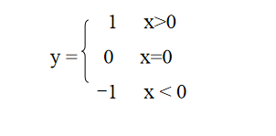
1.
Samples:
Input:
1
Output
1

Input:
-4
Output
-1

Input
0
Output
0

//if ...else

Leap Year Judgment
Description:Input a year, determine whether it is a leap year.

A year is a leap year if:
It is divisible by 4 but not divisible by 100, OR
It is divisible by 400.
Samples:
Input:
2024
Output:
2024 is a leap year.

Input:
2000
Output:
2000 is a leap year.

Input:
1900
Output:
1900 is not a leap year.

- //Nested if
Game Character Class Judgment
Enter three values of a character: Strength, Agility, Intelligence (each from 0 to 10).Determine the character’s class according to the following rules:
If Intelligence ≥ 8 → Mage
If Strength ≥ 8 → Warrior
If Agility ≥ 8 → Ranger
If at least two attributes are ≥ 6 → Omniknight
Otherwise → Civilian
Sample Input & Output
Input:5 5 9
Output:Class: Mage

Sample Input & Output 2
Input:7 7 4O
utput:Class: Omniknight

Sample Input & Output 3
Input:3 4 5
Output:Class: Civilian

