Recursive function
[basics]
- to calculate x to the power of n^{th}
- to display Fibonacci series
- To get the minimum number
- To return the number of digits of an integer
- to display a positive number in a reverse order.
- to return the sum of an array.
- to return the sum of each digits of a positive integer
- To return the length of a cstring
- Binary Search {19,28,31,33,35,40,45}

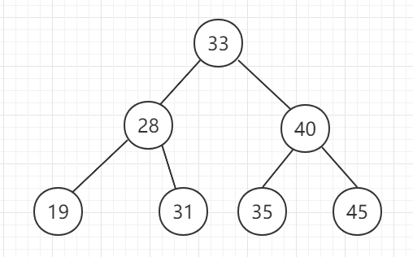

[Comprehensive practice]

Please input several positive integers into array a, end input when user type -1
Save all the prime numbers of a into another array b.
output the sorted prime numbers of b.

Input : 3 5 1 13 78 93 2 11 4 9 7 -1
Output: 2 3 5 7 9 11 13

