## Title: Measuring Impact of Natural Events

## Snopysis

This analysis measures the impact of natural events. The two metrics used to measure the impact of the natural events are fatalities and economic damage.

## Data Processing

require("data.table")

## Loading required package: data.table

setwd("C:/Users/Eric.Kim/Desktop/TSA Files/Coursera/Reproducible Research/Assignment 2")  
  
#read bz2 file  
storm<-read.csv("repdata-data-StormData.csv.bz2")  
  
#aggregate fatalities by event  
storm<-data.table(storm)  
setkey(storm, EVTYPE)  
health<-data.frame(storm[,sum(FATALITIES), by=EVTYPE])  
names(health)[1]<-"event"  
names(health)[2]<-"fatalities"  
health<-health[with(health, order(-fatalities)),]  
health<-head(health,20)

#convert storm from data table to data frame  
storm<-data.frame(storm)  
  
#Transform the costs data by multipling by thousands or millions. The reason for the transformation   
#is to add the crop and property damage as total costs  
storm$CROPDMG2<-ifelse(storm$CROPDMGEXP=='K', storm$CROPDMG*1000,   
 ifelse(storm$CROPDMGEXP=='M', storm$CROPDMG*1000000, storm$CROPDMG))  
storm$PROPDMG2<-ifelse(storm$PROPDMGEXP=='K', storm$PROPDMG*1000,   
 ifelse(storm$PROPDMGEXP=='M', storm$PROPDMG*1000000, storm$PROPDMG))  
  
#sum damage costs  
storm$damage<-rowSums(storm[,38:39])  
storm<-data.table(storm)  
setkey(storm, EVTYPE)  
damage<-data.frame(storm[,sum(damage), by=EVTYPE])  
names(damage)[1]<-"event"  
names(damage)[2]<-"damage"  
damage<-damage[with(damage, order(-damage)),]  
damage<-head(damage,20)

## Results

The most destructive natural events are tornados. They caused the most fatalities and economic damage is Tornado, resulting in 5,633 deaths and causing $52B in damages.

### Events Most Harmful to Public Health

#display to 20 fatal events  
health

## event fatalities  
## 834 TORNADO 5633  
## 130 EXCESSIVE HEAT 1903  
## 153 FLASH FLOOD 978  
## 275 HEAT 937  
## 464 LIGHTNING 816  
## 856 TSTM WIND 504  
## 170 FLOOD 470  
## 585 RIP CURRENT 368  
## 359 HIGH WIND 248  
## 19 AVALANCHE 224  
## 972 WINTER STORM 206  
## 586 RIP CURRENTS 204  
## 278 HEAT WAVE 172  
## 140 EXTREME COLD 160  
## 760 THUNDERSTORM WIND 133  
## 310 HEAVY SNOW 127  
## 141 EXTREME COLD/WIND CHILL 125  
## 676 STRONG WIND 103  
## 30 BLIZZARD 101  
## 350 HIGH SURF 101

#plot fatalities by event   
library(ggplot2)  
ggplot(health, aes(event, fatalities))+geom_bar(stat="identity")+theme(axis.text.x = element_text(angle = 90, hjust = 1))+ggtitle("Events Most Harmful to Public Health")

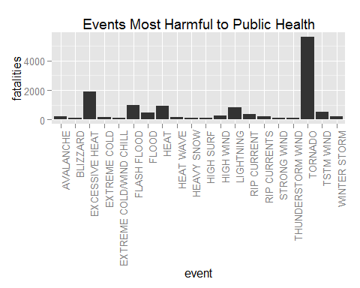

Figure Description: The figure above lists the top 20 events that have caused the most fatalities

### Events with the Greatest Economic Damage

#display events that cause the most economic damaging   
damage

## event damage  
## 834 TORNADO 5.204e+10  
## 170 FLOOD 2.782e+10  
## 244 HAIL 1.695e+10  
## 153 FLASH FLOOD 1.656e+10  
## 95 DROUGHT 1.352e+10  
## 402 HURRICANE 8.910e+09  
## 856 TSTM WIND 5.039e+09  
## 411 HURRICANE/TYPHOON 4.904e+09  
## 359 HIGH WIND 4.609e+09  
## 957 WILDFIRE 4.021e+09  
## 427 ICE STORM 3.967e+09  
## 760 THUNDERSTORM WIND 3.898e+09  
## 848 TROPICAL STORM 3.232e+09  
## 786 THUNDERSTORM WINDS 1.924e+09  
## 972 WINTER STORM 1.715e+09  
## 955 WILD/FOREST FIRE 1.609e+09  
## 290 HEAVY RAIN 1.428e+09  
## 140 EXTREME COLD 1.361e+09  
## 212 FROST/FREEZE 1.104e+09  
## 310 HEAVY SNOW 1.067e+09

#graph economic damage  
ggplot(damage, aes(event, damage))+geom_bar(stat="identity")+theme(axis.text.x = element_text(angle = 90, hjust = 1))+ggtitle("Events that Cause the Most Economic Damage")

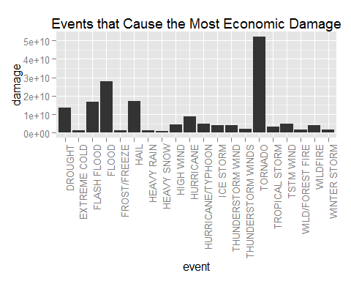

Figure Description: The figure above lists the top 20 events that have caused the most economic damage