The VAST 2017 Mini Challenge 1:  
Mystery at Lekagul Preserve – The Pipits Kick It

Hiloni Mehta  
Information Sciences and Technology

Rochester Institute of TechnologyRochester USA  
[hm1691@rit.edu](mailto:hm1691@rit.edu)

Xiaofu Jin

Computing and Information Science

Rochester Institute of Technology

Rochester USA

[xj7572@rit.edu](mailto:xj7572@rit.edu)

Edward Rao

Information Sciences and Technology

Rochester Institute of Technology

Rochester USA

[er9427@rit.edu](mailto:er9427@rit.edu)

***Abstract* -** **The main goal of the mini challenge 1 is to find patterns-of-life and analyze the provided trajectories to visualize the regular patterns, large term patterns and unusual behavior and patterns of the vehicles and nature preserve visitors. The data provided includes the description of how traffic through the preserve is and how the traffic is measured through the sensors. We have focused on developing visualizations based on the questions stated in the VAST mini challenge 1. We combined our imagination with the data types, different visualization techniques and tools to draw out the visualizations which are interactive, explanatory and appealing to the user’s eyes. The data analyzed helps find out the reasons for the decline in Rose Crested Blue Pipit in the Lekagul Nature Preserve. Our study has also suggested future aspects of the work done based on the results.**

***Keywords— visual analysis, spatio-temporal data, heatmap analysis***

# **INTRODUCTION**

# The Vast Challenge 2017 is all about dealing with challenges faced due to environmental issues which are potentially caused by human patterns of life as well as by the chemically laden effluent plumes being emitted from factory smokestacks. This problem was solely stated when a post-doc student, Mitch realized there was a potential threat with the decreasing nesting pairs of the Rose-Crested Blue Pipit, a popular local bird. This visual analysis challenge is focused on finding patterns through the movement of vehicles through a preserve park and how the preserve works to look for the causes that result in the decline of the rose crested blue pipit bird’s population.

# **DATA PREPROCESSING AND EXPLORATION**

In this challenge our data primarily revolved around the Lekagul Sensor Data csv file that contained all the information for traffic passing through various checkpoints located around the reserve. The data consists of the id, date/time, and car type columns. Our preprocessing involved adjusting the data to fit the visualizations we wanted to move towards making. For some, we included only data from certain car types, and for others only cars with unique ids that showed up multiple times were included. We also had to adjust some of the dates to fit a standardized format. For one of our observations, we had to roughly estimate the speed based on the time differences from checkpoints and the approximate distance displayed on the complimentary map provided. An important aspect of the data exploration involved visually representing the information in the csv onto the map of the reserve, which helped immensely in understanding zones of control and potential areas of pollution.

# **VISUAL ANALYTICS**

## **Seasonal Patterns**

Visitors, especially campers, visit the reserve more frequently in warmer seasons like late spring, summer and early fall. These days are in the same period of time when the birds breed, which indicates that disturbing breeding of birds could be one possible reason for the decreased number of them. Particularly, in summer, for certain days, campers may have big activities with more than 40 people at one camping area. The expecting loud noise may also frighten the birds.

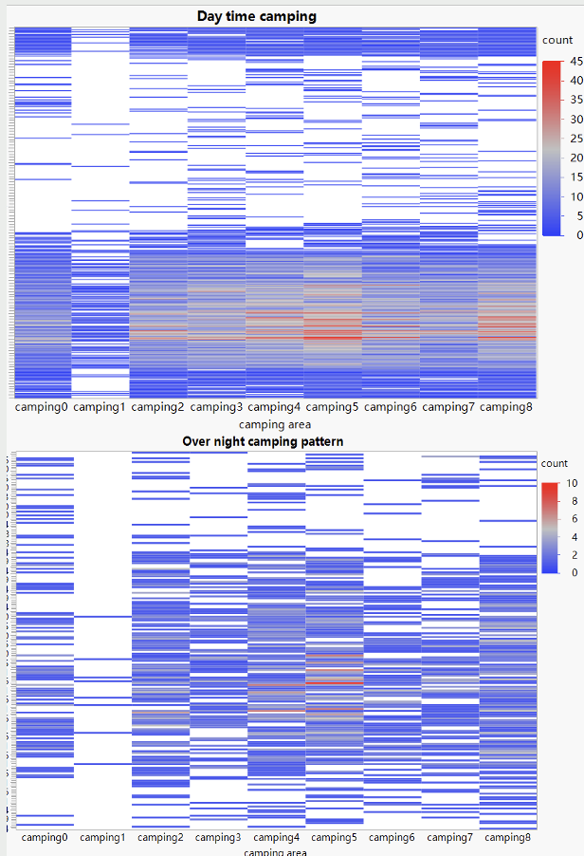

*Figure 01: Heatmap showing Seasonal Camping Patterns*

## **Repeating Patterns**

The primary long-term pattern revolves around the frequency of car visits to the reserve, and how these activities over time could affect the pipits. Car trends reveal that several unique cars have repeatedly visited the park, with trucks showing up during one part of late July numerous times. As for the rangers who reside/work on the “campus” daily, they are generally concentrated in the Ranger-stop locations that are inaccessible to the public as well as the gates bordering the ranger base (aka gates 8, 5, etc). Finally, the areas near the entrances, particularly in the northern path, have high concentrations of vehicle activity, and particular attention may have to be paid in these parts of the reserve.

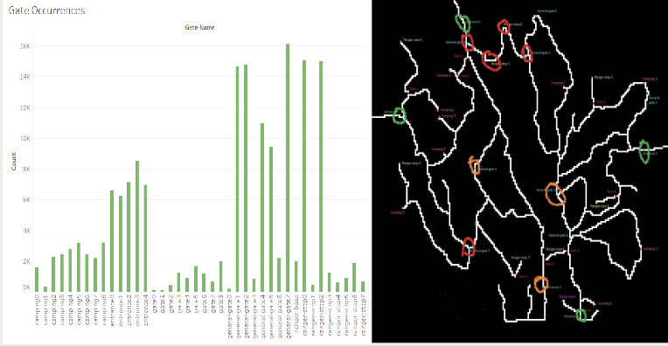

*Figure 02: Visualization of Repeating Gate Occurances of Vehicles*

## **Unusual Patterns**

## The individuals have been seen visiting the preserve early in the morning from 5am to 8am. This behavior shows some potential suspect behavior. It may be an early tourist spot to visit. Heatmap Analysis from Tableau results show unusual activity based on the visits more likely in the ranger stops or to the general gates rather than campsite visits (Figure 03).

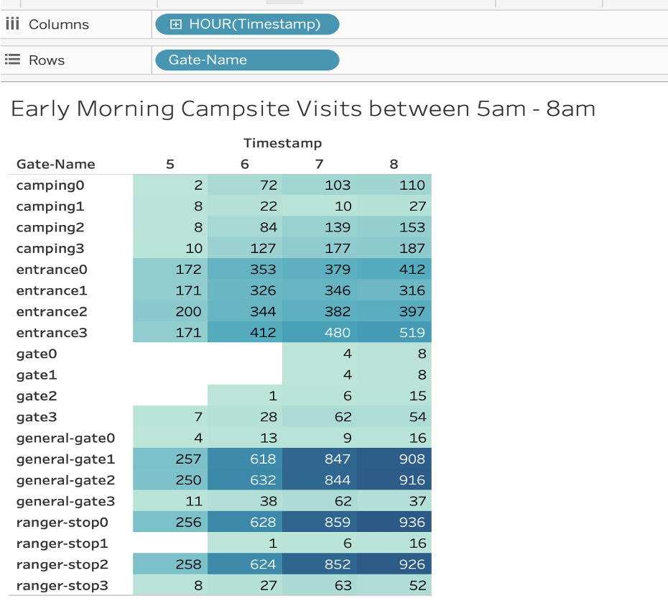

*Figure 03: Count of Early Morning Campsite Visitors*

In figure 04, another suspicious activity seen was on July 20th, two Car Type 01 vehicles followed each other and with stops and between different gates within seconds of each other. Two cars might be following each other for fun or must’ve lost their way. The campers must be following each other since they must’ve been planning on some activity together that may lead to any harm to the Pipits.

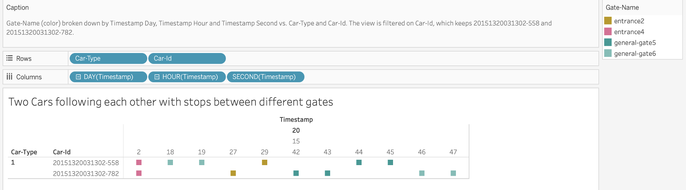

*Figure 04: Illegitimate Car Route Pattern*

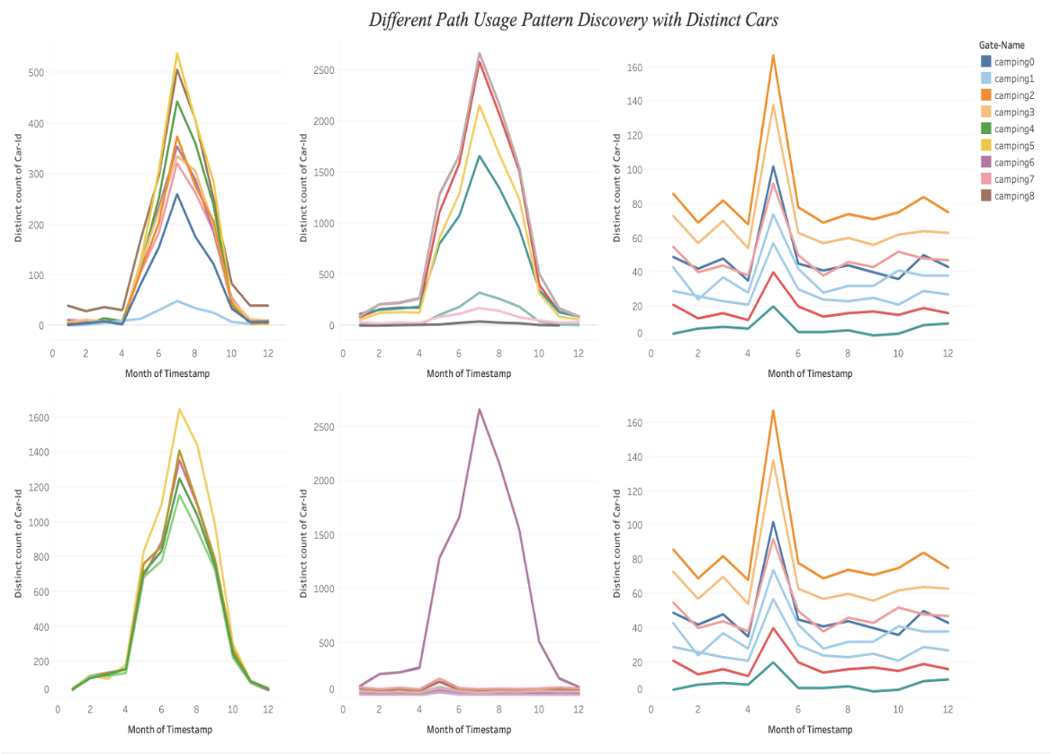

*Figure 05: Visualization of Different Path Usage by different vehicles*

In this interactive dashboard (Figure 05), it is seen that various paths are the least popular in some months but the most popular path in the month of July. This is unusual because the preserve is divided into two sides which is only connected by routes that are not allowed for the general public.

# **CONCLUSION**

After analyzing the data, we found several interesting events. This could be the result of any unusual activity or the noise resulting from this activity could pose a potential threat to bird habitat and activities, particularly if the birds nested in the areas of the preserve and park. We also found that if the campsites are nearby to the nesting areas, this activity may also lead to decline in bird population.

Our tools and visualizations helped us analyse patterns. Tableau and other tools played a great role in understanding patterns of trajectories followed by vehicles and finding unusual patterns. In this way, Visual Analytics has proved to be quite essential in this significant study to find solutions to the VAST challenge and draw interactive visualizations from the rich data sets.

For future work, we may generate more life patterns to investigate other factors which could impact the preserve. And we have considered non-interactive dashboards, we could consider showing different transitions based on the timestamp and relevant attributes. Moreover, we could integrate data from the other Challenges to reinforce and expand on our conclusions.

##### **REFERENCES**

1. M. A. Whiting et al., "VAST Challenge 2017: Mystery at the Wildlife Preserve," 2017 IEEE Conference on Visual Analytics Science and Technology (VAST), 2017, pp. 173-178, doi: 10.1109/VAST.2017.8585503.
2. A. Gupta, V. R. Chikka and K. Karlapalem, "VAST Mini-Challenge 1," 2017 IEEE Conference on Visual Analytics Science and Technology (VAST), 2017, pp. 221-222, doi: 10.1109/VAST.2017.8585677.
3. D. Kirilov, I. Lindmae, A. Burks, C. Ma and G. E. Marai, "MC1: A Bespoke Analysis Tool for Spatio-temporal Park Traffic Data," 2017 IEEE Conference on Visual Analytics Science and Technology (VAST), 2017, pp. 235-236, doi: 10.1109/VAST.2017.8585624.
4. A. Tuladhar, S. Malla, G. J. Quadri and P. Rosen, "Data Aggregation and Visualization Technique for Traffic Sensor Data," 2017 IEEE Conference on Visual Analytics Science and Technology (VAST), 2017, pp. 239-240, doi: 10.1109/VAST.2017.8585568.