Understanding of ATM (Automated Teller Machine) in

Bangladesh

A Thesis

Submitted to the Department of Computer Science and

Engineering

Of

BRAC University

By

Md. Mosabber Hossain

ID: 02201014

Md. Razwanul Bari

ID: 02201020

In partial fulfillment of the requirements for the degree

Of

Bachelor of Computer Science and Engineering

May 2006

DECLARATION

I hereby declare that this thesis is based on the results found by me and my partner (Md. Rezwanul Bari Id: 02201020). This thesis has not yet been submitted by any student specially not any BRAC university student.

Signature of

Supervisor

Signature of

Author

ACKNOWLEDGEMENTS

This thesis work has been done for the fulfillment of Bachelor of Computer Science and Engineering in BRAC University.

First of all, I would like to express my heartiest gratitude to Bushra Tawfiq Chowdhury, lecturer of the department of Computer Science and Engineering, for giving me the opportunity to perform my thesis under his supervision.

I would like to gratefully acknowledge Bank Asia, BRAC Bank and HSBC for the total support with documents and the valuable time they spend with us.

ABSTRACT

This report focuses on a clear view of two different working procedure of ATM (Automated Teller Machine) in Bangladesh. Two processes are Core Banking and Consortium of Banks and this conclusion is reached after few surveys to the bank. It has total description how these two systems works and maintained. The Major problem of using ATM is user do not have the information when the ATM machine is off or on. So, if user find it closed after traveling a long distance then it is very much annoying. To support this suggestion, I have built software which can be really helpful to this situation. Besides this few problems like booths limitations, using limitations and transaction limitations were identified in this paper. And few suggestions are mentioned here which is helpful to meet the situation.
 |  | Contents | Pages
1. Introduction |  |  | 1
2. | Embedded System |  | 1
 | 2.1 What is Embedded System? |  | 1
 | 2.2 | Parts of Embedded System | 1
 | 2.3 Figure of Embedded System |  | 1
 | 2.4 | Examples of Embedded System | 2
3. | Automated Teller Machine |  | 2
 | 3.1 What is ATM? |  | 2
 | 3.2 | Internal Structure of ATM | 3
 | 3.3 | Figure of ATM | 4
 | 3.4 | Interactive components of ATM | 5
 | 3.5 | Figure of Interactive Components | 5
4. | Relationship between ATM and embedded system |  | 5
5. | Strip Card |  | 5
 | 5.1 | Magnetic Strip Card | 5
 |  | 5.1.1 What is Magnetic Strip Card? | 6
 |  | 5.1.2 Possible Type of Data stored in Magnetic Strip Card | 6
 |  | 5.1.3 Process of Storing Data in Magnetic Strip Card | 6
 |  | 5.1.4 Algorithm use for Card Number Generation | 6
 | 5.2 | ATM Card | 7
 |  | 5.2.1 What is ATM Card? | 7
 |  | 5.2.1 Possible Data Type in ATM Card | 8
6. | Protocol |  | 8
 | 6.1 | Protocol X.25 | 8
 | 6.2 | Figure of Network Design using X.25 | 8
 | 6.3 | Working Layer of X.25 | 9
7. | Connection |  | 9
 | 7.1 | Connection Type of ATM | 9
8. | Working Process of ATM |  | 10
 | 8.1 | ATM Network Design | 10
 | 8.2 | Figure of Basic ATM Connection | 10
9. | Vendor of ATM |  | 10
 | 9.1 | Hardware Manufacturer of ATM | 10
 | 9.2 | Software Manufacturer of ATM | 11
10. ATM Service Provider in Bangladesh |  |  | 11

11. Survey Report |  |  |  | 11
11.1 Bank Asia |  |  |  | 11
 | 11.1.1 Abstraction |  |  | 11
 | 11.1.2 Ways of Transaction |  |  | 11
 | 11.1.3 Network |  |  | 12
 |  | 11.1.3.1 Network Provider |  | 12
 |  | 11.1.3.2 Bank’s Under This Network |  | 12
 |  | 11.1.3.3 | Connectivity Type | 12
 |  | 11.1.3.3 | Cable Type | 12
 | 11.1.4. Transaction Process |  |  | 13
 |  | 11.1.4.1 Figure of Transaction Process |  | 13
 |  | 11.1.4.2 | Steps of Transaction Process | 13
 | 11.1.5 | Card Number |  | 14
 |  | 11.1.5.1 No of Digit Use |  | 14
 |  | 11.1.5.1 Figure of Card Number Generation |  | 14
11.1.6 | ATM Card Issue |  |  | 15
11.1.6.1 Steps of Issue ATM card |  |  |  | 15
 | 11.1.7 | Software Use by the Bank |  | 15
 | 11.1.8 | Upload Database |  | 15
 |  | 11.1.8.1 Database Upload Time |  | 15
 |  | 11.1.8.2 KNOCK |  | 15
 | 11.1.9 | Report |  | 16
 |  | 11.1.9.1 24 Hours Report |  | 16
 |  | 11.1.9.2 Figure of the Report |  | 16
 | 11.1.10 Other Details |  |  | 17
 |  | 11.1.10.1 Rent |  | 17
 |  | 11.1.10.2 Reloading Money |  | 17
 | 11.1.10.3 Card Validation |  |  | 17
 | 11.1.10.4 ATM Card keeps by ATM Machine |  |  | 17
 | 11.1.10.5 ATM Facilities provided by the bank |  |  | 17
11.1.11 Problems |  |  |  | 18

11.2 BRAC Bank |  | 18
11.2.1 Abstraction |  | 18
11.2.2 Banking System |  | 18
11.2.3 Network |  | 18
11.2.3.1 Network Maintain |  | 18
11.2.3.2 Connectivity Type |  | 18
 | 11.2.3.3 Cable Type | 19
11.2.4. Transaction Process |  | 19
 | 11.2.4.1 Figure of Transaction Process | 19
 | 11.2.4.2 Steps of Transaction Process | 19
11.2.5 Card Number |  | 20
 | 11.2.5.1 No of Digit Use | 20
 | 11.2.5.2 Figure of Card Number Generation | 20
11.2.6 ATM Card Issue |  | 20
11.2.7 Software Use by the BRAC Bank |  | 20
11.2.8 Upload Database |  | 21
11.2.8.1 Database Upload Time |  | 21
11.2.8.2 Reloading Money |  | 21
11.2.8.2.1 Process of Reloading Money |  | 21
11.2.9 | ATM Facilities provided by the bank | 22
12. Problems |  | 22
13. Suggestions |  | 22
17. Conclusion |  | 22
18. References |  | 24

LIST OF FIGURES
Fig 1: Typical Embedded System | 1
Fig2: Shows the Complete Internal Structure. | 3
Fig3: ATM machines | 4
Fig4: Interactive components of ATM | 5
Fig5: X.25 Network Design | 9
Fig6: Basic Connection of ATM | 10
Fig7: Transaction in Network | 13
Fig8: Transaction Process | 19

1. Introduction

ATM stands for Automated teller machine. Presently this is one of the most improvised ways of transaction. As people do not feel comfortable to carry huge amount of money, they use ATMs. By adding new features and also increasing the security issues it may provide more supremacy than it today. As a result life becomes reliable and lighten up. Here in this paper we tried to give a full description, how ATM works and comparisons among the ATM services of different banks in Bangladesh. We also tried to focus few problems and few suggestions how to eliminate these problems.

2. Embedded System

2.1 What is Embedded System?

Embedded system is one that does the same work again and again. It is real-time software that contains component of hardware and software. It may large or small but it does the same work again and again. So, the output we get is really very fast. As it just takes input, process it and give the output.

2.2 Parts of Embedded System

It has mainly two parts:

- Hardware:

Processor, RAM, ASIC etc

- Software:

Now java is used for hardware language.

2.3 Figure of Embedded System
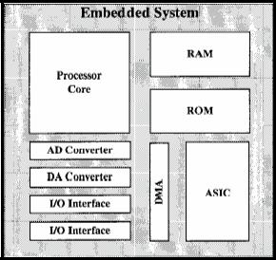

Fig 1: Typical Embedded System

2.4 Examples of Embedded System

Few examples of embedded system

  - Washing Machine

  - Cell Phones

  - Vending Machines

  - Automated Teller Machines

- Automated Teller Machine

3.1 What is ATM?

ATM is Automated Teller Machine. Now it’s making peoples life very easy as they get their money when they need. So, they do not need to carry either big amount of money or the cheque book all the time. To get rid from this burden they need to deposit money in the bank by opening an account and then the bank will be given a Card i.e. an ATM card with a PIN number to them. By using that they can withdraw money from any ATM machine of that bank. When they insert the card in the machine and the PIN number the machine will show few instructions on the screen. By that time verification (PIN Number and Account Number) will be done with the main bank computer as they are connected. If the verification is correct then the user will choose an instruction and the ATM will dispense money to the card holder.

3.2 Internal Structure of ATM

In the following pictures we have the internal structure of two different type of ATM machine.

And also it can be divided into two different parts:

- Upper Unit

- Lower Unit
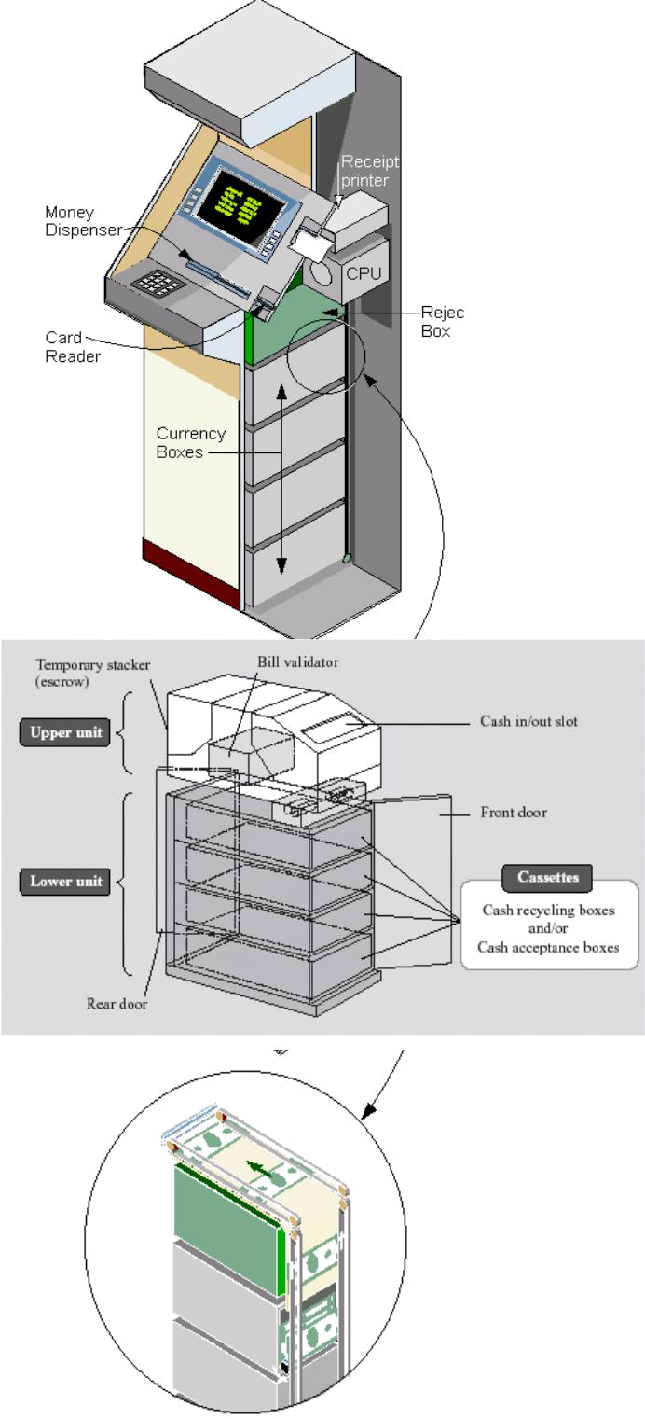

Fig2: Shows the Complete Internal Structure.

In the upper unit it has the CPU that processes and validates customer details by connecting to the bank computer after customer has entered ATM card. This ATM has few layered boxes in the lower unit of it. These boxes are called currency boxes or cassettes where currencies are kept for withdrawal or the deposited money to be kept. A rubber roller is there to check if more than one banknote is moving and also sensor to see that more than one banknote or bill stuck together or not when cash is dispensing. There is a receipt printer as we see in the
figure to print current statistics of the cardholder’s account or every times cardholder withdraws cash.

3.3 Figure of ATM Machines
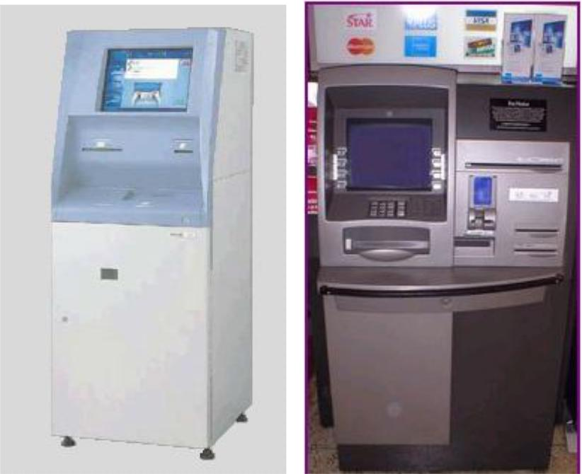

Fig3: ATM machines

3.4 Interactive components of ATM

Card Reader:

Customer inserts their card in it when there is written “Please Insert your card” on the screen.
Keypad:

Use for PIN code input, choices, amount of money etc as the input to the ATM machine.
Display Screen:

This screen shows all the instructions or options for the customers’ convenience.

Screen Buttons:

When options are given on the screen one user can choose any of the options accordingly by the use of button on left or right side of the screen. These buttons select the option from the screen.

Cash Dispenser:

Withdrawal money is given by this slot.

Deposit Slot:

To deposit money this slot is use.

Speaker:

Speaker provides the facilities to the customer by giving auditory feedback.

3.5 Figure of Interactive Components
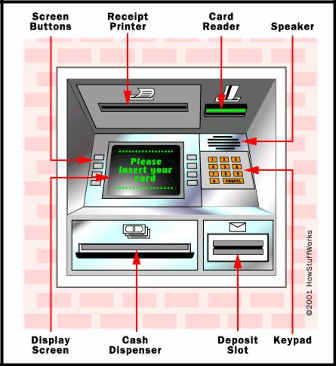

Fig4: Interactive components of ATM

4. Relationship between ATM and embedded system

Automated Teller Machine (ATM) is also an embedded system. Because it does the same work again and again like deposit money, withdraw money etc. For that it gives output very fast. Most importantly it has all the features of an embedded system like processor, RAM etc and also software for user interaction.

5. Stripe Card

5.1 Magnetic Stripe Card

5.1.1 What is Magnetic Stripe Card?

Card with a magnetic stripe serving as a data carrier, with the data being read and stored electronically. In the back of the magnetic strip card there is magnetic strip to hold the information of the cardholder. These magnetic strips mainly have two or three tracks with varying storage capacities.

5.1.2 Possible Type of Data stored in Magnetic Stripe Card

Mainly magnetic strip hold the following information:

Cardholder Name

Card Number / Account Number Expiration Date and
Additional Data if needed

5.1.3 Process of Storing Data in Magnetic Stripe Card

Data in the magnetic strip holds mainly in track one and two. But third track is not always used. Track three mainly intended to support offline Automated Teller Machine (ATM). Once deployed, ATMs are quickly networked.

Magnetic Strip has the data with varying densities. Different encoding techniques are used to store data. An example is given below.

Track |  | Encoding | Density |  | Format |  | Characters |  | Use
1 |  | IATA | 210 BPI |  | Alpha |  | 79 |  | Name
2 |  | ABA | 75 BPI |  | BCD |  | 40 |  | Account
3 |  | THRIFT | 210 BPI |  | BCD |  | 107 |  | Others

Fig: Information stored in magnetic strip

Here with different densities with different data format, data is written to different track. So it can easily be identified by a machine.

5.1.4 Algorithm use for Card Number Generation

LUHN ‘s algorithm is used for card number generation and encoding. It is also called mod 10 algorithms.

Card number must be 13 to 16 digits. And the last digit is the check digit.

To calculate check Digit:

- First drop the last digit from the card number (because that’s what we are trying to calculate)

- Reverse the number

- Multiply all the digits in odd positions (The first digit, the third digit, etc) by 2.

- If any one is greater than 9 subtract 9 from it.

- Sum those numbers up

- Add the even numbered digits (the second, fourth, etc) to the number you got in the previous step
- The checkdigit is the amount you need to add to that number to make a multiple of 10. So if you got 68 in the previous step the check digit would be 2. You can calculate the digit in code using checkdigit = ((sum / 10 + 1) * 10 – sum) % 10

For Credit Card Number Validation use 10 mod Algorithm:

- First step: number is reversed and then every second digit is doubled

Example:

378282246310005

Reverse

5 0 0 0 1 3 6 4 2 2 8 2 8 7 3

second digit

0 0 6 8 4 4 14

- Second step: resulted values will be added to those of which are not multiplied.

  - 5 + (0) + 0 + (0) + 1 + (6) + 6 + (8) + 2 + (4) + 8 + (4) + 8 + (14-9) + 3 = 60

5.2 ATM Card

5.2.1 What is ATM Card?
ATM card is also like magnetic strip card. It is also a data carrier which electronically reads and writes data. ATM card mainly a debit card.

5.2.1 Possible Data Type in ATM Card

Back of the ATM card there is a magnetic strip that holds information of the cardholder. ATM card mainly have two things encoded on it:

- Account Number and

- Some check bytes.

Account number is the number that is given by the bank. And check bytes are arbitrary bytes. That is decided by the bank how it is generated and used.

- Name of the User

- Issue and Expire Date

- Account Number

6. Protocol

6.1Protocol X.25

The protocol use for ATM connection is X.25. It is a packet switch data network protocol which defines an international recommendation for the exchange of data as well as control information between two end systems.

X.25 network devices fall into three general categories:

- Data terminal equipment (DTE).

- Data circuit equipment (DCE).

- Packet switching exchange (PSE).

- DTE devices : PC or network hosts (subscribers)

- DCE devices : modem, packet switches

- PSN : are switches & transfer data to DTE to DTE

6.2 Figure of Network Design using X.25
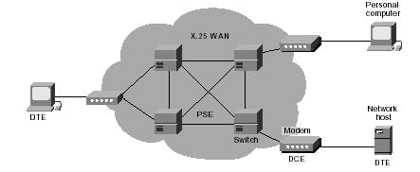

Fig5: X.25 Network Design

6.3 Working Layer of X.25

X.25 works on lower three layers of OSI (open system interconnection) defined by ISO.

– Packet level protocol

    - Similar to data link layer of OSI model

– Link level (Link access procedure balanced)

    - Similar to physical layer of OSI model

– Physical level

    - Similar to physical layer of OSI model

- Connection

7.1 Connection Type of ATM

Different types of ATM Connections:

ATM connections mainly have two types:

- Dial up Connection using Modem

- Leased Line Connection

Dial up connection is mostly used because dial up connection is less costly. But the throughput rate is low as it is not connected all the time.

And Leased Line Connection is mostly use by those where throughput rate high is strongly needed. But it is costly.

- Working Process of ATM

8.1 ATM Network Design

ATM is connected to host computer and the host computer is connected to the Bank Computer. Here the connection network is telephone network that may be leased line or dial up using modem. Some places where Output is very important but the cost is not a factor there leased line is used and the dial up connection is used where cost is important. Host computer mainly work as a gateway between ATM and bank computer. Many ATM’s can be connected through this host computer.

8.2 Figure of Basic ATM Connection
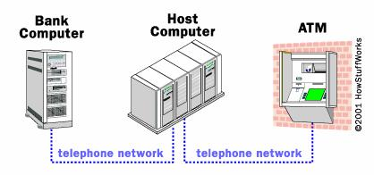

Fig6: Basic Connection of ATM

Basically ATM machines are connected to host computer and host computer is connected to Bank computer. Basically host computer is the third party which maintains all these facilities and equipments. Sometimes ATM machines are directly connected to Bank computer.

9. Vendor of ATM

9.1 Hardware Manufacturer of ATM

The following manufacturers mainly supply the complete ATM’s.

  - NCR

  - IBM (Wincor Nixdorf Partner)

  - KEBA

  - HATEF

  - Diebold

  - Tidel

- Triton

9.2 Software Manufacturer of ATM

Software manufacturer of ATM machines is mainly

  - KAL

- ATM Service Providers in Bangladesh

-Standard Chartered

-HSBC

-BRAC Bank

-Dhaka Bank

-Dutch Bangla Bank

-Bank Asia

- NCC

- Survey Report

11.1 Bank Asia

11.1.1 Abstraction

Bank Asia uses ETN (Electrical Transaction Network) network which is a United International ATM service provider. ETN combined nine banks to give E-Cash services. Network equipments like ATM machine, switches etc are setup by ETN. Also software and networked database are maintained and setup to these bank by ETN. Every morning they send to every bank a report containing all the transactions of the previous day. So, every bank can check that last days transaction is correct. ETN distributed ATM machines to all these banks and every other bank customer can use any of these ATM machines.

11.1.2 Ways of Transaction

In Bank Asia transactions are divided into three main categories

- My bank to others bank

- Others bank to my bank

- My bank to my bank

A customer uses it’s own bank ATM machine.

11.1.3 Network
11.1.3.1 Network Provider

ETN is the network provider to all these nine banks. Total ATM maintenance, equipment facilities are provided by ETN. Also card issue, report etc are provided by ETN.

11.1.3.2 Bank’s Under This Network

This network contains nine banks.

- National Bank Ltd.

- NCC Bank Ltd.

- Dhaka Bank Ltd.

- Social Investment Bank Ltd.

- Islami Bank Ltd.

- Bank Asia Ltd.

- South East Bank Ltd.

- Agroni Bank Ltd.

- Commercial Bank of Cylon Ltd.

11.1.3.3 Connectivity Type

For ATM machines Bank Asia (provided by ETN) uses two types of connections. They use leased line for connection. Bank Asia uses two connection lines because if one line is down immediately other one will be activated within a minute. These connections are:

- DDN (under T&T)

- Metronet

11.1.3.4 Cable Type

Bank Asia (provided by ETN) uses fiber optic cable for ATM connection. As Fiber optic given highest data rate that is why they use this type of connection.

11.1.4. Transaction Process

11.1.4.1 Figure of Transaction Process
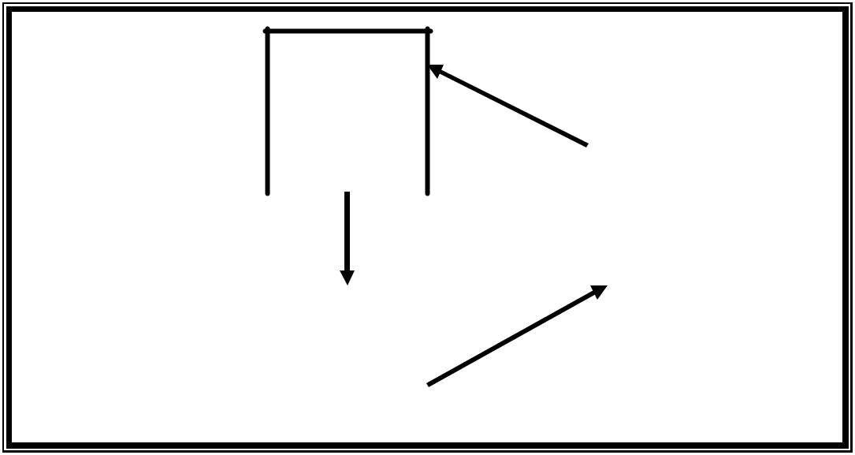  A/C and PIN is | ATM
being checked in | ATM | ETN sends clearance signal
being checked in | Machine | ETN sends clearance signal
ATM machine | Machine | to the ATM machine

 |  |  |  |  | ETN
 | Request for |  |  |  | Server
 | money
 |  | Bank
Debited the amount |  | server
Debited the amount |  | server |  | Send all transaction
from the customers |  |  |  | information to ETN server
A/C

Fig7: Transaction in Network

11.1.4.2 Steps of Transaction Process

Steps of Transaction

  - First customer insert ATM card (E-cash card) into the machine and wait to insert PIN (personal identification number). When both processes are done ATM Machine check account number and PIN for further processing like requesting money to the bank server.
- Bank Server debited the amount of money from the customer account. And update database for that customer account and send all transaction information to ETN server.

- ETN server then update database so that they can send report to the banks. And

then ETN send clearance signal to the ATM machine to dispenser.

∆ After the clearance signal ATM machine dispense money to the customer.

11.1.4 Card Number

11.1.4.1 No. of Digit Uses

Bank Asia uses 18 digit ATM card (provided by ETN). As nine banks under this network so, they divide 18 in five sections for the identification of those banks, account number, branch etc.

Fig: Classification of 18 Digit Number

IIN

First six digits are different for those nine banks. So, ATM machine can easily identify among these banks.

Regional Code

These 3 digits are used to distinguish between different districts

Branch Code

These 3 digits are used to distinguish between different districts

Account Number

These five digits are the account number which differentiate among the user and unique for each user.

Computer Generated

This digit is randomly generated.

11.1.5 ATM Card Issue

11.1.5.1 Steps of Issuing an ATM card

- For ATM/Debit card, every customer has to open an account to that respective bank.

- Need to fill up a requisition form for ATM/Debit card.

1-6 digits | 7-9 digits | 10-12 digits | 13-17 digits | 18 digit
International | Regional code | Branch code | Account number | Computer
Identification |  |  |  | generated
number (IIN)
- Bank officer verify all those fill up information and send a request for ATM/Debit card to the ETN, providing all necessary information. This request is send through the dialup connection to ETN (this request is send to ETN by ABS software).

- ETN issues same E-Cash card for all the banks just embossing the label of the bank, card number, customer name and as well as the expired date.

11.1.6 Software Uses by the Bank

Bank Asia uses ABS (ATM Banking Software) software version 7.0 for keeping track of all ATM transactions as well as other ATM services like new ATM card requisition to ETN, export and import data from ETN etc.

Bank Asia also uses STELAR software to keep or update database of all type of customer like ATM customer or non ATM customer. But this is also connected with ETN

ABS software

File | Setup | Card | Payment | Report | Help

Issue _{Add}
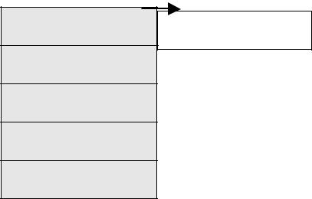

Maintain

Transfer

……………

…………..

Fig: ABS software.

11.1.7 Upload Database

11.1.7.1 Database Upload Time

ETN updates database of the ATM machines after 24 hours at 11:45 pm to 12:00 pm. So these 15 minutes all the ATM transaction remains stop.

11.1.7.2 KNOCK

ETN server will automatically KNOCK the Bank server when and where to upload money in the ATM machine. In this way bank knows where to load money and when.

11.1.9 Report

11.1.9.1 24 Hours Report

ETN provide 24 hours report to every bank in every morning. So, bank can check those reports and verify with their database which is correct or not. In this way, chances of making mistakes are less and also they can easily identify each problem if occurs.

11.1.9.2 Figure of the Report

This report contains all the details of each transaction. For example card number, term number, date, time, account number etc. So, it becomes very easy to track an error and verify.
Card | UTRN | TERM | Date | A/c No | Amount | Acquire | Issuer | Network | Bank Owes
No | no | No | /Time |  |  |  |  | Owes
18 | Refer | Terminal | Time and | Bank | Withdrawn | From | From | Transact | Transaction
Digits | ence | (Booth | Date of | Account | Amount | which | which | ion | made | from
 | No | No) | Transacti | Number |  | ATM | bank | made | it’s | own
 |  |  | on |  |  |  |  | from | banks ATM
 |  |  |  |  |  |  |  | other
 |  |  |  |  |  |  |  | banks
 |  |  |  |  |  |  |  | ATM
 |  |  | Fig: Report | generated | by ETN

Also the report has summary of all the transactions. So, it becomes very easy to check for all these banks.

Summary of Transaction:

Total Transaction ______________

Bank Owes to Network ______________

Network Owes to Bank ______________

Net Payable to Network ______________

From this report each bank can know how much money it owes or how much to pay to network ( If customer of Bank Asia withdraw more money from other banks ATM machines then net payable increases. And if other banks customer withdraw money from Bank Asia’s ATM machines then owes increase.)

11.1.10 Other Details

11.1.10.1 Rent

As ETN provides all the ATM facilities, so Bank Asia needs to pay 7,500/= taka per month for every booth. Same condition is also applied for other banks under this network.

11.1.10.2 Reloading Money

At a time Bank Asia load 20,00000 (twenty lacs taka) in the Principle Office (PO). This amount is same for every other banks.

11.1.10.3 Card Validation

Each Card is valid for 3 years. After 3 years customer needs to renew this card.

11.1.10.4 ATM Card keeps by ATM Machine

If a customer does not take card after transaction within 50 seconds then that card will be automatically captured by the ATM machine and keep in a secured place in the ATM machine.

11.1.10.5 ATM Facilities provided by the bank

Bank Asia provide few facilities

Deposit Money in their account.

Pay land phone bills through ATM machines. Pay electric bills through ATM machines.

- AKTEL

- GrameenPhone

- BangaLink

  - Citycell

Also pay mobile bills through ATM machines.

11.1.11 Problems

Bank Asia has few problems with their ATM machines

Do not have Bangla Interface

ATM booths are not available in every locality

11.2 BRAC Bank

11.2.1 Abstraction

Brac Bank Ltd. is a private limited national bank in our country. Presently they are considering as the fastest growing bank in the country. Basically BRAC Bank uses the application of core banking. They provide all ATM supports by themselves. They have strong IT support and gradually they are increasing their area to support their customer by using ATM machines. As we have said they have very strong IT support that they have 24 hour customer service and always monitor their own network. The software they used is PHONIX SOFT which is they also called as “SWITCHING SOFTWARE”

11.2.2 Banking System
BRAC Bank banking system is Core Banking system. As ATM machines are directly connected to the Bank Server that’s why it is called Core Banking System.

11.2.3 Network

11.2.3.1 Network Maintain

BRAC Bank provides all their ATM network solutions by themselves. They have their own strong IT department and their duty is to look after the entire ATM network through out the whole nation. They do not use any third party company for there ATM support.

11.2.3.2 Connectivity Type

BRAC Bank basically uses the Lease Line connectivity for their entire network system. They also have the backup connectivity option so that if one line goes down then another one will be automatically up within a minute. This gives them tremendous support for their reliable banking services.

11.2.3.3 Cable Type

BRAC Bank mainly uses Fiber Optic as Fiber Optic provides highest data rates.

11.2.4. Transaction Process

11.2.4.1 Figure of Transaction Process
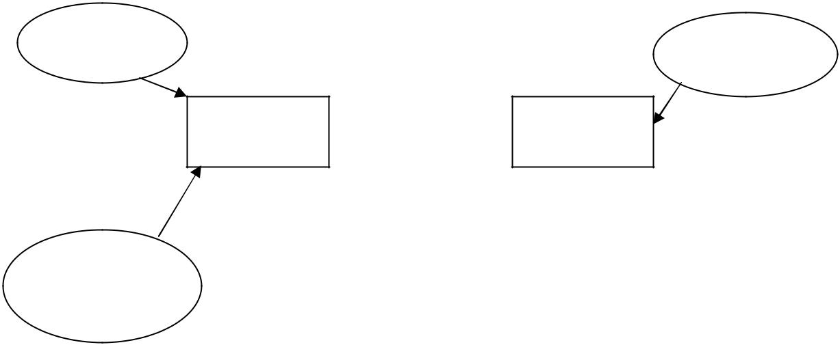

Card and PIN
_{insert} Verify information and send Signal

Send to verify

ATM Machine | Bank SERVER

Responded signal

Choose

Instructions

(withdraw amount,

deposit etc)

Fig8: Transaction Process
11.2.4.2 Steps of Transaction Process

Step1: Customer Insert ATM card and PIN number. Then ATM machines verify account number and PIN number for further processing. If verification is successful, ATM machine takes dispense amount and forward those information and dispense amount to the Bank Server.

Step2: Again Bank Server verifies the amount and if successful sends signal to the ATM machine.

Step3: If the machine gets successful signal from the Bank Server then it dispenses money to the customer. Otherwise on not successful signal machine shows error message.

11.2.5 Card Number

11.2.5.1 No of Digit Uses

BRAC Bank uses 16 digits ATM Card number. Each of this number is unique for each customer. With this number BRAC Bank can easily identify each customer and manages customer account.

11.2.5.2 Figure of Card Number Generation

1- 6 Digit |  | 7-10 Digit | 11 -16 Digit
International | Identification | Branch Code | Account Number
number (IIN)

IIN

First six digits are fixed for BRAC Bank customers. This number is unique for BRAC Bank.

Regional Code

Regional code is used for distinguish between different districts.

Branch Code

Branch Code is a four digit number which represents the branch information. By checking the Branch Code bank can easily identify the customer belongs to which branch.

11.2.6 ATM Card Issues
Card division of BRAC Bank maintains total ATM card issuing system. In BRAC Bank ATM account can be different types. For example

- EAZEE Account or Current Account

- Saving Account

11.2.7 Software Uses by the BRAC Bank

BRAC Bank uses PHONIX software for their total ATM banking system. This software has the option to monitor each ATM machine. So, if an error or any problem might occur they can easily track those. Also log file is generated for each ATM machine which can easily identify the problems.

11.2.8 Update Database

BRAC Bank updates database for ATM machine from around 11.45 pm to 12.00 am. For these 15 minutes all the ATM machines remain closed.

11.2.8.2 Reloading Money

There are basically two modes of the ATM machine.

- User mode or normal mode

- Supervisor mode

To reload money into the ATM machine we have to choose the supervisor mode by pressing a switch which is on the behind of ATM machine.

When you press the switch you will on to the supervisor mode. In the supervisor mode we will find a menu list with different kind of options there. From that menu list we chose the “Daily Service” option to reload money and for any other activities of the daily services.

There mainly three trays for money to deposit.

- Tray One

- Tray Two

- Tray Three.

Before putting money into the ATM machine we need to dispense all the rest of the money which has already existed there. Then in general we put 2000 notes of five hundred taka into the tray one and then in tray two and three we put 1000 notes of five hundred taka each.

After putting money among all these trays, when we inject those trays into the ATM machine, the ATM machine will automatically ask the supervisor how many notes are in which tray.
Then the ATM machine will check both the input figure and the money deposited into the ATM machine.

When the customers want to withdrawal money from the ATM machine then it will not dispense from the one particular tray. It will dispense money from first two tray and third one keep reserve for the backing up of tray two. When tray two is finished its money then tray three is used in place of tray two.

Another interesting option of the ATM machine is the Confidence Test option. It will reshuffle all the money so that notes are not attached together.

11.2.9 ATM Facilities provided by the bank

BRAC Bank provided the following facilities

BRAC Bank ATM machines have Bangla Interface.

Few restaurants and shopping have BRAC ATM service. Also provide ATM service for students.

11.2.10 Problems

>Transaction Limit

  - Booths are Not Available in all places

  - Booths are in open place

  - Not available to restaurants and shopping center

  - ATM booths are not always UP

- Suggestions

  - Increase Security

  - Bangla Interface some more facilities

  - Voice Command for blind people

  - SMS to know ATM booths availability

As we were a two member group, this portion of survey report of HSBC and the rest of the part of software has done by my thesis partner.

12. Conclusion

This thesis has been completed with a great success of understanding of ATM (Automated Teller Machine) in Bangladesh. We basically give more emphasis on the real time infrastructure of how ATMs are connected and how they maintained. At the end we come with a conclusion that what we have read and how it works in live situation are totally different from
our expectation. Our thesis paper has been written with a contrast with both sides from the bookish knowledge and real time experience.

