Business Template

Adventure work and contoso retail datasets
Yerassyl Kudaibergenov

Contents
1 Business Description 3
1.1 Business background 3
1.2 Problems because of poor data management 3
1.3 Benefits from implementing a Data Warehouse 3
1.4 DATASETS DESCRIPTION 3
1.5 GRAIN / DIM / FACT 4
2 Business Layer 3NF 4
3 Business Layer Dimensional Model 4
4 Logical Scheme 4
5 Data Flow 4
6 Fact Table Partitioning Strategy 4

Business Description

Business background
The modern retail firms operate in a highly competitive environment where data plays a vital role. Companies dealing with the sale of consumer products at different touch points, which include brick-and-mortar, resellers, and online channels, are generating a large volume of transactional data related to products, customers, employees, and geography. Decision-making for such businesses relies on the analysis of historical data related to sales, costs, and profitability from different perspectives.
Adventure Works and Contoso Retail datasets describe two realistic retail organizations that have operations across various regions. These organizations have a wide variety of products for retailing. The organizations have complex structures that involve employees, stores, customers, and suppliers. The organizations have transactional systems that resemble enterprise resource planning systems. The data for analysis will be consolidated.
Using these data sets as source systems, a model for a real-world retail industry scenario can be created, wherein the organization needs consolidated reporting for sales, costs, customers, and regions.

Problems because of poor data management
The source data for this project is based on a denormalized structure for both AdventureWorks and Contoso, where transactional data, customer information, product attributes, geography information, and organizational information are stored in a wide and flat structure. However, even though a denormalized structure may make it easier for data to be extracted from source systems, it creates several challenges for analysis and decision-making.
One major problem with using a denormalized structure is the presence of redundant data. Much of the information used for description, such as product description, customer information, store information, and geography information, is repeated across multiple records for a single sales transaction. However, redundant data increases storage needs and creates a high likelihood for data inconsistencies, where a single data entity may be represented with different attributes across multiple records.
Another problem with a denormalized structure is that it becomes difficult to analyze historical information. When attributes such as customer demographics, store information, and product information change, these historical values are overwritten and cannot be recovered. As a result, it becomes impossible to analyze how these changes in business entities impacted historical performance.
These issues force reporting and analysis into a reactive posture rather than a strategic one. Determining profitability by product, customer segment, store, or region is not feasible, and decisions are often based upon limited or inconsistent information. This is where the need for a well-designed data warehouse with normalized business entities and analysis fact and dimension modeling is highlighted.

Benefits from implementing a Data Warehouse
The solution for the limitations of the denormalized source data is implemented by using a Data Warehouse (DWH). In this solution, the integrated and normalized business entities are used for storing the integrated and cleansed data from AdventureWorks and Contoso.
The Data Warehouse solution provides consistent and reliable information for sales, cost, and profitability dimensions. It eliminates redundancy and inconsistencies in the data. In addition, it maintains historical information for trend analysis and performance comparison over time.
The Data Warehouse solution acts as a single source of truth for integrated and normalized business entities and supports better quality information for strategic business decisions. A centralized DWH based on AdventureWorks and Contoso data enables:
- Consistent analysis of sales, cost, and profit across all dimensions.
- Fast analytical queries using fact and dimension tables.
- Historical analysis and comparison of performance over time.
- Evaluation of employee, store, and customer contribution to revenue.
- Support for strategic business questions, such as:
  - Which product categories generate the highest profit?
  - How does cost structure vary by geography and sales channel?
  - Which regions and stores perform best over time?
  - How do online and reseller sales differ in terms of margin?
Overall, the Data Warehouse becomes a reliable foundation for business intelligence and data-driven decision-making.

DATASETS DESCRIPTION
- Dataset 1: AdventureWorks
The AdventureWorks dataset represents a retail sales environment where the data structure of the sales transactions, product details, reseller details, employee details, sales territory details, and sales targets are all flattened into a single structure. The dataset initially is one big denormalized table which contains 57k rows, I multiplied the rows and changed dates, keys, ids for dataset to have only unique rows. In total it has 34 attributes which belong to different business meanings:
- Sales order transactions (core measures): sales_id, quantity, unit_price, total_sales, cost
- Time attributes: sales_order_date, sales_order_date_of_week
- Product attributes: product_key, product_name
- Reseller (B2B channel) attributes: reseller_key, reseller_name, reseller_business_type, location fields (reseller_city/state/country)
- Employee/salesperson attributes:
employee_id, salesperson_fullname, salesperson_title, email_address
- Sales territory/geography attributes:
sales_territory_key, assigned_sales_territory, sales_territory_region/country/group
- Targets (planning data): target and target_date
- Technical load timestamp: ta_insert_dt
The analytical value of this dataset is that it can be used to analyze revenue, cost, and margin data for products, resellers, employees, and territories, and can also be used to analyze and compare actual sales to targets over a period of time.
Some of the columns were deleted by me before loading to the staging layer because these columns are dependent and derived from other columns. Columns ‘sales_order_date_month’, ‘sales_order_date_day’, ‘sales_order_date_year’ are all derived from ‘sales_date’, ‘employee_key’ is the same as ‘employee_id’, ‘target_date_year’ etc. are derived from ‘target_date’.

- Dataset 2: Contoso Retail
The Contoso dataset represents a retail sales environment where the data structure of the sales transactions includes, in addition to the sales transactions themselves, attributes of customer demographics, product master data, store/entity structure, geography, and calendar data. Dataset consists of three csv file named CB, CBE and CP, which contain 1.05M, 1.22M and 0.5M data points respectively. For this project I used only CB file with 1 million records because it is enough for the project. Overall, the dataset consists of 48 attributes that can be classified into:
- Online sales identifiers & measures: online_sales_key, sales_amount, sales_order_number
- Date/calendar attributes: full_date, calendar_year, calendar_month_label, quarter_label, calendar_quarter
- Customer attributes (demographics/segmentation):
customer_label, customer_name, birth_date, gender, education, occupation,
yearly_income, total_children, number_children_at_home, house_owner_flag, number_cars_owned, date_first_purchase
- Entity/store attributes:
entity_key, parent_entity_label, entity_description, entity_type,
status_store, status_entity, source_entity
- Geography attributes: geography_type, continent_name, region_country_name, state_province_name, city_name
- Product attributes and hierarchy:
product_description, manufacturer, brand_name, class_name, style_name, size_txt, weight_num,
product_subcategory_label, product_subcategory_description, product_category_description,
status_product, stock_type_name
- Cost/price attributes: unit_cost, unit_price
- Season attributes by region: europe_season, north_america_season, asia_season
- Technical load timestamp: ta_insert_dt
The analytical value of this dataset is that it can be used to analyze customer demographics, product hierarchy, geography, store/entity attributes, seasonality, and time.
Also deleted some columns that depended and derived from one column, these are ‘CalendarYear’, ‘CalendarMonthLabel’, ‘CalendarQuarter’ which are derived from ‘FullDate’.

GRAIN / DIM / FACT
AdventureWorks — Sales and Targets are separated, mainly Sales.
Step 1 - Identify the business processes
- Sales performance (orders sold through reseller channel / sales org)
- Sales planning (targets assigned by date/territory/employee)
Step 2 - Identify the event that creates a record
- Sales: when a sales order is recorded (sales_order_number) on a specific sales_order_date
- Targets: when a target value is set for a specific target_date
Step 3 - Define the grain
- FCT_SALES_ORDERS grain: one row per sales order line (all other data refer to sales).
- FCT_TARGETS grain: one row per target assignment (per target_date, mainly monthly).
Step 4 - Justification
This grain is chosen because it:
- preserves the most detailed measurable level (quantity, price, cost, sales),
- supports flexible aggregation (daily/monthly, by product/reseller/employee/territory),
- enables accurate margin/profit calculations from total_sales and cost,
- allows comparing actuals vs targets without losing detail.
- All other columns refer to that grain and preserve a dependency.

Contoso — Online Sales
Step 1 — Identify the business process
- Online retail sales transactions.
Step 2 — Identify the event that creates a record
- When an online sale line is created (online_sales_key) for a given sales_order_number and full_date.
Step 3 — Define the grain
- FCT_SALES_ORDERS grain: one row per online sales transaction line (per online_sales_key, tied to order and date).
Step 4 — Justification
This grain is selected because it:
- captures the lowest reliable transaction level provided,
- supports drill-down analytics by customer/product/store/geography/time,
- enables revenue and unit economics analysis using sales_amount, unit_cost, and unit_price,
- keeps customer segmentation fields available through dimensions rather than repeated in the fact.

DIMENSIONS AND FACTS FROM SOURCE DATA
A) AdventureWorks — Dimension Tables
DIM_DATE_AW — Description
Calendar dimension for analyzing sales and targets by day/month/year.

Column name | Description | Data Type
Full_date | Calendar date | date
Date_day_of_week | Day of week label | varchar(20)

Example:

Full_date | Date_day_of_week
2025-01-15 | Monday

DIM_PRODUCT_AW — Description
Product reference data used for grouping sales by product.

Column name | Description | Data Type
product_key | Product identifier | integer
product_name | Product name | varchar(255)

Example:
product_key | product_name
310 | Mountain Bike

DIM_RESELLER_AW — Description
Reseller (B2B customer) attributes and location for reseller sales analysis.
Column name | Description | Data Type
reseller_key | Reseller identifier | integer
reseller_name | Reseller name | varchar(255)
reseller_business_type | Business type | varchar(100)
reseller_city | City | varchar(100)
reseller_state | State/Province | varchar(100)
reseller_country | Country | varchar(100)

Example:
reseller_key | reseller_name | reseller_business_type | reseller_city | reseller_state | reseller_country
501 | Bike World Reseller | Specialty Bike Shop | Seattle | Washington | USA

DIM_EMPLOYEE_AW — Description
Salesperson/employee dimension for performance analysis.
Column name | Description | Data Type
employee_id | Employee business ID | varchar(50)
salesperson_fullname | Full name | varchar(255)
salesperson_title | Job title | varchar(100)
email_address | Email address | varchar(255)

Example:
employee_id | salesperson_fullname | salesperson_title | email_address
E-0042 | David Brown | Sales Representative | david.brown@adventure-works.com

DIM_SALES_TERRITORY_AW — Description
Sales territory attributes for grouping sales and targets by territory/region.
Column name | Description | Data Type
sales_territory_key | Territory identifier | numeric(10,2)
assigned_sales_territory | Territory name | varchar(100)
sales_territory_region | Territory region | varchar(100)
sales_territory_country | Territory country | varchar(100)
sales_territory_group | Territory group | varchar(100)

Example:
sales_territory_key | assigned_sales_territory | sales_territory_region | sales_territory_country | sales_territory_group
3.00 | Northwest | North America | USA | NA

B) AdventureWorks — Fact Tables
FCT_SALES_DD_AW — Description
Sales fact at order level capturing measures (quantity, sales, cost) linked to product/reseller/employee/territory and date.
Column name | Description | Data Type
sales_order_number | Sales order number | varchar(50)
sales_order_date | Order date (event date) | date
product_key | FK to product | integer
reseller_key | FK to reseller | integer
employee_key | FK to employee | integer
sales_territory_key | FK to territory | numeric(10,2)
quantity | Units sold | integer
unit_price | Unit price | numeric(19,4)
total_sales | Total sales amount | numeric(19,4)
cost | Total cost amount | numeric(19,4)
ta_insert_dt | Load timestamp | timestamp

Example:
sales_order_number | sales_order_date | product_key | reseller_key | employee_key | sales_territory_key | quantity | unit_price
SO43659 | 2025-01-15 | 310 | 501 | 42 | 3.00 | 2 | 1200.0000

FCT_TARGETS_DD_AW — Description
Targets fact table capturing planned target amounts by employee, territory, and target
Column name | Description | Data Type
target_date | Target date (event date) | date
employee_key | FK to employee | integer
sales_territory_key | FK to territory | numeric(10,2)
target | Target amount | numeric(19,4)
ta_insert_dt | Load timestamp | timestamp

Example:
target_date | employee_key | sales_territory_key | target | ta_insert_dt
2025-01-15 | 42 | 3.00 | 50000.0000 | 2026-02-04 10:15:00

- C) Contoso — Dimension Tables
DIM_DATE_CT — Description
Calendar dimension for time-based analysis of online sales.
Column name | Description | Data Type
full_date | Calendar date | date
quarter_label | Quarter label | varchar(20)

Example:
full_date | quarter_label
2025-01-15 | Q1

DIM_SEASON_CT — Description
Calendar dimension for time-based analysis of online sales.
Column name | Description | Data Type
Europe_season | Season in Europe | varchar(20)
North_america_season | Season in North America | varchar(20)
Asia_season | Season in Asia | varchar(20)

Example:
Europe_season | North_america_season | Asia_season
Back to school | Holiday | Back to school

DIM_CUSTOMER_CT — Description
Customer demographic/segmentation attributes for customer analytics.
Column name | Description | Data Type
customer_label | Customer identifier | varchar(100)
customer_name | Full name | varchar(255)
birth_date | Birth date | date
gender | Gender | varchar(20)
education | Education level | varchar(50)
occupation | Occupation | varchar(50)
yearly_income | Yearly income | numeric(19,4)
total_children | Total children | smallint
number_children_at_home | Children at home | smallint
house_owner_flag | Home owner flag | varchar(10)
number_cars_owned | Cars owned | smallint
date_first_purchase | First purchase date | date

Example:
customer_label | customer_name | birth_date | gender | education | occupation
CUST-0001 | John Smith | 1992-05-11 | Male | Degree | Professional

DIM_PRODUCT_CT — Description
Product master data and product hierarchy attributes for product analytics.
Column name | Description | Data Type
product_description | Product description/name | varchar(255)
manufacturer | Manufacturer | varchar(100)
brand_name | Brand name | varchar(100)
class_name | Class name | varchar(100)
style_name | Style name | varchar(100)
size_txt | Size text | varchar(50)
weight_num | Weight | numeric(18,4)
stock_type_name | Stock type | varchar(50)
unit_cost | Unit cost | numeric(19,4)
unit_price | Unit price | numeric(19,4)
status_product | Product status | varchar(50)
product_subcategory_label | Subcategory label | varchar(100)
product_subcategory_description | Subcategory description | varchar(255)
product_category_description | Category description | varchar(255)

Example:
product_description | manufacturer | brand_name | class_name | style_name | size_txt
Laptop 14-inch | Fabrikam | Contoso | Electronics | Modern | 14"

DIM_STORE_ENTITY_CT — Description
Store/entity dimension describing the organizational entity that performs sales (store/online unit).
Column name | Description | Data Type
entity_key | Entity/store identifier | bigint
parent_entity_label | Parent entity label | varchar(200)
entity_description | Entity description/name | varchar(200)
entity_type | Entity type | varchar(50)
status_store | Store status | varchar(50)
status_entity | Entity status | varchar(50)
source_entity | Source dataset tag (CB/CBE/CP) | varchar(20)

Example:
entity_key | parent_entity_label | entity_description | entity_type | status_store | status_entity | source_entity | entity_key
10001 | Germany | Contoso Online Store EU | Warehouse | Active | Current | CB | 10001

DIM_GEOGRAPHY_CT — Description
Geography dimension for analyzing sales by continent/country/state/city.
Column name | Description | Data Type
geography_type | Geography type | varchar(50)
continent_name | Continent | varchar(50)
region_country_name | Country/region | varchar(100)
state_province_name | State/Province | varchar(100)
city_name | City | varchar(100)

Example:
geography_type | continent_name | region_country_name | state_province_name | city_name
City | Europe | Germany | Berlin | Berlin

DIM_SEASON_CT (optional) — Description
Season labels by region to support seasonality analysis.
Column name | Description | Data Type
europe_season | Season label for Europe | varchar(50)
north_america_season | Season label for North America | varchar(50)
asia_season | Season label for Asia | varchar(50)

Example:
europe_season | north_america_season | asia_season | europe_season | north_america_season
Winter | Winter | Spring | Winter | Winter

- D) Contoso — Fact Table
FCT_ONLINE_SALES_DD_CT — Description
Online sales fact table at transaction-line level capturing revenue and unit economics.
Column name | Description | Data Type
online_sales_key | Unique transaction line ID | bigint
sales_order_number | Sales order number | varchar(50)
full_date | Event date | date
customer_label | FK to customer | varchar(100)
entity_key | FK to store/entity | bigint
city_name | City (geo attribute / FK if keyed) | varchar(100)
state_province_name | State/Province | varchar(100)
region_country_name | Country/Region | varchar(100)
product_description | FK to product (source key) | varchar(255)
sales_amount | Revenue amount | numeric(19,4)
unit_cost | Unit cost | numeric(19,4)
unit_price | Unit price | numeric(19,4)
ta_insert_dt | Load timestamp | timestamp
source_entity | Source dataset tag (CB/CBE/CP) | varchar(20)

Example:
online_sales_key | sales_order_number | full_date | customer_label | entity_key | city_name | state_province_name | region_country_name | product_description
50000001 | SO-90001 | 2025-01-15 | CUST-0001 | 10001 | Berlin | Berlin | Germany | Laptop 14-inch
online_sales_key | sales_order_number | full_date | customer_label | entity_key | city_name | state_province_name | region_country_name | product_description

Business Layer 3NF
2.1 Overview of the Business Layer (3NF)
The Business Layer in Third Normal Form (3NF) is the core integrated layer of the DWH where data from AdventureWorks and Contoso staging schemas is consolidated into a single, normalized model. The 3NF layer is designed to store business entities in a non-redundant way and provide a stable foundation for the Dimensional Model (DM).
Main goals of the 3NF layer:
- Eliminate redundancy and update anomalies by separating entities into dedicated tables.
- Preserve integrity using surrogate PKs and (optionally) FK constraints.
- Provide traceability back to sources using source triplet attributes.
- Support downstream analytics by feeding the DM layer with consistent surrogate keys.
The data flow is implemented as:
CSV files → SA (Source Abstraction / Staging) → BL_3NF → BL_DM

2.2 Source Systems and Integration Approach
The 3NF layer is populated from typed SA tables:
- sa_adventureworks.src_sales (AdventureWorks reseller sales + targets)
- sa_contoso.src_online_sales (Contoso online sales)
These SA tables represent cleansed/typed versions of raw external files and are used as the primary input for 3NF loading
Integration is done by mapping overlapping concepts into a single 3NF entity where possible:
- Geography is unified into a single table (CE_GEOGRAPHY) that stores city/state/country/type for both sources.
- Products are stored in one product entity (CE_PRODUCTS) even though the attribute completeness differs by dataset (Contoso has hierarchy fields; AdventureWorks provides only product name/key).
- Sales transactions from both sources are loaded into one fact-like table (CE_SALES_ORDERS) with consistent surrogate references.

2.3 Key Design Rules Applied (3NF Standards)
Surrogate keys (technical PKs)
All 3NF tables use surrogate keys generated by sequences (no SERIAL), e.g., seq_ce_products, seq_ce_sales_orders, etc.
Natural keys + Source Triplet
To ensure lineage, every 3NF table contains:
- source_system
- source_entity
- source_id
This “source triplet” allows tracing each record back to the original dataset and business identifier, as required by the methodology
Technical audit attributes
All tables include:
- insert_dt
- update_dt
And for SCD2:
- start_dt, end_dt, is_active (for customer history tracking)
Default rows for FK safety
To avoid broken references during loading, default “unknown” rows with surrogate id -1 are used (e.g., unknown product, unknown geography). This supports the rule “use default values instead of nulls”.

2.4 3NF Entity Model (Tables and Relationships)
The implemented 3NF schema is BL_3NF and contains the following core entities
- Reference / Master Entities
- CE_SEASONS
Stores season labels by region (Europe / North America / Asia).
PK: season_surr_id
- CE_DATES
Calendar date entity (one row per date), linked to seasons.
PK: date_surr_id, Unique: full_date_label, FK: season_surr_id → CE_SEASONS
- CE_GEOGRAPHY
Unified geography entity for both datasets.
PK: geography_surr_id (attributes: city, state, country, geography_type)
- CE_PRODUCT_CATEGORIES / CE_PRODUCT_SUBCATEGORIES / CE_PRODUCTS
Normalized product hierarchy:
- Category → Subcategory → Product
PKs: product_category_surr_id, product_subcategory_surr_id, product_surr_id
FK: subcategory → category, product → subcategory
- CE_EMPLOYEES (AdventureWorks)
Sales employees reference.
PK: employee_surr_id, unique: employee_business_id
- CE_RESELLERS (AdventureWorks)
Reseller entity with FK to geography.
PK: reseller_surr_id, FK: geography_surr_id → CE_GEOGRAPHY
- CE_STORES (Contoso)
Store/entity structure for Contoso.
PK: store_surr_id, unique: store_key
- Relationship Entity (Bridge)
- CE_EMPLOYEE_TERRITORY (M:N bridge)
Many-to-many mapping between employees and territories/geographies.
Composite PK: (geography_surr_id, employee_surr_id)
- Time-variant Entity (SCD2)
- CE_CUSTOMERS_SCD2 (Contoso)
Customer is implemented as Slowly Changing Dimension Type 2 to preserve history of changes in demographic and segmentation attributes.
Composite PK: (customer_surr_id, start_dt) with is_active flag

2.5 Fact-like 3NF Tables (Transactional Entities)
Although 3NF usually separates facts into DM, in this project the 3NF layer includes two fact-like tables to preserve atomic transactions and targets before dimensional transformation:
- CE_SALES_ORDERS
Unified sales transactions from both datasets.
PK: sales_surr_id
Business unique id: sales_order_id (unique)
References (FKs): date_surr_id, product_surr_id, employee_surr_id, geography_surr_id, reseller_surr_id, store_surr_id (customer stored as surrogate without FK due to composite PK in SCD2).
Measures:
- sales_amount
- quantity
- unit_price
- cost
- CE_TARGETS
Sales targets (planning) connected only to dates (no dependency on product/customer/etc.).
PK: target_surr_id
FK: date_surr_id → CE_DATES
Measure: target
This design supports the earlier business requirement that targets depend on date rather than on sales transaction grain.

2.6 Summary
The 3NF Business Layer (BL_3NF) provides a normalized, integrated representation of retail business entities across AdventureWorks and Contoso. It enforces:
- single source of truth for shared entities (geography, products),
- history preservation via SCD2 for customers,
- full lineage using source triplet columns,
- and a clean base for loading the Dimensional Model layer.
This layer fulfills the DWH architecture and naming requirements described in the course knowledge base and matches the implemented 3NF physical schema. The schema is shown in Figure 1.

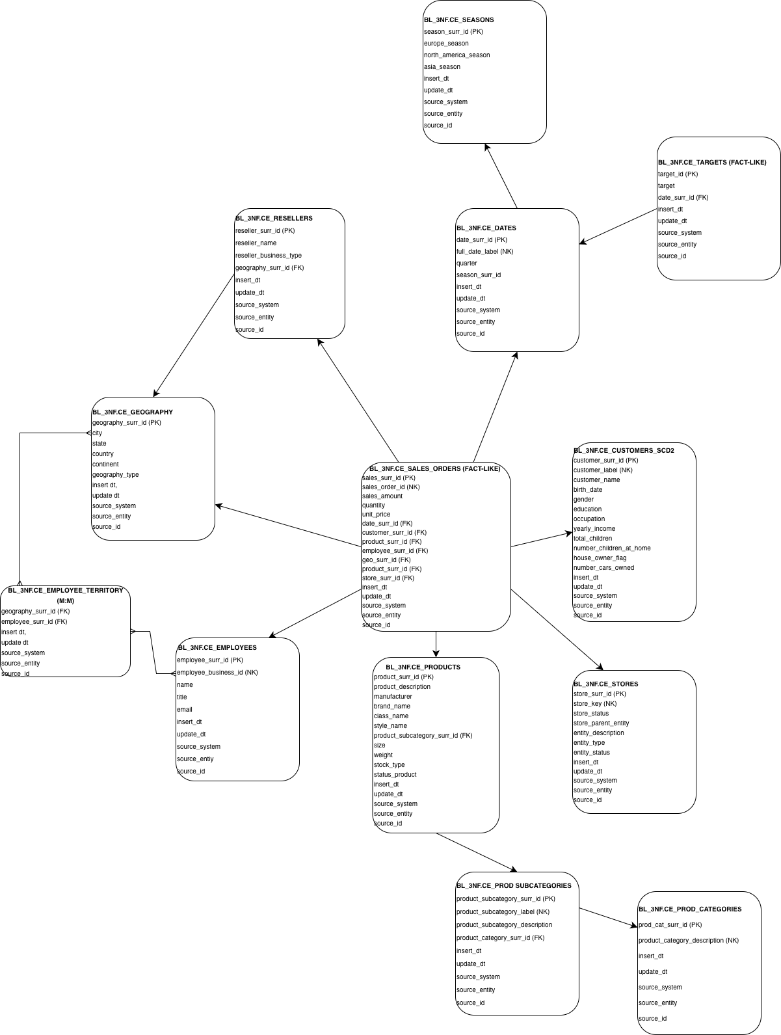
Figure 1. 3NF model

Business Layer Dimensional Model
3.1 Overview of the Dimensional Model
The Dimensional Model (DM) represents the analytical layer of the Data Warehouse.
Its main purpose is to provide a structure optimized for analytical queries, reporting, and BI tools.
Unlike the normalized 3NF layer, the dimensional model uses a star schema where:
- Fact tables store quantitative business measurements.
- Dimension tables store descriptive attributes used for filtering, grouping, and slicing data.
The DM layer is populated from the BL_3NF layer through cleansing procedures, ensuring that:
- surrogate keys are used for efficient joins,
- historical changes are handled properly,
- analytical queries remain simple and performant.
The dimensional layer schema is BL_DM.

3.2 Star Schema Design
The implemented dimensional model follows a Star Schema structure.
Central fact tables:
- FCT_SALES_DD – daily sales fact table
- FCT_TARGETS – monthly sales targets
Dimension tables:
- DIM_DATE
- DIM_PRODUCTS
- DIM_GEOGRAPHY
- DIM_CUSTOMERS
- DIM_EMPLOYEES
- DIM_RESELLERS
- DIM_STORES
These dimensions provide contextual attributes for analyzing sales data.
The schema allows answering questions such as:
- Sales by product category
- Sales by country or city
- Sales by customer demographics
- Sales by employee
- Comparison of sales vs targets

3.3 Fact Table Design
3.3.1 Fact Table: FCT_SALES_DD
The FCT_SALES_DD table stores the primary business measurements related to sales transactions.
- Grain
The grain of the fact table is:
One row per sales transaction per product per day
This means each record corresponds to a single product sold in a specific order on a specific date.
- Measures
The fact table contains the following quantitative measures:
- sales_amount – total revenue for the transaction
- quantity – number of units sold
- unit_price – price per unit
- cost – cost of the sold item
These measures enable analysis of revenue, volume, and profitability.
- Foreign Keys
The fact table references several dimensions:
- date_surr_id
- product_surr_id
- customer_surr_id
- employee_surr_id
- geography_surr_id
- reseller_surr_id
- store_surr_id
Each of these keys links to the corresponding dimension table.

3.3.2 Fact Table: FCT_TARGETS
The FCT_TARGETS table stores business targets used for performance evaluation.
- Grain
The grain of the table is:
One target per date (month start date)
Targets are assigned monthly and are linked only to the date dimension.
- Measures
- target_amount
This table allows comparing actual sales vs planned targets.

3.4 Dimension Tables
Dimension tables store descriptive attributes used for filtering and grouping fact data.

3.4.1 DIM_DATE
The DIM_DATE table contains calendar information for each date.
Typical attributes include:
- full date
- day
- month
- quarter
- year
- season
This dimension enables time-based analysis such as:
- monthly sales
- quarterly growth
- seasonal trends.

3.4.2 DIM_PRODUCTS
The DIM_PRODUCTS table stores information about products.
Attributes include:
- product name
- product key
- product subcategory
- product category
This dimension enables analysis by:
- product hierarchy
- product category performance
- product popularity.

3.4.3 DIM_GEOGRAPHY
The DIM_GEOGRAPHY table stores geographical information.
Attributes include:
- city
- state
- country
- geography type
This dimension supports analysis such as:
- sales by country
- sales by city
- regional performance.

3.4.4 DIM_CUSTOMERS
The DIM_CUSTOMERS table stores customer demographic information.
Attributes include:
- gender
- birth date
- education
- occupation
This dimension supports segmentation analysis such as:
- sales by age group
- sales by occupation
- sales by education level.
Customer history is preserved in the 3NF layer using SCD2, while the dimensional model typically uses SCD1 representation for simplified analytics.

3.4.5 DIM_EMPLOYEES
The DIM_EMPLOYEES table contains information about sales employees.
Attributes include:
- employee business id
- full name
- title
- email
This dimension allows analysis of:
- sales by salesperson
- performance by employee.

3.4.6 DIM_RESELLERS
The DIM_RESELLERS table stores reseller information.
Attributes include:
- reseller name
- business type
- location reference
This dimension enables analysis of reseller performance and distribution channels.

3.4.7 DIM_STORES
The DIM_STORES table represents stores from the Contoso dataset.
Attributes include:
- store key
- store status
- parent entity
- entity type
- entity status
This dimension enables analysis of store activity and performance.

3.5 Slowly Changing Dimensions
The dimensional model supports Slowly Changing Dimensions (SCD).
- SCD Type 1
Most dimensions in the DM layer use SCD Type 1, where attribute updates overwrite previous values.
This approach simplifies analytics and reduces storage.
- SCD Type 2
Customer history is preserved in the 3NF layer using SCD Type 2, where:
- start_dt
- end_dt
- is_active
track historical versions of records.

3.6 Default Dimension Rows
Each dimension contains a default record with surrogate key = -1.
This row represents:
- unknown
- missing
- not applicable
This ensures referential integrity when fact records contain missing dimension references.

3.7 Summary
The Dimensional Model layer provides an analytical structure optimized for reporting and BI tools.
The design:
- follows a star schema
- separates facts and dimensions
- uses surrogate keys
- supports historical tracking
- enables efficient analytical queries.
The DM layer receives data from the 3NF layer through cleansing procedures, ensuring data consistency and integrity across the entire data warehouse architecture. The schema is provided in Figure 2 below.

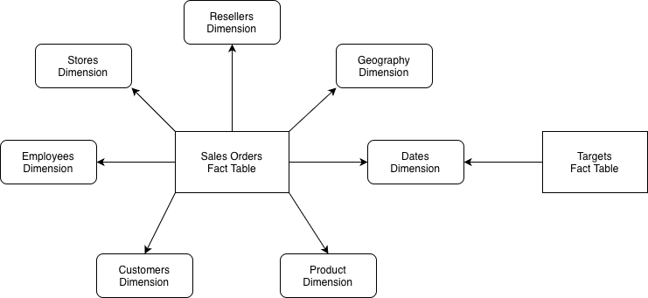
Figure 2. DM layer diagram

Logical Scheme
From data sources, in our case, datasets, data is loaded to the staging area, from where it is loaded to the 3NF layer and distributed across tables. Then, data is transferred to a dimensional layer where different business-related entity tables receive data and store it for business usage. Later, the data can be directed to different data marts for different business purposes. Throughout the journey the meta data is added in loggings and insert_dt, source_id etc. The whole process is illustrated in Figure 3.
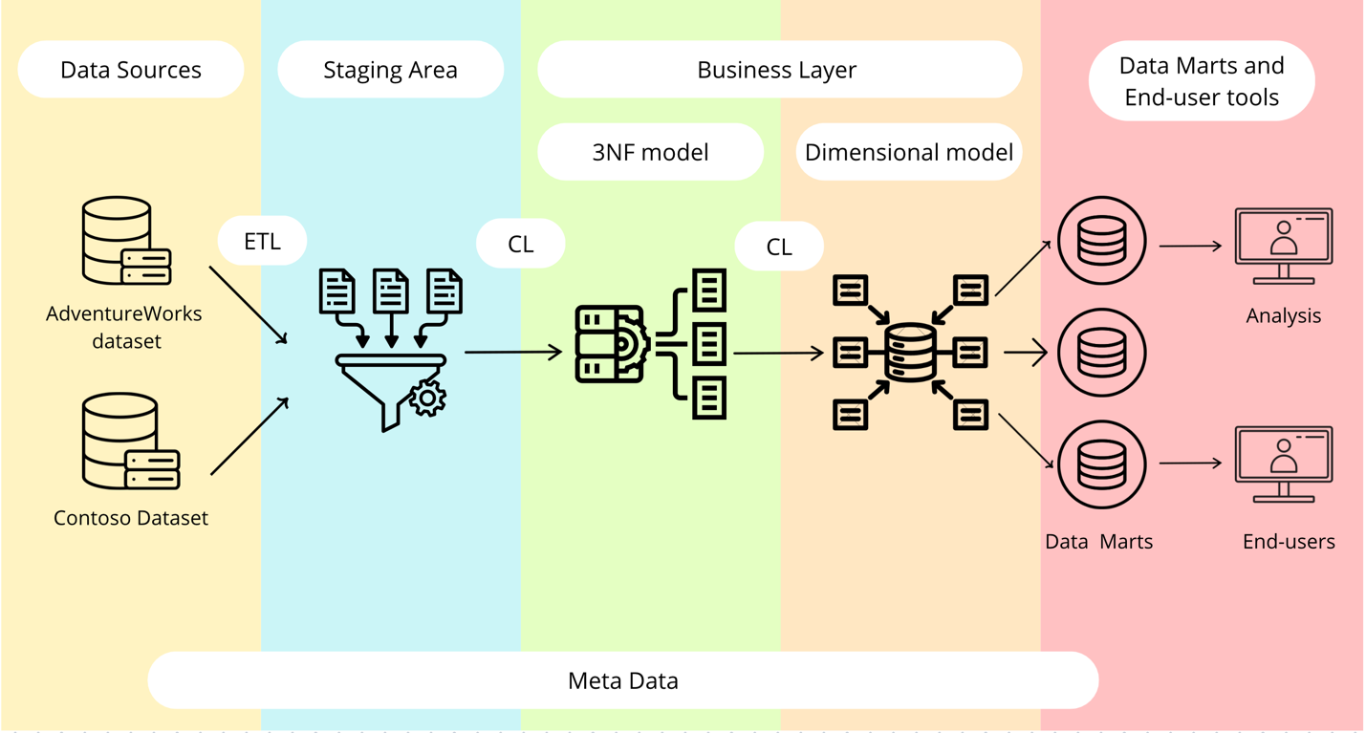
Figure 3. Logical scheme of the project.

Data Flow
The more detailed data flow can be observed below in Figure 4.
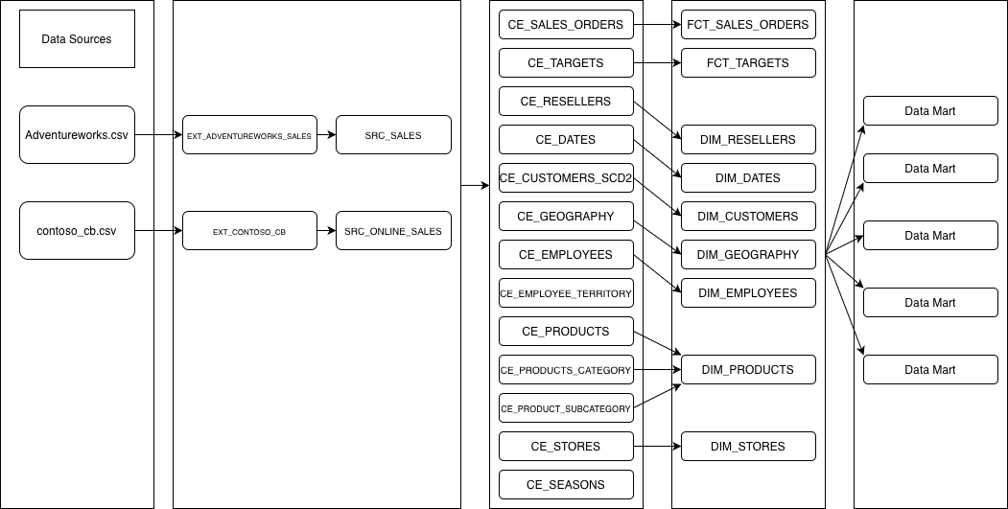
Figure 4. Data flow of the project.

Fact Table Partitioning Strategy
Fact table partitioning was implemented by partitioning fct_sales_orders table by month. The new partition is created for each new month. The result is shown in Figure 5.

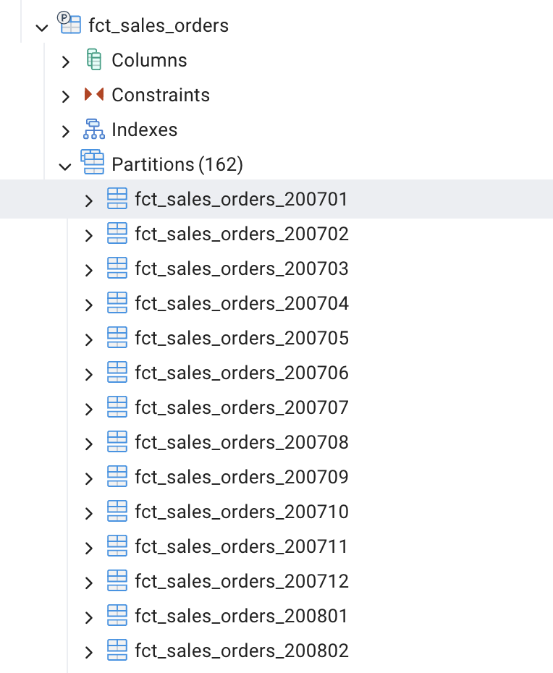
Figure 5. Fact table partitioning.

