LAB REPORT ON DATABASE QUERIES

Course Name: Sessional based on CSE 3101 (Database System)

Course No.: 3102

Index:

Queries for 8th cycle: 1.1 – 2.8

Queries for 9th cycle: 3.1 – 3.8

Queries for 10th cycle: 4.1 – 4.7

Submitted to – Barshon Sen

Assistant Professor,

Dept. of CSE, RUET

Submitted By –

Anika Tabassum Era

Roll – 1703176

CSE’17, RUET

**Query 1.1**

Find the name, genre, IMDB-rating of all the movies.

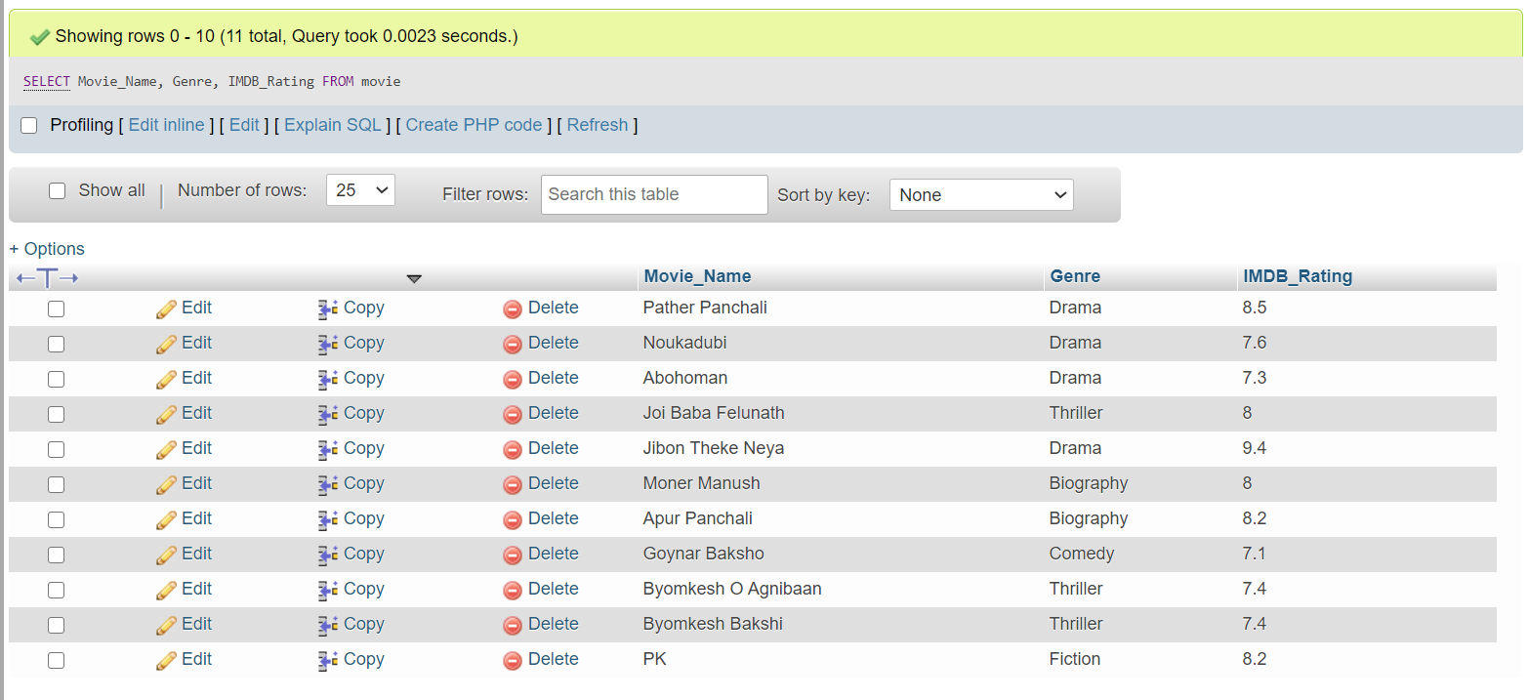SELECT Movie_Name, Genre, IMDB_Rating FROM movie;

**Query 1.2**

Display all the distinct movie-genres.

SELECT DISTINCT (Genre) FROM movie;

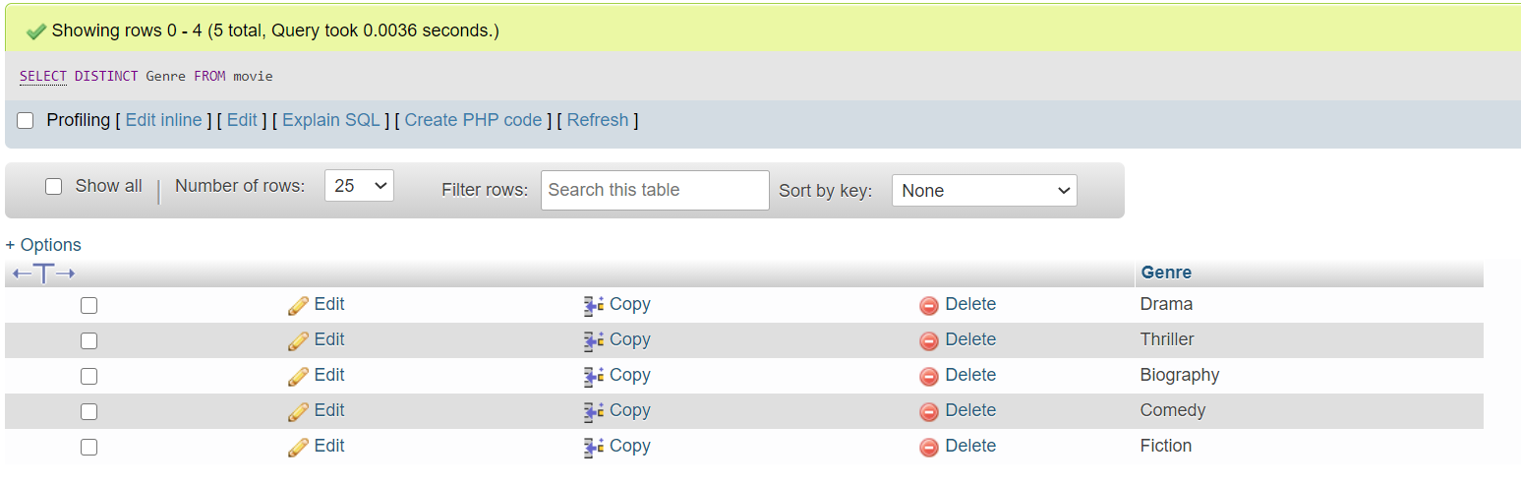

**Query 1.3**

Find the name and current age of all the actors.

SELECT Actor_Name, 2021-Birth_Year as Current_Age FROM actor;

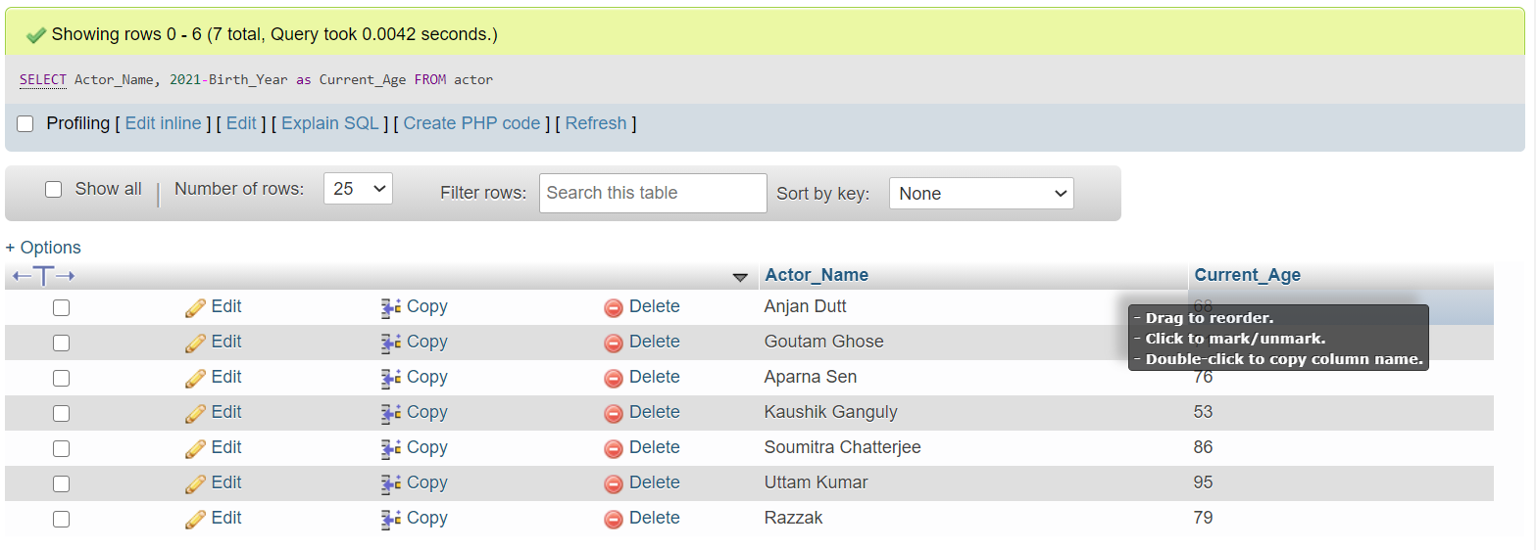

**Query 1.4**

Find all the movies of the thriller genre with an IMDB rating.

greater than or equal to 8.0.

SELECT Movie_Name, Genre, IMDB_Rating FROM movie WHERE Genre IN ('thriller') AND IMDB_Rating > 7.9;

Or

SELECT Movie_Name, Genre, IMDB_Rating FROM movie WHERE Genre IN ('thriller') AND IMDB_Rating >= 8;

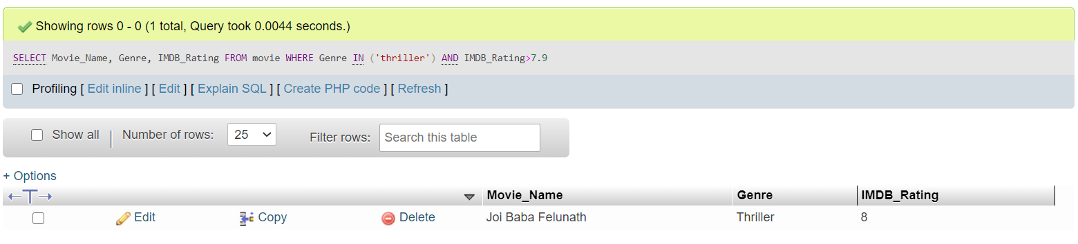

**Query 1.5**

Find the movie_name, release year, IMDB rating, and the name of the

director of all the movies.

SELECT movie.Movie_Name, movie.Year, movie.IMDB_Rating, director.Director_Name FROM movie JOIN director using (Person_ID);

or

SELECT movie.Movie_Name, movie.Year, movie.IMDB_Rating, director.Director_Name FROM movie, director WHERE movie.Person_ID = director.Person_ID;

or

SELECT Movie_Name, Year, IMDB_Rating, Director_Name FROM movie NATURAL JOIN director;

or

SELECT Movie_Name, Year, IMDB_Rating, Director_Name FROM movie INNER JOIN director ON movie.Person_ID=director.Person_ID;

or

SELECT Movie_Name, Year, IMDB_Rating, Director_Name FROM movie INNER JOIN director USING(Person_ID);

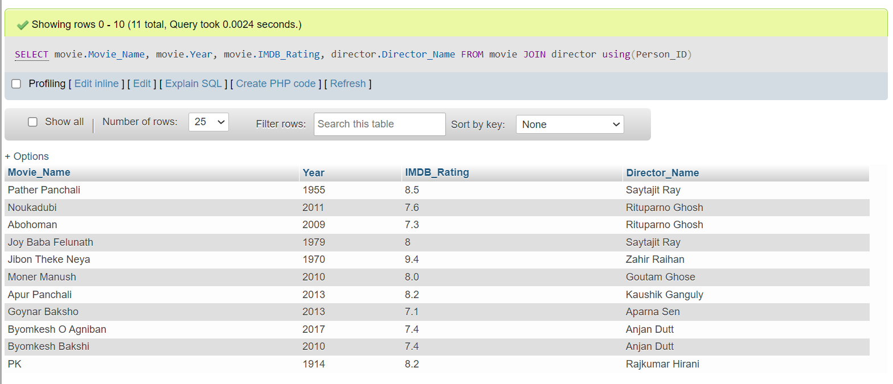

**Query 1.6**

Find the name and number of awards of those directors whose

name starts with an ‘S’.

SELECT Director_Name, No_Of_Awards FROM director WHERE Director_Name LIKE 'S%';

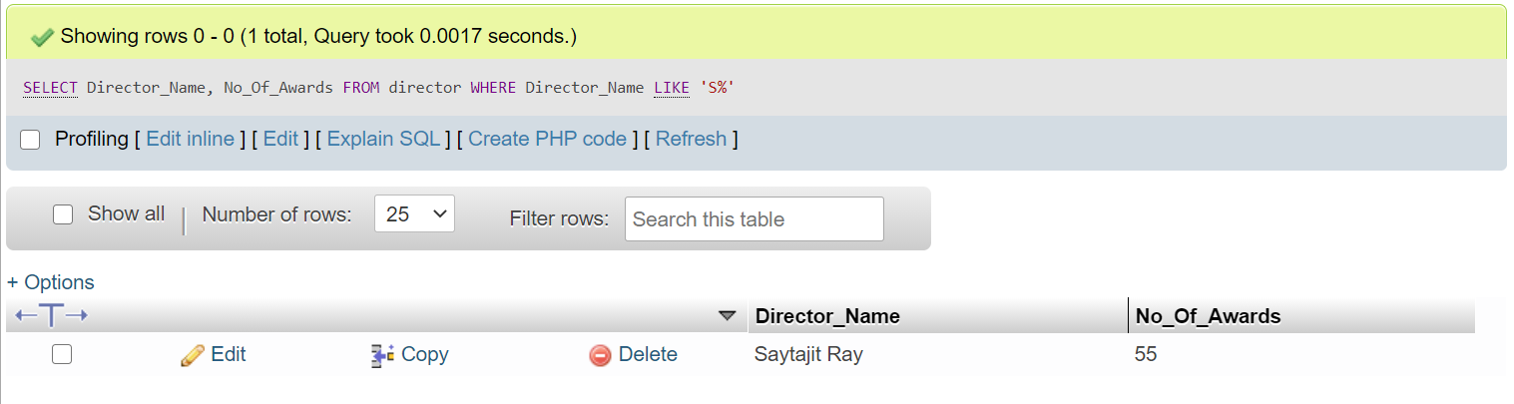

**Query 1.7**

Find the name and birth year of those directors whose name

contains an ‘a’ as its 2nd last character.

SELECT Director_Name, Birth_Year FROM director WHERE Director_Name LIKE '%a_';

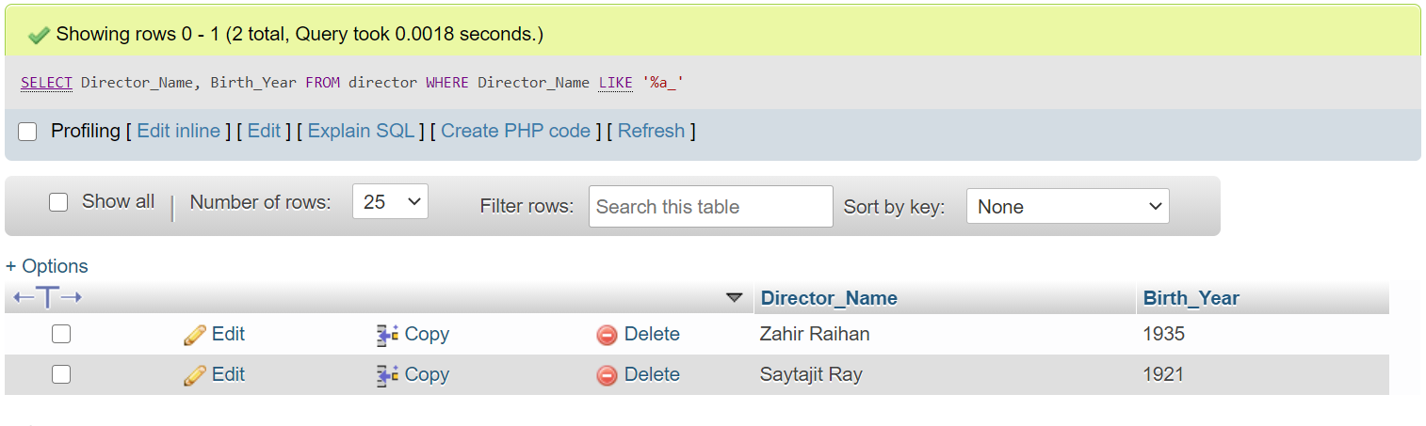

**Query 1.8**

Find the name, release year, and genre of all the movies which

contain the word ‘Byomkesh’ anywhere in their name.

SELECT Movie_Name, Genre, Year FROM movie WHERE Movie_Name LIKE '%Byomkesh%';

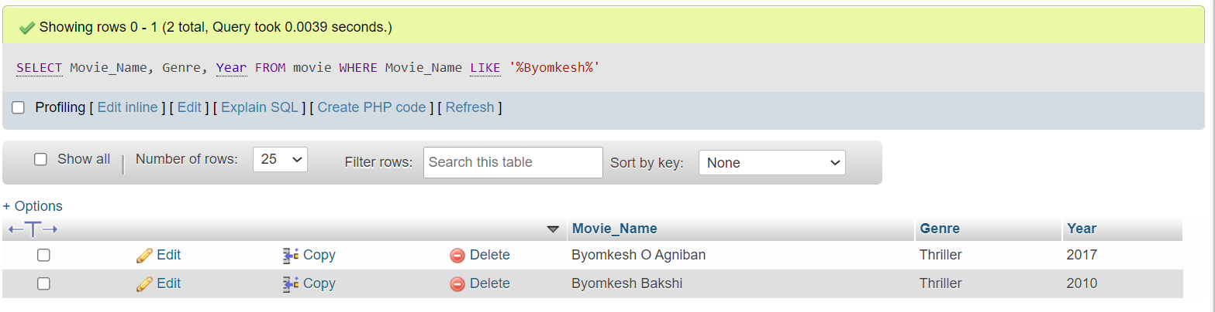

**Query 1.9**

Find the name and IMDB rating of all the movies whose name

consists of only 2 characters.

SELECT Movie_Name, IMDB_Rating FROM movie WHERE Movie_Name LIKE '__';

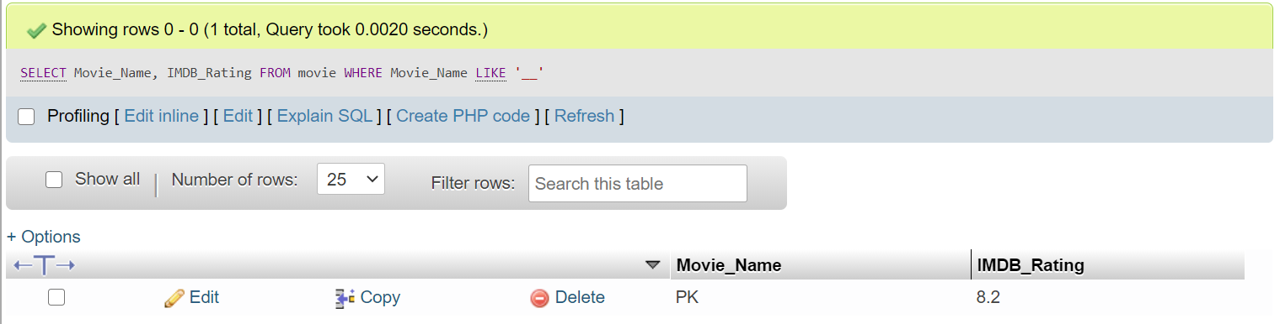

**Query 2.0**

Find the name and genre of all the movies whose name consists

of at least 4 characters.

SELECT Movie_Name, Genre FROM movie WHERE LENGTH(Movie_Name)>=4;

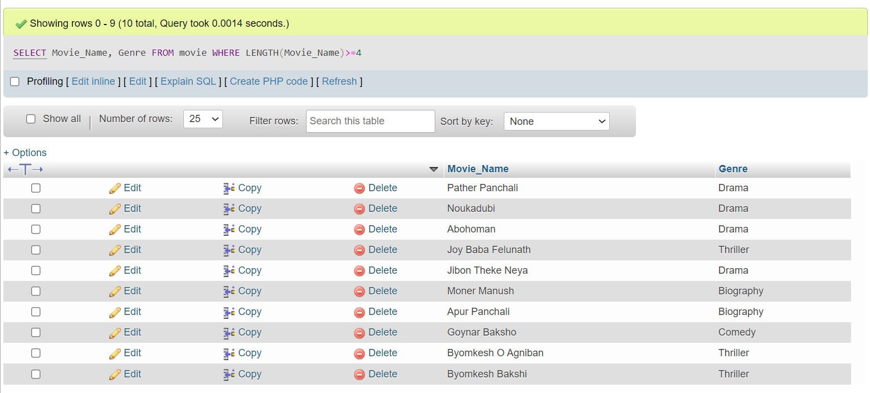

or

SELECT Movie_Name, Genre FROM movie WHERE Movie_Name LIKE "____%"

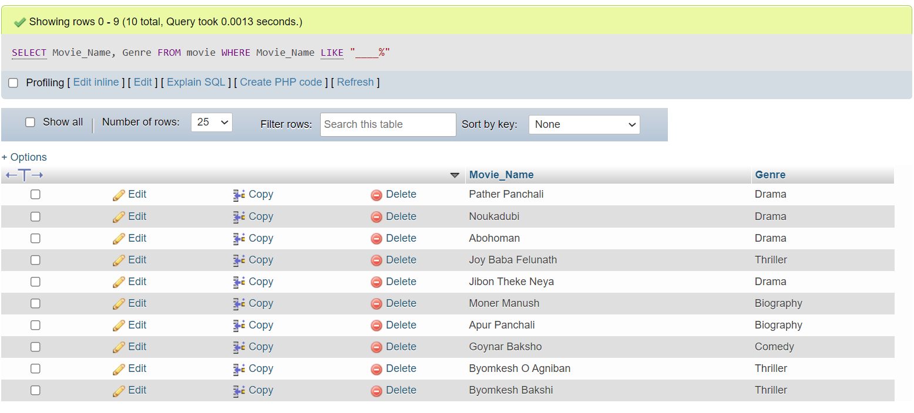

**Query 2.1**

Find the name and IMDB rating of all the movies which contain

either 1 or, 2 or, 3 or, 4 characters in their name.

SELECT Movie_Name, IMDB_Rating FROM movie WHERE LENGTH(Movie_Name)=1 OR LENGTH(Movie_Name)=2 OR LENGTH(Movie_Name)=3 OR LENGTH(Movie_Name)=4;

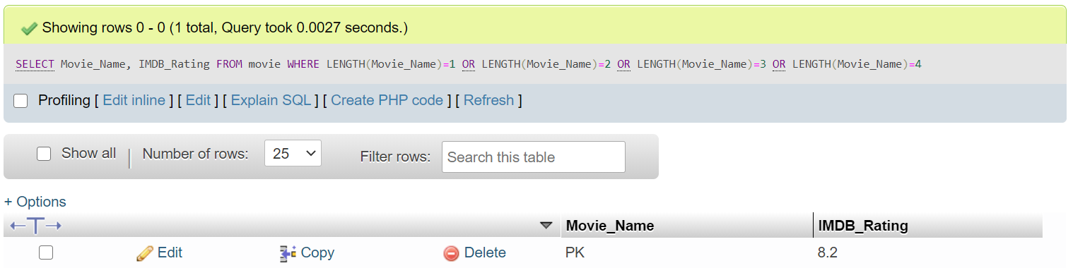

or

SELECT Movie_Name, Genre FROM movieWHERE Movie_Name NOT LIKE "____%"

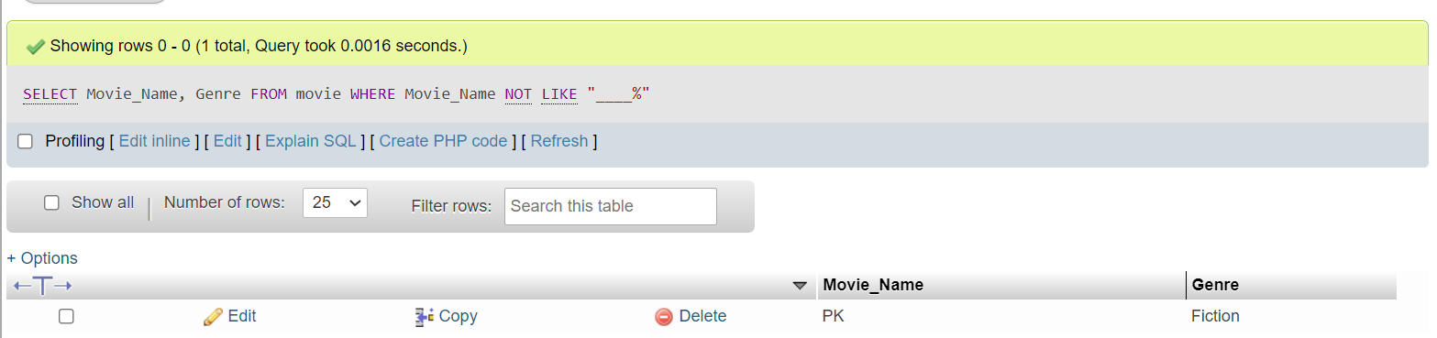

**Query 2.2**

Display all the movies according to their IMDB rating (in

descending order); if multiple movies have the same IMDB rating then

rearrange those movies alphabetically according to their names.

SELECT * FROM movie ORDER BY IMDB_Rating DESC, Movie_Name ASC;

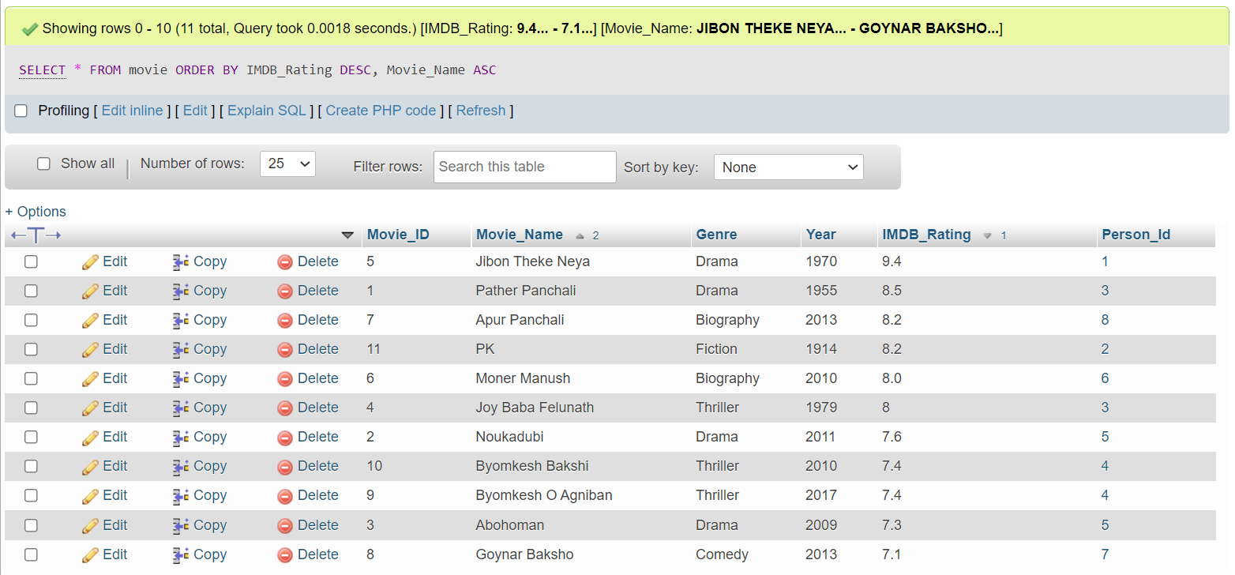

**Query 2.3**

Find the average IMDB rating of all the movies of the drama

genre.

SELECT Genre, AVG(IMDB_Rating) FROM movie WHERE Genre IN ('Drama');

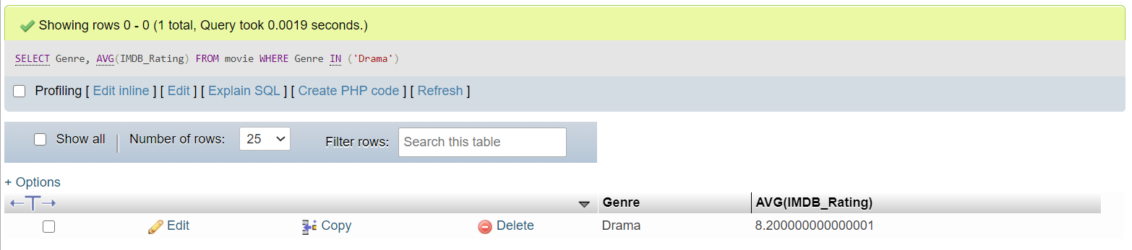

**Query 2.4**

Find the total number of movies in the database.

SELECT COUNT(Movie_ID) AS Total_Movie FROM movie;

or

SELECT COUNT(Movie_Name) AS Total_Movie FROM movie;

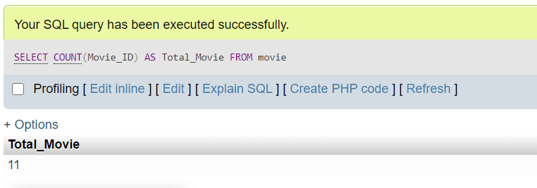

**Query 2.5**

Find how many movie-genres are there in the database.

SELECT COUNT(DISTINCT Genre) AS Dissimilar_Genres FROM movie;

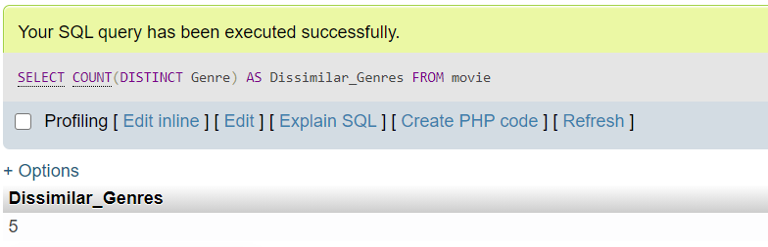

**Query 2.6**

Find the total number of movies in each genre.

SELECT Genre AS Dissimilar_Genre,COUNT(Movie_ID) FROM movie GROUP BY Genre HAVING COUNT(Movie_ID)>=1;

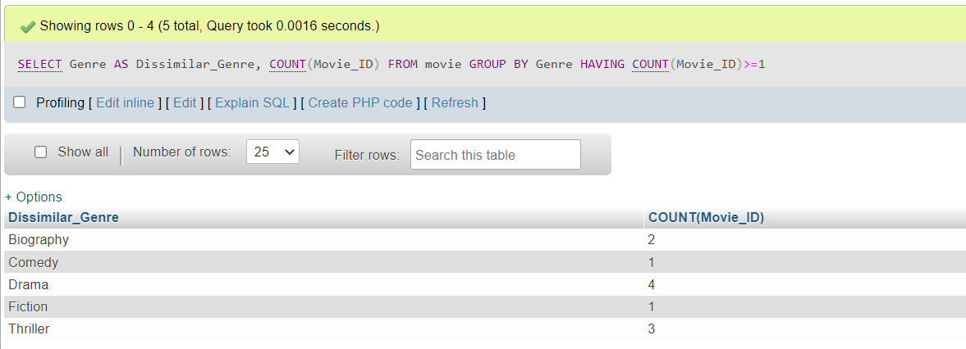

**Query 2.7**

Find all the movies of action, thriller/fiction genre.

SELECT Movie_Name, Genre FROM movie WHERE Genre='Action' OR Genre ='Thriller' OR Genre='Fiction';

or

SELECT Movie_Name, Genre FROM movie WHERE Genre IN ('Action', 'Thriller', 'Fiction');

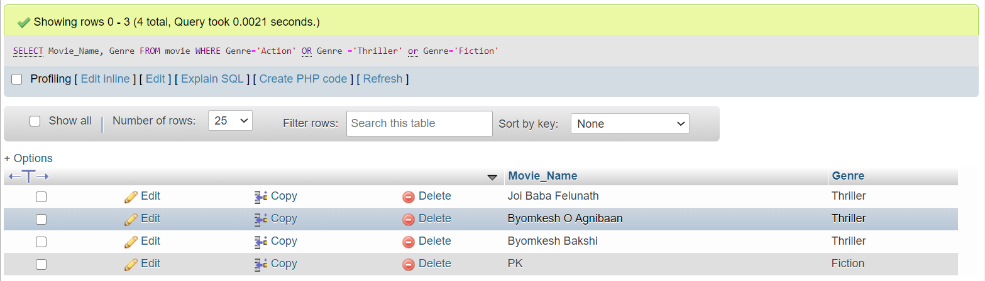

**Query 2.8**

Find the Name and current age of all the directors and actors.

SELECT Director_Name, 2021-director.Birth_Year AS Directors_Age FROM director UNION SELECT Actor_Name, 2021-actor.Birth_Year AS Actors_Age FROM actor;

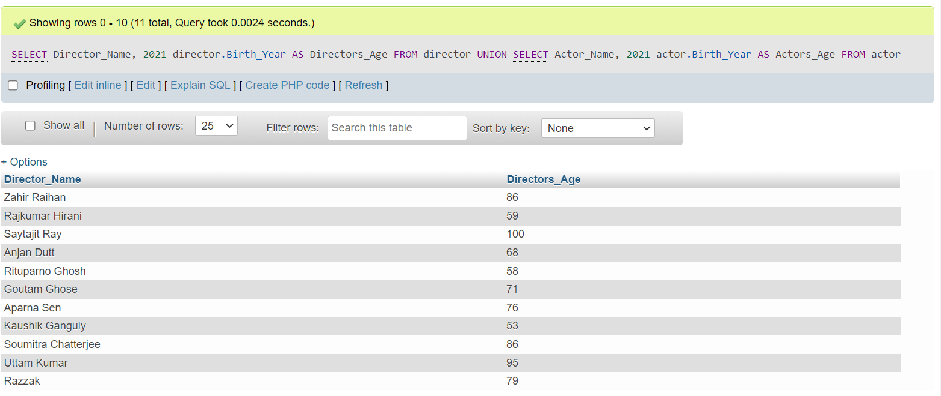

or

SELECT Director_Name AS Name, (2021-director.Birth_Year) AS Current_age FROM director UNION SELECT Actor_Name AS Name, (2021-actor.Birth_Year) AS Current_age FROM actor;

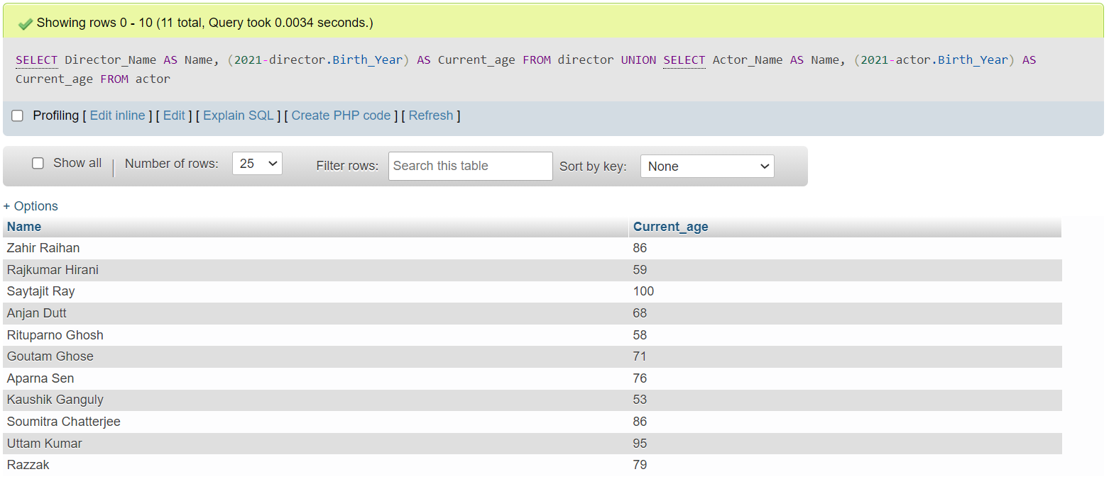

**Query 3.1**

Display the name, IMDB rating and genre of all the movies with

an IMDB rating greater than or equal to 8.0.

SELECT Movie_Name, IMDB_Rating, Genre FROM movie WHERE IMDB_Rating >= 8.0;

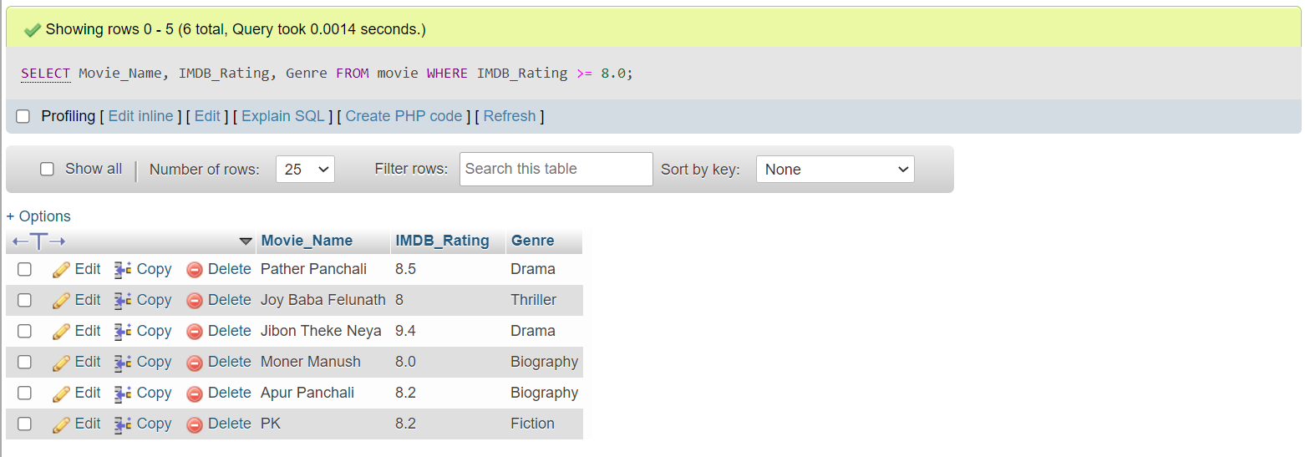

**Query 3.2**

Display all the distinct movie-genres and the average IMDb

rating of each movie-genre.

SELECT Genre, AVG(IMDB_rating) AS Average_IMDB_Rating FROM movie GROUP BY Genre;

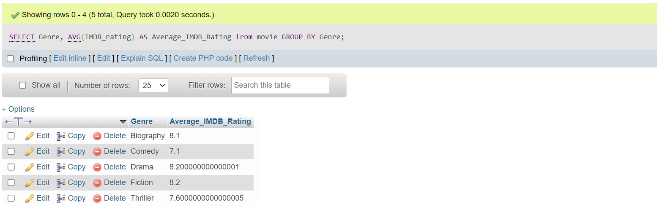

**Query 3.3**

Find the name and the average IMDb rating of those

movie-genres whose average IMDb rating is greater than or equal to 7.5.

SELECT Movie_Name, Genre, AVG(IMDB_Rating) AS Average_IMDB_Rating FROM movie GROUP BY Genre HAVING AVG(IMDB_Rating) >= 7.5;

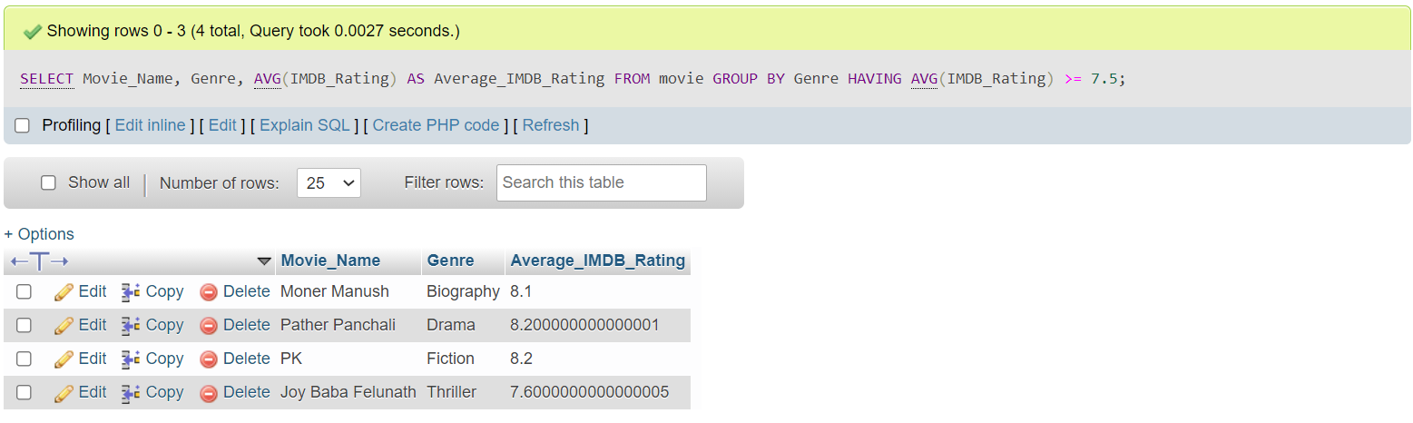

**Query 3.4**

Find the name, number of films and number of awards of the

director who directed the most number of films

SELECT Director_Name, No_of_Films, No_of_Awards FROM director GROUP BY No_of_Films DESC, Director_Name HAVING MAX(No_of_Films);

Or

SELECT Director_Name, No_of_Films, No_of_Awards FROM director GROUP BY Director_Name HAVING MAX(No_of_Films) ORDER BY No_of_Films DESC

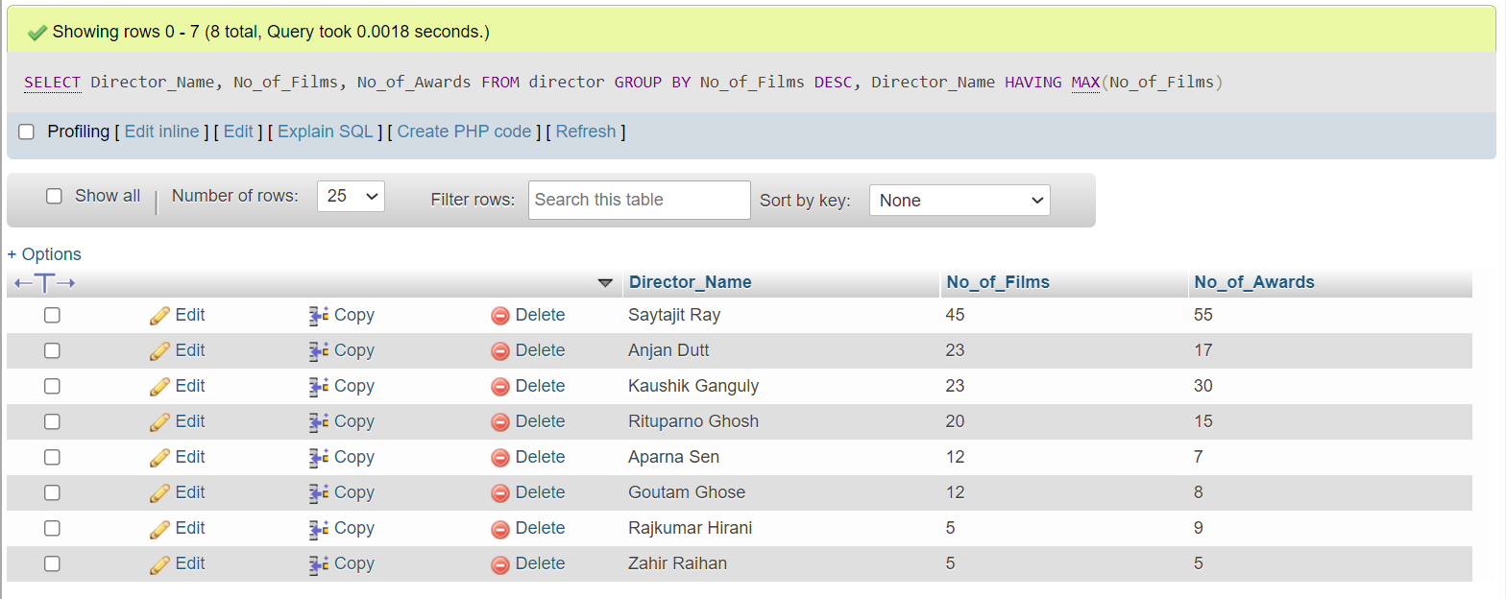

**Query 3.5**

Find the name, current age, number of films and number of

awards of the youngest actor.

SELECT Actor_Name, 2021-Birth_Year AS Youngest_aged, No_of_Films, No_of_Awards FROM actor WHERE 2021-Birth_Year = (SELECT MIN(2021-Birth_Year) FROM actor);

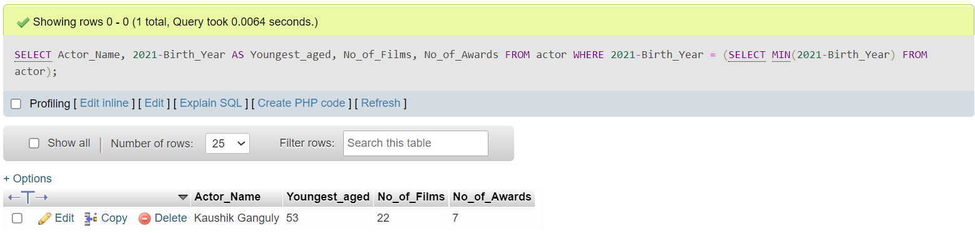

**Query 3.6**

Find the name, IMDb rating and genre of those movies whose

IMDb Rating is above average.

SELECT Movie_Name, IMDB_Rating AS IMDB_Rating_Greater_than_avg, Genre FROM movie WHERE IMDB_Rating > (SELECT AVG(IMDB_Rating) FROM movie);

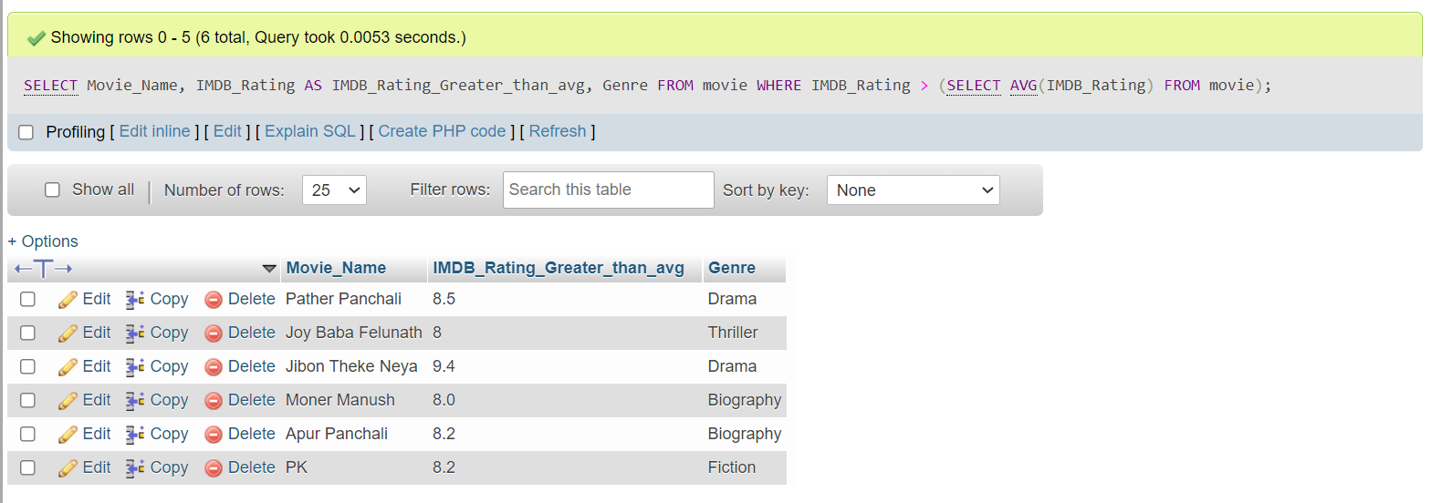

**Query 3.7**

Find the name and average IMDb rating of those movie-genres

whose average IMDb rating is below average.

SELECT Genre, AVG(IMDB_Rating) AS Below_avg FROM movie GROUP BY Genre HAVING AVG(IMDB_Rating) < (SELECT AVG(IMDB_Rating) FROM movie);

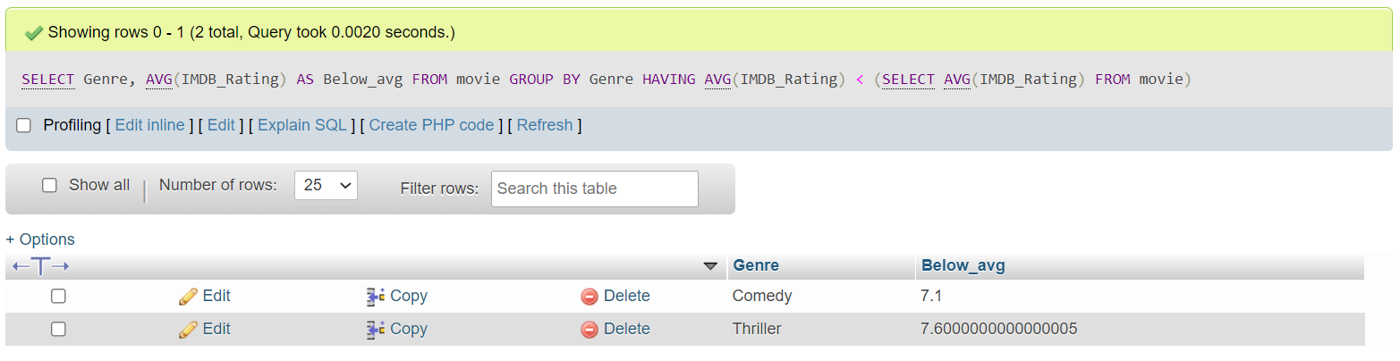

**Query 3.8**

Among all the movie genres, find the highest average IMDb

rating.

SELECT Genre, AVG(IMDB_Rating) AS High_avg_Genre FROM movie

GROUP BY Genre HAVING AVG(IMDB_Rating) >= ALL(SELECT AVG(IMDB_Rating) FROM movie GROUP BY Genre);

Or

SELECT AVG(IMDB_Rating) AS High_avg, Genre FROM movie GROUP BY Genre ORDER BY AVG(IMDB_Rating) DESC LIMIT 1

or

SELECT genre, MAX(Imdb) FROM (SELECT Genre AS genre, AVG(IMDB_Rating) AS Imdb FROM movie GROUP BY Genre ORDER BY IMDB_Rating DESC ) AS avg_imdb;

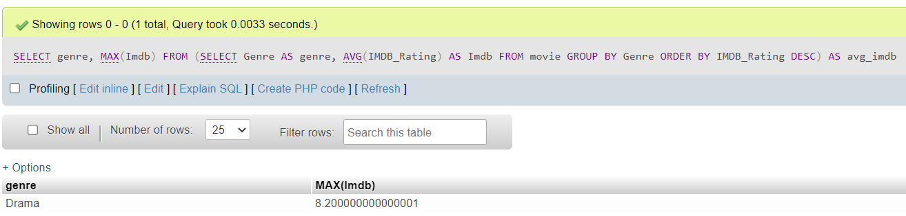

**Query 4.1**

Find the name and age of all the movie characters who are not

teenagers.

SELECT Character_Name, Age FROM movie_characters WHERE Age < 13 OR Age > 19;

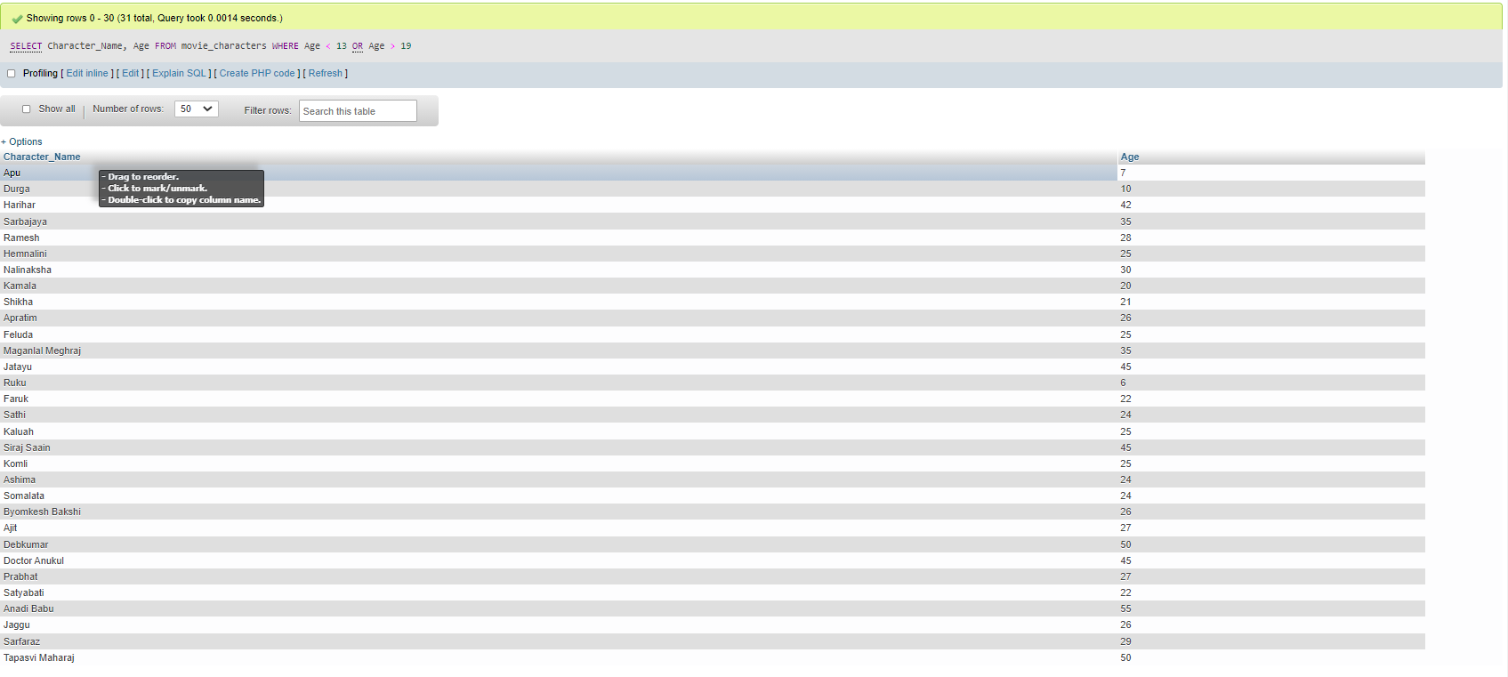

**Query 4.2**

Find the movie ID of all the movies and the number of

movie-characters in each movie

SELECT Movie_ID, COUNT(Character_ID) AS Character_number FROM movie_character_relationship GROUP BY Movie_ID;

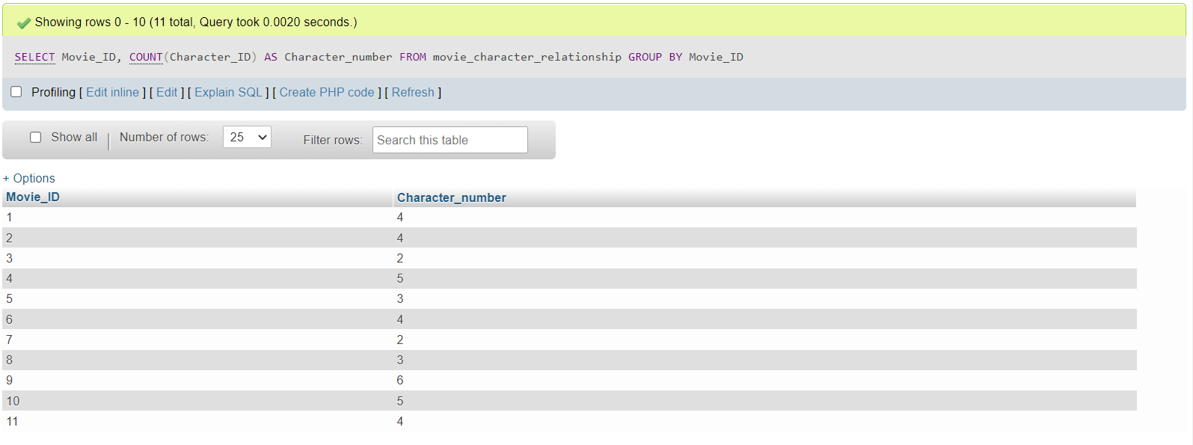

**Query 4.3**

Find the movie name of all the movies and the number of

movie-characters in each movie.

SELECT Movie_Name, COUNT(Character_ID) FROM movie AS m JOIN movie_character_relationship AS mcr ON m.Movie_ID=mcr.Movie_ID GROUP BY mcr.Movie_ID;

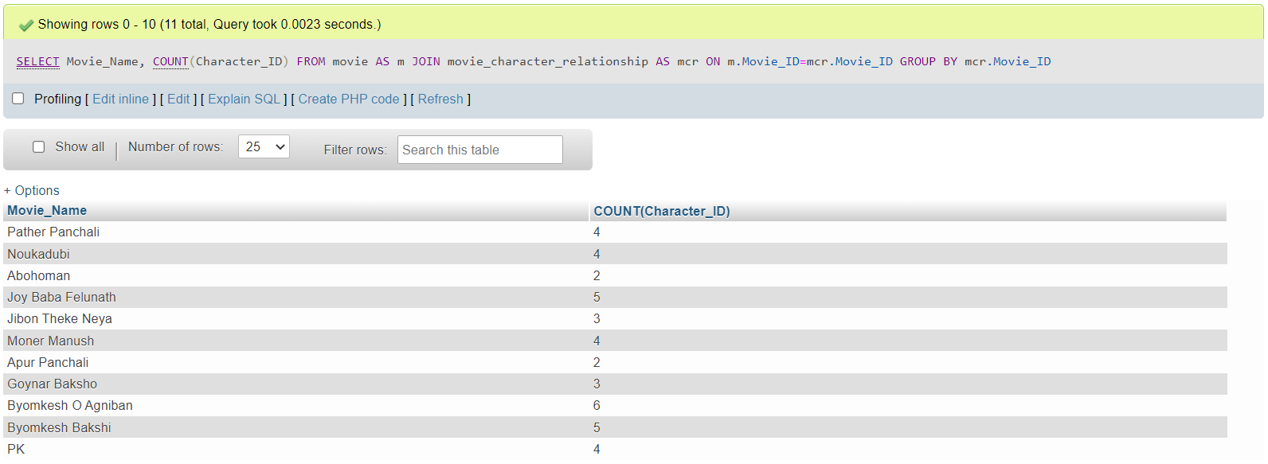

**Query 4.4**

Find the name, year of release, IMDB rating and the name of the

director of all the movies that contain at least 12 characters (including

spaces) in their name.

SELECT Movie_Name, Year, IMDB_Rating, Director_Name FROM movie AS m JOIN director AS d ON m.Person_Id=d.Person_Id WHERE Director_Name LIKE "____________%";

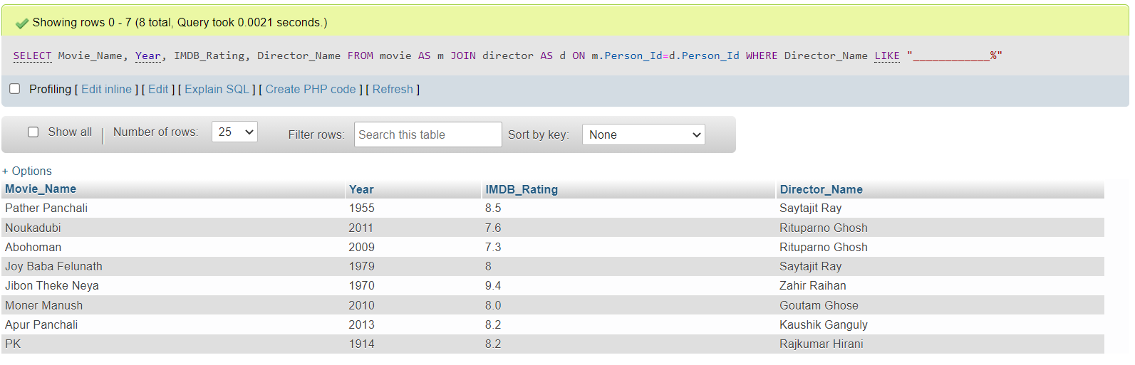

or

SELECT Movie_Name, Year, IMDB_Rating, Director_Name FROM movie AS m JOIN director AS d ON m.Person_Id=d.Person_Id WHERE LENGTH(Director_Name)>=12;

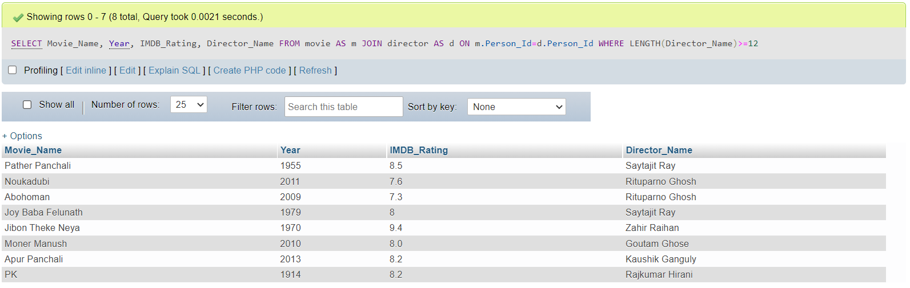

**Query 4.5**

Find the name, year of release, IMDB rating and the name of the

director of all the movies that contain at most 12 characters (including

spaces) in their name.

SELECT Movie_Name, Year, IMDB_Rating, Director_Name FROM movie AS m JOIN director AS d ON m.Person_Id=d.Person_Id WHERE LENGTH(Director_Name)<=12;

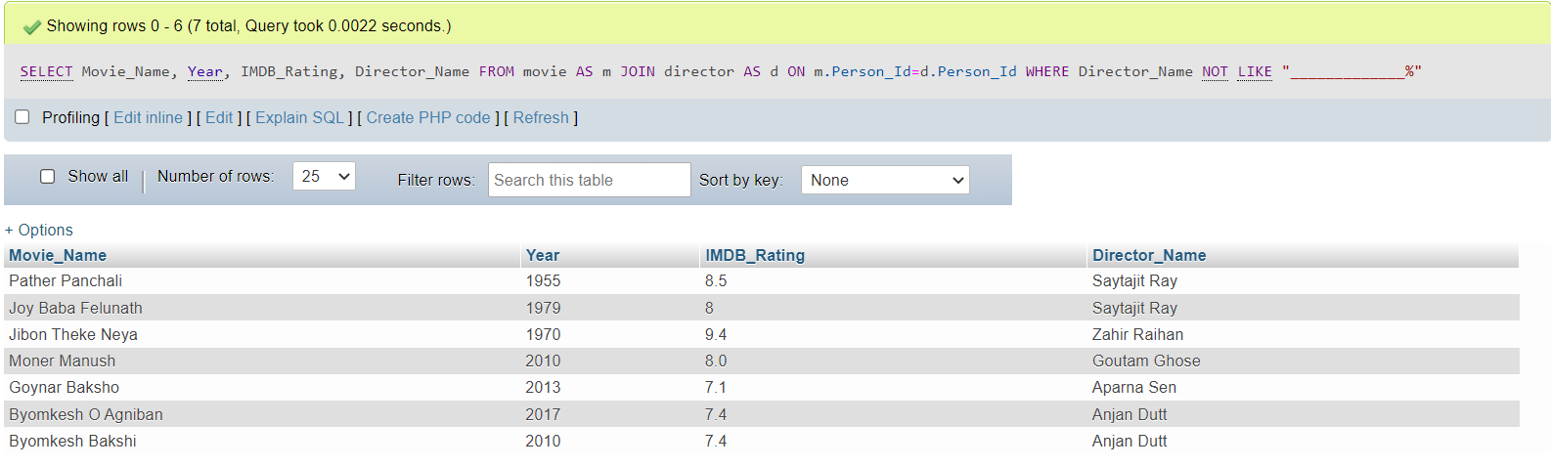

or

SELECT Movie_Name, Year, IMDB_Rating, Director_Name FROM movie AS m JOIN director AS d ON m.Person_Id=d.Person_Id WHERE Director_Name NOT LIKE "_____________%";

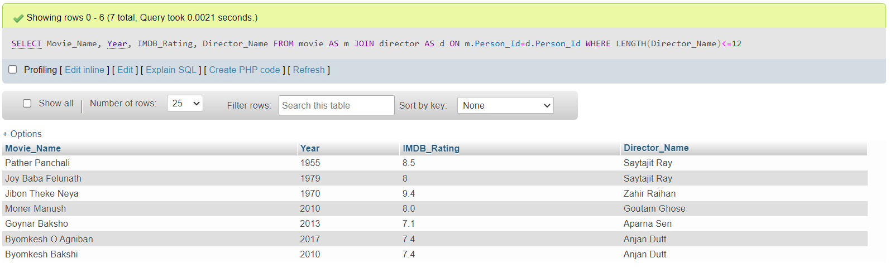

**Query 4.6**

Find the name, year of release, IMDB rating of all the movies of

Byomkesh (N.B.: A movie of Byomkesh may not contain the term

‘Byomkesh’ in its name).

SELECT Movie_Name, Character_Name, Year, IMDB_Rating

FROM movie_character_relationship AS mcr

JOIN movie AS m

ON m.Movie_ID=mcr.Movie_ID

JOIN movie_characters AS mc

ON mcr.Character_ID=mcr.Character_ID

WHERE Movie_Name LIKE "%Byomkesh%" AND Character_Name LIKE "%Byomkesh%"

GROUP BY m.Movie_Name;

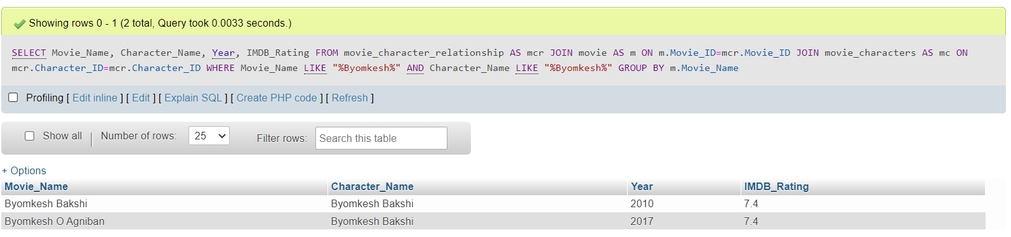

or

SELECT Movie_Name, Character_Name, Year, IMDB_Rating

FROM movie_character_relationship AS mcr

JOIN movie AS m

ON m.Movie_ID=mcr.Movie_ID

JOIN movie_characters AS mc

ON mcr.Character_ID=mc.Character_ID

WHERE Character_Name LIKE "%Byomkesh%"

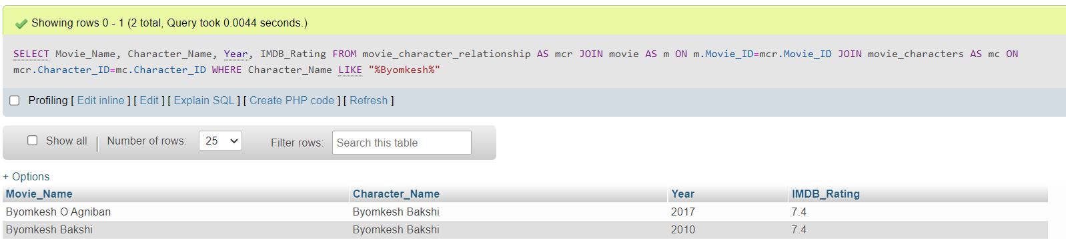

**Query 4.7**

Find the name and age of all the characters from the movies of

Feluda (N.B.: A movie of Feluda may not contain the term ‘Feluda’ in its

name).

SELECT Character_Name AS Characters_From_Feluda, Age

FROM movie_characters AS mc

JOIN movie_character_relationship AS mcr

ON mc.Character_ID=mcr.Character_ID

WHERE Movie_ID IN (SELECT Movie_ID FROM movie_character_relationship

WHERE Character_ID IN (SELECT Character_ID FROM movie_characters WHERE Character_Name LIKE "%Feluda%"))

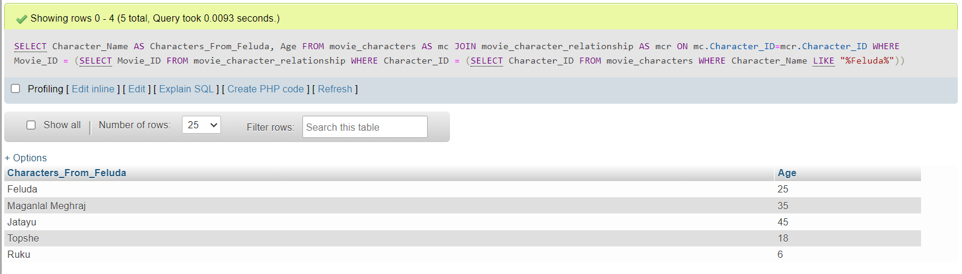

**Database Preview:**

