LAB REPORT - 1

**Topic:** Linux & It’s Basic Commands

**Course Name:** Sessional Based on CSE 3201 (Operating System)

**Course No:** CSE 3202

**Submitted To:**

Mohiuddin Ahmed

Lecturer,

CSE, RUET

**Submitted By:**

Anika Tabassum Era

**Roll:** 1703176

**Section:** C

17 Series, CSE, RUET

**Date of Submission:** 06-04-2022

**Introduction to Linux**

Linux is an open-source operating system convention. The most reasonable condition to switch to Linux is because it is light-weight than most other operating systems and also it is free to learn the basic concepts of the OS world.

Operating System based on Linux are Debian, Ubuntu, Fedora, centOS, Gentoo, Arch Linux, SUSE, Deepin, Parrot OS, Ubuntu MATE, Bodhi Linux, Garuda Linux, Kubuntu, Peppermint Linux, Mandriva Linux, Mageia, NixOS, BlackArch, Kanotix, Grml, Lliure, SuperGamer, BlackBox, SolydXK, Parsix, Ubuntu Kylin etc are also known as the distros or distributions.

Shell: Shell is a computer program that connects the OS kernel with the user. It basically depicts the functions of the OS and presents it to the user or other programs. The most 5 used shells in Linux are –

* Bash shell (Bourne Again Shell)
* csh/tcsh shell (C Shell)
* ksh shell (Korn Shell)
* zsh shell
* Fish (Friendly Interactive Shell)

**Linux Commands:**

* pwd: Present working directory refers to the current folder
* cd: Change directory refers to switching directory to another folder
* ls -al: This command will present list of all folder and files in current directory
* touch abc.txt: Creates a new file in current directory
* nano abc.txt: The command is used to update the text file
* cat abc.txt: Used to show text files content in terminal interface
* rm abc.txt: This command removes/deletes the text file
* mkdir xyz: Create a directory/folder in the current location
* rm -R xyz: Remove/delete folder xyz
* chmod u = rw: Means user can only operate the read and write operation
* clear: To clean terminal

**Command Practice & Preview:**

* Locate current directory and route to a new directory. List all the contents (file, folder) inside it.

**Commands:**

pwd

cd /mnt/y

ls -al

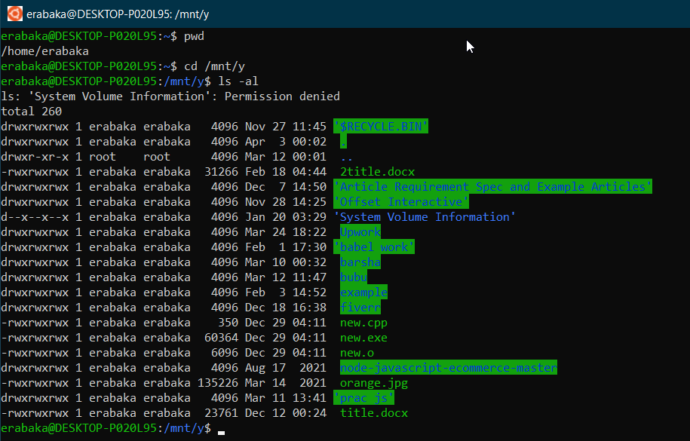

* Read current directory and create a text file. Update the text file and preview the context of text file in the terminal. And lastly remove the file.

**Command:**pwd  
touch abc.txt  
ls -al  
nano abc.txt  
(write content in text file) 🡪 (ctrl + x) 🡪 y 🡪 enter

cat abc.txt

rm abc.txt

ls -al

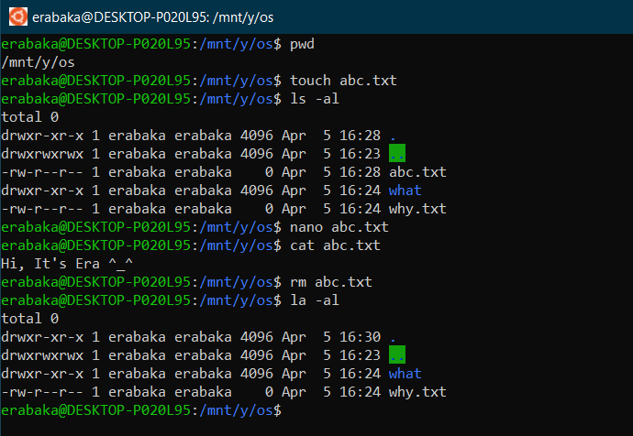

* Read current directory. Create a folder and go to that folder. Later delete the folder.

**Command:**  
pwd  
mkdir xyz  
ls -al  
cd xyz  
pwd  
cd ..  
rm -R xyz  
ls -al  
  
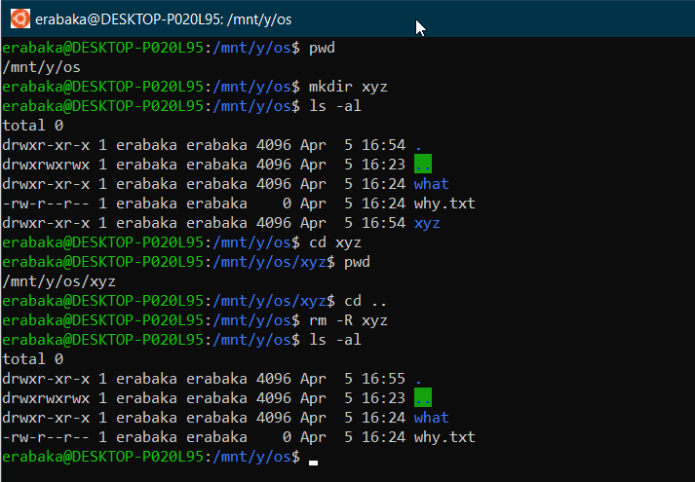

* A text file (spd.txt) is located in the os2 folder. Preview its permission. Later change the user permission.

**Command:**

ls -al  
sudo vim /etc/wsl.conf

(Enter password)

i + enter (To go to insert mode)  
[automount] + enter

options=``metadata``

press esc (to get out from insert mode)

:wq

exit

chmod u=wr spd.txt

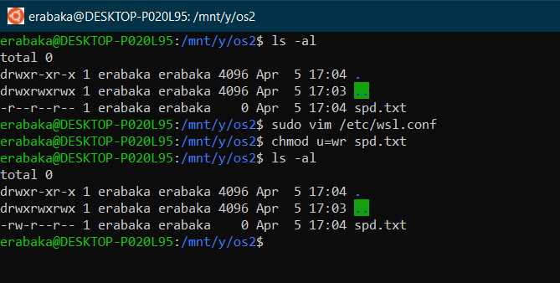

**Discussion:**  
  
The overall command lines in the CLI was executed successfully. Ubuntu WSL was used while checking up on the operations. A folder was effortlessly created, so was a file created and updated. Later, the removal of them was possible via commands. Finally, the “change mode (chmod)” was used to change permission for user. The outputs were as expected.