**LAB REPORT - 1**

**Topic:** Shell Programs

**Course Name:** Sessional Based on CSE 3201 (Operating System)

**Course No:** CSE 3202

**Submitted To:**

Mohiuddin Ahmed

Lecturer,

CSE, RUET

**Submitted By:**

Anika Tabassum Era

**Roll:** 1703176

**Section:** C

17 Series, CSE, RUET

**Date of Submission:** 09-04-2022

**Problems:**

1. Take 2 user input numbers and do the operations: Addition, Subtraction, Multiplication, Division.

Code:

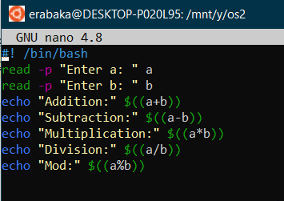

Output:

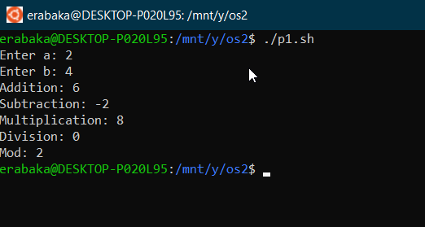

1. Take a user input number and check if it is odd or even.

Code:

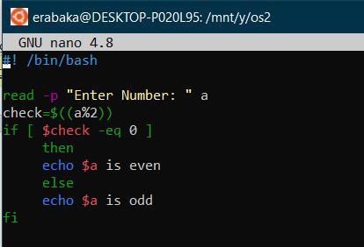

Output:

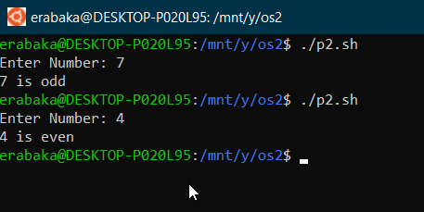

1. Take an array and store the primes from 1-100

Code:

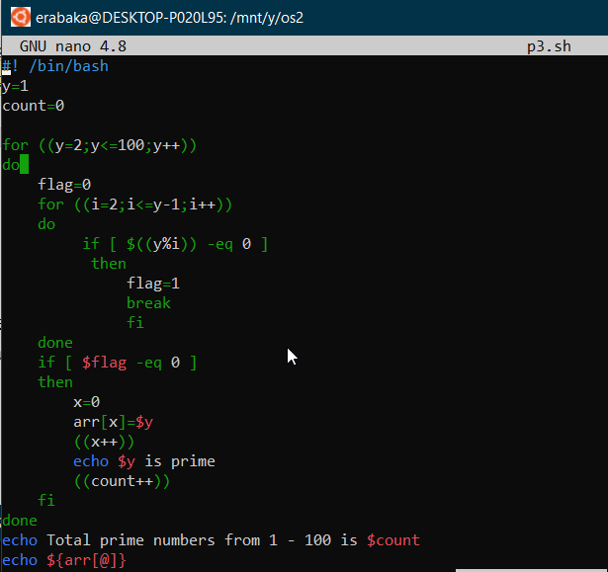

Output:

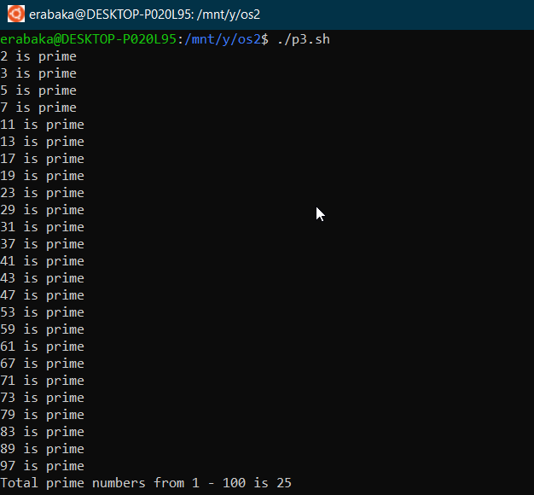

**Discussion:** The solve was done as per dictated. Also, the results were accurate