**LAB REPORT - 3**

**Topic:** Shell Programs

**Course Name:** Sessional Based on CSE 3201 (Operating System)

**Course No:** CSE 3202

**Submitted To:**

Mohiuddin Ahmed

Lecturer,

CSE, RUET

**Submitted By:**

Anika Tabassum Era

**Roll:** 1703176

**Section:** C

17 Series, CSE, RUET

**Date of Submission:** 21-05-2022

**Problems:**

1. Print the maximum and minimum number from a given array of numbers (Static)

**Code:**

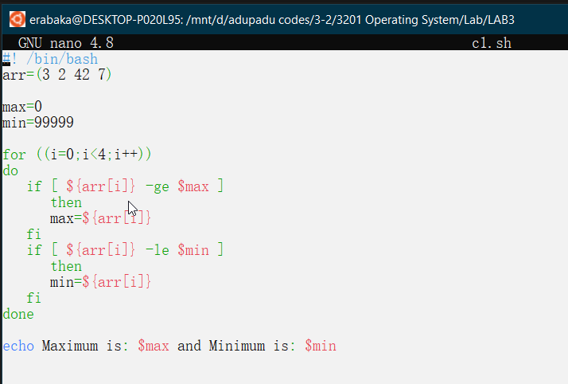

**Output:**

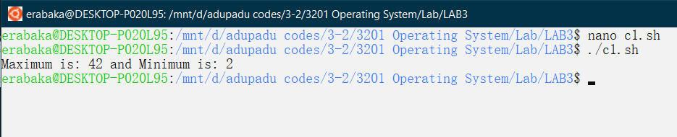

1. Print the maximum and minimum number from a given array of numbers (Dynamic)

**Code:**

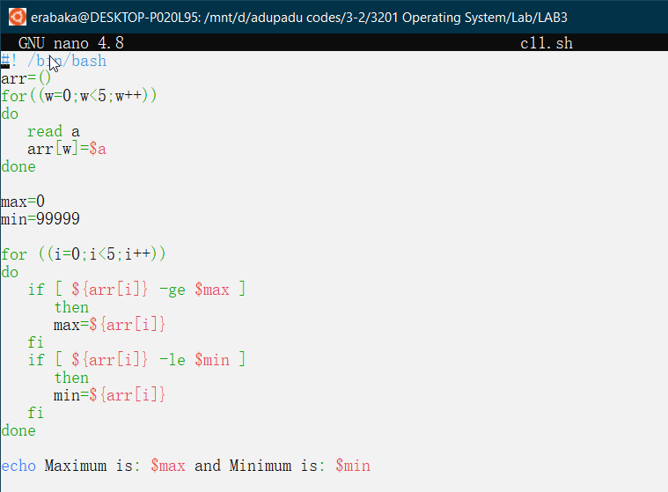

**Output:**

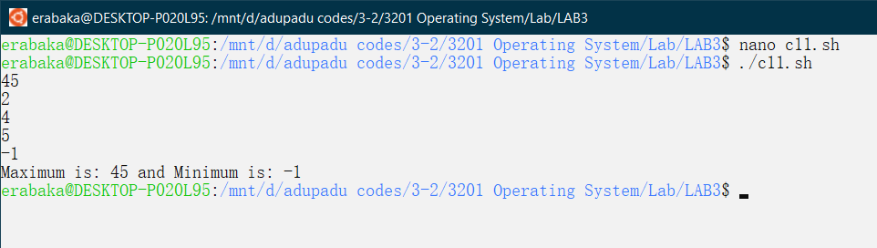

1. Sort a given array of numbers (Static)

**Code:**

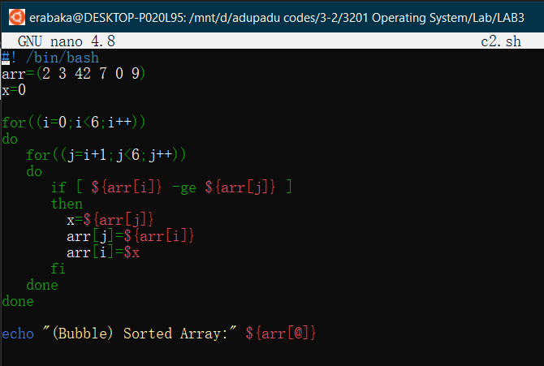

**Output:**

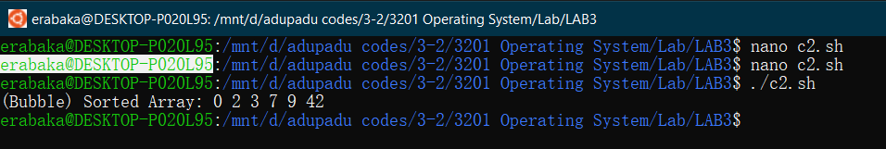

1. Sort a given array of numbers (Dynamic)

**Code:**

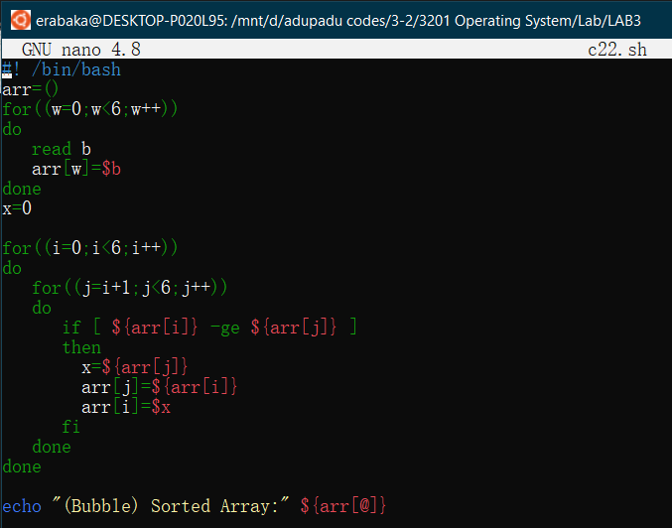

**Output:**

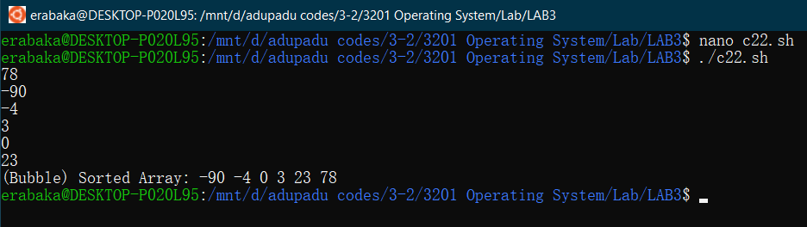

**Discussion:** The problem set was to define scopes that will extract the maximum and minimum value from a given array and to sort the array in sorted manner (Ascending or Descending). Here, the max-min program was executed successfully, both static and dynamically. And the sort was performed via bubble sort and in an ascending manner.