RTOS Assignment

Problem 1. Find what is the task priority numbering for the RTOS you are using. eg. Higher the number higher the priority or vice-versa. Find the range of priority that can be assigned to a task for your RTOS.

Solution : Task Priorities

Each task is assigned a priority from 0 to ( configMAX_PRIORITIES - 1 ), where configMAX_PRIORITIES is defined within FreeRTOSConfig.h.
If the port in use implements a port optimised task selection mechanism that uses a 'count leading zeros' type instruction (for task selection in a single instruction) and configUSE_PORT_OPTIMISED_TASK_SELECTION is set to 1 in FreeRTOSConfig.h, then configMAX_PRIORITIES cannot be higher than 32. In all other cases configMAX_PRIORITIES can take any value within reason - but for reasons of RAM usage efficiency should be kept to the minimum value actually necessary.
Low priority numbers denote low priority tasks. The idle task has priority zero (tskIDLE_PRIORITY).
The FreeRTOS scheduler ensures that tasks in the Ready or Running state will always be given processor (CPU) time in preference to tasks of a lower priority that are also in the ready state. In other words, the task placed into the Running state is always the highest priority task that is able to run.
Any number of tasks can share the same priority. If configUSE_TIME_SLICING is not defined, or if configUSE_TIME_SLICING is set to 1, then Ready state tasks of equal priority will share the available processing time using a time sliced round robin scheduling scheme.

Source : Digikey

FreeRTOS allows us to set priorities for tasks, which allows the scheduler to preempt lower priority tasks with higher priority tasks. The scheduler is a piece of software inside the operating system in charge of figuring out which task should run at each tick.
Concepts
Writing a multi-threaded (or multi-task) program looks something like this in code:
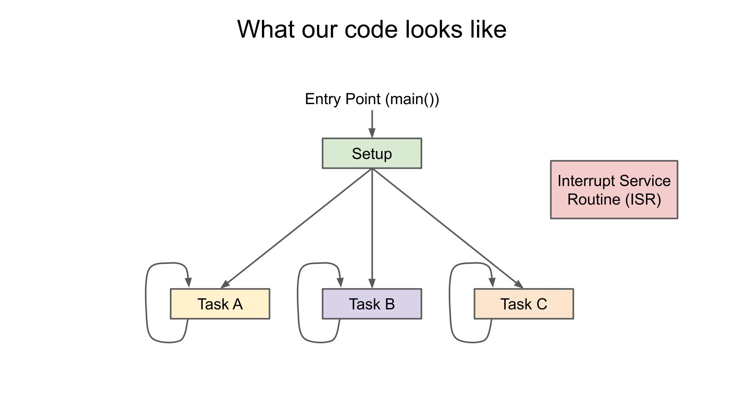

Each task appears to run concurrently in its own while loop (assuming we don’t end a thread after a single execution). In microcontrollers, we can also set up independent interrupt service routines (ISRs) that can preempt any of the tasks to execute some code. An ISR is used to handle things like hardware timer overflows, pin state changes, or new communication on a bus.
In a single-core system, the CPU must divide up the tasks into time slices so that they can appear to run concurrently. The scheduler in an operating system is charged with figuring out which task to run each time slice.
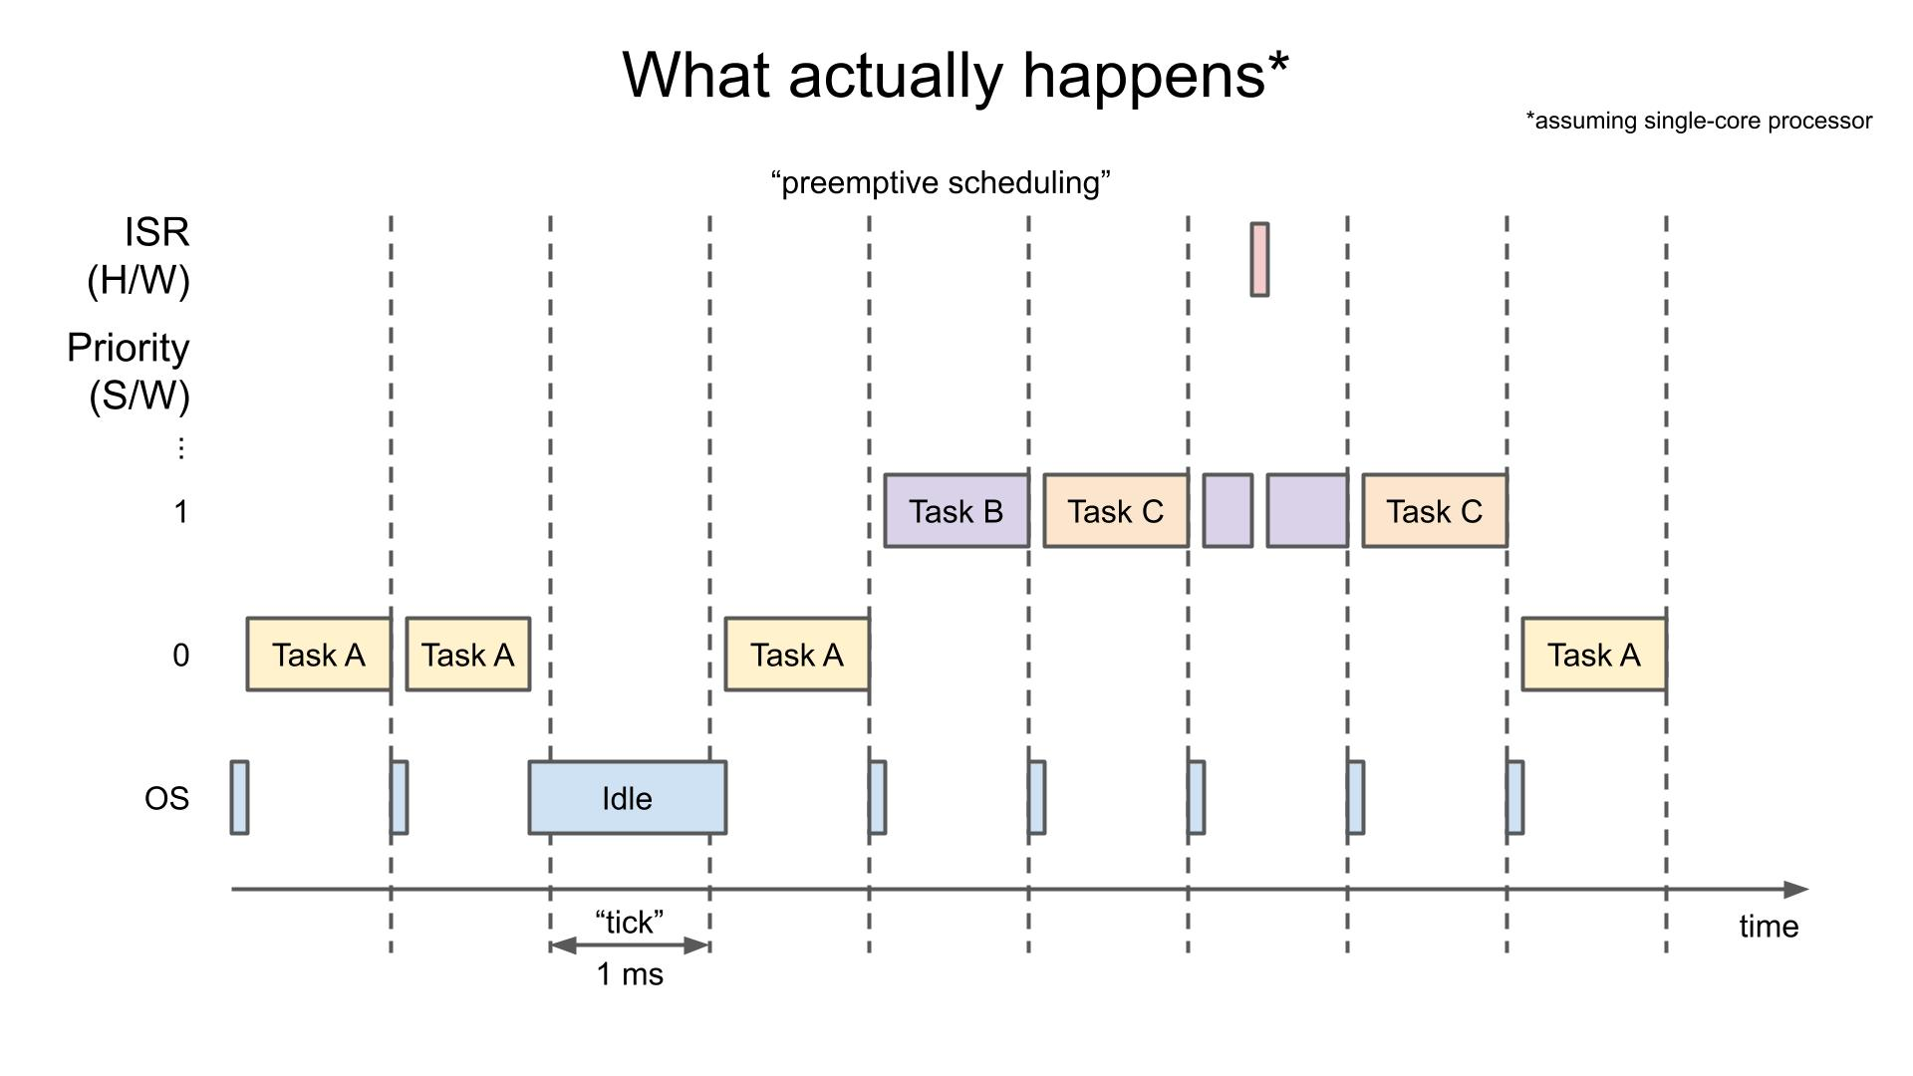

In FreeRTOS, the default time slice is 1 ms, and a time slice is known as a “tick.” A hardware timer is configured to create an interrupt every 1 ms. The ISR for that timer runs the scheduler, which chooses the task to run next.
At each tick interrupt, the task with the highest priority is chosen to run. If the highest priority tasks have the same priority, they are executed in a round-robin fashion. If a task with a higher priority than the currently running task becomes available (e.g. in the "Ready" state), then it will immediately run. It does not wait for the next tick.
A hardware interrupt is always considered to have a higher priority than any task running in software. As a result, a hardware ISR can interrupt any task. Because of this, we recommend keeping any ISR code as short as possible to reduce interruptions to the running tasks.
When we create tasks, we can assign them priorities. In fact, we can even change priorities of tasks with vTaskPrioritySet() (read more about that function here).

vTaskPrioritySet
[Task Control]
task. h

void vTaskPrioritySet( TaskHandle_t xTask,
UBaseType_t uxNewPriority );

INCLUDE_vTaskPrioritySet must be defined as 1 for this function to be available. See the RTOS Configuration documentation for more information.
Set the priority of any task.
A context switch will occur before the function returns if the priority being set is higher than the currently executing task.

Parameters:

xTask | Handle of the task whose priority is being set. A NULL handle sets the priority of the calling task.
uxNewPriority | The priority to which the task will be set.  Priorities are asserted to be less than configMAX_PRIORITIES. If configASSERT is undefined, priorities are silently capped at (configMAX_PRIORITIES - 1).

Example usage:
void vAFunction( void )
{
TaskHandle_t xHandle;
// Create a task, storing the handle.
xTaskCreate( vTaskCode, "NAME", STACK_SIZE, NULL, tskIDLE_PRIORITY, &xHandle );
// ...
// Use the handle to raise the priority of the created task.
vTaskPrioritySet( xHandle, tskIDLE_PRIORITY + 1 )
// ...
// Use a NULL handle to raise our priority to the same value.
vTaskPrioritySet( NULL, tskIDLE_PRIORITY + 1 );
}

Tasks in FreeRTOS can be in one of four states.

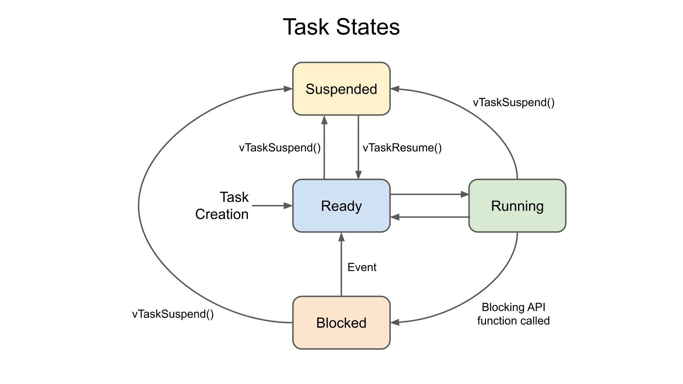
As soon as a task is created, it enters the Ready state. Here, it tells the scheduler that it’s ready to run. Each tick, the scheduler chooses 1 task to run that’s in the ready state (on a multi-core system, the scheduler can choose multiple tasks, but we won’t cover multi-core systems here).
While running, a task is in the Running state and can be returned to the Ready state by the scheduler.
Functions that cause the task to wait, like vTaskDelay(), put the task in the Blocked state. Here, the task is waiting for some other event to occur, such as the timer on the vTaskDelay() to expire. The task may also be waiting for some resource, like a semaphore, to be released by another task. Tasks in the Blocked state allow other tasks to run instead.
Finally, an explicit call to vTaskSuspend() can put a task in the Suspended mode (much like putting that task to sleep). Any task may put any task (including itself) into the Suspended mode. A task may only be returned to the Ready state by an explicit call to vTaskResume() by another task.

Problem 2. What is the mechanism used to make a task periodic for the RTOS you are using? Write a program to make a task periodic with periodicity of 500ms.

Solution :

In FreeRTOS, there are two APIs to create delay or make the task periodic.

1. void vTaskDelay( const TickType_t xTicksToDelay );

For eg.
vTaskDelay( pdMS_TO_TICKS( ms ) ); // less complex in computation as per blogs.
or
vTaskDelay(ms / portTICK_PERIOD_MS);

2. void vTaskDelayUntil( TickType_t *pxPreviousWakeTime, const TickType_t xTimeIncrement );

"vTaskDelay" specifies a time at which the task wishes to unblock relative to the time
at which vTaskDelay() is called.
Whereas vTaskDelayUntil() specifies an absolute (exact) time at which the task wishes to unblock.
Hence it is safe to use vTaskDelayUntil().
It should be noted that vTaskDelayUntil() will return immediately (without blocking)
if it is used to specify a wake time that is already in the past. Therefore a task using
vTaskDelayUntil() to execute periodically will have to re-calculate its required wake time
if the periodic execution is halted for any reason (for example, the task is temporarily placed into the Suspended state) causing the task to miss one or more periodic executions.

#include <stdio.h>
#include "freertos/FreeRTOS.h"
#include "freertos/task.h"

TaskHandle_t task1_handle, task2_handle;

void task_1(void *data)
{
while (1)
{
printf("This is the First Task\n");
vTaskDelay(500 / portTICK_PERIOD_MS);
}
vTaskDelete(task1_handle);
}

void task_2(void *data)
{
while (1)
{
printf("This is the Second Task\n");
vTaskDelay(500 / portTICK_PERIOD_MS);
}
vTaskDelete(task2_handle);
}

void app_main()
{
BaseType_t res1, res2;
printf("This is the Main Task\n");
res1 = xTaskCreate(task_1, "First Task", 2048, NULL, 4, &task1_handle);
res2 = xTaskCreate(task_2, "Second Task", 2048, NULL, 3, &task2_handle);
if (res1 !=pdPASS || res2 != pdPASS)
{
perror("Error in Creating Tasks : ");
}
}

Problem 3. Find the APIs in your RTOS that provides timestamp and use it to print the periodic task.
Observe the jitter in the timestamp vs the periodicity. Enhance the code to 10 periodic tasks
with different periodicity. Futher observe the jitter in each of the task.

Solution :

Problem 4. Create two task with priority 10 and 20. Each task prints its own custom message.
Solution :

#include <stdio.h>
#include "freertos/FreeRTOS.h"
#include "freertos/task.h"

TaskHandle_t task1_handle, task2_handle;

void task_1(void *data)
{
UBaseType_t prio;
while (1)
{
printf("This is the First Task\n");
vTaskDelay(500 / portTICK_PERIOD_MS);
prio = uxTaskPriorityGet(task1_handle);
printf("Task1 Priority: %d\n", prio);
}
vTaskDelete(task1_handle);
}

void task_2(void *data)
{
UBaseType_t prio;
while (1)
{
printf("This is the Second Task\n");
vTaskDelay(500 / portTICK_PERIOD_MS);
prio = uxTaskPriorityGet(task2_handle);
printf("Task2 Priority: %d\n", prio);
}
vTaskDelete(task2_handle);
}

void app_main()
{
BaseType_t res1, res2;
printf("This is the Main Task\n");
res1 = xTaskCreate(task_1, "First Task", 2048, NULL, 4, &task1_handle);
res2 = xTaskCreate(task_2, "Second Task", 2048, NULL, 3, &task2_handle);
if (res1 !=pdPASS || res2 != pdPASS)
{
perror("Error in Creating Tasks.\n");
}
}

Problem 5. Swap the priority and observe the changes in the output. What is your conclusion on the sequence of printing the messages.

Solution :

****** Output without SWAP : Priority Task1 - 4, Priority Task2 - 3
This is the Main Task

This is the Second Task

This is the First Task
Task1 Priority: 4

This is the First Task
Task2 Priority: 3

This is the Second Task
Task1 Priority: 4

This is the First Task
Task2 Priority: 3

This is the Second Task
Task1 Priority: 4

****** Output After SWAP : Priority Task1 - 3, Priority Task2 - 4
This is the Main Task

This is the Second Task

This is the First Task
Task2 Priority: 4

This is the Second Task
Task1 Priority: 3

This is the First Task
Task2 Priority: 4

This is the Second Task
Task1 Priority: 3

This is the First Task
Task2 Priority: 4
*/
// CONCLUSION : Higher Priority Task started first in each case.

#include <stdio.h>
#include "freertos/FreeRTOS.h"
#include "freertos/task.h"

TaskHandle_t task1_handle, task2_handle;

void task_1(void *data)
{
UBaseType_t prio;
while (1)
{
printf("\nThis is the First Task\n");
vTaskDelay(1000 / portTICK_PERIOD_MS);
prio = uxTaskPriorityGet(task1_handle);
printf("Task1 Priority: %d\n", prio);
}
vTaskDelete(task1_handle);
}

void task_2(void *data)
{
UBaseType_t prio;
while (1)
{
printf("\nThis is the Second Task\n");
vTaskDelay(1000 / portTICK_PERIOD_MS);
prio = uxTaskPriorityGet(task2_handle);
printf("Task2 Priority: %d\n", prio);
}
vTaskDelete(task2_handle);
}

void app_main()
{
BaseType_t res1, res2;
printf("This is the Main Task\n");
res1 = xTaskCreate(task_1, "First Task", 2048, NULL, 3, &task1_handle);
res2 = xTaskCreate(task_2, "Second Task", 2048, NULL, 4, &task2_handle);
if (res1 !=pdPASS || res2 != pdPASS)
{
perror("Error in Creating Tasks.\n");
}
}

Problem 6. What are the maximum number of tasks that can be created on the RTOS you are using? Is it limited by the RTOS design or underlying hardware resources or both.

Solution : The task control block (TCB) and the task's stack space are both allocated from the FreeRTOS heap as defined by configTOTAL_HEAP_SIZE (and the specific heapX.c file included in the build). There is nothing in FreeRTOS that limits the number of created tasks except the available FreeRTOS heap space.

Problem 7. What is the scheduling algorithm used by your RTOS?

Solution : FreeRTOS kernel supports two types of scheduling policy:

- Time Slicing Scheduling Policy: This is also known as a round-robin algorithm. In this algorithm, all equal priority tasks get CPU in equal portions of CPU time.

- Fixed Priority Preemptive Scheduling: This scheduling algorithm selects tasks according to their priority. In other words, a high priority task always gets the CPU before a low priority task. A low priority task gets to execute only when there is no high priority task in the ready state.

But in FreeRTOS, we usually use scheduling policy by mixing both the above-mentioned algorithms and it is known as Prioritized Preemptive Scheduling with Time Slicing.

Problem 8. List the customization options for creating a task for the RTOS you are using. eg. Priority etc.

Solution : FreeRTOS is customised using a configuration file called FreeRTOSConfig.h.

1. Idle Task.
2. Hooks (Callbacks)
3. Symmetric Multiprocessing (SMP) Support.
4. Memory Protection Support.
5. Thread Local Storage Pointers.
6. Blocking on Multiple Objects.
7. Deferred Interrupt Handling.
8. Low Power Support. etc
Problem 9. Find the fields that are maintained in the Task Control Block / Process Control Block of the RTOS you are using.

Solution : FreeRTOS uses a newly allocated TCB object to store the name, priority, and other details for a task, then allocates the amount of stack the user requests (assuming there's enough memory available) and remembers the start of the stack memory in TCB's pxStack member.

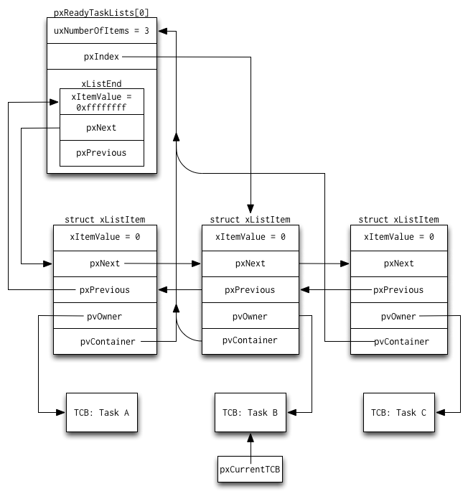

Problem 10. Draw a process or task state diagram for the RTOS you are using.

Solution :

Problem 11. What is the API for deleting a task? Write a program demonstrate this capability.

Solution :

void vTaskDelete( TaskHandle_t pxTask );
*
* It will delete an instance of a task that was previously created using a call to
* xTaskCreate() or xTaskCreateStatic().
*
* When a task is deleted, it is the responsibility of the idle task to free the memory
* that had been used to hold the deleted task’s stack and data structures (task control block).
* Therefore, if an application makes use of the vTaskDelete() API function, it is vital that
* the application also ensures the idle task is not starved of processing time
* (the idle task must be allocated time in the Running state).
*
*/

#include <stdio.h>
#include "freertos/FreeRTOS.h"
#include "freertos/task.h"

TaskHandle_t task1_handle, task2_handle;

void task_1(void *data)
{
UBaseType_t prio;
while (1)
{
printf("\nThis is the First Task\n");
prio = uxTaskPriorityGet(task1_handle);
printf("Task1 Priority: %d\n", prio);
vTaskDelay(1000 / portTICK_PERIOD_MS);
}
}

void app_main()
{
BaseType_t res1;

UBaseType_t mt_prio;
mt_prio = uxTaskPriorityGet(NULL);
printf("This is the Main Task\n");
printf("Task created successfully:Prio:%d\n", mt_prio);
printf("\n*************************************\n");
res1 = xTaskCreate(task_1, "First Task", 2048, NULL, 3, &task1_handle);
if (res1 !=pdPASS)
{
perror("Error in Creating Tasks.\n");
}
else
{
/* Delete the task just created. Use the handle passed out of xTaskCreate()
to reference the subject task. */
vTaskDelete(task1_handle);
printf("Task1 Deleted\n");
}
}

Problem 12. What are the APIs provided by your RTOS for enabling and disabling the interrupts? Write a program to demonstrate this capability?

Solution :

Problem 13. Does your RTOS provide APIs to collect task statistics. If yes, list the statistics parameters that are collected and write a program to display the runtime task statistics?

Solution :

Problem 14. Find the tick frequency configuration for your RTOS.

Solution : 1000

Problem 15. Create a task to suspend itself after 1200 ms and resume it from another task.

Solution :

Problem 16. Write a RTOS application to demonstrate the use of changing priority.

Solution :

#include <stdio.h>
#include "freertos/FreeRTOS.h"
#include "freertos/task.h"

TaskHandle_t task1_handle, task2_handle;

void task_1(void *data)
{
int count = 0;
while (1)
{
printf("This is the First Task\n");
count += 1;
if (count > 5)
{
vTaskResume(task2_handle);
printf("Task 2 Resumed\n");
count = 0;
}
vTaskDelay(500 / portTICK_PERIOD_MS);
}
}

void task_2(void *data)
{
while (1)
{
vTaskSuspend(task2_handle);
printf("This is the Second Task\n");
}
}

void app_main()
{
BaseType_t res1, res2;
printf("This is the Main Task\n");
res1 = xTaskCreate(task_1, "First Task", 2048, NULL, 4, &task1_handle);
res2 = xTaskCreate(task_2, "Second Task", 2048, NULL, 3, &task2_handle);
if (res1 !=pdPASS || res2 != pdPASS)
{
perror("Error in Creating Tasks :");
}
}

Problem 17. If your RTOS supports idle task hooking, write a program to demonstrate it.

Solution :

Problem 18. Write a RTOS application to demonstrate the use of task to task communication using Queue management APIs. Also demonstrate blocking on a queue.

Solution :

Problem 19. Write a RTOS application to demonstrate the effects of task priorities when sending to and receiving from a queue.

Solution :

Problem 20. Write a RTOS application to demonstrate deferred interrupt processing using binary semaphores.

Solution :

Problem 21. Write a RTOS application to demonstrate counting semaphores to synchronize a task.

Solution :

#include <stdio.h>
#include "freertos/FreeRTOS.h"
#include "freertos/task.h"
#include "freertos/timers.h"
#include "freertos/semphr.h"

TaskHandle_t task1handle, task2handle, task3handle, task4handle;
SemaphoreHandle_t serial_counting_sem;

void task1(void *data)
{
printf("Task1: Starting the task1 \n");
printf("Task1 Requesting for the serial port\n");
xSemaphoreTake(serial_counting_sem, pdMS_TO_TICKS(20000));
printf("Task1 Got the serial port\n");
vTaskDelay(1000 / portTICK_PERIOD_MS);
xSemaphoreGive(serial_counting_sem);
printf("Task1 Released the serial port\n");
vTaskDelete(NULL);
}

void task2(void *data)
{
printf("Task2: Starting the task2 \n");
printf("Task2 Requesting for the serial port\n");
xSemaphoreTake(serial_counting_sem, pdMS_TO_TICKS(20000));
printf("Task2 Got the serial port\n");
vTaskDelay(2000 / portTICK_PERIOD_MS);
xSemaphoreGive(serial_counting_sem);
printf("Task2 Released the serial port\n");
vTaskDelete(NULL);
}

void task3(void *data)
{
printf("Task3: Starting the task3 \n");
printf("Task3 Requesting for the serial port\n");
xSemaphoreTake(serial_counting_sem, pdMS_TO_TICKS(20000));
printf("Task3 Got the serial port\n");
vTaskDelay(3000 / portTICK_PERIOD_MS);
xSemaphoreGive(serial_counting_sem);
printf("Task3 Released the serial port\n");
vTaskDelete(NULL);
}

void task4(void *data)
{
printf("Task4: Starting the task4 \n");
printf("Task4 Requesting for the serial port\n");
xSemaphoreTake(serial_counting_sem, pdMS_TO_TICKS(20000));
printf("Task4 got the serial port\n");
vTaskDelay(8000 / portTICK_PERIOD_MS);
xSemaphoreGive(serial_counting_sem);
printf("Task4 released the serial port\n");
vTaskDelete(NULL);
}

int app_main()
{
BaseType_t res;
UBaseType_t mt_prio;
printf("DESD RTOS PROJECT\n");
mt_prio = uxTaskPriorityGet(NULL);
printf("MT: Task created successfully: prio : %d\n", mt_prio);
serial_counting_sem = xSemaphoreCreateCounting(2,2);
res = xTaskCreate(task1, "TASK1", 2048, NULL,5, &task1);
res = xTaskCreate(task2, "TASK2", 2048, NULL,5, &task2);
res = xTaskCreate(task3, "TASK3", 2048, NULL,5, &task3);
res = xTaskCreate(task4, "TASK4", 2048, NULL,5, &task4);
return 0;
}

Problem 22. Write a RTOS application to demonstrate the usage of queues within an interrupt service routine.

Solution :

Problem 23. Write a RTOS application to manage resources using mutual exclusion.

Solution :

Problem 24. Write a RTOS application to demonstrate a priority inversion problem. If your RTOS supports priority inheritance or priority ceiling, use it to solve the priority inversion problem.

Solution :

Problem 25. Write a RTOS application to create a software timer that invokes a callback function every 5 seconds.

Solution :

