**Guideline – Insert Client Logo**

**Guideline –Template**

<Student Name>

BCDE311 – Software Development PROJECT

Semester x, 202x

<Project NAME> for <CLIENT NAME>

Project Proposal

Version <version number>

Contents

Introduction 5

Project Details 6

Project Name 6

Overview of Industry Client 6

Project Background 6

Information Gathering 7

Documentation 7

Project Scope 8

Project Goal(s) 8

Benefits of Project 8

Project Requirements 8

Expected Deliverables 8

User Personas 8

Project Plan – High Level 9

Project Management Framework adopted 9

Phases 9

Timetable 9

Burndown Charts 9

Resources/Access Required 9

Risk Management 10

Approach 10

Risk Table 10

Quality Assurance 11

Approach 11

Quality Assurance Table 11

Test Plans – Functional and Usability 11

Project Management Framework Methodology 12

Overview 12

Literature Review 12

Critique (Pros and Cons) 12

Ethics 13

Relevance of ITP Code of Ethics 13

Relevant Legislation 14

Reflections 15

Approach 15

Specifications 16

Reference List 17

Appendices 18

Appendix A – Detailed Project Plan 18

Appendix B – Risk Management Table 18

Appendix C – Quality Assurance Table 18

Document Control

|  |  |  |  |
| --- | --- | --- | --- |
| Date | Author | Version | Status of Document/Updates Made |
| dd/mm/yyyy | <Name of Student> | v0.1 | Document Creation |
| dd/mm/yyyy | <Name of Student> | v0.2 etc |  |
| dd/mm/yyyy | <Name of Student> | v1.0 | Signed Off, Submitted |

**Guideline – Effective Written Communication**

Use these standards to create a document that is effective and well-written.

1. Remove all guidelines from the document before submission.
2. Cover Page – Ara Logo, Client Logo, Project Name, Client Name, Document Name, Student Name, Date, Version, Paper Code and Name, Pathway.
3. Table of Contents (TOC) – No more than 3 heading levels, Table of Tables & Table of Figures not required.
4. Document Control – keep this up to date.
5. Header and Footer - Header contains Project Name, Client Name, Date ; Footer contains Student Name and Page Numbering (e.g. Page 1 of 10) ; Both Header and Footer in smaller font than body font size ; Header has a separating underline ; Footer has a separating overline.
6. Use of Heading 1, 2, 3… for the TOC, Online navigation, and readability.
7. Heading 1 Topics start on a new page.
8. Diagrams, Charts, Tables have captions (if used).
9. The document is optimised for black & white printing and colour-blind readers.
10. APA v7 Reference List supported by in text referencing.
11. The point of view of the document is consistent e.g., 1st person (I/we) or 2nd person (you) or 3rd person (he, she, it, they).
12. Business/Professional Language used conveys a strong, clear and concise tone (active voice).
13. Document is A4, double sided, font size is professional/business suitable, font size for body text is 10.5-to-12-point, single line spacing.
14. Appendices included where useful to maintain flow of main document.
15. Bullets used to help readability.
16. Lead-In sentences/paragraphs to describe/introduce main sections (usually Heading 1 sections) and for diagrams/charts/tables.
17. Do not split sentences/paragraphs over a page.
18. If tables split over a page, use table headings.
19. Use portrait and landscape page orientations to improve readability (Hint: this is done using section breaks).
20. Include an introduction to the document after the Table of Contents - It will cover: the objective or purpose of the report (not the project); an outline of the report’s structure.
21. Correct spelling & grammar for a business-English (NZ) audience.
22. Wow-Factor - The overall design of the document is innovative/creative/positively memorable/relevant to the client/makes you want to read it.

# Introduction

**Guideline - the objective or purpose of the report (not the project) ; an outline of the report’s structure.**

# Project Details

**Guideline - lead in sentence to describe this section**

## Project Name

**Guideline - Short, Sharp, Catchy**

## Overview of Industry Client

**Guideline - Who is the client?**

## Project Background

### Overview

**Guideline – Why is the project important to the client? What is the business problem/opportunity?**

### Current Situation

**Guideline – what is happening today for the client – before the project is started?**

### Future Situation

**Guideline – what does the situation look like for the client once the project is completed?**

# Information Gathering

**Guideline - lead in sentence to describe this section**

## Documentation

**Guideline: document the questions and answers and summary analysis you made from your interview with the client.**

# Project Scope

**Guideline - lead in sentence to describe this section**

## Project Goal(s)

**Guideline – what specific goals/outcomes will the project achieve for the client**

## Benefits of Project

## Project Requirements

**Guideline – list the high-level requirements (if known at this stage)**

## Expected Deliverables

**Guidelines – make a list of the deliverables**

## User Personas

**Guidelines – describe the target personas**

# Project Plan – High Level

**Guideline - lead in sentence to describe this section**

## Project Management Framework adopted

**Guideline – an overview of the Framework adopted**

## Phases

**Guideline – the major phases of the project, include the estimated task breakdown**

## Timetable

**Guideline – includes the order of the tasks within the phases, the forecasted hours per task and phase, due dates for deliverables, (the timeline will be updated with actual hours and delivery dates as the project progresses).**

Burndown Charts

An example of a WIL Capstone Project Academic Burndown Chart

**Figure 7**   
*Academic Burndown Chart*

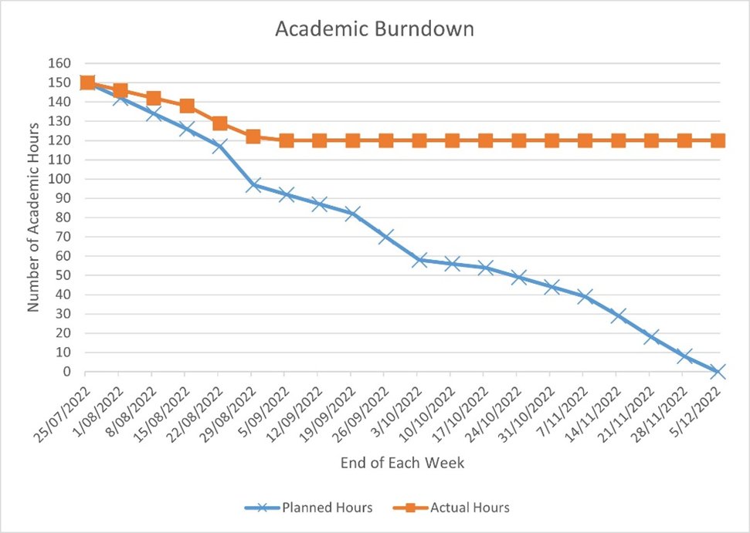

## Resources/Access Required

# Risk Management

**Guideline - lead in sentence to describe this section**

## Approach

**Guideline – describe the selected approach/framework/method for risk identification and management, why it was selected, how often the risks will be reviewed, and how to read the risk table.**

## Risk Table

**Guideline – no more than top 5 risks, covering business, project, personal etc – identify the Probability, Impact and rank by exposure, Create Mitigation, Contingency and Triggers – this plan will be updated throughout the project. The full table and updates may be placed in an appendix for readability.**

# Quality Assurance

**Guideline - lead in sentence to describe this section**

## Approach

**Guideline – describe the selected approach/framework/method for maintaining quality assurance (deliverables must meet client and good practice criteria) ,why it was selected, how often the quality assurance table will be reviewed, and how to read the quality assurance table.**

## Quality Assurance Table

**Guideline – this is a list of all deliverables, the criteria for acceptance, who will accept them and date of acceptance.**

## Test Plans – Functional and Usability

**Guideline – detail your separate Functional and Usability testing plans – you will use these, update and document the results during the project.**

# Project Management Framework Methodology

**Guideline - lead in sentence to describe this section**

## Overview

## Literature Review

## Critique (Pros and Cons)

# Ethics

**Guideline - lead in sentence to describe this section**

## Relevance of ITP Code of Ethics

**Guideline – see** <https://itp.nz/s/ITP-Code-of-Ethics.pdf>  **for further information**

### Good Faith

**Guideline – the student shall treat people with dignity, good faith and equality; without discrimination; and have consideration for the values and cultural sensitivities of all groups within the community affected by their work;**

### Integrity

**Guideline – the student shall act in the execution of their profession with integrity, dignity and honour to merit the trust of the community and the profession, and apply honesty, skill, judgement and initiative to contribute positively to the well-being of society;**

### Community Focus

**Guideline - Responsibility for the welfare and rights of the community shall come before their responsibility to their profession, sectional or private interests or to other professionals;**

### Skills

**Guidelines – students shall apply their skills and knowledge in the interests of their clients or employers for whom they will act without compromising any other of these Tenets;**

### Continuous Development

**Guideline - students shall develop their knowledge, skills and expertise continuously through their careers, contribute to the collective wisdom of the profession, and actively encourage their associates to do likewise;**

### Informed Consent

**Guideline - students shall take reasonable steps to inform themselves, their clients or employers of the economic, social, environmental or legal consequences which may arise from their actions;**

### Conflicts of Interest

**Guideline - students shall inform their clients or employers of any interest which may be, or may be perceived as being, in conflict with the interests of their clients or employers, or which may affect the quality of service or impartial judgement;**

### Competence

**Guideline – students shall follow recognised professional practice, and provide services and advice carefully and diligently only within their areas of competence.**

## Relevant Legislation

**Guideline – see** [**https://www.privacy.org.nz/**](https://www.privacy.org.nz/) **and** [**https://www.iponz.govt.nz/**](https://www.iponz.govt.nz/)

## 

### Privacy/Confidentiality

**Guideline: what aspects of privacy/confidentiality practice/legislation are relevant to the project**.

### Copyright

**Guideline: what aspects of copyright practice/legislation are relevant to the project**.

### Patents

**Guideline: what aspects of patents practice/legislation are relevant to the project**.

# Reflections

**Guideline - lead in sentence to describe this section**

## Approach

**Guideline: what is the way that notes will be taken to capture lessons learnt and reflections during the project.**

# Specifications

**Guideline - this is a placeholder to indicate you will be creating specification documentation derived from your initial low-fidelity wireframe / story board processes and submitting them in an appropriate manner here.**

# References

**Guideline – APA v7, supported by in-text references.**

# Appendices

**Guideline - lead in sentence to describe this section**

## Appendix A – Detailed Project Plan

**Guideline – work breakdown structure including phases, tasks, deliverables, time allocated, completion dates, resources.**

## Appendix B – Risk Management Tables

Guideline -Use this to give provide updates of the risk tables and other evidence that may not be suitable to display in the main report section – example of a table from WIL Capstone Project Risk Management

**Table B4**   
*Risk Issues Management - 3 October 2022*

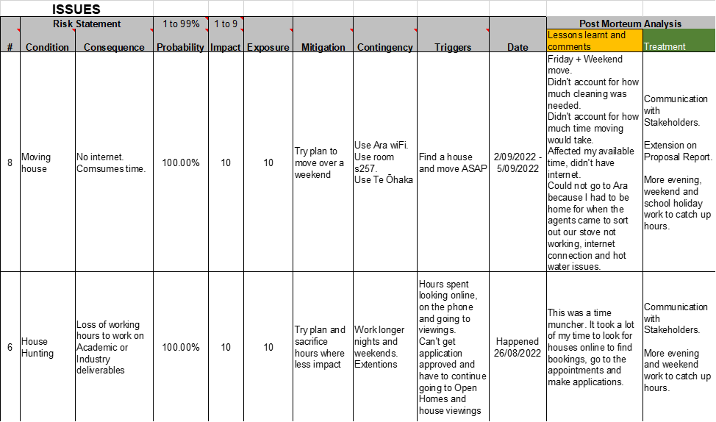

## Appendix C – Quality Assurance Tables

Guideline -Use this to give provide updates of the QA table and other evidence that may not be suitable to display in the main report section