**App.module.ts**

import { BrowserModule } from '@angular/platform-browser';

import { NgModule } from '@angular/core';

import { AppComponent } from './app.component';

import { MenuComponent } from './menu/menu.component';

import { WeatherComponent } from './weather/weather.component';

import { MovieComponent } from './movie/movie.component';

import { CurrencyComponent } from './currency/currency.component';

import { RouterModule, Routes} from '@angular/router'

import { FormsModule} from '@angular/forms';

import { HttpClientModule } from '@angular/common/http';

const approutes: Routes=[

{path: 'weather', component:WeatherComponent},

{path: 'movie', component:MovieComponent },

{path: 'curreny', component:CurrencyComponent}

];

@NgModule({

declarations: [

AppComponent,

MenuComponent,

WeatherComponent,

MovieComponent,

CurrencyComponent

],

imports: [

BrowserModule,[RouterModule.forRoot(approutes,{enableTracing : true}), HttpClientModule , FormsModule]

],

providers: [],

bootstrap: [AppComponent]

})

export class AppModule { }

**App.component.ts**

import { Component } from '@angular/core';

@Component({

selector: 'app-root',

templateUrl: './app.component.html',

styleUrls: ['./app.component.css']

})

export class AppComponent {

title = 'My Angular 2 App Works';

}

**App.component.html**

<div style="text-align:center">

<h1>

{{ title }}!

</h1>

<app-menu></app-menu>

<br>

<hr>

<router-outlet></router-outlet>

**Shared.service.ts**

import { Injectable, Injector } from '@angular/core';

import { Observable, of } from 'rxjs';

import { HttpClient } from '@angular/common/http';

@Injectable({

providedIn: 'root'

})

export class SharedService {

MovieAPIURL = '';

constructor(private injector: Injector, private httpClient: HttpClient) {

}

public getWeather(city: string): Observable<any> {

var weathereAPIurl = 'https://query.yahooapis.com/v1/public/yql?q=select * from weather.forecast where woeid in (select woeid from geo.places(1) where text="' + city + '")&format=json&env=store%3A%2F%2Fdatatables.org%2Falltableswithkeys ';

return this.httpClient.get(weathereAPIurl);

}

public getCurrency(currency: String): Observable<any> {

var currencyAPIurl = 'https://data.fixer.io/api/latest?base=' + currency;

return this.httpClient.get(currencyAPIurl);

}

public getMovie(movieName:String): Observable<any> {

var movieapiurl ='http://www.omdbapi.com/?t=%27'+movieName+'%27&apikey=8b8b3f2'

return this.httpClient.get(movieapiurl);

}

}

**Menu.component.ts**

import { Component, OnInit } from '@angular/core';

@Component({

selector: 'app-menu',

templateUrl: './menu.component.html',

styleUrls: ['./menu.component.css']

})

export class MenuComponent implements OnInit {

constructor() { }

ngOnInit() {

}

}

**Menu.component.html**

<div class="container">

<div class="col-xs-12">

<div class="navbar navbar-expand-sm navbar-light bg-light">

<li class="nav-item"> <a routerActiveLink="active" routerLink="/weather">Weather</a></li>

<li class="nav-item"> <a routerActiveLink="active" routerLink="/movie">movies</a></li>

<li class="nav-item"> <a routerActiveLink="active" routerLink="/curreny">Currency</a></li>

</div>

</div>

</div>

**Currency.component.ts**

import { Component, OnInit } from '@angular/core';

import {SharedService} from '../shared.Service'

@Component({

selector: 'app-currency',

templateUrl: './currency.component.html',

styleUrls: ['./currency.component.css']

})

export class CurrencyComponent implements OnInit {

data:any;

public txtCurrency: string='USD';

constructor(private sharedservice: SharedService) {

}

ngOnInit() {

}

public getCurrencyInfor(){

this.sharedservice.getCurrency(this.txtCurrency.toString()).subscribe(res=>

{

this.data = res;

});

}

}

**Currency.component.html**

<p>

currency works!

</p>

<input type="text" style="width:130px" class="form-control" id="txtCurrency"

required

[(ngModel)]="txtCurrency"

name="txtCurrency">

<input type="button" value="GetCurrencyInfo" (click)="getCurrencyInfor()" >

<div>{{data |json}}</div>

**Movie.commponent.html**

import { Component, OnInit } from '@angular/core';

import { SharedService } from '../shared.Service';

import { fn } from '@angular/compiler/src/output/output_ast';

@Component({

selector: 'app-movie',

templateUrl: './movie.component.html',

styleUrls: ['./movie.component.css']

})

export class MovieComponent implements OnInit {

data: any;

public txtInput: string='thor';

constructor(private sharedservice: SharedService) { }

ngOnInit() {

}

public getData(){

this.sharedservice.getMovie(this.txtInput.toString()).subscribe(res => {

this.data = res;

});

}

}

**Movie.component.html**

<p>

movie works!

</p>

<input type="text" style="width:130px" class="form-control" id="txtInput"

required

[(ngModel)]="txtInput"

name="txtInput">

<input type="button" value="GetMovieInfo" (click)="getData()" >

<div>{{data |json}}</div>

**Weather.component.ts**

import { Component, OnInit } from '@angular/core';

import {SharedService } from '../shared.Service'

@Component({

selector: 'app-weather',

templateUrl: './weather.component.html',

styleUrls: ['./weather.component.css']

})

export class WeatherComponent implements OnInit {

data:any;

public txtWeather: string='TamilNadu';

constructor(private sharedservie: SharedService) {

}

ngOnInit() {

}

public GetWeatherInfo(){

this.sharedservie.getWeather(this.txtWeather.toString()).subscribe(res=>

{

this.data = res;

},

err=>{console.log(err);},

() => {console.log("Done loading");}

);

}

}

**Weather.component.html**

<p>

weather works!

</p>

<input type="text" style="width:130px" class="form-control" id="txtWeather" required name="txtWeather">

<!-- [(ngModel)]="txtWeather" -->

<div>

<input type="button" value="GetWeatherInfo" (click)="GetWeatherInfo()">

</div>

<div>{{data |json}}</div>

**Output:**

**Weather:**

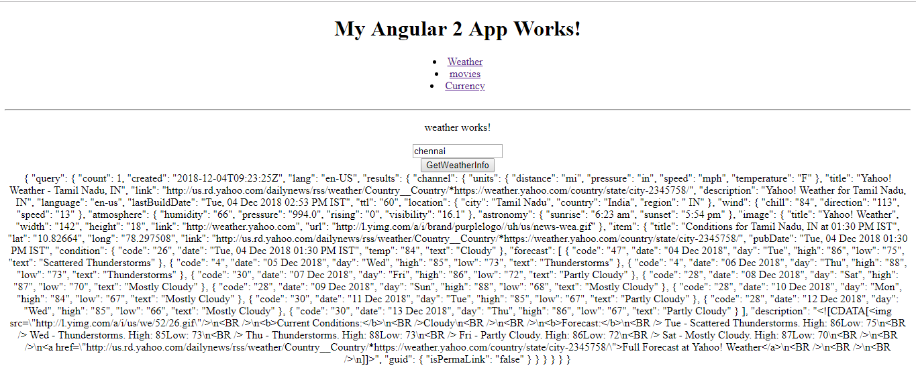

**Movie:**

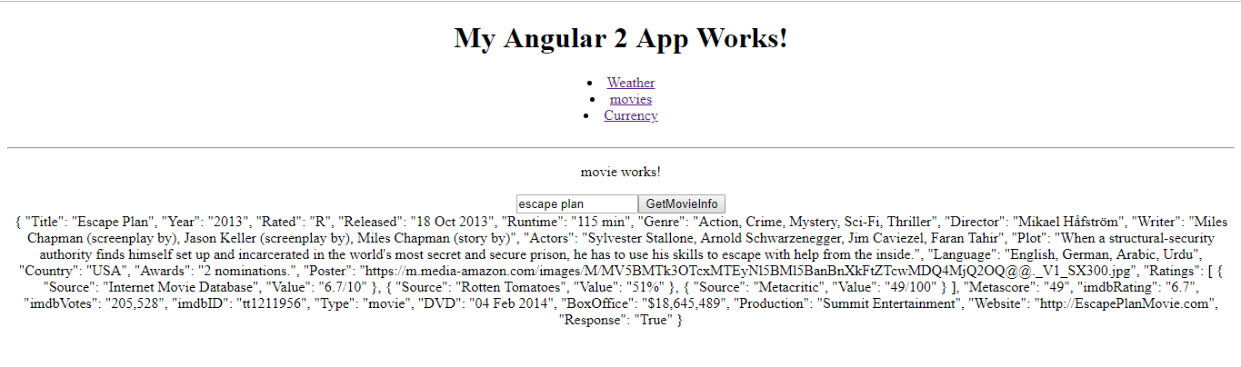

**Currency:**

