Scroll to the top of the page with jQuery.

<!DOCTYPE html>

<html>

<head>

<script src="https://ajax.aspnetcdn.com/ajax/jQuery/jquery-3.3.1.min.js">

</script>

<script>

$(document).ready(function(){

$('#top').click(function(){

$(window).scrollTop(0);

});

});

</script>

</head>

<body>

    <p>jquery</p>

    <p>jquery</p>

    <p>jquery</p>

    <p>jquery</p>

    <p>jquery</p>

    <p>jquery</p>

    <p>jquery</p>

    <p>jquery</p>

    <p>jquery</p>

    <p>jquery</p>

    <p>jquery</p>

    <p>jquery</p>

    <p>jquery</p>

    <p>jquery</p>

    <p>jquery</p>

    <p>jquery</p>

    <p>jquery</p>

    <p>jquery</p>

    <p>jquery</p>

    <p>jquery</p>

    <p>jquery</p>

    <p>jquery</p>

    <p>jquery</p>

    <p>jquery</p>

    <p>jquery</p>

    <p>jquery</p>

    <p>jquery</p>

    <p>jquery</p>

    <p>jquery</p>

    <p>jquery</p>

    <p>jquery</p>

    <p>jquery</p>

    </br></br>

    <a href='#' id="top">GoTop</a>

    </body>

</html>



How to detect a textbox's content has changed using jQuery?

<!DOCTYPE html>

<html>

<head>

<script src="https://ajax.aspnetcdn.com/ajax/jQuery/jquery-3.3.1.min.js">

</script>

<script>

$(document).ready(function () {

var myFunction = function () {

var $Name1 = $("#name1");

var $Name2 = $("#name2");

var $DivContent = $("#divContent");

$DivContent.text("");

if ($Name1.val().trim() != "" && $Name2.val().trim() != "") {

$DivContent.text("Firstname & LastName are not empty");

}

else if ($Name1.val().trim() != "") {

$DivContent.text("LastName empty");

}

else if ($Name2.val().trim() != "") {

$DivContent.text("Firstname empty");

}

else {

$DivContent.text("Firstname & LastName empty");

}

};

$("#name1").change(myFunction);

$("#name2").change(myFunction);

});

</script>

</head>

<metacharset="utf-8">

<metaname="viewport" content="width=device-width">

<title>How to detect a textbox's content has changed using jQuery</title>

</head>

<body>

<formaction="demo_form.asp">

<span id="divContent"></span>

<br>

<br> Firstname:

<input type="text" id="name1" name="fname">

<br> Lastname:

<input type="text" id="name2" name="lname">

<br>

<input type="submit" id="btn1" value="Submit">

</form>

</body>

</html>



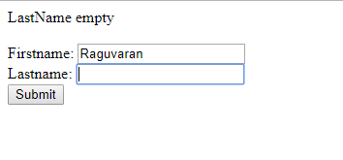

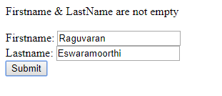

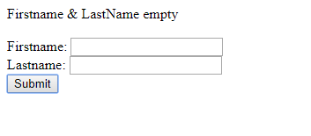

**Change button text using jQuery.**

<!DOCTYPE html>

<html>

<head>

<script src="https://ajax.aspnetcdn.com/ajax/jQuery/jquery-3.3.1.min.js">

</script>

<script>

$(document).ready(function () {

var myFunction = function () {

var $button1 = $("#button1");

if ($button1.val() == "Cancel") {

$button1.val("Enabled");

}

else {

$button1.val("Cancel");

}

};

$("#button1").click(function () {

myFunction();

});

});

</script>

</head>

<metacharset="utf-8">

<metaname="viewport" content="width=device-width">

<title>Change button text using jQuery.</title>

</head>

Click to to change the button text using Jquery

<body>

<input type='button' value='Cancel' id='button1' />

</body>

</html>

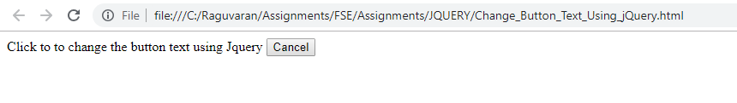

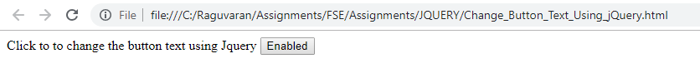

**Add 3 new options to a drop-down list using jQuery.**

<!DOCTYPE html>

<html>

<head>

<script src="https://ajax.aspnetcdn.com/ajax/jQuery/jquery-3.3.1.min.js">

</script>

<script>

$(document).ready(function(){

var loadOptions = function() {

var selectValues = { "1": "Blue", "2": "Yellow" , "3": "Orange"};

$.each(selectValues, function(key, value) {

$('#myColors')

.append($('<option>', { value : key })

.text(value));

});

    };

var UnloadOptions = function() {

var selectValues = { "1": "Blue", "2": "Yellow" , "3": "Orange"};

$.each(selectValues, function(key, value) {

$("#myColors option[value='"+key+"']").each(function() {

$(this).remove();

});

});

    };

$("#button1").click(function(){

loadOptions();

});

$("#button2").click(function(){

UnloadOptions();

});

});

</script>

</head>

<metacharset="utf-8">

<metaname="viewport"content="width=device-width">

<title>Add options to a drop-downlist using jQuery.</title>

</head>

Click to load 3 more options to a drop-downlist using jQuery.

<body>

</br> </br>

<input type='button'value='Load Options'id='button1'/>

<input type='button'value='Reset Options'id='button2'/>

</br> </br> </br>

<select id='myColors'>

<option value="Red">Red</option>

<option value="Green">Green</option>

<option value="White">White</option>

<option value="Black">Black</option>

    </select>

</body>

</html>



**Set background-image using jQuery CSS property.**

<!DOCTYPE html>

<html>

<head>

<meta charset="utf-8">

<meta name="viewport" content="width=device-width">

<title>Set background-image using jQuery CSS property.</title>

</head>

<script src="https://ajax.aspnetcdn.com/ajax/jQuery/jquery-3.3.1.min.js"></script>

<script>

$(document).ready(function () {

let imageUrl = './water.jpg';

$("body").css("background-image", "url(" + imageUrl + ")");

});

</script>

<body>

</body>

</html>

