**Create the tables Customers and Orders with the following columns. (do not declare the corresponding primary and foreign keys )**

CREATE TABLE Customers

(

Customerid char(5) not null,

CompanyName varchar(40) not null,

contactName Char(30) null,

[Address] varchar(60) null,

City Char(15) null,

Phone Char(24) null,

Fax Char(24) null

)

select * from Customers

CREATE TABLE Orders

(

OrderId integer not null,

customerId char(5) not null,

Orderdate datetime null,

Shippeddate datetime null,

Freight money null,

Shipname varchar(40) null,

Shipaddres varchar(60) null,

Quantity integer null

)

select * from Orders

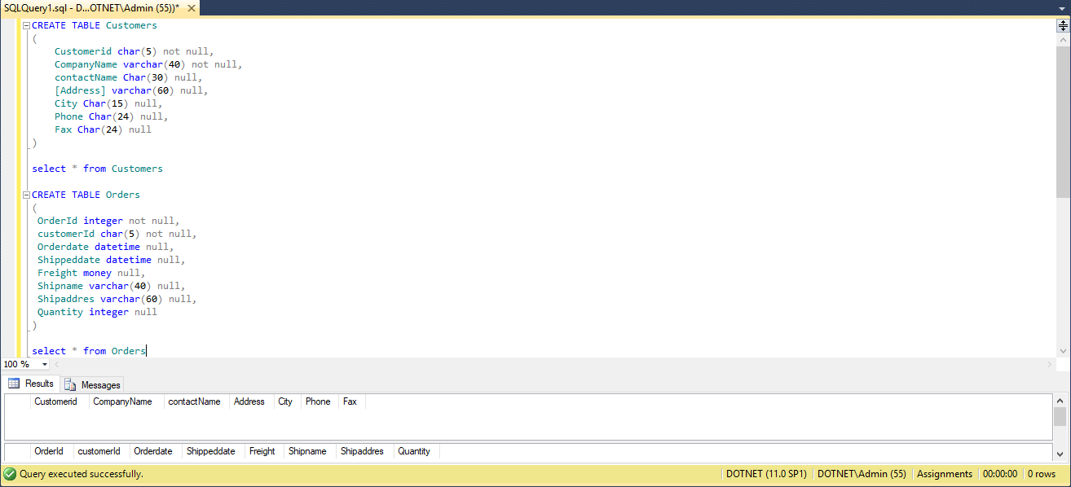

**Using the ALTER TABLE statement, add a new column named shipregion to the Orders table. The fields should be nullable and contain integers.**

Alter table dbo.Orders

Add shipregion integer null

select * from Orders

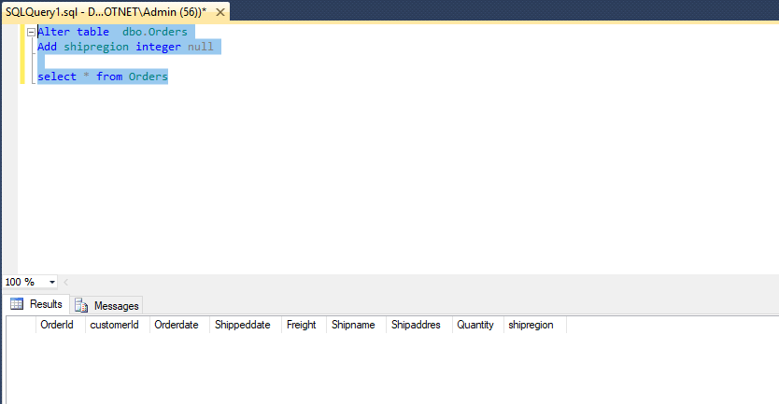

**Using the ALTER TABLE statement, change the data type of the column shipregion from INTEGER to CHARACTER with length 8. The fields may contain null values.**

Alter table dbo.Orders

Alter column shipregion Char(8) null

select * from Orders

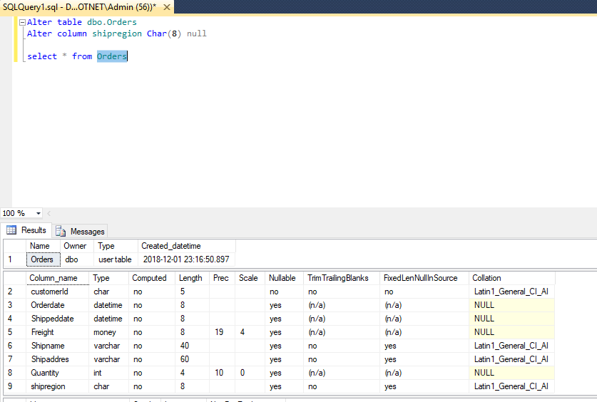

**Delete the formerly created column shipregion.**

Alter table dbo.Orders

Drop column shipregion

select * from Orders

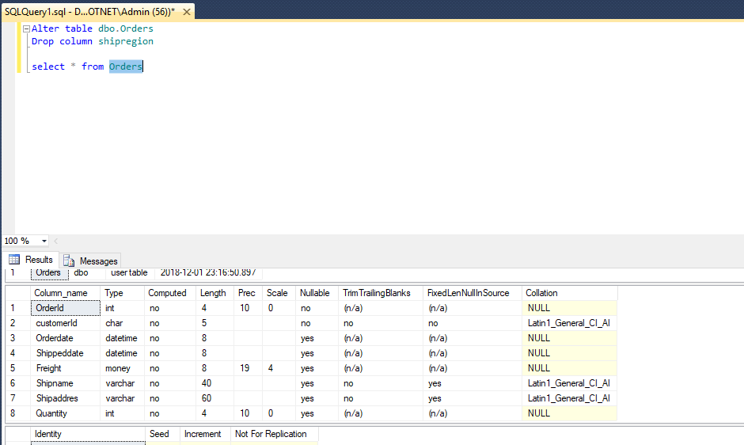

**Using the SQL Server Management Studio, try to instert a new row into the Orders table with the following values:**

**(10, ‘ord01’, getdate(), getdate(), 100.0, ‘Windstar’, ‘Ocean’ ,1)**

insert into dbo.Orders values ( 10, 'ord01', getdate(), getdate(), 100.0, 'Windstar', 'Ocean' ,1)

select * from Orders

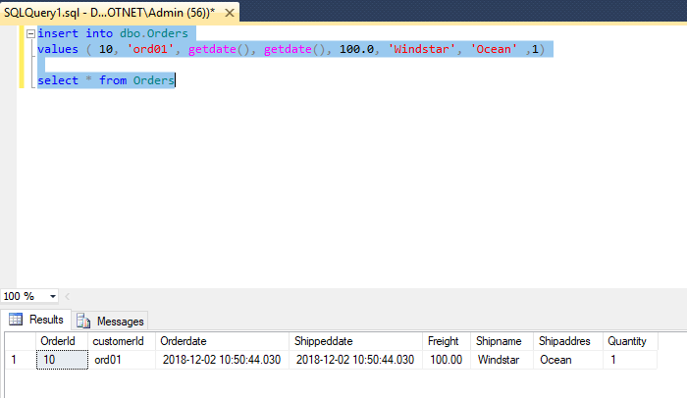

**Using the ALTER TABLE statement, add the current system date and time as the default value to the orderdate column of the Orders table.**

Alter table dbo.Orders

Add Constraint Df_OrderDate Default GetDate() for Orderdate

select * from Orders

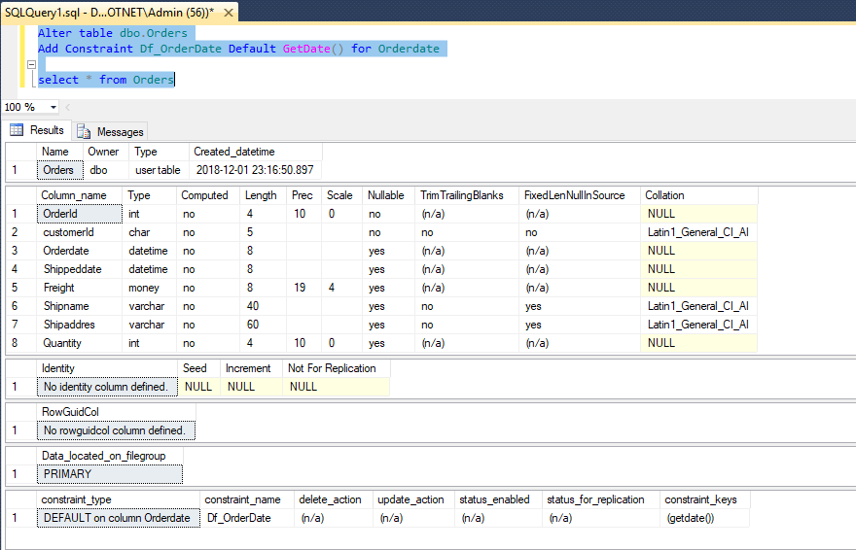

**Rename the city column of the Customers table. The new name is Town.**

select * from Customers

Exec sp_rename 'dbo.Customers.City','Town','COLUMN'

select * from Customers

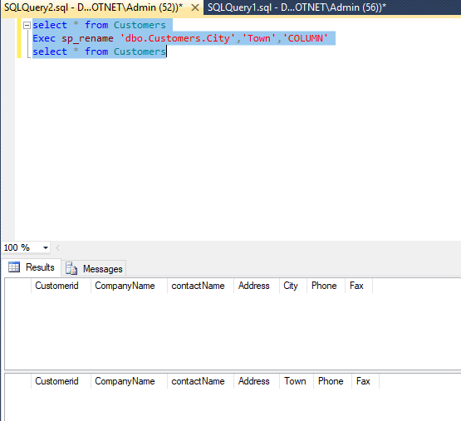

**Create Department, Employee, Project, Works_On Tables and insert the data**

CREATE TABLE Department

(

Dept_no Char(10) not null,

Dept_name Char(10) not null,

location CHAR(50) not null

)

Insert into dbo.Department values('d1','Res','Dallas')

Insert into dbo.Department values('d2','Ac','Seattle')

Insert into dbo.Department values('d3','Ma','Dallas')

select * from Department

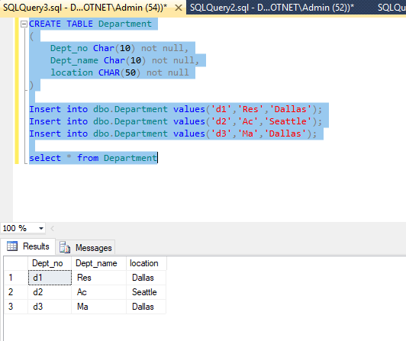

CREATE TABLE Employee

(

emp_no Integer not null,

emp_fname char(50) not null,

emp_lname char(50) not null,

Dept_no Char(10) not null

)

Insert INTO dbo.Employee values('25348','Matthew','Smith','d3')

Insert INTO dbo.Employee values('10102','Ann','Jones','d3')

Insert INTO dbo.Employee values('18316','John','Barrimore','d1')

Insert INTO dbo.Employee values('29346','James','James','d2')

select * from Employee

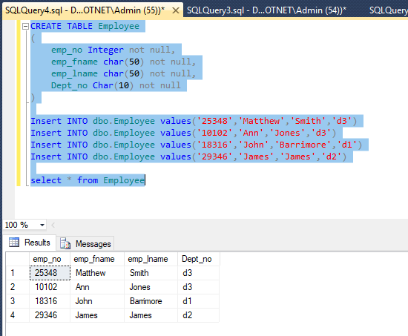

CREATE TABLE Project

(

project_no Char(10) not null,

project_name char(50) not null,

Budget Varchar(50) not null

)

Insert into dbo.Project values('p1','Apollo','12000')

Insert into dbo.Project values('p2','Gemini','95000')

Insert into dbo.Project values('p3','Mercury','18560')

select * from Project

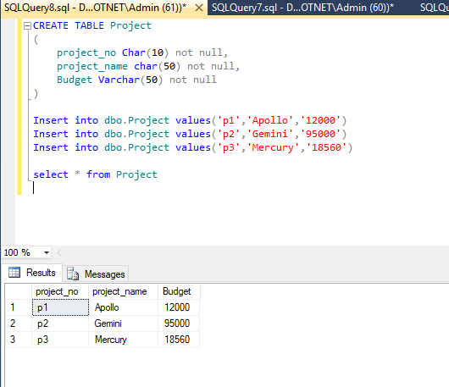

CREATE TABLE Works_on

(

emp_no Integer not null,

project_no char(10) not null,

Job Varchar(50) null,

enter_date date not null

)

insert into Works_on values('10102','p1','Analyst','1997.10.1')

insert into Works_on values('10102','p3','manager','1999.1.1')

insert into Works_on values('25348','p2','Clerk','1998.2.15')

insert into Works_on values('18316','p2',NULL,'1998.6.1')

insert into Works_on values('29346','p2',NULL,'1997.12.15')

insert into Works_on values('2581','p3','Analyst','1998.10.15')

insert into Works_on values('9031','p1','Manager','1998.4.15')

insert into Works_on values('28559','p1',NULL,'1998.8.1')

insert into Works_on values('28559','p2','Clerk','1992.2.1')

insert into Works_on values('9031','p3','Clerk','1997.11.15')

insert into Works_on values('29346','p1','Clerk','1998.1.4')

select * from Works_on

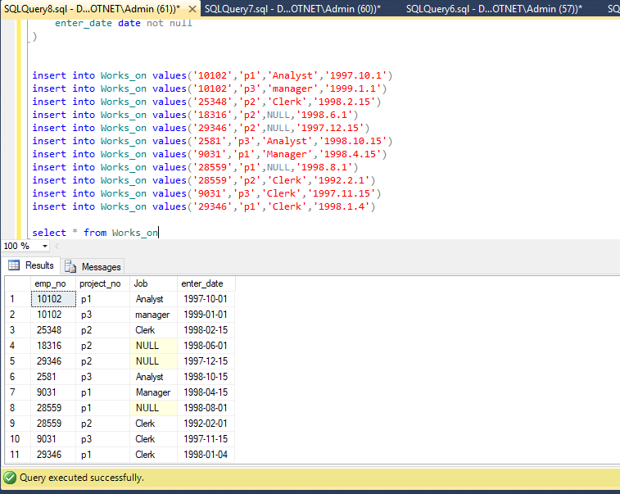

**Simple Queries:**

**Get all row of the works_on table.**

select * from Works_on

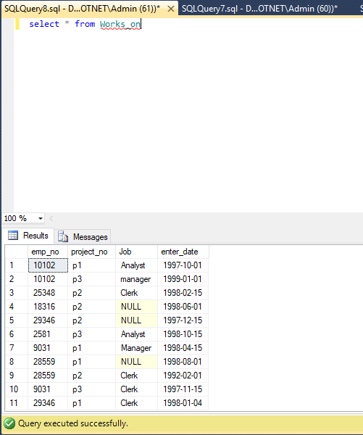

**Get the employee numbers for all clerks**

Select Emp_no from dbo.Works_on Where Job = 'Clerk'

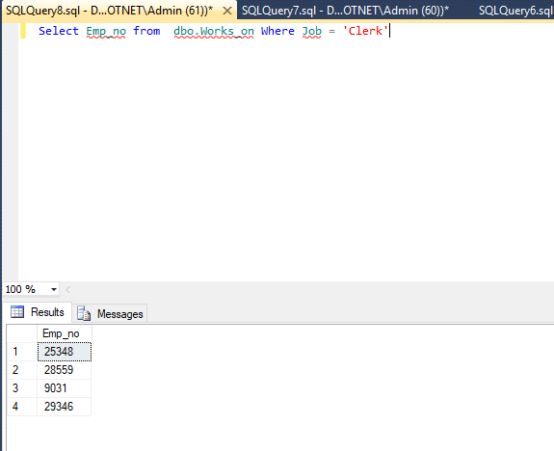

**Get the employee numbers for employees working in project p2, and having employee numbers smaller than 10000. Solve this problem with two different but equivalent SELECT statements.**

select emp_no from dbo.works_on where project_no = 'p2'

UNION

SELECT emp_no FROM dbo.Works_on Where emp_no < 10000

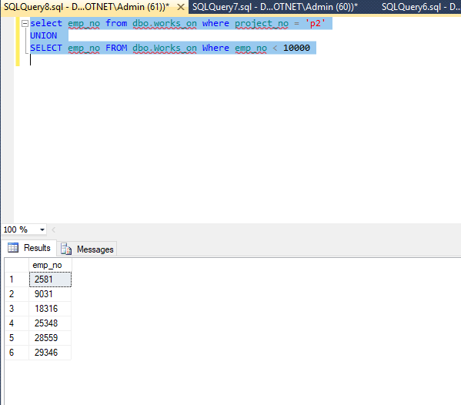

**Get the employee numbers for all employees who didn’t enter their project in 1998**

select emp_no from dbo.works_on where DATEPART(yyyy,enter_date) <> '1998'

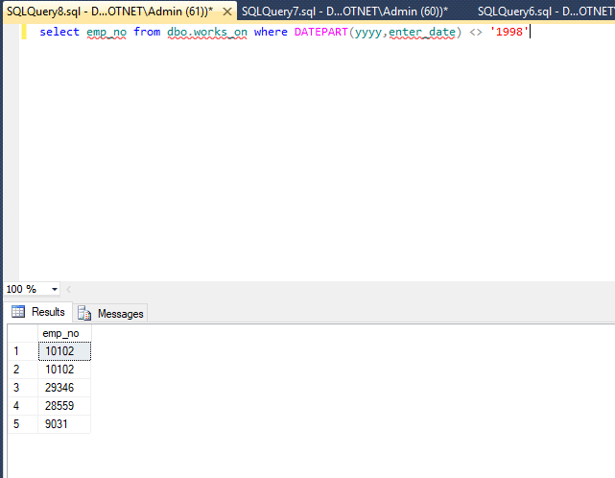

**Get the employee numbers for all employees who have a leading job( i.e., Analyst or Manager) in project p1**

select emp_no from dbo.works_on where project_no = 'p1' and (Job ='Analyst' OR Job = 'manager')

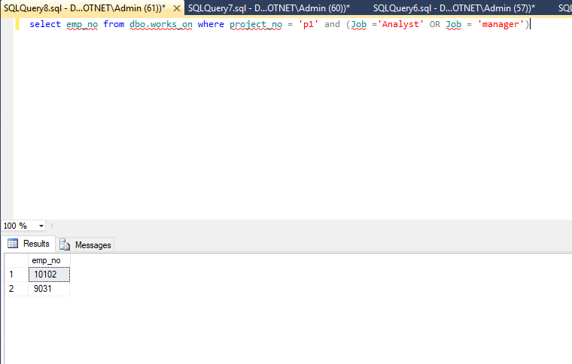

**Get the enter dates for all employees in project p2 whose jobs have not been determined yet.**

select enter_date from dbo.works_on where project_no = 'p2' and Job is null

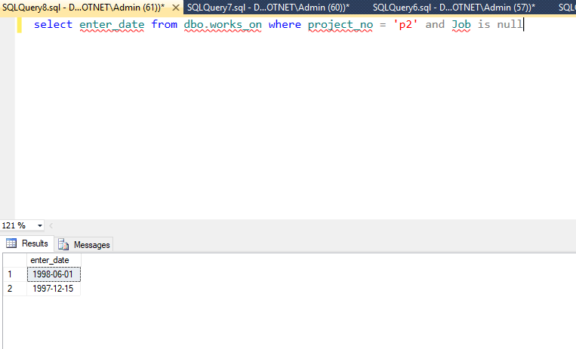

**Get the employee numbers and last names of all employees whose first names contain two letter t’s**

select emp_no,emp_lname from dbo.Employee where emp_fname like ('%tt%')

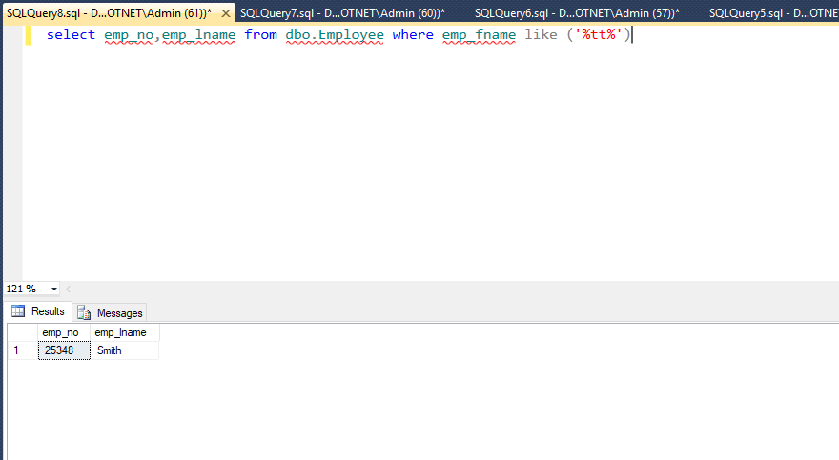

**Get the employee numbers and first names of all employees whose last names have a letter o or a as the second character and end with the letters es**

select emp_no,emp_fname from dbo.Employee where (emp_lname like ('_o%') or emp_lname like ('_a%')) AND emp_lname like ('%es')

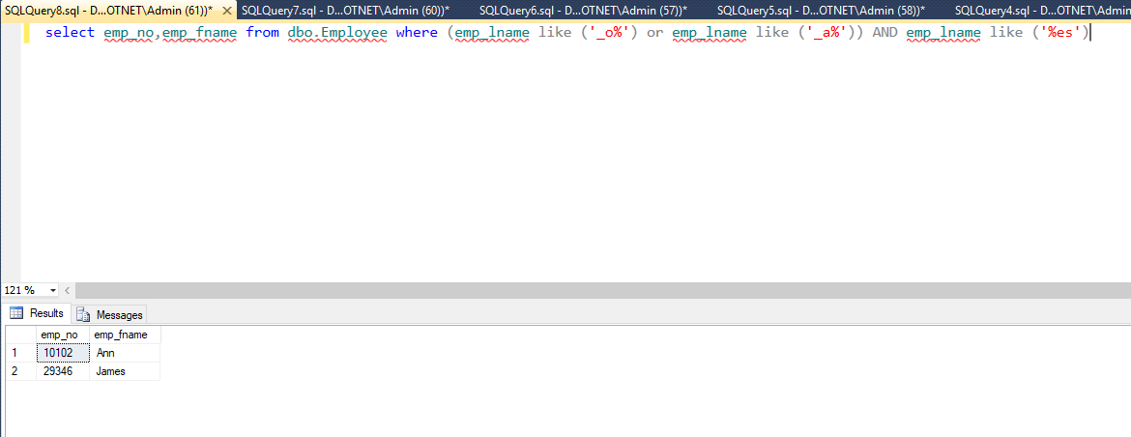

**Get the employee numbers of all employees whose departments are located in Seattle**

select E.emp_no from dbo.Employee E

INNER JOIN dbo.Department D ON E.Dept_no = D.Dept_no

where D.location = 'Seattle'

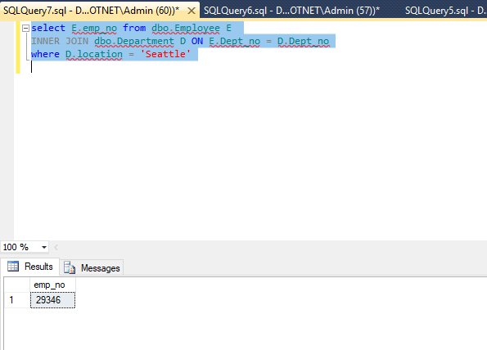

**Find the last and first names of all employees who entered their projects on 04.01.1998**

select E.emp_fname,E.emp_lname,W.enter_date

from dbo.Employee E

INNER JOIN dbo.Works_on W ON E.emp_no = W.emp_no

where CONVERT(datetime,W.enter_date,101) = CONVERT(datetime, '01-04-1998', 101)

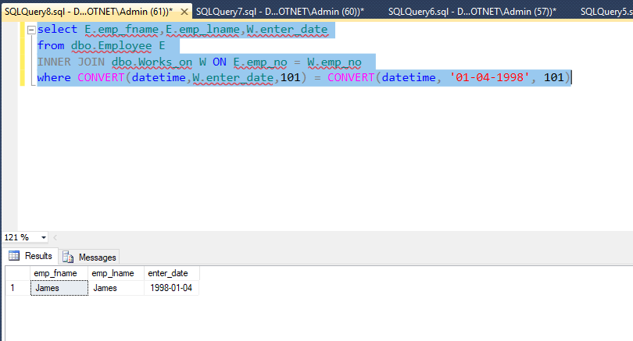

**Group all departments using their locations**

select Location from Department group by Location

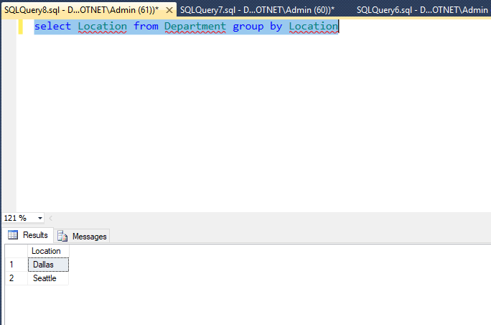

**Find the biggest employee number**

select Max(emp_no) From dbo.Employee

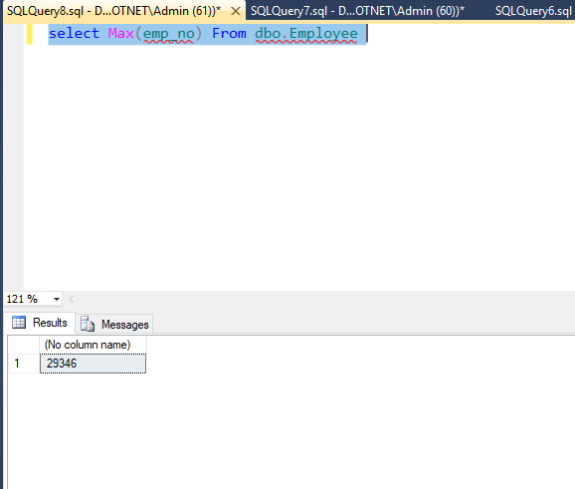

**Get the jobs that are done by more than two employees**

select Job,count(emp_no) as NumberofEmployees from works_on

where job is not null

group by job having count(emp_no) > 2

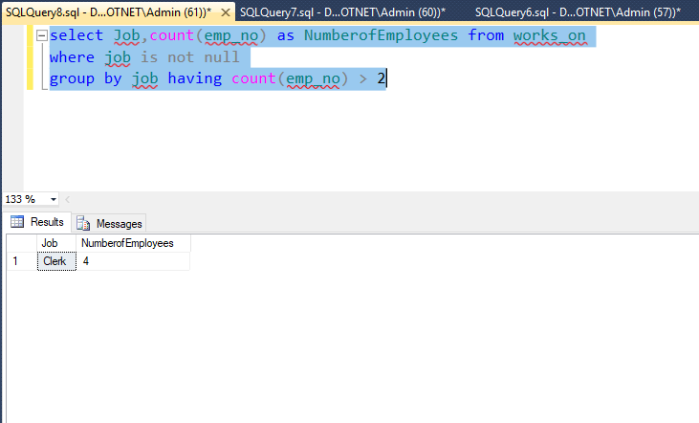

**Find the employee numbers of all employees who are clerks or work for department d3.**

Select e.emp_no

from Dbo.works_on W

inner join dbo.Employee E ON W.emp_no = E.emp_no

where job = 'Clerk' or Dept_no = 'd3'

