**Create a nonclusterd index for the enter_date column of the works_on table.**

**Sixty percent of each index leaf page should be filled**

CREATE NONCLUSTERED INDEX IX_works_on_EnterDate

ON dbo.Works_on (enter_date) with (fillFactor = 60)

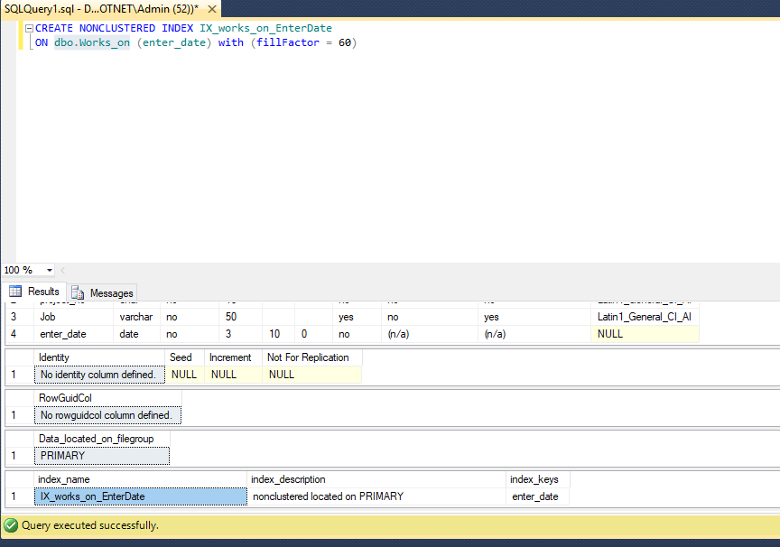

**Create a unique composite index for the l_name and f_name columns of the employee table.**

CREATE UNIQUE INDEX IQ_emp_Name

ON dbo.Employee(emp_fname,emp_lname)

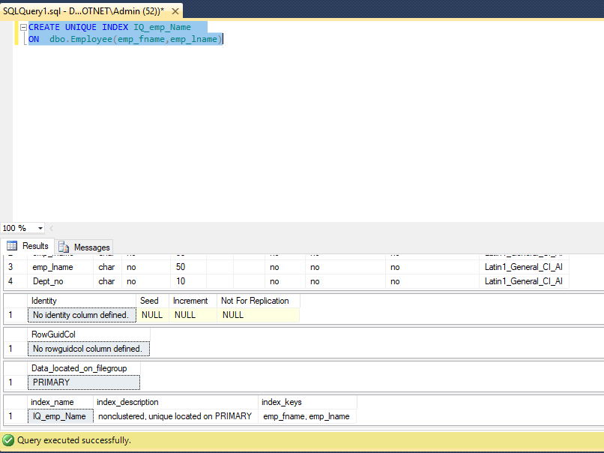

**Create a view that comprises the data of all employees that work for the department d1.**

CREATE View [dbo].[VW_GETALLEmployeeofD1]

AS

SELECT * FROM Dbo.Employee WHERE Dept_no = 'd1'

GO

Select * from [VW_GETALLEmployeeofD1]

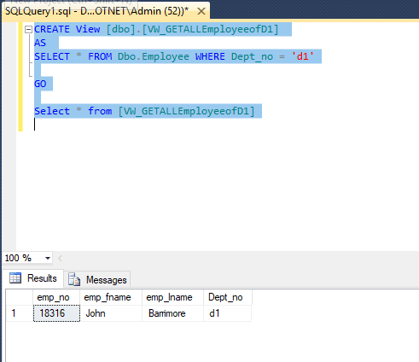

**For the project table, create a view that can be used by employees who are allowed to view all data of this table except the budget column**

CREATE View [dbo].[VW_ProjectDetails]

AS

SELECT project_no,project_name FROM Dbo.Project

GO

select * from [VW_ProjectDetails]

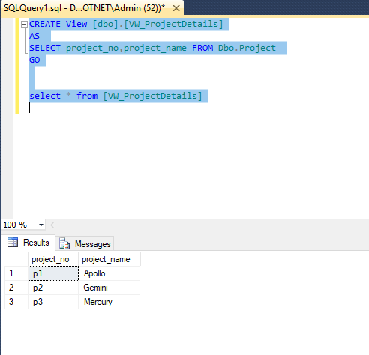

**Create a view that comprises the first and last names of all employees who entered their projects in the second half of the year 1988**

CREATE View [dbo].[VW_EmployeeDetails]

AS

SELECT emp_fname ,emp_lname

FROM dbo.Employee E

JOIN dbo.Works_on W ON E.emp_no = W.emp_no

WHERE DAtEPART(YYYY,W.enter_date) = '1998' AND DATEPART(M,W.enter_date) > 6

GO

select * from [VW_EmployeeDetails]

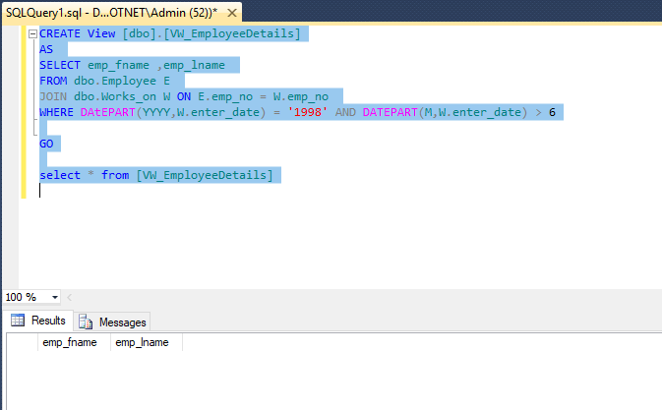

**Solve the previous exercise so that the original columns f_name and l_name have new names in the view: first and last, respectively.**

ALTER View [dbo].[VW_EmployeeDetails]

AS

SELECT emp_fname as [first] ,emp_lname as [last]

FROM dbo.Employee E

JOIN dbo.Works_on W ON E.emp_no = W.emp_no

WHERE DAtEPART(YYYY,W.enter_date) = '1998' AND DATEPART(M,W.enter_date) > 6

GO

select * from [VW_EmployeeDetails]

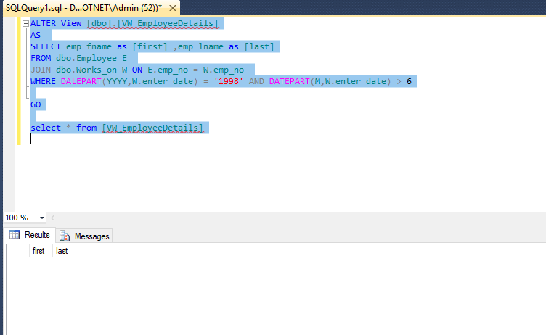

**Use the view in Exercise 3 to display full details of all employees whose last names begin with the letter M.**

select * from [VW_EmployeeDetails] WHERE [last] like 'm%'

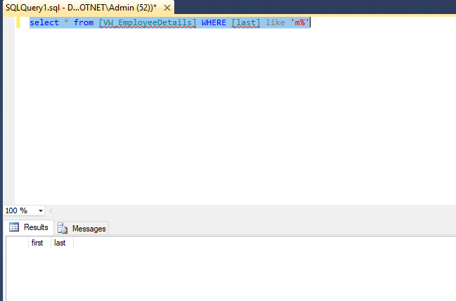

**Create a view which comprises full details of all projects on which the employee named smith works**

CREATE VIEW [dbo].[VW_EmployeeWorkedDetails]

AS

SELECT P.* FROM dbo.Project P

INNER JOIN dbo.Works_on W ON P.project_no = W.project_no

INNER JOIN dbo.Employee E ON W.emp_no = E.emp_no

WHERE CONCAT(e.emp_fname,' ',e.emp_lname) like '%smith%'

GO

select * from [VW_EmployeeWorkedDetails]

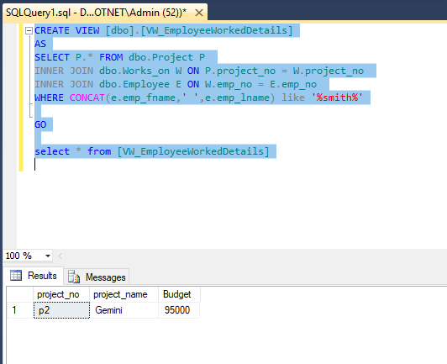

**Using the ALTER VIEW statement, modify the condition in the view in Exercise - 3. The modified view should comprise the data of all employees that work either for the department d1 or d2, or both.**

ALTER View [dbo].[VW_GETALLEmployeeofD1]

AS

SELECT * FROM Dbo.Employee WHERE Dept_no = 'd1' or Dept_no ='d2'

GO

Select * from [VW_GETALLEmployeeofD1]

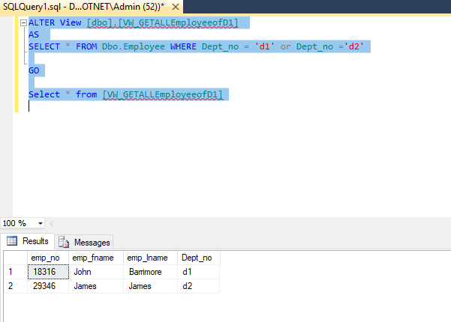

**Using the view from Exercise 4, insert details of a new project with project no ‘p2’ and**

**name ‘moon’**

Insert INTO [VW_ProjectDetails] values('p2','moon')

select * from [VW_ProjectDetails]

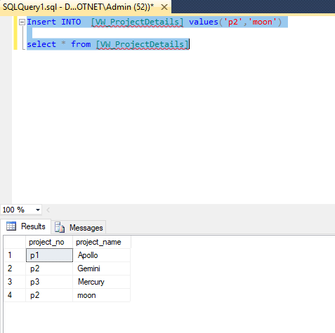

**Create a view (with the WITH CHECK OPTION clause) that comprises the first and last names of all employees whose employee number is less than 10,000. After that, use he view to insert data for a new employee named Kohn with the employee number 22123, who works for the department d3**

CREATE View [dbo].[VW_VerifyAndInsertEmployee]

AS

SELECT emp_no,emp_fname,emp_lname,Dept_no

FROM Dbo.Employee

WHERE emp_no < 10000

WITH CHECK OPTION;

GO

Insert INTO VW_VerifyAndInsertEmployee VALUES(22123,'Kohn','','d3')

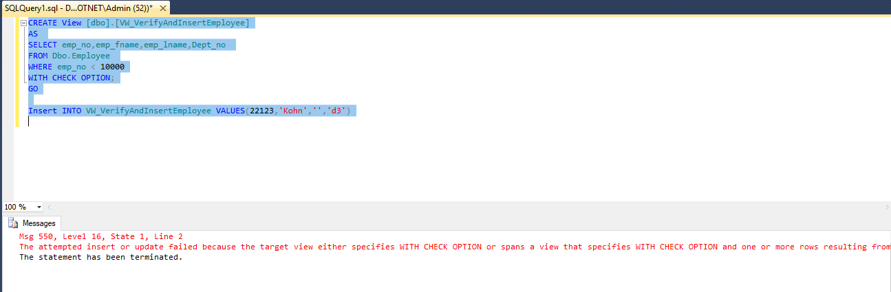

**Create a view (with the WITH CHECK OPTION clause) with full details from the works_on table for all employees that entered their projects during the years 1998 and 1999. After that, modify the entering date of the employee with the employee number 19346. The new date is 06/01/1997**

CREATE VIEW VW_GETEmployeeDetailsFromWORK

AS

select * from dbo.Works_on WHERE DATEPART(YYYY,enter_Date) between 1998 and 1999

with check option;

GO

select * from VW_GETEmployeeDetailsFromWORK

Update VW_GETEmployeeDetailsFromWORK set enter_date = '06-01-1997' WHERE emp_no = 29346

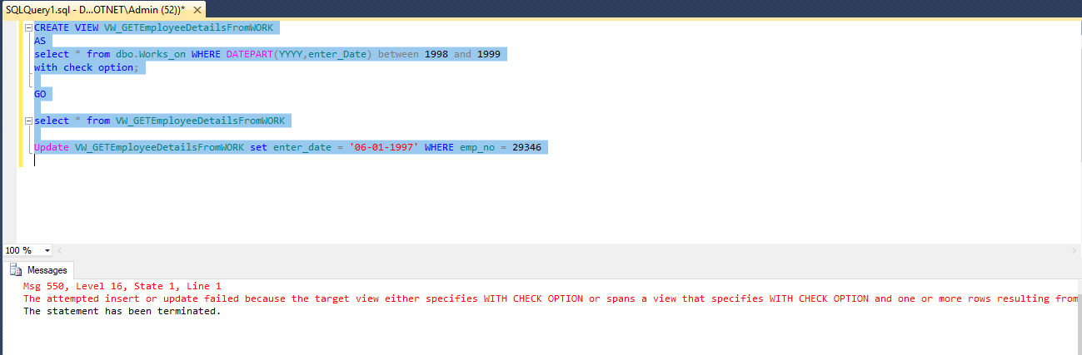

**Solve the above exercise without the WITH CHECK OPTION clause and find the differences in relation to the modification of the data.**

Alter VIEW VW_GETEmployeeDetailsFromWORK

AS

select * from dbo.Works_on WHERE DATEPART(YYYY,enter_Date) between 1998 and 1999

GO

select * from VW_GETEmployeeDetailsFromWORK

Update VW_GETEmployeeDetailsFromWORK set enter_date = '06-01-1997' WHERE emp_no = 29346

