

American International University- Bangladesh

CSC 3222: Web Technologies

CO1.1 and CO2.1 Evaluation

Project Report

Fall 19-20

**Project Title:** **Rental Management System.**

**Section**: **F**

|  |  |
| --- | --- |
| Student Name | Student Id |
| 1. Hossain, Muntasir | **18-36421-1** |
| 2. Banik, Pryam | **18-37571-1** |
|  |  |
|  |  |

**Introduction:**

Write the answer of why you are doing this project? (No more than 60 words)

🡺 In our present world, our life mainly depends on our technology, people now-a-days wants to accomplish their daily basis works in short time with efficiently.

So to reduce people’s time and energy we are doing this project, so that they can be beneficial through our work. Our system aims at enabling efficient rental management by using technological centralized system.

**Background Study

Web Site References and short description of the websites. Here you will describe about the reference websites that you have studied so far in order to get ideas and thoughts about your proposed project

Requirement Analysis:

1. User Category 1 : Car Dealer.
2. User Category 2 : House/Room Vendor.

There are 2-types of Users here. They are:

* **ADMIN.**
* **SELLER.**

1. Feature List:

In this project the **“ADMIN”** has the following features:

* Log In
* Sign Up
* Edit Profile
* Add_Option
* Maintain(Rules & Regulations)

In this project the **“SELLER”** has the following features:

* Log In
* Sign Up
* Edit Profile
* Payment_Option
* Ads_Option
* Service_Option

Design:

Entity diagram of our project, given below;

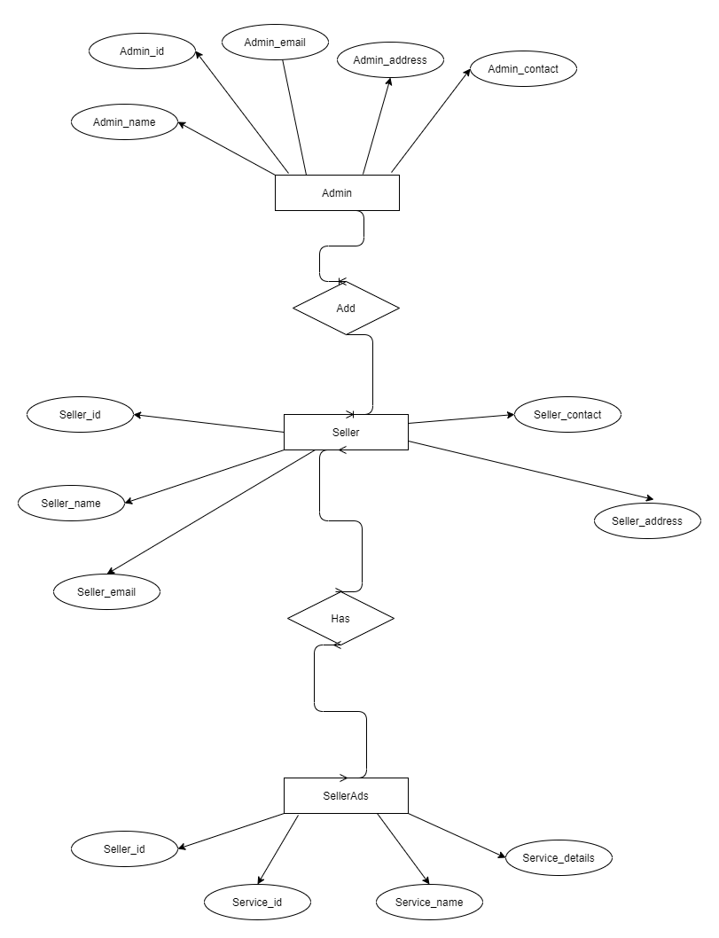

**Tools Used:**

**To develop this project, we have used the following:**

**• Visual Studio Code(Editor).**

**• Xampp Control Panel(Server).**

**• Chrome(Browser).**

**• MySQL Database Software.**

**System Images against the Specification:**

Screen shots of some GUIs (Midterm project) and write a very small description (Maximum 40 words) for each of the GUIs.

**1.** **HomePage :**

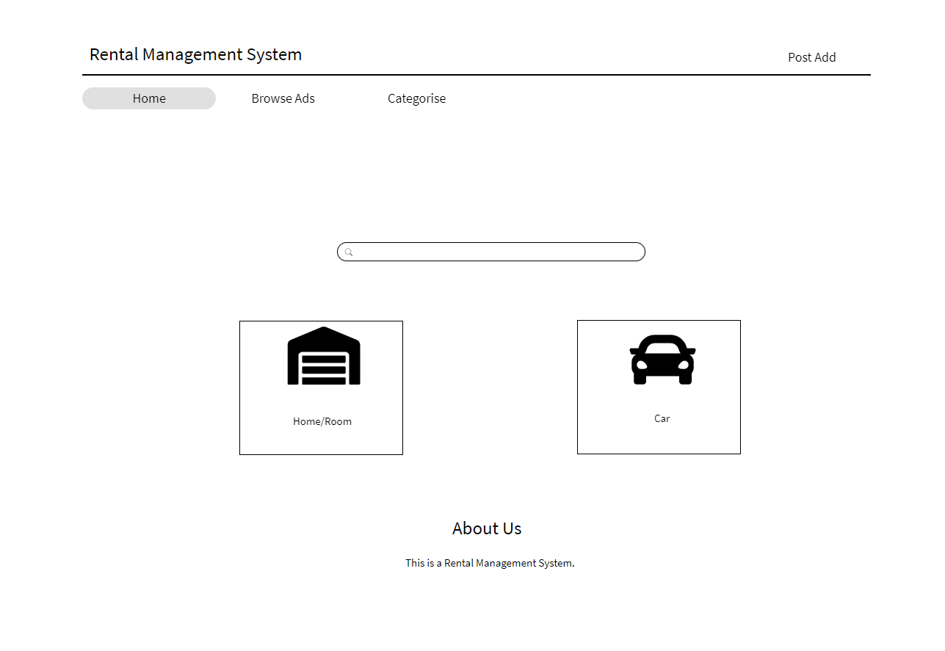

**This is the Homepage of our Rental Management Project, where you will able to see some features like BrowseAds, Categorise, a Search Option, Home/Room and Car rental service options, lastly, there is an option which is About Us option menas where the some legal information might display about our project**.

**2. BrowseAds and Categorise :**

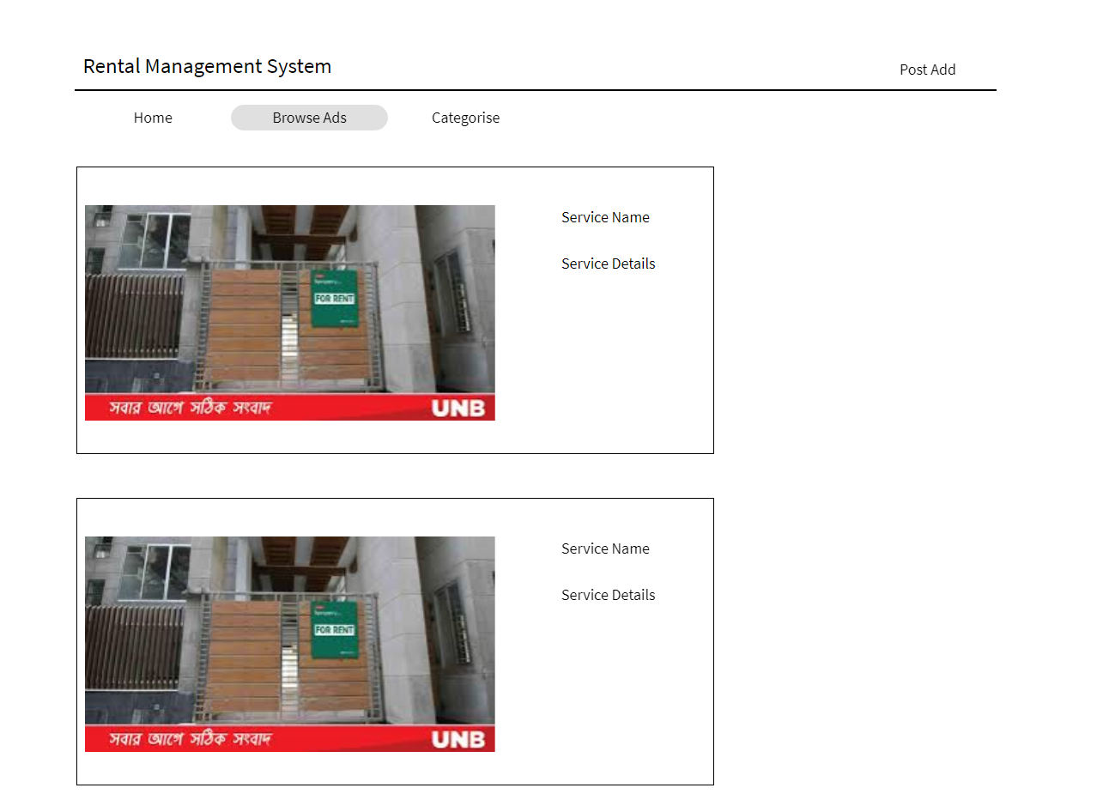

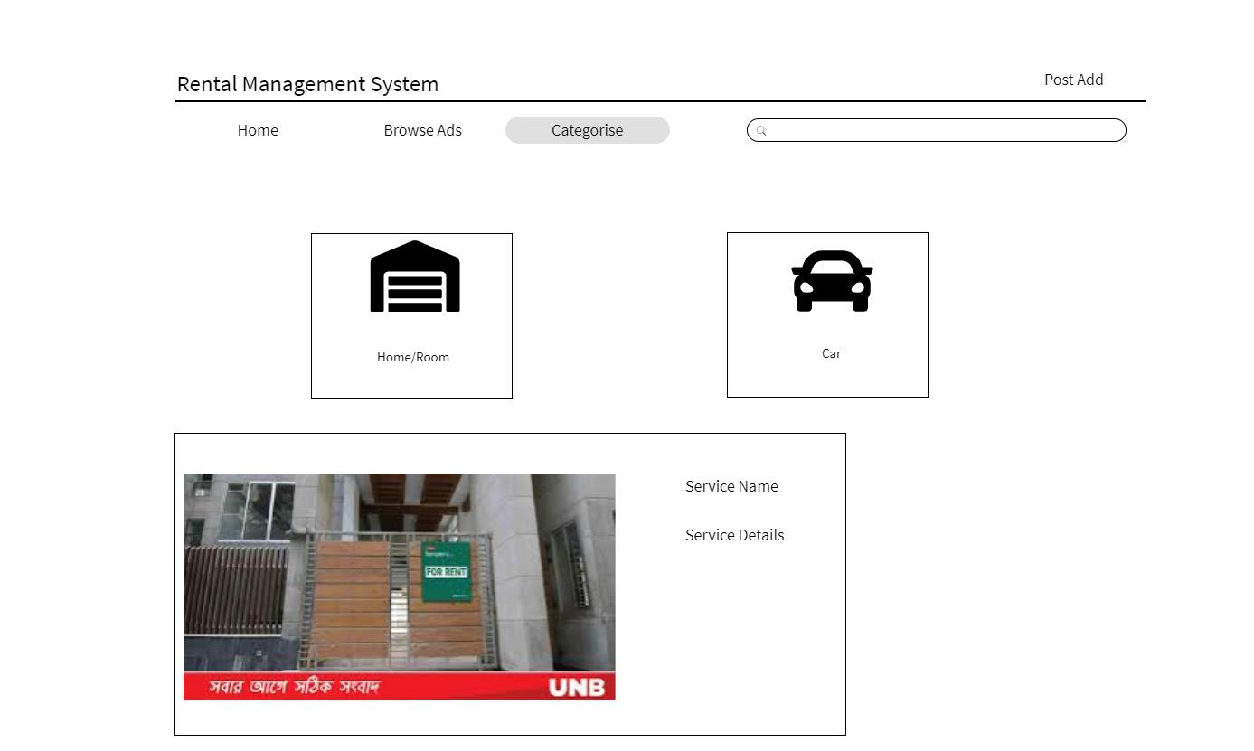

This two features are part of our Homepage, which will present the service regarding information that we will provide.

**3. SignUp Page:**

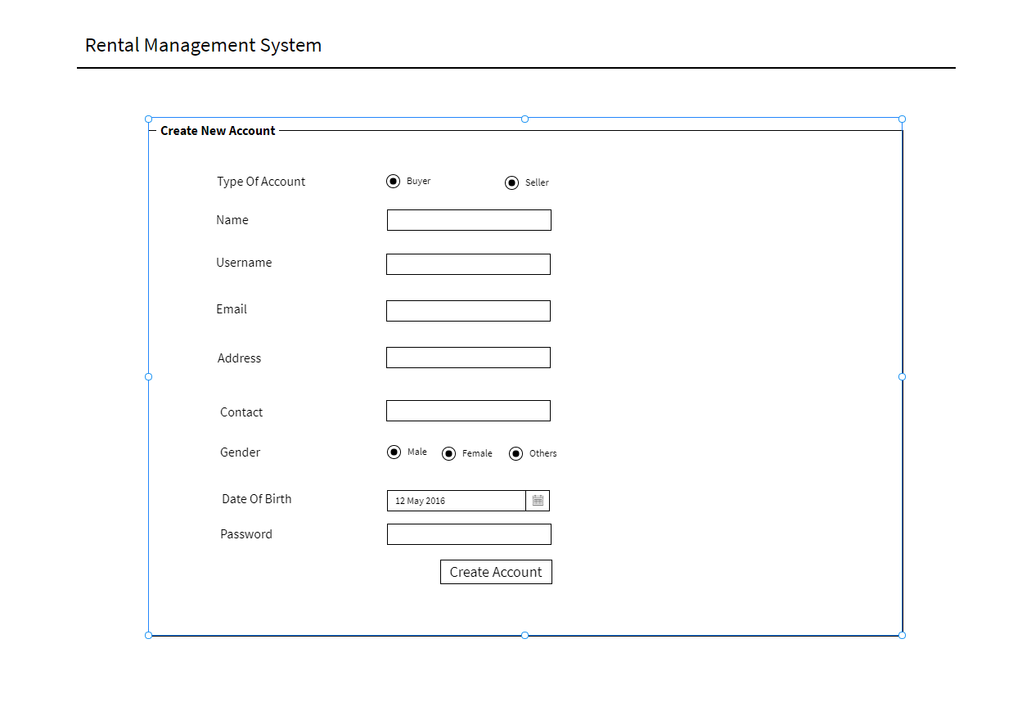

**Now, we would like to introduce with our SignUp page where many informations are visible for our users. This page will shown up to a new user, who will take our service system by creating an account in our website for the first time.**

**5. Login Page:**

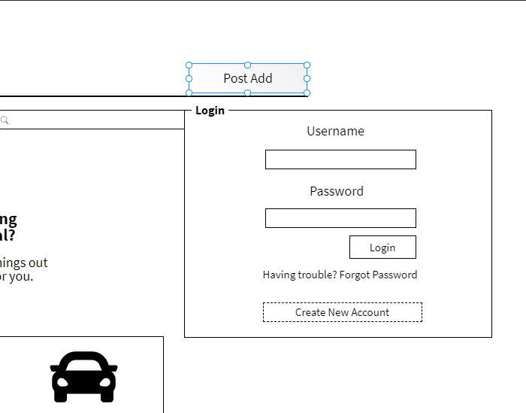

**Lastly, we now present our ending GUI feature for our project which is our Login page. This page will be visible for every users, everytime when they are going to us our system after signing in our site. In the page we put a field for username and password and others according to the above picture.**

Impact of this Project:

Describe the increasing importance of your project on modern society and environment.

How will people be benefitted from your project?

(Maximum 80 words)

Limitations and Possible Future Improvements:

(Maximum 80 words)

*[Note: Make sure that your report is maximum 10 pages (including cover page).*

|  |  |  |  |  |  |
| --- | --- | --- | --- | --- | --- |
| CO1.1 and CO2.1 Evaluation: Project Report Evaluation | | | | | |
| Project Proposal  (5) | Background  Study  (5) | Requirement Analysis  (5) | Entity  Diagram  (5) | System Images  against the  Specification (5) | Total (25) |
|  |  |  |  |  |  |
|  | | | | | |