ASTANA IT UNIVERSITY
Software Design Patterns
ASSIGNMENT 2
Factory Method & Abstract Factory
Smart Home System

Student | ____________________________
Group | ____________________________
Year | 2026

Astana, 2026

1. Project idea
The project is a small Smart Home application. A smart home contains several device types, and the devices can belong to different product families. The main goal is to create related objects without making the client depend on every concrete class.
The three product types are:
- Light
- Thermostat
- Security System
The first three product families are Budget, Premium, and Eco. After the main design is finished, a fourth Industrial family is added.
Product type | Budget | Premium | Eco | Industrial
Light | BudgetLight | PremiumLight | EcoLight | IndustrialLight
Thermostat | BudgetThermostat | PremiumThermostat | EcoThermostat | IndustrialThermostat
Security | BudgetSecuritySystem | PremiumSecuritySystem | EcoSecuritySystem | IndustrialSecuritySystem

2. Part A - version without factories
The first Git commit contains a small version without Factory Method and Abstract Factory. The program asks for a family and directly creates concrete classes with if/else.
if (family.equals("budget")) {
BudgetLight light = new BudgetLight();
BudgetThermostat thermostat = new BudgetThermostat();
BudgetSecurity security = new BudgetSecurity();
} else if (family.equals("premium")) {
// another group of concrete classes
}
This version has several design problems:
- The client knows all concrete classes.
- The if/else block becomes bigger when a new family is added.
- Creation code is repeated for every family.
- It is easy to manually combine products from different families.
This initial version is kept in Git history in the commit “Initial domain model without factories”.

3. Part B - Factory Method
Factory Method is used for the first level of device creation. DeviceCreator is an abstract creator. It defines createDevice(), while subclasses decide which concrete standard device is created.
public abstract class DeviceCreator {
public abstract Device createDevice();

public String installAndCheckDevice() {
Device device = createDevice();
return "Installing " + device.getName() + " -> "
+ device.connect() + " -> " + device.runDiagnostic();
}
}
Concrete creators are LightCreator, ThermostatCreator, and SecurityCreator. They create StandardLight, StandardThermostat, and StandardSecuritySystem.
The creator has real logic in installAndCheckDevice(). It creates a device, connects it, and runs diagnostics. For this reason, the pattern is not only a method that returns new Product().
It is Factory Method instead of only a static factory because subclasses override createDevice(). The created product changes through inheritance and polymorphism.

4. Part C - Abstract Factory
Abstract Factory is used when the application needs a complete compatible smart-home family. The SmartHomeFactory interface creates all three related product types.
public interface SmartHomeFactory {
Light createLight();
Thermostat createThermostat();
SecuritySystem createSecuritySystem();
String getFamilyName();
}
Concrete factories are BudgetFactory, PremiumFactory, EcoFactory, and later IndustrialFactory.

5. Part D - Compatibility rule
The compatibility rule is handled mainly by the architecture. SmartHomeController receives one SmartHomeFactory. It does not receive a Light, Thermostat, and SecuritySystem separately. The controller creates all devices from the same factory.
public SmartHomeController(SmartHomeFactory factory) {
this.light = factory.createLight();
this.thermostat = factory.createThermostat();
this.securitySystem = factory.createSecuritySystem();
this.family = factory.getFamilyName();
}
Because one factory creates the complete set, normal client code cannot accidentally build a controller with BudgetLight + PremiumThermostat + EcoSecuritySystem. The method productsAreCompatible() is also used by tests to show that all created products have the same family.

6. Part E - Runtime factory selection
The user chooses the family when the application starts. FactoryProvider converts the user input into a SmartHomeFactory. After this step, SmartHomeController works only with the SmartHomeFactory abstraction.
SmartHomeFactory factory = FactoryProvider.getFactory(family);
SmartHomeController controller = new SmartHomeController(factory);
Supported values in the final version are budget, premium, eco, and industrial. Unknown values produce an IllegalArgumentException.

7. Part F - Business operations
The project has three operations where several products collaborate:
- startMorningMode(): turns on the light, sets temperature to 22C, and disarms security.
- leaveHome(): turns off the light, lowers temperature to 18C, and arms security.
- startNightMode(): uses 20% light, sets temperature to 19C, and arms security.
The concrete families have small behavior differences. For example, Budget Light has a 70% maximum, Eco Light has a 50% maximum, and Premium/Industrial can use the full brightness. Thermostat temperature ranges are also different.

8. Part G - Adding the fourth family
Industrial was added only after Budget, Premium, and Eco were already implemented. The important result is that the business logic in SmartHomeController did not need to be changed.
Files added for the new family:
- IndustrialLight.java
- IndustrialThermostat.java
- IndustrialSecuritySystem.java
- IndustrialFactory.java
Existing files changed:
- FactoryProvider.java - added the industrial selection case.
- Main.java - added industrial to the displayed list of choices.
- SmartHomeTest.java - added tests for Industrial creation, compatibility, and runtime selection.
SmartHomeController.java and the three business operations were not changed for the new family.

9. Part H - UML class diagram
The diagram below marks the Factory Method part, Abstract Factory part, product interfaces, concrete product families, runtime selector, and client.
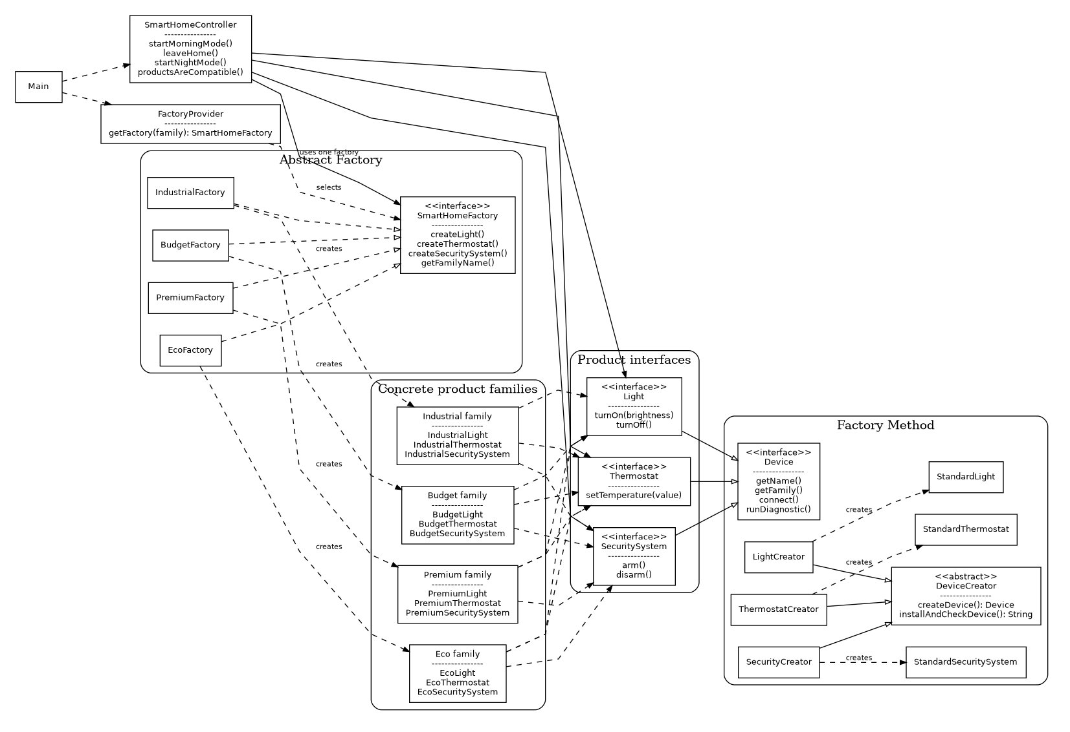
Figure 1. UML class diagram

10. Part I - Automated tests
The project contains 18 JUnit 5 tests in SmartHomeTest.java. The tests cover the required areas:
- creation of Budget, Premium, and Eco original families;
- correct concrete classes returned by each factory;
- compatibility of products from each family;
- runtime factory selection;
- three business behavior tests;
- negative case: unknown family;
- negative case: invalid light brightness;
- Industrial family creation, compatibility, and selection;
- client working with the SmartHomeFactory interface.
The test class is written with JUnit 5 and can be run from IntelliJ IDEA or with mvn test.

11. Part J - Git history
The repository contains meaningful commits that show the development process. Main stages are:
1. Initial domain model without factories
2. Add product abstractions
3. Introduce Factory Method
4. Add Budget Premium and Eco product families
5. Introduce Abstract Factory and business controller
6. Add runtime factory selection and console app
7. Add tests and compatibility rules
8. Add fourth Industrial product family

12. Project structure
src/main/java/kz/aitu/smarthome/
abstractfactory/
app/
client/
factorymethod/
family/
budget/
premium/
eco/
industrial/
product/

src/test/java/kz/aitu/smarthome/
SmartHomeTest.java

docs/
uml/
defense-notes.md

13. Example program output
Factory Method demo:
Installing Standard Light -> Standard Light connected -> Standard Light diagnostic passed
Installing Standard Thermostat -> Standard Thermostat connected -> Standard Thermostat diagnostic passed
Installing Standard Security -> Standard Security connected -> Standard Security diagnostic passed

Available families: budget, premium, eco, industrial
Choose smart home family: budget

Created family: Budget
Compatible products: true

Morning mode:
Budget Light on at 60% (basic lamp)
Budget Thermostat set to 22C (basic heating)
Budget Security disarmed

14. Conclusion
The final application uses Factory Method and Abstract Factory for different creation problems. Factory Method lets creator subclasses decide which standard device is created and keeps useful installation logic in the parent creator. Abstract Factory creates a full compatible family of smart-home products. Runtime selection lets the application change the family without changing the business controller. Adding the Industrial family shows that the design can be extended with small changes.

