Simulation platform design: engine, model, framework and frontend
Oct 10, 2026 · @Samir Tushar

Short answers
Is this a common model or a one-off? It is common. We build four layers. Three layers are reusable across every customer. Only the last layer belongs to one site.
- Engine. It runs any simulation. It knows nothing about warehouses.
- Block library. Reusable parts such as a dock, a reach truck, a lane and a gate.
- World template. Blocks wired into a warehouse, a production line or a port.
- Site calibration. The numbers for one real site, taken from its SAP data.
The warehouse demo is the first world template. It is not a one-off build.
What does "model" mean here? A simulation model has four parts.
Part | Meaning | Warehouse example | Who sets it
Structure | Which blocks exist and how items flow between them | Gate → parking → dock → staging lane → truck | World template
Rules | What happens inside each block | A truck waits until a dock is free | Block library and rule plug-ins
Parameters | The numbers the rules use | Pick time per pallet, 7 reach trucks, 12 docks | Site calibration and the user
Inputs | The day we play | Trucks and orders from a past SAP day | SAP extract, then user edits
What is the core technology? Optimisation uses a solver. Prediction uses a fitted equation such as ARIMA. Simulation uses a discrete-event engine. The engine keeps a list of future events sorted by time. It jumps to the next event and changes the state. Queues, randomness and statistics sit on top of this loop.
Is there open source we can use? Yes. SimPy is the standard Python engine under the MIT licence. Our own engine (simulation-lab/des.js) already does the same job in the browser. So we do not build an engine. We spend our effort on the block library, the glass-box model card and the frontend.
Where does the team focus until the pilot and the raise? On the frontend. A user picks a past day, changes a few inputs and watches the stress move in 3D. The backend stays thin until a pilot gives us real SAP data.

The core technology, compared with solvers and ARIMA
Each problem type has its own core technology. Each one answers a different question.
Problem type | Core technology | Question it answers | What it returns | Open-source examples
Optimisation | Solver for linear or mixed-integer programs | What is the best plan under these constraints? | One best plan | HiGHS, OR-Tools
Prediction | Fitted statistical equation | What value comes next? | A forecast with a range | ARIMA in statsmodels
Simulation | Discrete-event engine | What happens over the day if we run this plan? | A full log of events, queues and delays | SimPy, salabim, JaamSim

The five parts of a discrete-event engine
- Future event list. A queue of events sorted by time. Example: "truck T14 arrives at 16:05".
- Clock. The clock jumps from one event to the next. Nothing is computed between events.
- Random variates. Seeded random numbers draw pick times and arrival gaps from fitted distributions. The same seed gives the same day.
- Resources and queues. Docks, reach trucks and lanes have a capacity. A request waits in a queue when the capacity is used up.
- Statistics collector. It records every start, end and wait. Turnaround, late trucks and queue lengths come from this log.
The whole engine is this loop:
while event list is not empty and clock < end of day:
event = take the earliest event
clock = event.time
run the rule for this event # may add new future events
record the event in the log

Event-driven and time-stepped
Our Warehouse Twin page uses a time-stepped clock. It moves the clock in fixed steps, such as one minute. Our Simulation Lab uses an event-driven clock. It jumps straight to the next event. The event-driven clock is exact and fast. The time-stepped clock is simpler to animate. We keep the event-driven engine as the truth. The 3D view replays its event log at any speed.

Why simulation and not only a solver
A solver gives the best plan when the world behaves as assumed. Real days vary. Trucks come late, picks take longer and queues build. Simulation shows what the plan does under that variation. The two also work together. A solver can propose a dock plan, and the simulation can test it on a past day.

Open-source engines and our choice
The engine is a solved problem. Good open-source engines exist. Licences decide what we can ship inside a paid product.
Tool | What it is | Language | Licence | Latest release seen | Fit for us
SimPy | Discrete-event engine: processes, resources, events | Python | MIT | 4.1.2, May 2026 | Engine for the backend. Small, stable, widely taught
salabim | Discrete-event engine with built-in 2D and 3D animation | Python | MIT | 26.0.8, June 2026 | Good for quick studies. Its animation does not fit a web product
Ciw | Queueing-network simulation | Python | Check the repository before use | 3.2.7, Dec 2025 | Useful to check queue results against theory
JaamSim | Drag-and-drop simulation with 3D view | Java | Apache 2.0 | Active | Reference for block design. Not a web engine
Mesa | Agent-based modelling | Python | Apache 2.0 | 3.5.1, Mar 2026 | Later, for driver or operator behaviour
PM4Py | Process mining: finds the real process from event logs | Python | AGPL-3.0, or a paid licence | 2.7.23.9, Oct 2026 | Strong for reading SAP logs. AGPL needs legal review before use in a hosted product
SciPy | Fits distributions and curves | Python | BSD-3 | Stable | Fits pick times and the congestion curve
three.js | 3D in the browser | JavaScript | MIT | Stable | 3D replay
Blender | 3D modelling, scriptable in Python | Python | GPL (the models we make are ours) | Stable | Builds every 3D item
glTF-Transform | Shrinks and optimises GLB files | JavaScript | MIT | Stable | Asset pipeline
Kenney City Kit Industrial | 35+ low-poly industrial models | GLB, FBX, OBJ | CC0 | Stable | Placeholders until our own items are ready

Our choice
- Now, in the browser: keep simulation-lab/des.js. It already runs the fill-rate experiments. It needs no server.
- At the pilot, on the server: move the engine to SimPy. Python gives us SciPy for fitting and pandas for SAP extracts.
- One contract between them: a scenario goes in as JSON. An event log comes out as JSON. The frontend reads only the event log. So we can swap the engine without touching the frontend.
- Option: SimPy is pure Python. It can also run inside the browser through Pyodide. We test this in week 5. If it is fast enough, one engine serves both places.
We do not pay for AnyLogic, FlexSim or Simio. Those are desktop tools for consultants. Our product is the block library, the glass box and the web experience on top of an open engine.

The layers: from engine to scenario
The product has five layers. Each layer uses the one below it.
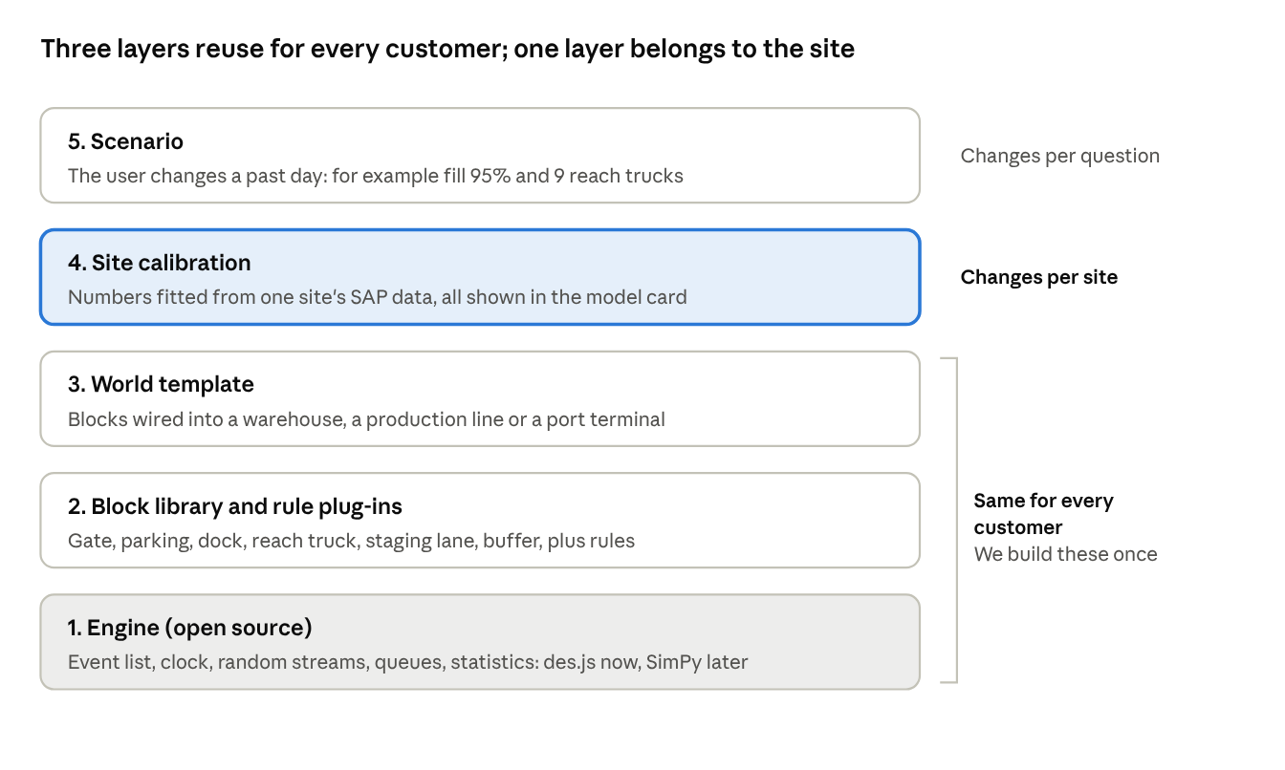
platform layers · engine to scenario
The engine, the block library and the world templates are the same for every customer. Site calibration is the only site-specific layer. It fills in numbers, not code. A new customer therefore costs data work, not engine work. The scenario is the user's question for the day.

The glass-box model: built from a past SAP day

Trained or learned?
Neither, in the machine-learning sense. A machine-learning model fits millions of weights that nobody can read. Our model is calibrated. We fit a small set of named numbers from SAP event logs. Each number has a name, a source and a fit. Samir can read every number and change it.

Three kinds of number
Every number in the model is one of three kinds.
Kind | Meaning | Examples | Can the user change it?
Read | Taken as it is from the past SAP day | Truck arrival times, orders per truck, pallets per order, delivery windows, stock level | Yes, as a scenario edit (for example "+15% trucks")
Fitted | Estimated from many past days of SAP logs | Pick time per pallet, dock service time, the fill-congestion curve | Yes, in the model card, with a warning
Set | A decision or a fact about the site | Number of docks, reach trucks, staging lanes; the pre-pick policy | Yes, freely. These are the levers

How a run works
- The user picks a baseline day: the same weekday last week, last month or last year.
- The system loads that day from SAP: shipments (VTTK, VTTP), deliveries (LIKP, LIPS), warehouse tasks (LTAK, LTAP or EWM), goods movements (MKPF, MSEG; movement types 101 and 601) and gate times.
- The system runs the baseline. It compares the result with what really happened that day. This is the replay check.
- The user changes only a few inputs. Example: fill rate to 95%, or two more reach trucks.
- The system runs 30 replications with different random seeds. It shows the average and a 95% confidence range.
- The frontend shows baseline and scenario side by side, in numbers and in 3D.

The model card
The model card lists every number. It is the glass box. Below is the first version for the warehouse world.
Parameter | Value now | Kind | Source in SAP | How we fit it | Status
Truck arrivals | Per past day | Read | Gate log, VTTK | Taken as is (trace-driven) | Ready when we get data
Pallets per truck | Per past day | Read | LIPS, VTTP | Taken as is | Ready when we get data
Delivery slot length | 3 h | Read | Delivery window on LIKP or the slot system | Taken as is | Assumption until checked
Pick and put-away time | Triangular distribution | Fitted | LTAP or EWM task confirm times | Fit min, mode, max with SciPy | Assumption until fitted
Fill-congestion strength a | 0.12 | Fitted | Task times against stock level by day | Least-squares fit of the curve below | Assumption
Fill-congestion start f0 | 0.70 | Fitted | Same as above | Same as above | Assumption
Share of the effect on loading | 40% | Fitted | Loading task times against stock level | Same as above | Assumption
Reach trucks (engine default 7; the fill experiments used 9) | 7 | Set | Site fact | Ask the site | Demo value
Docks, staging lanes | Site layout | Set | Site fact | Ask the site | Demo value
Policy | Gate or pre-pick | Set | User choice | None | Lever
The fill-congestion curve is the heart of the warehouse model:
\text{task time} = \text{base time} \times \left(1 + a \cdot \frac{\max(0,\ f - f_0)}{1 - f}\right)
Here f is the fill rate. Below f0 the curve is flat. Above f0 it rises fast, because free slots get scarce. With a = 0.12 and f0 = 0.70, task time rises about 60% at 95% full. The queues then turn that into a 2.8× rise in turnaround (1.18 h to 3.28 h in our runs).

What makes it a glass box
- Every number sits in the model card with its source.
- Every rule is a named plug-in that the user can switch off.
- Every result links back to the events that caused it. Click a red truck and see why it waited.
- No hidden weights. If a result looks wrong, we can trace it to one number.

Calibration and validation
A model earns trust in five checks. We run them in this order. Each check has a clear pass rule.
Check | Question | How we run it | Pass rule (our target, to agree with the pilot)
1. Verification | Does the code do what the rules say? | Unit tests per block. Fixed seed gives the same log. A known queue (one dock, one truck) gives the known answer | All tests pass
2. Input validation | Do the fitted numbers match the data? | Plot fitted pick times against SAP task times. Run a goodness-of-fit test in SciPy | Fitted curve inside the data spread
3. Replay validation | Does the baseline day match what happened? | Run the past day trace-driven. Compare turnaround and late trucks with the real day | Average turnaround within 10% of actual; late-truck count within 2
4. Hold-out test | Does it work on days we did not fit on? | Fit on 8 weeks. Test on the next 2 weeks | Same pass rule as check 3
5. Face validation | Does the site manager believe it? | Walk the manager through the 3D replay of a day they remember | Manager agrees the stress points are right

Calibration steps for the pilot
- Get 10 weeks of SAP extracts for one warehouse.
- Fit pick, put-away and loading times by fill-rate band.
- Fit a and f0 of the congestion curve to those bands.
- Write every fitted value into the model card with its date and data range.
- Run checks 3 to 5. Record the results in the model card.
- Re-fit every quarter, or when the site changes layout or fleet.

What we say when the model is wrong
A miss is useful. It tells us which number or rule is missing. We log each miss, find the cause, and add a rule or re-fit a number. This is how the constraint list keeps growing.

Constraints as plug-in rules
Constraints never stop growing. Each pilot finds new ones. So a constraint is never hard-coded inside a block. It is a rule plug-in. A rule hooks onto an event, checks a condition and changes what happens next.

The rule contract
Every rule has the same seven fields:
// rules/driver-hours.js
export default {
id: 'driver-hours',
name: 'Driver driving-time limit',
hook: 'truck.beforeDepart', // which event it listens to
params: { maxDriveHours: 9 }, // shown in the model card
source: 'Site fact or regulation', // where the number comes from
check: (truck, p, state) => truck.driveHours + truck.tripHours > p.maxDriveHours,
effect: (truck, p, state) => state.hold(truck, 'driver-rest'), // what changes
};
The engine calls every active rule at its hook. The frontend lists all rules with a switch. A user can switch a rule off and see its effect. Each rule writes its reason into the event log, so a red truck can say "held by driver-hours".

First rules for the warehouse world
Rule | Hook | What it does | Status
Dock free | Truck arrives at gate | Truck waits in parking until a dock is free | In engine
Staging lane full | Pallet picked | Picking stops when the lane is full | In engine
Yard full | Truck arrives at gate | Truck waits on the road; counts as overflow | In engine
Fill congestion | Task starts | Task time follows the fill curve | In engine
Pre-pick policy | Order released | Picks start before the truck arrives | In engine
Production buffer full | Pallet leaves the line | The line stops when its buffer is full | In engine (lineHeld)
Shift breaks | Clock reaches break time | Operators pause | Next
Reach-truck charging | Battery low | Truck leaves for charging | Next
Dock type | Truck assigned to dock | Reefer trucks only use reefer docks | Next
Delivery window | Truck departs | Marks the order late after its slot | Next
Hazardous goods | Pallet put away | Keeps set distances between classes | Later
Adding a constraint now means writing one file, not changing the engine. The maxDriveHours: 9 value above is an example only. The site supplies the real limit.

World templates and linking
The user selects "Warehouse" or "Production plant", and a world appears. A world template makes this work. It holds four things:
- Blocks and flow. Which blocks exist and how items move between them.
- Default numbers. A sensible model card that runs before any SAP data arrives.
- Stress meters. Which queues turn amber and red, and at what level.
- Layout. Where each block sits in 3D, and which 3D item draws it.

Templates in build order
Template | Blocks | Main stress meters | When
Warehouse (outbound) | Gate, parking, dock, reach truck, pick zone, staging lane, truck | Truck turnaround, yard queue, lane fill, late orders | Now
Production line | Machine, buffer, operator, changeover, quality check | Line stops, buffer fill, output per shift | After the warehouse passes validation
Machine cell | Machine, setup, breakdown, repair crew | Machine use, downtime | With the production line
Yard and gate | Gate lanes, weighbridge, parking slots | Gate queue, road overflow | Splits out of the warehouse later
Port terminal | Berth, crane, tractor, stack | Ship turnaround, crane wait | Later. A demo exists today

Solve alone, then link
Each world must pass its own validation first. Only then do we link it to another world. Otherwise one wrong world hides inside the joint result.
Worlds link through a shared buffer. The upstream world puts items into the buffer. The downstream world takes items out. The buffer has a capacity. When it is full, the upstream world stops. When it is empty, the downstream world waits. This is how stress crosses from one world to the next.
{
"link": "line-to-warehouse",
"from": { "world": "production-line-1", "block": "end-of-line" },
"to": { "world": "warehouse-a", "block": "inbound-dock" },
"buffer": { "item": "pallet", "capacity": 40 },
"transfer": { "mode": "shuttle", "timeMinutes": 6 }
}
The numbers in this example are placeholders. The site supplies the real buffer size and transfer time.
Our engine already models this link in one direction. When the warehouse cannot clear the buffer, the production line stops (lineHeld). This is the last step of the demo cascade: picking at 16:00, lanes at 17:00, docks at 17:30, yard at 18:30, orders at 19:00, then the line stops.

3D items: what the research says, and the item skill standard

What makes a web 3D world look good and run fast
Finding | Evidence | What we do
Draw calls limit speed more than triangles | A three.js forum case drew 4,000 separate boxes at 25 fps. With InstancedMesh it drew 1 million cubes at 120 fps | Every repeated item (pallet, rack bay, truck) uses InstancedMesh
File size limits the first load | GLB optimisation guides target a first scene under about 10 MB | Run every GLB through glTF-Transform
Small props need few triangles | Guides target props under 5,000 triangles and 1024 px textures | Budget per item, checked in review
Draw calls should stay in the low hundreds | Same guides | Merge static parts; instance moving parts
Free models speed up the prototype | Kenney City Kit Industrial: 35+ models, CC0, in GLB | Use as placeholders; replace with our items

The GLB pipeline
Every item goes through the same glTF-Transform steps after Blender exports it:
# per item: compress, but keep moving parts and sockets
npx @gltf-transform/cli@4 optimize item.glb item.opt.glb \
--compress meshopt --flatten false --join false --simplify false --prune false --instance false
# per textured scene asset: shrink textures too
gltf-transform resize in.glb a.glb --width 1024 --height 1024
gltf-transform webp a.glb out.glb # or ktx2 for large scenes
We tested this on the reach truck. The default optimize merged the item into 3 nodes and dropped its sockets. With the five false flags, the file went from 72.7 KB to 32.2 KB and kept all 11 parts and 3 sockets. Instancing happens in three.js at scene level, not per item.

How motion looks real
- Paths, not straight jumps. Vehicles follow a road or aisle path. In three.js a CatmullRomCurve3 gives a smooth path.
- Heading from the path. The vehicle faces along the path tangent, so it turns into corners.
- Start and stop smoothly. Speed eases in and out at each stop.
- Timing from the engine. The engine says when a truck leaves and arrives. The 3D view only draws the trip between. The picture never changes the result.
- Parts move. A forklift raises its forks; a truck opens its doors. These are named parts that the state drives.

The item skill standard
Each item family has one skill folder. The skill is a written method that a developer or Claude Code follows to build the item well every time. After each review, the team adds what it learned to the skill. So the next item comes out better.
.claude/skills/3d-item/
SKILL.md # the method: budgets, naming, states, review checklist, lessons
items/reach-truck.json # the item definition (contract); next: truck.json, pallet.json
blender/build_item.py # headless Blender script: builds, checks budget, renders a review picture
out/ # built GLB, report and render
reviews/ # review notes and renders, one per version
The item definition is one contract for both the engine and the viewer:
{
"id": "reach-truck",
"engine": { "speedMps": 2.2, "liftSecondsPerMetre": 2.5, "capacityPallets": 1 },
"look": { "glb": "items/reach-truck.glb", "maxTriangles": 5000, "texture": 1024 },
"parts": ["body", "mast", "forks", "wheel_fl", "wheel_fr", "wheel_r"],
"sockets": { "load": "forks", "driver": "body" },
"states": {
"idle": { "color": "base" },
"moving": { "animate": ["wheels"] },
"lifting": { "animate": ["mast", "forks"] },
"blocked": { "color": "red", "label": "reason" }
}
}
The engine numbers above are placeholders. Calibration replaces them. The starter kit now holds this skill in .claude/skills/3d-item/. It includes a working reach-truck definition and a build script. We ran it: the reach truck built at 1,240 triangles against a 5,000 budget, with a review render.

Review checklist for every item
- Triangles and texture size are inside the budget.
- Parts carry the exact names in the definition.
- Every state shows on screen and reads clearly at a wide camera.
- The item looks right next to a truck and a person for scale.
- Screenshots go into reviews/. Lessons go into SKILL.md.

Frontend-first plan until the pilot and the raise
Investors and pilot buyers judge what they see. So the team spends most effort on the frontend. The backend stays thin until a pilot gives us real SAP data.
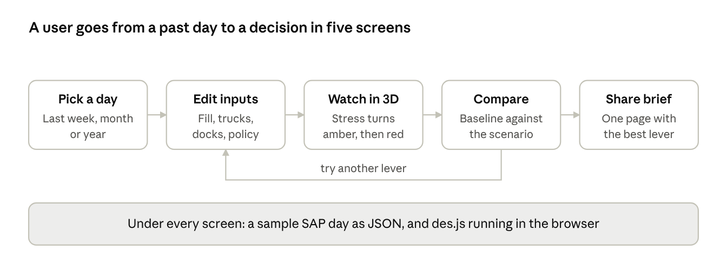
frontend flow · five screens on a thin backend

The five screens
Screen | What the user does | What it shows | Built from
Pick a day | Chooses the same weekday last week, last month or last year | Trucks, orders and fill rate of that day | Sample SAP day in JSON
Edit inputs | Moves a few sliders: fill rate, reach trucks, docks, pre-pick on or off, trucks +x% | Which numbers changed against the baseline | Model card
Watch in 3D | Plays the day at 60× to 600× speed | Trucks move; queues fill; blocks turn amber then red; a red truck shows its reason | Event log + 3D items
Compare | Looks at baseline and scenario side by side | Average turnaround, % of trucks over slot, first red time per stage, 95% range | 30 replications
Share brief | Exports one page | The problem, the lever and the gain in numbers | Compare results

What is real and what is a stand-in until the pilot
Part | Until the pilot | At the pilot
Engine | des.js in the browser | SimPy on a server, same event-log contract
Data | One sample day shaped like the pilot site, with no real names | Real SAP extracts
Model card | Assumed numbers, marked "Assumption" | Fitted numbers with source and date
3D items | Our forklift and truck; Kenney placeholders for the rest | Full item set from the item skills
Accounts, storage | None. Scenarios save as files | Login and saved scenarios

The demo the frontend must deliver
The demo proves one message: act at 88%, not at 95%. At 88% full, pre-pick cuts turnaround from 1.67 h to 1.03 h, and late trucks fall from 15% to 0%. At 95% full, the same lever only brings turnaround from 3.28 h to 2.13 h. Two extra reach trucks give 2.14 h. The viewer must see this in under two minutes.

Developer tasks for the next six weeks
The plan assumes three people: a frontend developer, a 3D developer and a data and engine developer. Each week ends with something Samir can click.
Week | Frontend developer | 3D developer | Data and engine developer | Done when
1 | Set up the app shell and routing for the five screens | Set up Blender headless build; run .claude/skills/3d-item on the forklift | Freeze the scenario JSON and event-log JSON formats; wrap des.js behind them | des.js runs from the app and writes an event log
2 | Build "Pick a day" and "Edit inputs" against the model card | Truck and trailer items through the same skill; GLB pipeline in CI | Build one sample SAP day (VTTK, LIKP, LIPS, LTAP shape) with no real names | A user edits fill rate and runs 30 replications
3 | Build the 3D replay that reads the event log; timeline and speed control | Site layout: gate, parking, docks, racks, lanes; instanced pallets and racks | Add stress meters and reasons to the event log | The 95% day plays in 3D and turns red in the right order
4 | Build "Compare": the numbers, the 95% range and first-red times | Item states: idle, moving, lifting, blocked (red) | Rule plug-in loader; move the six current rules into files | Baseline and scenario sit side by side
5 | Build the model card screen and the rule switches | Polish pass: lighting, wide camera paths for recording | Test SimPy in Pyodide; write the SAP extract mapping for the pilot | Samir can change a and f0 and see the effect
6 | Build "Share brief" export | Record the 2-minute demo video | Replay check on one real pilot day, if data arrives | Demo video ready; validation result in the model card

Rules for the team
- The frontend reads only the event log. It never computes results itself.
- Every number on screen links to the model card.
- Every new constraint is a rule file.
- Every new 3D item goes through its item skill and review checklist.
- Nothing ships with a real company or person name in the sample data.

Sources
Engines and libraries
- SimPy on PyPI: MIT licence, version 4.1.2
- salabim on PyPI: MIT licence, version 26.0.8
- Ciw on PyPI: version 3.2.7
- JaamSim and JaamSim on GitHub: Apache 2.0
- Mesa on PyPI: Apache 2.0, version 3.5.1
- PM4Py on PyPI: AGPL-3.0 or commercial licence
- Pyodide: Python in the browser
- SciPy statistics: distribution fitting
3D
- three.js forum: rendering thousands of objects: the 4,000-box and instancing case
- three.js InstancedMesh
- glTF-Transform: the GLB pipeline commands
- Kenney City Kit Industrial: CC0 models
- Cinevva GLB optimisation guide: source of the size, triangle and texture budgets (read during research)
Our own results
- experiments/fill.js and experiments/lever.js in the starter kit: 30 replications per point, 9 reach trucks, random arrivals.

