Simulation problem statements and demo scenarios
Oct 10, 2026 · @Samir Tushar

What makes a demo land
A demo lands when the viewer sees their own tomorrow fail before it happens. Animation alone does not do this. Every problem statement we build must pass five tests.
- A hidden knee. Performance stays flat as load rises, then collapses past a point that nobody can see from daily averages.
- A visible cascade. Stress starts at one place and travels to others: docks, then parking, then the gate, then orders.
- A real baseline. The run starts from a real past day in SAP: same day last week, last month or last year. The user changes only what is different tomorrow.
- A lever that works. One change the user can make tonight that moves the knee or stops the cascade, shown on the same day.
- A number in money. Detention, overtime, missed delivery windows, or a stopped line.
The aha sentence we want from the viewer: "If I had this, I would know how tomorrow goes before it starts."

Flagship problem: warehouse fill and truck turnaround
Problem statement: "When my warehouse is more than about 85% full, my trucks take far longer to turn around, and I find out only when the yard is full."
Industry guidance puts practical storage use at about 85%, with 85% to 90% seen as the high-performing band (Storage Solutions, ISM). Above that, flow in and out slows, and a delay at one step spreads to the next.
Why the knee exists: two effects stack
- Each task gets slower once free locations run out. At 40% to 70% full, every pallet has a good slot near the dock, so task times barely change. Past about 70%, four things start:
  - Putaway searches longer for a free slot, and lands further away.
  - Some pallets block others, so a pick needs extra moves (rehandling).
  - Overflow pallets get parked in aisles and staging areas, which slows every vehicle.
  - Marshalling lanes fill, so loaders work around pallets.
- Queues amplify the slowdown. Reach trucks near full use cannot absorb even a small slowdown. Waiting time grows roughly with utilisation ÷ (1 − utilisation), so going from 85% to 95% busy roughly triples the wait. A 24% slower task can mean a 58% longer turnaround.
The first effect is physical and must be fitted from the customer's data. The second comes from the simulation itself, which is why a spreadsheet misses it.
How we model the first effect, as a glass box: one curve per task type, with two numbers the user can see and tune.
\text{task time} = \text{base time} \times \left(1 + a \cdot \frac{\max(0,\ f - f_0)}{1 - f}\right)
Here f is warehouse fill, f0 is where slowing starts (assumed 70%), and a is how sharply it rises (assumed 0.12). Both are fitted from SAP warehouse task confirmation times against stock level on that day.

The curve: turnaround against warehouse fill
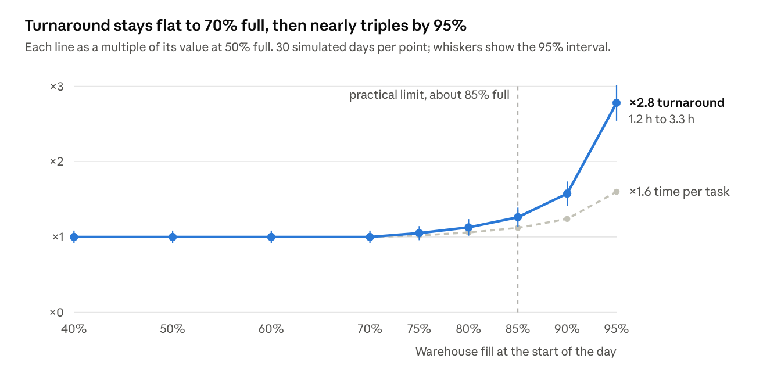
Simulation Lab engine · random days of about 70 trucks, 9 reach trucks, 30 replications per fill level
At 95% full each task takes 60% longer, but turnaround grows 2.8 times: the gap between the two lines is what queues add. The flat part below 70% comes from the assumed start of slowing; the customer's data sets where the knee really is.

The cascade: how stress travels
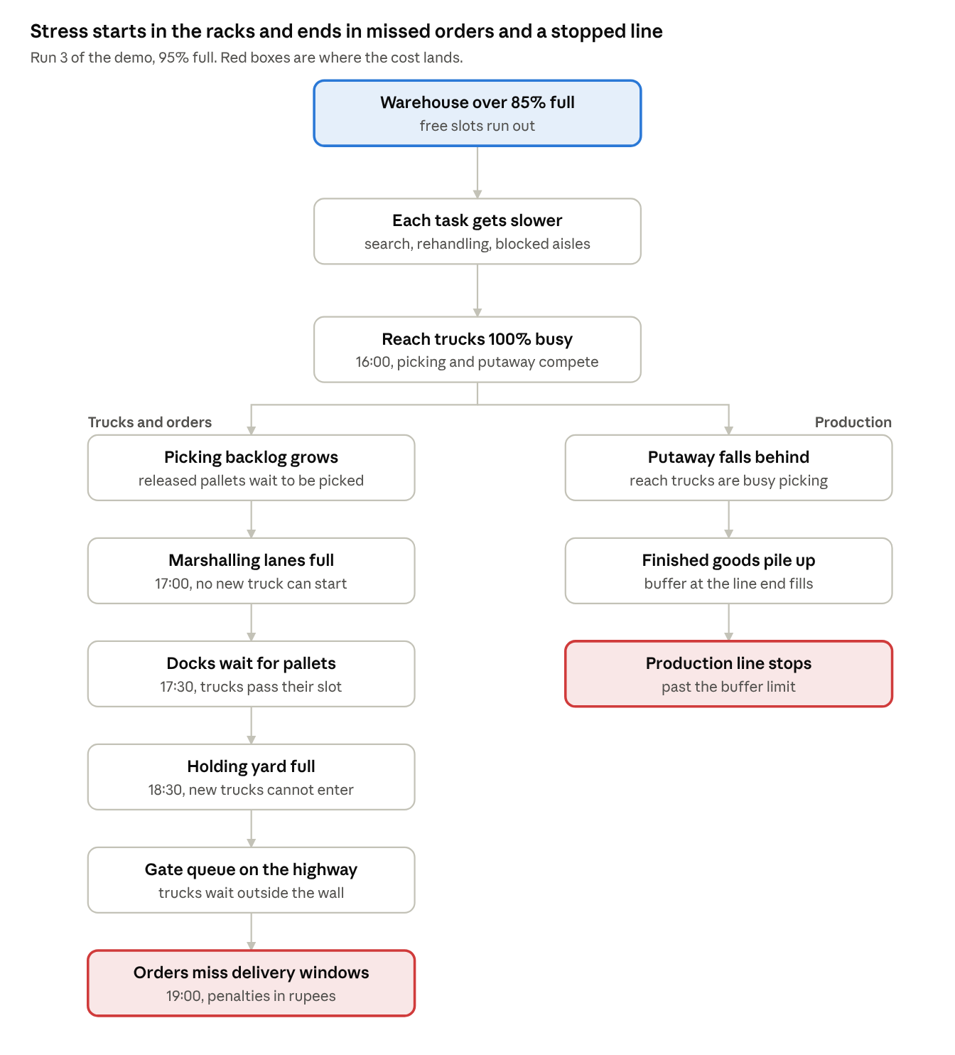
stress cascade · flagship demo, run 3
One root cause splits two ways: outbound stress reaches customers through missed windows, and inbound stress reaches production through a full buffer. The 3D view shows each box as a zone turning red in this order.

The demo script: one past day, three fill levels
The demo takes last Tuesday from SAP and replays it three times. Only the opening stock level changes. Everything else stays as it happened: about 70 trucks, the same orders, the same people and equipment.
Run | Opening fill | Average turnaround | Trucks past the 3-hour slot | Days the holding yard overflows
1. As it happened | 50% | 1.2 h | 2% | 0 of 30
2. Before the festive build-up | 85% | 1.5 h | 10% | 3 of 30
3. Peak build-up | 95% | 3.3 h | 49% | 24 of 30, from about 18:30
Results are averages of 30 simulated days with random variation; turnaround at 95% is 3.3 h ± 0.3 h at 95% confidence.
What the viewer sees in run 3, in order
- 16:00, picking. Reach trucks hit 100% busy. The picking zone turns amber, then red.
- 17:00, marshalling lanes. Lanes fill with half-picked trucks. No new truck can start picking.
- 17:30, docks. Docks wait for pallets, not trucks. A truck past its 3-hour slot turns red and stays red until it leaves.
- 18:30, holding yard. The yard is full. New trucks queue on the highway outside the gate.
- 19:00 onwards, orders. Delivery windows are missed. Order lines turn red in the side panel, with the penalty in rupees.
- Behind it all, production. Putaway falls behind, so finished goods pile up at the end of the line. Past the buffer limit, the line must stop.
The lever, and the real aha
- At 88% full, pre-picking evening orders in the morning fixes the day completely: turnaround drops from 1.7 h to 1.0 h, and no truck misses its slot.
- At 95% full, no single lever is enough. Pre-picking brings turnaround to 2.1 h, and adding two reach trucks gives the same. A quarter of trucks still miss their slot.
The message to the user: act at 88%, not at 95%. The simulation tells you which day you cross that line, a week in advance.
Rules for the red states (all configurable per site)
Object | Amber when | Red when
Truck | 80% of its slot used | Past its slot
Picking zone | Reach trucks above 85% busy | Above 95% busy, or backlog above 90 pallets
Marshalling lanes | 80% of lanes used | All lanes used
Holding yard | 75% of bays used | Full, with trucks queuing outside
Order line | Forecast to miss by under 1 hour | Missed window
Finished-goods buffer | 70% full | 90% full, line at risk

More problem statements across supply chain
Each of these passes the same five tests: a knee, a cascade, a real past day as baseline, a lever, and a cost. Each one is first built on its own.
Area | Problem in the user's words | The knee | How stress spreads | Baseline from SAP | The lever
Warehouse dispatch | "Above 85% full, trucks take twice as long." | Storage fill past about 85% | Picking, lanes, docks, yard, gate, orders, then production | Deliveries, shipments, warehouse tasks, stock level | Pre-pick at 88%; clear slow stock before the peak
Inbound receiving | "Supplier trucks bunch in the morning, and my line waits for parts." | Unloading docks and quality check above 85% busy | Docks, yard, detention charges, quality check backlog, line starved of a part | Purchase orders, goods receipts, inspection lots | Supplier time slots; quality check staff by hour
Production line | "One breakdown on the bottleneck machine ruins the whole day." | Bottleneck machine above 85% loaded, so lost time cannot be recovered | Work piles before it, machines after it starve, orders run late, overtime | Production orders, confirmations, maintenance notifications | A buffer before the bottleneck; planned maintenance timing
Production planning | "Tomorrow has more product changes than usual, and I do not know if it fits." | Changeover time eats the last of the spare capacity | Lost output, late orders, weekend overtime | Production plan, setup times, order due dates | Sequence and campaign size (heijunka)
Materials | "One late part stops final assembly." | Part coverage falls below the supplier's lead time | Assembly stops, finished goods short, dispatch misses, penalties | Purchase orders, delivery schedules, stock by part | Expedite one supplier; re-sequence orders around the gap
Maintenance | "Breakdowns pile up on the night shift." | Technicians above 80% busy on a thin shift | Machines stay down longer, production lost, morning plan breaks | Maintenance notifications, work orders, confirmations | Move one technician to the night shift; pre-stage spare parts
Transport | "When transporters place fewer trucks, my warehouse fills up." | Truck placement below about 80% of plan | Finished goods pile up, warehouse fill crosses its knee, then the flagship problem | Shipments, transporter indents, gate entries | Backup transporter; cap the plant's dispatch plan
Dark store (quick commerce) | "At the 7 pm rush, deliveries go past 10 minutes." | Pickers above 85% busy at peak | Order queue, rider wait, missed delivery promise, cancellations | Order logs from the order system | Pre-stage the top items; shift pickers to the peak
Three of these feed each other: transport shortfall fills the warehouse, a full warehouse slows putaway, and slow putaway stops production. That chain is where linking pays off later.

Build order: solve alone, then link
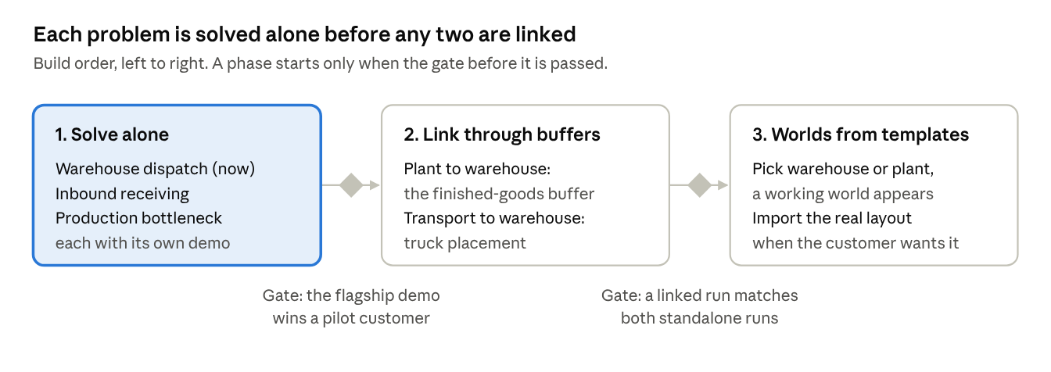
build order · 3 phases, 2 gates
Worlds link only through a shared buffer, such as the finished-goods buffer between a plant and its warehouse. Each world can then still run alone, and a linked run must give the same answers as the two separate runs when the buffer never fills.

What comes next
This doc settles the problems. The next four parts settle how to build them, one part per working session, each with a downloadable copy.
- The world model, as a glass box. How a model is built from past SAP days: what is read straight from data, what is fitted (like the knee curve above), and what the user sets. How it is checked against reality. Which open-source engines to build on. How you, as product owner and seller, can see and tune every number.
- An extensible framework. Constraints added as plug-in rules, never as rewrites. World templates: pick "warehouse" or "production plant" and a working world appears with sensible defaults, and later the customer's real layout. Linking worlds through shared buffers.
- 3D item skills. Research on how good stylised 3D assets and motion are made, then one skill per item family (truck, forklift, reach truck, rack, dock), so every item meets the same standard.
- The developer handoff. The brief updated with all of the above, as tasks per developer with done-when tests.
The team does not wait for the later parts. Workstream B starts the flagship demo now, on the curve and rules in this doc.

