Employees Rate of Pay Upload To Profitool Process

Purpose: To upload from a spreadsheet hourly rates of pay stored on screen PR PERSONNEL
NEW.

- Run PR EMP REVIEW DL. Change Form to your Profitool’s auto email code for receiving report in text format. Chang also Payroll Type to OFF.

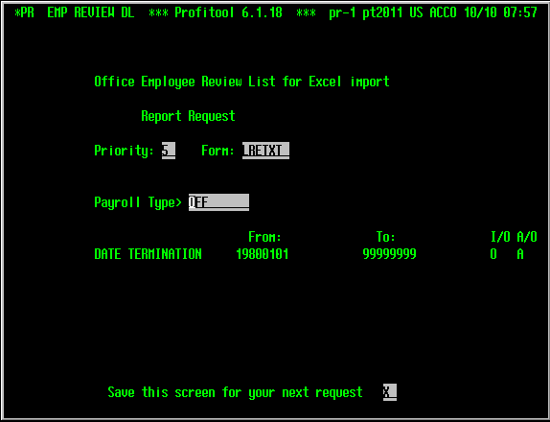

- Once report run to completion , open your email then download attachment as *.txt file.

- Open Excel. Open downloaded file changing the file type to a Text File (*.txt).
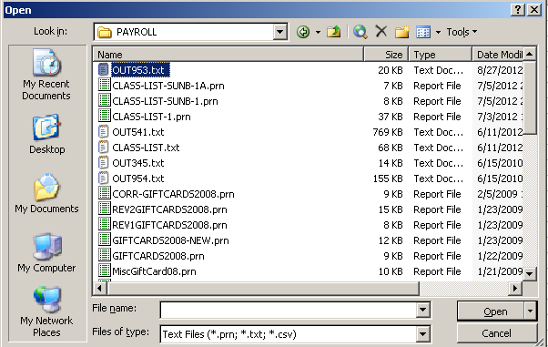

- When you click OPEN, the Import Wizard appears:
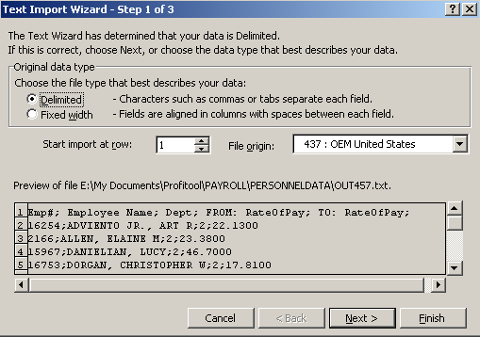

- Click Next:
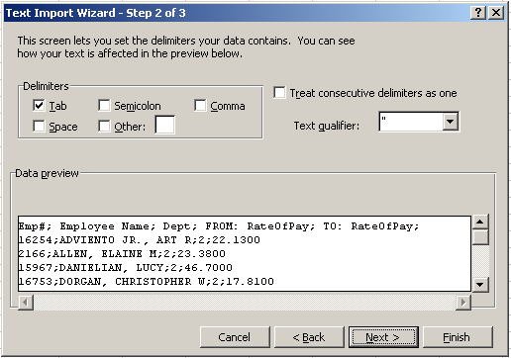

- Now click on Semicolon and columns appears.

- Notice that column headings and data is divided into columns. Now click Next:
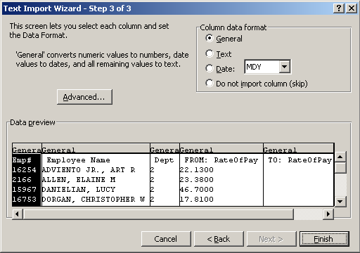

- Click Finish and the Excel worksheet appears.

- Click on cell A2. While pressing Ctrl and Shift key at the same, press the arrow right key →.
- This highlight row A2 to D2.
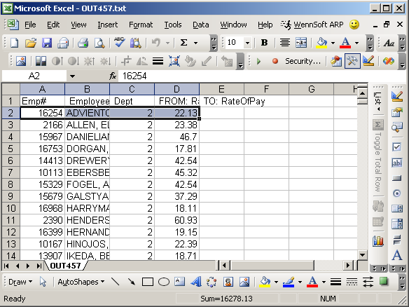

- Release arrow right key then press the arrow down key ↓.
- This highlight or select all records.
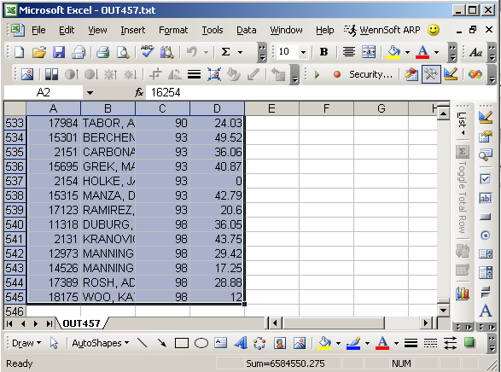

- Click Edit button on the top Toolbar and click Copy:
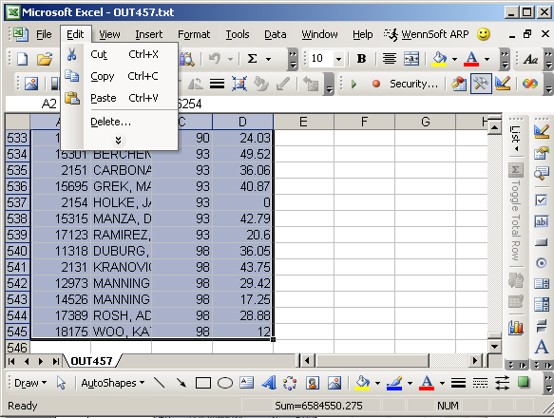

- Now open Excel template EmployeeReviewUpload xlt and click on cell A4.
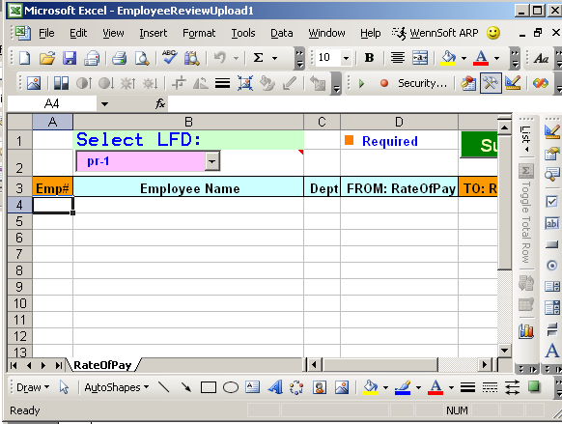

- Click on cell A4 then press Ctrl and V at the same time.
- This will copy the records to the excel template that has a macro.
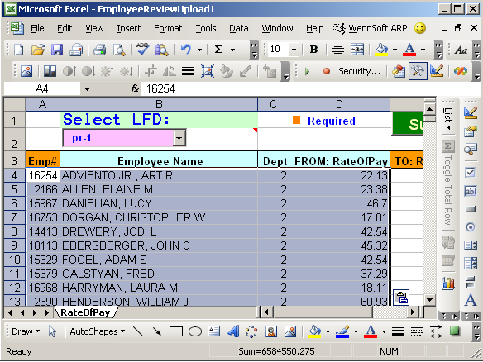

- Click on D to highlight column D.
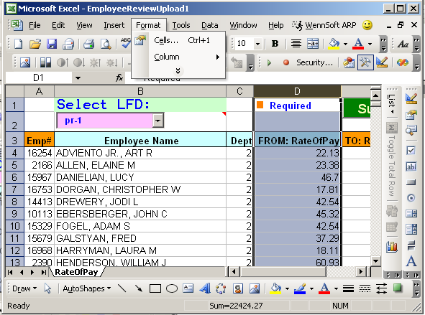

- Put your cursor on any area on the highlighted area then press the right button of your mouse.
- On the drop down list select Format cells. Format Cell window appears.
- Select the Number tab then select the first line on the Negative numbers drop down list.
- Click OK button.
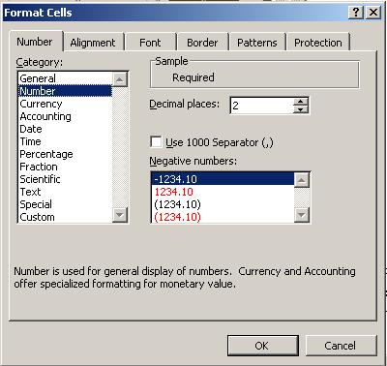

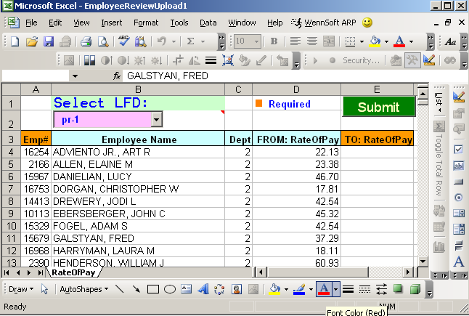

- Enter new employee pay rates in column E.

- On the combo list box Select LFD, select pr-1 if employee are for ACCO company or select sunpr for employee records are for SUNB company. Click Submit button. This creates an ASCII text file that is
- Copied to Profitool pr-1 or sunpr directory. Click Yes button.

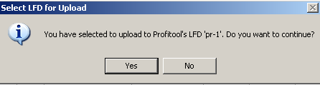

- Login to Profitool.and access SA FILE LOAD screen.
- Enter the following screen parameters:
- File To Receive Data: PERSONNEL$DATA
- Format Name: rate-of-pay-upload
- Filename (Or Pathname)… To Be Loaded: /home/pr-1/ROPmmddyy
  - where mmddyy is date file is loaded
- Update It: X
- Save This Screen: Y

- Press Enter key and take note of the report number.
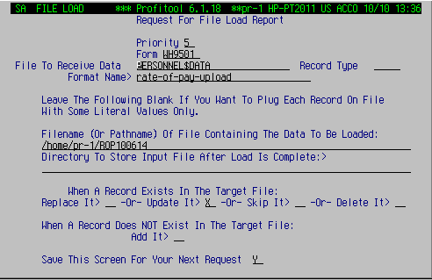

- Verify result using PERSONNEL DATA NEW screen or running again
- PR EMP REVIEW DL and compare the result from the original file created
in Step 1.

