Report
Of

Understanding Exam Preparation Challenges
Under The Tree Initiative

Submitted
To

School of Computer Science and Engineering
IILM University, Greater Noida, U.P.

In partial fulfilment of the requirement of degree of
B.Tech CSE


By

Roll Number of Student: 25SCS1003000729
Name of Student: Eram Rahman
Batch: 2026-27

Under the Supervision of
Anup Sinha
Under The Tree Foundation

CANDIDATE'S DECLARATION
I, Eram Rahman , do hereby declare that the internship report titled “Understanding Exam Preparation Challenges - Under The Tree Initiative” has been completed by me to fulfil the requirement for the award of the degree of Bachelor of Technology in Computer Science and Engineering. All the references have been quoted and I have not taken as such any material from any other source. I affirm that this report is my own work and has not been submitted to any other institute for any degree/diploma requirement, and I shall be solely responsible for any kind of copyright violation in this regard.

Eram Rahman

Signature
Student Name: Eram Rahman
Roll No.: 25SCS1003000729

ACKNOWLEDGEMENT
I am using this opportunity to express my gratitude to everyone who supported me throughout the Under The Tree Internship Program. I am deeply thankful to my supervisor, Mr. Anup Sinha , for invaluable guidance, continuous encouragement, and constructive feedback at every stage of this project. Their expertise and insight were instrumental in shaping the direction and quality of this work.
I would also like to thank Under The Tree NGO for providing me the opportunity, mentorship, and platform to undertake this internship project, and for the resources and guidance extended throughout its duration. I extend my gratitude to IILM University for its continued support and encouragement of my participation in this internship.
I am using this opportunity to express my gratitude to everyone who supported me throughout the Internship Program. I am thankful for their aspiring guidance, invaluably constructive criticism and friendly advice during this work. I am sincerely grateful to them for sharing their truthful and illuminating views on a number of issues related to this work.
I express my gratitude to my parents for their blessings.

Signature
Student Name: Eram Rahman
Roll No.: 25SCS1003000729

INTERNSHIP COMPLETION CERTIFICATE
[ Certificate of Internship Completion issued by Under The Tree NGO to be attached here ]

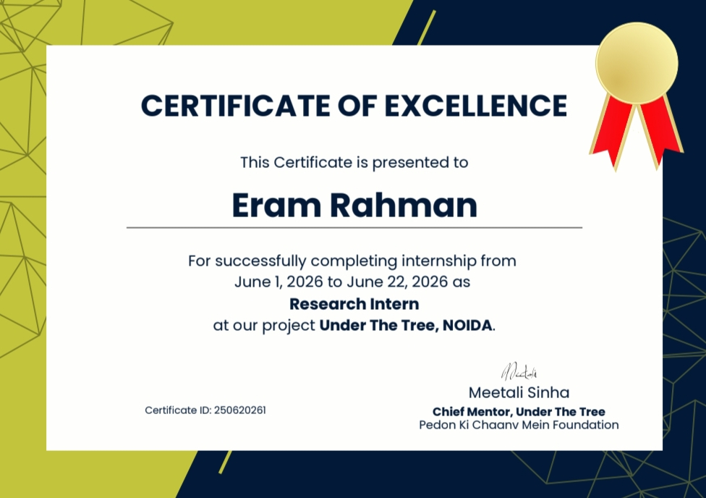

TABLE OF CONTENTS
Chapter No. | Chapter Name | Page Nos.
 | Cover Page | ---
1. | Candidate's Declaration | i
2. | Acknowledgement | ii
3. | Internship Completion Certificate | iii
4. | Project Description | 1
 | 4.1 Introduction | 1
 | 4.2 Organization Profile | 2
 | 4.3 Problem Statement | 2
 | 4.4 Project Objectives | 3
 | 4.5 Scope of the Project | 4
 | 4.6 Technologies and Tools Used | 4
 | 4.7 System Architecture | 5
 | 4.8 Methodology | 6
 | 4.9 Expected Outcomes | 8
 | 4.10 Certificates of completion and other communication mail proof | 9
5. | Bibliography/References | 12

Chapter 4: Project Description
4.1 Introduction
This project, titled "Understanding Examination Preparation Challenges among K-12 and Higher Education Students," is a six-week mixed-methods research initiative conducted under the "Under The Tree" programme of Pedon Ki Chhanv Mein Foundation. The research is designed to systematically identify, document, and analyse the multidimensional barriers that students face when preparing for examinations — with a particular emphasis on students from underserved communities across India.
Students at every level of education encounter a complex web of challenges that impede effective exam preparation. These include the language barrier arising from instruction in English when students' mother tongues are different regional languages, the absence of a conducive home study environment, the pervasive distraction of social media, inadequate access to guidance and mentorship, poor study habits, financial stress, and a lack of awareness of effective exam strategies.
Two trained volunteer researchers will conduct this study over six structured weeks, employing primary data collection through structured questionnaires, one-on-one student interviews, focus group discussions, and secondary data collection through student forums and social media communities. Data will be analysed using Microsoft Power BI to generate visual insights, and findings will be compiled into a comprehensive evidence-based report with targeted recommendations for students, educators, parents, and policy makers.
The ultimate goal of this research is to feed into the Under The Tree initiative's mission of providing tree-shade-level support — accessible, grounded, and community-rooted — to help every student thrive academically regardless of their background.
4.2 Organization Profile
Pedon Ki Chhanv Mein Foundation (meaning "In the Shade of Trees Foundation") is a non-profit organisation committed to nurturing the growth of underserved children and youth through education, mentorship, and community engagement. The Foundation's name is a metaphor — just as trees provide shade, cooling, and oxygen without expectation, the Foundation aims to provide unconditional support to those who need it most. The Foundation's flagship initiative, "Under The Tree," brings educational support directly to communities, operating in low-income neighbourhoods, rural pockets, and semi-urban areas where institutional support is thin and parental education levels are often low.
The internship was carried out under the supervision of Anup Sinha , whose guidance shaped the technical direction, review process, and quality standards followed throughout the project. The work was undertaken in coordination with IILM University, Greater Noida, as part of the academic requirement for the B.Tech CSE program, session 2025–2026.
4.3 Problem Statement
The following problem categories have been identified through the Foundation's field experience and preliminary community consultations. Each represents a research domain that this project will investigate systematically:
- Language Barrier : For students whose mother tongue is Hindi, Bengali, Tamil, Telugu, Marathi, Odia, or any of India's 22 scheduled languages, navigating English-medium textbooks is a double burden.
- Absence of a Conducive Home Study Environment : Students in low-income or joint-family households frequently lack a dedicated study space.
- Distraction from Social Media and Digital Devices : Platforms like Instagram, YouTube, and WhatsApp — has emerged as a significant competitor for study time.
- Lack of Knowledge of Effective Exam Preparation Strategies : Many students, especially first-generation learners, simply do not know how to study. Concepts such as spaced repetition, active recall etc. are unknown to large sections of the student population
- Absence of Guidance and Mentorship : Students from families where neither parent completed secondary education lack the cultural capital needed to navigate academic systems.
- Financial Stress and Economic Vulnerability : Economic pressure within the household affects student performance directly and indirectly.
- Poor Mental Health and Examination Anxiety : Competitive examinations in India — from Class 10 Boards to JEE/NEET to university entrance tests — generate intense societal pressure
4.4 Project Objectives
Primary Objective : To systematically document and analyse the types, severity, and contextual patterns of examination preparation challenges experienced by students across K-12 and higher education levels, with particular focus on students from underserved communities.
Secondary Objectives :
1. To identify which challenges are most prevalent across different student cohorts (primary, secondary, and higher education).
2. To understand how language barriers specifically affect comprehension, preparation quality, and examination performance.
3. To assess the role of the home environment — physical, social, and economic — in shaping study quality.
4. To document how digital distraction, particularly social media, competes with academic preparation time.
5. To identify gaps in mentorship, guidance, and study-skills awareness among the student population.
6. To capture the voices of students from underserved communities and amplify their lived experience of academic struggle.
7. To generate evidence-based recommendations that can be operationalised by the Foundation's Under The Tree programme.

4.5 Scope of the Project
The study will focus on students accessible to the Foundation's existing network. Primary data will be collected from community education centres, government schools, and local colleges in areas where the Foundation operates. Secondary data will be gathered from national-level student forums and social media groups, ensuring broader representation. This study will not assess academic performance data (marks, grades) as primary evidence. It will also not include students who attend private coaching institutions as their primary source of exam preparation, as the focus is on students who rely primarily on self-study and school instruction.
4.6 Technologies and Tools Used
- Questionnaire Design Principles: Three questionnaires have been designed — one for each major student cohort (see separate Questionnaire document)
Mix of Likert-scale, multiple-choice, and open-ended questions. Organised by seven challenge themes: (1) Language Barrier, (2) Home Environment, (3) Digital Distraction, (4) Exam Preparation Strategy, (5) Guidance & Mentorship, (6) Financial Stress, and (7) Mental Health & Anxiety.
- Interview Guide : Themes Individual interviews will use the following thematic prompt areas:
• Describe a typical day of exam preparation. What works and what doesn't?
• Has the language of instruction ever created difficulty for you? How?
• What does your study space at home look like? What disrupts your focus?
• How much time do you spend on social media per day? Do you think it affects your studies?
• Who helps you plan how to study for exams? Have you ever had a mentor or guide?
• Do financial pressures at home affect your ability to focus on studies?
• How do you feel emotionally during the examination period?
• What one change would make the biggest difference to your exam preparation?
- FGD Discussion Guide: Focus Group Discussions will explore group-level experiences, peer support patterns, and shared coping mechanisms around each of the seven challenge themes.
4.7 System Architecture
1.Target Students:
- K-8 students ,Grades 9–12 students ,Undergraduate students ,Postgraduate/professional students ,Special focus on underserved communities
2. Data Collection :
- Structured questionnaires to collect quantitative responses
- One-to-one interviews to understand individual experiences
- Focus Group Discussions (FGDs) to identify common experiences
- Observation notes to record study-environment conditions
- Secondary data from student forums and online communities
- Social media listening for student opinions and concerns
3. Data Processing & Storage :
- Enter questionnaire responses into an Excel master sheet
- Clean and organise collected data
- Check questionnaires and entered data for accuracy
- Maintain secure storage and anonymise student information
4. Data Analysis :
- Use Power BI for quantitative analysis and visualisation
- Analyse frequency and severity of different challenges
- Compare challenges across cohorts and other categories
- Perform qualitative/thematic analysis of interviews and FGDs
- Identify recurring patterns and challenge clusters
5. Data Triangulation :
- Compare quantitative questionnaire results
- Compare qualitative interview and FGD findings
- Compare secondary/online data
- Identify areas where different sources agree or differ
6. Findings & Visualisation :
- Identify the most common examination-preparation challenges
- Generate Power BI dashboards and visualisations
- Prepare a preliminary findings document
- Highlight important patterns among different student groups
4.8 Methodology
This study adopts a Mixed-Methods Research Design, integrating both quantitative data (structured questionnaire responses) and qualitative data (interviews, focus groups, forum analysis). This triangulation approach ensures richness, validity, and depth of findings.
- Mixed-Methods Research Design : The study uses both quantitative and qualitative methods. This provides a broader understanding of students' examination-preparation challenges.
- Primary Data Collection :
- Structured questionnaires
- One-to-one student interviews
- Focus Group Discussions (FGDs)
- Field observation notes
- Secondary Data Collection : Student forums , online communities and Social media listening.
These sources are used to identify common student experiences, concerns and preparation-related issues.

4. Sampling Strategy : Purposive sampling is used.
The study targets 180 students across K-8, Grades 9–12, undergraduate and postgraduate/professional levels. At least 60% of participants are targeted from underserved communities.
5. Key Research Areas :
- Language barriers
- Home study environment
- Digital distractions
- Exam preparation strategies
- Guidance and mentorship
- Financial stress
- Mental health and examination anxiety
6. Data Analysis :
- Questionnaire data is organised in an Excel master sheet.
- Power BI is used for quantitative analysis and visualisation.
- Interviews and FGDs are analysed using thematic analysis.
- Findings include challenge frequency, severity, comparisons and recurring patterns.
7. Triangulation : Quantitative, qualitative and secondary findings are compared.
Common findings are identified, while differences between sources are also documented.
8. Ethical Considerations :
- Informed consent is obtained.
- Participation is voluntary.
- Student information is anonymised and securely stored.
- Parental/guardian consent is obtained for participants under 18.
Overall Methodology Flow :
Research Design → Data Collection → Sampling → Data Processing → Data Analysis → Triangulation → Findings & Recommendations.
4.9 Expected Outcomes
These outcomes are based on the overall research analysis:
1. Comprehensive Identification of Student Needs: Develop a clear understanding of the major academic, personal, and career-related needs of undergraduate students.
2. Improved Academic Support: Identify areas where students require additional academic guidance, learning resources, and study support.
3. Strengthened Mentorship & Guidance: Establish the need for structured mentorship programs to support academic planning, career decisions, and personal development.
4. Enhanced Career Readiness: Identify career-related concerns and highlight the importance of career guidance, skill development, and future planning.
5. Better Digital Wellbeing: Promote awareness of the impact of excessive social-media and smartphone use on concentration, productivity, and study habits.
6. Improved Student Wellbeing: Highlight the need for accessible support systems to address examination stress, anxiety, sleep issues, and other wellbeing concerns.
7. Inclusive Learning Support: Identify language and environmental barriers and suggest resources that make higher education more accessible to students from diverse backgrounds.
8. Evidence-Based Recommendations: Develop practical recommendations for colleges, educators, mentors, and student-support organisations based on the survey findings.
9. Stronger Student Support Systems: Encourage institutions to move beyond basic academic assistance toward continuous mentorship, career guidance, digital wellness, and wellbeing support.
4.10 Certificates of completion and other communication mail proof
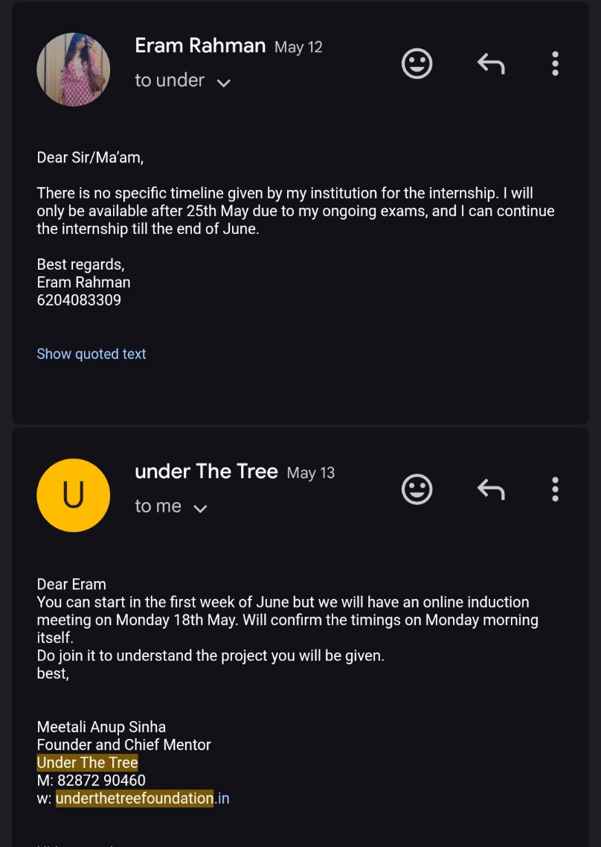
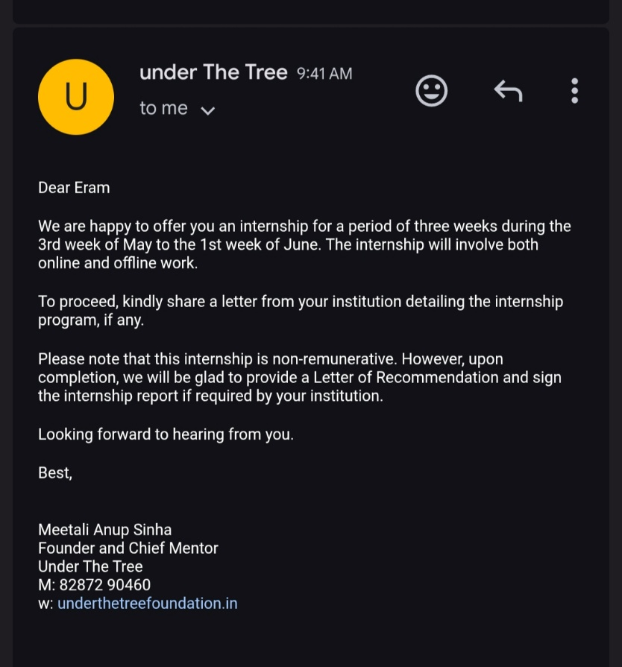
[ Certificates of internship completion and copies of related communication/mail correspondence with the supervisor and Under The Tree NGO are to be attached here. ]

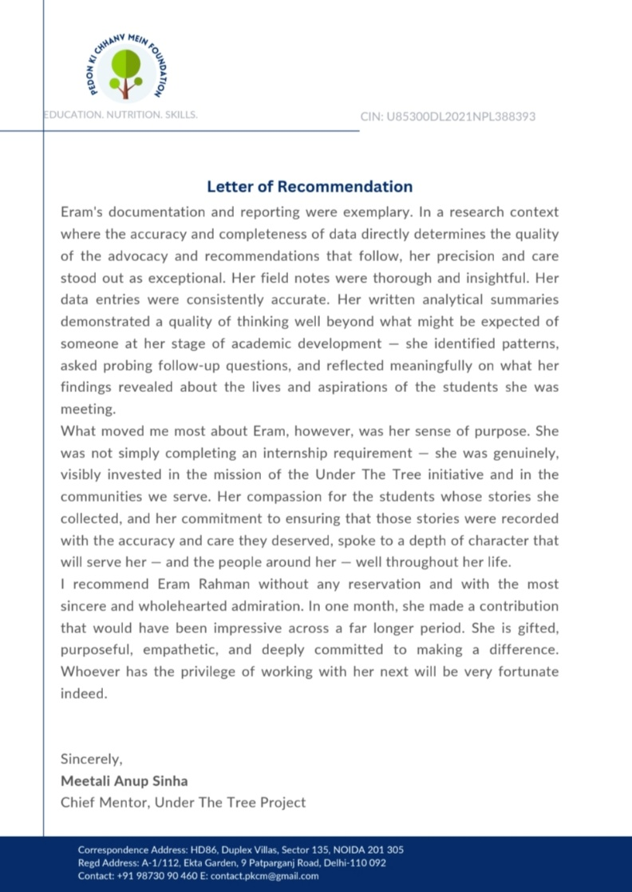
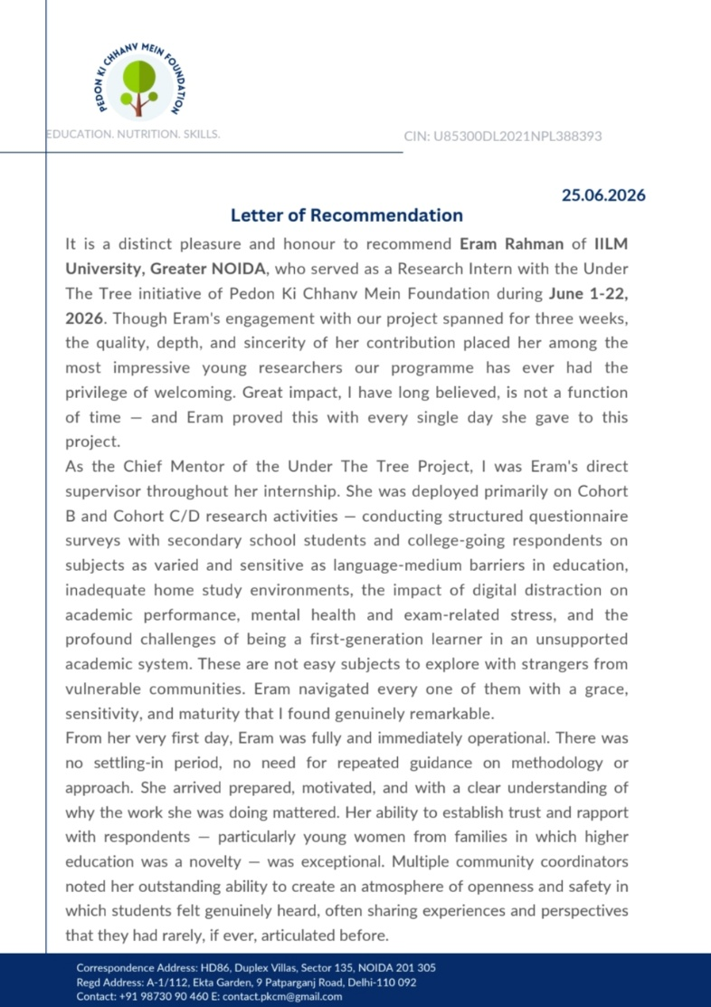



Chapter 5: Bibliography/References

[1] Pedon Ki Chhanv Mein Foundation. Understanding Examination Preparation Challenges Among K-12 and Higher Education Students with Focus on Underserved Communities. Under The Tree, 2026.
[2] Under The Tree – Pedon Ki Chhanv Mein Foundation. Cohort C/D Student Survey: Comprehensive Analysis Report. 2026.
[3] Creswell, J. W., & Creswell, J. D. Research Design: Qualitative, Quantitative, and Mixed Methods Approaches. SAGE Publications.
[4] World Health Organization (WHO). World Mental Health Report: Transforming Mental Health for All. World Health Organization, 2022.
[5] UNESCO. Global Education Monitoring Report. UNESCO.
[6] Ministry of Education, Government of India. National Education Policy 2020. Government of India, 2020.
[7] Microsoft. Microsoft Power BI Documentation. Microsoft.

