**Introduction**

The Staphylinidae fauna of the Aegean Islands has until recently been rather poorly known. With the recent works of Volker Assing many of the islands have received much needed attention and initial species lists have been produced, Chios (Assing, 2015a, 2016a), Corfu (Assing et al., 2018), Crete (Assing, 2013a, 2015b), Cyprus (Assing, 2017b, 2017a; Assing and Wunderle, 2001), Ikaria (Assing, 2017c), Karpathos (Assing, 2016b), Kos (Assing, 2017a), Lesbos (Assing, 2005, 2016a, 2017a), Rhodes (Assing, 2013b, 2017a) and Samos (Assing, 2015c, 2016a, 2017a). With over a thousand islands of the archipelago there are still many targets for exploration. One such is the Island of Skyros, part of the Thellesian Sporades in the western Aegean Sea.

With an area of approximately 209 km2 Skyros Island is the largest of the Thellesian Sporades, situated in the western Aegean Sea, quite isolated from other islands. Neglecting a number of smaller islands, the closest larger landmass is the large island of Euboea 40 km away, which only separated by the mainland by a small strait. Most of the rest of the Thellasian Sporades islands are found roughly 50 km to the North of Skyros. Skyros stretches roughly from north-west to south-east with two major mountains and a depression in the middle of the island. Mount Kochylas is tallest at 792m and dominates the south-eastern part of the island, while Mount Olympus is quite a bit lower at 402 in the north-western part. The north-western part is covered in a mix of coniferous forests of mainly *Pinus halepensis*, maquis with *Juniperus phoenicea*, and is generally covered in abundant, green vegetation. The south-eastern part is dominated by dry, spiny phrygana an maquis containing *Quercus coccifera,* *Quercus ilex* and *Acer sempervires*(Vrahnakis et al., 2012). At higher altitudes this is replaced by rocky bare ground, with very little vegetation. The coast is a mix between rocky cliffs and beaches with good amounts of coastal debris. The whole island shows signs of extensive grazing by the goats, with the large herds being in the south-eastern part. On the southern part of the island there is additionally a population of wild horses(Fotiadis and Vrahnakis, 2012). The south-eastern part is largely uninhabited with only few permanent structures to be found, while the northern part contains the main city of the island as well as other, smaller settlements.

Staphylinidae, commonly known as rove beetles, are an extremely diverse group of beetles with more than 60.000 species currently known (Solodovnikov et al., 2013). They are very diverse in their ecological preference as well as their feeding habits and are found in almost all habitats across Earth (Thayer, 2016). A recent study of the rove beetles of Læsø, a danish island, shows this rather well as they found rove beetles In a wide variety of macro- and microhabitats ranging from freshwater to grasslands, ants nests to dung(Hansen et al., 2018). While generally quite small, usually from 4 to 8 mm, some species grow to be more than 30 mm. Most species are quite flat and slender, with shortened elytra and flexible abdomen, which make them able to maneuver through small spaces (leaf litter, under bark, crevices, etc.) (Thayer, 2016).

In this paper we update the knowledge of the Staphylinidea species on the Island based on two recent targeted trips, one for nine days in 2015 and one for five days in 2019. On these trips we collected as broadly as possible, to get closer to a true species list for the island and thus we sampled using both various methods and habitats to get as broad a sample as possible.

**Materials and Methods**

Data presented in this paper is based on two trips to Skyros, one in April of 2015 and one in the end of March of 2019. While the first trip was under decent collecting conditions, with warm and sunny weather, the second trip was during a very cold and windy week, following a very cold winter. We used various methods to get as broad and varied sample as possible. Specifically, we sifted various types of debris, set pitfall traps, swept vegetation, set combined Flight Intercept Trap (FIT) and Malaise trap, and hand collecting from ground-based microhabitats, carcasses found in the wild and in goat, sheep, horse and cow dung. Most of our sifted material was from leaf litter or other similar plant debris, while a few samples were done sifting soil around grass roots. The sifted material was sorted using both Winkler eclectors as well as manually in warm conditions to extract as many specimens as possible. Salted water and cheap Greek wine were used as a preservative for the lower pans of the FIT as well as the pitfall traps set. All hand- or trap-collected material was eventually preserved in 96% alcohol.

Below is a full list of localities, and a map showing the distribution of these sites (figure 1):  
GREECE, Skyros Island, IV.2015leg. L. Kræmer, A. Brunke, S. Selvantharan & A. Solodovnikov: **A:** 1 km E of Skyros airport nr. Trachy, N38°57.561’, E024°30.096’, 20 m, 16.IV.2015, farmland: a) sifting debris, b) hand collecting nr. creek.; **B:** S of the airport, N38°56.726’, E024°29.029’, 50 m, 11.IV.2015, pine forest: a) sifting leaf litter, b) sweeping vegetation.; **C**: 0.91 km N of Atsitsa, N38°55.584’, E024°27.933’, 16.IV.2015, stony beach, in seaweeds.; **D**: S of Atsitsa, N38°54.690’, E024°28.358’, 110 m, 11.IV.2015, pine forest/evergreen understory: a) sifting in creek valley, b) under bark.; **E**: 3.3 km SW of Atsitsa, N38°54.127’, E024°29.961’, 200 m, 12.IV.2015, pine forest/evergreen understory: a) sifting leaf litter, b) sweeping vegetation, c) FIT, d) Malaise trap, e) pitfall traps.; **F**: 1.4 km S of Skyros nr. Lino, N38°53.539’, E024°34.373’, 18.IV.2015, sandy pebble beach, sifting seaweeds.; **G**: nr. Aghios Fokas, N38°52.458’, E024°28.756’, 10 m, 12.IV.2015, hillside nr. coast w. *Euphorbia*: a) sweeping vegetation, b) under stones.; **H**: Dekatria Hill, SW slopes, N38°52.039’, E024°30.035’, 250 m, 12.IV.2015, dry pine forest/scrubby understory: a) sifting leaf litter, b) under bark.; **I**: Kochylas Range, NW slopes, N38°50.902’, E024°35.124’, 440 m, 14.IV.2015, maple forest: a) sifting leaf litter, b) under rocks, c) hand collected.; **J**:Kochylas Range, NW slopes, N38°50.647’, E024°35.484’, 580 m, 14.IV.2015, maple forest: a) sifting leaf litter, b) in dung.; **K**: Kochylas Range, SW slopes, N38°50.382’, E024°34.919’, 300 m, 13.IV.2015, rocky pastures. *Euphorbia*: a) under stones, b) in dung, c) on carrion.; **L**: Kochylas Range, SW slopes, N38°50.210’, E024°35.424’, 530 m, 13.IV.2015, maple forest: a) sifting leaf litter, b) under stones, c) pitfall traps.; **M**: Kochylas Range, NW slopes, N38°50.238’, E024°35.554’,550 m, 17.IV.2015, maple forest: a) sifting leaf litter, b) on ground.; **N**: Kochylas Range, NW slopes, N38°50.011’, E024°35.799’, 640 m, 17.IV.2015, maple dominated forest: a) sifting leaf litter, b) hand collecting.

Greece, Skyros island, III.2019, leg. A. Bogri, A. K. Hansen, A. Marstrand, A. Solodovnikov: **O:** SE of Nifi, N38°48.355', E24°34.461', 0 m, 27.III.2019, grazed meadow with *Quercus coccifera* patches: a) sifting leaf litter, b) sifting meadow and grass, c) under rocks, d) pitfall traps.; **P:** SE of Nifi, N38°48.321', E24°35.208', 103 m, 27.III.2019, dry creek in *Quercus* and *Acer* forest: a) sifting litter and flood debris, b) hand collecting, c) pitfall traps.; **Q:** Around Skyrian Horse Lake, N38°48.0510', E024°38.612', 373 m, 27.III.2019, meadow with artificial lake: a) on dung, b) under rocks.; **R:** SW of Skyros city, N38°53.469', E24°32.433', 44m, 28.III.2019, near lake, hand collecting.; **S:** SW of Skyros city, N38°53.400', E24°31.297', 137 m, 28.III.2019, *Pinus* forest with *Pinus brutia* and *Pinus halepensis*: a) sifting leaf litter, b) hand collecting.; **T:** SW of Skyros city, N38°54.1488', E24°30.2466', 217 m, 28.III.2019, pine forest with laurel: a) pitfall traps, b) hand collecting, c) sifting.; **U:** N of Atsitsa, N38°55.5852', E24°27.9646', 0 m, 28.III.2019, around beach and nearby meadow: a) sifting, b) hand collecting.; **V:** N of Skyrian Horse Lake, N38°48.278', E24°38.143', 384m, 29.III.2019, mountainous forest: a) hand collecting, b) sifting leaf litter.; **W:** Near Kalamitsa, N38°50.465', E24°33.913', 4m, 29.III.2019, beach with seaweed debris: sifting seaweed and other beach litter.

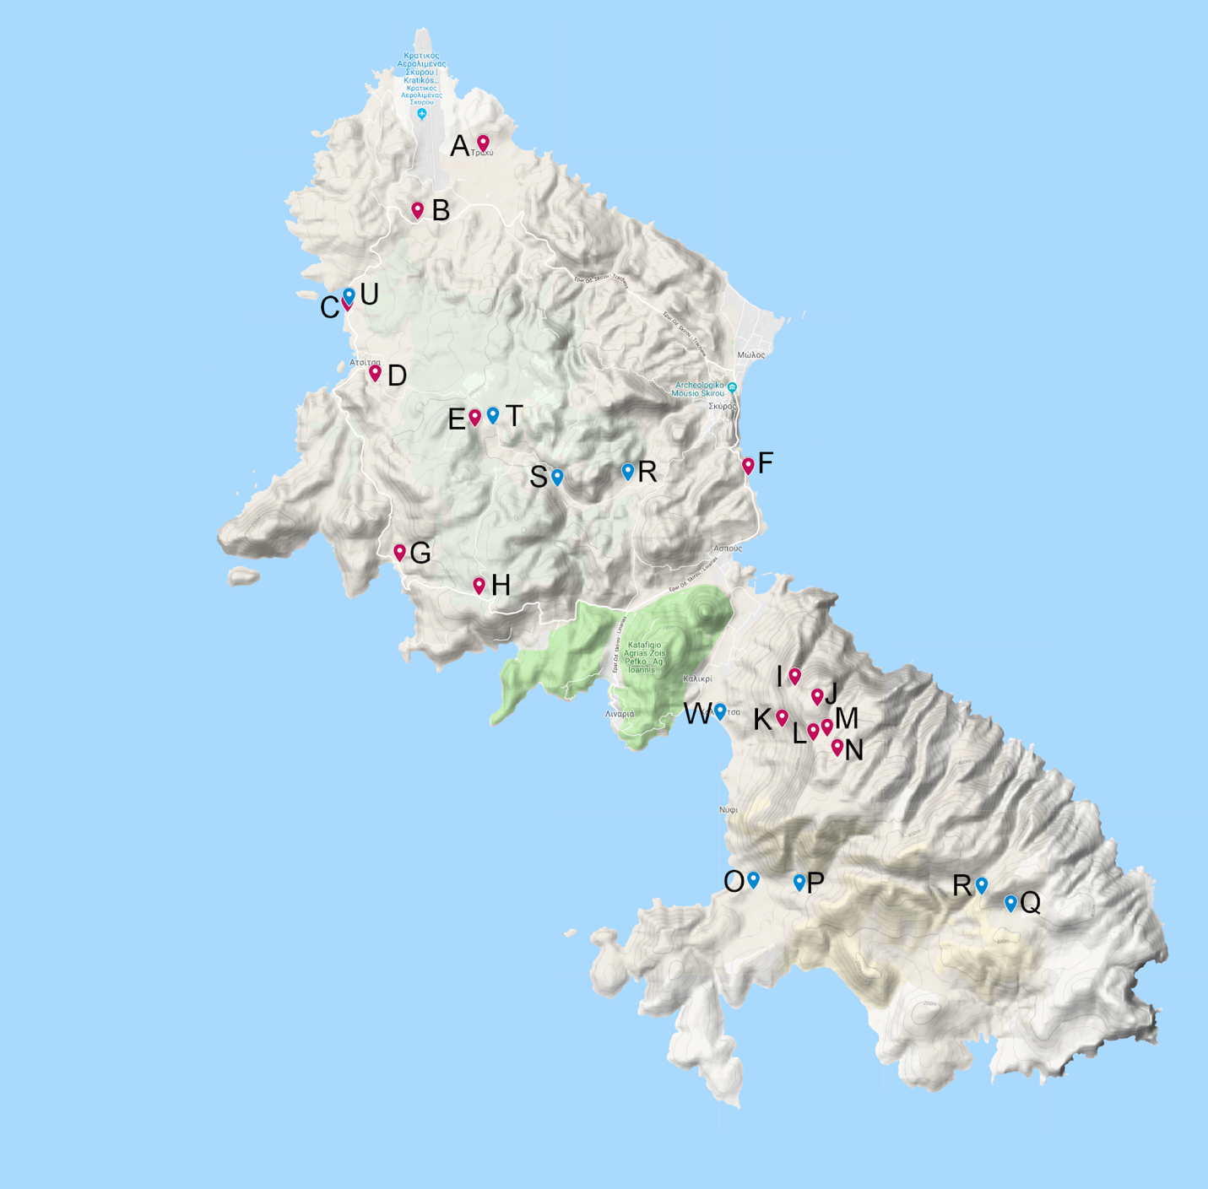

Figure 1. Sampling localities at Skyros Island. Localities marked in red (A-N) were sampled in 2015 and those marked in blue (O-W) were sampled in 2019.

**Results**

Based on two trips to Skyros, we have collected a total of 65 species, with X species identified only as morphospecies. These species are compiled below in table 1, with localities marked by their abbreviations.

Table 2. Species composition and distribution of Staphylinidae on Skyros. Localities (Capital letters) here match those in figure 1 as well as our list of localities (see Materials and Methods section). The collecting methods (lower case letters) are marked according to our list of localities. In brackets we indicate the number of specimens collected from each locality using the respective method. Some (A-N) are from an earlier trip (Kræmer, 2015), while the rest (O-W) are from our current trip.

|  |  |
| --- | --- |
| Species | Locality |
| **Omaliinae** |  |
| *Omalium cinnamomeum* Kraatz, 1857 | Ec(8)e(1), Ha(1), Ia(1), Ja(2), La(11), Ma(1), Na(7), |
| *Dropephylla gobanzi* Ganglbauer, 1904 | Ea(1) |
| **Proteinae** |  |
| *Megarthrus depressus* Paukull, 1789 | Lc(1) |
| *Proteinus atomarius* Erichson, 1840 | Da(1),Ec(6)e(4) |
| *Proteinus brachypterus* Fabricius, 1792 | Ec(1) |
| *Proteinus ovalis* Stephens, 1834 | Na(1) |
| **Micropeplinae** |  |
| *Arrhenopeplus cf. thrasicus/turcicus* | La(1) |
| **Tachyporinae** |  |
| *Lordithon thoracicus* Fabricius, 1777 | Ba(5), Da(2), Ec(2)d(2) |
| *Mycetoporus ignidorsum* Eppelsheim, 1880 | Da(1), Ec(1), Ha(3), Ja(2), La(2), Na(3), Pa(2), Vb(1) |
| *Mycetoporus mulsanti* Ganglbauer, 1895 | Ba(2), Da(2), Ea(2)c(1), Ha(3) |
| *Mycetoporus nr. altaicus* Luze, 1901 | Ba(1), Da(1), Ia(1), Ja(3), La(3), Na(1), Pa(1)c(1), Vb(2) |
| *Mycetoporus sp.* | Ja(1), La(2) |
| *Sependophilus sp.* | W(1) |
| *Tachyporus scitulus* Erichson, 1839 | Ab(1), Ed(2), F(2), La(1) |
| *Tachyporus solutus* Erichson, 1839 | Ed(1) |
| **Habrocerinae** |  |
| *Habrocerus piscidus* Korge, 1971 | Da(5), Ja(1), Ma(4), Vb(2) |
| **Aleocharinae** |  |
| *Alevonota rufotestacea* Kraatz, 1856 | Ia(1) |
| *Aloconota cambrica* Wollaston, 1855 | R(1) |
| *Aloconota gregaria* Erichson, 1839 | Ba(1), Ec(1) |
| *Atheta amicula* Stephens, 1832 | Ec(5)d(1)e(11), Lc(1) |
| *Atheta atramentaria* Gyllenhal, 1810 | Da(1), Ia(1), Lc(5) |
| *Atheta aquatilis* Thomsom, 1867 | Ec(3)d(4)e(5), La(5), Lc(3), Na(1), Ob(1), Pb(3) |
| *Atheta crassicornis* Fabricius, 1792 | Ec(4),d(1), La(5)c(6), Na(11) |
| *Atheta  fungi fungi* Gravenhorst ,1806 | Ec(1), La(1), Oa(14), Ob(1), Pb(9), Vb(10), W(2) |
| *Atheta (s. str.) graminicola* Gravenhorst, 1806 | Ec(1), La(1), Lc(2) |
| *Atheta orbata* Erichson, 1837 | Da(1), Ec(1),d(1), F(1), La(2), Na(2) |
| *Atheta (Ceritaxa) testaceipes* Heer, 1839 | Da(1) |
| *Atheta trinotata* Kraatz 1856 | La(4), Lc(7), Ma(3) |
| *Bolitobius sp. (n.?)* | Db(3) |
| *Dalotia coriaria* Kraatz 1856 | La(3), Ma(1), Na(1) |
| *Falagria sulcatula* Gravenhorst, 1806 | Sb(1) |
| *Geostiba oertzeni* Eppelsheim, 1888 | Ja(1), La(1), Lc(7), Ma(4), Na(12) |
| *Ischnopoda umbratica* Erichson, 1837 | Oa(26) |
| *Leptusa sp.* | C(3) |
| *Liogluta microptera* Thomson, 1867 | Ec(1) |
| *Myllaena intermedia* Erichson, 1837 | Oa(1) |
| *Ocalea badia* Erichson, 1837 | Ec(2), La(1), Na(1) |
| *Oxypoda abdominalis* Mannerheim, 1830 | Ia(1), La(2), Ma(1), Na(1), Vb(1) |
| *Oxypoda alternans* Gravenhorst, 1802 | Ee(3) |
| *Oxypoda induta* Mulsant & Ray 1861 | Ba(1), La(6), Lc(1), Ma(1), Na(4) |
| *Oxypoda opaca* Gravenhorst, 1802 | Ec(4)e(1) |
| *Oxypoda praecox* Erichson, 1839 | Da(1), Lc(2), Ma(1), Na(4) |
| *Oxypoda togata* Erichson, 1837 | Ed(1) |
| **Oxytelinae** |  |
| *Anotylus inustus* Gravenhorst, 1806 | Ba(20), C(1), Da(20), Ed(5), Hb(4), Ia(2), Ja(54)b(6), Lc(42), Ma(6) |
| *Anotylus sculpturatus* Gravenhorst, 1806 | Da(1), Ec(3)d(1), Ha(1), Ia(1), Ja(4)b(2), Ka(2)b(16), La(3)c(8), Ma(3) |
| **Steninae** |  |
| *Stenus erythrocnemus* Eppelsheim, 1884 | Aa(1) |
| *Stenus ludiy* Fauvel, 1886 | Da(15), Ea(1)c(1), Ha(10), Na(6) |
| *Stenus ochropus* Kiesenwetter, 1858 | Ba(37), Ha(3), Na(2), La(2) |
| *Stenus (Hypostenus) sp.* | Sa(1)b(1) |
| *Stenus (s. str.) sp.* | Aa(1), Sa(1) |
| **Scydmaeninae** |  |
| *Leptomastax sp.* | Sa(1) |
| **Paederinae** |  |
| *Astenus sp.* | W(1) |
| *Lathrobium creticum* ***???*** | Oa(2) |
| *Leptobium sp. n. cf creticum/graecum* | Ba(7), Ec(2), Ha(4), Ma(1), Oc(1), Qb(1), Sb(1), Vb(4) |
| *Medon apicalis* Kraatz, 1857 | Ba(1), Ec(1) |
| *Medon dilutus cephalus* Koch, 1938 | Oa(3) |
| *Medon dilutus pythonissa* Saulsy, 1864 | Ba(7), Da(6), Ea(4)c(5)d(7)e(1), Ha(16), Ia(4), Ja(17), La(9), Ma(2), Na(21), Oc(1), Vb(1) |
| *Medon fusculus* Mannerheim 1831 | Ja(2), Vb(2) |
| *Medon sp.* | Vb(1) |
| *Platydomene sp.* | W(2) |
| **Staphylininae** |  |
| *Dinothenarus flavocephalus* Goeze, 1777 | Bb(1), Jb(1) |
| *Heterothops dissimilis* Gravenhorst, 1802 | Ba(1), Ec(1) |
| *Hypnogyra sp. 1* | La(1) |
| *Hypnogyra sp. 2* | Vb(1) |
| *Ocypus mus* Brulle, 1832 | Lc(1), Ma(1) |
| *Ocypus picipennis* Fabricius, 1793 | Qb(1) |
| *Othius lapidicola* Markel & Kiesenwetter, 1848 | Ba(13), Ia(3), Ja(1), La(6), Ma(3), Na(3), Vb(1) |
| *Philonthus debilis* Gravenhorst, 1802 | Kb(5), Lc(1), Qb(1) |
| *Quedius humeralis* Stephens, 1831 | Ba(1), Ec(8)d(2), Ha(1), Ia(3), Ja(22), La(2)c(3), Ma(5), Vb(2) |
| *Quedius nivicola* Kiesenwetter, 1858 | Ja(2), Ma(1), Na(1) |
| *Quedius scintillans* Gravenhorst, 1806 | Ja(1), Lc(7), Na(1), Qb(1) |

**Discussion**

The Staphylinidae of Skyros are most like those of the Greek mainland. Most, but not all species found are shared with the mainland, and Skyros shares far more species with the mainland than any other location we have investigated.. While it also has many species which are found in Turkey, all but one (*Stenus erythrocnemus*, Eppelsheim, 1884) are also found in Greece. Although some of the species which we have found are not yet found among the remaining, sampled Aegean islands those which have been found are generally shared by more than one other island. Some species are also new to the Aegean Islands as a whole, these include *Stenus ludyi*, *Oxypoda abdominalis*, *Oxypoda alternans*, *Oxypoda praecox*, *Oxypoda togata*, *Liogluta microptera*, *Atheta aquatilis*. Most of these are known from the Balkan mainland, so they were expected to be present.

Most of the beetles which we have found are widespread, most are found across the Palearctic (22 species), some are even Holarctic (8 species), and a few cosmopolitan (5 species) or found just in Europe (11 species). There is also quite a few restricted to the Mediterranian Region (8 species) and only a few species which are restricted to the Aegean/Anatolian region (3 species). Thus we see that only a clear minority of the species which we have found are exclusive or near exclusive to the region.

We believe that we have compiled a good initial species list of the Skyrian rove beetles. The large temperature difference contributes to the variation in species collected between the trips and makes for a more representative species list of the island. This said our trips have only covered a small portion of habitats found on Skyros and very limited temporal variation with both trips occurring during the spring. With more collecting on the island we are sure that the list of species will grow, but this paper will make for a good starter for more thorough investigation of Skyros and other Aegean Islands.

**References**

Assing, V. (2005). Two new species and new records of Staphylinidae from the Greek island Lesbos (Insecta: Coleoptera). Linzer Biol. Beitr. *37*, 1035–1046.

Assing, V. (2013a). On the Staphylinidae (Coleoptera) of Crete , Greece. Stuttgarter Beiträge Zur Naturkunde, Ser. A *30*, 83–102.

Assing, V. (2013b). On the Staphylinidae of Rhodes, Greece. Linzer Biol. Beitr. *45*, 1587–1613.

Assing, V. (2015a). On the Staphylinidae of the Greek island Chios ( Insecta : Coleoptera ). Linzer Biol. Beitraege *47*, 43–55.

Assing, V. (2015b). On the Staphylinidae (Coleoptera) of Crete II. Seven new species, a new synonymy, and additional records. Stuttgarter Beiträge Zur Naturkunde, Ser. A *30*, 95–112.

Assing, V. (2015c). On the Staphylinidae of the Greek island Samos (Coleoptera: Staphylinidae). Koleopterol. Rundschau *85*, 81–102.

Assing, V. (2016a). On the Staphylinidae of the Greek island Lesbos II, with supplementary notes on the fauna of Samos and Chios. Koleopterol. Rundschau *86*, 103–138.

Assing, V. (2016b). On the Staphylinidae of the Greek island Karpathos (Insecta: Coleoptera). Linzer Biol. Beitraege *48*, 253–263.

Assing, V. (2017a). On the Staphylinidae of the Greek island Kos, with an appendix on Carabidae and additional records from other islands (Insecta: Coleoptera). Linzer Biol. Beitraege *49*, 191–205.

Assing, V. (2017b). A revision of the Alevonota species of the Palaearctic region. II. A new species from Cyprus and additional records (Coleoptera: Staphylinidae: Aleocharinae). Linzer Biol. Beitraege *49*, 229–234.

Assing, V. (2017c). On the Staphylinidae of the Greek island Ikaría, with supplementary notes on the fauna of Samos (Coleoptera: Staphylinidae). Koleopterol. Rundschau *87*, 89–116.

Assing, V., and Wunderle, P. (2001). On the Staphylinidae of Cyprus (Coleoptera). Entomol. Zeitschrift *111*, 34–41.

Assing, V., Brachat, V., and Meybohm, H. (2018). On the Staphylinidae of the Greek island Corfu (Insecta : Coleoptera). Beiträge Zur Entomol. *68*, 31–67.

Fotiadis, G., and Vrahnakis, M.S. (2012). Action Plan for Agropastoral Ecosystems. Final Report. A project run under the framework of Acion Α2. Agropastoral Action Plan. LIFE09NAT/GR/000323 - “Demonstration of the Biodiversity Action Planning approach, to benefit local biodiversity on an Aegean i.

Hansen, A.K., Justesen, M.J., Kepfer-Rojas, S., Byriel, D.B., Pedersen, J., and Solodovnikov, A. (2018). Ecogeographic patterns in a mainland-island system in Northern Europe as inferred from the rove beetles (Coleoptera: Staphylinidae) on Læsø island. Eur. J. Entomol. *115*, 256–263.

Kræmer, L. (2015). Rove beetle ( Coleoptera : Staphylinidae ) fauna of the Greek Island Skyros : composition and biogeography. University of Copenhagen.

Solodovnikov, A., Yue, Y., Tarasov, S., and Ren, D. (2013). Extinct and extant rove beetles meet in the matrix: Early cretaceous fossils shed light on the evolution of a hyperdiverse insect lineage (Coleoptera: Staphylinidae: Staphylininae). Cladistics *29*, 360–403.

Thayer, M.K. (2016). Staphylinidae Latreille, 1802. In Zoology Online, (Berlin, Boston: De Gruyter), p.

Vrahnakis, M., Fotiadis, G., and Kazoglou, Y. (2012). Skyros : a very “ dry grassland ” Greek island. *14*, 9–10.