LAB Logbook

Lab 1
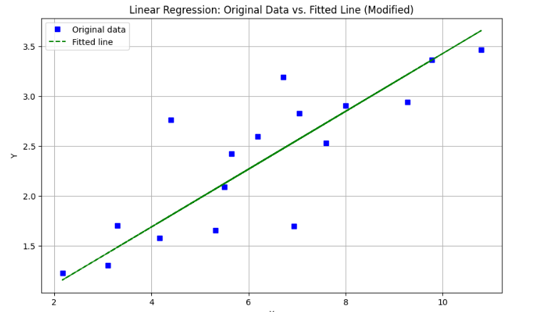

Lab 2
Model 1
Test Accuracy: 0.905
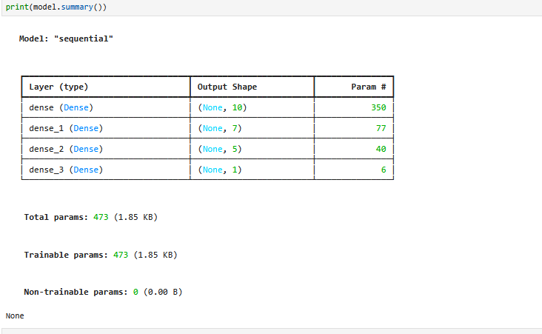
Model 2
Improved Test Accuracy: 0.905

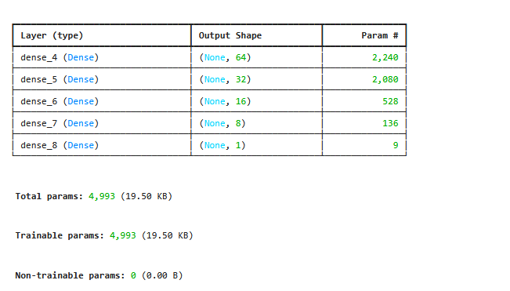

Lab 3
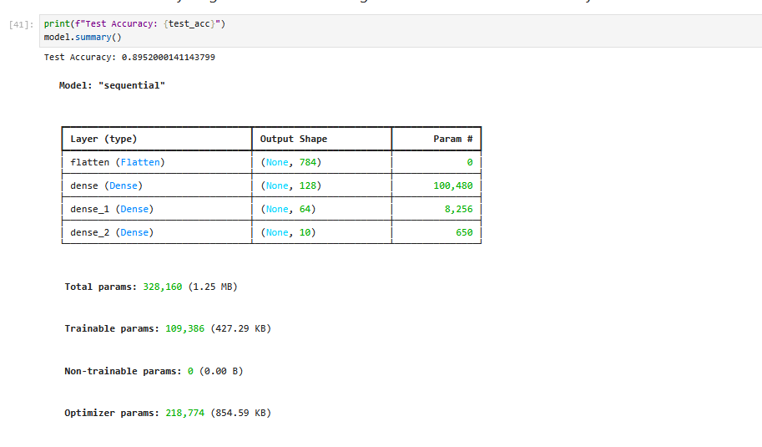
Lab 4
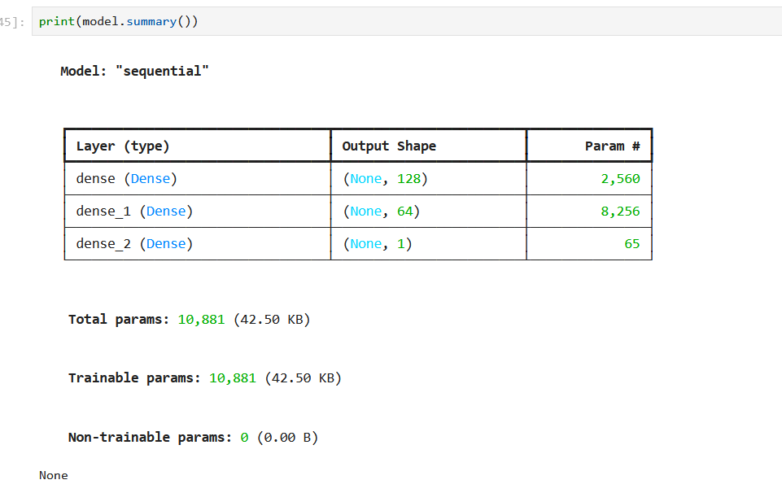
Lab 5
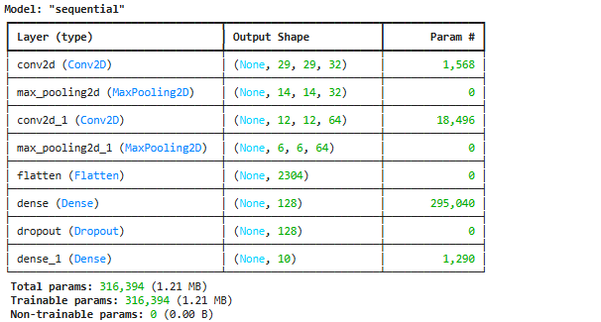
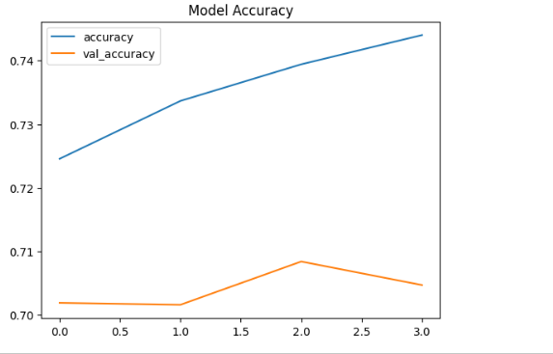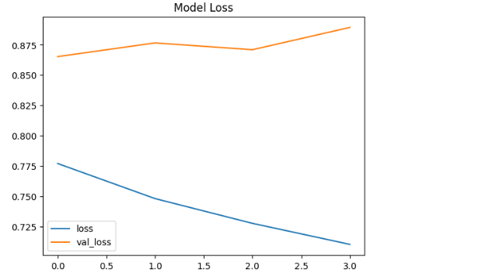
Based on the validation loss from my last training run, the optimal number of epochs was 1
Lab 6
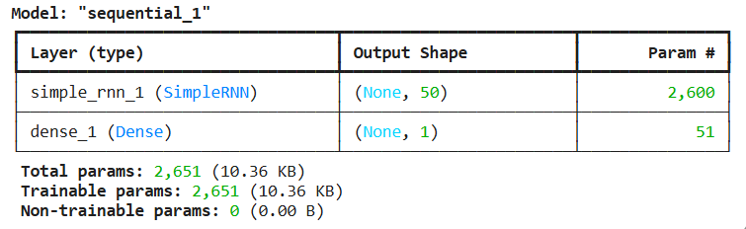

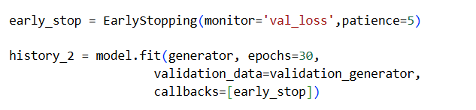

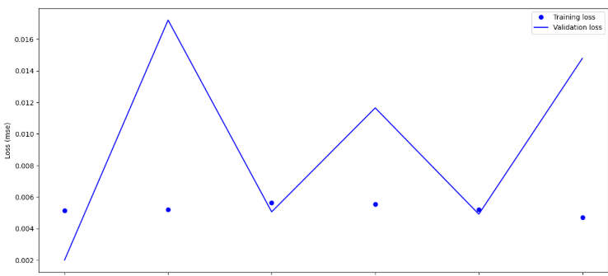
the training stopped at epoch 8, which suggests 8 epochs were considered optimal

Lab 7
1. Plot graphs for Accuracy and Loss Function for VGG16
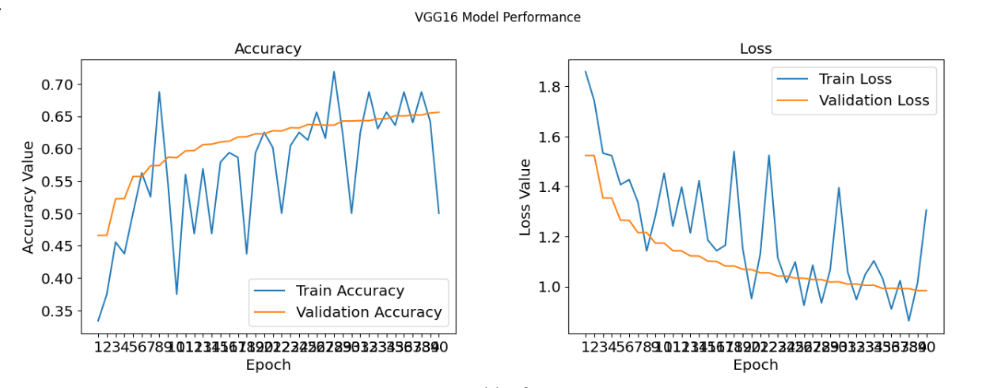

1. Plot graphs for Accuracy and Loss Function for VGG19

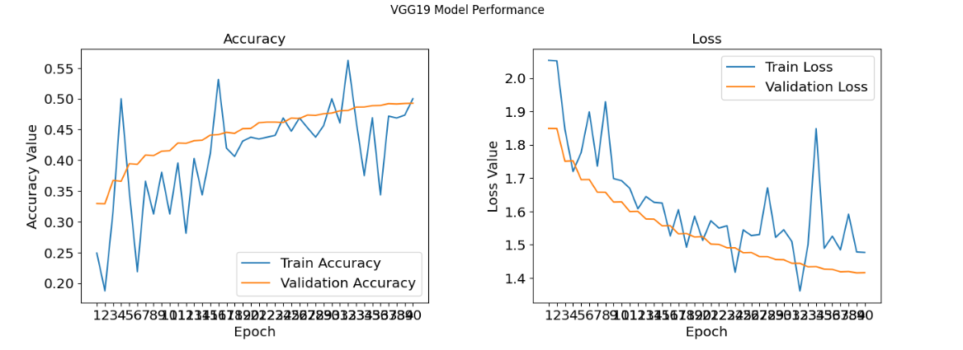

2. Analysis for optimal number of epochs for VGG16
Based on the VGG16 plots:
The validation accuracy generally increases and then starts to plateau, while the validation loss decreases and then might start to slightly increase or flatten out. The optimal number of epochs for VGG16 would be around where the validation accuracy is highest and the validation loss is lowest before overfitting begins.
By observing the VGG16 plots, a reasonable optimal epoch count appears to be around **Epoch 25-30**, as the validation accuracy plateaus and the validation loss starts to level off or slightly increase after this point.
3. Add the final Performance Table and 4. Plot the performance comparing histogram of VGG16 and VGG19 (using F1-Score for comparison)

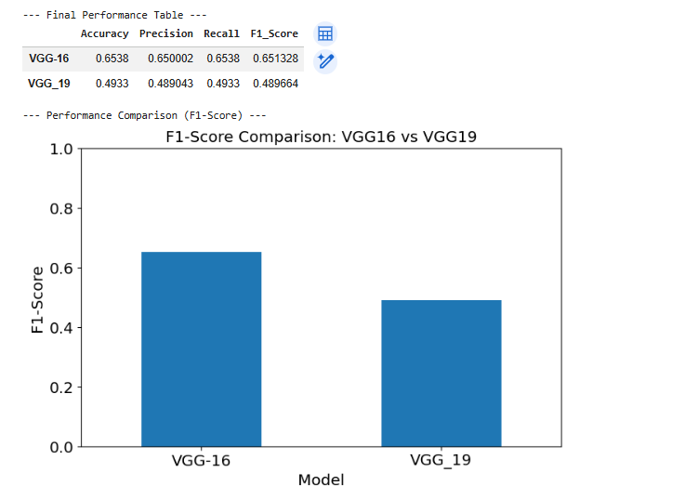

Lab 8
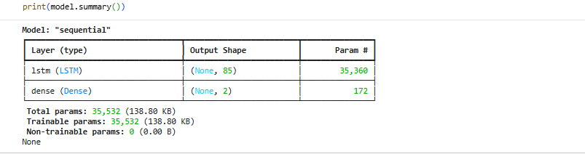
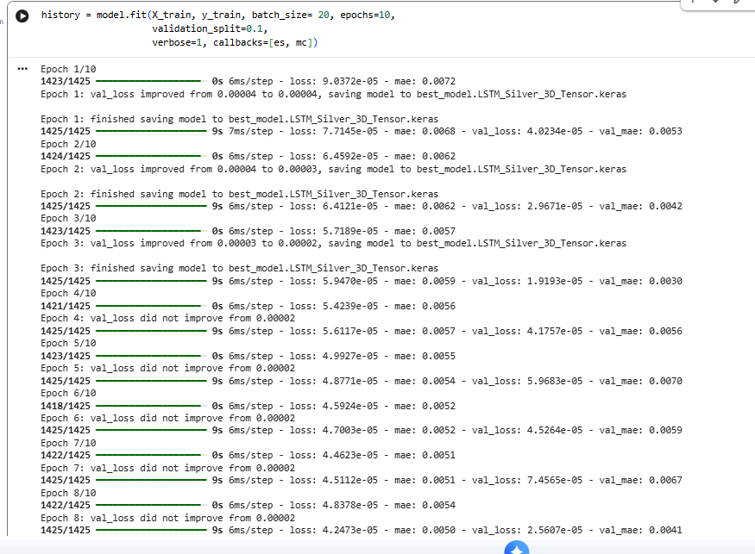
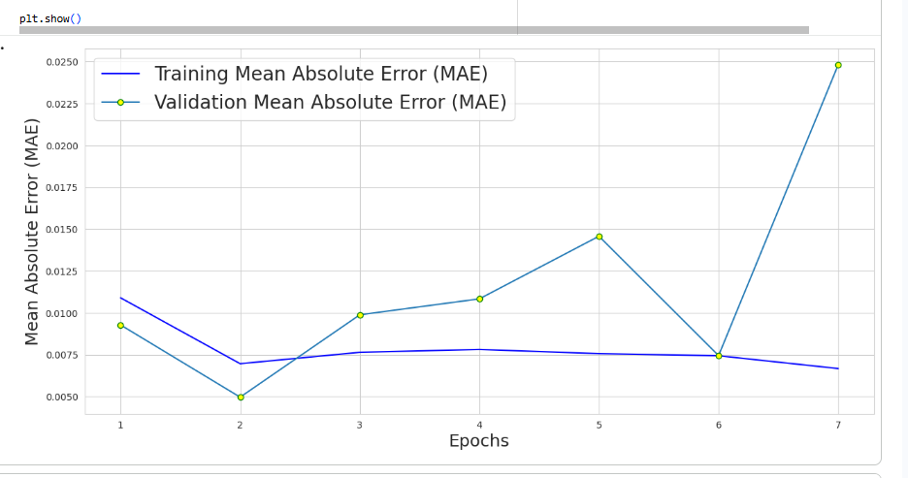
Lab 9
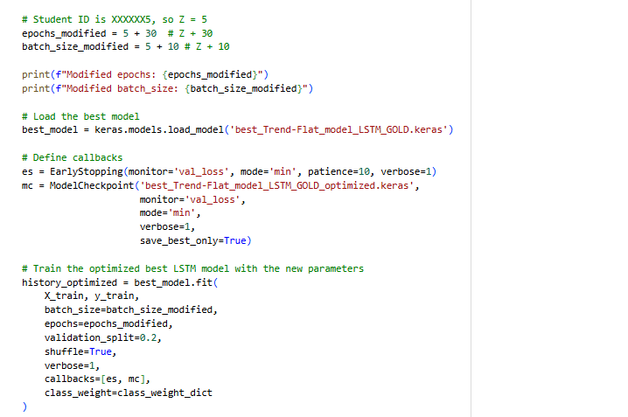

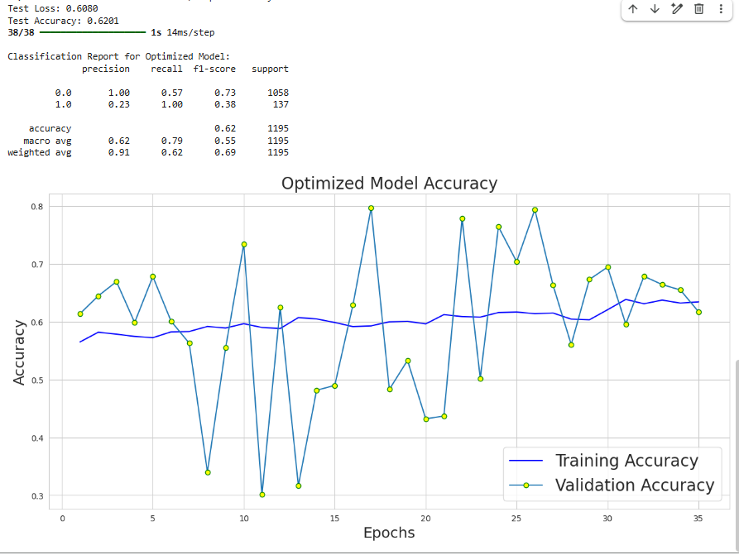
Lab 10
Simple_Autoendoder_std_2025
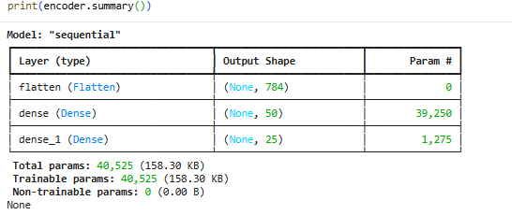
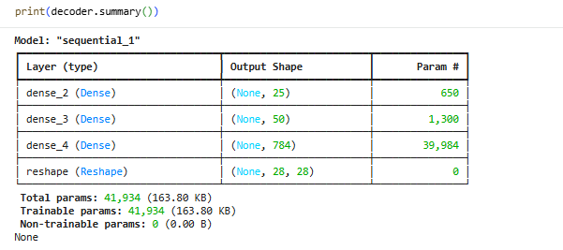
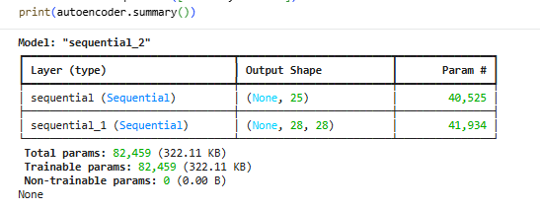

10_CNN_autoencoder_std_2025
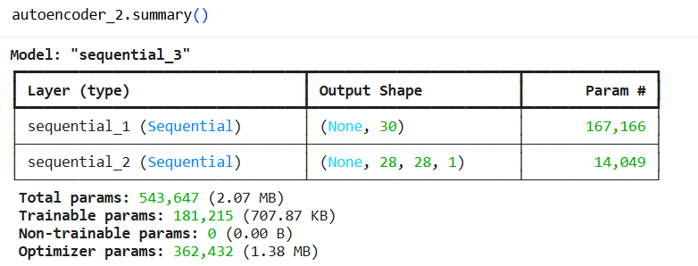

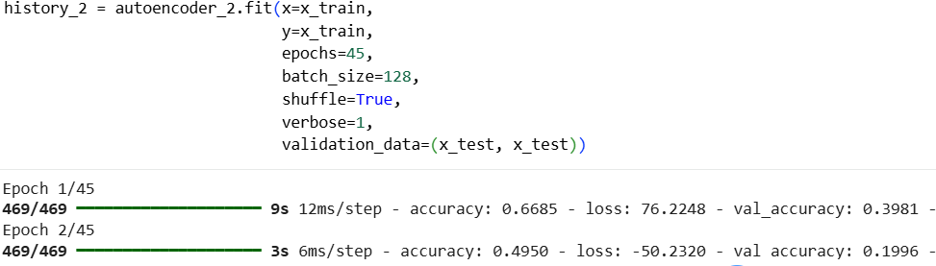
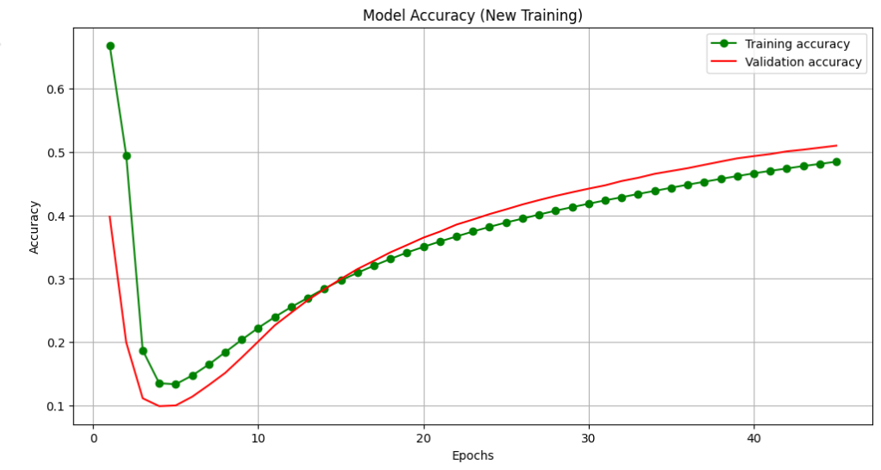

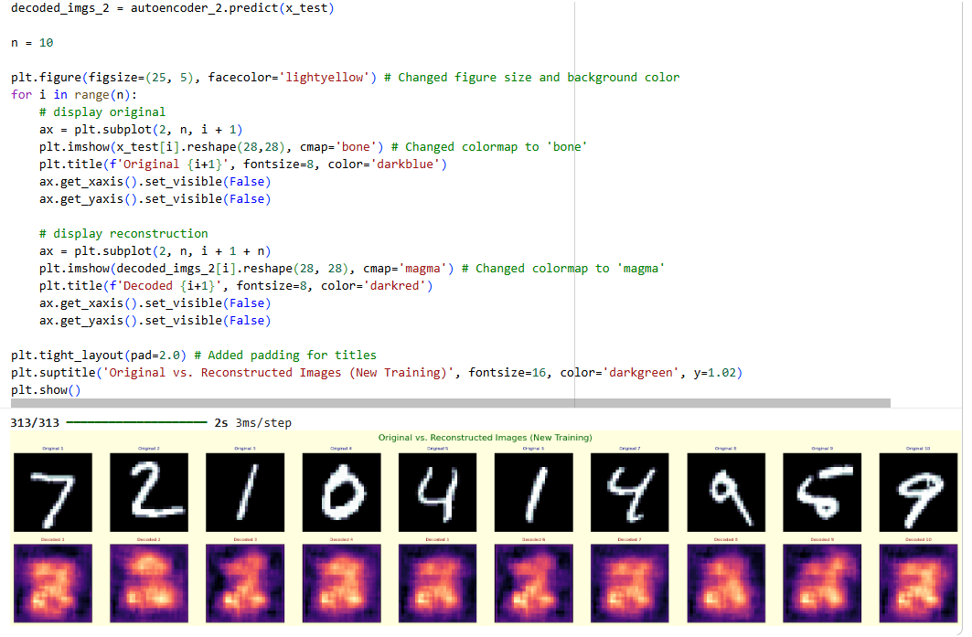
Lab 11
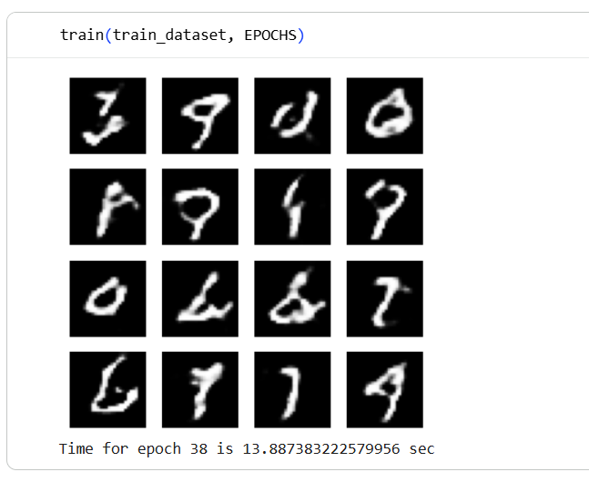
Lab 12

