Diagnostic Information for JAVA MIDI problems:

- Create a document in Microsoft Word or Wordpad to describe the error messages you are getting and any screen pictures you capture as you do the following steps.

- Log in to the course and go to one of the practice exercises. If any error messages appear, copy them into the document.

- Look for a “coffee cup” icon in your system tray at the bottom right corner of the screen. When you move your mouse over it might say “Java (TM) 2 Platform”

- Right click that icon and select “Open Console” from the menu.

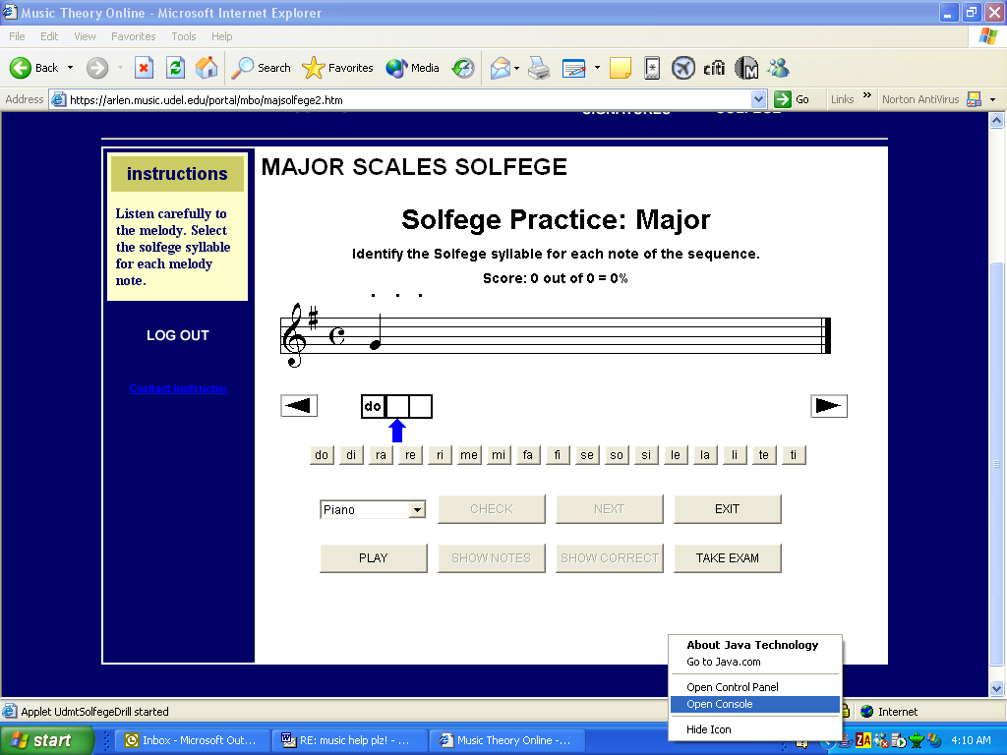
- The Java Console will appear at the top of the screen. Click the “Copy” button.

- Switch to your document and Paste the information that you copied from the console.

- Close the Java Console by clicking the “Close” button.

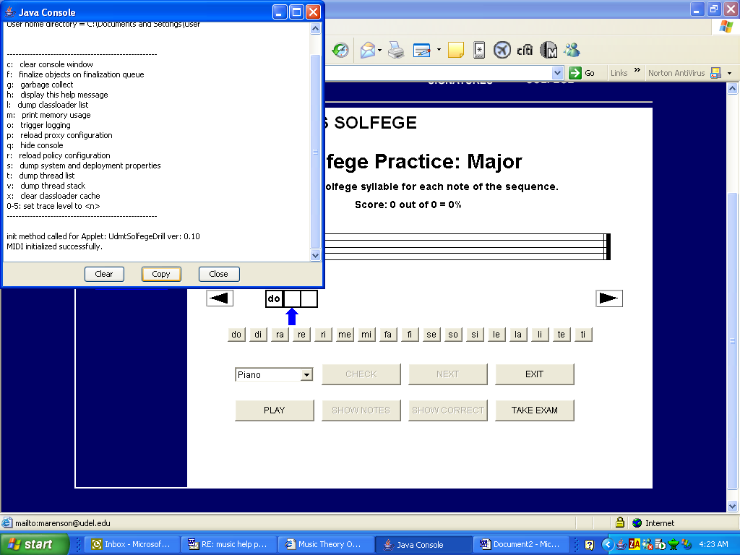

- Click the “Help” menu in your Internet Browser, and click the option labeled “About Internet Explorer”, or something similar.

- When the information box appears, press the “PrtScn” or “PrtSc” key in the upper right corner of your keyboard. This will capture the screen you are looking at.

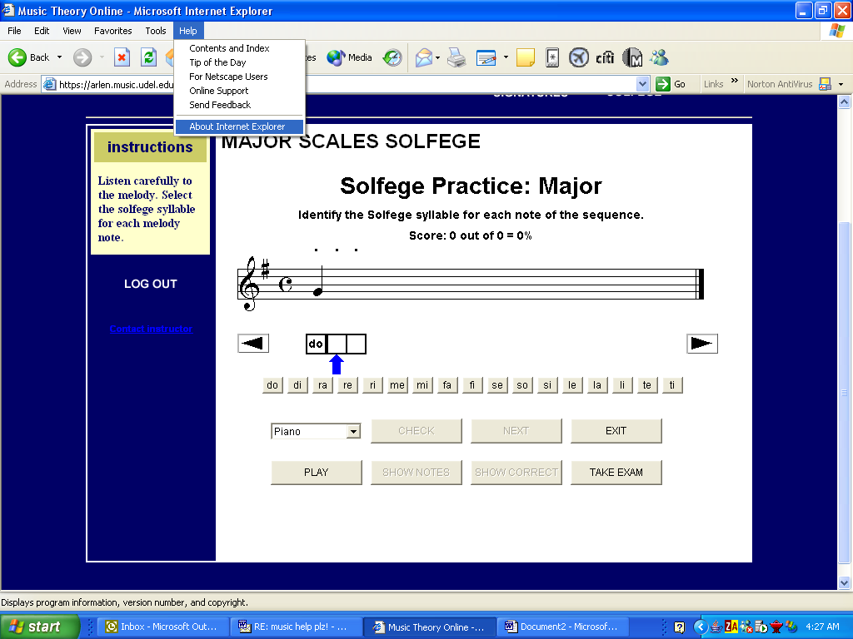

- Switch to your document and Paste the screen picture.

- Capture and Paste any other screens where the exercise comes up in red, or which display technical errors.

- Copy and Paste the Java Console output for any screens that come up in red or display technical errors.

- Save your document and attach it to an email message. Send the email to:
erangell@udel.edu and
marenson@udel.edu

