ES6:

1. Let & Const

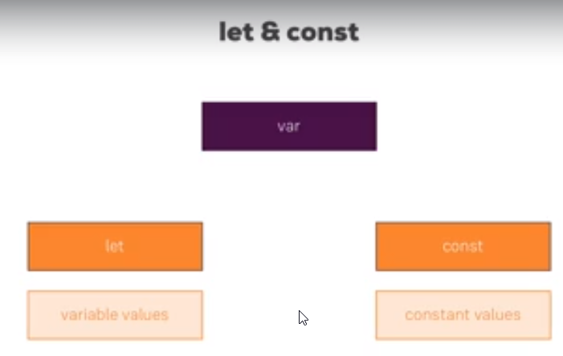

1. Arrow function:

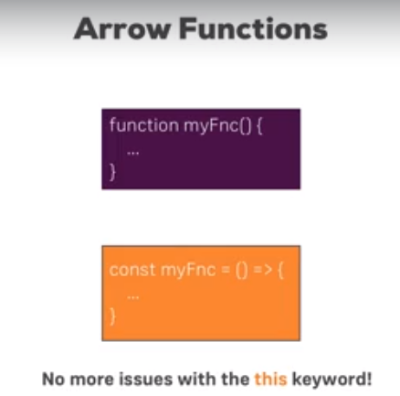

1. Imort export

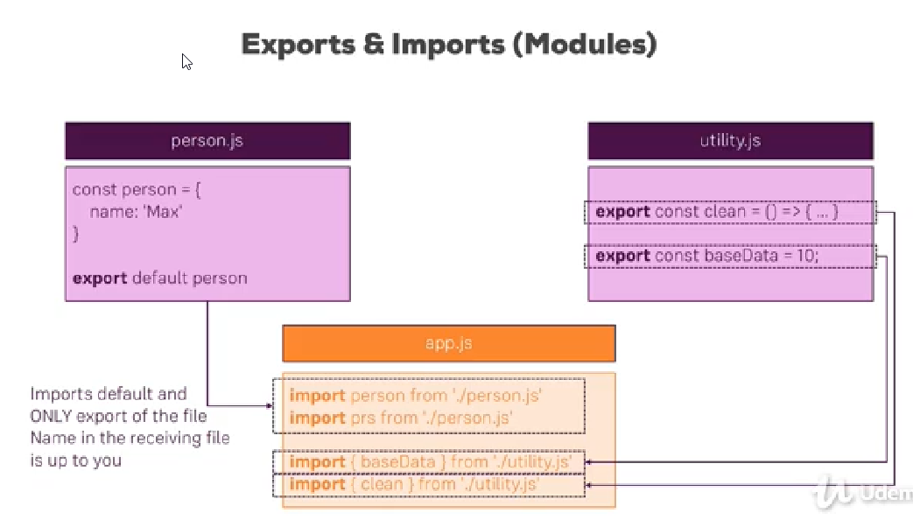

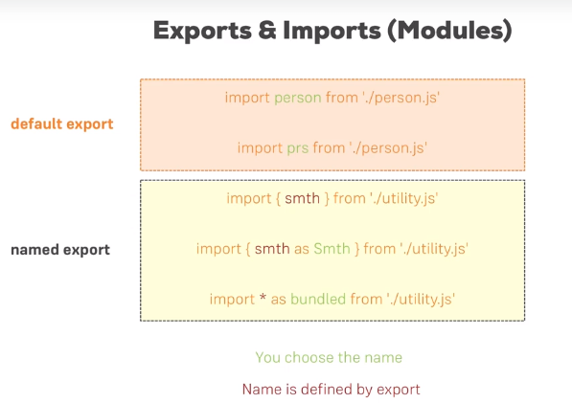

1. Classes are blueprints for javascript objects:

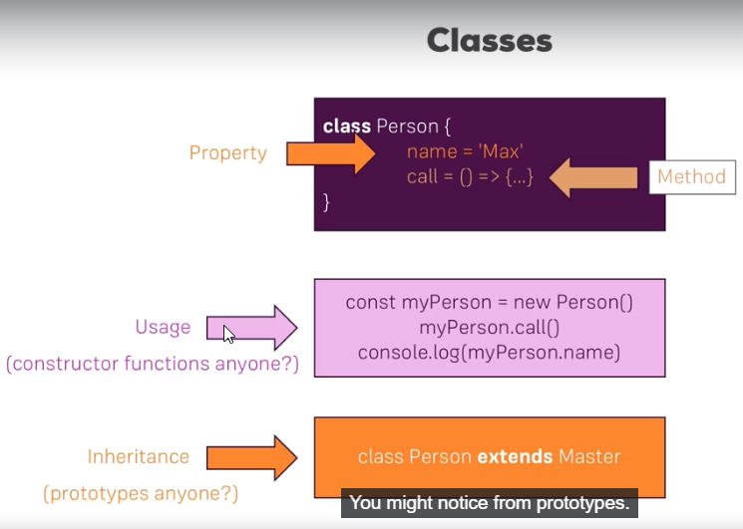

1. Classes & properties: 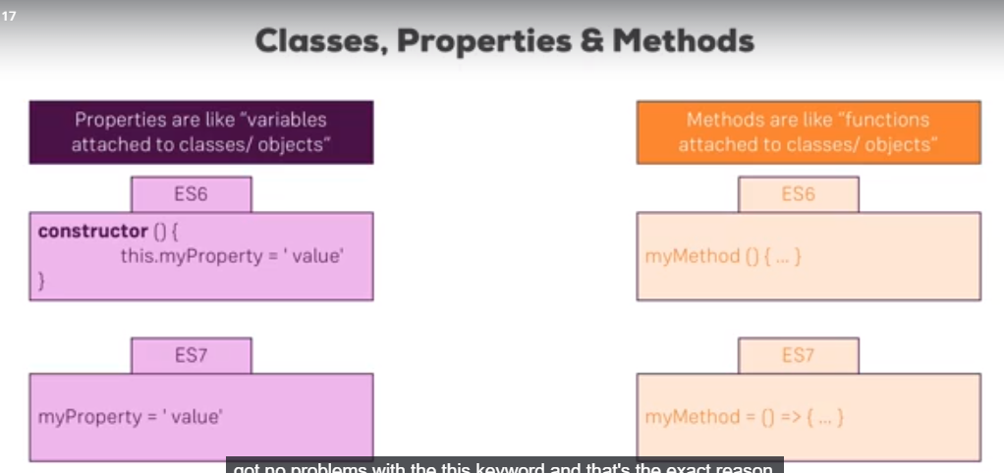 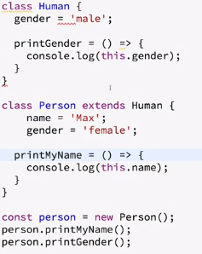

Spread Operators: 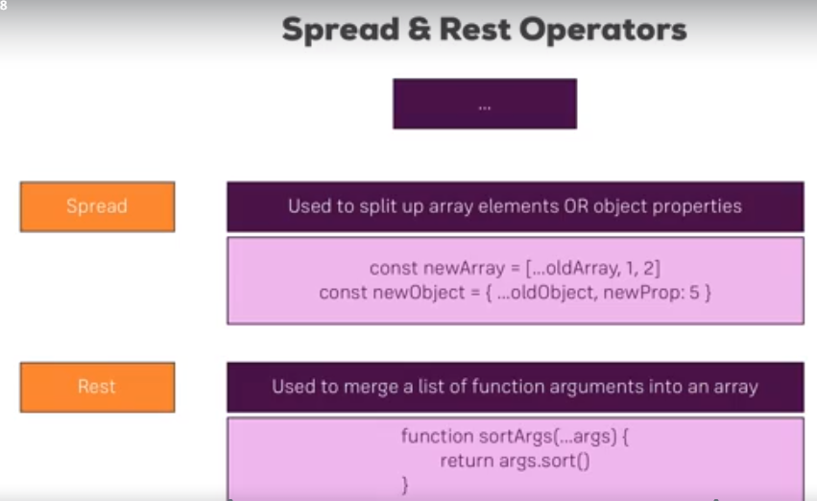  
// Spread with Array

const numbers = [1,2,3];

const newNumbers = [...numbers,4];

console.log(newNumbers);

// Spread with Object

const person = {

name: 'Anil'

}

const personMoreInfo = {

...person,

age:28

}

console.log(personMoreInfo);

// REST with Array

const filter = (...args) => {

return args.filter( el => el === 1 )

}

console.log(filter(1,2,3));

Destructuring:  
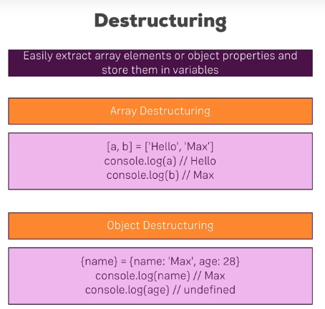  
//Destructuring Array  
 const [num1, ,num3] = [1,2,3];  
 console.log(num1);  
 console.log(num3);

Primitive / Reference type: // Primitive Type (Numbers, Srings, Boolean)

//When you re-assin or store a value of one

//variable to another variable it will copy the value

const num = 1;

const num2 = num;

console.log(num2);

// Reference Type (Objects and arrays)

//It will not copy the person object to

//secondPerson instead {name:'Anil'} will

//stored in memory and const person pointer

//we stored that as pointer in memory.

// IN this case pointer will be copied

const person = {

name:'Anil'

};

const secondPerson = person;

person.name = 'Sunil';

console.log(secondPerson);

//Copy oject or array to new array with spread operator

const person = {

name:'Anil'

};

const secondPerson = {...person}; // Spread operator

person.name = 'Sunil';

console.log(secondPerson);

Array Functions: Particularly important in this course are:

* map()  => <https://developer.mozilla.org/en-US/docs/Web/JavaScript/Reference/Global_Objects/Array/map>
* find()  => <https://developer.mozilla.org/en-US/docs/Web/JavaScript/Reference/Global_Objects/Array/find>
* findIndex()  => <https://developer.mozilla.org/en-US/docs/Web/JavaScript/Reference/Global_Objects/Array/findIndex>
* filter()  => <https://developer.mozilla.org/en-US/docs/Web/JavaScript/Reference/Global_Objects/Array/filter>
* reduce()  => <https://developer.mozilla.org/en-US/docs/Web/JavaScript/Reference/Global_Objects/Array/Reduce?v=b>
* concat()  => <https://developer.mozilla.org/en-US/docs/Web/JavaScript/Reference/Global_Objects/Array/concat?v=b>
* slice()  => <https://developer.mozilla.org/en-US/docs/Web/JavaScript/Reference/Global_Objects/Array/slice>
* splice()  => <https://developer.mozilla.org/en-US/docs/Web/JavaScript/Reference/Global_Objects/Array/splice>