ReactJS

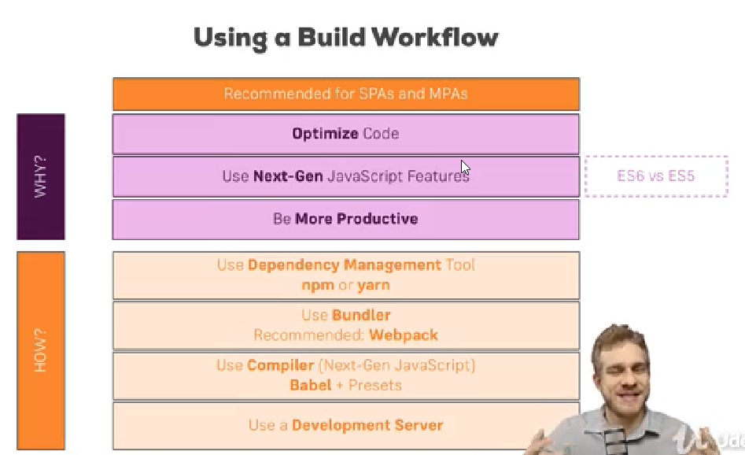

Dwnload and install NodeJS:

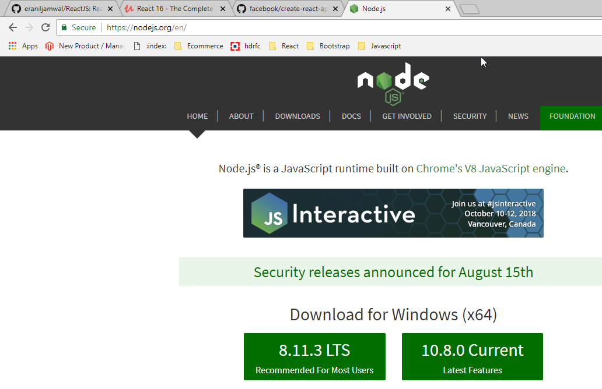

React JS installation:

***npx create-react-app my-app***

***cd my-app***

***npm start***

***JSX code(Commented) will get converted to html element with following react manner implicitly.***

// <div className="App">

// <h1>Hi, I am first React App</h1>

// </div>

React.createElement("div", {className : "App"}, React.createElement("h1",null, "Hi I am first React App"))

);

We can say component is a javascript function which will return jsx code

Creating a Functional Component

import React from 'react';

const person = () => {

return <p>Hi I am Person</p>

}

export default person;

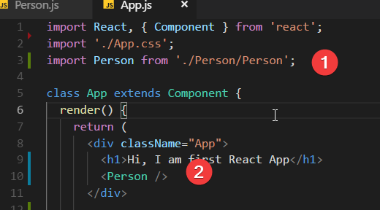

If we want to display dynamic content we should use expression syntax(curly braces {}):

return <p>Hi I am Person and my age is {Math.floor(Math.random() *30)} </p>

Understanding children property:

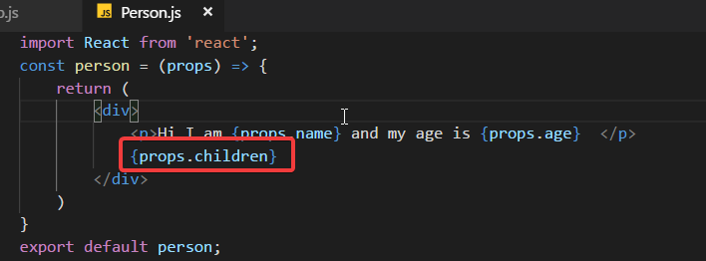

Update the State:

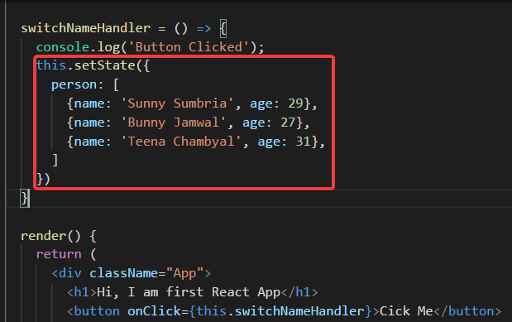

Passing method reference between components:  
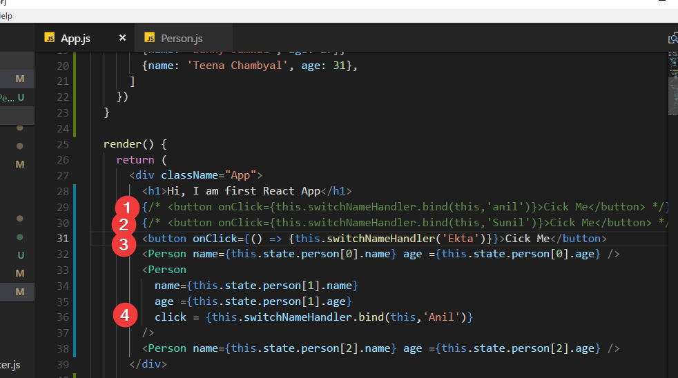

Adding Two way Binding:

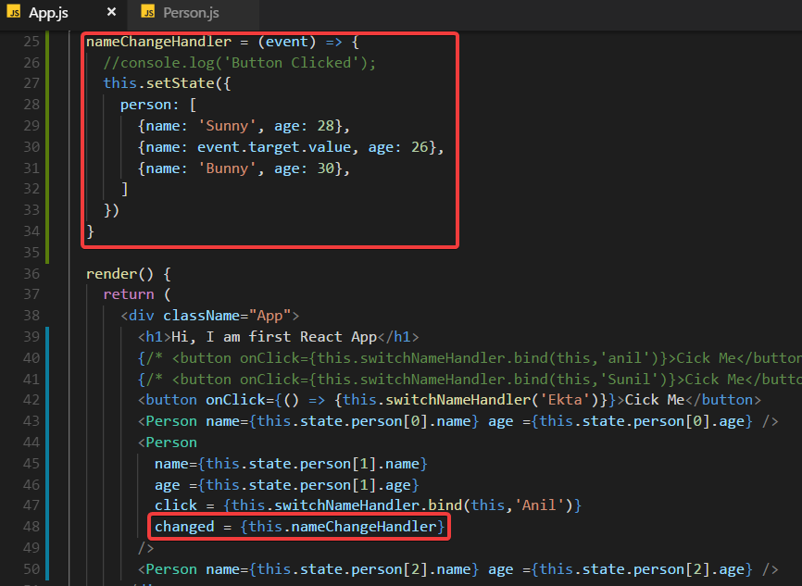

Working With CSS:

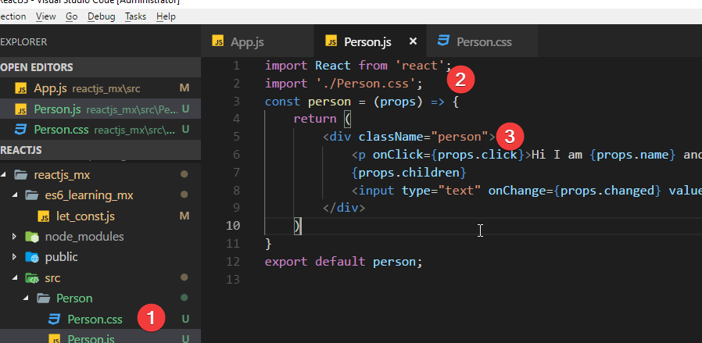

Add Inline CSS:

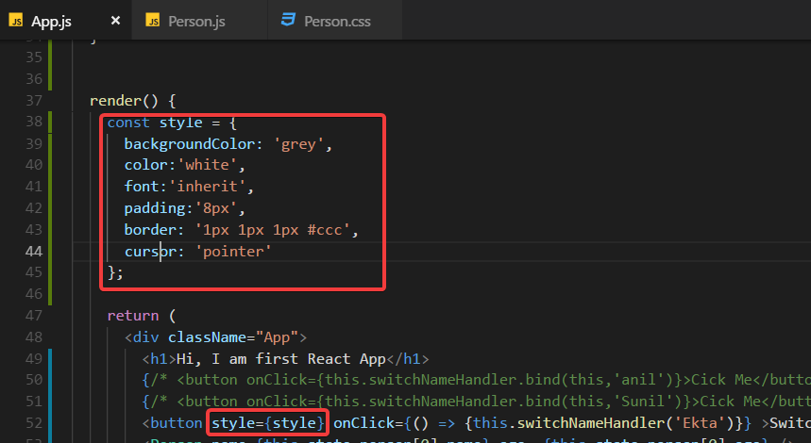

Rendering Content Conditionally:

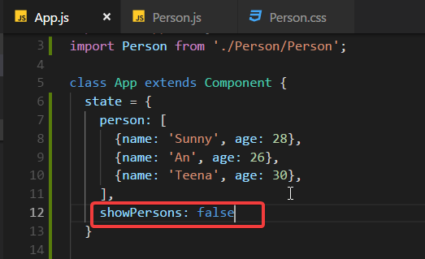

Add this function :

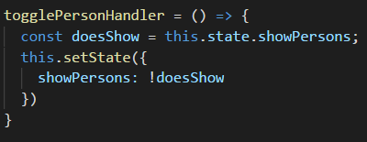

Display content conditionally:

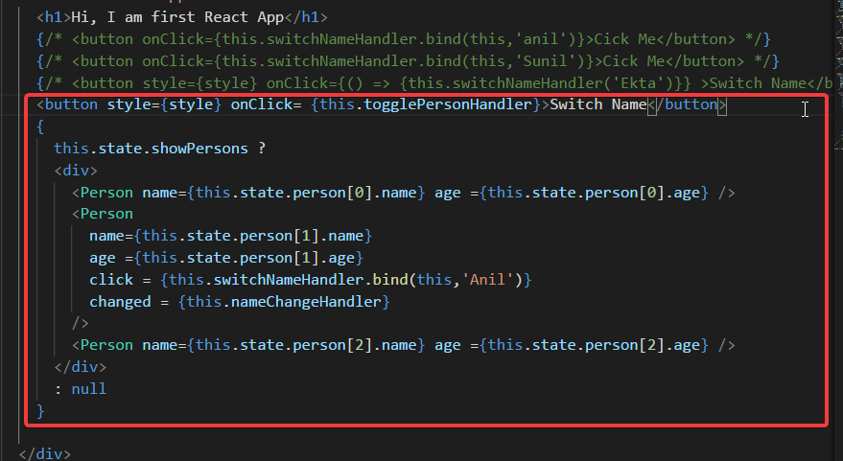

Handling Dynamic Content "The JavaScript Way":

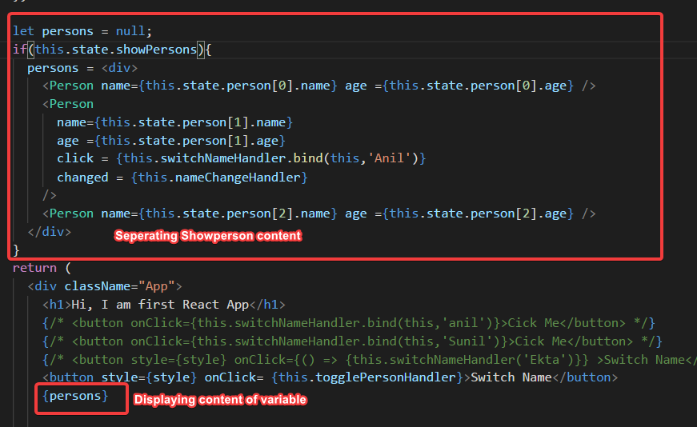

Outputting Lists:

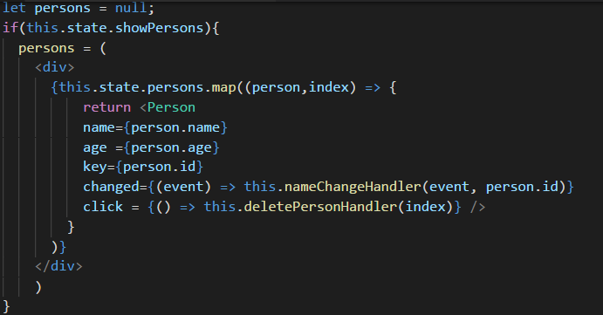

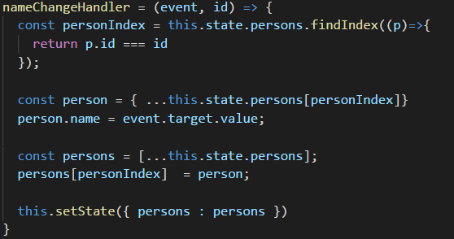

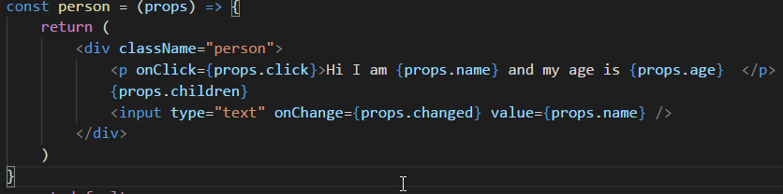

Setting Style Dynamically:

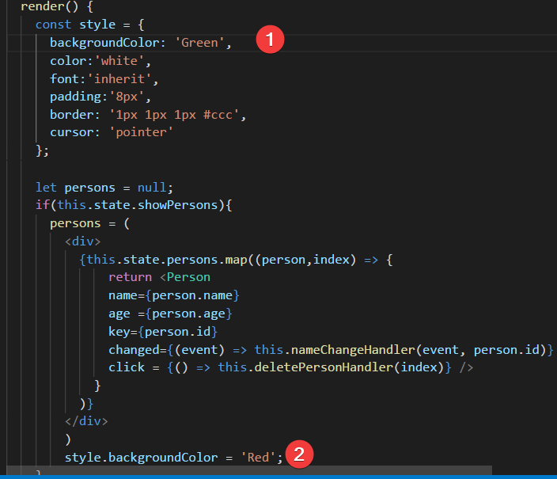

Setting class name dynamically:

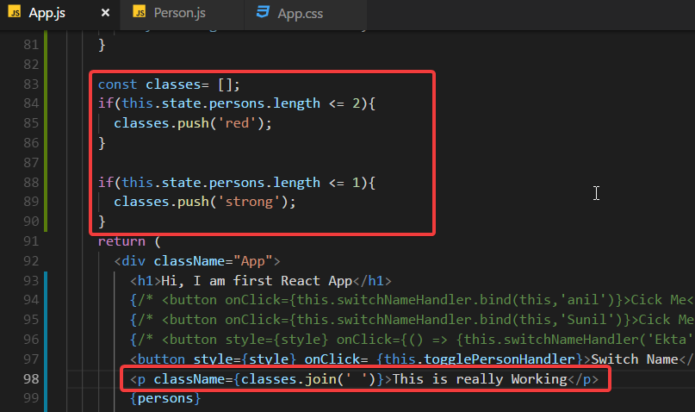

Adding and using radium:

Npm install –save radium

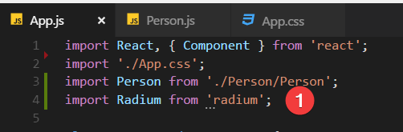

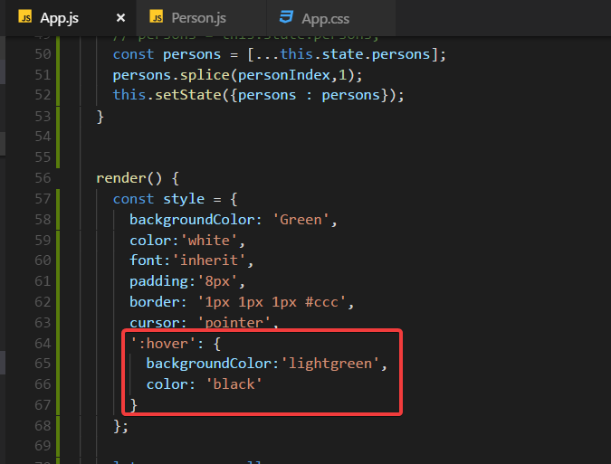

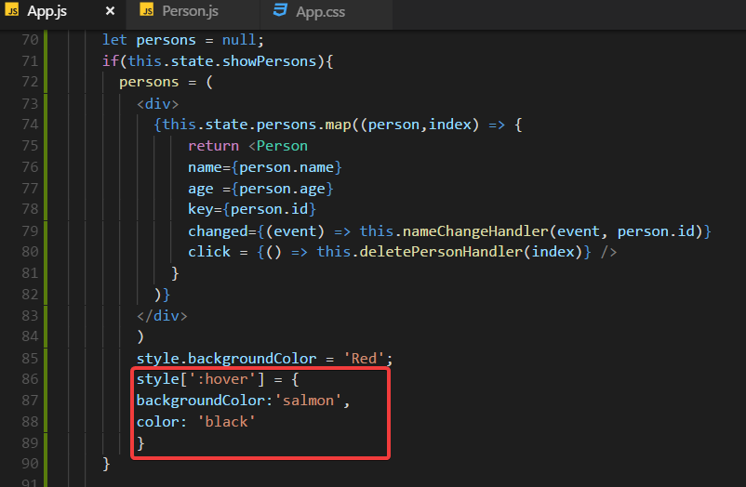

Add mediaquery:

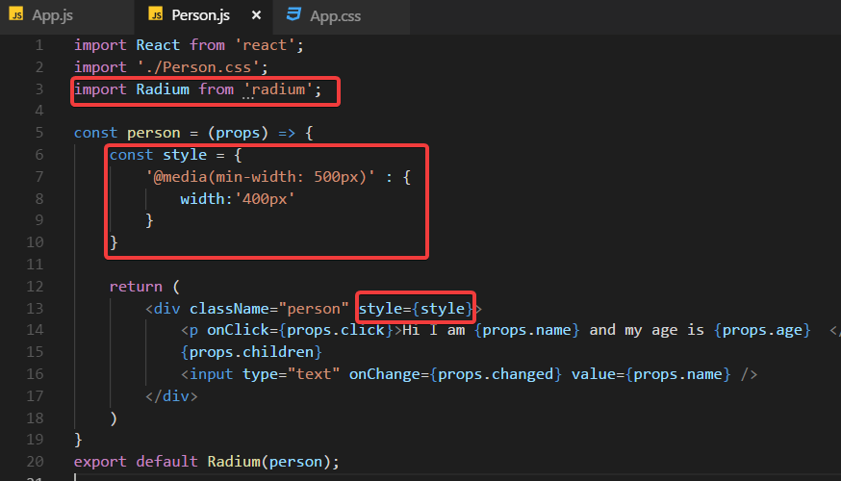

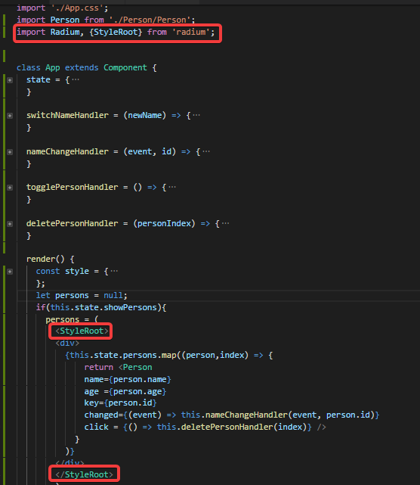

Enabling and using CSS module:

Write following mysql command: npm run eject

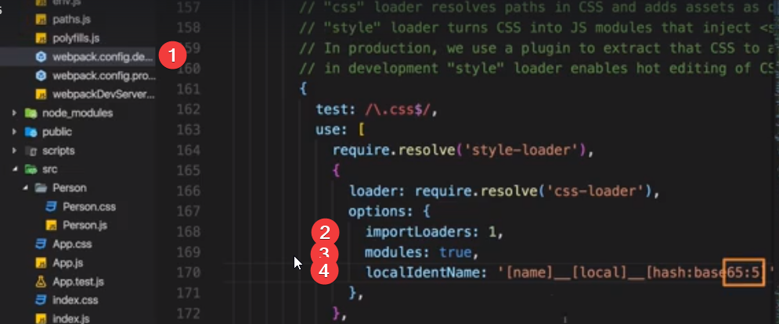

Debugging:

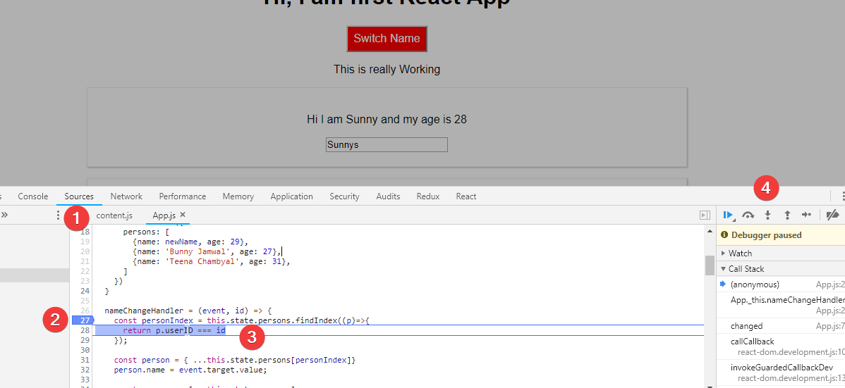

React Developer tool:

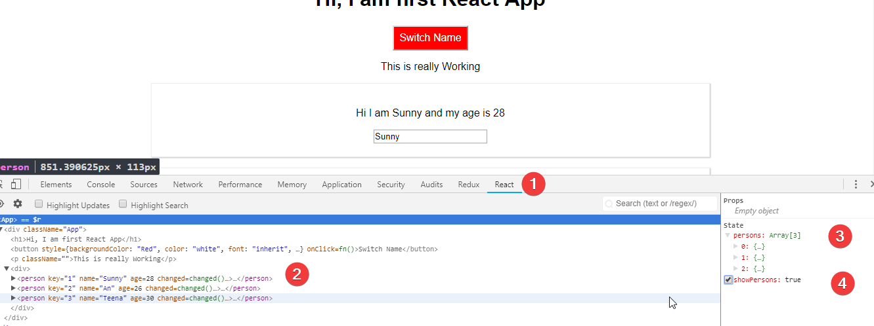

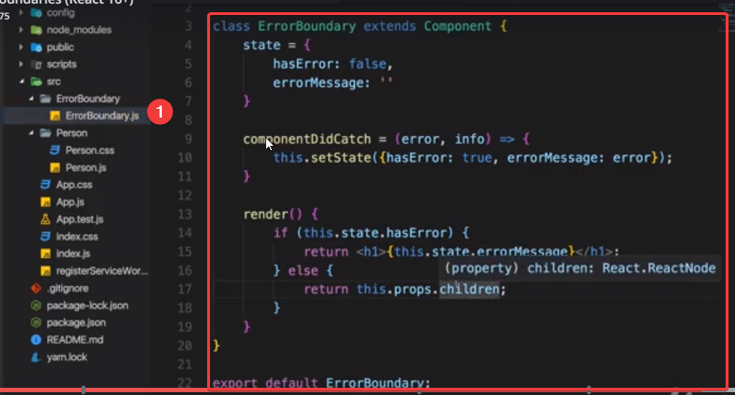

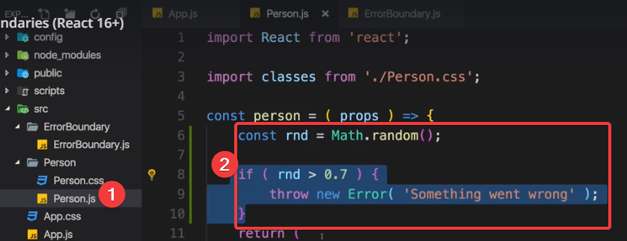

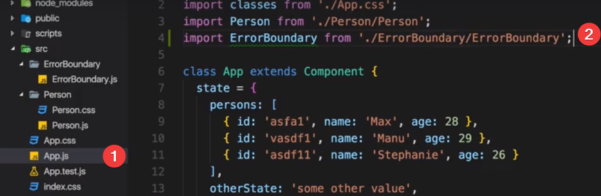

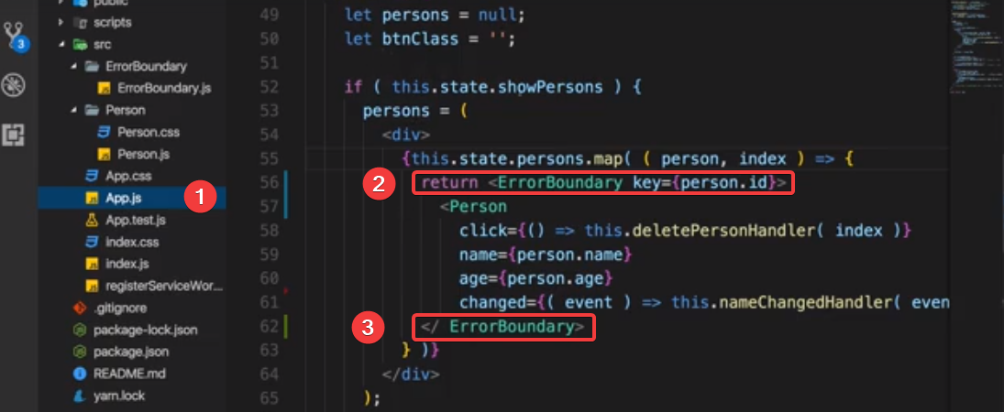

Component:

Better Project tructure:

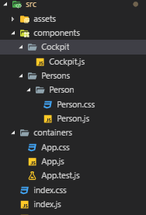

Stateful vs stateless components: Do minimal use of class component as much as possible because we want state should be changed from minimal places

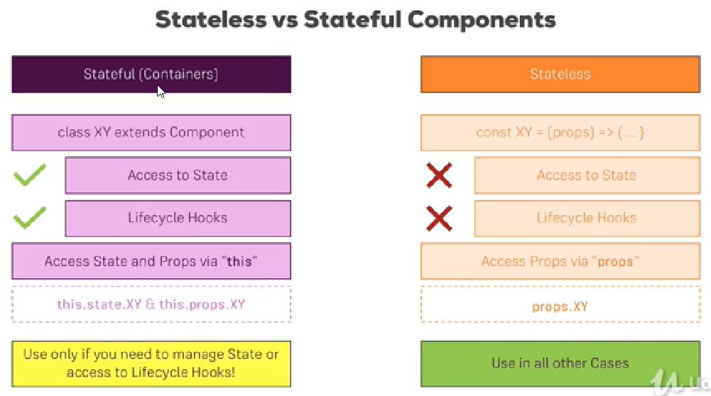

Component Lifecycle:

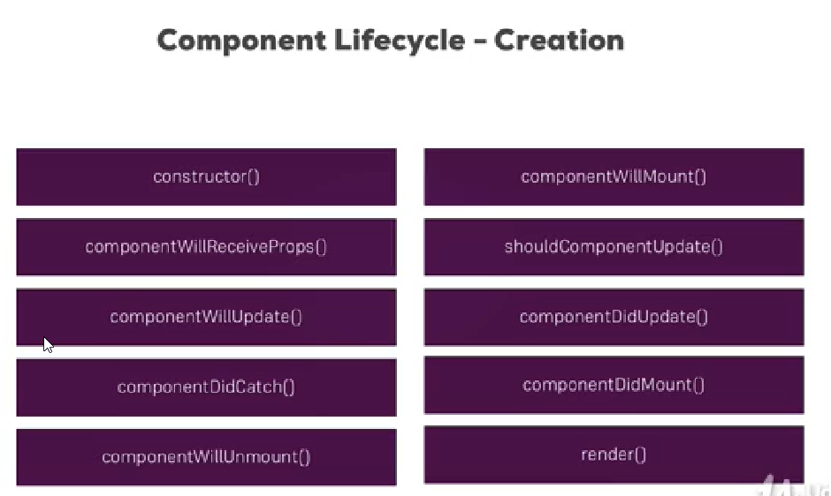

These methods (Lifecycle hooks) will execute during component creation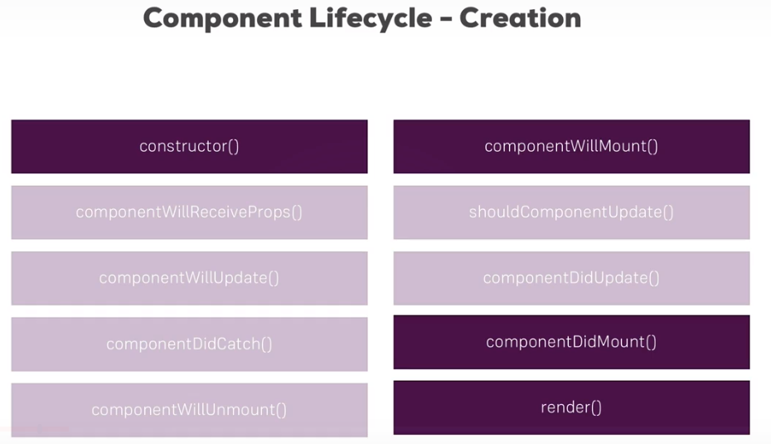

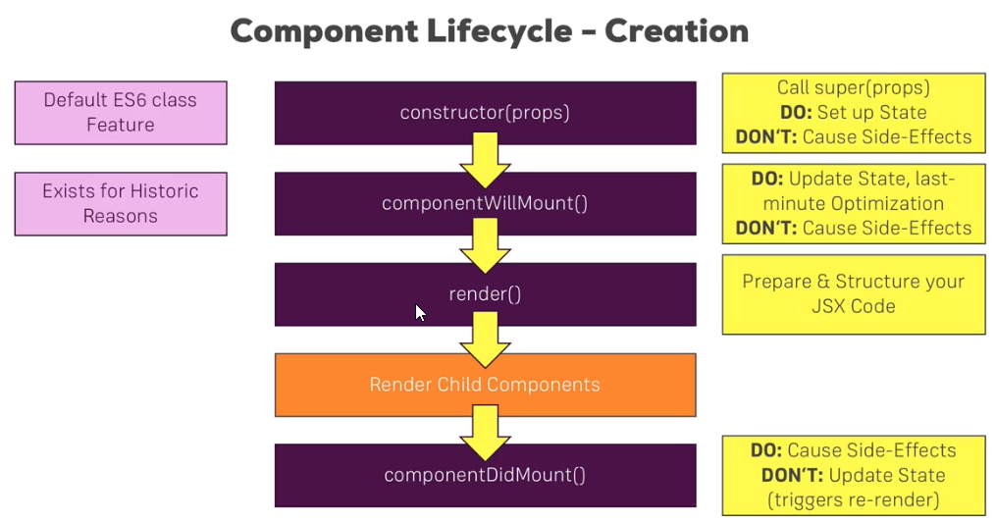

Converting stateless component to stateful:

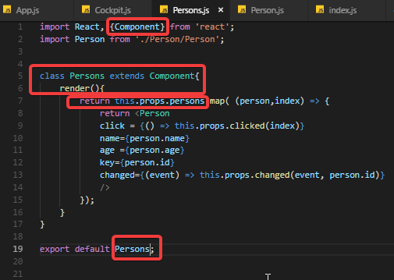

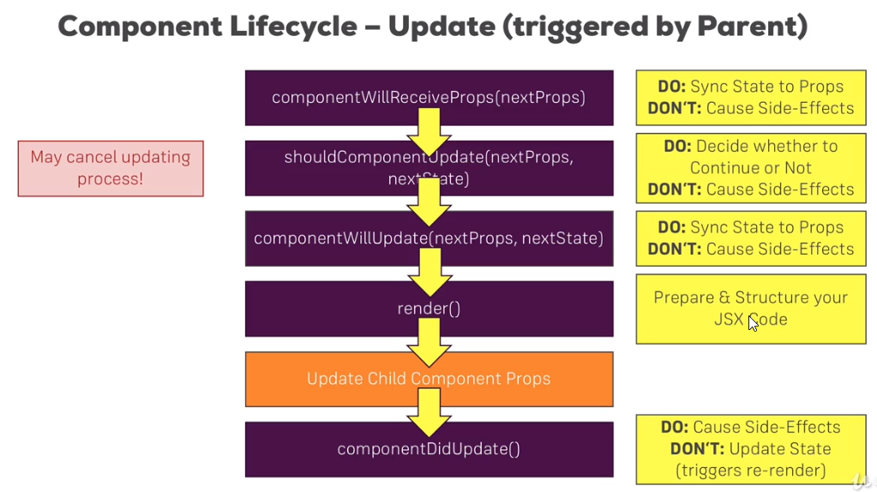

Component Updating Lifecycle in Action