1.write a program to print array of numbers count of values and value name also from array?

let res = [1,1,2,2,3,3,3,4,4,5,6] // expected output : [[1],[8,8],[1,1]]

let result = [...new Set(res)]

// console.log(result)

let count =[]

result.map((e)=>{

let res2 = []

for(let i=0;i<res.length;i++){

if(res[i]===e){

res2.push(res[i])

}

}

count.push(res2)

})

console.log(count)

output:- [ [ 1, 1 ], [ 2, 2 ], [ 3, 3, 3 ], [ 4, 4 ], [ 5 ], [ 6 ] ]

another example with array

var arr = [1,1,2,3,3,2,4,5,4,2,5,5,5,4,3];

var resultArr = [];

var count = [];

for(let i in arr){

if(resultArr.includes(arr[i])){

count[resultArr.indexOf(arr[i])]++;

}

else{

resultArr.push(arr[i]);

count.push(1);

}

}

for(let i in resultArr){

console.log(`${resultArr[i]} count is ${count[i]}`);

another example

var arr = [1,1,2,3,3,2,4,5,4,2,5,5,5,4,3];

var dup = [...new Set(arr)];

for(let i in dup){

var count = 0;

for(let j=0;j<arr.length;j++){

if(dup[i]===arr[j]){

count++;

}

}

console.log(`${dup[i]} count is ${count}`);

}

2.same above program is equal program but I need print array of values print in object.

let res = [1,1,2,2,3,3,3,4,4,5,6] //[[1],[8,8],[1,1]]

let count ={}

res.forEach((e)=>{

if(count[e]){

count[e]+=1

}else{

count[e]=1

}

})

console.log(count)

output:- { '1': 2, '2': 2, '3': 3, '4': 2, '5': 1, '6': 1 }

3. write a program to print from array to get positive and negative and zero values length.

let res = [1,0,-2,4,0,-8,-7] // given inputs

expected output =

3.5000,2.3333,3.5000;

var pos =0,neg=0,zero=0;

let arrlen = res.length

for(let i=0;i<res.length;i++){

if(res[i]>0){

pos++

}else if(res[i]<0){

neg++

}else{

zero++

}

}

// console.log(zero)

let posl = arrlen/pos

console.log((posl.toFixed(4)))

let negl = arrlen/neg

console.log((negl.toFixed(4)))

let zerol = arrlen/zero

console.log((zerol.toFixed(4)))

// console.log(pos)

// console.log(neg)

// console.log(zero)

4.write a program to get sum total given array but remove max and min value from array after print sum total value.

let res = [1,2,5,4,8,9,10]

let sum = 0

let min = Math.min(...res)

let max = Math.max(...res)

for(let i=0;i<res.length;i++){

sum += res[i]

}

console.log((sum-max)+","+(sum-min))

expected output: 29,38

5. Given an array of integers, where all elements but one occur twice, find the unique element.

Example: array=[1,2,3,4,3,2,1]

The unique element is =4.

Build a javascript program

function findUniqueElement(arr) {

let uniqueElement = 0;

for (let num of arr) {

uniqueElement ^= num;

}

return uniqueElement;

}

const array = [1, 2, 3, 4, 3, 2, 1];

const uniqueElement = findUniqueElement(array);

console.log("The unique element is:", uniqueElement);

7.write a program to print take array to print to reverse the array and if vowels occurs only first index vowels should be print uppercase remaining add to array.

let result = ['hello','APPLE']

let vowels = 'AEIOUaeiou'

for(let i=0;i<result.length;i++){

let res = result[i].split('').reverse().join('').toLowerCase()

if(vowels.includes(res[0])){

res = res.replace(res[0],res[0].toUpperCase())

}

result[i]=res;

}

console.log(result)

8.wirte a program to get multiple values give values.

function product(a){

return (b) => {

return a\*b;

}

}

console.log (product (2)(5));

write a program of sum of digits.

let num = 12345;

let sum = 0;

let str = num.toString()

for(let i =0;i<str.length;i++){

sum += parseInt(str[i])

// console.log(sum)

}

console.log(sum)

1.remove duplicates,,,

2.reverse string,,

3.palindrome,,

4.vowels count,,

5.vowels get,,

6.vowels reverse first value uppercase,,

7.even get,,

8.odd get,,

9.repeat word ,,

10.repeat each letter,

11.factorial,,

12.get uniques elements,,

13.angram,,

14.armstrong,,

15.strong number,,

16.delete string in obj,,

17.multiplication,,

18.missing numbers,,

19.capitalize first letter

20.count the repeat values store in separate array,

21. count the repeat values store in separate object,

22.product,

­­23.remove min and max remaining array get sum,

24.from array get positive count and negative count and zero count,

25. prime

26.find second largest number

27.find second smallest number

28.find ocuurence give string each letter.

29.wirte a program to remove duplicates from given array.

React programs

1.pass data p to c.,

2.pass data c to c.,

3.pass button with varients to child.,

4.fetch data with fetch method from array.,

5.data with axios method from array.,

6.data to display based on user to display particular id to button click.,

7. 6.data to display based on user to display particular id to button click from object.

8.create a count with usestate.,

9.create a fetch data from api with using useeffect.,

10.create todos and count increment with usecallback.,

11.create todos and count increment with usememo.,

12.create a usecontext example to update with button display value in specific component in reactjs

13.create curd operations in reactjs

14.create a fetch data from api with ajax in reatjs.

15.create add to task in p tag without using spread operator and map and filter method to display.

let arr = [1,2,3,5,7,9,11]

const res = []

for(let i =0;i<arr.length-1;i++){

for(let j =arr[i]+1;j<arr[i+1];j++){

arr.push(j)

}

}l

console.log([...new Set(arr)])

const [data,setData]= useState({}{})

const res = data.splice(1,1)

setData(res)

const data = useRef(0)

{data}

data.current = data.current + 1

{data.current}

useEffect(()=>{

code

},[])

const deletbutton =useCallback(()=>{

code

},[count])

const user = createContext()

const [data,setData]= usestate('ravi')

<user.provider value={data,setdata}>

<App/>

</user.provider>

import createcontext,useContext

function component {

const user = useContext(user)

return(

<div>

{user}

</div>

)

}

const calculation = useMemo(()=>{

eclkjda(count)

},[count])

custom hook format

const usefetch{

useeffect(()=>{

fetch(url)

})

}

app

const [data]= useFetch('')

data.map to list

coding problems platform:-

snakify website

https://snakify.org/en/

how to write a program to reverse a string and after reverse string the first letter should be capital.

function titleCase(str) {

var reversed = str.toLowerCase().split('').reverse();

console.log(reversed)

reversed = reversed.join('').split(' ');

// console.log(reversed)

var newArr = [];

for (var i = 0; i < reversed.length; i++) {

var firstLetter = reversed[i].charAt(1).toUpperCase();

var restOfWord = reversed[i].slice(2);

newArr[i] = firstLetter + restOfWord;

}

return newArr.join(' ');

}

console.log(titleCase('hello'));

without function

let res = 'hello'

let rev = res.toLowerCase().split('').reverse()

rev = rev.join("").split(' ')

let rev1 = []

for(let i=0;i<rev.length;i++){

let first = rev[i].charAt(0).toUpperCase()

let rest = rev[i].slice(1)

rev1[i] = first + rest

}

let total = rev1.join('')

console.log(total)

// console.log(rev)

Prime program;

let num = 3;

let count = 0;

for(let i =2;i<=parseInt(num/2);i++){

if(i%2===0){

count++;

break;

}

}

if(count ===0){

console.log('prime')

}else{

console.log('notprime')

}

Give number is present or not in given array

let res = [1,2,3,4,5]

let e = 5

if(res.indexOf(e)!==-1){

console.log('present')

}else{

console.log('not')

}

Write a program a fibinaico series in javascript?

let n = 10

if(n<=0){

return []

}else if(n===1){

return [0]

}else if(n===2){

return [0,1]

}else{

let seq = [0,1]

for(let i=2;i<n;i++){

seq.push(seq[i-1]+seq[i-2])

}

console.log(seq)

}

let res = [1,2,3,45,45] // 96,24

let result = res.toString().split(',')

console.log(result)

let sum = 0;

let sum2= 0;

for(let i =0;i<result.length;i++){

sum += parseInt(result[i])

sum2 += (result[i].split('')).reduce((sum,total)=>sum+parseInt(total),0)

}

console.log(sum)

console.log(sum2)

write a program to get annagrams form given arrays.

let res = ["eat", "tea", "tan", "ate", "nat", "bat"]

let result = []

for(let i = 0;i<res.length;i++){

let words = res[i].split('').sort().join('')

if(result[words]==res){

console.log(res[i])

result[words].push(res[i])

}

result[words] = [res[i]]

}

console.log(result)

let res = ["eat", "tea", "tan", "ate", "nat", "bat"]

let result = {}

for(let i =0;i<res.length;i++){

let word = res[i].split('').sort().join('')

if(!result[word]){

result[word]=[]

}

result[word].push(res[i])

}

console.log(result)

1.console.log (! []=='')

Ans: - true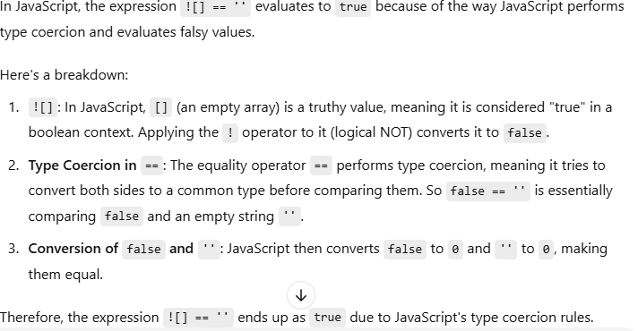

2. console.log([]=='') explain

Ans: - true

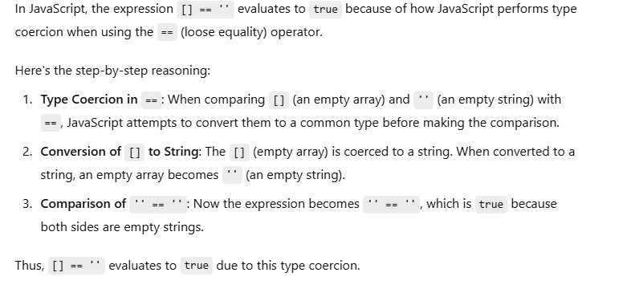

3. console.log (! []==[])

Ans: -true

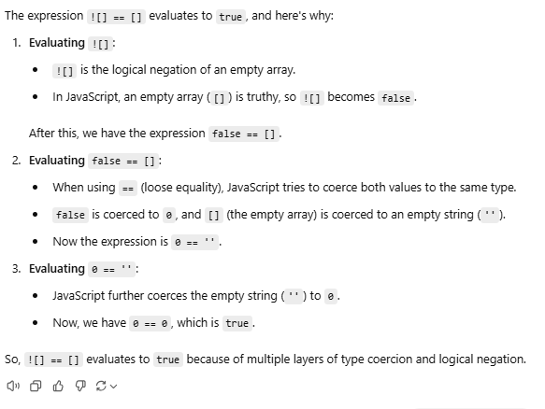

4.console.log ([] ==!"")

Ans: - false

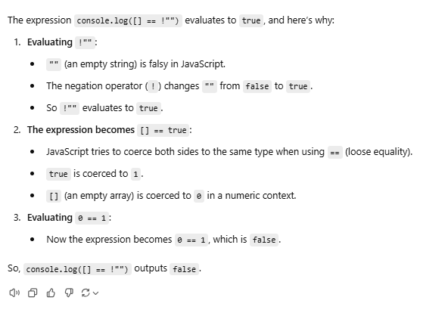

let res = [1,2,3,4,5,2,3,4,4]

let dup = []

for(let i =0;i<res.length;i++){

for(let j=i+1;j<res.length;j++){

let temp = res[i]

if(temp === res[j]){

if(!dup.includes(res[j])){

dup.push(temp)

}

}

}

}

console.log(dup)