**Introduction**

**AWS:-**

Amazon Web Services (AWS) is the world's most comprehensive and broadly adopted cloud, offering over 200 fully featured services from data centers globally. It can be used to manage resources in cloud computing and cloud storage as well as security credentials. The AWS Console interfaces with all AWS resources.

**S3 BUCKET:-**

Amazon Simple Storage Service (Amazon S3) is an object storage service. S3 is an object storage service that stores data as objects within buckets. An object is a file and any metadata that describes the file. A bucket is a container for objects. To store your data in Amazon S3, you first create a bucket and specify a bucket name and AWS Region. Then, you can upload data in bucket. Each object has a key (or key name), which is the unique identifier for the object within the bucket. A bucket is a container for objects stored in Amazon S3. A bucket you can create 100 buckets in s3. AWS S3 allows you to upload video files in a wide range of formats, including popular formats such as MP4, AVI, MOV, and more.

**Prequistes:-**

* Aws user account
* Reactjs

Upload files using AWS s3 bucket:-

In AWS to upload files using as frontend of reactjs to store multiple flies in s3 bucket to store. It will helps to a lot of data stored and retrieve.

* First we need to create AWS account to access s3 bucket.
* After that we create bucket name and region name access bucket.
* And we need change some of policies in permission and properties also change your bucket name and some changes.
* At last we need start frontend part in browser and configure with access key, secret key and bucket name connection to amazon. Run the browser and choose file option and clicks upload button it will added in s3 object.

Picture of process to upload video files in S3 bucket:-



Frontend part:-



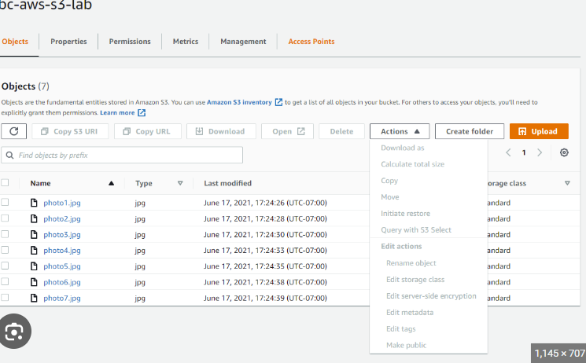

Benefits of upload file in S3 bucket:-

* We can store unlimited storage capacity occurs to store video files.
* In s3 we don’t have any time duration or corrupted it’s fully secured.
* We can access our files at any time or anywhere with high availability in S3.
* Multiple access the files in s3 bucket.
* Distributing data across multiple available zones, get quick and access from anywhere in world.
* Actually AWS S3 is pay on storage of space use Additionally, S3 provides different storage classes with varying pricing options.
* S3 provides multiple security features to protect your video files. Only authorized user can access and modify the files.
* In S3 bucket we can upload files and download quickly.

Case studies of uploading video files in AWS S3 bucket:-

* Video Streaming Service: A popular video streaming service utilizes AWS S3 to store their vast library of video content. By uploading videos to S3, they benefit from the scalable storage and high availability provided by AWS.
* Marketing and Advertising Agency: A marketing and advertising agency creates video advertisements for their clients. By uploading the video files to an AWS S3 bucket, they can easily share and distribute the ad content with their clients and partners.
* Real Estate Company: A real estate company uploads property tour videos to an AWS S3 bucket. By storing the videos in S3, they can efficiently share them with potential buyers and agents, even in remote locations.
* Training and Development Organization: A training and development organization uploads instructional videos to an AWS S3 bucket. They benefit from S3's scalability and cost-effectiveness, as they can easily store and distribute a large number of training videos.

Case studies of uploading video files in AWS S3 bucket:-

1. E-commerce Video Catalog: An e-commerce platform faced the challenge of creating a comprehensive video catalog to showcase product demonstrations and customer reviews. To address this, they implemented a web application that allowed sellers to upload videos directly to AWS S3 using signed URLs. By integrating AWS SDKs into their platform, the process became seamless for sellers, ensuring a smooth upload experience. As a result, the uploaded videos were securely stored in S3 buckets, readily accessible for playback on product pages. This implementation significantly enhanced the platform's customer engagement, leading to increased sales and improved user satisfaction.
2. User-Generated Content Platform: A social media platform aimed to provide a seamless video upload and sharing experience for its users. To achieve this, they integrated AWS SDKs into their mobile app, enabling users to directly upload videos to AWS S3. By leveraging the capabilities of S3, the platform ensured scalable storage and quick access to user-generated videos. With S3 as the underlying storage solution, the platform achieved efficient video management, resulting in enhanced user experiences and increased engagement on the platform.
3. Video Training Platform: An online learning platform required a reliable solution to upload and deliver video training courses to its users. They leveraged AWS S3 as the storage solution for uploading and storing course videos. Additionally, they utilized Amazon CloudFront, a content delivery network (CDN), for global content distribution. By combining S3 and CloudFront, the platform ensured efficient and reliable delivery of video courses worldwide. This implementation significantly improved the learning experience for users, providing smooth playback without buffering or latency issues.

Challenges of upload video files:-

* When we upload any files in AWS s3 bucket we should use must access key and secret key and bucket name.
* I don’t know how to change policies and some enable options in s3.
* Some of difficult to store multiple video files to add some of cors config.
* When we upload large files its take time to upload.
* It only upload small sizes files easily upload in s3 bucket.
* It difficult to understand the process to upload files in s3 bucket.