LOGIC design COURSE

1 Revision History
Version | DATE | BY | BRIEF DESCRIPTION OF CHANGES
Rev 0 | 7-03-2021 | Itai 311166623 | Design Reviwe
 |  | Eran 203331889

Protocol
Supported protocol features

UART t supports 9600/115200 baud rate, 7/8 bits data length and even/no parity bit selection.
IR
LCD

Top module

Overview
UART and Control module.

Block diagram
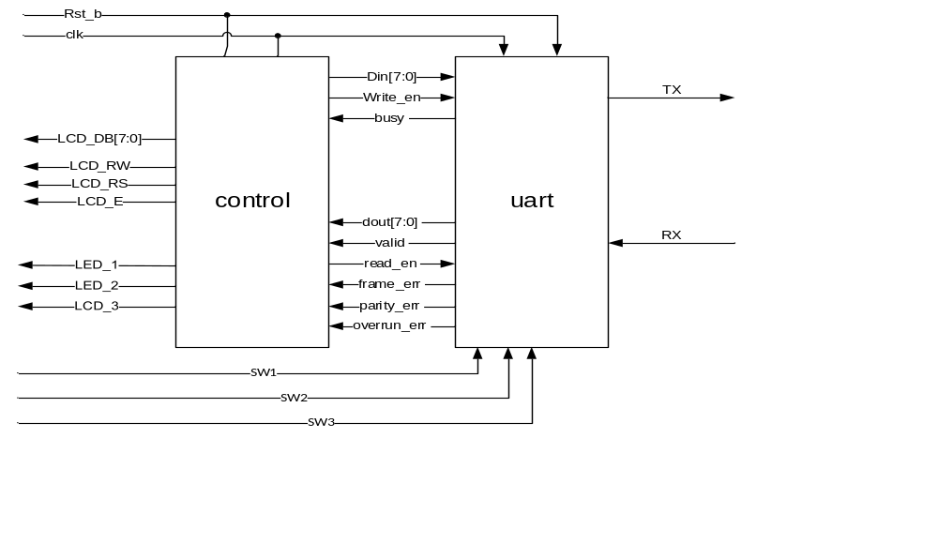

Pin in/out

Pin name | Size in bit | In /out | Description
Rst_b | 1 | In | Reset
clk | 1 | In | Clock
TX | 1 | Out | Transmitted frame
RX | 1 | In | Receiving frame
LCD_DB | 8 | Out | LCD data bits
LCD_RW | 1 | Out | LCD read enable
LCD_RS | 1 | Out | LCD write enable
LCD_E | 1 | Out | LCD enable
LEDG_0 | 1 | Out | Indicates overrun error
LEDG_1 | 1 | Out | Indicates parity error
LEDG_2 | 1 | Out | Indicates frame error
SW1 | 1 | In | Data length selection
SW2 | 1 | In | Baud rate selection
SW3 | 1 | In | Even/no parity selection

Sub block’s:

Sub block (RX)

Overview:
Responsible of receiving data from the computer, validate it and send it to the controller.

Block diagram / method

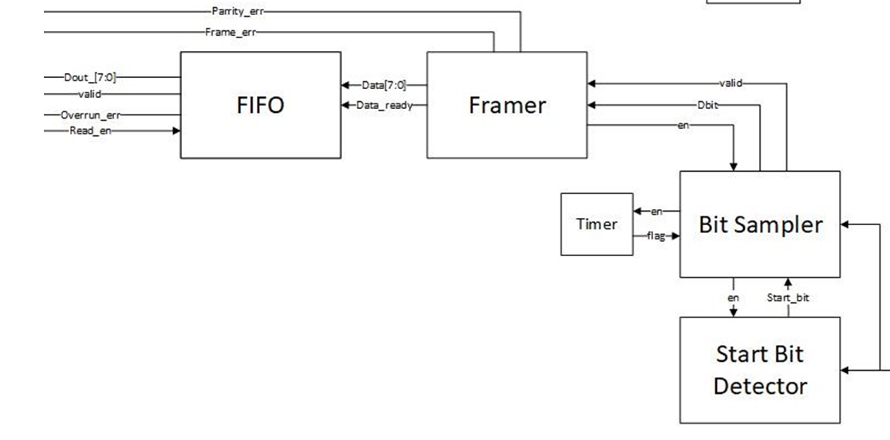

Majority Unit
RX
Delay
4.1.3 Pin in/out

Pin name | Size in bit | In /out | Connect to | Description
RX | 1 | In | Start Bit Detector, Bit Sampler | Receiving frame
Parity_err | 1 | Out | Framer | Indicates parity error
Frame_err | 1 | Out | Framer | Indicates frame error
Dout | 8 | Out | FIFO | Data bits to be sent to LCD
Valid | 1 | Out | FIFO | Indicates data is valid
Overrun_err | 1 | Out | FIFO | Indicates FIFO overrun error
Read_en | 1 | In | FIFO | Indication from control module that he's ready to read
SW_1 | 1 | In | Board | Even/no parity selection
SW_2 | 1 | In | Board | Data length selection
SW_3 | 1 | In | Board | Baud rate selection

Sub block’s:

Sub block (TX)

5.1.1 Overview:
receiving data from the controller and transmit it to the computer.

5.1.2 Block diagram / method
Frame Builder
Data in
TX
Write_en
BUSY
Finish
Start
Delay

5.1.3 Pin in/out

Pin name | Size in bit | In /out | Connect to | Description
TX | 1 | Out | Start Bit Detector | Transmitted frame
Busy | 1 | Out | Frame Encapsulation | Signals the controller that the Frame encapsulation module is busy to be written to
Din | 8 | In | Frame Encapsulation | Data bits received from control module
Write_en | 1 | In | Frame Encapsulation | Signals that data from control is ready to be written.
SW_1 | 1 | In | Board | Even/no parity selection
SW_2 | 1 | In | Board | Data length selection
SW_3 | 1 | In | Board | Baud rate selection

Sub block (Control)

Overview:
Responsible for communication between the UART and the LCD and the IR.

Block diagram / method
IR DATA [7:0]
IR DATA [7:0]
Write_en_tx
IR
UNIT
Valid
DATA [7:0]
Read_en
BUSY TX

BUSY_LCD
LCD
UNIT
DATA [7:0]
RX_DATA [7:0]
selector
Valid
Write_en_lcd
Read_en

Pin in/out

Pin name | Size in bit | In /out | Connect to | Description
LCD_Data | 8 | Out | LCD_Control | LCD data
LCD_RW | 1 | Out | LCD_Control | LCD read enable
LCD_RS | 1 | Out | LCD_Control | LCD write enable
LCD_E | 1 | Out | LCD_Control | Enable read/write
Busy | 1 | In | Frame Encapsulation | Signals the controller that the Frame encapsulation module is busy to be written to
Din | 8 | Out | Frame Encapsulation | Data bits received from control module
Write_en | 1 | Out | Frame Encapsulation | Signals that data from control is ready to be written.
Dout | 8 | In | FIFO | Data bits to be sent to LCD
Valid | 1 | In | FIFO | Indicates data is valid
Read_en | 1 | In | FIFO | Indication from control module that he's ready to read
IR_DATA | 1 | In | IR_UNIT | The input from the IR

Sub block (Majority)

Overview:
This sub block is responsible for sampling the bit that is received from Rx (the computer) and decide if it ‘1’ or ‘0’.

Pin in/out

Pin name | Size in bit | In /out | Connect to | Description
Rx | 1 | In | Computer | Data bit that is received from the computer
Valid | 1 | Out | Framer | Signals that Dbit is valid
Dbit | 1 | Out | Framer | Data bit received from Rx
Start | 1 | In | Framer | Enable signal from framer
En | 1 | Out | Timer | Timer enable signal
Flag | 1 | In | Timer | Timer finish flag

Sub block (Frame builder)

Overview:
Responsible for encapsulation of the data that is received from the control module and transmitting it to the Computer.

Pin in/out

Pin name | Size in bit | In /out | Connect to | Description
Tx | 1 | Out | Computer | Data bit that is transmitted to the computer
Busy | 1 | Out | Control | Signals the controller that the Frame encapsulation module is busy to be written to
Din | 8 | In | Control | Data bits received from control module
Write_en | 1 | In | Control | Signals that data from control is ready to be written.
en | 1 | Out | Control | Timer enable
flag | 1 | In | Control | Timer finish flag

Sub block (Start bit detector)

Overview:
Responsible for detecting start bit '0' in every beginning of a frame.

Block diagram / method

Pin in/out

Pin name | Size in bit | In /out | Connect to | Description
Rx | 1 | In | Computer | Data bit that is received from the computer
en | 1 | In | Frame Bit Collector | Enable
Start_bit | 1 | Out | Frame Bit Collector | Start bit detected flag

Sub block (Frame Bit Collector)

Overview:
Responsible for building frames from the received bits from the sampler and sending them to the FIFO queue.

Pin in/out

Pin name | Size in bit | In /out | Connect to | Description
Valid | 1 | In | Majority | Indicate that Dbit is valid
Dbit | 1 | In | Majority | Data bit
En | 1 | Out | Majority | Enable Sampler
Parity_err | 1 | Out | RX_control | Indicator for parity error
Frame_err | 1 | Out | RX_control | Indicator for frame error
Data | 8 | Out | RX_control | Data bits
Data_ready | 1 | Out | RX_control | Indicated that data bits are ready to be sent
overrun_err | 1 | Out | RX_control
finish | 1 | In | Timer
Start | 1 | Out | Timer
select | 1 | Out | Timer
enable | 1 | Out | Start_detector
Start_detected | 1 | In | Start_detector

Sub block (FIFO)

Overview:
FIFO queue that contains all the data that is received from the computer.

Pin in/out

Pin name | Size in bit | In /out | Connect to | Description
Data | 8 | In | Framer | Received data bits from the framer
Data_ready | 1 | In | Framer | Indicates that data is ready to read
Dout | 8 | Out | Control | Transmitted data bits
Valid | 1 | Out | Control | Indicates that data bits are valid
Read_en | 1 | In | Control | Indicates that Control is ready to read data

Sub block (LCD_Control)

Overview:
Responsible for LCD Initialization and to Print the text to the LCD display
  - When a new character arrives from the RX UART port it appears next to the previous character (same as regular writing)
  - After the 16 characters the line is full with characters, when a new character is arriving the display will slide and show the last 16 characters.
  - When a 'Enter' key is pressed, this is a command to clear the display.

Block diagram / method

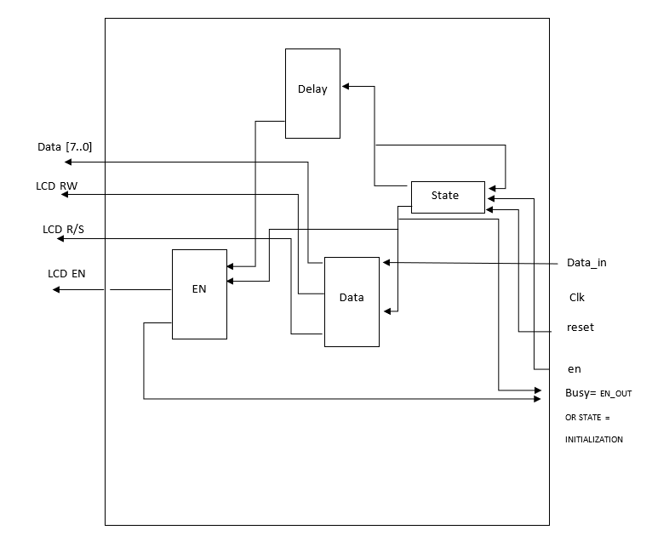

Pin in/out

Pin name | Size in bit | In /out | Connect to | Description
LCD_data | 8 | In | Control | LCD data Input
Data_en | 1 | In | Control | LCD input ready indicator
LCD_busy | 1 | Out | Control | LCD busy indicator
LCD_Data | 8 | Out | LCD | LCD data Output
LCD_RW | 1 | Out | LCD | LCD read enable
LCD_RS | 1 | Out | LCD | LCD write enable
LCD_E | 1 | Out | LCD | Enable read/write

Sub block (IR_Control)

Overview: This module receive IR data of 1 bit and returns 8 characters to the control. It converts every 4 bits from the 32 bits packet and reform it to its ASCII value.

Block diagram / method

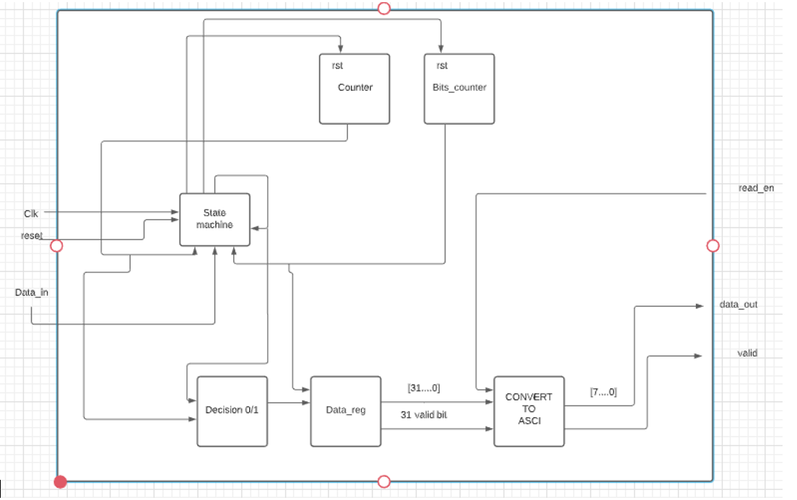
Pin name | Size in bit | In /out | Connect to | Description
IR_data | 1 | In | IR | IR data Input
Data_valid | 1 | Out | Control | Data is valid
_Read en | 1 | In | Control | Control ready to read
Data_to_control | 8 | Out | Control | Char to control

Sub block (IR_Converter)

Overview: This module receives 32 bits from the IR control and return 8 characters of ASCCI.

Block diagram / method

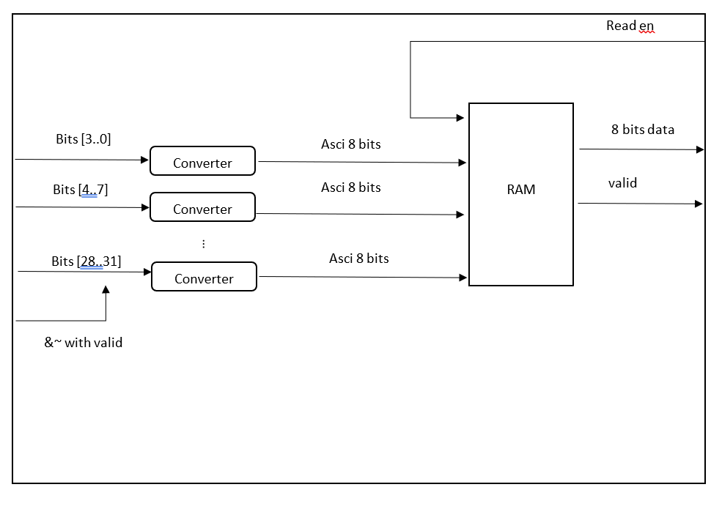

Pin name | Size in bit | In /out | Connect to | Description
IR_data | 32 | In | IR control | IR data packet
Packet_valid | 1 | In | IR control | Packet is valid
_Read en | 1 | In | IR control | Control ready to read
Data_to_control | 8 | Out | IR control | Char to control
Data_valid_out | 1 | Out | IR control | Character is valid

Sub block (10) (Counter)

Overview:
Responsible for the timing of the modules.

Block diagram / method

Pin in/out

Pin name | Size in bit | In /out | Connect to | Description
Start | 1 | In |  | Timer enable
flag | 1 | Out |  | Timer finish flag

