Final project NLP course
Eran Novak 027167386
Github link –
Youtube link -
Abstract This work implements a language modeling approach to analyze Hebrew math word problems, based on the GPT-2 framework. The work addresses two key objectives: (1) the generation of vector embeddings for the domain-specific lexicon, and (2) binary classification of problem difficulty (Grade 8 vs. Grade 9). Findings indicate that the specific LM architecture allows for robust results, demonstrating efficiency even under conditions of data scarcity and restricted processing power.

1. Embeddings
The dataset was curated from publicly available web-based study materials, comprising collections of word problems and subject-specific textbook chapters. The raw data was converted from multiple formats into plain text (.txt) and preprocessed. This cleaning phase involved the removal of artifacts, whitespace, and non-textual elements. Furthermore, question indices and numerical answers were stripped from the text to prevent potential noise or bias in the analysis.
Tokenization was performed using the Stanza NLP library. This library effectively handles Hebrew morphology, allowing for accurate token extraction even from complex words. The Word2Vec algorithm was implemented following the course textbook guidelines, with necessary adaptations for the Hebrew language and the specific tokenizer used.
The selected hyperparameters were as follows: a skip-gram window size of 8, as the linguistic context in mathematical word problems is typically local. The number of negative samples was set to 16 per token to conserve computational resources. Similarly, resource constraints dictated an embedding vector length (dimension) of 200; shorter vectors yielded inferior results, while larger vectors would have been computationally too expensive.
A visualization of the embeddings for several sample words demonstrates that the model successfully identifies semantically related words; however, it occasionally errs by associating words that are merely proximate in their text location. Furthermore, it is evident that the representation of certain words relies heavily on context rather than the isolated word itself, as seen with the ambiguous Hebrew word 'לשער'.
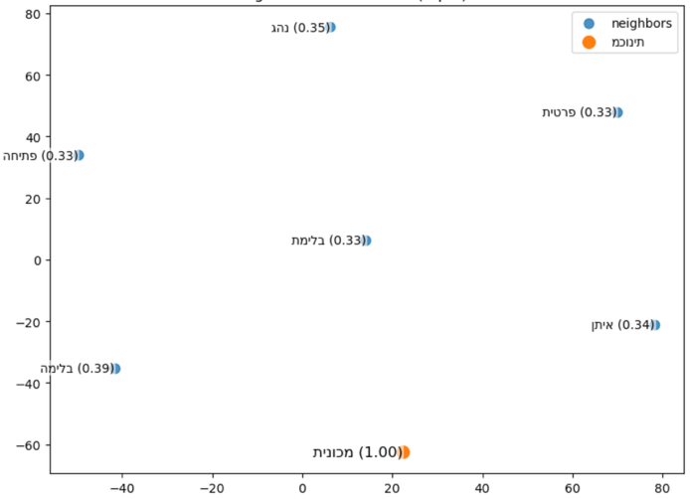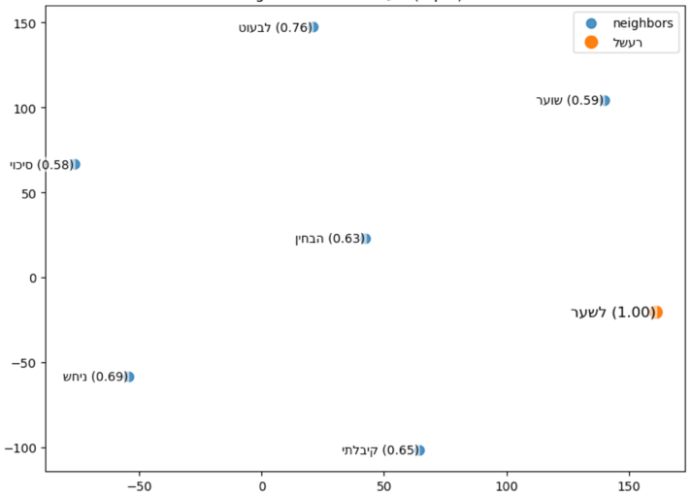
Figure 1Embeddings visualization for the words 'מכונית' and 'לשער'.
Code for this section is at 1_embeddings notebook.

2. GPT2 model from scratch
In this section, a GPT-2 model was implemented from scratch, similar to the implementation presented in the course textbook. The sole difference lies in the input data, which consisted of the identical dataset used for computing the embeddings. The model utilizes the embedding vectors calculated in the previous step, alongside the Hebrew tokenizer. As described in the textbook, prior to training, the model completes sentences randomly. Looking at the training, it is evident that the model suffers from significant overfitting. The generated text lacks coherence; instead, it merely reproduces memorized segments of the input data. 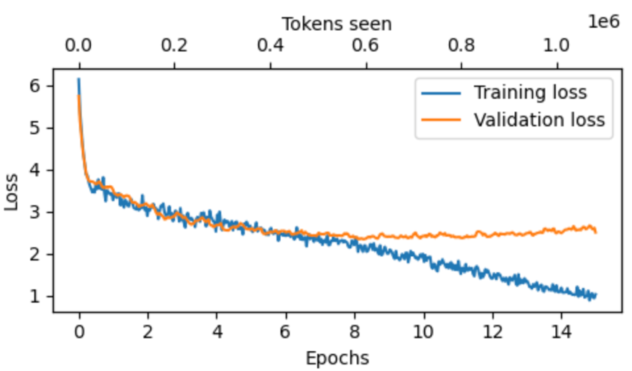
Figure 2GPT-2 model training loss of train and val data. Overfitting is evident.
Code for this section is at 2_custom_GPT2 notebook.

3. Data preperation and augmentation for classification
In this section, the dataset for training the Hebrew mathematical word problem classifier was constructed. Initially, approximately 250 word problems were collected, comprising both 8th-grade and 9th-grade levels. This dataset was subsequently expanded through data augmentation, which was performed using two methods: back-translation and word substitution.
Back-translation alters the writing style of a text while preserving its meaning by translating it into a foreign language and then back into the original language. Passing through these translation stages naturally introduces variations into the text. Since translating to English and back yielded only minor changes, an additional language (Arabic) was incorporated into the process. Consequently, the complete translation pipeline proceeded from Hebrew, to English, to Arabic, and finally back to Hebrew.
Word substitution was executed through textual analysis of the questions, replacing names using the Faker library, and modifying keywords such as 'bought', 'sold', 'known', etc. Throughout this process, the original sentence order was strictly preserved; rearranging sentences in mathematical word problems can easily result in nonsensical or ill-posed questions.
As a result of these procedures, the dataset was quadrupled (doubled via translation and doubled via word substitution), reaching a total of 1,084 samples.
Code for this section is at 3_data_generation notebook.

4. classification of word problems
In this final section, a classification model for Hebrew word problems was implemented. To align as closely as possible with the methodology presented in the course, the Norod78/distilgpt2-base-pretrained-he model was selected (as no more advanced Hebrew models utilizing this specific architecture were found). The model was loaded alongside its corresponding tokenizer from the Hugging Face library. The AutoModelForCausalLM was loaded instead of its corresponding classification model, in order to enable a custom implementation of the classification layer. As described in the textbook, a classification layer was added to the model.
With the exception of the final transformer block and the newly appended classification head, all base model parameters were frozen. The model was then fine-tuned on the aforementioned dataset. Optimization was performed utilizing the AdamW algorithm, with Cross-Entropy serving as the objective loss function. The outcomes of the training phase are presented below – the model appears to be converging as expected. The test accuracy was over 92%.
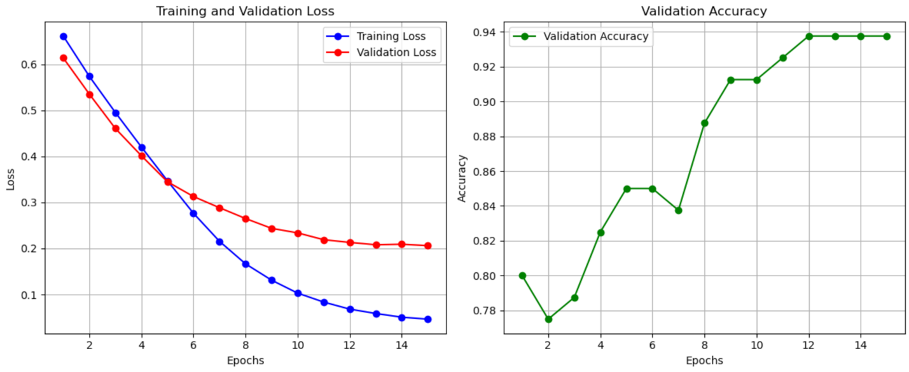
Figure 3classification model loss and accuracy plots
Evaluating the trained classifier on several new examples (external to the test dataset) demonstrated that it functions properly.
Code for this section is at 4_heb_class_model notebook.

