ENTERPRISE KUBERNETES
SECURITY ARCHITECTURE
Threats, Controls, and Implementation Guidance

For: Enterprise Architects & Security Leadership
Classification: Internal / Confidential
Version 1.0 | March 2026

Executive Summary
Kubernetes has become the de facto standard for container orchestration in enterprise environments. Its inherent complexity, distributed architecture, and extensible API surface create a broad attack surface that requires deliberate, layered security design.

This document provides enterprise architects with a structured analysis of the primary security risks in Kubernetes deployments, paired with proven architectural patterns and controls to mitigate them. It is grounded in real-world breach case studies, CNCF security best practices, the NSA/CISA Kubernetes Hardening Guide, and CIS Kubernetes Benchmarks.

⚠ Key Finding
The majority of Kubernetes breaches are not exploits of zero-day vulnerabilities. They result from misconfiguration: over-privileged service accounts, exposed API servers, unencrypted secrets, and absent network policies. Architecture decisions made at design time determine your blast radius when — not if — a breach occurs.

1. Kubernetes Threat Landscape
Before defining controls, architects must understand the attack surface across three domains: the control plane, the data plane, and the software supply chain.

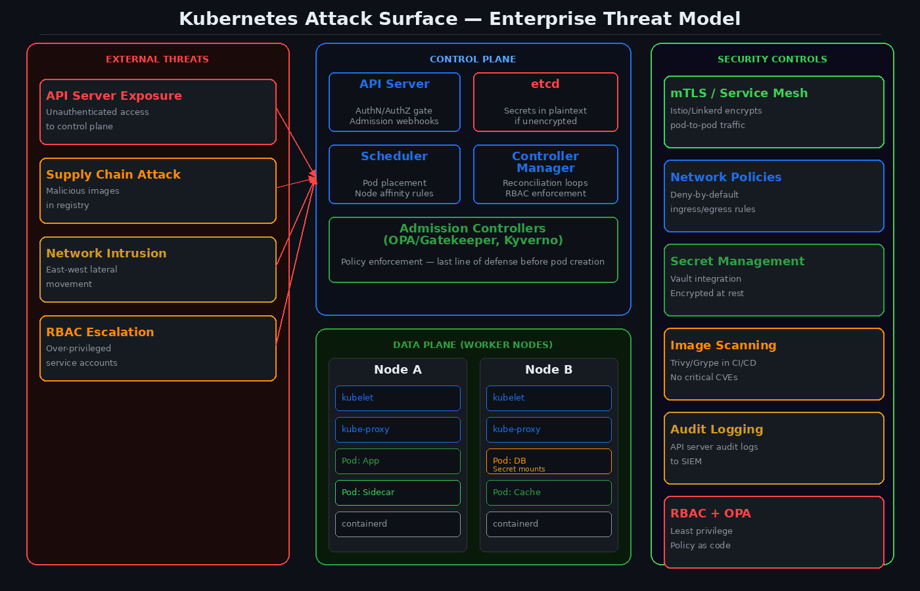
Figure 1: Kubernetes Enterprise Attack Surface — Control Plane, Data Plane, and Security Controls

1.1 Risk Register
The following table summarizes the highest-impact risks, their severity rating (aligned with CVSS v3.1 scoring principles), and the primary mitigation for each.

Risk | Severity | Attack Vector | Mitigation
Unauthenticated API Server Access | Critical | Public endpoint, no AuthN | Private endpoint + OIDC + firewall rules
Etcd Data Exposure | Critical | Unencrypted data at rest | Encryption at rest + mTLS between etcd peers
Over-privileged Service Accounts | High | RBAC misconfiguration | Least-privilege RBAC + automated auditing
Container Escape | High | Privileged pods, host namespace | Pod Security Standards (Restricted profile)
Lateral Movement via Network | High | No network segmentation | Network Policies + service mesh mTLS
Malicious Container Images | High | Unscanned images in registry | Image signing (Cosign) + admission controller
Secrets in Environment Variables | High | Exposed in pod spec, logs | External secrets operator + Vault agent
Supply Chain Compromise | High | Tampered images or Helm charts | SLSA Level 3 + provenance verification
Insecure Admission Controllers | Medium | Bypassing policy enforcement | OPA/Gatekeeper in Fail-Closed mode
Unpatched Node OS / Kubernetes | Medium | Known CVEs in runtime | Automated patching + CVE scanning pipeline

2. Control Plane Hardening
The control plane is the brain of Kubernetes. Compromise here grants an attacker unrestricted cluster access. Every component requires explicit hardening.

2.1 API Server
The API server is the single entry point for all cluster operations. Its exposure profile must be actively minimized.
- Disable anonymous authentication: --anonymous-auth=false
- Enforce RBAC authorization: --authorization-mode=Node,RBAC — never AlwaysAllow
- Require TLS everywhere: --tls-cert-file, --tls-private-key-file explicitly set
- Restrict API server endpoint to private network — never expose to public internet
- Enable audit logging: --audit-log-path, --audit-policy-file with a comprehensive policy
- Disable insecure port: --insecure-port=0 (default in K8s 1.20+, verify it is not re-enabled)

✓ Architecture Decision: API Server Access Pattern
In enterprise environments, the API server should be accessible only via a bastion host or VPN-authenticated jump server. Direct public exposure — even with valid certificates — violates defense-in-depth. Cloud provider private endpoint features (EKS Private Endpoint, GKE Private Cluster) should be the default, not an option.

2.2 Etcd — The Crown Jewel
Etcd stores all cluster state including Secrets (base64-encoded, not encrypted by default). A read on etcd is equivalent to full cluster compromise.
- Enable envelope encryption: KMS provider with --encryption-provider-config
- Restrict etcd access to control plane nodes only — network policy + firewall
- Enable mTLS between API server and etcd: --etcd-certfile, --etcd-keyfile, --etcd-cafile
- Back up etcd with encrypted snapshots — treat the backup with the same security posture as the live cluster
- Audit etcd access separately from API server audit logs

2.3 Admission Controllers
Admission controllers are the last enforcement point before a resource is written to etcd. They are your policy firewall. Running without them is equivalent to having no perimeter.
Controller | Function | Status
NodeRestriction | Limits kubelet API access to its own node objects | Required
PodSecurity | Enforces Pod Security Standards profiles | Required
OPA/Gatekeeper | Policy as code — custom constraints via Rego | Recommended
Kyverno | Policy engine with native K8s resource model | Alternative to OPA
ImagePolicyWebhook | Blocks unsigned or unscanned images | Required in production
MutatingAdmissionWebhook | Injects Vault agent sidecars, labels, etc. | Context-dependent

3. Zero Trust Network Architecture
The default Kubernetes network model allows all pods to communicate with all pods. In an enterprise environment, this is equivalent to having no internal firewall. Zero Trust must be actively implemented — it is not a default.

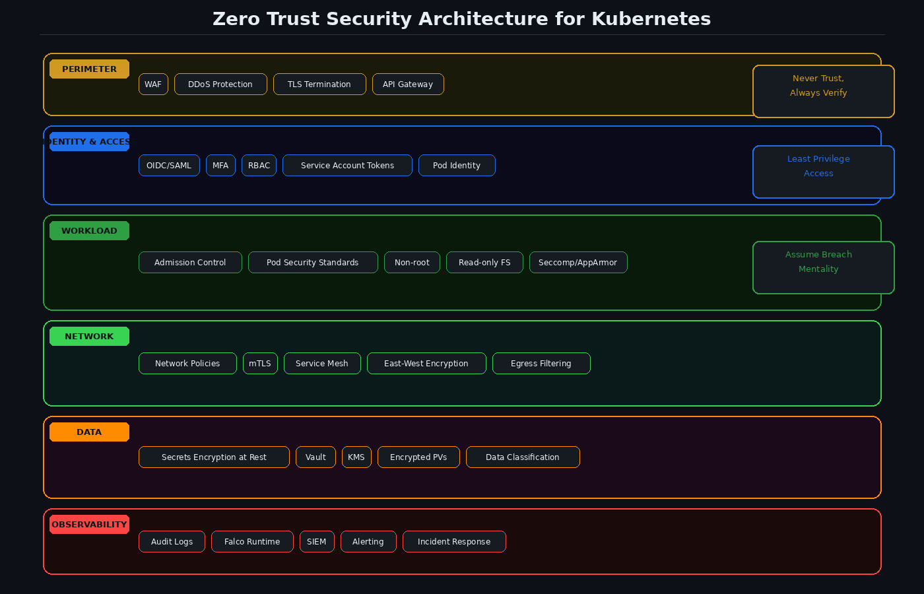
Figure 2: Zero Trust Security Layers — From Perimeter to Data

3.1 Network Policies
Kubernetes NetworkPolicy resources are the primary tool for pod-level network segmentation. The architecture principle is deny-by-default with explicit allowlists.
- Deploy a CNI that enforces NetworkPolicy: Calico, Cilium, or Weave (Flannel does NOT enforce policies)
- Start with a default-deny-all policy in every namespace
- Allow only required ingress and egress paths explicitly
- Use namespace selectors for cross-namespace communication — never IP-based rules alone
- Cilium extends NetworkPolicy to Layer 7: HTTP path, method, and gRPC method filtering

✓ Architecture Decision: CNI Selection
For enterprise environments requiring fine-grained policy and observability, Cilium is the recommended CNI. Its eBPF-based architecture provides Layer 3-7 enforcement, Hubble for network observability, and transparent encryption without a service mesh overlay. Calico is a strong alternative with broad ecosystem support and BGP-based routing flexibility.

3.2 Service Mesh — mTLS and Traffic Policy
Network policies operate at the IP level. A service mesh adds mutual TLS authentication at the workload identity level, ensuring that even east-west traffic within the cluster is encrypted and authenticated.
- Istio: Full-featured service mesh with SPIFFE/SPIRE identity, traffic management, and policy enforcement
- Linkerd: Simpler operational model, automatic mTLS with lower resource overhead
- Cilium Service Mesh: eBPF-native, no sidecar proxies required — lower latency and overhead
- Enforce PeerAuthentication policy in STRICT mode — reject plaintext connections
- Define AuthorizationPolicies to restrict which services can call which endpoints

4. Identity, RBAC, and Secret Management

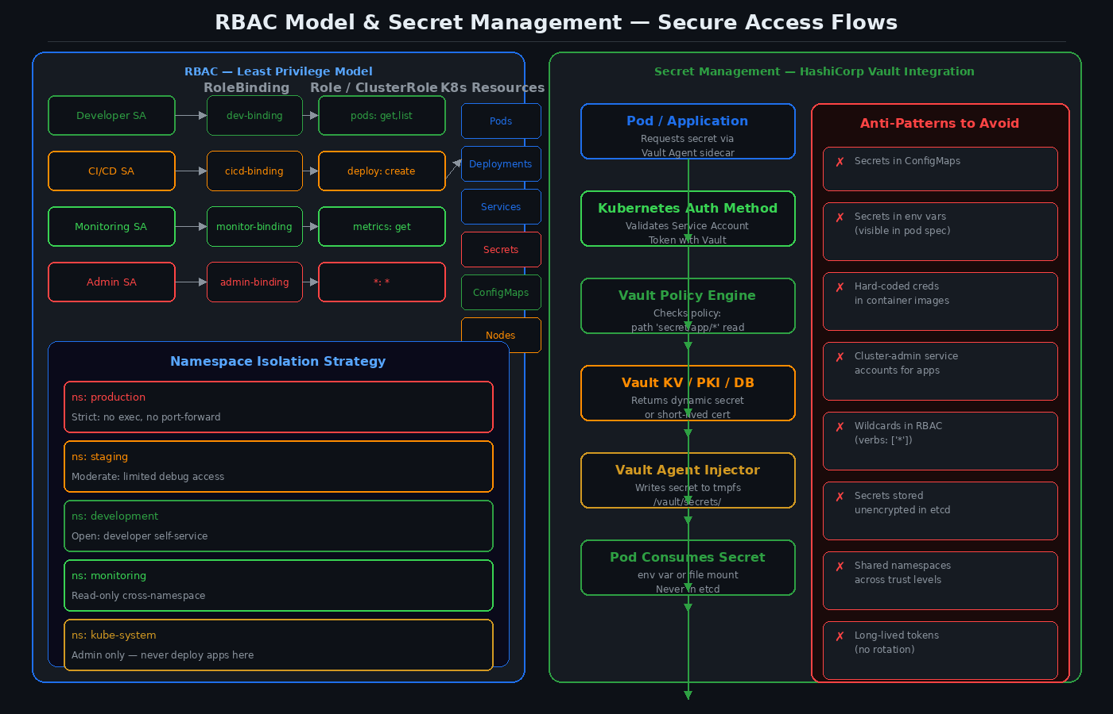
Figure 3: RBAC Least-Privilege Model and Vault Secret Management Flow

4.1 RBAC Design Principles
RBAC misconfiguration is the single most common path to privilege escalation in Kubernetes. The following principles are non-negotiable in an enterprise context.
- Never assign cluster-admin to application service accounts
- Scope roles to namespaces (Role/RoleBinding) unless cluster-wide access is explicitly justified
- Audit RBAC configurations with tools such as kubectl-who-can, rbac-lookup, or Fairwinds Insights
- Rotate service account tokens — use TokenRequest API with bounded expiry, not long-lived static tokens
- Use projected service account tokens for Vault authentication — avoid static secrets entirely
- Implement just-in-time access for cluster-admin operations via tools such as Teleport or Pomerium

4.2 Secret Management — External Secrets over Native
Kubernetes Secrets are base64-encoded, not encrypted, by default. Even with etcd encryption at rest, the Secrets API surface remains exposed. Enterprise architectures should treat Kubernetes Secrets as a transport layer, not a storage layer.
- HashiCorp Vault: Dynamic secrets, PKI, database credential rotation — preferred for regulated environments
- Vault Agent Injector: Injects secrets as files into pod tmpfs — never stored in etcd
- External Secrets Operator: Syncs secrets from Vault, AWS Secrets Manager, or Azure Key Vault into Kubernetes Secrets with automatic rotation
- Sealed Secrets (Bitnami): Acceptable for GitOps workflows — asymmetric encryption, safe to commit

⚠ Hard Rule: No Secrets in Environment Variables
Environment variables are exposed in the pod spec (visible to anyone with pods/get permission), in process listings, and frequently captured in logs. Use file mounts to /vault/secrets/ or equivalent tmpfs paths. This is a non-negotiable control in any PCI-DSS, HIPAA, or SOC 2 regulated environment.

5. Workload Security — Pod and Container Hardening

5.1 Pod Security Standards
Kubernetes replaced PodSecurityPolicy (deprecated in 1.21, removed in 1.25) with Pod Security Standards, enforced via the PodSecurity admission controller. Three profiles exist:

Profile | Restrictions | Use Case
Privileged | No restrictions | Node-level system workloads only
Baseline | Prevents known privilege escalations | General application workloads
Restricted | Heavily restricted, runs as non-root, no privilege escalation, seccomp required | Production workloads — enterprise default target

5.2 Container Security Context — Required Fields
Every pod spec in production must define a securityContext. The following fields are required in a hardened deployment:
- runAsNonRoot: true — reject containers running as UID 0
- runAsUser: 1000 (or higher non-privileged UID)
- allowPrivilegeEscalation: false — prevent sudo and setuid binary escalation
- readOnlyRootFilesystem: true — write to explicit volume mounts only
- capabilities: drop: [ALL] — then add back only the specific capabilities required
- seccompProfile: type: RuntimeDefault — enable syscall filtering

5.3 Supply Chain Security
The container image is the primary artifact in Kubernetes. A compromised image is equivalent to a compromised workload. Enterprise supply chain security requires controls at every stage of the image lifecycle.
- Image scanning in CI/CD: Trivy, Grype, or Snyk — block on Critical/High CVEs
- Image signing with Sigstore/Cosign — enforce signature verification via admission controller (Connaisseur or Kyverno)
- Private registry with access control — no direct pulls from public Docker Hub in production
- SBOM generation: CycloneDX or SPDX format for every image — required for SLSA Level 2+
- Distroless or minimal base images — remove shells, package managers, and unnecessary binaries
- Pin image tags to digests (sha256:...) — never use latest or mutable tags in production

6. Security Observability and Incident Response

6.1 Audit Logging
Kubernetes API server audit logs are the primary forensic record of cluster activity. They must be configured comprehensively and shipped to a SIEM — not stored locally on the control plane node.
- Define an audit policy covering Metadata level for all resources, Request+Response for Secrets, ConfigMaps, and RBAC changes
- Ship logs to a tamper-evident destination: AWS CloudWatch, Splunk, Elastic SIEM, or Datadog
- Set retention aligned to compliance requirements: PCI-DSS requires 12 months, SOC 2 typically 6-12 months
- Alert on: cluster-admin binding creation, new ClusterRoleBindings, exec into pods, secret access in production namespaces

6.2 Runtime Threat Detection — Falco
Falco is the CNCF-graduated runtime security tool for Kubernetes. It uses eBPF or kernel module hooks to detect anomalous behavior at the syscall level — catching threats that static policies cannot.
- Deploy Falco as a DaemonSet on all worker nodes
- Enable the default ruleset — then extend with environment-specific rules
- Critical rules to enforce: shell spawned in container, sensitive file read (/etc/passwd, /etc/shadow), network connection to unexpected destination, privilege escalation attempt
- Route Falco alerts to PagerDuty, Slack, or SIEM via Falcosidekick

✓ Architecture Decision: Defense-in-Depth for Runtime
Static admission control (OPA/Gatekeeper) prevents known-bad configurations from being deployed. Falco detects unknown-bad behavior at runtime. Both are required. An attacker who bypasses admission control — via a misconfigured webhook or a supply chain compromise — should still be detected by runtime monitoring within seconds, not days.

7. Compliance Alignment
The following table maps security controls to common compliance frameworks. All controls referenced align with the CIS Kubernetes Benchmark v1.8 and the NSA/CISA Kubernetes Hardening Guide.

Control Domain | PCI-DSS | HIPAA | SOC 2 | CIS K8s
API Server Hardening | Req 6.4 | ADDRESSABLE | CC6.6 | 1.2.x
Etcd Encryption at Rest | Req 3.5 | Required | CC6.7 | 1.2.34
RBAC Least Privilege | Req 7.1 | Required | CC6.3 | 5.1.x
Network Segmentation | Req 1.3 | ADDRESSABLE | CC6.6 | 5.3.x
Secret Management | Req 8.3 | Required | CC6.1 | 5.4.x
Audit Logging to SIEM | Req 10.x | Required | CC7.2 | 3.2.x
Image Scanning | Req 6.3.3 | ADDRESSABLE | CC7.1 | 5.5.x
Pod Security Standards | Req 6.2 | ADDRESSABLE | CC6.8 | 5.2.x

8. Implementation Roadmap
Security hardening should be sequenced by risk reduction per unit of implementation effort. The following phases apply to both greenfield clusters and existing production environments.

Phase 1 — Foundation (Weeks 1-4)
- Enable etcd encryption at rest with KMS provider
- Lock down API server: disable anonymous auth, enable audit logging
- Apply CIS Benchmark Level 1 across all nodes using kube-bench
- Implement namespace isolation with default-deny NetworkPolicies
- Enforce Pod Security Standards at Baseline level cluster-wide

Phase 2 — Identity & Secrets (Weeks 5-8)
- Audit all RBAC bindings — remove all cluster-admin assignments not explicitly justified
- Deploy External Secrets Operator or Vault Agent Injector
- Migrate all application secrets from etcd to Vault
- Enable image signing and admission enforcement in staging

Phase 3 — Zero Trust & Observability (Weeks 9-16)
- Deploy Falco with SIEM integration and alerting
- Implement service mesh (Istio or Cilium) with STRICT mTLS
- Deploy OPA/Gatekeeper with custom policies for organizational standards
- Establish CI/CD pipeline gates: SBOM generation, Trivy scan, Cosign signature

Phase 4 — Continuous Assurance (Ongoing)
- Automate CIS Benchmark runs with kube-bench in CI and on schedule
- Conduct quarterly RBAC audits with rbac-lookup
- Run penetration tests against cluster using tools such as kube-hunter
- Track CVEs in deployed images via continuous scanning (Trivy Operator)
- Run game days — simulate container escape, lateral movement, and secret exfiltration scenarios

✓ Final Architectural Principle
Security is not a state — it is a process. A Kubernetes cluster that passes a CIS benchmark today will drift toward insecurity within weeks without continuous enforcement, monitoring, and human review. Automate detection, enforce policy as code, and treat every cluster configuration change as a security event that requires audit trail.

References & Further Reading
- NSA/CISA Kubernetes Hardening Guide (August 2022)
- CIS Kubernetes Benchmark v1.8 — Center for Internet Security
- CNCF Security Whitepaper v2 — cloud-native-security-whitepaper
- OWASP Kubernetes Security Cheat Sheet
- MITRE ATT&CK for Containers — containers.mitre.org
- Kubernetes Documentation: Pod Security Standards — kubernetes.io/docs
- HashiCorp Vault Kubernetes Auth Method — developer.hashicorp.com
- Falco Runtime Security — falco.org
- Sigstore / Cosign — sigstore.dev
- Cilium Network Policies — docs.cilium.io

