qKubernetes
Architecture Reference
Core Components, Object Model & Operational Architecture
Enterprise Security Architect Edition

Table of Contents
Table of Contents 2
1. What Is Kubernetes 4
1.1 Design Principles 4
2. Architecture Overview 5
2.1 The Two Planes at a Glance 7
3. Control Plane Components 8
3.1 kube-apiserver 8
Authentication Pipeline 8
Admission Controllers 8
3.2 etcd 8
Architecture 8
Security Implications 9
3.3 kube-scheduler 9
3.4 kube-controller-manager 9
3.5 cloud-controller-manager 10
4. Data Plane – Worker Nodes 11
4.1 kubelet 11
4.2 kube-proxy 11
4.3 Container Runtime (containerd) 11
5. Kubernetes Object Model 13
5.1 Workload Objects 15
5.2 Networking Objects 15
5.3 Configuration & Storage Objects 15
5.4 Identity & Access Objects 16
5.5 Namespace Isolation 16
6. Networking Model 17
6.1 The Kubernetes Networking Contract 17
6.2 CNI Plugins 17
6.3 Service Discovery 17
6.4 NetworkPolicy and Zero Trust Posture 17
7. Storage Architecture 19
7.1 Volume Types 19
7.2 CSI Secrets Store Driver 19
8. Role-Based Access Control (RBAC) 20
8.1 RBAC Architecture 20
8.2 Common Mistakes and Attack Patterns 20
8.3 Least-Privilege Design Pattern 20
9. Pod Security 21
9.1 Pod Security Standards 21
9.2 Critical Pod-Level Security Controls 21
10. Observability 22
10.1 The Three Pillars in Kubernetes Context 22
10.2 Audit Logging 22
11. Upgrade and Operations 23
11.1 Kubernetes Release Cadence 23
11.2 Rolling Upgrade Strategy 23
11.3 Multi-Cluster Architecture 23

1. What Is Kubernetes
Kubernetes (K8s) is an open-source container orchestration platform originally designed by Google and donated to the Cloud Native Computing Foundation (CNCF) in 2014. It automates the deployment, scaling, self-healing, and lifecycle management of containerized applications across clusters of machines. It is not a container runtime. It is the control system that decides where, when, and how containers run.

Why it matters at enterprise scale
Kubernetes decouples application workloads from the underlying infrastructure. In a financial services or large enterprise context, this means consistent deployment pipelines across on-premises, cloud, and hybrid environments, with built-in primitives for availability, traffic management, and access control.

1.1 Design Principles
- Declarative state: You describe the desired state; Kubernetes continuously reconciles the actual state to match it via control loops.
- API-driven: Every operation goes through the kube-apiserver. No side channels. This makes auditing and access control tractable.
- Self-healing: Failed pods are restarted, unhealthy nodes are drained, and replacements are scheduled automatically.
- Extensible: Custom Resource Definitions (CRDs) allow extending the API without modifying core Kubernetes. Operators codify domain-specific automation.
- Workload portability: The same manifest runs on EKS, AKS, GKE, or bare metal with minimal changes. The cloud-controller-manager abstracts provider differences.

2. Architecture Overview
A Kubernetes cluster consists of two logical planes: the Control Plane, which manages the desired state of the cluster, and the Data Plane (Worker Nodes), which runs the actual workloads. The two planes communicate exclusively through the kube-apiserver.

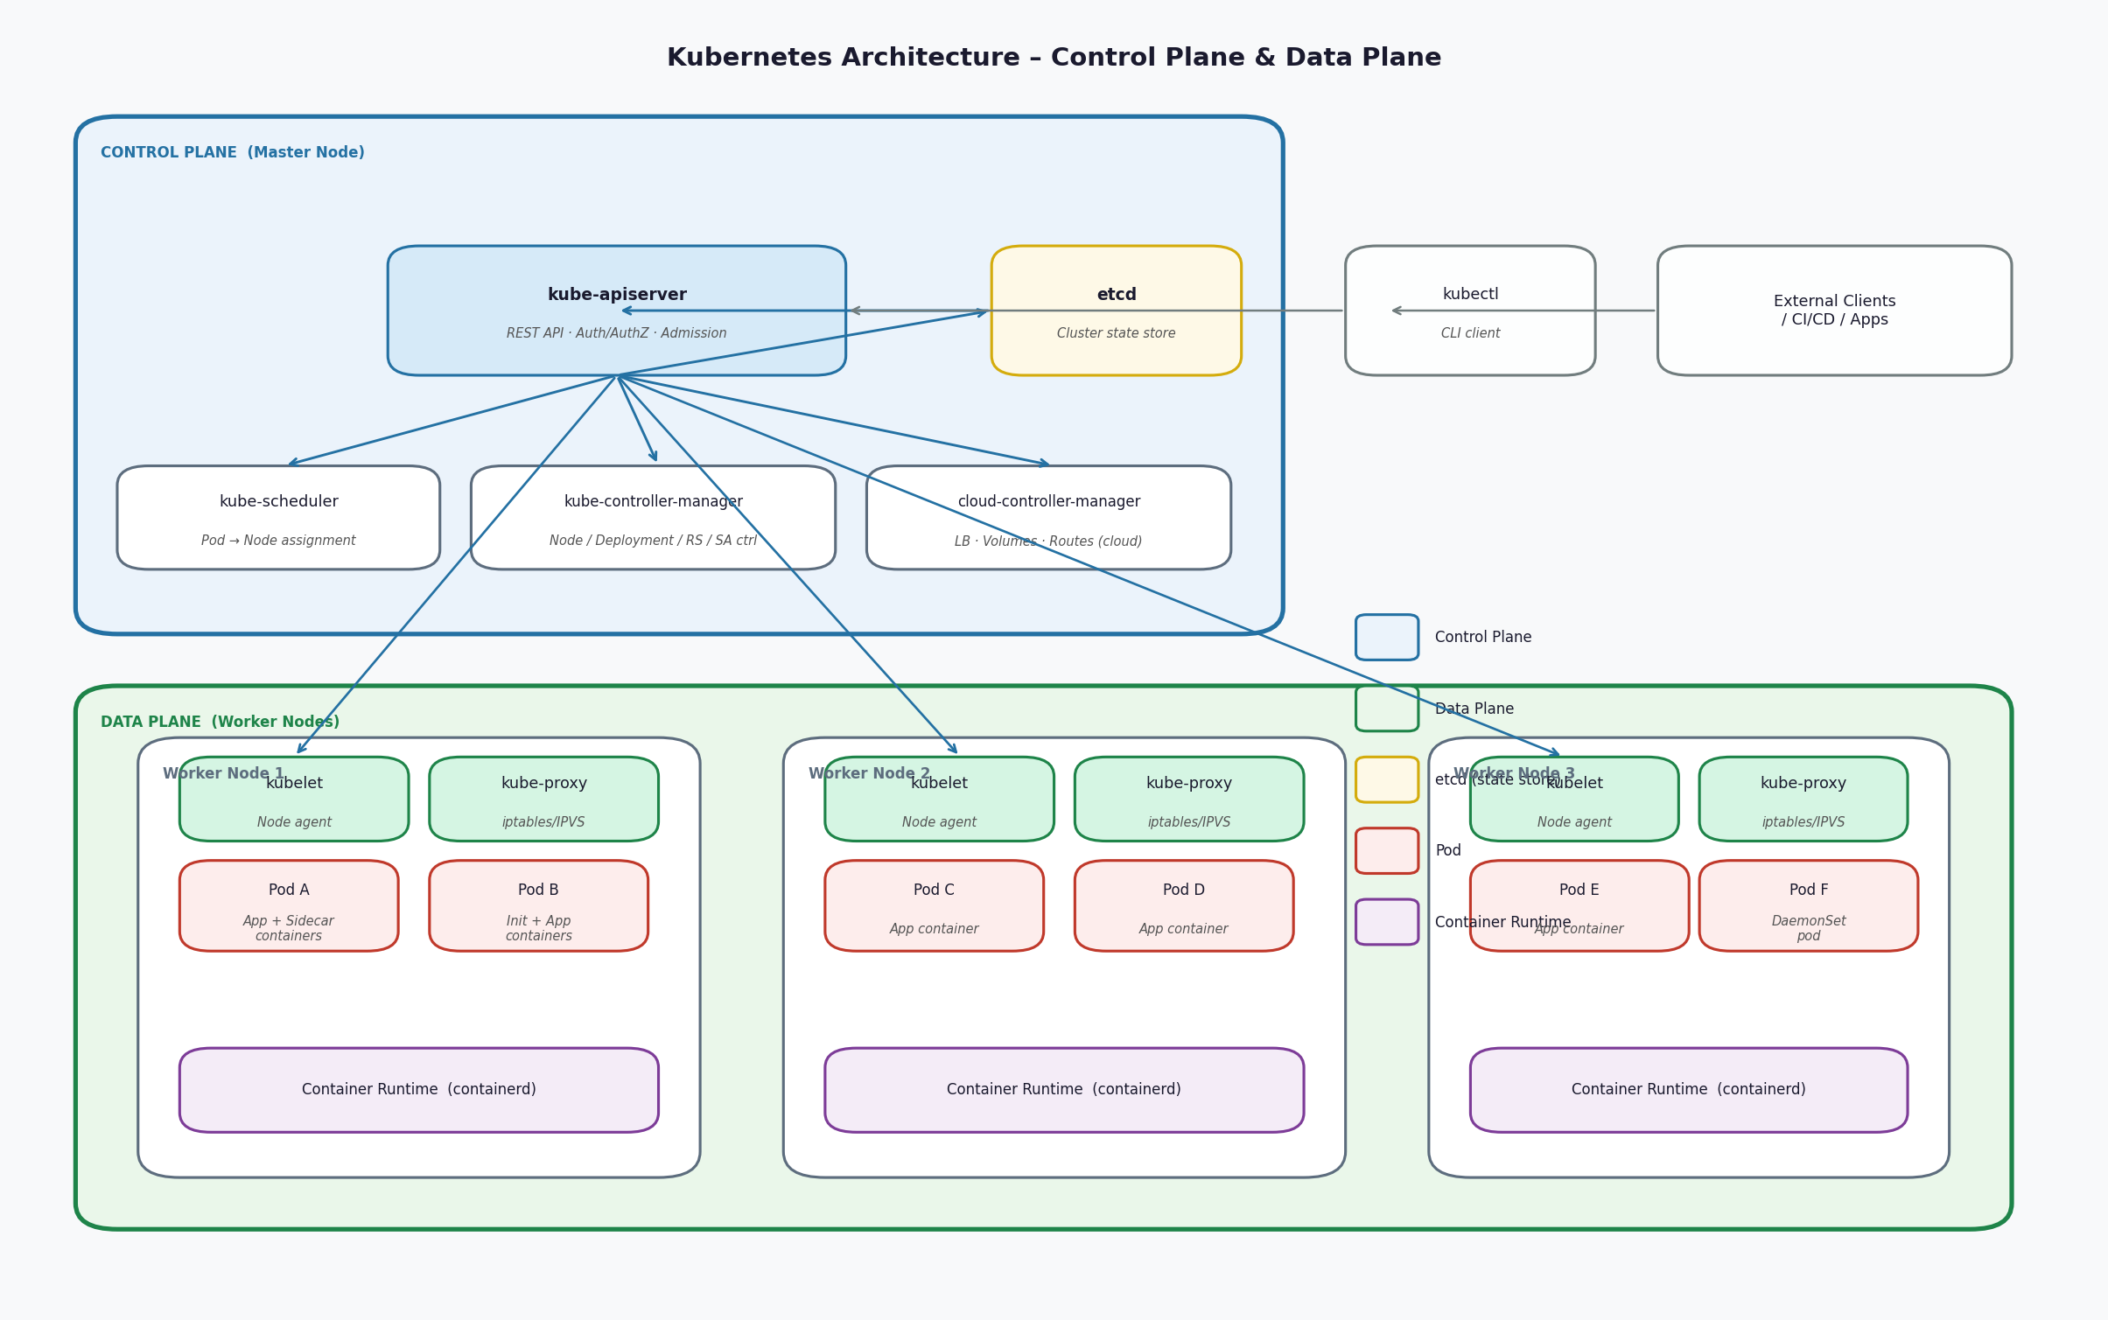
Figure 1: Kubernetes Architecture. Control Plane manages cluster state; Worker Nodes execute workloads.

2.1 The Two Planes at a Glance
Component | Layer | Function
Control Plane | Management | Holds cluster state, schedules workloads, enforces desired configuration
kube-apiserver | Control Plane | Single entry point for all cluster operations. Handles auth, authz, admission
etcd | Control Plane | Distributed key-value store. Single source of truth for all cluster state
kube-scheduler | Control Plane | Assigns unscheduled pods to nodes based on resource and policy constraints
kube-controller-manager | Control Plane | Runs reconciliation loops: node, deployment, replicaset, serviceaccount, etc.
cloud-controller-manager | Control Plane | Interfaces with cloud provider APIs for load balancers, volumes, and routes
Worker Node | Data Plane | Executes pods. Managed via kubelet. Reports status to control plane
kubelet | Data Plane | Node agent. Receives pod specs from API server; manages container lifecycle
kube-proxy | Data Plane | Implements Service networking on each node. nftables mode recommended (v1.31+). IPVS deprecated in v1.35.
Container Runtime | Data Plane | Executes containers. Standard is containerd (Docker runtime is deprecated)

3. Control Plane Components

3.1 kube-apiserver
The API server is the only component that communicates directly with etcd. All other components, including kubelets, controllers, and external clients, interact exclusively through the API server. This architectural choice is intentional: it centralizes authentication, authorization, and audit logging into a single choke point.

Authentication Pipeline
Every request to the API server traverses a pipeline: authentication (who is this?), authorization (are they allowed?), and admission control (should we accept this object?). The API server supports multiple authentication methods simultaneously. In production, you will typically see client certificates for service accounts, OIDC tokens for human users, and webhook token authentication for external identity providers.

Admission Controllers
Admission controllers are plugins that intercept requests after authentication and authorization but before persistence to etcd. They are the last line of defense for policy enforcement at the API level. There are two types:
- MutatingAdmissionWebhook: Modifies the object before storage. Used to inject sidecars (service mesh, secrets store), set default values, or add labels.
- ValidatingAdmissionWebhook: Rejects objects that violate policy. Used by OPA Gatekeeper, Kyverno, and similar policy engines to enforce security constraints.
- ValidatingAdmissionPolicy (CEL-based, GA in v1.30): A native, in-process alternative to ValidatingAdmissionWebhook for simpler policy rules. Policies are expressed in Common Expression Language (CEL) directly in Kubernetes API objects, with no external webhook server required. For straightforward constraints (e.g., "images must come from approved registries"), ValidatingAdmissionPolicy reduces operational complexity. OPA Gatekeeper and Kyverno remain the standard for complex policy sets.

Security Note: API Server Attack Surface
The API server is the highest-value target in a Kubernetes cluster. Key hardening controls: disable anonymous authentication, enforce RBAC (never use cluster-admin broadly), enable audit logging with a backend that writes to immutable storage, restrict API server network access to known CIDRs, and use private endpoint configuration in managed cloud services.

3.2 etcd
etcd is a consistent, distributed key-value store that holds the complete state of the Kubernetes cluster. Every object you create. every status update, every configuration change. it all persists in etcd. If etcd is compromised or corrupted, the cluster cannot function and cluster state is lost.

Architecture
etcd runs as a cluster (typically 3 or 5 members for high availability) using the Raft consensus algorithm. Raft ensures that a majority of members must agree before any write is committed. This means etcd can survive the loss of one member in a 3-node cluster or two members in a 5-node cluster without data loss.

Security Implications
- Encryption at rest: By default, Kubernetes Secrets stored in etcd are NOT encrypted. They are only base64-encoded. Enabling envelope encryption via KMS is non-negotiable in any production deployment.
- Encryption in transit: All communication between etcd members and between the API server and etcd uses mutual TLS.
- Direct access is catastrophic: Anyone with direct network access to etcd and the ability to make requests can read all secrets, inject arbitrary configurations, and escalate to full cluster admin. etcd must never be accessible outside the control plane network.
- Backup and recovery: etcd snapshots are the authoritative backup mechanism. Without a current snapshot, cluster recovery from total failure is not possible.

3.3 kube-scheduler
The scheduler watches for pods in a Pending state (pods with no assigned node) and selects an appropriate node for each one. This process has two phases:
- Filtering: Eliminates nodes that cannot satisfy the pod's requirements. This includes resource requests (CPU, memory), node selectors, affinity/anti-affinity rules, taints and tolerations, and topology spread constraints.
- Scoring: Ranks the remaining feasible nodes using weighted scoring functions. Default priorities include balanced resource utilization, image locality, and inter-pod affinity.

Advanced scheduling patterns relevant to enterprise deployments: Taints and tolerations control which pods can run on which nodes. This is the mechanism used to create dedicated node pools for sensitive workloads, GPU nodes, or nodes with specific compliance requirements. Node affinity allows you to express preferences or hard requirements about node labels. Pod disruption budgets ensure that voluntary disruptions (like node drains for upgrades) maintain minimum availability.

3.4 kube-controller-manager
The controller manager is a single binary that runs multiple independent control loops. Each controller watches a subset of Kubernetes resources and takes action to reconcile the actual state with the desired state. Key controllers include:
- Node Controller: Monitors node health and marks nodes as unavailable after a timeout. Evicts pods from unhealthy nodes.
- Deployment Controller: Manages ReplicaSets to implement rolling updates, rollbacks, and scaling for Deployments.
- ReplicaSet Controller: Ensures that the correct number of pod replicas are running at all times.
- ServiceAccount Controller: Creates default ServiceAccounts in new namespaces.
- EndpointSlice Controller: Manages EndpointSlice objects, which map Service traffic to backing pod IPs. EndpointSlice replaced the legacy Endpoints API as the default since v1.21 and scales better for large Services with many pods. The legacy Endpoints controller is maintained only for backward compatibility.
- Job Controller: Manages batch jobs to completion.

3.5 cloud-controller-manager
The cloud-controller-manager is the abstraction layer between Kubernetes and the cloud provider API. It is what enables Kubernetes to work the same way across AWS, Azure, and GCP despite completely different underlying infrastructure. When a Service of type LoadBalancer is created, the cloud-controller-manager calls the cloud provider API to provision an actual load balancer. When a PersistentVolumeClaim is bound, it provisions the appropriate cloud storage. When a node is added or removed, it updates cloud-specific routing tables.

4. Data Plane – Worker Nodes

4.1 kubelet
The kubelet is the primary node agent. It runs on every worker node and is responsible for ensuring that the containers described in PodSpecs are running and healthy. The kubelet receives pod specifications from the API server, communicates with the container runtime via CRI (Container Runtime Interface), and reports node and pod status back to the API server.

Critical security function: the kubelet is responsible for mounting volumes (including secrets from the Secrets Store CSI driver), managing pod lifecycle, enforcing resource limits via cgroups, and running liveness and readiness probes. The kubelet API endpoint itself is an attack surface. It should never be publicly accessible, and anonymous access should be disabled.

4.2 kube-proxy
kube-proxy runs on every node and implements the Kubernetes Service abstraction at the network level. When a Service is created, kube-proxy programs network rules on the node so that traffic destined for the Service's ClusterIP gets load-balanced to the backing pod IPs. kube-proxy supports multiple backend modes:
- nftables (recommended): The current recommended mode on Linux nodes as of Kubernetes v1.31+. Uses the Linux nftables subsystem, offering better performance and maintainability than iptables.
- iptables: The legacy default mode. Still widely deployed. Being superseded by nftables.
- IPVS (deprecated): IPVS mode is deprecated as of Kubernetes v1.35 and will be removed in a future release. Do not adopt it for new deployments.
In clusters using eBPF-based CNI plugins (like Cilium), kube-proxy can be replaced entirely. This is more performant, eliminates iptables overhead entirely, and provides deeper per-flow observability including intranode traffic.

4.3 Container Runtime (containerd)
The container runtime is responsible for pulling images, managing image layers, creating container processes, and enforcing isolation via Linux namespaces and cgroups. The standard runtime is containerd, which implements the CRI specification. Docker as a Kubernetes runtime was deprecated in v1.20 and removed in v1.24. containerd itself calls runc (or an alternative like gVisor's runsc) to create the actual container process.

containerd and cgroup v2 — Version Requirements (as of v1.35)
containerd 1.x reaches end of upstream support in 2026. Kubernetes v1.35 is the last release supporting containerd 1.x; v1.36 will require containerd 2.0 or later. Plan your runtime upgrade accordingly. Additionally, cgroup v1 support is disabled by default in Kubernetes v1.35 and will be fully removed in a subsequent release. All production nodes should be running a Linux distribution with cgroup v2 (unified hierarchy) enabled. Major cloud provider AMIs (Amazon Linux 2023, GKE COS, Bottlerocket) already default to cgroup v2.

Runtime Security Consideration
The container runtime is the last line of kernel-level isolation. A compromised container that achieves a container escape can directly access the node kernel. This is why runtime security tools (Falco, Sysdig) focus on kernel syscall monitoring, and why node OS hardening (read-only root filesystems, minimal OS like Bottlerocket or COS) is critical.

5. Kubernetes Object Model
Every resource in Kubernetes is an object. Objects are persistent entities that represent the desired state of cluster components. They are stored in etcd and manipulated through the API server. Understanding the object hierarchy is essential for reasoning about workload isolation, access control, and network segmentation.

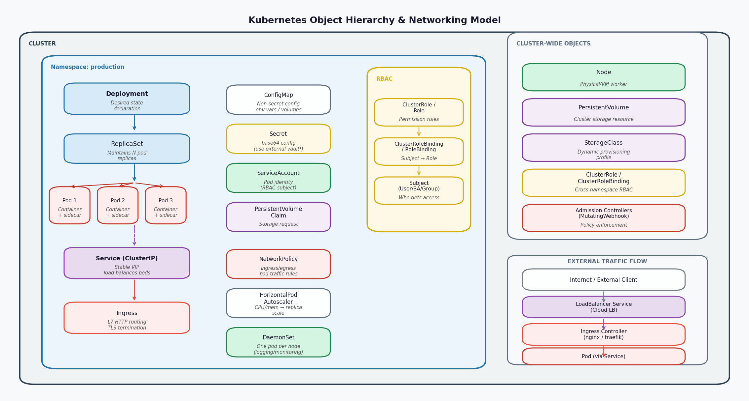
Figure 2: Kubernetes Object Hierarchy. Deployments manage ReplicaSets which manage Pods. Services provide stable network identity.

5.1 Workload Objects
- Pod: The smallest deployable unit. One or more containers sharing a network namespace and storage volumes. Never deploy bare pods in production. Always use a controller.
- Deployment: Declarative update mechanism for stateless applications. Manages a ReplicaSet to maintain desired replica count. Supports rolling updates, rollbacks, and pause/resume.
- ReplicaSet: Ensures N replicas of a pod template are running. Normally managed by a Deployment, not directly.
- StatefulSet: Like a Deployment but for stateful applications. Provides stable network identities, ordered deployment/scaling, and persistent storage per replica. Since Kubernetes v1.32 (GA), StatefulSets support automatic PVC deletion via the persistentVolumeClaimRetentionPolicy field, which prevents orphaned PVCs when a StatefulSet is scaled down or deleted.
- DaemonSet: Ensures exactly one pod runs on each (or selected) nodes. Used for logging agents, monitoring agents, security tooling (Falco), and CNI plugins.
- Job / CronJob: Runs pods to completion. Job for one-time tasks, CronJob for scheduled tasks.

5.2 Networking Objects
- Service: Provides a stable virtual IP (ClusterIP) and DNS name for a set of pods selected by label. Types: ClusterIP (internal), NodePort (node-level), LoadBalancer (cloud LB), ExternalName.
- Ingress: L7 HTTP/HTTPS routing. Routes external traffic to Services based on hostname and path rules. Requires an Ingress Controller (nginx, Traefik, AWS ALB, etc.) to function. Note: the upstream Ingress NGINX project has announced retirement guidance. New deployments should evaluate Gateway API.
- Gateway API: The strategic successor to Ingress, GA since Kubernetes v1.28. Provides a richer, role-oriented routing model with support for HTTP, gRPC, and TCP traffic. Decouples infrastructure (Gateway) from routing (HTTPRoute, GRPCRoute). Prefer Gateway API for new deployments targeting Kubernetes v1.28+.
- NetworkPolicy: Defines allowed ingress/egress traffic for a group of pods. Enforced by the CNI plugin (requires a CNI that supports NetworkPolicy, e.g., Calico, Cilium, AWS VPC CNI with Calico). Default-deny posture requires explicit policies for all pod communication.

5.3 Configuration & Storage Objects
- ConfigMap: Stores non-secret configuration data as key-value pairs. Injected into pods as environment variables or volume mounts.
- Secret: Stores sensitive data. base64-encoded, NOT encrypted by default. The correct architecture is to never put sensitive secrets in Kubernetes Secrets. Use a secrets manager (Vault, AWS Secrets Manager, Azure Key Vault, GCP Secret Manager) and mount them via the CSI Secrets Store driver.
- PersistentVolume (PV): A piece of storage in the cluster provisioned by an administrator or dynamically by a StorageClass.
- PersistentVolumeClaim (PVC): A request for storage by a pod. Bound to a PV.
- StorageClass: Defines the provisioner, parameters, and reclaim policy for dynamic volume provisioning.

5.4 Identity & Access Objects
- ServiceAccount: Provides an identity for processes running in a pod. The mechanism through which workload identity (IRSA, Workload Identity Federation) is implemented. Every pod runs under a ServiceAccount, and the default one should be minimally privileged.
- Role / ClusterRole: Defines a set of permissions (verbs on API resources). Role is namespace-scoped; ClusterRole is cluster-wide.
- RoleBinding / ClusterRoleBinding: Binds a Role to one or more subjects (users, groups, or ServiceAccounts). Grants the permissions defined in the Role.

5.5 Namespace Isolation
Namespaces are the primary isolation boundary in Kubernetes. They provide scoping for names, RBAC policies, ResourceQuotas, and NetworkPolicies. They do NOT provide strong security isolation by default. Two pods in different namespaces on the same node share the same kernel. Namespace isolation is a logical/access-control boundary, not a security sandbox. For hard multi-tenancy, you need additional controls: NetworkPolicy for traffic isolation, LimitRange and ResourceQuota for resource fairness, and pod security standards (restricted profile) to prevent privilege escalation.

6. Networking Model

6.1 The Kubernetes Networking Contract
Kubernetes requires that: (1) every pod gets a unique IP address, (2) pods on the same node can communicate without NAT, (3) pods on different nodes can communicate without NAT, and (4) the IP a pod sees for itself is the same IP that other pods use to reach it. This model is implemented by the CNI (Container Network Interface) plugin, which is responsible for allocating IP addresses and programming the network fabric.

6.2 CNI Plugins
The CNI plugin is selected at cluster creation and determines much of the network security posture. Key options:
- AWS VPC CNI: Pods get real VPC IPs. Native AWS networking. NetworkPolicy enforcement requires either the native AWS VPC CNI network policy controller (available since EKS 1.25 without a separate Calico installation) or a separate Calico plugin. Both options are supported; the native controller is simpler to operate on EKS.
- Azure CNI / Azure CNI Overlay: Pods get VNet IPs. Full VNet integration. NSGs apply at the subnet level.
- Calico: Feature-rich, supports BGP and overlay modes. Widely used. Strong NetworkPolicy support including egress controls.
- Cilium: eBPF-based. Best-in-class observability and L7-aware policy. Used natively in GKE Dataplane V2. Replaces kube-proxy. Strongly recommended for new deployments.

6.3 Service Discovery
CoreDNS runs as a deployment in the kube-system namespace and provides DNS-based service discovery. Every Service gets a DNS name of the form <service>.<namespace>.svc.cluster.local. Pods can resolve service names using short forms within the same namespace. DNS is the primary mechanism for inter-service communication in microservice architectures running on Kubernetes.

6.4 NetworkPolicy and Zero Trust Posture
By default, all pods can communicate with all other pods across all namespaces. This is the opposite of zero trust. Establishing a zero-trust network posture in Kubernetes requires:
- Default-deny policies: Apply a deny-all NetworkPolicy to every namespace that blocks all ingress and egress traffic unless explicitly allowed.
- Explicit allowlist policies: Define NetworkPolicies that allow only the specific communication paths your application requires.
- Egress controls: Explicitly allow only the external endpoints your workloads need to reach. Block unrestricted internet egress from pods.
- CNI enforcement: NetworkPolicies are only enforced if the CNI plugin supports them. Cilium or Calico are required. The default CNI in many bare-metal deployments (kubenet) does not enforce NetworkPolicy.

7. Storage Architecture

7.1 Volume Types
Kubernetes supports many volume types. The most important for enterprise deployments:
- emptyDir: Ephemeral. Created when a pod is assigned to a node, deleted when the pod is removed. Shared between containers in the same pod. Useful for scratch space and inter-container data sharing.
- hostPath: Mounts a path from the host node filesystem into the pod. CRITICAL SECURITY RISK. Avoid in production. A pod with hostPath access to sensitive directories can read node secrets, escape container isolation, or modify node configuration. Always flag in security reviews.
- PersistentVolumeClaim: The correct pattern for persistent storage. Decouples storage provisioning from pod lifecycle. Backed by cloud block storage (EBS, Azure Disk, GCE PD) or network filesystems.
- CSI (Container Storage Interface): Plugin-based storage architecture. Enables third-party storage providers including secrets management (CSI Secrets Store driver for Vault/cloud KMs integration).

7.2 CSI Secrets Store Driver
The Secrets Store CSI driver is the correct architecture for secrets management in Kubernetes. It mounts secrets from external stores (HashiCorp Vault, AWS Secrets Manager, Azure Key Vault, GCP Secret Manager) as files in the pod filesystem. Secrets are never stored in etcd. They are fetched on pod start and can be auto-rotated. This is the pattern required for any production deployment handling sensitive data.

Architecture Pattern: Secrets Management
The path that a secret takes: External Secrets Manager (Vault / cloud KMS) > CSI Secrets Store Driver (node-level agent) > mounted file in pod > application reads from file. The Kubernetes Secret object is bypassed entirely. etcd never contains plaintext credentials. This pattern also enables automatic rotation without pod restart using the sync-as-secret and auto-rotation features.

8. Role-Based Access Control (RBAC)

8.1 RBAC Architecture
Kubernetes RBAC is an authorization mechanism that controls who can do what to which API resources. It operates on four object types: Roles, ClusterRoles, RoleBindings, and ClusterRoleBindings. RBAC is additive. There is no deny rule. If a subject has no binding that allows an action, it is denied. If they have any binding that allows it, it is permitted.

8.2 Common Mistakes and Attack Patterns
- cluster-admin overuse: The cluster-admin ClusterRole grants unrestricted access to all resources. Binding any ServiceAccount or user to cluster-admin is a critical misconfiguration. It appears in nearly every Kubernetes penetration test report.
- Wildcard permissions: Roles with verbs: ["*"] or resources: ["*"] are effectively cluster-admin within their scope. Enumerate explicitly.
- Bind / Escalate verbs: The ability to create RoleBindings allows privilege escalation. A subject that can create RoleBindings can grant themselves or others higher permissions.
- ServiceAccount token auto-mount: By default, every pod has its ServiceAccount token mounted at /var/run/secrets/kubernetes.io/serviceaccount/token. If the pod is compromised, an attacker can use this token to query the Kubernetes API. Set automountServiceAccountToken: false on pods that do not need API access.
- Impersonation: The impersonation verb allows acting as another user or ServiceAccount. Tools that need this (like certain admission webhooks) should be audited carefully.

8.3 Least-Privilege Design Pattern
The correct approach: create a dedicated ServiceAccount per workload. Create a Role in the same namespace that grants only the specific API operations the workload requires. Bind the ServiceAccount to that Role with a RoleBinding. Never reuse ServiceAccounts across workloads with different trust levels. Regularly audit bindings using tools like kubectl-who-can or rbac-lookup.

9. Pod Security

9.1 Pod Security Standards
Kubernetes provides three built-in security profiles enforced via the Pod Security Admission controller (replaced PodSecurityPolicy in v1.25):
- Privileged: No restrictions. Allows privilege escalation, host namespaces, any capabilities. Appropriate only for system-level infrastructure pods (e.g., CNI plugins, certain monitoring agents).
- Baseline: Prevents known privilege escalations. Disallows privileged containers, hostPath volumes, host networking. Minimum acceptable for most workloads.
- Restricted: Heavily restricted. Requires running as non-root, dropping all capabilities, disabling privilege escalation. Best practice for application workloads.

9.2 Critical Pod-Level Security Controls
- runAsNonRoot: true: Container process must not run as root (UID 0). Reduces blast radius of container escape.
- readOnlyRootFilesystem: true: Container cannot write to its own filesystem. Forces explicit use of writable volume mounts. Severely limits attacker persistence.
- allowPrivilegeEscalation: false: Prevents a process from gaining more privileges than its parent.
- capabilities: drop ALL: Removes all Linux capabilities from the container. Add back only what is explicitly required.
- seccompProfile: RuntimeDefault: Applies the container runtime's default seccomp filter, which blocks ~200 rarely-used and dangerous syscalls.
- hostNetwork / hostPID / hostIPC: false: Prevents access to the host network namespace, process table, or IPC namespace. Any pod requesting these should be flagged in security reviews.

Security Architecture Principle
Every pod spec that goes to production should be reviewed against these controls as a non-negotiable checklist. In enterprises, this is enforced via OPA Gatekeeper or Kyverno policies in the admission webhook chain. The policies should block deployment of pods that violate the restricted profile unless they are in explicitly exempted namespaces (like kube-system).

10. Observability

10.1 The Three Pillars in Kubernetes Context
- Metrics: The Metrics Server is a lightweight aggregator of resource usage data (CPU, memory) used by HPA and kubectl top. For full observability, Prometheus (or a managed equivalent) is the standard. Node Exporter exposes OS-level metrics; kube-state-metrics exposes Kubernetes object state; application pods expose /metrics endpoints.
- Logs: Kubernetes does not provide a native log aggregation system. Logs from containers go to stdout/stderr and are collected by node-level agents (Fluent Bit, Filebeat) running as DaemonSets. These agents ship logs to a central store (Elasticsearch, CloudWatch, Azure Monitor, Cloud Logging, Splunk).
- Traces: Distributed tracing (OpenTelemetry, Jaeger, Zipkin) requires instrumentation of application code or injection of tracing proxies via service mesh (Istio, Linkerd). Not automatic.

10.2 Audit Logging
Kubernetes audit logging records every request to the kube-apiserver. This is the forensic record for cluster security. It is NOT enabled by default in managed Kubernetes services; you must explicitly enable it. Audit logs should capture at minimum: metadata for all requests, request body for write operations on sensitive resources (secrets, configmaps, RBAC objects), and responses for sensitive reads. Logs must ship to immutable storage outside the cluster. Retention should align with your compliance requirements (typically 90 days to 1 year in financial services).

11. Upgrade and Operations

11.1 Kubernetes Release Cadence
Kubernetes releases a new minor version approximately three times per year (roughly every 15 weeks, or about once every four months, per the official 15-week release cycle). Each minor version is supported for approximately 14 months: 12 months of active patch releases followed by a 2-month maintenance window. This means you need a cluster upgrade cycle of roughly every 6-12 months to stay within the supported N-2 window. In managed services (EKS, AKS, GKE), the control plane upgrade is managed by the provider. Worker node upgrades are your responsibility unless you use auto-upgrade features. As of February 2026, the current release is Kubernetes v1.35 (December 2025); v1.32 has reached end of life.

11.2 Rolling Upgrade Strategy
The standard node upgrade pattern: cordon the node (mark as unschedulable), drain the node (evict all pods, respecting PodDisruptionBudgets), upgrade the node OS and kubelet, then uncordon. PodDisruptionBudgets (PDBs) are critical here. Without a PDB on your deployment, a drain can evict all replicas simultaneously, causing a service outage. Always define PDBs for production workloads.

11.3 Multi-Cluster Architecture
At enterprise scale, a single cluster is rarely sufficient. Common multi-cluster patterns: (1) Separate clusters per environment (dev/staging/prod) for blast radius containment. (2) Separate clusters per compliance domain (PCI-DSS scope vs. non-PCI). (3) Multi-region active-active for disaster recovery. (4) Hub-spoke model with a management/fleet cluster controlling workload clusters via GitOps. Tools for multi-cluster management include Flux, ArgoCD, and cloud-native fleet management (GKE Fleet, Azure Arc, AWS EKS Anywhere).

Kubernetes Architecture Reference | Enterprise Security Architect Edition | Kubernetes v1.35 (December 2025)

