**DESIGN AND IMPLEMENTATION OF EMPLOYEE CLOCKING SYSTEM**

**1. SYSTEM & USER REQUIREMENTS**

**System Identification**

The Employee Clocking System is a web-based application built using **Next.js** and **Supabase** to allow employees to log their work hours efficiently. The system ensures secure authentication, tracks attendance, and provides an admin dashboard for employee management.

**Objectives**

* Enable employees to clock in and clock out.
* Provide real-time attendance tracking.
* Allow admins to manage employees and monitor attendance.
* Secure authentication and role-based access control.
* Generate attendance reports.

**Features**

* **User Authentication:** Secure login, logout, and role-based access.
* **Clock-In/Clock-Out:** Employees can log their work hours.
* **Attendance Tracking:** Employees can view their attendance records.
* **Leave Management:** Employees can request leave.
* **Admin Dashboard:** Admins can manage employees and view reports.
* **Reports Generation:** Export attendance and leave data.

**Technology Stack**

* **Backend:** Next.js (API Routes), Supabase (PostgreSQL)
* **Frontend:** Next.js, Tailwind CSS
* **Authentication:** Supabase Auth
* **Hosting:** Vercel

**2. ACTIVITY DIAGRAM**

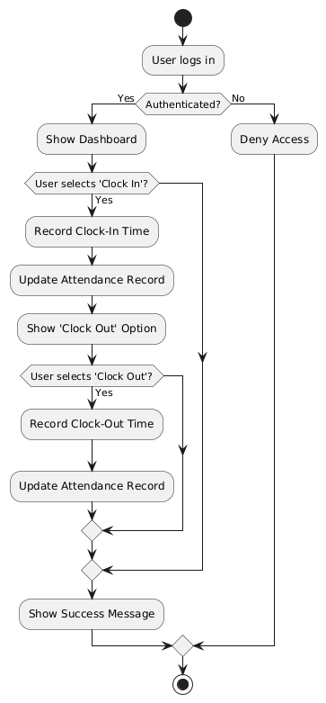

**3. USE CASE DIAGRAM**

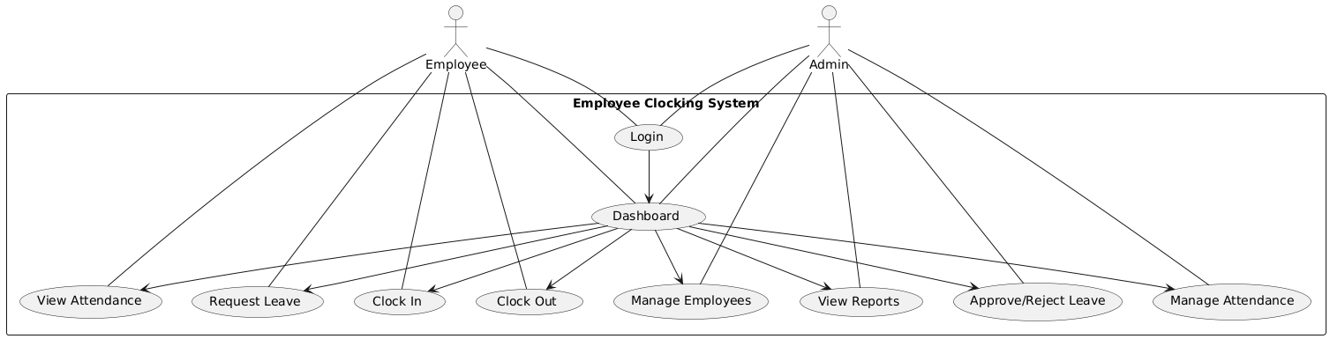

**4. CLASS DIAGRAM**

