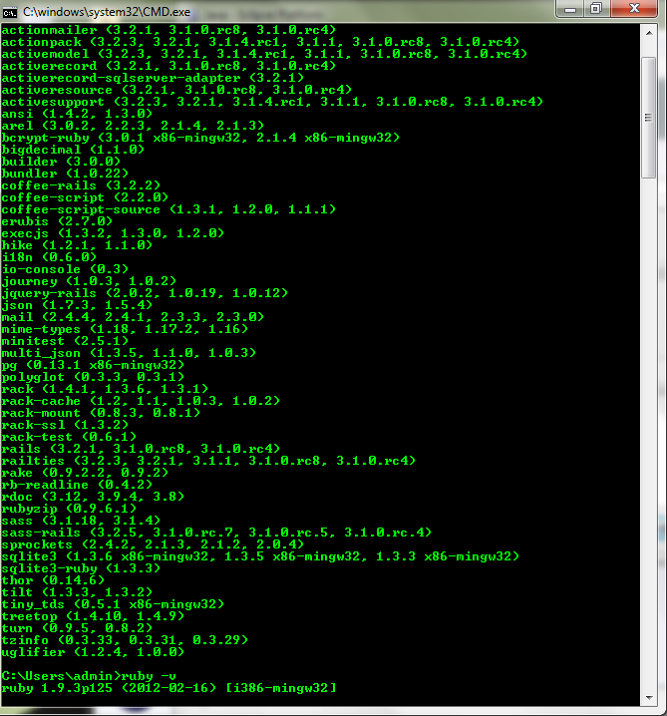

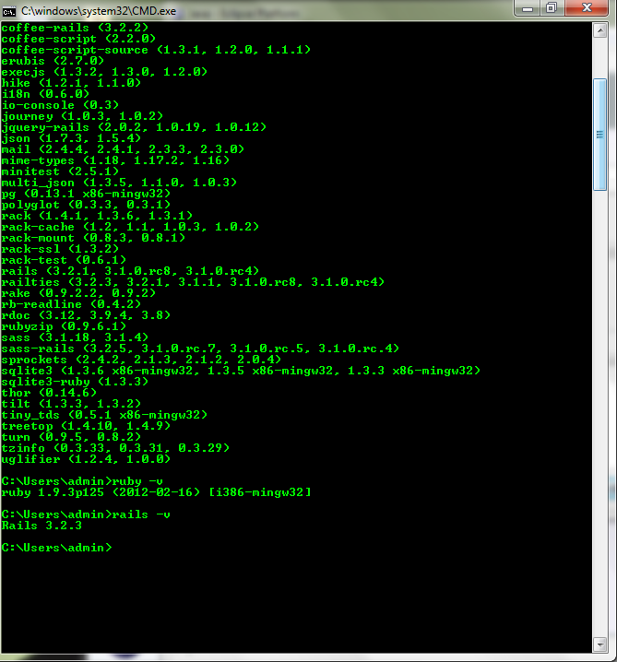

Open command prompt

Cd to the sites/rxinteraction directory

Rails server

Then open browser window to <http://localhost:3000/>