Midterm Project Template File

Module 5

Graded at 100 points

NAME: ________________________________________

 | Analysis to be performed: | EXCEL COMMAND USED  (if applicable): | NUMERIC RESULT or text-based response:
Section 2. DESCRIPTIVE STATISTICS  (20 points total, 2 points each) | - Mean | =AVERAGE(Sample_250!M2:M251) | 3.9 minutes
 | - Median | =MEDIAN(Sample_250!M2:M251) | -6.0 minutes
 | - Standard Deviation | =STDEV.S(Sample_250!M2:M251) | 38.1 minutes
 | - Variance | =VAR.S(Sample_250!M2:M251) | 1449.9 minutes squared
 | - Minimum | =MIN(Sample_250!M2:M251) | -56.0 minutes
 | - Maximum | =MAX(Sample_250!M2:M251) | 257.0 minutes
 | - 1st Quartile | =QUARTILE.INC(Sample_250!M2:M251,1) | -16.0 minutes
 | - 3rd Quartile | =QUARTILE.INC(Sample_250!M2:M251,3) | 11.0 minutes
 | - Compare the mean on-time arrival results for AIRLINE #1 vs. AIRLINE #2 and state a conclusion. | =AVERAGEIF(Sample_250!D:D,"UA",Sample_250!M:M); =AVERAGEIF(Sample_250!D:D,"WN",Sample_250!M:M); use STDEV.S with filtered carrier data. | Airline #1 = UA; Airline #2 = WN. UA mean delay is -0.8 minutes with SD 34.9 minutes. WN mean delay is 7.8 minutes with SD 29.7 minutes. UA has the better average arrival performance because its mean delay is lower, while WN is somewhat more consistent because its SD is smaller.
 | - Compare the median on-time arrival results for AIRLINE #1 vs. AIRLINE #2 and state a conclusion. | =MEDIAN(FILTER(Sample_250!M:M,Sample_250!D:D="UA")); =MEDIAN(FILTER(Sample_250!M:M,Sample_250!D:D="WN")) | UA median delay is -10.0 minutes; WN median delay is -1.0 minute. A typical UA flight arrived earlier than a typical WN flight in this sample.
Section 3.  TRIMMED MEAN  (10 points, 2.5 points each) | - Calculate a 20% trimmed mean. | =TRIMMEAN(Sample_250!M2:M251,0.2) | -4.3 minutes
 | - Does this trimmed mean represent a significantly different result as compared to the untrimmed mean calculated in Step 2a? | Compare TRIMMEAN with AVERAGE | Yes. The trimmed mean is -4.3 minutes, compared with the untrimmed mean of 3.9 minutes. The difference is about 8.2 minutes, which is noticeable for arrival-delay data.
 | - Explain why the results were significantly different or explain why the results were not significantly different. | N/A | The results differ because the sample has very large positive delay outliers, including a maximum of 257 minutes. Those unusually late flights pull the ordinary mean upward. The trimmed mean removes extreme values from both ends, so it better reflects the center of most flights.
 | - Why would someone want to calculate a trimmed mean instead of using the untrimmed mean? | N/A | A trimmed mean is useful when data are skewed or contain outliers. It reduces the effect of unusually early or unusually late flights while still using more of the dataset than the median alone.
Section 4.  SIDE-BY-SIDE BOXPLOTS  (20 points total, 4 points each) | - Copy and paste the side-by-side boxplot here: | 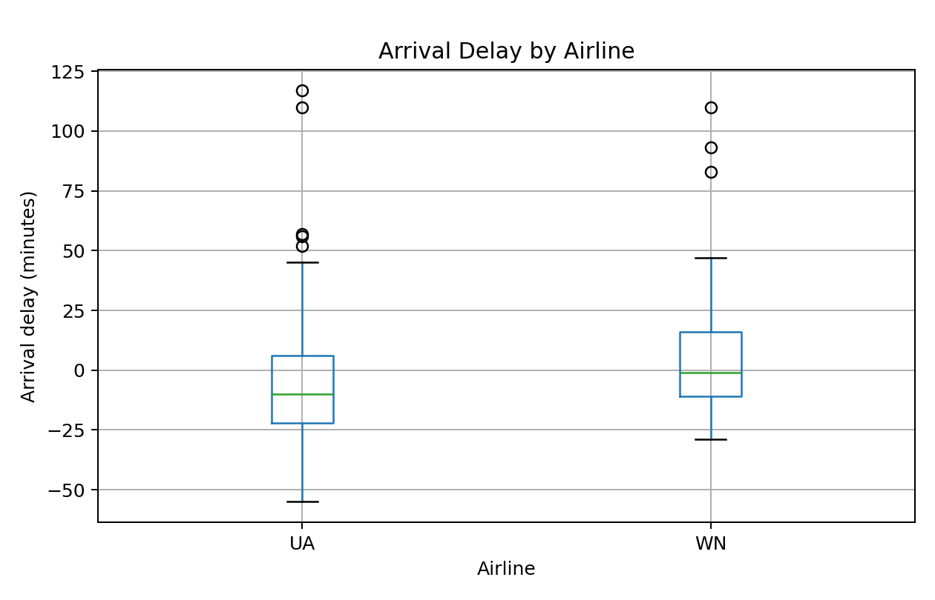
 | - Examine each boxplot separately, and comment on the shape of the distribution with respect to symmetric or skewed for each airline. | N/A | Both UA and WN appear right-skewed. Most flights are near on-time or early, but a few very late flights create long upper tails.
 | - Are there any outliers shown on the boxplots? If there are any outliers shown on the boxplot, comment on what this indicates with respect to on-time arrivals. Should the airline be concerned? | N/A | Yes. UA has high-delay outliers at 52, 56, 57, 110, 117 minutes. WN has high-delay outliers at 83, 93, 110 minutes. These are unusually late flights. The airlines should be concerned because even a few very late flights can hurt customers and raise average delay.
 | - Examining the boxplots, do you observe any significant differences in the distribution of on-time arrivals data for the two airlines? | N/A | UA has a lower median delay (-10.0 minutes) than WN (-1.0 minute), so UA has better typical performance. WN has slightly less spread by SD (29.7 vs. 34.9), so WN is somewhat more consistent. Both distributions have high positive outliers.
 | - Assume you are a manager at AIRLINE #1. State a conclusion based on your analysis of the side-by-side boxplots. | N/A | As a UA manager, I would conclude that typical performance is good because the median UA flight arrived 10 minutes early. However, the high-delay outliers show that UA should investigate causes of very late flights, especially delays above 100 minutes.
Section 5.  PARETO CHART  (10 points, 2 points each) | - Copy and paste the Pareto chart: | 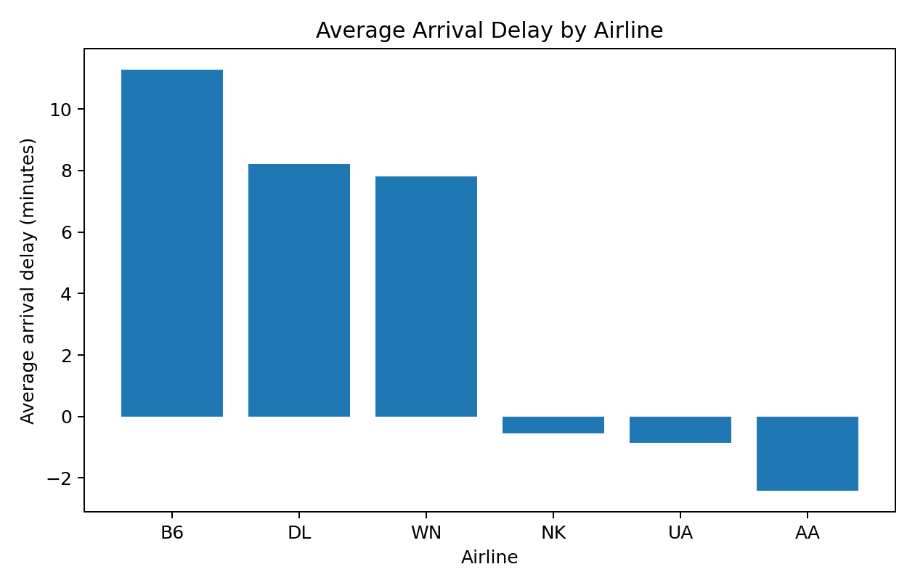
 | - Based on the Pareto chart, which is the worst performing airline for average on-time arrivals? | Sorted carrier averages | B6 is worst, with average delay 11.3 minutes.
 | - Based on the Pareto chart, which is the best performing airline for average on-time arrivals? | Sorted carrier averages | AA is best, with average delay -2.4 minutes.
 | - What is the benefit of creating a Pareto chart versus a bar chart? | N/A | A Pareto chart orders categories from largest to smallest impact, making the worst performers easy to identify quickly.
 | - Assume you are a manager at the airline with the worst performance. What steps would you investigate to improve on-time arrival? What factors might be within the control of the airline and which factors might be out of the control of the airline with respect to on-time arrival performance? | N/A | As a B6 manager, I would investigate scheduling, aircraft turnaround time, staffing, maintenance availability, boarding procedures, and whether particular routes or airports drive most delays. Within-control factors include staffing, scheduling, aircraft readiness, gate operations, and boarding efficiency. Less-controllable factors include weather, air traffic control restrictions, airport congestion, and security disruptions.
Section 6.  APPLYING NORMAL DISTRIBUTION  (20 points, 3.33 points each) | - Calculate the probability that a flight arrives early. Include the Excel command used. | =NORM.DIST(0,3.876,38.0772389823,TRUE) | 0.459
 | - Calculate the probability that a flight arrives late. Include the Excel command used. | =1-NORM.DIST(0,3.876,38.0772389823,TRUE) | 0.541
 | - Calculate the probability that the on-time arrival of a flight falls between the 1st quartile and 3rd quartile as determined from Steps 2g and 2h. Include the Excel command used. | =NORM.DIST(11,3.876,38.0772389823,TRUE)-NORM.DIST(-16,3.876,38.0772389823,TRUE) | 0.273
 | - Is the result from part (c) reasonable? What is the expected area under the normal curve between the 1st and 3rd quartile? How does your actual numeric result from part (c) compare with the expected area? | N/A | For the actual sample, Q1 to Q3 contains the middle 50% of observations. Under this fitted normal model, the area is only 0.273, much less than 0.500. This suggests the arrival-delay data are not very normal and are affected by skewness/outliers.
 | - Calculate the probability that the on-time arrival of a flight falls between the 2 standard deviations below the mean and 2 standard deviations above the mean. Include the Excel command used. | =NORM.DIST(3.876+2*38.0772389823,3.876,38.0772389823,TRUE)-NORM.DIST(3.876-2*38.0772389823,3.876,38.0772389823,TRUE) | 0.954
 | - Is the result from part (e) reasonable? What is the expected area under the normal curve between 2 standard deviations below the mean and 2 standard deviations above the mean? How does your actual numeric result from part (e) compare with the expected area? | N/A | Yes. For a normal distribution, about 95% of values fall within two standard deviations of the mean. The computed value 0.954 is very close to the expected normal-rule area.
Section 7.  INVERSE NORMAL DISTRIBUTION  (10 points, 5 points each) | - What on-time arrival delay cuts off the top 10% of the distribution? Include the Excel command used. | =NORM.INV(0.90,3.876,38.0772389823) | 52.7 minutes. Under the normal model, about 10% of flights have delays greater than this.
 | - What on-time arrival delay cuts off the bottom 15% of the distribution? Include the Excel command used. | =NORM.INV(0.15,3.876,38.0772389823) | -35.6 minutes. Under the normal model, about 15% of flights arrive more than 35.6 minutes early.
Section 8.  CHEBYSHEV’S THEOREM  (10 points, 3.3 points each) | a) For this specific question, we will assume that the distribution of age of aircraft is skewed left. Using Chebyshev’s Theorem, find the probability that the age of aircraft falls within 3 standard deviations of the mean. Show details of your calculation. | N/A | Chebyshev's theorem gives P(|X - mu| < 3sigma) >= 1 - 1/3^2 = 1 - 1/9 = 8/9 = 0.889. Therefore, at least 0.889 of the arrival-delay values fall within 3 standard deviations of the mean.
 | b) Using the normal distribution, find the probability that the age of aircraft falls within 3 standard deviations of the mean. Show details of your calculation and include any Excel commands used. | =NORM.DIST(3.876+3*38.0772389823,3.876,38.0772389823,TRUE)-NORM.DIST(3.876-3*38.0772389823,3.876,38.0772389823,TRUE) | 0.997
 | - Compare your results from parts (a) and (b). What do you conclude about the use of Chebyshev’s Theorem? | N/A | Chebyshev gives a conservative lower bound that works for any distribution with finite mean and variance. The normal result is much tighter because it assumes a specific normal shape. Here Chebyshev guarantees at least 0.889, while the normal model gives 0.997.

Note on Section 8 wording: The template says "age of aircraft," but the project instructions and dataset are about on-time arrival delay. The Section 8 calculations use the Section 2 arrival-delay mean and standard deviation.

