**COP4424 - Netaş Advanced Web Technologies**

**Project Report**

Seyfettin Eray Alp - 1507463

**1)Project Definition and Scope**

It is a website project that I have realized as a full stack developer. In my dream, I created an advertising agency and a production company called "Fact.ory". I created a site that promotes this company, specifies its works and provides contact.

**2)Motivation**

Responsive web design to make a goal.The purpose of responsive design is to have one site, but with different elements that respond differently when viewed on devices of different sizes. Since I was interested in front end develeping, I tried to work very fine in this part.

**3)Technical Details**

Use of HTML, CSS, JavaScript languages ​​for front end. I took advantage of the beautiful contents of the bootstrap library for CSS. I've used bootstrap as well as font-awasome and lightbox libraries for CSS. I also used libraries like popper.js, lightbox.js and smoothScroll.js to add dynamism to the site. I chose JS in the back-end section. I used Firebase as the database.

**4)Conclusion**

From my point of view, it was a project that I gained a lot of information and made with pleasure. I have experienced the convenience and difficulties of Full-Stack Developer.

**Project**

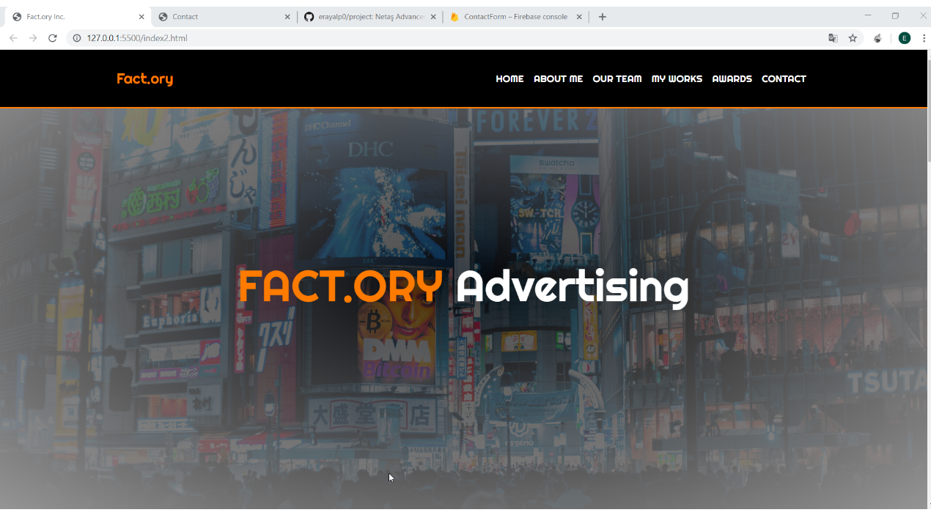

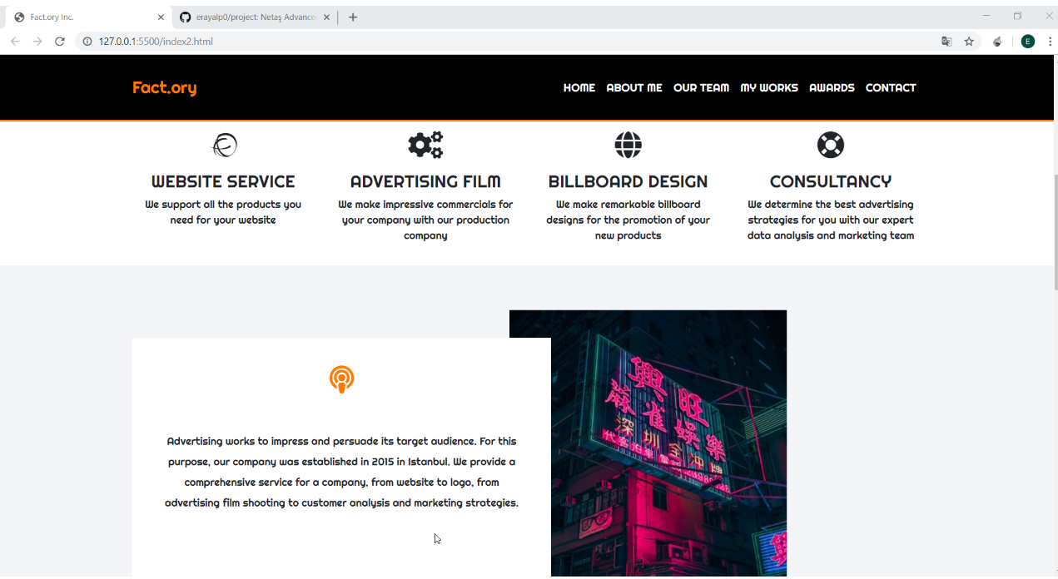

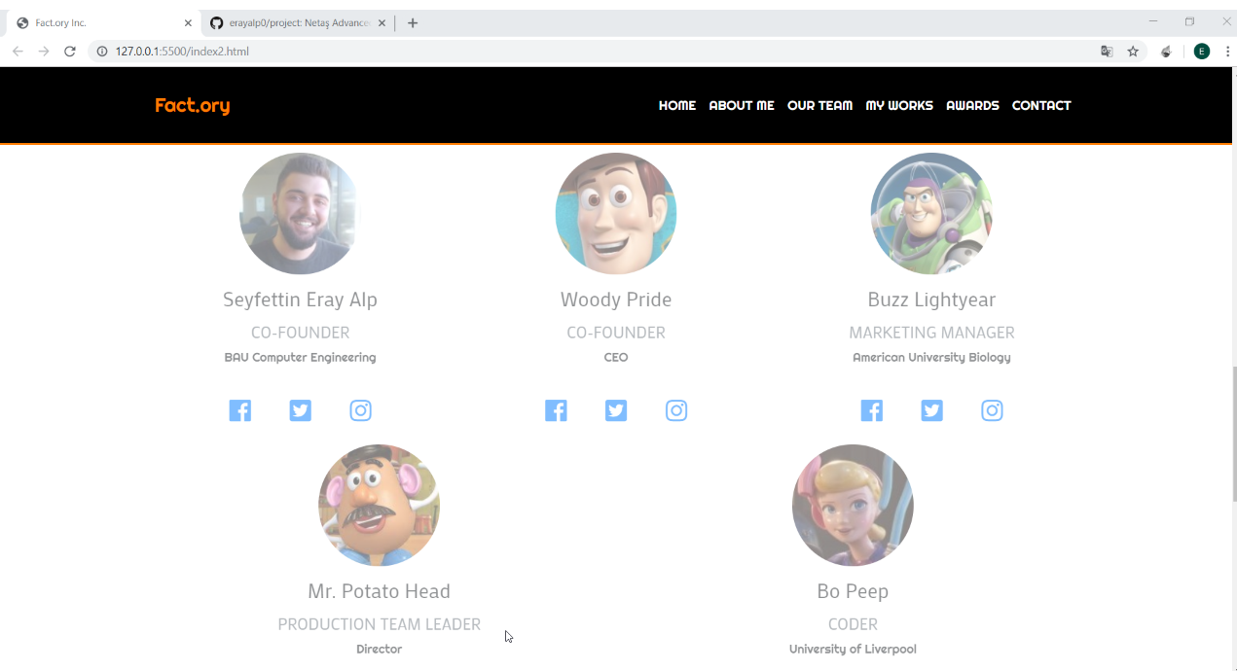

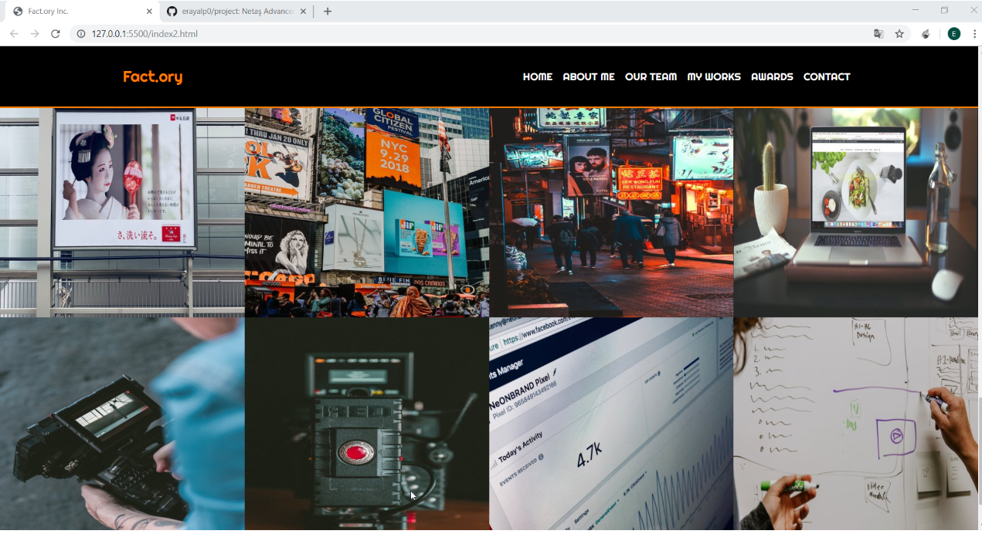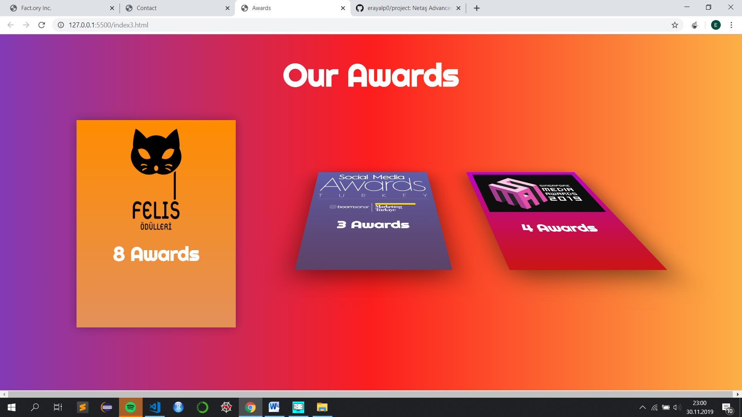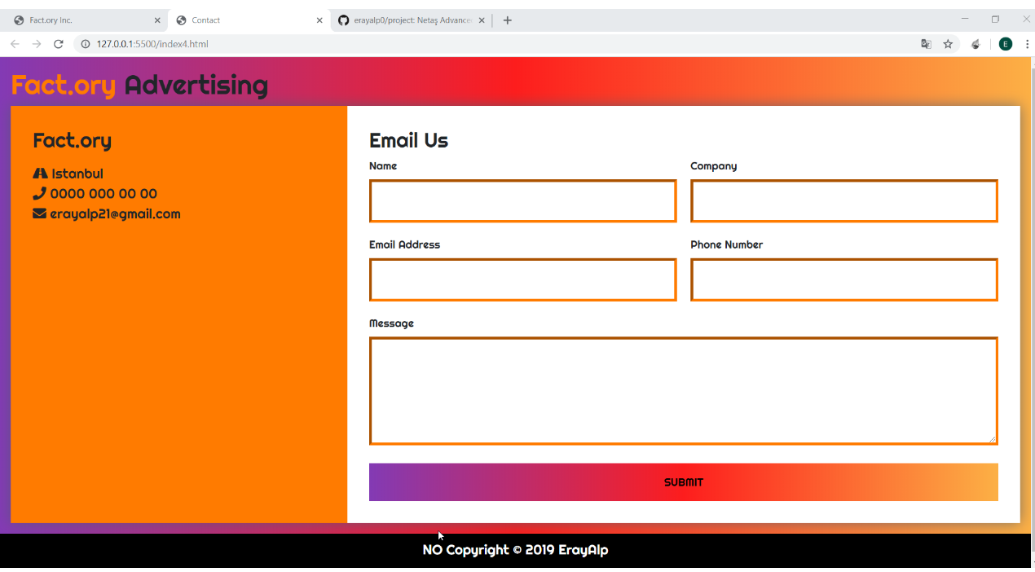

**Firebase**

