We started with implementing web server. The main method get port of the web server from user. If user didn’t specify a port number, program shows how to use the program. When user give a port number, it starts the web server with creating new HttpServer object. Then, this HttpServer creates a server socket with given port and starts for waiting connections. When there is an incoming request, it creates a GETHandler object with connection. Then a new thread is created and this GETHandler object’s run method is started.
GetHandler creates InputStreamReader and DataOutputStream with socket’s input and output streams. With this InputStreamReader a bufferedreader is created to read request from client. After request is read, request is separated with “\” token. First we check first part, method type. If it is not equal to “GET”, method of not_implemented is called. This method simply writes 501 status code, server information, content type, content length to dataOutputStream of the socket. If method type is “GET”, it checks if request contains only digits. If request contains non-digit characters it calls bad_request method. It is similar to not_implemented method, just status code header changed wih 400. If size is not between 100 and 20000 it again calls bad_request method. Otherwise, ok method is called. This method sends a html file with given size. We create an empty string and add it to a character of “a” until it reaches given size.

We implement proxy server similar to web server. It creates proxy server with 8888 port number and starts to wait requests. When a request is recevied, it creates a socket with given port number. First, it analyzes the request and convert it to the form that web server understand. It checks also size of request and call request_too_long method if size is greater than 9999. Then proxy looks cache to if request is saved. If cache doesn’t contain request, it tries to open connection with web server. If web server doesn’t respond, not_found method is called. It returns to the client response with 404 not found header. If web server accepts connection, proxy send all headers to the web server. Web server does same process to this request and send response to the proxy this time. When proxy server get the response, it creates file for caching and write the response to this file and client at same time. Finally, it adds this file to the cache. We used hash map for cache. Its key is the name of file and value is the file itself. If cache contains the requested file, it again sends request to web server to check that file is modified or not with adding a new header named “cache”. Web server actually check if first line of the response is “cache” or not. If web server get a request with this header, it checks length of the request. Notmodified method is called for odd length request with 304 not_motified header. Otherwise, it creates new file for given length and sends it to proxy. Proxy examine the response and when it contains 304 header, it returns cached file. If a new file is returned from web server, proxy sends response to client and overwrites existing cached file with new file.

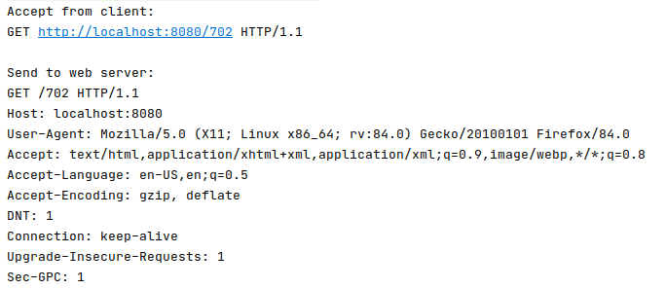Figure 1: Proxy getting request from client and forward it to web server
Figure 2: Server getting request from proxy

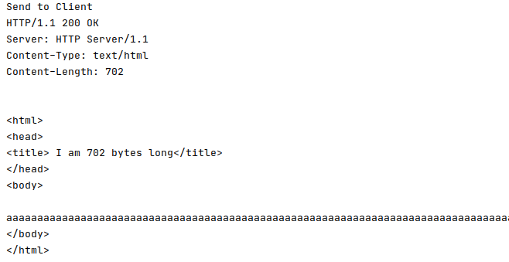Figure 3: Server preparing request send it to proxy

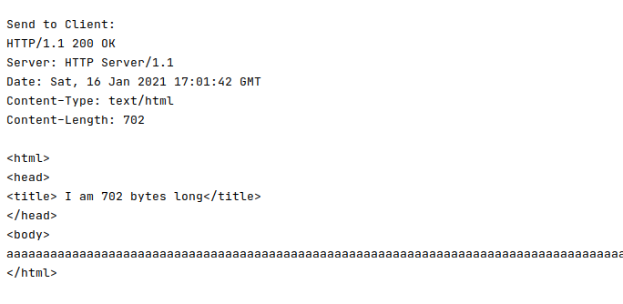Figure 4: Proxy send server's response to client

3)
a) Time taken for tests = 75,73 seconds
Total transferred = 52431510 bytes
HTML transffered = 52428800 bytes
Time per request = 7573,017 ms
Time per request = 7573,017 [ms] (mean, across all concurrent requests)
Request per second = 0.133 #/sec
Transfer rate = 676,646 Kbytes/sec
Connection times (ms)=
min mean[+/-sd] median max
Connect: 70 79 5.8 80 90
Processing: 6703 7394 876.3 7217 9640
Waiting: 73 81 5.1 82 91
Total: 6784 7473 877.9 7293 9721

b) Time taken for tests = 62,897 seconds
Total transferred = 52431510 bytes
HTML transffered = 52428800 bytes
Time per request = 31448,803 [ms] (mean)
Time per request = 6289,76 [ms] (mean, across all concurrent requests)
Request per second = 0.16 #/sec
Transfer rate = 814,076 Kbytes/sec
Connection times (ms) =
min mean[+/-sd] median max
Connect: 75 86 11.8 80 106
Processing: 24264 29454 4107.0 30079 37771
Waiting: 78 121 74.6 100 329
Total: 24352 29540 4100.6 30176 37848

c)Time taken for tests = 63.093 seconds
Total transferred = 52431510 bytes
HTML transffered = 52428800 bytes
Time per request = 63092,673 [ms] (mean)
Time per request = 6309,267 [ms] (mean, across all concurrent requests)
Request per second = 0.16 #/sec
Transfer rate = 811,573 Kbytes/sec
Connection times (ms) =
min mean[+/-sd] median max
Connect: 73 87 11.5 86 104
Processing: 53816 59227 2776.0 60156 62542
Waiting: 77 202 153.8 149 537
Total: 53903 59314 2774.0 60260 62616

d) a)Time taken for tests = 64.6183 seconds
Total transferred = 52431510 bytes
HTML transffered = 52428800 bytes
Time per request = 6388.991 [ms] (mean)
Time per request = 6388.991 [ms] (mean, across all concurrent requests)
Request per second = 0,156 #/sec
Transfer rate = 792,653 Kbytes/sec
Connection times (ms) =
min mean[+/-sd] median max
Connect: 0 7 23.4 0 74
Processing: 6288 6360 64.0 6347 6451
Waiting: 77 78 1.3 78 81
Total: 6288 6367 71.8 6347 6465

b)Time taken for tests = 66.131seconds
Total transferred = 52431510 bytes
HTML transffered = 52428800 bytes
Time per request = 33065,982 [ms] (mean)
Time per request = 6613,196 [ms] (mean, across all concurrent requests)
Request per second = 0,153 #/sec
Transfer rate = 776,63 Kbytes/sec

Connection times (ms) =
min mean[+/-sd] median max
Connect: 0 39 42.2 69 98
Processing: 27108 30371 2530.6 30724 35134
Waiting: 71 91 12.4 93 116
Total: 27206 30410 2543.5 30724 35209

c)Time taken for tests = 63,925 seconds
Total transferred = 52431510 bytes
HTML transffered = 52428800 bytes
Time per request = 63958,518 [ms] (mean)
Time per request = 6392,518 [ms] (mean, across all concurrent requests)
Request per second = 0,156 #/sec
Transfer rate = 801,296 Kbytes/sec
Connection times (ms) =
min mean[+/-sd] median max
Connect: 71 83 6.3 85 89
Processing: 53369 60452 2669.1 61472 63096
Waiting: 72 158 99.7 128 343
Total: 53454 60535 2667.3 61561 63171

Times taken for tests are very similar between concurrency level 5 and 10. However, there is a big difference concurrency level 1 test. When we increase concurrency level, required time of processing for each request is also increased, we can see processing time in connection times section. So time per request is higher for high level of concurrency. If we look time per request across all concurrent request, they are not different because it tells us mean time of a single request to complete, not the real time it takes to complete.

When we use keep alive option, values don’t change except min time of connect time. It changed to 0 for concurrency level 1 and 5. Since connection between is not closed, server doesn’t require establish a new connection for other requests.

4) We sent 10000 request to our web server with concurrency level of 1, 2, 3, 4, 5. Time per request and request per second values are provided in the table below.

Concurrency level | 1 | 2 | 3 | 4 | 5
Request per second(#/sec) | 2218.50 | 3056.71 | 3181.17 | 3021.99 | 2933.53
Time per request(ms) | 0.451 | 0.654 | 0.943 | 1.324 | 1.704
Time per request(ms)(mean, across all concurrent requests) | 0.451 | 0.327 | 0.314 | 0.331 | 0.341

Time per request value is increasing when concurrency level is increasing. Since server is processing all parellel request at the same time, required time for completing a single request is higher than completing a non-parellel request. Advantage of this accepting parellel request is number of the completed requets per second. Server served 2218 request per second with concurrency level 1 but it increased 3000 for other concurrency levels. So it affects time per request value across all concurrent requets. Even though time of individual request is higher while sending parellel requests, average of completing a request is lower than concurrency level 1.

We also test how many concurrent request server handle. If concurrency level is higher than 1019, server can’t handle any request. If we use high concurrency levels such as 100, server behaves similar to concurrency level 1 in terms of request per second and time per request (across all concurrent request). Our server handled 500000 request with concurrency level 10 in 103 seconds.

Concurrency level | 1 | 2 | 3 | 4 | 5
Request per second(#/sec) | 842.49 | 1504.73 | 1678.43 | 1557.46 | 1767.45
Time per request(ms) | 1.187 | 1.329 | 1.787 | 2.133 | 2.389
Time per request(ms)(mean, across all concurrent requests) | 1.187 | 0.665 | 0.596 | 0.642 | 0.835

We tested our proxy server with 10000 request with same concurrency levels as web server. Results are very similar to web server but times are higher. Since we create two threads for two different connections this difference is normal.

