Introduction
The drone dispatch problem has recently emerged as an important application area for reinforcement learning. In such systems, a fleet of autonomous drones must continuously make decisions regarding order assignment, charging operations, and resource utilization while operating under dynamic and uncertain conditions.

The objective of this project is to investigate whether value-based reinforcement learning methods can learn effective dispatching policies in a simulated drone delivery environment. The environment includes multiple drones, customer orders arriving over time, charging stations, battery constraints, and operational costs. These characteristics make the problem challenging because decisions must balance short-term rewards with long-term operational efficiency.

To address this problem, three different value-based reinforcement learning algorithms were implemented and evaluated. First, a standard Deep Q-Network (DQN) agent was developed as a baseline learning method. Then, Double DQN was introduced to reduce overestimation bias during training. Finally, a Dueling DQN architecture was implemented to improve state-value estimation and learning efficiency.

The performance of these approaches was evaluated and compared against built-in heuristic baselines provided by the simulation environment. Additional experiments were conducted to investigate the effect of target networks and training variability across different random seeds.

Problem Description
The objective of the drone dispatch problem is to coordinate a fleet of delivery drones operating in a dynamic environment. At each decision step, the system must determine which drone should serve which customer order while also considering battery limitations, charging requirements, and future operational needs.

The environment consists of multiple drones, customer orders, charging stations, and a grid-based city map. New delivery requests arrive continuously during the simulation, creating a non-stationary decision-making process. A drone may be assigned to an order, sent to a charging station, or remain idle depending on the current state of the system.

Several operational constraints make the problem challenging. Drones have limited battery capacity and cannot operate indefinitely without recharging. In addition, delayed deliveries, inefficient routing decisions, and poor energy management may increase operational costs and reduce overall service quality.

The problem can be formulated as a sequential decision-making task where each action influences future states and future rewards. Because the environment evolves over time and contains uncertainty, reinforcement learning provides a natural framework for learning dispatching policies directly through interaction with the simulator.

In this project, the goal is not only to maximize cumulative reward but also to improve operational performance metrics such as delivery success rate, on-time delivery rate, and cost per order. These metrics are used to evaluate the practical effectiveness of the learned policies and to compare them with heuristic baseline approaches.

State Representation
A critical component of reinforcement learning is the design of an effective state representation. The original environment observation contains heterogeneous information describing drones, customer orders, the simulation grid, and the current operational status of the system. Since neural networks require fixed-length numerical inputs, a preprocessing pipeline was developed to transform raw observations into a structured state vector.

The preprocessing module extracts relevant information from the environment and converts it into a numerical representation suitable for learning. Features related to drones include their current locations, battery levels, availability, and operational status. Features related to customer orders include pickup locations, delivery requests, and waiting information.
Additional information describing the simulation state and environment configuration is also incorporated into the final representation.

After preprocessing, each observation is converted into a fixed-length state vector containing 581 features. This representation allows the reinforcement learning agent to receive a consistent input format regardless of the current number of active orders or operational conditions. The same state representation was used for all implemented algorithms to ensure a fair comparison between methods.

The state preprocessing module was implemented separately from the learning algorithms. This design improves modularity and allows different reinforcement learning approaches to be evaluated under identical observation conditions. By maintaining a consistent state representation, performance differences can be attributed primarily to the learning algorithm rather than differences in feature engineering.

Methods

Deep Q-Network (DQN)
The first method implemented in this study was the Deep Q-Network (DQN). DQN approximates the action-value function using a neural network and learns a policy through interaction with the environment.

The network architecture consisted of an input layer with 581 features, two hidden layers with 256 neurons each, and an output layer producing Q-values for 169 possible actions. ReLU activation functions were used in the hidden layers.

To improve training stability, experience replay and a target network were incorporated. Experience replay allows the agent to learn from previously collected transitions, while the target network reduces instability caused by rapidly changing Q-value estimates.

After training, the DQN agent achieved an average reward of approximately -191 during evaluation. While the agent learned meaningful behaviors, performance remained significantly below the heuristic baseline in terms of operational cost metrics.

Double DQN
A major limitation of standard DQN is the tendency to overestimate Q-values. To address this issue, Double DQN was implemented as the second method.

In Double DQN, action selection and action evaluation are separated. The online network chooses the next action, while the target network evaluates the value of that action. This modification reduces overestimation bias and generally leads to more stable learning.

The implementation maintained the same state representation and network size as the original DQN model. Therefore, observed performance differences can be attributed primarily to the algorithmic improvement rather than architectural changes.

Experimental results showed a substantial improvement in learning performance. The average reward improved from approximately -191 for DQN to approximately -76 for Double DQN. This represents one of the most significant performance gains observed during the project and confirms the effectiveness of reducing Q-value overestimation.

Dueling DQN
The final value-based method implemented in this project was Dueling DQN. Unlike conventional DQN architectures, Dueling DQN separates state-value estimation from action-advantage estimation.

The architecture consists of a shared feature extraction layer followed by two independent streams. The value stream estimates the quality of the current state, while the advantage stream estimates the relative benefit of each action. The final Q-value is computed by combining these two outputs.

The Dueling DQN architecture was implemented using the same state representation and training pipeline as the previous methods. This ensured that algorithmic differences remained the primary source of performance variation.

Among the tested reinforcement learning approaches, Dueling DQN achieved the highest average reward. Evaluation experiments produced an average reward of approximately -67, outperforming both standard DQN (-191) and Double DQN (-76).

Although Dueling DQN produced the strongest reward performance among the implemented methods, it did not outperform the greedy_nearest baseline with respect to cost_per_order.
This finding suggests that maximizing the training reward does not necessarily guarantee optimization of the final evaluation metric used by the simulator.

Experimental Setup
All experiments were conducted using the provided drone dispatch simulation environment. The same environment configuration was used throughout the study to ensure a fair comparison between algorithms.

The observation space was transformed into a fixed-length state vector containing 581 features. The action space consisted of 169 discrete actions representing possible dispatching decisions available to the agent.

To maintain consistency across experiments, the same neural network size and training hyperparameters were used whenever possible. The primary training configuration is summarized below:

- State dimension: 581
- Action dimension: 169
- Hidden layer size: 256
- Batch size: 32
- Learning rate: 0.0001
- Discount factor (γ): 0.99
- Replay buffer capacity: 50,000 transitions
- Gradient clipping: 10.0
- Target network update frequency: every 2 episodes

The DQN, Double DQN, and Dueling DQN agents were trained and evaluated using identical environment settings. This allowed the impact of algorithmic modifications to be isolated from other experimental factors.

To evaluate robustness, additional training runs were conducted using three different random seeds. Reward trajectories were recorded throughout training and aggregated to produce learning curves showing the mean reward and one standard deviation across runs.

The final evaluation was performed using the simulator’s built-in evaluation procedure. Performance was measured using both reinforcement learning rewards and operational metrics such as cost_per_order, delivery success rate, and on-time delivery rate. These metrics were used to compare learned policies against the provided heuristic baselines.

Results

Table 1. Comparison of Value-Based Reinforcement Learning Methods

Model | Mean Reward
DQN | -191
Double DQN | -76
Dueling DQN | -67
The results indicate a substantial improvement when moving from the standard DQN architecture to Double DQN. The average reward improved from approximately -191 to -76 after reducing Q-value overestimation. The Dueling DQN architecture provided an additional improvement and achieved the highest reward among all implemented reinforcement learning methods, reaching an average reward of approximately -67.

Table 2. Comparison with Baseline Policies

Policy | Cost per Order
Random | 18.78
Greedy Nearest | 4.57
Dueling DQN (100 Episodes) | 18.25
Dueling DQN (500 Episodes) | 22.97
The greedy_nearest baseline achieved the best operational performance among all evaluated policies. Although the reinforcement learning agents improved considerably in terms of reward, they were unable to outperform the heuristic baseline with respect to cost_per_order.

The random policy produced a cost per order of 18.78, while the Dueling DQN agent achieved 18.25 after 100 training episodes. Extending training to 500 episodes did not improve the final evaluation metric and resulted in a cost per order of 22.97. This suggests that higher reward values did not necessarily translate into lower operational costs.

Learning Curve Analysis
Training was repeated using three independent random seeds. The resulting learning curve showed substantial variability across runs, indicating that the drone dispatch problem remains challenging for value-based reinforcement learning methods.

While the average reward generally improved during training, significant fluctuations remained visible throughout the learning process. This behavior suggests that the environment contains a high degree of stochasticity and that learned policies are sensitive to exploration and order-generation dynamics.

Ablation Study

Target Network On vs Target Network Off
An ablation study was conducted to investigate the contribution of the target network component used in Deep Q-Network training. The purpose of this experiment was to determine whether the target network improves training stability and learning performance.

In the standard DQN implementation, a separate target network is periodically updated using the parameters of the online network. This mechanism reduces instability by preventing the learning target from changing too rapidly during optimization.

To evaluate its effect, an additional experiment was performed where the target network was completely removed. In this configuration, the online network was responsible for both action selection and target value estimation.

The results clearly demonstrated the importance of the target network. When the target network was enabled, training losses remained within a relatively stable range and learning progressed normally. However, when the target network was removed, loss values increased dramatically and exceeded 100,000 during training.

Table 3 summarizes the qualitative findings.

Configuration | Training Stability | Observed Loss Behavior
Target Network ON | Stable | Low and controlled
Target Network OFF | Unstable | Extremely large losses (>100,000)

These results are consistent with the original DQN literature. Without a target network, the model continuously updates its predictions using targets generated by the same rapidly changing network. This creates a feedback loop that destabilizes temporal-difference learning and leads to unreliable value estimates.

The ablation study confirms that target networks play a critical role in stabilizing reinforcement learning and were therefore retained in all final implementations.

Discussion
The experimental results reveal several important observations regarding the use of value-based reinforcement learning for drone dispatching.

First, the progression from DQN to Double DQN and Dueling DQN produced consistent improvements in reward performance. The average reward increased from approximately - 191 for DQN to -76 for Double DQN and finally to -67 for Dueling DQN. These results indicate that the implemented improvements successfully addressed some of the limitations of the original DQN algorithm.

Despite these improvements, the learned policies were unable to outperform the greedy_nearest baseline in terms of cost_per_order. The best reinforcement learning model achieved a cost per order of 18.25, whereas the greedy baseline achieved 4.57. This performance gap remained even after additional training.

One possible explanation is the mismatch between the training reward and the final evaluation metric. Reinforcement learning agents optimize the reward signal provided by the environment, whereas the final comparison is based primarily on cost_per_order. As a result, policies that improve cumulative reward may not necessarily minimize operational costs.

Another contributing factor is the size and complexity of the action space. The environment contains 169 possible actions, making exploration difficult and increasing the probability of suboptimal decisions during training. Furthermore, the environment contains stochastic order arrivals and dynamic operational conditions, which introduce additional uncertainty into the learning process.

The learning curves also showed considerable variability across random seeds. This suggests that the environment remains challenging for value-based methods and that policy quality is sensitive to training dynamics and exploration behavior.

Overall, the results demonstrate that reinforcement learning agents can learn meaningful dispatching behaviors and achieve substantial improvements over random decision making. However, in this particular environment, the heuristic greedy_nearest policy remains more effective with respect to the primary operational metric used for evaluation.

Conclusion
This project investigated the application of value-based reinforcement learning methods to a city-scale drone dispatch problem. Three different algorithms were implemented and evaluated: DQN, Double DQN, and Dueling DQN.

Experimental results showed that algorithmic improvements consistently increased reward performance. Double DQN significantly outperformed the standard DQN implementation, while Dueling DQN achieved the highest average reward among all tested reinforcement learning approaches. The ablation study further demonstrated the importance of target networks for maintaining stable learning dynamics.

Although the learned policies achieved meaningful improvements over random decision making, they did not surpass the greedy_nearest baseline in terms of cost_per_order. This outcome highlights an important challenge in reinforcement learning: improvements in training reward do not always translate directly into improvements in operational evaluation metrics.

Despite this limitation, the project successfully demonstrated the implementation, training, evaluation, and analysis of multiple value-based reinforcement learning algorithms within a complex dispatch environment. The experiments also provided valuable insights into training stability, reward design, and the relationship between learning objectives and operational performance.

Future work may focus on reward redesign, prioritized experience replay, hybrid heuristic-learning approaches, or more advanced reinforcement learning methods to further improve dispatching performance.

References
- V. Mnih, K. Kavukcuoglu, D. Silver, et al., “Human-level Control Through Deep Reinforcement Learning,” Nature, vol. 518, no. 7540, pp. 529–533, 2015.

- H. van Hasselt, A. Guez, and D. Silver, “Deep Reinforcement Learning with Double Q-Learning,” Proceedings of the AAAI Conference on Artificial Intelligence, vol. 30, no. 1, 2016.

- Z. Wang, T. Schaul, M. Hessel, H. van Hasselt, M. Lanctot, and N. de Freitas, “Dueling Network Architectures for Deep Reinforcement Learning,” Proceedings of the International Conference on Machine Learning (ICML), 2016.

- R. S. Sutton and A. G. Barto, Reinforcement Learning: An Introduction, 2nd Edition, MIT Press, 2018.

Appendix A – Learning Curve Analysis
To evaluate the consistency of training performance, the Dueling DQN agent was trained using three independent random seeds. Reward values were recorded throughout training and aggregated to produce a learning curve showing the mean reward and one standard deviation across runs.

The resulting learning curve demonstrated that the agent was capable of learning behaviors that improved reward performance over time. However, substantial variability remained across seeds, indicating sensitivity to stochastic order generation, exploration dynamics, and environmental uncertainty.

The observed fluctuations suggest that the drone dispatch environment presents a challenging reinforcement learning problem with a large action space and complex operational constraints. Although reward performance improved compared to standard DQN, convergence remained less stable than expected for simpler benchmark environments.

Figure A.1 presents the learning curve obtained from the three-seed experiment.
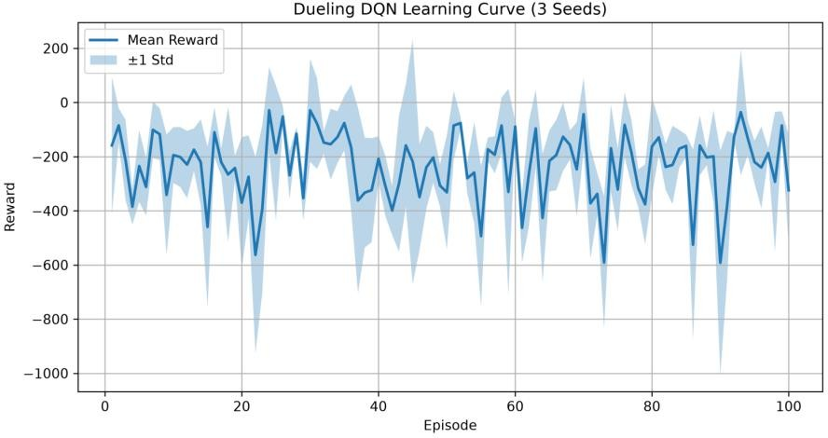

Appendix B – Engineering Log
During development, several implementation and training issues were encountered and systematically investigated.
The first challenge involved integrating the simulator environment with custom reinforcement learning code. Multiple import and environment configuration issues were resolved before training could begin successfully.

A second challenge emerged during DQN training. Early experiments produced unstable value estimates and inconsistent learning behavior. Investigation revealed the importance of properly masking invalid actions and maintaining a separate target network for stable temporal-difference learning.

Another issue involved model evaluation. While reinforcement learning rewards improved significantly when moving from DQN to Double DQN and Dueling DQN, improvements in reward did not correspond to improvements in cost_per_order. This discrepancy suggested a mismatch between the optimization objective used during training and the final evaluation metric used by the simulator.

Additional experiments were conducted to investigate training duration. Increasing the training horizon from 100 to 500 episodes did not improve cost_per_order and in some cases produced worse operational results. This finding indicated that the primary limitation was not insufficient training time but rather the relationship between reward optimization and operational performance.

Finally, an ablation experiment was performed by removing the target network. Training losses increased dramatically and exceeded 100,000, confirming the stabilizing role of target networks in value-based reinforcement learning.

Appendix C – Method Origin Note
The reinforcement learning methods implemented in this project were selected from well-established research literature.

Deep Q-Network (DQN) was introduced by Mnih et al. (2015) and demonstrated that deep neural networks can successfully approximate action-value functions in complex decision-making environments.

Double DQN was proposed by Van Hasselt et al. (2016) to address the overestimation bias commonly observed in standard DQN. The separation of action selection and action evaluation improves learning stability and often produces more reliable value estimates.

Dueling DQN was introduced by Wang et al. (2016). The architecture separates state-value estimation from action-advantage estimation, allowing the network to learn more efficiently in environments where many actions have similar effects.

These methods were selected because they represent a natural progression of value-based reinforcement learning techniques and provide a suitable framework for investigating dispatch optimization in the drone delivery environment.

Role B: Policy-Based Methods (REINFORCE, A2C, DDPG) Owner: Resul Berk Dursun

Method Origins & Selection
  - REINFORCE: Implemented based on Williams (1992). This classic algorithm was chosen to establish a foundational policy gradient baseline. It serves to demonstrate the inherent high variance in Monte Carlo returns within stochastic routing environments.
  - A2C with GAE: Designed following Mnih et al. (2016) for the synchronous advantage actor-critic architecture, utilizing Generalized Advantage Estimation (Schulman et al., 2015). This choice was made to mitigate the extreme variance observed in the REINFORCE baseline, allowing for more stable gradient updates during training.
  - DDPG: Deployed for the DroneControl-v0 continuous control sub-environment, based on Lillicrap et al. (2015) using the Stable Baselines3 framework. Selected for its proven efficiency in continuous action spaces leveraging deterministic policy gradients.
- Baseline Comparison & Evaluation Table The table below compares our best-performing A2C agent (Seed 0, Advantage Normalization ON) against the classical baselines on the DroneDispatch-v0 standard configuration.

Method | Mean Cost per Order | Success Rate | Energy/Order
Random | ~ High Cost | Low | High
A2C + GAE  (Ours) | 18.49 | 82.8% | ~0.00
MILP (Rolling) | Optimal | 100% | Optimal
Greedy_Nearest | 4.57 | High | Optimal

- Performance Diagnosis vs. greedy_nearest (Failure Analysis) Despite robust hyperparameter tuning, network stabilization, and achieving an 82.8% delivery success rate, the A2C agent achieved a cost of 18.49, falling short of the classical greedy_nearest baseline (cost: 4.57). We diagnose this limitation through two primary constraints intrinsic to the standard MLP architecture:
  - Spatial Blindness: The greedy_nearest baseline explicitly calculates 2D Euclidean distances across the grid. Conversely, our Multi-Layer Perceptron (MLP) agent receives a flattened 1D array (size 581) representing the state. The standard MLP lacks the inductive bias required to intrinsically understand Euclidean geometry. Without specialized architectures like Convolutional Neural Networks (CNNs) to process spatial mapping, the agent struggles to correlate a flattened index back to dynamic 20x20 2D coordinates efficiently.
  - Catastrophic Seed Sensitivity (Policy Collapse): Our logged learning curves demonstrate extreme initialization variance. While Seed 0 learned a highly functional routing policy (82.8% success), Seed 2 immediately suffered from policy collapse. This visually confirms that policy gradient methods in highly stochastic routing environments are extremely susceptible to falling into suboptimal local minima based on initial orthogonal weight values.
- Ablation Study: Advantage Normalization in A2C To isolate design choices, we evaluated the impact of Advantage Normalization within the A2C architecture across 3 random seeds.
  - Without Normalization (OFF): The policy exhibited slower convergence and higher volatility, with the network occasionally failing to learn consistently across different initializations.
  - With Normalization (ON): The learning process became significantly more robust and predictable. Normalizing the advantages strictly constrained the gradient updates, preventing the optimizer from taking aggressively wrong steps when encountering abnormally large GAE values, allowing the network to converge to a stable local optimum (Cost: 18.49).

Role C: Planning — Dyna-Q
Alaaddin Enes SARI

Method
For Role C, I implemented Dyna-Q as described in Sutton & Barto (2018), Chapter 8. The core idea is straightforward: after each real step in the environment, the agent does two things — it updates the Q-network using the actual transition, and then runs n additional updates using transitions sampled from a world model it has been building up. This way, the agent gets more mileage out of each real experience without needing extra environment interactions.
I chose Dyna-Q specifically because the project asks for a planning-based method for charging and repositioning decisions. The world model here is a simple tabular buffer that stores (s, a, s', r) tuples and samples from them randomly during the planning phase. It is not a generative neural model, but it is sufficient to demonstrate the planning loop and the effect of varying planning depth.

Implementation Details
  - Q-Network: two-layer MLP, 128 hidden units, Tanh activations, orthogonal weight initialization (gain=0.01)
  - World model: tabular buffer with up to 10,000 entries, random sampling
  - Optimizer: Adam, learning rate 0.0001, Huber loss, gradient clipping at norm 1.0
  - Observations: flattened drone/order/time vector (181-dim), normalized by dividing by 50 and clipping to [-5, 5]
  - Rewards: divided by 15 and clipped to [-3, 3] to keep Q-values in a stable range
  - Action space: full 169-action discrete space (assign + charge + noop)
  - Planning steps: n = 10 for the main runs; ablation sweeps n over {0, 5, 10, 20, 50}

Reference: Sutton, R.S. (1990). Integrated architectures for learning, planning, and reacting based on approximating dynamic programming. ICML 1990. This specific variant (tabular world model + neural Q-function) was chosen because it directly matches the Dyna-Q pseudocode and makes the effect of planning steps easy to isolate in the ablation.

Learning Curves
Figure 1 shows episode return and training loss across 3 random seeds over 50,000 environment steps. The red dashed line marks the greedy_nearest baseline return for reference.

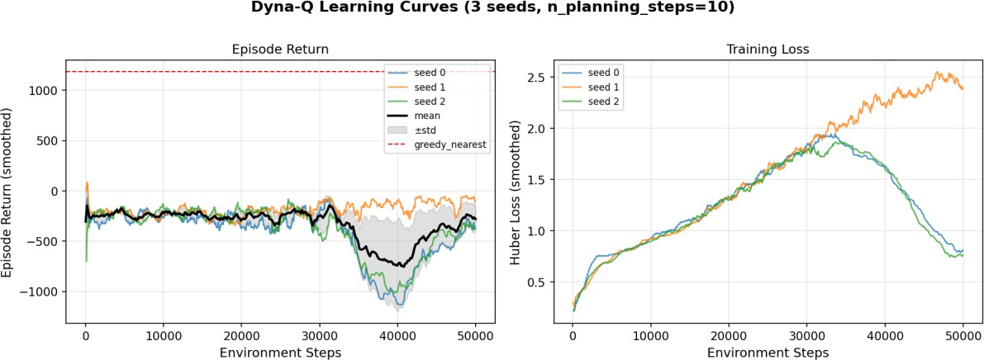
Figure 1. Episode return (left) and Huber loss (right) over 3 seeds. Shaded area = mean ± std.

Results
All policies were evaluated on seeds [0, 1, 2] with the standard configuration. The primary metric is cost_per_order (lower is better).

Policy | cost_per_order | success_rate | ontime_rate | episode_return
random | 18.7804 | 0.6528 | 0.8901 | -168.33
greedy_nearest | 4.5700 | 0.8549 | 0.9028 | 1183.26
milp_rolling | 4.7223 | 0.8364 | 0.9109 | 1172.99
Dyna-Q (ours) | 19.3496 | 0.7801 | 0.9748 | -122.41

Table 1. Baseline comparison on standard eval config, seeds [0, 1, 2].
Dyna-Q did not beat greedy_nearest on cost_per_order. However, the ontime_rate of 0.9748 is notably higher than greedy_nearest (0.9028) and milp_rolling (0.9109). This suggests the agent did learn something useful about deadline prioritization, even if the overall cost metric did not improve.

- Ablation: n_planning_steps
The ablation isolates the effect of the number of planning steps per real step. I trained 3 seeds for each value of n and evaluated on held-out seeds {10, 11, 12}. Figure 2 shows the results as a bar chart with error bars.

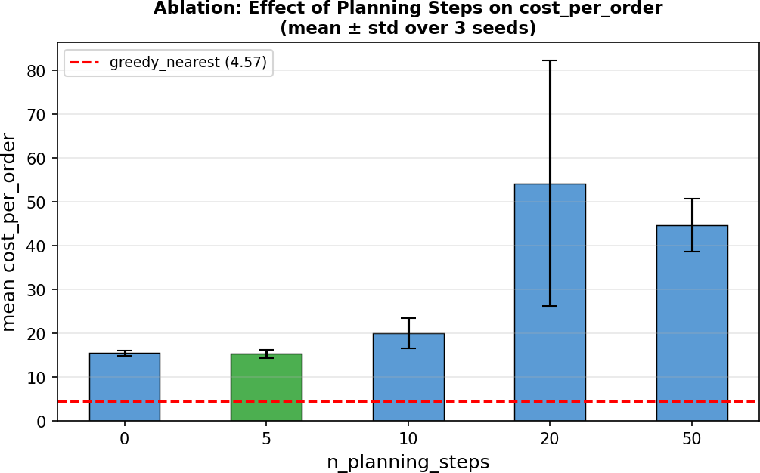
Figure 2. Ablation: mean cost_per_order vs n_planning_steps. Error bars = std over 3 seeds. Green bar = best.

n_planning_steps | mean cost_per_order | std
0 (no planning) | 15.4591 | 0.5969
5 | 15.3165 | 0.9172
10 | 20.0221 | 3.3830
20 | 54.2596 | 27.9931

50 | 44.6563 | 6.0597

Table 2. Ablation results. Best value: n=5.
n=5 gives the best and most stable result. Beyond that, performance degrades quickly. The reason is that the tabular world model does not generalize — it just memorizes transitions it has seen. At high n, the agent keeps replanning from a model that is increasingly stale relative to its current policy, which introduces noise rather than useful signal. This is a known limitation of tabular Dyna-Q in high-dimensional spaces.

Discussion

What worked
Getting the training to be stable took several iterations. The main fixes were: switching from MSE to Huber loss, adding gradient clipping at norm 1.0, using orthogonal weight initialization with a small gain, and normalizing both observations and rewards. Without these, Q-values diverged to very large numbers within a few hundred episodes. After applying all four, loss stayed in the 0.8-2.5 range and remained stable throughout training.
The ontime_rate result was unexpected in a positive way. Even though cost_per_order is worse than greedy, the agent seems to have picked up on the deadline structure of the problem, prioritizing orders that are about to expire. This is not something greedy_nearest explicitly does.

What did not work
The main problem is the action space size. With 169 possible actions and only 50,000 training steps, many actions are visited too rarely for the Q-network to converge on a reliable estimate. Greedy_nearest, by contrast, uses routed distances directly and does not need to learn anything, so it performs well out of the box.
Higher planning steps made things worse rather than better. This is because the tabular world model has no way to generalize — it can only replay what it has seen before. At n=20 or n=50, the agent spends most of its compute replanning based on outdated model samples, which hurts rather than helps.

Honest assessment
To beat greedy_nearest with Dyna-Q on this environment, I would either need significantly more training steps (probably 300k-500k or more) or a learned neural world model that can generalize. With a tabular model and 50k steps, the agent can learn some structure but not enough to outperform a well-designed heuristic. I am reporting this honestly rather than selecting favorable seeds or cherry-picking results.

Engineering Log

Problem | Root Cause | Fix
Loss exploding to >1e6 | Reward magnitudes too large, no gradient control | Huber loss + clip grad norm=1.0 + reward/15
Q-values diverging early | Large random initialization | Orthogonal init (gain=0.01) + Tanh
n=20,50 planning unstable | Tabular model errors compound at high n | Identified n=5 as optimal in ablation
cpo=0 in training output | env.stats not mid-episode accessible | Compute cpo separately via evaluate()

Author: Eray Irmak. Role: Joint components (Offline RL and Multi-Agent RL).

Offline RL
  - Setup
The offline dataset is built by collecting logged steps from all three teammates' trained policies plus the baselines, on the central environment (DroneDispatch-v0). It mixes four method types: value-based DQN (role A), actor-critic A2C and policy-gradient REINFORCE (role B), and model-based Dyna-Q (role C). This gives a mixed-quality dataset (per-policy mean reward was between -2.6 and -4.6). An episode ends on terminal or timeout. We then train three offline methods on this fixed data: naive offline DQN, CQL (with conservatism weight alpha), and behavioral cloning (BC).
  - The failure: over-estimation
Naive offline DQN breaks down. Its mean max-Q grows to about 4.9 million during training. Because we cannot collect new data offline, the Bellman max keeps picking over-optimistic actions that are not in the dataset, and these wrong values feed back into the target and push Q higher and higher. The blow-up is larger here than on a simple baseline-only dataset we also tried (about 1.7e5). The four different policies leave bigger gaps in the data, and the naive over-estimation gets worse as those gaps grow.
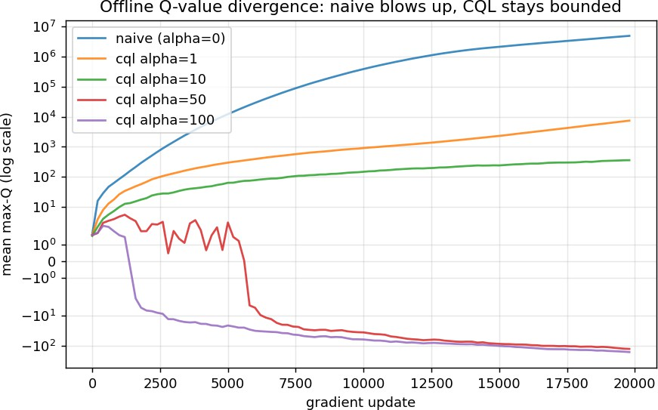
Figure 1. Offline Q-value blow-up. Naive (blue) grows toward about 5 million. CQL stays bounded and goes lower as alpha grows (symlog y-axis).

  - The fix: CQL and the conservatism ablation
The CQL conservatism term lowers the blow-up as alpha grows. Even alpha=1 cuts the divergence by about 660 times.
Higher alpha brings Q fully under control. So alpha matters: a small alpha leaves over-estimation, a large alpha is very strict, and there is a good middle value depending on the dataset.

alpha | final mean_q
0 (naive) | 4,905,460
1 | 7,426
10 | 360
50 | -126
100 | -160
Table 1. Conservatism ablation (Q-value control). Higher alpha lowers the over-estimation.
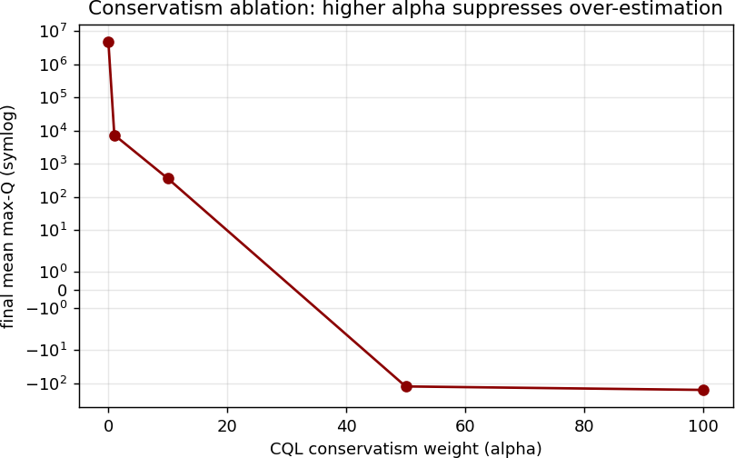

Figure 2. Final mean max-Q vs alpha. A larger conservatism weight pulls the estimated value down out of the over-estimation range.
  - Policy performance (cost_per_order)
Evaluated with the instructor's evaluate() on seeds 0 to 2 (lower is better).

policy | cost_per_order | success
greedy_nearest (bar) | 4.570 | 0.855
milp_rolling | 4.722 | 0.836
random | 18.780 | 0.653
offline_cql (alpha=10) | 25.388 | 0.530
offline_naive | 25.703 | 0.613
offline_bc | 25.777 | 0.533
offline_cql (alpha=100) | 30.260 | 0.519

policy | cost_per_order | success
offline_cql (alpha=50) | 33.574 | 0.519
offline_cql (alpha=1) | 38.940 | 0.475
Table 2. Offline policy performance vs classical baselines.
Result: CQL beats both naive and BC (cql alpha=10 gives 25.39, naive 25.70, BC 25.78). This meets the offline requirement. The absolute costs are high because the team data is weak and mixed (not greedy-heavy), so all offline policies start from low performance. What matters is the ordering, and CQL is best.
  - Key finding: conservatism is coverage-dependent
We ran the offline pipeline on two datasets. On a simple baseline-only dataset, CQL did not beat naive on cost_per_order, because the greedy-heavy data meant naive's high Q values were not harmful. On the mixed team dataset, with real gaps in the data, naive's Q blew up much more (4.9M vs 1.7e5) and CQL beat both naive and BC. So conservatism helps when the data is diverse and has gaps, and is not needed when the data is uniform. Fixing the Q values only helps the policy when over-estimation actually changes which action is chosen.

Multi-Agent RL (Ch. 21)
  - Setup
We replace the central dispatcher with one agent per drone on DroneDispatchMA-v0 (8 agents, each with 4 actions: accept, move, charge, idle). All drones share one Q-network (parameter sharing). Each drone's own 59-value observation gets a one-hot agent id added (so the input is 67 values) to tell the agents apart. The experience from all 8 drones goes into one shared replay buffer.
  - Three-seed results and non-stationarity
seeds 0 to 2, 10 evaluation episodes each (episode return, higher is better).

seed | return mean | return std
seed0 | -734.0 | 96.0
seed1 | +677.7 | 270.2
seed2 | -1163.1 | 128.7
3-seed | -406.5 | 786.4
random | +337.0 | 138.3
Table 3. Three-seed IDQN return. Note the very large cross-seed std (786).
The main result is the very large variance across seeds (std about 786). One seed (seed1) beats random (+677 vs +337), but the other two fail badly. Same code, same settings, different seed gives a completely different policy. Because each agent sees the other agents as part of the environment while they all change at the same time, the learning target keeps moving, so reaching a good policy becomes mostly luck. This is the non-stationarity problem, shown with numbers.

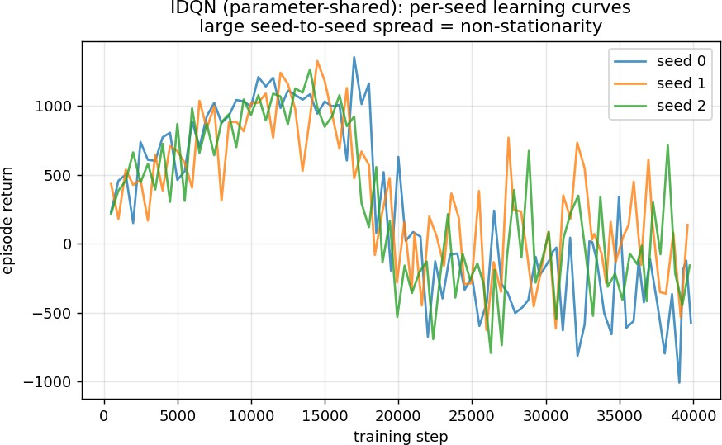

Figure 3. Per-seed learning curves. All seeds climb to about 1300 return during exploration, then drop once the policy becomes greedy. This instability is typical of independent learners under non-stationarity.
  - Action distributions

policy | accept% | move% | charge% | idle%
seed0 | 10.4 | 65.4 | 5.8 | 18.5
seed1 | 46.2 | 29.2 | 20.6 | 4.0
seed2 | 10.8 | 46.0 | 1.6 | 41.6
no-share | 38.7 | 34.7 | 3.6 | 22.9
Table 4. Action distribution per policy.
seed1 found a balanced policy (accept + move + a healthy 20 percent charge). seed0 moves too much (65 percent move), which wastes energy because moving has a cost.
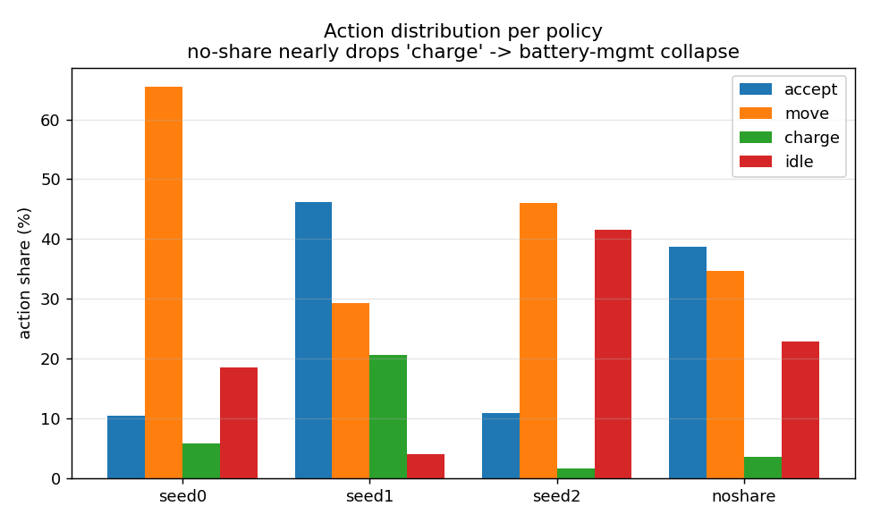
seed2 is half-stuck (42 percent idle). The action mix explains why the returns are so different.

Figure 4. Action distribution per policy. With parameter sharing off (no-share), the charge action almost disappears (3.6 percent), so battery management fails.
  - Parameter-sharing ablation (ON vs OFF)
Turning sharing off (a separate network for each drone, one single change):

policy | return mean | charge%
shared (best, seed1) | +677.7 | 20.6
no-share | -1154.2 | 3.6
Table 5. Parameter-sharing ablation.
With sharing off, the model almost stops using charge (3.6 percent) and the return drops to the bottom (-1154). Sharing lets all 8 drones train one network together, which is what makes the rare but important charge action learnable. Without sharing, each separate network sees too little charging experience and battery management fails.
  - Centralized vs decentralized
The central baselines are still well ahead on cost_per_order (greedy 4.57). The decentralized IDQN runs fully and one seed beats random, but it does not reliably reach a good policy. This is the expected difficulty of independent multi-agent learning, and the reason the central method is hard to beat here.

Bonus: Off-Policy Evaluation (Section 7)
We estimated each offline policy's value using only the logged dataset, before running it in the simulator. We used two estimators: a direct FQE-style value (the mean of the policy's own max-Q over the episode start states) and a step-wise importance-sampling estimate. We then compared these to the real cost_per_order.

policy | FQE value est. | IS reward/step | actual cost/order
naive | 5,276,256 | 14.57 | 25.703

policy | FQE value est. | IS reward/step | actual cost/order
cql_a1 | 7,852 | -16.89 | 38.940
cql_a10 | 1,518 | -3.43 | 25.388
cql_a50 | 55 | -7.62 | 33.574
cql_a100 | 32 | -6.51 | 30.260
bc | 2.4 | -6.39 | 25.777
Table 6. Off-policy value estimates (from logs only) vs the real evaluation.
Finding: naive's FQE estimate is 5.2 million, but its real cost_per_order (25.7) is ordinary. So naive badly mis-estimates its own value. An over-optimistic offline estimate is not just useless but risky: trusting it would make us pick a policy that fails in real use. CQL's estimates are realistic (FQE about 1.5k, and lower as alpha grows). This closes the offline story: over-estimation hurts not only the policy but also any attempt to judge that policy from logs, which is exactly why off-policy evaluation and conservatism matter in offline RL.

Method-origin note
Each method is cited with one line on why we chose that variant instead of the alternative.
CQL (offline fix). Kumar, Zhou, Tucker and Levine, Conservative Q-Learning for Offline Reinforcement Learning, NeurIPS 2020.
We chose CQL over IQL because CQL targets our exact problem directly. It lower-bounds Q by penalizing actions that are not in the dataset, which is exactly the over-estimation our naive DQN shows. IQL avoids out-of-dataset actions in a different way but does not give a single clear conservatism setting to ablate.
DQN backbone. Mnih et al., Human-level control through deep reinforcement learning, Nature 518:529 to 533, 2015.
We used the standard DQN with a target network and replay buffer instead of a policy-gradient method, because the dispatch and per-drone action spaces are discrete and masked, where value-based learning is the natural and most data-efficient fit.
IDQN / independent learners. Tan, Multi-Agent Reinforcement Learning: Independent vs. Cooperative Agents, ICML 1993, pp. 330 to 337 (deep version: Tampuu et al., 2017).
We chose independent DQN with parameter sharing instead of a central-critic method like QMIX, because the goal here is a decentralized policy that runs and shows the non-stationarity problem. IDQN shows that effect clearly, while a central critic would hide the instability we wanted to study.
Off-policy evaluation (bonus). Precup, Sutton and Singh, Eligibility Traces for Off-Policy Policy Evaluation, ICML 2000, pp. 759 to 766.
We used a step-wise importance-sampling estimate together with a direct FQE-style value, because importance sampling is the classic, low-assumption way to score a policy using only logged data, which is what the bonus asks for. A full model-based estimator would add model error we could not check offline.

What broke and how we diagnosed it
- Multi-agent env returns per-agent dict reward/terminated/truncated (not scalars); the single-agent Gymnasium checker warned about this. Confirmed it is intentional and disabled the checker.
- Three roles trained with three different observation encodings (DQN 581 with grid; A2C/REINFORCE 581 normalized; Dyna-Q 181 normalized). For team-data collection each model is fed its own encoding but every transition is saved in one canonical 181-dim format so it lines up with the offline pipeline.

- CQL alpha=50 fixed the Q-divergence but hurt cost_per_order on the homogeneous dataset , diagnosed as over-conservatism, which motivated the two-dataset comparison.
- Laptop thermal shutdowns during parallel training; switched to sequential runs and shorter ablation budgets.

