Hacker News Mobile Site Project

Eray Ozcan

C0700346

BootCamp

31 August 2017

**Hacker News Mobile Site**

Hacker News Mobile Site presents Hackers News to all customers via mobile web site. Mobile Web site includes Main page that includes three categories (Top Stories, New Stories, and Job Stories), News Detail page shows us detail information and comments about the news.

Mobile Web Site software developed on four tier architecture. **jQuery** and **jQuery Mobile** is used for front end. Ajax web service call technique is used for reaching web services. Web services layer developed based on **RESTful** (Representational state transfer) web services architecture. Services provided by Hacker News web site.

**Mobile Website Details**

In this section, detail information and screen shots are given.

**Frontend Development:**

Development tools: jQuery Mobile 1.4.5, jQuery 1.11.1, Aptana Studio 3, HTML 5, Ajax

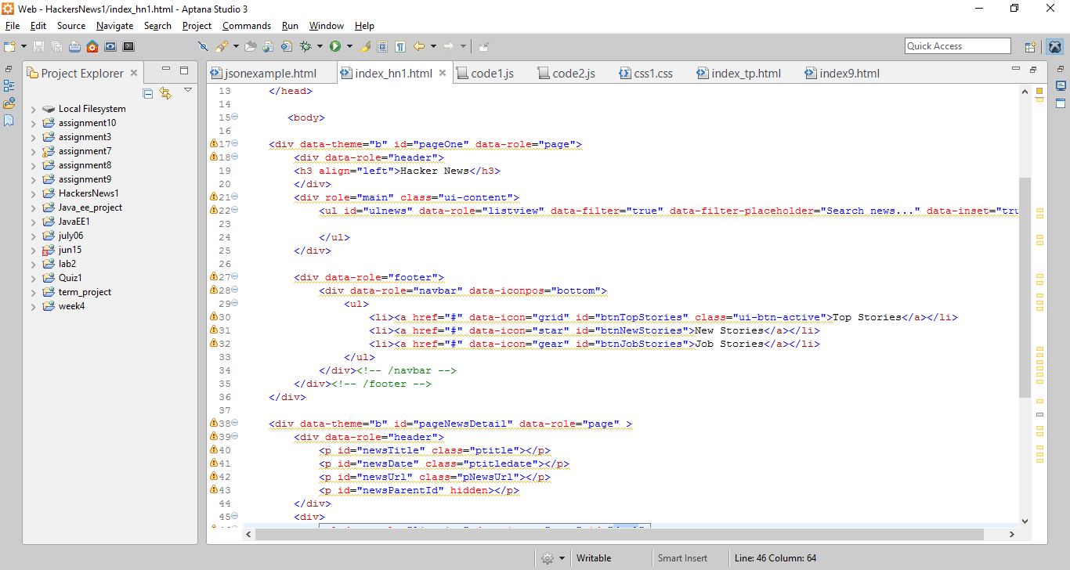

**Application:**

**Main page: News Detail Page:**

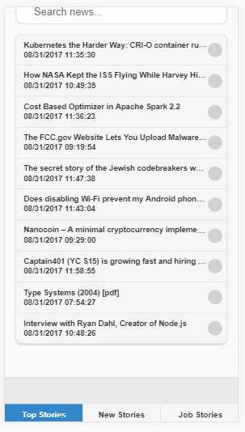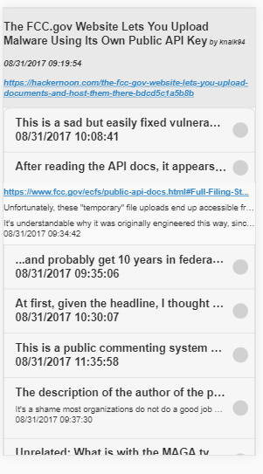

**Comment Details Page:**

